Supplementary Table S1. Frozen cohort, marker, phenotype, endpoint, and validation definitions.
Domain | Source | Window | Operational definition
Acute pancreatitis eligibility | MIMIC-IV diagnoses_icd | Hospital admission | ICD-9 5770 or ICD-10 K85* on the linked admission; primary-diagnosis sensitivity retained seq_num=1.
Index ICU stay | MIMIC-IV icustays | First eligible AP ICU stay | First AP ICU hospitalization per patient, adult, ICU admission within 0–24 h of hospital admission.
24-hour landmark | ICU timestamps/death linkage | 24 h after ICU admission | Patient alive and still in the ICU at 24 h; early ICU death/discharge excluded from the landmark estimand.
Cumulative fluid burden | inputevents + outputevents + dialysis output audit | 0–24 h in four 6-h bins | Cumulative measured input minus audited output, including dialysis output, divided by admission weight (mL/kg).
Vasopressor intensity | inputevents | 0–24 h in four 6-h bins | Time-weighted norepinephrine-equivalent dose: norepinephrine + epinephrine + phenylephrine/10 + dopamine/100 + vasopressin (U/min)×2.5; no vasopressor event coded 0 after interface verification.
Lactate response | labevents item 50813 | 0–24 h in four 6-h bins | Median mmol/L within each bin; unmeasured bins retained as missing and modeled through observation likelihood.
Trajectory model | Three-marker 2-part joint finite mixture | 0–24 h | Gaussian fluid and observed-lactate components plus Bernoulli pressor use and conditional Gaussian positive-dose component; K=3 linear model frozen before outcomes.
P1 phenotype | Frozen K3 class 1 | Frozen after outcome-blind modeling | Low cumulative fluid burden, low lactate, and low vasopressor burden.
P2 phenotype | Frozen K3 class 2 | Frozen after outcome-blind modeling | Predominantly rising cumulative fluid burden with declining lactate and little vasopressor exposure.
P3 phenotype | Frozen K3 class 3 | Frozen after outcome-blind modeling | High cumulative fluid burden, persistent vasopressor exposure/intensity, and high lactate.
Organ-support states | Vasopressors, invasive ventilation, and RRT | 24 h to ICU discharge/death | No, single, or multiple concurrent supports; alive ICU discharge and ICU death were absorbing states.
Escalation/de-escalation | 6-hour state episodes after landmark | 24 h to ICU discharge/death | Movement to a higher/lower concurrent-support count; exact transitions stratified in Cox models.
Alive ICU discharge | ICU outtime/status | After 24-h landmark | ICU discharge without death at/before outtime.
ICU death | Death before or at ICU outtime | After 24-h landmark | Death occurring before or at ICU outtime.
Primary adjustment | Baseline/prior encounter variables | Before/at ICU admission | Age, sex, prior Charlson score, primary AP diagnosis, emergency/urgent admission, initial MAP, baseline BUN, ICU delay, and the actual MIMIC-IV calendar-period group.
Missing covariates | MAP and BUN only | Patient-level MI | Twenty chained-equation imputations using predictive mean matching; complete-case analysis was prespecified.
Temporal validation | MIMIC-III CareVue | Same 0–24 h definition | Frozen MIMIC-IV parameters applied to CareVue; interpreted as same-center historical/temporal transport.
Multicenter transportability | eICU-CRD screened hospitals | Same 0–24 h definition where quantifiable | Hospitals screened for infusion-interface completeness; unrecoverable mL/h drug rates were not converted to NEE; interpreted as partial structural transport only.
NEE, norepinephrine-equivalent dose; MI, multiple imputation; RRT, renal replacement therapy.

Supplementary Table S2A. Candidate trajectory-model fit and classification quality.
Model | BIC | Entropy | Minimum class, % | Mean APPA | Admissible | Selected
K4, degree 1 | 11,661.24 | 0.9344897 | 9.913043 | 0.9638238 | False | No
K4, degree 2 | 11,687.93 | 0.9371793 | 10.260870 | 0.9647137 | True | No
K3, degree 1 | 12,024.17 | 0.9294355 | 24.000000 | 0.9699974 | True | Yes
K3, degree 2 | 12,036.42 | 0.9296031 | 26.956522 | 0.9685922 | True | No
K2, degree 1 | 13,129.06 | 0.9531240 | 29.217391 | 0.9862796 | True | No
K2, degree 2 | 13,144.26 | 0.9621469 | 29.391304 | 0.9903050 | True | No
Lower BIC is favored, but admissibility, minimum class size, stability, and interpretability were prespecified co-criteria.

Supplementary Table S2B. Patient-level bootstrap and lactate-density stability.
Model | Bootstrap success, % | Median OOB ARI | 5th percentile OOB ARI | Median minimum-class Jaccard | Serial-lactate ARI | Dense-lactate ARI | Stability gate
K3_d1 | 100 | 0.8737405 | 0.6610424 | 0.9144361 | 0.8141267 | 0.7173992 | PASS
K4_d2 | 100 | 0.7655575 | 0.4379099 | 0.6478537 | 0.7086472 | 0.5832690 | FAIL
ARI, adjusted Rand index; APPA, average posterior probability of assignment; OOB, out-of-bag.

Supplementary Table S3A. Time-bin marker completeness across lactate-density cohorts.
Cohort | Marker | Patients | Time-bin rows | Observed | Missing | Missing, % | Median | Q1 | Q3
Primary (≥1 lactate bin) | Cumulative net fluid, mL/kg | 575 | 2,300 | 2,300 | 0 | 0.0 | 22.78 | 6.18 | 48.50
Primary (≥1 lactate bin) | NEE, µg/kg/min | 575 | 2,300 | 2,300 | 0 | 0.0 | 0.00 | 0.00 | 0.03
Primary (≥1 lactate bin) | Lactate, mmol/L | 575 | 2,300 | 1,292 | 1,008 | 43.8 | 1.90 | 1.30 | 3.30
Serial lactate (≥2 bins) | Cumulative net fluid, mL/kg | 372 | 1,488 | 1,488 | 0 | 0.0 | 29.92 | 10.83 | 59.01
Serial lactate (≥2 bins) | NEE, µg/kg/min | 372 | 1,488 | 1,488 | 0 | 0.0 | 0.00 | 0.00 | 0.08
Serial lactate (≥2 bins) | Lactate, mmol/L | 372 | 1,488 | 1,089 | 399 | 26.8 | 2.20 | 1.40 | 3.55
Dense lactate (≥3 bins) | Cumulative net fluid, mL/kg | 223 | 892 | 892 | 0 | 0.0 | 38.71 | 18.16 | 69.80
Dense lactate (≥3 bins) | NEE, µg/kg/min | 223 | 892 | 892 | 0 | 0.0 | 0.00 | 0.00 | 0.15
Dense lactate (≥3 bins) | Lactate, mmol/L | 223 | 892 | 791 | 101 | 11.3 | 2.60 | 1.60 | 4.10
Lactate missingness was retained; unmeasured bins were not imputed as normal.

Supplementary Table S3B. Informative lactate measurement intensity and severity markers.
Observed lactate bins | N | Vasopressor, n (%) | Multiple support at 24 h, n (%) | ICU death, n (%) | Hospital death, n (%) | Median maximum lactate
1 | 203 | 36 (17.7%) | 16 (7.9%) | 4 (2.0%) | 15 (7.4%) | 1.4
2 | 149 | 51 (34.2%) | 20 (13.4%) | 7 (4.7%) | 11 (7.4%) | 1.8
3 | 101 | 47 (46.5%) | 32 (31.7%) | 12 (11.9%) | 17 (16.8%) | 2.7
4 | 122 | 84 (68.9%) | 64 (52.5%) | 25 (20.5%) | 32 (26.2%) | 4.4
Observed lactate-bin count is associated with severity and outcomes, supporting explicit missingness sensitivity analyses.

Supplementary Table S4. Complete primary and sensitivity estimates for grouped post-landmark transitions.
Analysis | Contrast | Outcome | HR (95% CI) | P value | Exposed/reference events | Note
Primary adjusted MI | P2 vs P1 | Escalation to higher support | 0.86 (0.57–1.32) | 0.499
Primary adjusted MI | P3 vs P1 | Escalation to higher support | 1.80 (1.22–2.65) | 0.003
Primary adjusted MI | P2 vs P1 | De-escalation to lower support | 0.78 (0.57–1.06) | 0.112
Primary adjusted MI | P3 vs P1 | De-escalation to lower support | 1.01 (0.77–1.31) | 0.960
Primary adjusted MI | P2 vs P1 | Alive ICU discharge | 0.91 (0.75–1.11) | 0.349
Primary adjusted MI | P3 vs P1 | Alive ICU discharge | 0.68 (0.55–0.84) | <0.001
Primary adjusted MI | P2 vs P1 | ICU death | 1.81 (0.73–4.51) | 0.203
Primary adjusted MI | P3 vs P1 | ICU death | 1.95 (0.86–4.42) | 0.109
Unadjusted | P2 vs P1 | Escalation to higher support | 0.82 (0.54–1.24) | 0.349
Unadjusted | P3 vs P1 | Escalation to higher support | 1.79 (1.22–2.64) | 0.003
Unadjusted | P2 vs P1 | De-escalation to lower support | 0.75 (0.56–1.01) | 0.059
Unadjusted | P3 vs P1 | De-escalation to lower support | 0.98 (0.75–1.29) | 0.892
Unadjusted | P2 vs P1 | Alive ICU discharge | 0.89 (0.74–1.07) | 0.202
Unadjusted | P3 vs P1 | Alive ICU discharge | 0.70 (0.58–0.86) | <0.001
Unadjusted | P2 vs P1 | ICU death | 1.75 (0.71–4.31) | 0.223
Unadjusted | P3 vs P1 | ICU death | 1.91 (0.85–4.29) | 0.119
Complete case | P2 vs P1 | Escalation to higher support | 0.86 (0.55–1.33) | 0.497
Complete case | P3 vs P1 | Escalation to higher support | 1.74 (1.16–2.61) | 0.008
Complete case | P2 vs P1 | De-escalation to lower support | 0.77 (0.57–1.05) | 0.103
Complete case | P3 vs P1 | De-escalation to lower support | 1.00 (0.76–1.32) | 0.977
Complete case | P2 vs P1 | Alive ICU discharge | 0.94 (0.77–1.16) | 0.583
Complete case | P3 vs P1 | Alive ICU discharge | 0.71 (0.56–0.90) | 0.004
Complete case | P2 vs P1 | ICU death | 1.47 (0.59–3.70) | 0.408
Complete case | P3 vs P1 | ICU death | 1.96 (0.86–4.49) | 0.111
Time-varying age/Charlson | P2 vs P1 | Escalation to higher support | 0.86 (0.56–1.31) | 0.476
Time-varying age/Charlson | P3 vs P1 | Escalation to higher support | 1.81 (1.24–2.67) | 0.002
Time-varying age/Charlson | P2 vs P1 | De-escalation to lower support | 0.78 (0.57–1.07) | 0.126
Time-varying age/Charlson | P3 vs P1 | De-escalation to lower support | 1.02 (0.78–1.32) | 0.909
Time-varying age/Charlson | P2 vs P1 | Alive ICU discharge | 0.92 (0.76–1.11) | 0.382
Time-varying age/Charlson | P3 vs P1 | Alive ICU discharge | 0.68 (0.55–0.84) | <0.001
Time-varying age/Charlson | P2 vs P1 | ICU death | 1.81 (0.72–4.56) | 0.205
Time-varying age/Charlson | P3 vs P1 | ICU death | 1.97 (0.86–4.48) | 0.108
Posterior pseudo-class (100 draws) | P2 vs P1 | Escalation to higher support | 0.89 (0.58–1.38) | 0.606
Posterior pseudo-class (100 draws) | P3 vs P1 | Escalation to higher support | 1.84 (1.24–2.75) | 0.003
Posterior pseudo-class (100 draws) | P2 vs P1 | De-escalation to lower support | 0.79 (0.58–1.08) | 0.147
Posterior pseudo-class (100 draws) | P3 vs P1 | De-escalation to lower support | 1.04 (0.79–1.36) | 0.794
Posterior pseudo-class (100 draws) | P2 vs P1 | Alive ICU discharge | 0.90 (0.74–1.10) | 0.307
Posterior pseudo-class (100 draws) | P3 vs P1 | Alive ICU discharge | 0.68 (0.55–0.85) | <0.001
Posterior pseudo-class (100 draws) | P2 vs P1 | ICU death | 1.83 (0.73–4.60) | 0.199
Posterior pseudo-class (100 draws) | P3 vs P1 | ICU death | 2.02 (0.88–4.60) | 0.096
Early circulatory dysfunction | P2 vs P1 | Escalation to higher support | 0.38 (0.20–0.70) | 0.002 | 34/78
Early circulatory dysfunction | P3 vs P1 | Escalation to higher support | 1.03 (0.67–1.59) | 0.887 | 245/78
Early circulatory dysfunction | P2 vs P1 | De-escalation to lower support | 0.62 (0.41–0.93) | 0.020 | 60/131
Early circulatory dysfunction | P3 vs P1 | De-escalation to lower support | 0.89 (0.65–1.22) | 0.469 | 399/131
Early circulatory dysfunction | P2 vs P1 | Alive ICU discharge | 0.89 (0.62–1.28) | 0.543 | 63/63
Early circulatory dysfunction | P3 vs P1 | Alive ICU discharge | 0.75 (0.55–1.01) | 0.061 | 106/63
Early circulatory dysfunction | P2 vs P1 | ICU death | 2.58 (0.61–10.85) | 0.196 | 4/3 | Sparse: <5 events in ≥1 group
Early circulatory dysfunction | P3 vs P1 | ICU death | 2.95 (1.04–8.41) | 0.042 | 30/3 | Sparse: <5 events in ≥1 group
Strict shock-like subgroup | P2 vs P1 | Escalation to higher support | 0.33 (0.12–0.94) | 0.038 | 7/24
Strict shock-like subgroup | P3 vs P1 | Escalation to higher support | 0.97 (0.55–1.71) | 0.925 | 199/24
Strict shock-like subgroup | P2 vs P1 | De-escalation to lower support | 1.00 (0.52–1.89) | 0.991 | 18/38
Strict shock-like subgroup | P3 vs P1 | De-escalation to lower support | 0.99 (0.65–1.49) | 0.953 | 319/38
Strict shock-like subgroup | P2 vs P1 | Alive ICU discharge | 0.88 (0.38–2.06) | 0.769 | 15/9
Strict shock-like subgroup | P3 vs P1 | Alive ICU discharge | 0.77 (0.41–1.43) | 0.406 | 79/9
Strict shock-like subgroup | P2 vs P1 | ICU death | NE | NE | 0/1 | NE: zero events in one comparison group
Strict shock-like subgroup | P3 vs P1 | ICU death | 3.25 (0.50–21.14) | 0.218 | 25/1 | Sparse: <5 events in ≥1 group
Primary-diagnosis AP | P2 vs P1 | Escalation to higher support | 1.00 (0.45–2.22) | 0.998 | 52/23
Primary-diagnosis AP | P3 vs P1 | Escalation to higher support | 2.75 (1.17–6.46) | 0.020 | 54/23
Primary-diagnosis AP | P2 vs P1 | De-escalation to lower support | 0.51 (0.28–0.92) | 0.025 | 62/38
Primary-diagnosis AP | P3 vs P1 | De-escalation to lower support | 0.65 (0.38–1.11) | 0.118 | 77/38
Primary-diagnosis AP | P2 vs P1 | Alive ICU discharge | 0.85 (0.60–1.20) | 0.357 | 94/64
Primary-diagnosis AP | P3 vs P1 | Alive ICU discharge | 0.70 (0.43–1.14) | 0.155 | 19/64
Primary-diagnosis AP | P2 vs P1 | ICU death | 1.26 (0.10–15.44) | 0.857 | 5/1 | Sparse: <5 events in ≥1 group
Primary-diagnosis AP | P3 vs P1 | ICU death | 0.48 (0.01–15.40) | 0.678 | 3/1 | Sparse: <5 events in ≥1 group
Lactate observed in ≥2 bins | P2 vs P1 | Escalation to higher support | 0.96 (0.59–1.54) | 0.854 | 101/82
Lactate observed in ≥2 bins | P3 vs P1 | Escalation to higher support | 1.88 (1.23–2.87) | 0.004 | 230/82
Lactate observed in ≥2 bins | P2 vs P1 | De-escalation to lower support | 0.82 (0.57–1.16) | 0.261 | 135/136
Lactate observed in ≥2 bins | P3 vs P1 | De-escalation to lower support | 1.09 (0.81–1.46) | 0.574 | 375/136
Lactate observed in ≥2 bins | P2 vs P1 | Alive ICU discharge | 1.03 (0.79–1.33) | 0.847 | 144/83
Lactate observed in ≥2 bins | P3 vs P1 | Alive ICU discharge | 0.78 (0.61–1.01) | 0.064 | 101/83
Lactate observed in ≥2 bins | P2 vs P1 | ICU death | 1.58 (0.61–4.14) | 0.349 | 11/6
Lactate observed in ≥2 bins | P3 vs P1 | ICU death | 1.56 (0.68–3.58) | 0.297 | 27/6
Lactate observed in ≥3 bins | P2 vs P1 | Escalation to higher support | 0.81 (0.40–1.68) | 0.579 | 78/37
Lactate observed in ≥3 bins | P3 vs P1 | Escalation to higher support | 1.53 (0.80–2.92) | 0.202 | 207/37
Lactate observed in ≥3 bins | P2 vs P1 | De-escalation to lower support | 0.72 (0.41–1.24) | 0.238 | 93/57
Lactate observed in ≥3 bins | P3 vs P1 | De-escalation to lower support | 1.22 (0.78–1.91) | 0.384 | 328/57
Lactate observed in ≥3 bins | P2 vs P1 | Alive ICU discharge | 0.92 (0.61–1.39) | 0.690 | 80/25
Lactate observed in ≥3 bins | P3 vs P1 | Alive ICU discharge | 0.68 (0.47–0.98) | 0.040 | 81/25
Lactate observed in ≥3 bins | P2 vs P1 | ICU death | 0.99 (0.30–3.26) | 0.987 | 8/4 | Sparse: <5 events in ≥1 group
Lactate observed in ≥3 bins | P3 vs P1 | ICU death | 1.28 (0.46–3.53) | 0.636 | 25/4 | Sparse: <5 events in ≥1 group
ICU delay ≤12 h | P2 vs P1 | Escalation to higher support | 0.85 (0.55–1.31) | 0.451 | 106/120
ICU delay ≤12 h | P3 vs P1 | Escalation to higher support | 1.82 (1.23–2.71) | 0.003 | 226/120
ICU delay ≤12 h | P2 vs P1 | De-escalation to lower support | 0.79 (0.58–1.07) | 0.133 | 147/201
ICU delay ≤12 h | P3 vs P1 | De-escalation to lower support | 1.00 (0.76–1.30) | 0.976 | 365/201
ICU delay ≤12 h | P2 vs P1 | Alive ICU discharge | 0.91 (0.75–1.11) | 0.350 | 214/180
ICU delay ≤12 h | P3 vs P1 | Alive ICU discharge | 0.68 (0.54–0.84) | <0.001 | 98/180
ICU delay ≤12 h | P2 vs P1 | ICU death | 1.63 (0.65–4.12) | 0.300 | 10/7
ICU delay ≤12 h | P3 vs P1 | ICU death | 2.08 (0.92–4.70) | 0.080 | 30/7
Output documented in ≥3 bins | P2 vs P1 | Escalation to higher support | 0.93 (0.60–1.43) | 0.742 | 110/112
Output documented in ≥3 bins | P3 vs P1 | Escalation to higher support | 1.88 (1.26–2.81) | 0.002 | 236/112
Output documented in ≥3 bins | P2 vs P1 | De-escalation to lower support | 0.81 (0.59–1.10) | 0.180 | 151/192
Output documented in ≥3 bins | P3 vs P1 | De-escalation to lower support | 1.04 (0.80–1.36) | 0.757 | 386/192
Output documented in ≥3 bins | P2 vs P1 | Alive ICU discharge | 0.91 (0.74–1.10) | 0.327 | 218/184
Output documented in ≥3 bins | P3 vs P1 | Alive ICU discharge | 0.67 (0.54–0.83) | <0.001 | 103/184
Output documented in ≥3 bins | P2 vs P1 | ICU death | 1.49 (0.58–3.82) | 0.409 | 9/7
Output documented in ≥3 bins | P3 vs P1 | ICU death | 1.84 (0.80–4.23) | 0.150 | 28/7
No RRT during 0–24 h | P2 vs P1 | Escalation to higher support | 0.98 (0.63–1.53) | 0.927 | 106/92
No RRT during 0–24 h | P3 vs P1 | Escalation to higher support | 2.20 (1.42–3.40) | <0.001 | 217/92
No RRT during 0–24 h | P2 vs P1 | De-escalation to lower support | 0.79 (0.57–1.10) | 0.169 | 148/157
No RRT during 0–24 h | P3 vs P1 | De-escalation to lower support | 1.05 (0.77–1.43) | 0.772 | 354/157
No RRT during 0–24 h | P2 vs P1 | Alive ICU discharge | 0.91 (0.75–1.11) | 0.371 | 226/176
No RRT during 0–24 h | P3 vs P1 | Alive ICU discharge | 0.73 (0.59–0.92) | 0.006 | 97/176
No RRT during 0–24 h | P2 vs P1 | ICU death | 1.27 (0.48–3.36) | 0.631 | 9/6
No RRT during 0–24 h | P3 vs P1 | ICU death | 1.51 (0.59–3.87) | 0.396 | 23/6
Posterior probability ≥0.80 | P2 vs P1 | Escalation to higher support | 0.91 (0.59–1.40) | 0.662 | 109/110
Posterior probability ≥0.80 | P3 vs P1 | Escalation to higher support | 1.91 (1.28–2.86) | 0.002 | 239/110
Posterior probability ≥0.80 | P2 vs P1 | De-escalation to lower support | 0.79 (0.58–1.09) | 0.151 | 146/190
Posterior probability ≥0.80 | P3 vs P1 | De-escalation to lower support | 1.04 (0.80–1.37) | 0.757 | 389/190
Posterior probability ≥0.80 | P2 vs P1 | Alive ICU discharge | 0.90 (0.73–1.09) | 0.273 | 212/176
Posterior probability ≥0.80 | P3 vs P1 | Alive ICU discharge | 0.68 (0.54–0.84) | <0.001 | 102/176
Posterior probability ≥0.80 | P2 vs P1 | ICU death | 1.81 (0.72–4.53) | 0.206 | 11/7
Posterior probability ≥0.80 | P3 vs P1 | ICU death | 1.96 (0.86–4.45) | 0.108 | 30/7
Posterior probability ≥0.90 | P2 vs P1 | Escalation to higher support | 0.87 (0.57–1.34) | 0.534 | 103/110
Posterior probability ≥0.90 | P3 vs P1 | Escalation to higher support | 1.88 (1.25–2.83) | 0.003 | 231/110
Posterior probability ≥0.90 | P2 vs P1 | De-escalation to lower support | 0.77 (0.55–1.06) | 0.108 | 136/189
Posterior probability ≥0.90 | P3 vs P1 | De-escalation to lower support | 1.07 (0.82–1.39) | 0.633 | 380/189
Posterior probability ≥0.90 | P2 vs P1 | Alive ICU discharge | 0.89 (0.73–1.09) | 0.262 | 202/171
Posterior probability ≥0.90 | P3 vs P1 | Alive ICU discharge | 0.69 (0.55–0.86) | <0.001 | 102/171
Posterior probability ≥0.90 | P2 vs P1 | ICU death | 1.92 (0.77–4.79) | 0.163 | 11/7
Posterior probability ≥0.90 | P3 vs P1 | ICU death | 2.05 (0.89–4.73) | 0.091 | 29/7
Input-only cumulative fluid | P2 vs P1 | Escalation to higher support | 0.77 (0.51–1.17) | 0.226 | 105/123
Input-only cumulative fluid | P3 vs P1 | Escalation to higher support | 1.71 (1.15–2.55) | 0.008 | 249/123
Input-only cumulative fluid | P2 vs P1 | De-escalation to lower support | 0.80 (0.59–1.09) | 0.154 | 145/209
Input-only cumulative fluid | P3 vs P1 | De-escalation to lower support | 1.06 (0.80–1.39) | 0.687 | 403/209
Input-only cumulative fluid | P2 vs P1 | Alive ICU discharge | 0.88 (0.72–1.07) | 0.192 | 209/202
Input-only cumulative fluid | P3 vs P1 | Alive ICU discharge | 0.74 (0.60–0.92) | 0.006 | 116/202
Input-only cumulative fluid | P2 vs P1 | ICU death | 0.96 (0.39–2.32) | 0.922 | 8/11
Input-only cumulative fluid | P3 vs P1 | ICU death | 1.34 (0.67–2.69) | 0.405 | 29/11
Output events-only net fluid | P2 vs P1 | Escalation to higher support | 0.99 (0.64–1.51) | 0.953 | 111/104
Output events-only net fluid | P3 vs P1 | Escalation to higher support | 2.14 (1.44–3.17) | <0.001 | 262/104
Output events-only net fluid | P2 vs P1 | De-escalation to lower support | 0.73 (0.53–1.01) | 0.055 | 150/185
Output events-only net fluid | P3 vs P1 | De-escalation to lower support | 0.93 (0.69–1.25) | 0.631 | 422/185
Output events-only net fluid | P2 vs P1 | Alive ICU discharge | 0.87 (0.72–1.05) | 0.155 | 219/197
Output events-only net fluid | P3 vs P1 | Alive ICU discharge | 0.68 (0.54–0.84) | <0.001 | 111/197
Output events-only net fluid | P2 vs P1 | ICU death | 1.75 (0.66–4.64) | 0.263 | 11/6
Output events-only net fluid | P3 vs P1 | ICU death | 1.80 (0.72–4.50) | 0.210 | 31/6
Interval rather than cumulative fluid | P2 vs P1 | Escalation to higher support | 0.53 (0.37–0.77) | <0.001 | 160/116
Interval rather than cumulative fluid | P3 vs P1 | Escalation to higher support | 1.75 (1.20–2.56) | 0.004 | 201/116
Interval rather than cumulative fluid | P2 vs P1 | De-escalation to lower support | 0.78 (0.58–1.04) | 0.087 | 241/223
Interval rather than cumulative fluid | P3 vs P1 | De-escalation to lower support | 0.89 (0.67–1.18) | 0.421 | 293/223
Interval rather than cumulative fluid | P2 vs P1 | Alive ICU discharge | 1.15 (0.92–1.44) | 0.206 | 375/87
Interval rather than cumulative fluid | P3 vs P1 | Alive ICU discharge | 0.87 (0.66–1.14) | 0.314 | 65/87
Interval rather than cumulative fluid | P2 vs P1 | ICU death | 1.54 (0.59–3.99) | 0.375 | 12/7
Interval rather than cumulative fluid | P3 vs P1 | ICU death | 3.00 (1.49–6.05) | 0.002 | 29/7
Last rather than median lactate | P2 vs P1 | Escalation to higher support | 0.86 (0.57–1.31) | 0.493 | 111/121
Last rather than median lactate | P3 vs P1 | Escalation to higher support | 1.80 (1.22–2.67) | 0.003 | 245/121
Last rather than median lactate | P2 vs P1 | De-escalation to lower support | 0.77 (0.57–1.05) | 0.095 | 152/206
Last rather than median lactate | P3 vs P1 | De-escalation to lower support | 1.00 (0.77–1.30) | 0.990 | 399/206
Last rather than median lactate | P2 vs P1 | Alive ICU discharge | 0.90 (0.74–1.10) | 0.306 | 228/192
Last rather than median lactate | P3 vs P1 | Alive ICU discharge | 0.68 (0.55–0.84) | <0.001 | 107/192
Last rather than median lactate | P2 vs P1 | ICU death | 1.81 (0.72–4.51) | 0.205 | 11/7
Last rather than median lactate | P3 vs P1 | ICU death | 1.95 (0.86–4.42) | 0.109 | 30/7
Semi-Markov clock-reset model | P2 vs P1 | Escalation to higher support | 0.90 (0.63–1.28) | 0.542 | 111/121
Semi-Markov clock-reset model | P3 vs P1 | Escalation to higher support | 1.64 (1.23–2.20) | <0.001 | 245/121
Semi-Markov clock-reset model | P2 vs P1 | De-escalation to lower support | 0.80 (0.63–1.01) | 0.064 | 153/205
Semi-Markov clock-reset model | P3 vs P1 | De-escalation to lower support | 0.95 (0.79–1.14) | 0.568 | 399/205
Semi-Markov clock-reset model | P2 vs P1 | Alive ICU discharge | 0.98 (0.78–1.23) | 0.868 | 228/191
Semi-Markov clock-reset model | P3 vs P1 | Alive ICU discharge | 0.54 (0.41–0.70) | <0.001 | 108/191
Semi-Markov clock-reset model | P2 vs P1 | ICU death | 1.80 (0.67–4.83) | 0.246 | 11/7
Semi-Markov clock-reset model | P3 vs P1 | ICU death | 2.28 (0.97–5.37) | 0.059 | 30/7
Sparse estimates (<5 events in either comparison group) and ICU-death estimates are descriptive rather than confirmatory.
Exposed/reference events are shown where recorded by the sensitivity pipeline. NE denotes structurally non-estimable because one comparison group had zero events; no infinite or arbitrary HR was substituted.
HRs are grouped-transition cause-specific estimates with stay-level cluster-robust standard errors. The primary adjusted model used 20 imputations and adjusted for age, sex, prior Charlson score, primary AP diagnosis, emergency/urgent admission, initial MAP, baseline BUN, ICU admission delay, and the actual MIMIC-IV calendar-period group.
P1 was the reference phenotype. Phenotype labels were frozen; alternative-marker models were aligned outcome-blind.

Supplementary Table S5. Alternative landmark and hospital-to-ICU entry-window analyses.
Sensitivity | Outcome | Contrast | Measure | Estimate (95% CI) | P value | N | Events
12-hour landmark, partial frozen likelihood | 12h landmark hospital mortality logistic | P2 vs P1 | OR | 1.35 (0.67–2.76) | 0.403 | 589 | 87
12-hour landmark, partial frozen likelihood | 12h landmark hospital mortality logistic | P3 vs P1 | OR | 6.53 (3.42–12.44) | <0.001 | 589 | 87
12-hour landmark, partial frozen likelihood | 12h landmark cause-specific alive ICU discharge | P2 vs P1 | HR | 0.97 (0.80–1.19) | 0.779 | 589 | 530
12-hour landmark, partial frozen likelihood | 12h landmark cause-specific alive ICU discharge | P3 vs P1 | HR | 0.43 (0.34–0.55) | <0.001 | 589 | 530
Hospital-to-ICU interval expanded to 48 h | ICU entry <=48h hospital mortality logistic | P2 vs P1 | OR | 1.30 (0.65–2.61) | 0.461 | 607 | 83
Hospital-to-ICU interval expanded to 48 h | ICU entry <=48h hospital mortality logistic | P3 vs P1 | OR | 5.33 (2.79–10.17) | <0.001 | 607 | 83
Hospital-to-ICU interval expanded to 48 h | ICU entry <=48h cause-specific alive ICU discharge | P2 vs P1 | HR | 1.04 (0.86–1.26) | 0.687 | 607 | 552
Hospital-to-ICU interval expanded to 48 h | ICU entry <=48h cause-specific alive ICU discharge | P3 vs P1 | HR | 0.40 (0.31–0.50) | <0.001 | 607 | 552
The 12-hour model used only the first two bins of the frozen 24-hour likelihood; the 48-hour-entry analysis retained the 24-hour exposure and landmark.

Supplementary Table S6A. MIMIC-III CareVue phenotype distribution and descriptive outcomes.
Phenotype | N | Age, mean | Female, n (%) | Primary AP, n (%) | Hospital death, n (%) | ICU death, n (%) | Post-landmark ICU stay, median d | Mean posterior
P1 | 51 | 56.5 | 19 (37.3%) | 13 (25.5%) | 6 (11.8%) | 6 (11.8%) | 4.09 | 0.955
P2 | 85 | 58.9 | 51 (60.0%) | 30 (35.3%) | 13 (15.3%) | 10 (11.8%) | 6.72 | 0.948
P3 | 45 | 61.5 | 16 (35.6%) | 10 (22.2%) | 20 (44.4%) | 13 (28.9%) | 10.96 | 0.965

Supplementary Table S6B. MIMIC-III adjusted temporal-validation associations.
Outcome | Measure | N (events) | P2 vs P1 (95% CI) | P value (P2) | P3 vs P1 (95% CI) | P value (P3)
In-hospital mortality | OR | 181 (39) | 1.34 (0.45–3.98) | 0.594 | 5.74 (1.96–16.76) | 0.001
Alive ICU discharge | HR | 181 (152) | 0.94 (0.64–1.38) | 0.757 | 0.55 (0.35–0.87) | 0.011
OR, odds ratio; HR, cause-specific hazard ratio.
Models were adjusted for age, sex, and primary AP diagnosis. The three phenotype groups contained 51, 85, and 45 patients; mean posterior probabilities were 0.955, 0.948, and 0.965, respectively.
MIMIC-III CareVue is a same-center historical/temporal validation cohort, not an independent external cohort. P1 is the reference.

Supplementary Table S7A. Descriptive outcomes in the screened eICU structural-transport cohort.
Phenotype | N | Hospitals | Age, mean | Female, n (%) | Vasopressor, n (%) | Hospital death, n (%) | Post-landmark unit stay, median d | Mean posterior
P1 | 123 | 44 | 54.7 | 49 (39.8%) | 14 (11.4%) | 10 (8.1%) | 2.72 | 0.983
P2 | 20 | 10 | 48.4 | 11 (55.0%) | 2 (10.0%) | 0 (0.0%) | 2.20 | 0.951
P3 | 9 | 6 | 51.7 | 4 (44.4%) | 6 (66.7%) | 2 (22.2%) | 3.72 | 0.925
P3 and mortality events were sparse; no high-dimensional adjusted external-effect model was claimed.

Supplementary Table S7B. eICU hospital infusion-interface screening.
Screen | Hospitals, n | ICU stays represented, n
All hospitals | 208 | 200,859
Liberal infusion-interface screen | 115 | 140,319
Primary infusion-interface screen | 99 | 131,931
Strict infusion-interface screen | 83 | 125,023
Unit-complete vasopressor quantification | 48 | 50,780
Only hospitals passing interface screens could support interpreting absence of a vasopressor record as approximate zero. Unrecoverable mL/h rates were not converted without concentration information.

Supplementary Table S8. Observed exact post-landmark state transitions in the full landmark cohort.
From state | To state | Observed transitions, n
Multiple support | ICU death | 38
Multiple support | ICU discharge alive | 7
Multiple support | No support | 36
Multiple support | Single support | 464
No support | ICU death | 12
No support | ICU discharge alive | 717
No support | Multiple support | 31
No support | Single support | 200
Single support | ICU death | 16
Single support | ICU discharge alive | 54
Single support | Multiple support | 370
Single support | No support | 430
Counts represent 2,375 observed transitions among 844 patients in the full 24-hour landmark support-state cohort; this is distinct from the N=575 phenotype-association cohort. Patients could contribute repeated nonfatal transitions before alive ICU discharge or ICU death.

Supplementary figures
Figure S1. Candidate-model selection and stability
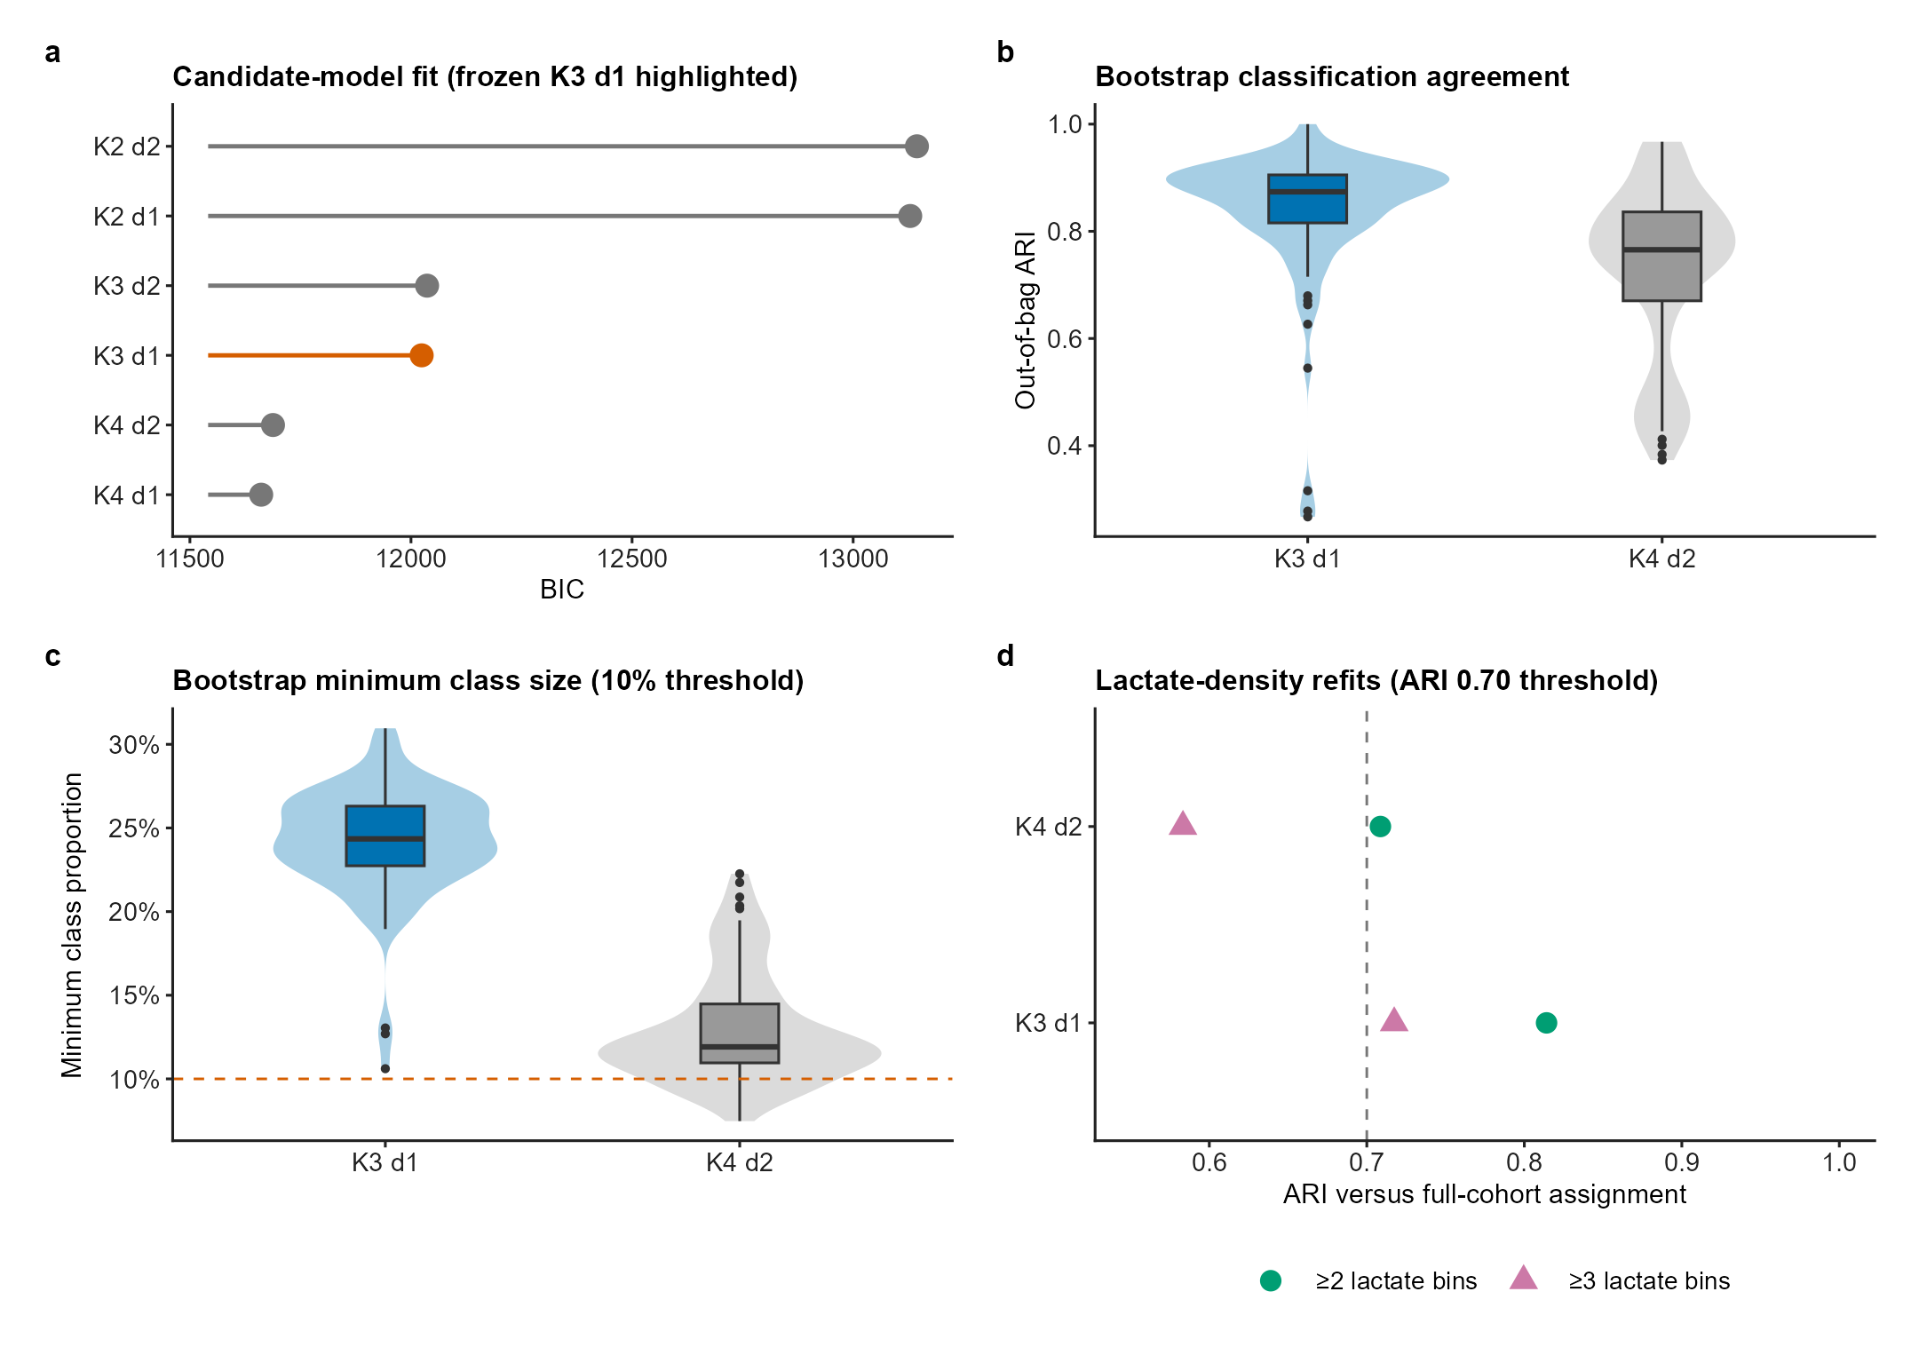
(a) Bayesian information criterion across candidate class-number and polynomial-degree combinations, with the frozen three-class linear model highlighted. (b) Patient-level bootstrap out-of-bag adjusted Rand index and (c) bootstrap minimum-class proportion for the selected K3 linear model and the lower-BIC K4 quadratic comparator. The dashed line in panel c marks the prespecified 10% minimum-class threshold. (d) Agreement between full-cohort assignments and refits restricted to patients with at least two or at least three observed lactate bins; the dashed line marks an adjusted Rand index of 0.70. Model selection jointly considered fit, class size, stability, and interpretability rather than BIC alone. ARI, adjusted Rand index; BIC, Bayesian information criterion.

Figure S2. Lactate missingness and measurement process
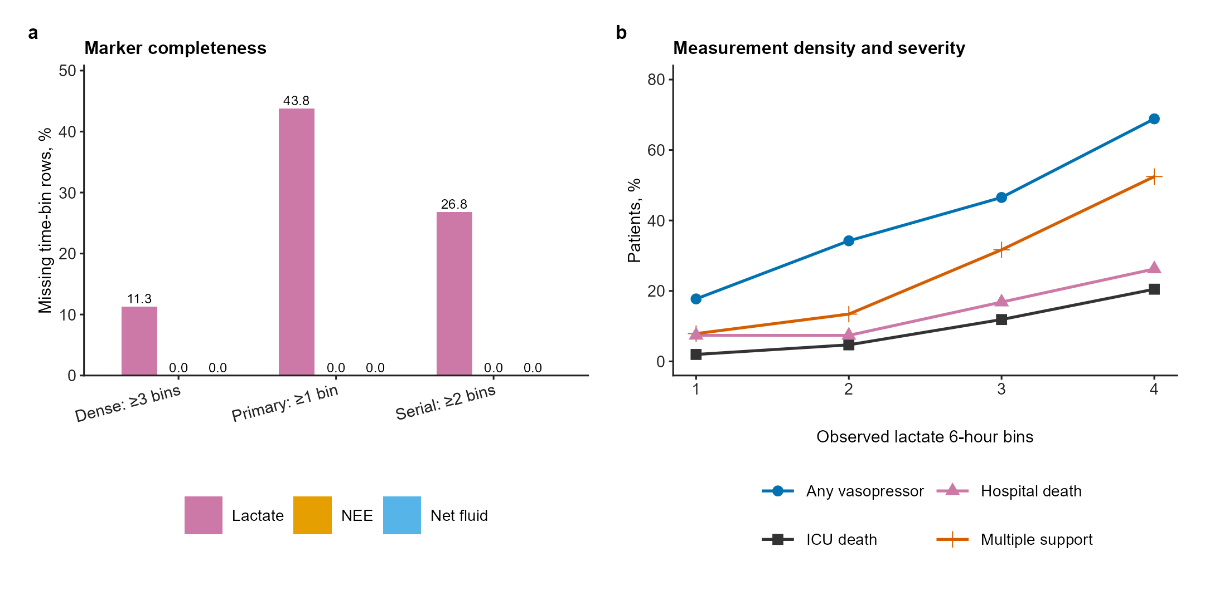
(a) Percentage of missing time-bin rows for cumulative net fluid, NEE, and lactate in the primary, serial-lactate, and dense-lactate cohorts. (b) Prevalence of vasopressor exposure, multiple support at the 24-hour landmark, ICU death, and hospital death according to the number of observed lactate 6-hour bins. The association between lactate measurement density and severity supports treating missing lactate as informative rather than as a normal measurement. NEE, norepinephrine-equivalent dose.

Figure S3. Sensitivity analyses for the P3 phenotype
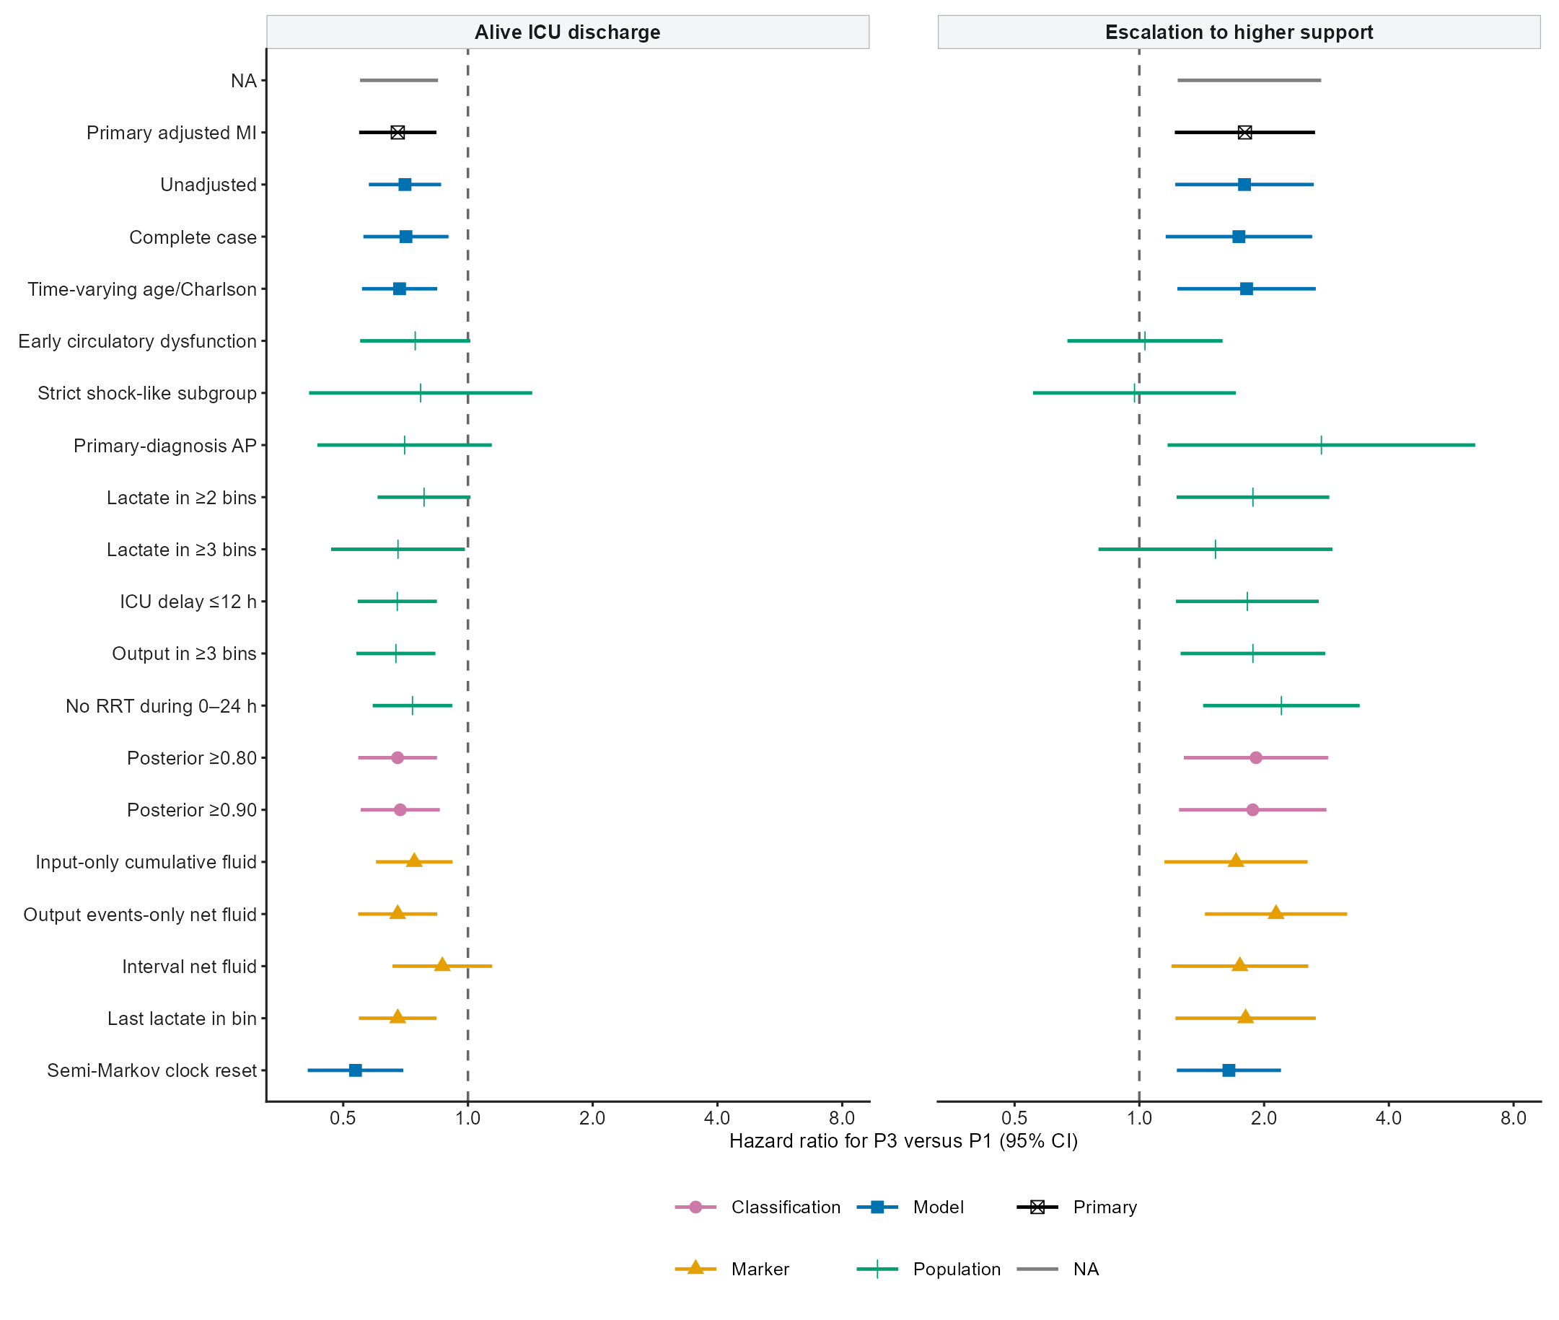
Hazard ratios for P3 versus P1 for escalation to higher support and alive ICU discharge across the primary model and prespecified model, population, classification-certainty, and marker-definition analyses. Points denote hazard ratios and horizontal lines 95% confidence intervals. Restricted subgroups and marker redefinitions are sensitivity analyses and do not replace the frozen primary estimand.

Figure S4. Cross-cohort phenotype profiles
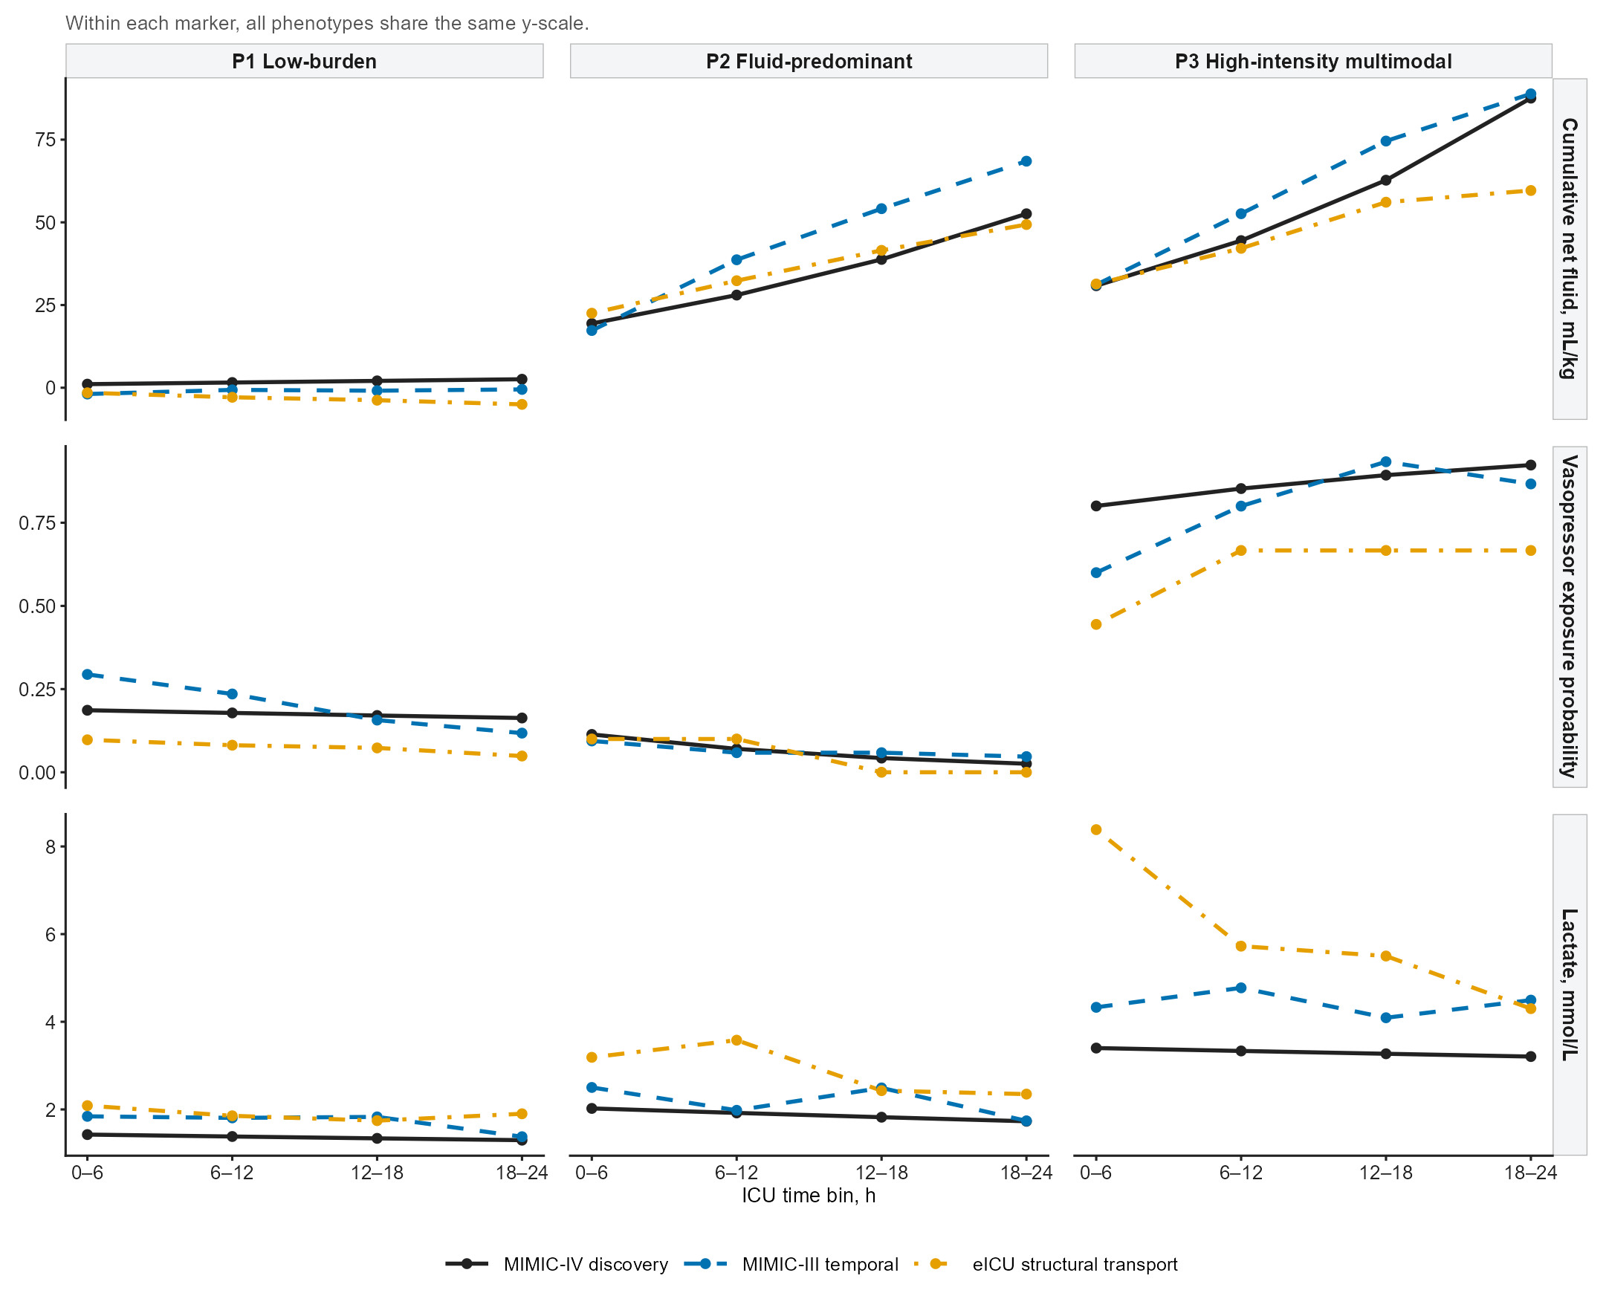
Mean marker profiles for the frozen P1, P2, and P3 phenotypes in MIMIC-IV discovery, MIMIC-III temporal validation, and screened eICU structural-transport cohorts. Rows show cumulative net fluid balance, vasopressor exposure probability, and lactate across the four 6-hour bins. Within each marker, all phenotypes share the same y-axis scale. eICU comparisons are constrained by hospital-level infusion-interface completeness and sparse P2/P3 groups.

Figure S5. Marker operationalization sensitivity
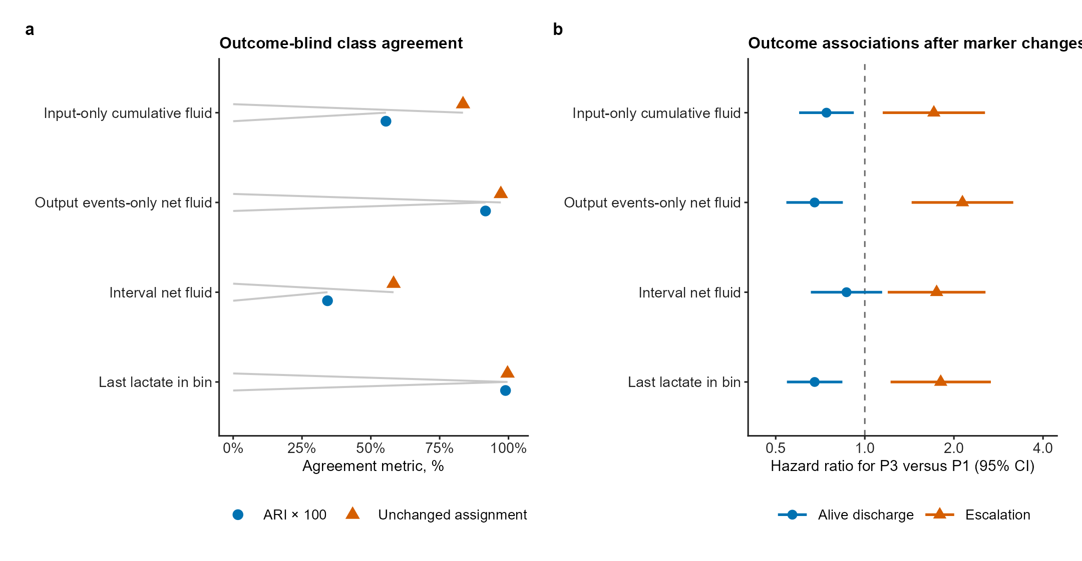
(a) Outcome-blind agreement of phenotype assignments after replacing the primary marker definitions with input-only cumulative fluid, output-events-only net fluid, interval net fluid, or last rather than median lactate within each bin. Agreement is shown using the adjusted Rand index multiplied by 100 and the percentage of unchanged assignments. (b) P3-versus-P1 hazard ratios for support escalation and alive ICU discharge after each marker redefinition. The interval-fluid analysis changes the construct from cumulative burden to interval balance and is therefore interpreted as construct sensitivity rather than simple measurement noise.

