Figure S1. Mass Spectrum (A) and ¹H NMR (B) characterization of TK
Figure S2.¹H NMR characterization of PTK

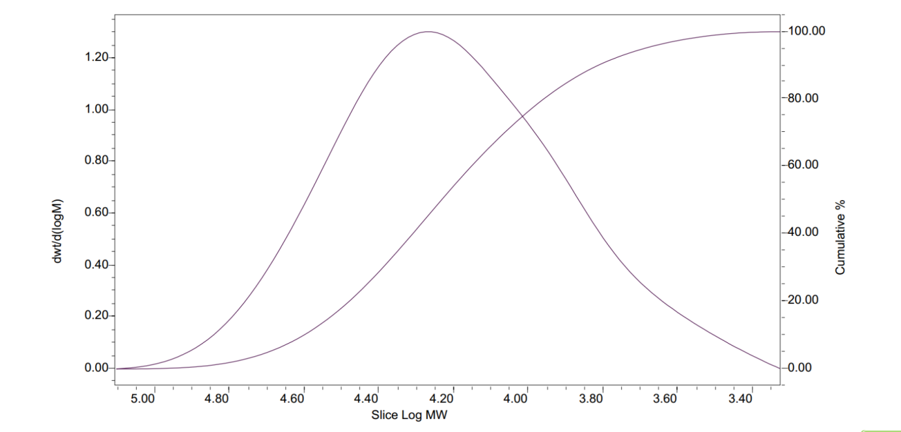
Figure S3. Gel permeation chromatography results of PTK

Figure S4. In vitro ROS responsibility of CsA@PTK. (A) The appearance changes of CsA@PTK in PBS and NaClO-containing PBS (pH7.4) solution. (B) Cumulative drug release of CsA@PTK in PBS (pH7.4) and NaClO-containing PBS solution.
Figure S5. The cytotoxicity of @PTK. (A) The cytotoxicity of @PTK on normal H9c2 cells. (B)The cytotoxicity of @PTK on H/R injured H9c2 cells. n = 6, x±SD; *P<0.05, **P<0.01, ***P<0.001, versus control; #P<0.05, ##P<0.01, versus H/R.
Figure S6. ROS scavenging effect of CsA@PPTK on H/R injured H9c2 cells. (A) The ROS (green color) in H/R injured H9c2 cells observed by LSCM. (B)Statistical results of ROS level in H/R injured H9c2 cell. n=3, x±SD; *p<0.05, versus control; ##p<0.01, versus H/R; &&p<0.01, versus CsA@PTK.
Figure S7. Cellular uptake of CsA@PPTK by normal and H/R injured H9c2 cells. n=3, x±SD; **p<0.01, versus CsA@PPTK in H/R injured H9c2 cells at 0.5 h; #p<0.05, versus CsA@PTK in normal H9c2 cells at 2 h; &p<0.05, versus CsA@PTK in H/R injured H9c2 cells at 2 h.
Figure S8. Effects of different uptake pathway inhibitors on the uptake of CsA@PPTK in H/R injured H9c2 cells. n=3, x±SD; ***p<0.001, versus control (without the inhibitor).
Figure S9. Distribution of Cy7.5@PPTK in main organs of sham and MI/RI mice.

FigureS10. Left ventricular function of MI/RI mice on 70th days after reperfusion. (A) Representative echocardiography of MI/RI mice. (B) Statistical results of LVEF. (C) Statistical results of FS in different groups. n>5, x±SD; ***p<0.001 versus sham; #p<0.05, ##p<0.01, ###p<0.001 versus normal saline; &p<0.05, versus CsA; $p<0.05, versus CsA@PTK.

Figure S11. Representative image of ROS staining in heart tissue slice of MI/RI mice on 1th day after different treatment.
Figure S12. Synthesis route of PTK

