Online resource 1: Detailed methodologies and supplementary figures

How pore size distribution affects fracture-enhanced permeability in lava domes
Colombier, M.¹, Kendrick, J.E.¹, Birnbaum, J.¹, Vasseur, J.¹, Lamur, A.¹, Lavallée, Y.¹, Dobson K.J.², Miwa, T.³, Scheu, B.¹, Kueppers, U.¹
¹Department of Earth and Environmental Sciences, Ludwig-Maximilians-Universität München, Munich, Germany
²Department of Civil & Environmental Engineering, University of Strathclyde, Glasgow, United Kingdom
³National Research Institute for Earth Science and Disaster Resilience (NIED), Japan
Corresponding author: m.colombier@lmu.de

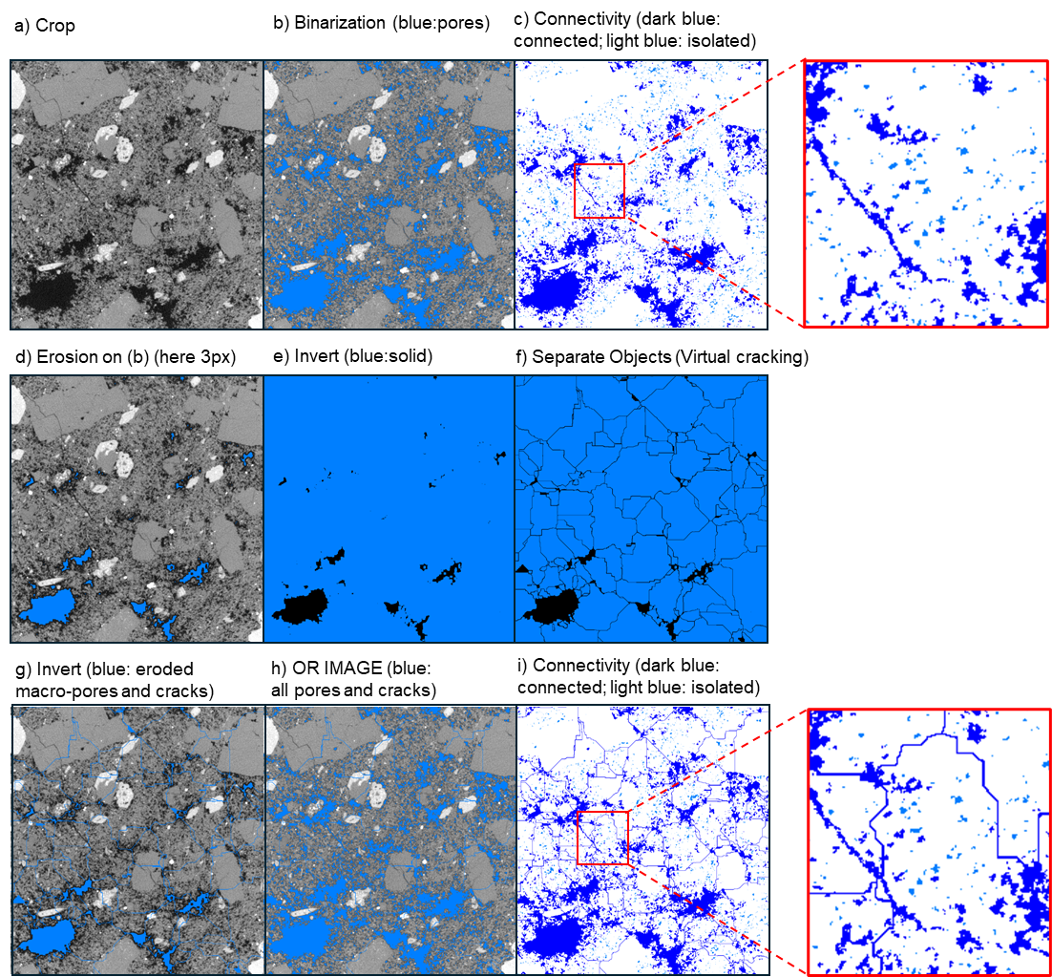
Figure SM1. The different segmentation and virtual cracking steps in our study.

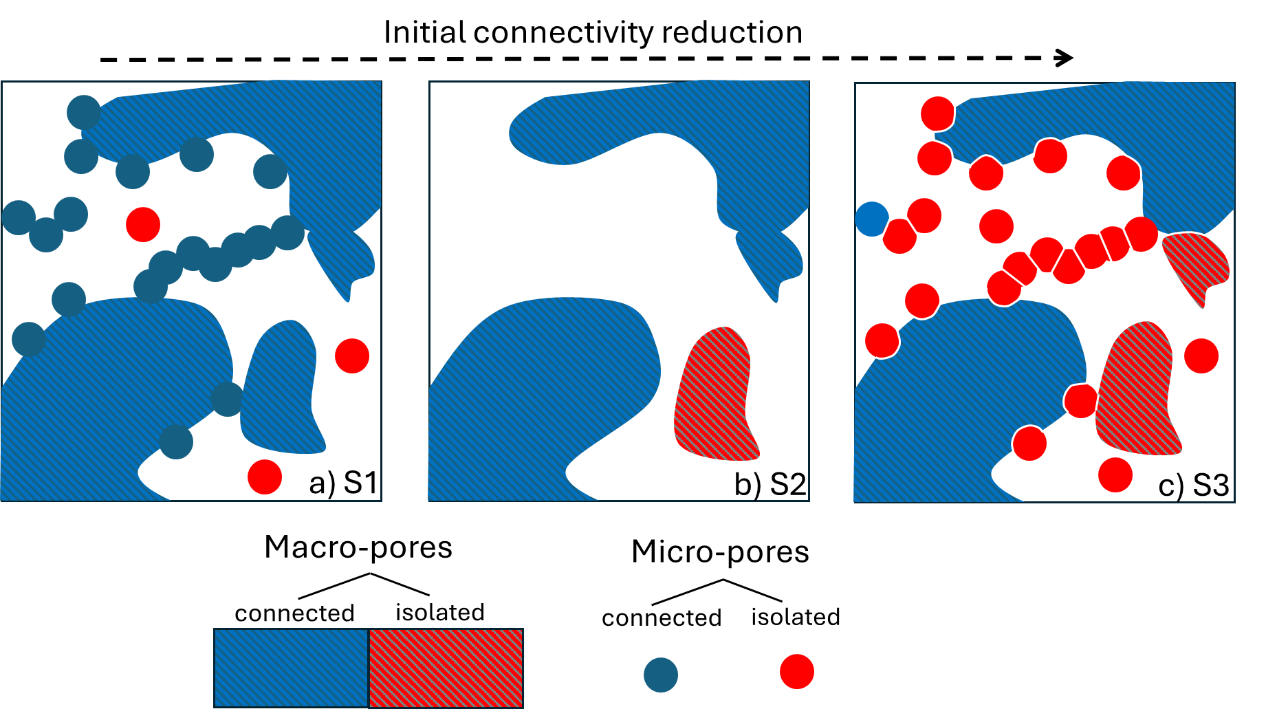
Figure SM2. A 2D schematic illustration of the different segmentation methods used in our study prior to virtual cracking. a) Segmentation S1 was achieved by simple binarization of the porous network. Macro-pores are largely connected to the exterior. Micro-pores are also strongly interconnected to one another, to macro-pores and to the exterior. b) Segmentation S2 was obtained by an erosion step of 2 pixels to remove micro-pores (either as individual clusters or as rims surrounding macro-pores). As a consequence of the micro-porosity removal, some macro-pores were no longer connected to one another and the whole pore network transitioned from permeable in S1 to impermeable in S2. c) Segmentation S3 was based on a separation of all pores present in S1, causing individualization and isolation of micro-pores and a reduction in size of macro-pores. Connectivity was significantly reduced in this step mostly as a result of the separation of micro-pores from the large interconnected cluster, as well as the separation of some macro-pores not connected anymore to the exterior.

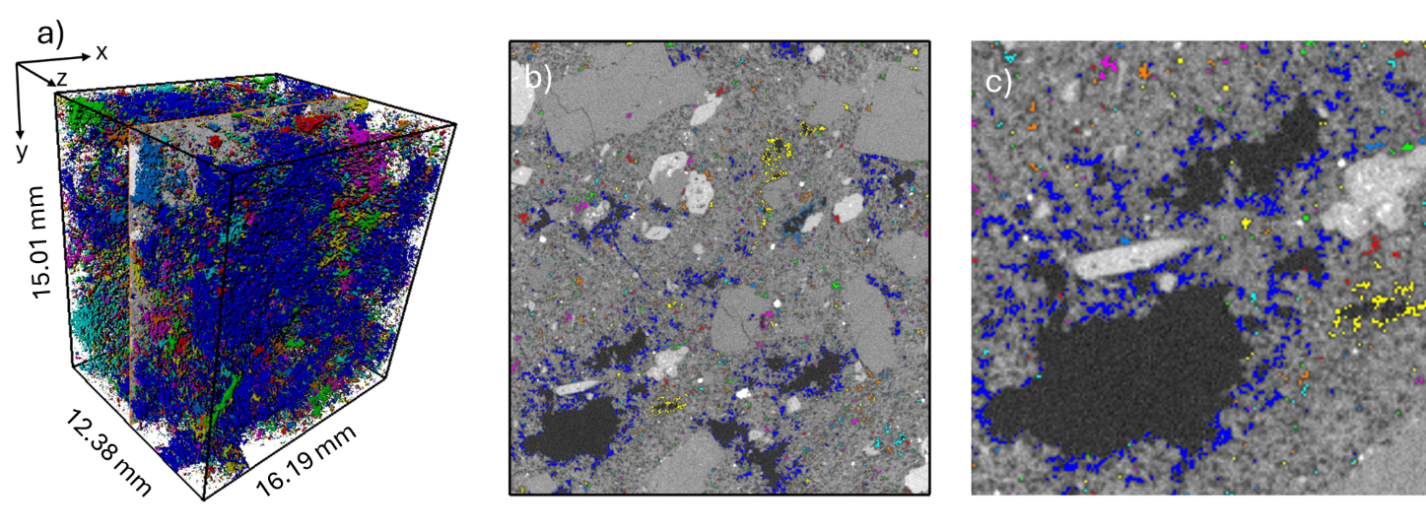
Figure SM3. The clustered distribution of micro-pores in the Unzen dacite. The separation with macro-pores was obtained by an erosion of 2 pixels on S1 to exclude macro-pores. Note the presence of a large interconnected micro-pore cluster in blue, which may be caused by partial volume effect during segmentation (Ketcham and Carlson, 2001).

