Supplementary Information
Ventricular repolarization in hospitalized patients with inflammatory bowel disease: a weighted real-world ECG study

Supplementary Methods

Sequence of blinded steps
The cohort definition and statistical analysis plan were frozen on 3 October 2026. The following steps were then completed, in this order, before any QTc value was compared between IBD and non-IBD patients.
1. Measurement source. The MIMIC-IV-ECG data dictionary and project documentation were reviewed. They do not state whether the RR interval and the QRS-onset and T-end time points come from the same representative beat. An analysis excluding ECGs with ectopy or irregular-rhythm statements was therefore retained as pre-specified.
2. Device and calendar check, without IBD status (Supplementary Table S2).
3. ECG clock check, without IBD status (Supplementary Table S3). The database documentation states that ECG times were recorded by each machine's internal clock, which in most cases was not synchronized with an external time source.
4. Pre-specified collapsing of sparse categories for admission type, admission source and first clinical service.
5. Propensity-score overlap, effective sample size and covariate balance, without QT data (Table 1, Supplementary Figure S1). After the device amendment (Supplementary Table S1) this step was repeated, again without QT data.
6. Model of selection into the ECG cohort, without QT data (Supplementary Table S4).
7. Counts of repeat-ECG pairs within IBD admissions, without QT data.

Propensity model and weights
The logistic model for IBD contained B-splines (4 degrees of freedom) for age, heart rate and log(1 + hours from presentation to ECG); sex; calendar period, ECG location and their interaction; admission type; admission source; emergency-department registration; first clinical service before the ECG; intensive-care admission before the ECG; any prior admission; prior chronic kidney disease, heart failure, coronary disease or prior myocardial infarction, and atrial fibrillation; and ECG bandwidth class. Overlap weights were 1 − e(x) for patients with IBD and e(x) for comparators, where e(x) is the estimated propensity score. Propensity scores ranged from 0.0030 to 0.2411 in IBD and from 0.0010 to 0.2188 in comparators; one patient with IBD had a score above the comparator maximum.
Category collapsing. Admission type: emergency (EW EMER., DIRECT EMER., URGENT), observation (EU OBSERVATION, OBSERVATION ADMIT, DIRECT OBSERVATION, AMBULATORY OBSERVATION), elective (ELECTIVE, SURGICAL SAME DAY ADMISSION). Admission source: emergency room; referral or self-referral (PHYSICIAN REFERRAL, CLINIC REFERRAL, WALK-IN/SELF REFERRAL); transfer (from hospital, skilled nursing facility or psychiatry); procedure site or other. First service: none assigned before the ECG; medicine (MED, OMED, PSYCH); cardiac (CMED, CSURG); neurological (NMED, NSURG); surgical (all other surgical services).

Selection weights
Among all 496,518 eligible admissions, the probability that the first ECG existed and was analysable was modelled by logistic regression on IBD, age (B-spline), sex, calendar period, admission type, emergency-department registration, any prior admission and prior chronic kidney disease, heart failure, coronary disease and atrial fibrillation, with patient-clustered standard errors. The inverse of the fitted probability was multiplied by the overlap weight in the selection-weighted sensitivity analysis. This addresses measured determinants of selection only.

Explanatory model M2 and missing data
The explanatory model M2 extended M1 by adding the most recent potassium, magnesium and creatinine (log-transformed) from the index encounter within 24 hours before the ECG, each as a B-spline, and indicators for a blood culture, an intravenous antibacterial and Sepsis-3 criteria (intensive care) before the ECG. Index-encounter laboratory records were those carrying the index admission identifier or, for records without an identifier, those drawn at or after presentation; emergency-department records in this database carry no admission identifier. Potassium was available in 59.8% of patients with IBD and 50.2% of comparators, magnesium in 37.0% and 26.0%, and creatinine in 59.4% and 50.0%. Missing values were imputed 20 times by chained equations with posterior sampling, using IBD status, all model covariates, the infection markers and QTcF as predictors; the propensity weights were estimated once from the complete baseline covariates; estimates were combined with Rubin's rules. Missing-indicator and complete-case analyses are in Supplementary Table S6.

Repeat ECGs within IBD admissions
Adjacent analysable ECGs within the same IBD admission, 6 hours to 7 days apart, formed pairs. The outcome was the change in QTcF from the first to the second ECG of a pair. Exposures were the lowest potassium (<3.5 mmol/L; continuous) and the lowest magnesium (<1.7 mg/dL; continuous) measured after the first and up to the second ECG; pairs without a measurement in the interval were not used for that exposure. Models adjusted for QTcF at the first ECG, interval length, change in RR, intensive-care location at the second ECG, calendar period, device bandwidth class at the second ECG and change of bandwidth class within the pair.
The pre-specified model was a linear mixed model with patient and admission (nested) random intercepts, using the model's own standard errors. The pre-specified fallback order, applied without reference to results, was (1) nested random intercepts, (2) admission random intercept when the fit did not converge or a variance component was singular, (3) generalized estimating equations with patient clusters and an exchangeable working correlation. Variance components were close to zero, so different exposures reached different levels (Supplementary Table S7); the generalized-estimating-equation estimate was computed for every exposure and agreed closely with the mixed-model estimate where both were available. An admission fixed-effects model was fitted in the subset of admissions with at least two pairs and a change of exposure within the admission.
The correlation between QTcF at the first ECG and its subsequent change was −0.53, and 20.7% of pairs changed bandwidth class. Repeat ECGs were obtained for clinical indications, the interval nadir does not describe the electrolyte level at the second ECG, and correction may have occurred within the interval. The analysis is descriptive and does not estimate the effect of untreated electrolyte disturbance.

Illustrative bias scenario
For an unmeasured binary factor, the bias in the mean difference was taken as the difference in its prevalence between IBD and comparators multiplied by its association with QTcF. Supplementary Table S8 shows the estimate under a grid of such values, together with the change in the estimate when each measured covariate was removed from the propensity model. The scenarios illustrate scale; they do not bound all possible unmeasured confounding.

Supplementary Table S1. Protocol freeze, amendments and deviations.
Date | Type | Item | Timing relative to outcome data | Effect on the confirmatory analysis
3 Oct 2026 | Freeze | Cohort definition and statistical analysis plan | Before any QTc was compared between groups | —
4 Oct 2026 | Amendment | ECG bandwidth class added to the propensity model, balance criteria and outcome model; three device sensitivity analyses added | After a device check blinded to IBD status; before any group-wise QTc was computed | Specification changed before outcome data were examined
4 Oct 2026 | Amendment | Sensitivity cohort restricted to the first admission in the database | Before any group-wise QTc was computed | None
4 Oct 2026 | Implementation clarification | M2 laboratory values taken from the index encounter; admission-identifier-only rule kept as sensitivity analysis | After the first M2 run | None; M2 changed from −0.75 to −0.82 ms
4 Oct 2026 | Implementation clarification | Date-only blood cultures count as pre-ECG only when the date precedes the ECG date | After the first M2 run | None; all cultures had a time stamp
4 Oct 2026 | Implementation note | Cart random-intercept analysis fitted as an unweighted covariate-adjusted mixed model because the software does not accept weights | At analysis | None
4 Oct 2026 | Deviation | The prespecified analysis of QT-prolonging medications was not performed because the required versioned CredibleMeds reference asset was unavailable. No substitute list was reconstructed post hoc. This omission did not affect the primary cohort, exposure definition, outcome, or confirmatory analysis. | After the primary analysis | None

Supplementary Table S2. Device and calendar check on index ECGs, without IBD status (n = 88,531).
 | n | QT, ms | RR, ms | QRS, ms | QTcF, ms, mean (SD)
2008–2010 | 34,994 | 386.4 | 795.1 | 89.9 | 418.9 (27.4)
2011–2013 | 22,355 | 385.2 | 791.5 | 89.9 | 418.3 (27.5)
2014–2016 | 19,959 | 385.3 | 781.0 | 90.8 | 420.3 (29.7)
2017–2019 | 11,223 | 388.0 | 779.2 | 92.3 | 423.7 (31.5)
Bandwidth 0.0005–150 Hz | 17,005 | 387.2 | 774.4 | 93.0 | 423.6 (32.3)
Bandwidth 0.005–150 Hz | 65,966 | 385.9 | 792.4 | 89.8 | 418.8 (27.3)
Bandwidth 0.05–150 Hz | 5,560 | 384.8 | 792.8 | 89.9 | 417.4 (29.9)

Adjusted for age, sex, heart rate (spline) and ECG location, QTcF relative to 2008–2010 was −0.24, +2.21 and +5.69 ms in the three later periods; after further adjustment for bandwidth and filter setting it was −0.49, +0.57 and +1.95 ms. Relative to 0.0005–150 Hz, adjusted QTcF was −6.67 ms for 0.005–150 Hz and −8.51 ms for 0.05–150 Hz. ECGs of the 0.0005–150 Hz class numbered 1,315, 1,242, 6,369 and 8,079 in the four periods. Of 127 carts, 59 had at least 200 index ECGs (84,749 ECGs); their adjusted mean residual QTcF ranged from −8.2 to +9.4 ms (5th–95th percentile −6.0 to +4.9), and none exceeded 10 ms.

Supplementary Table S3. Plausibility of ECG time stamps, without IBD status.
Setting | Comparison | n | Correlation of heart rates | Within 10 bpm
Emergency department, index ECGs | Charted heart rate within ±30 min of the ECG | 19,970 | 0.917 | 83.3%
 | Charted heart rate about 2 h later | 14,687 | 0.827 | 72.9%
 | Charted heart rate about 2 h earlier | 2,649 | 0.774 | 65.6%
Intensive care, ECGs of IBD admissions | Charted heart rate within ±30 min | 592 | 0.893 | 85.1%

ECG timestamps showed reasonable alignment with contemporaneous clinical heart-rate measurements. Measurements approximately 2 hours before and after the ECG served as temporal-displacement comparators; they do not establish timestamp accuracy at an hourly resolution.

Supplementary Table S4. Selection into the ECG cohort.
Probability that an admission's first ECG existed and was analysable (496,518 admissions; 32.6% eligible).
 | IBD | Non-IBD
2008–2010 | 30.5% | 36.2%
2011–2013 | 30.4% | 33.7%
2014–2016 | 26.6% | 32.5%
2017–2019 | 15.8% | 20.4%

Covariate | Odds ratio (95% CI)
IBD | 0.770 (0.722–0.822)
Male sex | 0.929 (0.909–0.950)
Period 2011–2013 vs 2008–2010 | 0.906 (0.883–0.931)
Period 2014–2016 | 0.872 (0.849–0.895)
Period 2017–2019 | 0.450 (0.437–0.463)
Emergency or urgent vs elective admission | 1.513 (1.469–1.559)
Observation vs elective admission | 0.948 (0.918–0.979)
Emergency-department registration | 2.669 (2.614–2.724)
Any prior admission | 0.694 (0.681–0.707)
Prior chronic kidney disease | 1.086 (1.041–1.134)
Prior heart failure | 0.804 (0.766–0.844)
Prior coronary disease | 1.178 (1.131–1.226)
Prior atrial fibrillation | 0.506 (0.481–0.532)

IBD admissions by ECG status:
 | All (n = 10,094) | No ECG (n = 6,735) | First ECG not analysable (n = 540) | Eligible (n = 2,819)
Age, years, mean | 52.8 | 49.5 | 72.2 | 56.7
Female | 54.3% | 54.5% | 44.3% | 55.7%
Emergency or urgent admission | 55.0% | 49.4% | 68.9% | 65.8%
Emergency-department registration | 71.6% | 66.9% | 78.0% | 81.5%
Prior heart failure | 8.6% | 6.5% | 30.2% | 9.7%
Prior atrial fibrillation | 7.0% | 5.3% | 31.1% | 6.5%

Supplementary Table S5. Difference in QTcF by calendar period (descriptive).
Period | IBD / non-IBD, n | Difference, ms (95% CI)
2008–2010 | 739 / 34,255 | −2.10 (−4.20 to −0.00)
2011–2013 | 404 / 21,951 | −1.48 (−4.25 to 1.30)
2014–2016 | 308 / 19,651 | −0.82 (−4.80 to 3.17)
2017–2019 | 167 / 11,056 | 2.32 (−3.26 to 7.91)

Overall weights were used and were not re-estimated within period. Joint test of IBD × period: P = 0.51.

Supplementary Table S6. Explanatory model M2 under alternative handling of laboratory data.
Difference in QTcF, IBD minus non-IBD, ms (95% CI).
Analysis | Index-encounter rule (main) | Admission-identifier-only rule (sensitivity)
M1, for reference | −1.22 (−2.74 to 0.29) | −1.22 (−2.74 to 0.29)
M2, multiple imputation | −0.82 (−2.35 to 0.72) | −0.72 (−2.24 to 0.80)
M2, missing-indicator method | −1.31 (−2.81 to 0.19) | −1.13 (−2.63 to 0.38)
M1 in complete cases | −0.38 (−3.05 to 2.29); n = 593 / 22,365 | −1.35 (−4.23 to 1.53); n = 451 / 15,446
M2 in complete cases | 0.28 (−2.42 to 2.97) | −0.94 (−3.81 to 1.92)
Potassium available, IBD / non-IBD | 59.8% / 50.2% | 35.1% / 25.9%
Magnesium available | 37.0% / 26.0% | 28.1% / 18.0%

Before the ECG, among those measured, potassium <3.5 mmol/L was present in 12.5% (IBD) and 9.1% (non-IBD) and magnesium <1.7 mg/dL in 13.7% and 10.9%; a blood culture had been drawn in 9.6% and 4.3%, an intravenous antibacterial started in 18.2% and 10.3%, and Sepsis-3 criteria met in intensive care in 2.9% and 3.1%. M2 is the association remaining after inclusion of these potential intermediates; it is not a direct effect and not a mediation analysis.

Supplementary Table S7. Change in QTcF between adjacent analysable ECGs within IBD admissions.
1,641 pairs from 929 admissions (669 patients).
Exposure in the interval | ECG pairs / admissions / patients | Model used | Difference in ΔQTcF, ms (95% CI)
Potassium nadir < 3.5 mmol/L | 1,494 / 868 / 631 | Generalized estimating equations (fallback level 3) | −2.40 (−5.46 to 0.66)
Potassium nadir, per 1 mmol/L higher | 1,494 / 868 / 631 | Mixed model, nested patient and admission intercepts (level 1) | −1.70 (−3.98 to 0.58)
Magnesium nadir < 1.7 mg/dL | 1,361 / 779 / 574 | Generalized estimating equations (fallback level 3) | −0.24 (−3.27 to 2.80)
Magnesium nadir, per 1 mg/dL higher | 1,361 / 779 / 574 | Generalized estimating equations (fallback level 3) | 3.17 (−1.78 to 8.11)
Joint model (both measured): potassium nadir < 3.5 mmol/L | 1,359 / 779 / 574 | Mixed model, admission random intercept (level 2) | −2.41 (−5.51 to 0.70)
Joint model (both measured): magnesium nadir < 1.7 mg/dL | 1,359 / 779 / 574 | Mixed model, admission random intercept (level 2) | 0.14 (−3.21 to 3.48)
Admission fixed effects (admissions with a change in exposure): potassium nadir < 3.5 mmol/L | 454 / 124 / 111 | Linear model with admission fixed effects, patient-clustered errors | −2.16 (−7.45 to 3.13)
Admission fixed effects (admissions with a change in exposure): magnesium nadir < 1.7 mg/dL | 324 / 99 / 87 | Linear model with admission fixed effects, patient-clustered errors | −3.68 (−9.31 to 1.95)

Adjusted for baseline QTcF, interval length, change in RR, ICU location at the second ECG, calendar period, device bandwidth class and change of device class. Repeat ECGs were obtained for clinical indications; nadir values do not describe the electrolyte state at the second ECG and correction may have occurred within the interval. Descriptive; no causal interpretation.

Supplementary Table S8. Illustrative bias scenarios.
Estimate (ms) that would result if an unmeasured binary factor differed in prevalence between IBD and comparators (rows) and was associated with QTcF (columns); observed estimate −1.22 ms.
Prevalence difference | −20 ms | −10 ms | −5 ms | +5 ms | +10 ms | +20 ms
5 percentage points | −0.22 | −0.72 | −0.97 | −1.47 | −1.72 | −2.22
10 | 0.78 | −0.22 | −0.72 | −1.72 | −2.22 | −3.22
20 | 2.78 | 0.78 | −0.22 | −2.22 | −3.22 | −5.22
30 | 4.78 | 1.78 | 0.28 | −2.72 | −4.22 | −7.22

Change in the estimate when one measured covariate was removed from the propensity model: heart rate −1.89 ms; age −0.48; admission type +0.35; time from presentation to ECG −0.24; first service +0.15; any prior admission −0.10; ECG location −0.01.

Supplementary Table S9. Pre-specified description of heterogeneity (overall M1 weights; subgroups not separately balanced).
Contrast | n | Difference in QTcF, ms (95% CI)
Crohn's disease vs non-IBD | 888 | −0.48 (−2.52 to 1.57)
Ulcerative colitis vs non-IBD | 728 | −2.22 (−4.44 to 0.01)
Crohn's minus ulcerative colitis |  | 1.74 (−1.26 to 4.73)
IBD as principal diagnosis vs non-IBD | 443 | −5.12 (−7.97 to −2.28)
IBD as secondary diagnosis vs non-IBD | 1,175 | 0.23 (−1.53 to 2.00)
Principal minus secondary |  | −5.36 (−8.68 to −2.04)

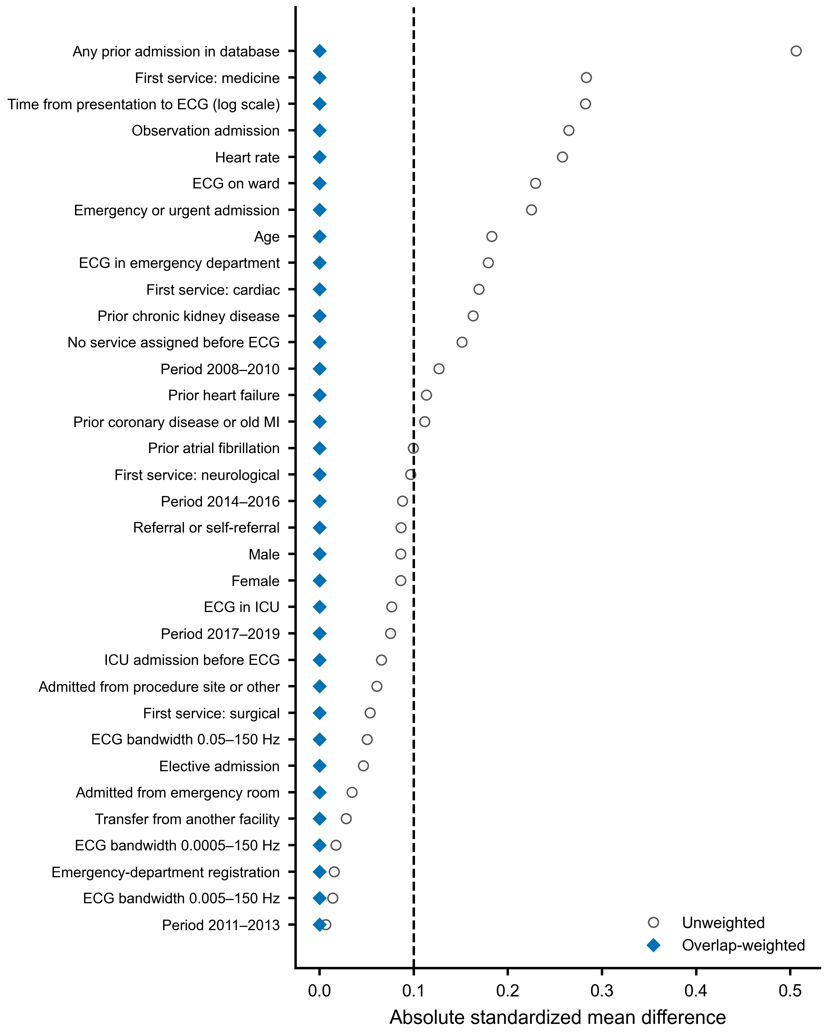
Supplementary Figure S1. Covariate balance before and after overlap weighting (model M1). Absolute standardized mean differences; the dashed line marks 0.10. Time from presentation to ECG was entered as log(1 + hours).

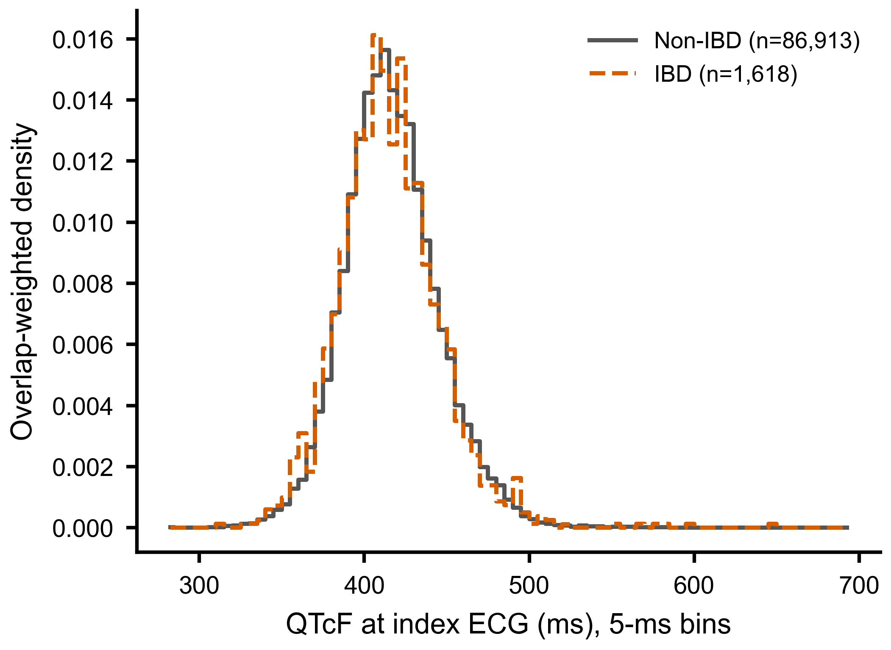
Supplementary Figure S2. Overlap-weighted distribution of QTcF at the index ECG. Histogram with 5-ms bins over the full observed range (281–694 ms). Values outside 330–540 ms: IBD 8 (weighted 0.50%), non-IBD 231 (weighted 0.31%).

