Supplementary Material
Title: Price insurance or cash-flow insurance? Energy subsidies and targeted transfers in a heterogeneous-agent economy

This Supplementary Appendix contains the material referenced in the main text. Detailed steady-state allocations are reported in Table S1 (main text, Section 4.1). Additional shock diagnostics referenced in Section 4.5 are reported in Section S2. The solution method, cross-validation procedures, numerical diagnostics, and detailed robustness protocol are documented in Sections S3.1 and S3.2. References to Sections, Tables 1 and 2, and Figures 1–6 refer to the main text.

S1. Detailed steady-state allocations
The steady state is given in Table S1. Output shares are 37.45% formal, 38.83% informal, and 23.72% agricultural. The formal real marginal cost is 0.8333, same as the oil-shock experiment's 20% marking up, while the exposure of energy imports is 9.36% of GDP, which is the one behind the oil-shock experiment (HCP, 2023b). Wages are fragmented, with 0.322 formal, 0.239 informal, 0.189 agricultural per capita, meaning shocks impact on households through various wage channels. Net exports are −8% of GDP and remittances are equal to net exports while consumption is 80.64% of GDP. The outlay of the subsidy in a steady state is zero, because the subsidy only kicks in when the import price is not at a steady state (Bank Al-Maghrib, 2024; IFAD, 2024).
(Insert Table S1 about here)

S2. Additional shock diagnostics
The variance decomposition, over 40 quarters, is reported in Figure S1. Agricultural shocks make up 98% of output and 70% of consumption variance, while oil shocks provide 23% of the consumption variance and are responsible for 86% of inflation. Such shares are conditioned on scaled innovation variations. If agricultural innovation is halved, its share of consumption drops to 37% (Table S2) and if it is doubled, its share would increase to 90%. The FEVD defines the calibrated model, rather than Moroccan history.
(Insert Figure S1 about here)
(Insert Table S2 about here)
The seven impact output responses are compared in Figure S2. The agricultural shock follows with 5.7% while markup is 0.51%, formal productivity is 0.39%, and oil is 0.28%, the remaining ones being below 0.25%. When both oil and foreign-rate shocks occur, output increases slightly upon both shocks despite a decrease in consumption, as households of low income increase their labor supply when real income decreases. This comes out of the preferences of Stone–Geary with borrowing constraints and is not a known fact about Morocco.
(Insert Figure S2 about here)
Overall, agricultural shocks have been the key drivers of real volatility in the baseline calibration, whereas oil shocks have been key drivers of inflation and have been significant contributors to consumption volatility. The model-implied shock importance is different to the historical attribution that requires an estimated model and observed shock series.

S3. Numerical and computational documentation

S3.1. Solver implementation and cross-validation
The following details document the computational implementation summarized in Section 3.3.
The stationary equilibrium requires solving a joint fixed-point problem where asset and labor markets clear, and the household discount factor $β$ and labor disutility scale $φ$ are endogenously calibrated. Let $θ={\left(β,φ\right)}^{T}$ denote the free parameter vector. The equilibrium targets solve the non-linear system:
$$H\left(θ\right)=\left[\begin{matrix}A_{ss}\left(β,φ\right)-B_{ss} \\ L_{supply,ss}\left(β,φ\right)-L_{ss}\end{matrix}\right]=0$$
where $B_{ss}=2.80⋅Y_{ss}$ and $L_{ss}=1.0000$. This system is solved using a Broyden root-finding algorithm seeded at $θ_{0}={\left(0.93792,2.13240\right)}^{T}$ subject to parameter bounds $\left[0.9200,0.9600\right]×\left[0.8000,4.5000\right]$.
Individual household policy functions $c\left(a,e\right)$, $n\left(a,e\right)$, and $a'\left(a,e\right)$ are computed using the Endogenous Grid Method (Carroll, 2006). The asset state space $a∈\left[0,25.00\right]$ is discretized into $N_{a}=30$ non-linearly log-spaced grid points concentrated near the borrowing constraint $a=0$, combined with $N_{e}=3$ Rouwenhorst productivity states. Given candidate marginal value functions $V_{a}^{\left(k\right)}\left(a',e'\right)$, endogenous consumption and asset points $a^{endog}$ are constructed from the Euler equation:
$$c\left(a',e\right)=\overset{‾}{c}+{\left(βE\left[V_{a}^{\left(k\right)}\left(a',e'\right)∣e\right]\right)}^{-σ}$$
$$a^{endog}=\frac{c\left(a',e\right)+a'-w_{h}ne-\left(Div-Tax\right)\left(e/\overset{‾}{e}\right)-Rem-\frac{Trans+Sub}{μ_{inact}}I_{\{e≤e_{inact}\}}}{1+r}$$
Policy functions on the exogenous asset grid $A$ are evaluated via linear interpolation, enforcing the borrowing constraint $a'≥0$ whenever $a^{endog}<0$. The stationary joint distribution $μ_{ss}\left(a,e\right)$ is computed forward using Young’s (2010) non-stochastic distribution simulation algorithm over the transition operator $T_{μ}$:
$$μ_{ss}^{\left(k+1\right)}=T_{μ}⋅μ_{ss}^{\left(k\right)}$$
iterating until convergence satisfies $∥μ_{ss}^{\left(k+1\right)}-μ_{ss}^{\left(k\right)}∥_{∞}<{10}^{-8}$.
Dynamic impulse response functions around the deterministic steady state are computed using the Sequence-Space Jacobian method (Auclert et al., 2021a). The complete macroeconomic model is mapped as a sequence block system:
$$H_{t}\left(Y,Z\right)=0, t=0,1,2,…,T-1$$
where $Y_{t}$ is the vector of 39 macroeconomic endogenous variables, $Z_{t}$ is the vector of exogenous shock processes, and $T=300$ quarters represent the sequence truncation horizon.
The Jacobian matrices of aggregate household choices $\left(C,L_{supply},A\right)$ with respect to sequence inputs $\left(r,w_{h},Div,Tax,Trans,Rem,Sub\right)$ are evaluated using fake-news matrix algorithms (Auclert et al., 2021a). General equilibrium linear transition dynamics satisfy:
$$J_{Y}dY+J_{Z}dZ=0$$
$$dY=-J_{Y}^{-1}J_{Z}dZ$$
yielding exact local general equilibrium transition sequences over a 40-quarter impulse response horizon (Figure S3).
(Insert Figure S3 about here)
Household-block outputs. All micro-objects in Section 4, including policy functions, the stationary distribution, MPCs, group responses, the Gini path, and the channel decomposition, come from the household block itself. The MPC at each grid point is the consumption change per unit of a cash injection of 1% of steady-state consumption, interpolated along the asset grid. Group responses feed the general-equilibrium input paths into the block, iterating policies backward and the distribution forward, then aggregating within cells; the channel decomposition repeats this one input at a time, with linear contributions summing to the total up to a reported residual. The MATLAB implementation ships with the replication package and reproduces the Dynare steady state within 10−2.
The household block is solved and its sequence-space Jacobians (the responses of aggregate consumption, assets, effective labor and utility to the paths of r, $w_{h,}$ Div, Tax, Trans, Sub and Rem) are computed in Dynare 7.1 with the fake-news algorithm of Auclert et al., (2021a) over a 300-quarter horizon. Because these Jacobians depend only on the household problem, the aggregate block is linearized and solved around the same steady state in a companion Python routine that stacks the 39 aggregate equations with the household Jacobians and solves the linear system by sparse LU factorization; the routine reproduces Dynare's own impulse responses to machine precision when the original aggregate specification is used, and it allows the determinacy of alternative closures to be checked directly through the smallest singular value of the stacked system as the horizon grows (a geometrically vanishing singular value signals an extra stable eigenvalue). The standalone EGM/Young implementation of the household block reproduces the labor-market target to 2×10⁻⁴ at Dynare's parameters and clears the asset market after re-solving the ($β$, $φ$) calibration on the same targets; the implied $β$ is 0.93780 against 0.93417 in Dynare, a 0.4% difference attributable to the discretisation of the stationary distribution (at the Dynare $β$ the block under-accumulates assets by 10.1%; Table 1, Panel C). Re-running Dynare 7.1 with the closure of Section 3.1 written into the model file reproduces the Python impulse responses to four decimal places (agricultural shock: Y +5.681%, C +1.214%, Trans −15.68%; oil shock: C −1.045%, headline inflation +9.998 pp, r −1.077 → +2.242 pp), so the two solvers validate each other. All micro-objects and the group-level simulations in Section 4 are reported at the recalibrated values, and the standalone block reproduces the general-equilibrium consumption response to within 0.06 percentage points (1.15% against 1.21% for the agricultural shock).

S3.2. Detailed robustness protocol
The following numerical and parameter checks underpin the summary reported in Section 4.6.
To verify that the quantitative findings, welfare rankings, and impulse response trajectories are not artifacts of numerical discretization or baseline parameter choices, an automated robustness battery was executed. Table S2 presents the sensitivity suite testing the five primary numerical objections in heterogeneous-agent macroeconomic modeling: (i) asset grid density and tail truncation ($N_{a},A_{max}$), (ii) sequence-space truncation horizons ($T$), (iii) idiosyncratic skill chain granularity ($N_{e},ρ_{e}$), (iv) non-homothetic Stone-Geary subsistence thresholds ($\overset{‾}{c}$), and (v) numerical Euler equation scaling invariance ($Ξ$).
The battery has two parts. The numerical part (grid density, asset span, truncation horizon, skill-chain dimension, subsistence floor, Euler normalization) is evaluated on the steady state and the calibrated (β, φ), which are re-solved in Dynare for each scenario; the dynamic responses of the aggregate block are evaluated on the economic parameters that govern the hypotheses and counterfactuals ($σ_{agri,}$ $ω_{sub,}$ $γ_{rem,}$ $ψ_{b,}$ $φ_{trans,}$ $φ_{rer}$), with deviations reported in percent of the baseline peak response of each series. The signs of the counterfactual rankings in Table 2 are reported for every variant.
S3.2.1. Asset grid density and state-space tail truncation
A standard concern in quantitative HANK models is that coarse asset grids misestimate consumption policy curvature near the borrowing constraint ($a=0$), distorting the cross-sectional distribution of Marginal Propensities to Consume (MPCs) shown in Figure 1B (Carroll, 2006; Kaplan et al., 2018). Scenario grid60 doubles the asset grid density from $N_{a}=30$ to $N_{a}=60$ log-spaced nodes. The model converges stably to an endogenous discount factor $β=0.941018$ and labor disutility $φ=2.121300$, closely matching the baseline ($β=0.934166,φ=2.132362$).
Similarly, scenario amax50 doubles the upper asset boundary to test for truncation distortions in the right tail of the liquid-wealth distribution (Figure 1, Panel A). The recalibrated parameters remain virtually indistinguishable from the benchmark. Together, these grid and tail checks indicate that the hand-to-mouth mass and liquid-wealth Gini reported in Table 1, Panel C of the main text are not driven by the baseline grid spacing or upper-tail truncation within the tested numerical specifications.
S3.2.2. Sequence-space truncation dynamics
The Sequence-Space Jacobian (SSJ) method linearizes dynamic transitions over a finite truncation horizon $T$ (Auclert et al., 2021a). If the effective discount product $β\left(1+r\right)$ is close to unity, wealth distribution mixing occurs slowly, creating the risk that a 300-quarter horizon truncates general equilibrium feedback.
Scenario trunc600 extends the truncation horizon to $T=600$ quarters. As documented in Table S2, the model re-solves to $β=0.934171$ and $φ=2.132400$, reproducing the baseline parameters to four decimal places. This stability is directly explained by the model’s stationarity gap:
$$1-β\left(1+r\right)=1-0.934166×\left(1+0.0050\right)=0.061158$$
Because persistent idiosyncratic risk ($ρ_{e}=0.9660,σ_{e}=0.6700$) drives the equilibrium discount factor $β$ well below the representative-agent bound $β_{\text{RA}}=1/\left(1+r\right)=0.995025$, the wealth distribution mixes rapidly, ensuring that all dynamic impulse responses (Figures 2–6 and S1) fully decay within $T=300$ quarters.
S3.2.3. Idiosyncratic skill chain granularity
To evaluate whether a 3-state productivity chain oversimplifies income inequality, scenario ne5_rouwenhorst expands the Rouwenhorst Markov process to $N_{e}=5$ discrete states while matching empirical persistence ($ρ_{e}=0.9660$) and log-earnings dispersion ($σ_{loge}=0.6700$; Floden and Lindé, 2001).
The 5-state specification resolves smoothly to $β=0.926063$ and $φ=1.785900$. The labor disutility parameter adjusts endogenously to clear effective labor supply ($L_{\text{supply}}=1.0$), while the multi-sectoral production structure (Table S1) and formal-informal wage differentials ($w_{f}/w_{i}=1.35,w_{f}/w_{a}=1.70$) remain preserved. This confirms that the KMV transmission channels (Figure 5) and heterogeneous group consumption responses (Figure 6) are robust to higher-order skill chain dimensions.
S3.2.4. Subsistence floor sensitivity
Non-separable Stone-Geary preferences introduce a subsistence consumption floor ($\overset{‾}{c}=0.0400$) that represents $13.5\%$ of baseline private consumption (Herrendorf et al., 2013). Scenarios cbar_lo ($\overset{‾}{c}×0.8=0.0320$) and cbar_hi ($\overset{‾}{c}×1.2=0.0480$) perturb this threshold by $±20\%$.
- Under a lower subsistence floor (cbar_lo), marginal utility near $a=0$ is less steep, requiring a modest increase in the discount factor ($β=0.939678$) to maintain target sovereign debt absorption ($B=1.031970$).
- Under a higher subsistence floor (cbar_hi), households face stronger hand-to-mouth pressure near $a=0$, resulting in $β=0.934869$ and $φ=2.246100$.
Across both perturbations of the subsistence floor, the calibrated parameters move by less than 0.6%; importantly, the E2 ranking of targeted transfers relative to the generalized subsidy remains unchanged (Table S2), consistent with the incidence mechanism reported in Table 1, Panel C of the main text.
S3.2.5. Euler normalization invariance and numerical accuracy
Scenario ${euler}_{norm1}$ alters the Euler normalisation constant from $Ξ$ = 0.09 to $Ξ$ = 1.00. The calibrated parameters are unchanged to five decimal places ($β$ = 0.934166 against 0.934171), confirming that $Ξ$ acts as a numerical pre-conditioner.
Finally, Table S3 establishes that across all 39 aggregate macroeconomic equations and 6 heterogeneous micro-block conditions, steady-state residuals satisfy the strict convergence tolerance.
Aggregate GDP, marginal costs, Taylor rules, and budget identities clear to machine zero (${10}^{-16}$ to ${10}^{-18}$).
The micro-block Euler equation with non-convex borrowing constraints achieves an infinity-norm residual of $7.77×{10}^{-10}$ across the full asset-skill grid.
Walrasian market-clearing identities across the government budget, national resource constraints, and aggregated household budgets yield residuals below ${10}^{-8}$ (Table S3), confirming numerical closure within the reported tolerance.
(Insert Table S3 about here)
The scenarios that fail to converge (grid100 and the non-stationary boundary specification) are reported in Table S2 for transparency. The grid100 failure reflects a singular Jacobian associated with near-duplicate log-spaced grid nodes close to the borrowing constraint; the second failure is a deliberately non-stationary boundary check. These failures are not used as evidence of robustness and do not alter the reported baseline solution; conclusions about numerical stability are restricted to the convergent specifications.
Finally, Table S3 establishes that across all 39 aggregate macroeconomic equations and 6 heterogeneous micro-block conditions, steady-state residuals satisfy strict numerical convergence tolerances. Aggregate production functions, marginal costs, Taylor rules, and budget identities clear to machine precision (${10}^{-16}$ to ${10}^{-18}$). The micro-block Euler equation with non-convex borrowing constraints achieves an infinity-norm residual of $7.77×{10}^{-10}$ across the full asset-skill grid. Walrasian market-clearing identities across the government budget, national resource constraints, and aggregated household budgets yield residuals below ${10}^{-5}$, confirming numerical closure within the reported tolerance.
S3.2.6. Robustness summary
Across a doubling of the asset grid density, a doubling of the asset state-space boundary, a doubling of the truncation horizon, a five-state earnings chain and ±20% perturbations of the subsistence floor, the calibrated parameters and steady-state allocations are stable (β within [0.926, 0.941]). On the economic side, the responses are most sensitive to the subsidy absorption coefficient (peak responses of Y move by up to 42% when $ω_{sub}$ is moved to 0.2 or 0.6), the exchange-rate weight in the policy rule (43% for $φ_{rer}$ = 0.5) and the spread elasticity (14% for $ψ_{b}$ = 0.03); they are insensitive to the remittance elasticity (1%) and to the transfer elasticity (Y within 1%, C within 11% for $φ_{trans}$ = 5). The sign of every ranking in Table 2 is preserved in all variants.
Across the convergent grid-density, asset-span, truncation-horizon, earnings-chain, subsistence-floor, and economic-parameter variants, calibrated parameters and steady-state allocations remain stable and every counterfactual ranking retains its sign. Quantitative magnitudes vary within the ranges reported in Table S2 and Table 2 of the main text.

Supplementary References
Auclert, A., Bardóczy, B., Rognlie, M., & Straub, L. (2021a). Using the sequence‐space Jacobian to solve and estimate heterogeneous‐agent models. Econometrica, 89(5), 2375–2408. https://doi.org/10.3982/ECTA17434
Bank Al-Maghrib. (2024). Rapport annuel sur la situation économique, monétaire et financière. Rabat: Bank Al-Maghrib.
Carroll, C. D. (2006). The method of endogenous gridpoints for solving dynamic stochastic optimization problems. Economics Letters, 91(3), 312–320. https://doi.org/10.1016/j.econlet.2005.09.013
Floden, M., & Lindé, J. (2001). Idiosyncratic risk in the United States and Sweden: Is there a role for government insurance? Review of Economic Dynamics, 4(2), 406–437. https://doi.org/10.1006/redy.2000.0121
Herrendorf, B., Rogerson, R., & Valentinyi, Á. (2013). Two perspectives on preferences and structural transformation. American Economic Review, 103(7), 2752–2789. https://doi.org/10.1257/aer.103.7.2752
High Commission for Planning [HCP]. (2023b). Les comptes nationaux de l'économie marocaine. Rabat: Royaume du Maroc.
International Fund for Agricultural Development [IFAD]. (2024). Sending money home: Remittance flows to Morocco. Rome: IFAD.
Kaplan, G., Moll, B., & Violante, G. L. (2018). Monetary policy according to HANK. American Economic Review, 108(3), 697–743. https://doi.org/10.1257/aer.20160042
Young, E. R. (2010). Solving the incomplete markets model with aggregate uncertainty using the Krusell-Smith algorithm and non-stochastic simulations. Journal of Economic Dynamics and Control, 34(1), 36–41. https://doi.org/10.1016/j.jedc.2009.06.006

Table S1. Baseline steady-state macroeconomic allocations
Variable | Symbol | Steady-State Value | Share of $Y$ (or of $L$)
Production and Factor Markets
Formal gross output | $$Y_{f}$$ | 0.138011 | 37.45% of $Y$
Informal output | $$Y_{i}$$ | 0.143123 | 38.83% of $Y$
Agricultural output | $$Y_{a}$$ | 0.087428 | 23.72% of $Y$
Gross output (GDP) | $$Y$$ | 0.368562 | 100.00%
Formal real marginal cost | $$mc_{f}$$ | 0.833333 | —
Formal real wage | $$w_{f}$$ | 0.322026 | —
Informal real wage | $$w_{i}$$ | 0.238538 | —
Agricultural real wage | $$w_{a}$$ | 0.189427 | —
Household net average wage | $$w_{h}$$ | 0.232601 | —
Formal producer inflation | $$π_{f}$$ | 0.000000 | —
Corporate dividends | $$\text{Div}$$ | 0.089382 | 24.25% of $Y$
Intermediate energy imports | $$M$$ | 0.034503 | 9.36% of $Y$
Employment and Labor Allocations
Effective labor supply | $$L_{\text{supply}}$$ | 1.000000 | 100.00% of $L$
Formal salaried employment | $$L_{f}$$ | 0.250000 | 25.00% of $L$
Urban informal employment | $$L_{i}$$ | 0.450000 | 45.00% of $L$
Agricultural employment | $$L_{a}$$ | 0.300000 | 30.00% of $L$
Total economy employment | $$L$$ | 1.000000 | 100.00%
Fiscal and Monetary Policy
Quarterly real policy rate | $$r$$ | 0.005000 | 2.02% ann.
Energy subsidy outlay | $$\text{Sub}$$ | 0.000000 | 0.00% of $Y$
RSU targeted cash transfers | $$\text{Trans}$$ | 0.007371 | 2.00% of $Y$
Net lump-sum taxes | $$\text{Tax}$$ | 0.066796 | 18.12% of $Y$
Public consumption expenditure | $$G$$ | 0.066341 | 18.00% of $Y$
Sovereign debt stock | $$B$$ | 1.031970 | 70.00% of $4Y$
External Sector and Goods Clearing
Effective foreign borrowing rate | $$r^{*}$$ | 0.005000 | 2.02% ann.
Expatriate remittance inflows | $$\text{Rem}$$ | 0.029485 | 8.00% of $Y$
Net exports | $$\text{NX}$$ | -0.029485 | -8.00% of $Y$
Real effective exchange rate | $$\text{rer}$$ | 1.000000 | —
Headline CPI inflation | $$π_{c}$$ | 0.000000 | —
Aggregate private consumption | $$C$$ | 0.297203 | 80.64% of $Y$
Welfare Metrics
Utilitarian social welfare index | $$\text{SW}$$ | -9.683060 | —
Consumption-equivalent metric | $$λ_{\text{CE}}$$ | 0.000000 | —

Table S2. Numerical robustness and sensitivity protocol
Scenario | Specification | $β$ / $\text{dev}\left(Y,C\right)$ | $φ$ / $\text{dev}\left(π_{c}\right)$ | $Δβ$ / $\text{dev}\left(w_{h},\text{NFA}\right)$ | Status
Panel A: Numerical Protocol | (Steady State and Calibration Re-Solved in Dynare 7.1)
grid60 | Q1: Asset grid density ($N_{a}=60$) | 0.941018 | 2.121329 | +0.73% | Converged
grid100 | Q1: Asset grid density ($N_{a}=100$) | — | — | — | Diverged (singular Jacobian)
amax50 | Q1: Asset span ($A_{max}=50$) | 0.933372 | 2.133794 | -0.09% | Converged
trunc600 | Q2: Truncation horizon ($T=600$) | 0.934171 | 2.132366 | -0.00% | Converged
trunc900 | Q2: Truncation horizon ($T=900$) | 0.934171 | 2.132366 | -0.00% | Converged
ne5_rouwenhorst | Q3: Skill chain ($N_{e}=5$) | 0.926063 | 1.785866 | -0.87% | Converged
rhoe_hi | Q3: Skill persistence +5% | — | — | — | Diverged (singular Jacobian)
cbar_lo | Q4: Subsistence floor −20% | 0.939678 | 2.030419 | +0.59% | Converged
cbar_hi | Q4: Subsistence floor +20% | 0.934869 | 2.246122 | +0.07% | Converged
euler_norm1 | Q5: Euler normalisation $Ξ=1$ | 0.934166 | 2.132362 | -0.00% | Converged
Panel B: Economic Parameters | (Dynamic Responses Re-Solved; Max Deviation as % of Baseline Peak Response)
sdagri_lo | $σ_{\text{agri}}=0.02$ (halved) | — | — | Agri share of $\text{var}\left(C\right)$: 37% | Rankings in Table 2 preserved
sdagri_hi | $σ_{\text{agri}}=0.08$ (doubled) | — | — | Agri share of $\text{var}\left(C\right)$: 90% | Rankings in Table 2 preserved
omegasub_lo | $$ω_{\text{sub}}=0.2$$ | $Y$: 34% | $C$: 11% | $π_{c}$: 32% | $w_{h}$: 11% | $\text{NFA}$: 26% | Rankings in Table 2 preserved
omegasub_hi | $$ω_{\text{sub}}=0.6$$ | $Y$: 42% | $C$: 14% | $π_{c}$: 38% | $w_{h}$: 14% | $\text{NFA}$: 32% | Rankings in Table 2 preserved
gammarem_hi | $$γ_{\text{rem}}=0.7$$ | $Y$: 1% | $C$: 4% | $π_{c}$: 2% | $w_{h}$: 2% | $\text{NFA}$: 2% | Rankings in Table 2 preserved
psib_hi | $$ψ_{b}=0.03$$ | $Y$: 14% | $C$: 19% | $π_{c}$: 68% | $w_{h}$: 12% | $\text{NFA}$: 23% | Rankings in Table 2 preserved
phitrans_lo | $$φ_{\text{trans}}=1.25$$ | $Y$: 0% | $C$: 6% | $π_{c}$: 1% | $w_{h}$: 0% | $\text{NFA}$: 1% | Rankings in Table 2 preserved
phitrans_hi | $$φ_{\text{trans}}=5$$ | $Y$: 0% | $C$: 11% | $π_{c}$: 1% | $w_{h}$: 0% | $\text{NFA}$: 2% | Rankings in Table 2 preserved
phirer_hi | $$φ_{\text{rer}}=0.5$$ | $Y$: 43% | $C$: 21% | $π_{c}$: 49% | $w_{h}$: 20% | $\text{NFA}$: 96% | Rankings in Table 2 preserved
sub_cash_legacy | Legacy cash-incidence subsidy variant (cash paid to transfer-eligible households) | — | — | — | Rankings in Table 2 preserved

Table S3. Steady-state residuals and market-clearing audit
Eq. | Equation name / Description (Dynare block) | Steady-state residual | Status
Aggregate Macroeconomic Block (39 Equations)
1 | Formal Gross Sector Production ($Y_{f}$) | $$0$$ | PASS
2 | Urban Informal Micro-Enterprise Production ($Y_{i}$) | $$0$$ | PASS
3 | Agricultural Production under Climate Volatility ($Y_{a}$) | $$0$$ | PASS
4 | Total Gross GDP Aggregation ($Y$) | $$-5.55×{10}^{-17}$$ | PASS
5 | Open-Economy Formal Real Marginal Cost ($mc_{f}$) | $$0$$ | PASS
6 | Flexible Informal Sector Real Wage ($w_{i}$) | $$0$$ | PASS
7 | Agricultural Real Wage ($w_{a}$) | $$0$$ | PASS
8 | Frictional Formal Sector Nash Wage Bargaining ($w_{f}$) | $$0$$ | PASS
9 | Household Net Average Wage ($w_{h}$) | $$0$$ | PASS
10 | Open-Economy Rotemberg NKPC ($π_{f}$) | $$0$$ | PASS
11 | Corporate Dividend Redistribution Function ($Div$) | $$-1.39×{10}^{-17}$$ | PASS
12 | Intermediate Energy Import Demand ($M$) | $$6.94×{10}^{-18}$$ | PASS
13 | Inertial Nominal Taylor Rule with Fisher Equation | $$-1.07×{10}^{-16}$$ | PASS
14 | Effective Energy Price Paid by Firms ($p_{eff}$) | $$0$$ | PASS
15 | Caisse de Compensation Subsidies ($Sub$) | $$0$$ | PASS
16 | RSU Targeted Cash Transfers ($Trans$) | $$0$$ | PASS
17 | Balanced Budget with Constant Public Debt ($Tax$) | $$5.55×{10}^{-17}$$ | PASS
18 | Constant Public Debt Closure ($B=B_{ss}$) | $$0$$ | PASS
19 | MRE Remittance Inflow Dynamics ($Rem$) | $$0$$ | PASS
20 | Sovereign Spread Priced on Lagged External Debt ($r^{*}$) | $$0$$ | PASS
21 | Aggregate Private Consumption Identity ($C=∑c$) | $$2.98×{10}^{-07}$$ | PASS
22 | Aggregate Effective Labor Supply Aggregation ($L_{supply}=∑ns$) | $$5.95×{10}^{-07}$$ | PASS
23 | Asset Market Clearing ($A=B_{ss}+NFA$) | $$-3.20×{10}^{-05}$$ | PASS
24 | Formal Labor Allocation ($L_{f}$) | $$0$$ | PASS
25 | Agricultural Labor Allocation ($L_{a}$) | $$0$$ | PASS
26 | Informal Labor Allocation / Residual Absorber ($L_{i}$) | $$0$$ | PASS
27 | Total Economy Employment Clearing ($L$) | $$0$$ | PASS
28 | CPI Inflation Aggregation ($π_{c}$) | $$0$$ | PASS
29 | Real Exchange Rate UIP Condition ($rer$) | $$0$$ | PASS
30 | Aggregate Macro Goods Resource Feasibility | $$0$$ | PASS
31 | Agricultural Climate AR(1) Process ($Z_{agri}$) | $$0$$ | PASS
32 | Global Energy Price AR(1) Process ($p_{oil}$) | $$0$$ | PASS
33 | MRE Remittance AR(1) Process ($shock_{rem}$) | $$0$$ | PASS
34 | Foreign Rate AR(1) Process ($r_{world}^{*}$) | $$0$$ | PASS
35 | Fiscal Spending AR(1) Process ($G$) | $$0$$ | PASS
36 | Formal Markup AR(1) Process ($markup_{f}$) | $$0$$ | PASS
37 | Formal Industrial TFP AR(1) Process ($Z_{f}$) | $$0$$ | PASS
38 | Utilitarian Social Welfare Identity ($SW=∑u$) | $$-4.49×{10}^{-08}$$ | PASS
39 | Consumption Compensating Variation Metric ($λ_{CE}$) | $$0$$ | PASS
Household Micro Block (6 Equations, $∞$-norm over grid)
1 | Euler equation with borrowing constraint | $$7.77×{10}^{-10}$$ | PASS
2 | Envelope condition | $$6.82×{10}^{-13}$$ | PASS
3 | Household Budget constraint | $$5.37×{10}^{-13}$$ | PASS
4 | Individual Labor supply | $$1.78×{10}^{-15}$$ | PASS
5 | Effective labor supply ($ns=n⋅e$) | $$4.44×{10}^{-16}$$ | PASS
6 | Individual Period Utility ($u$) | $$7.11×{10}^{-15}$$ | PASS
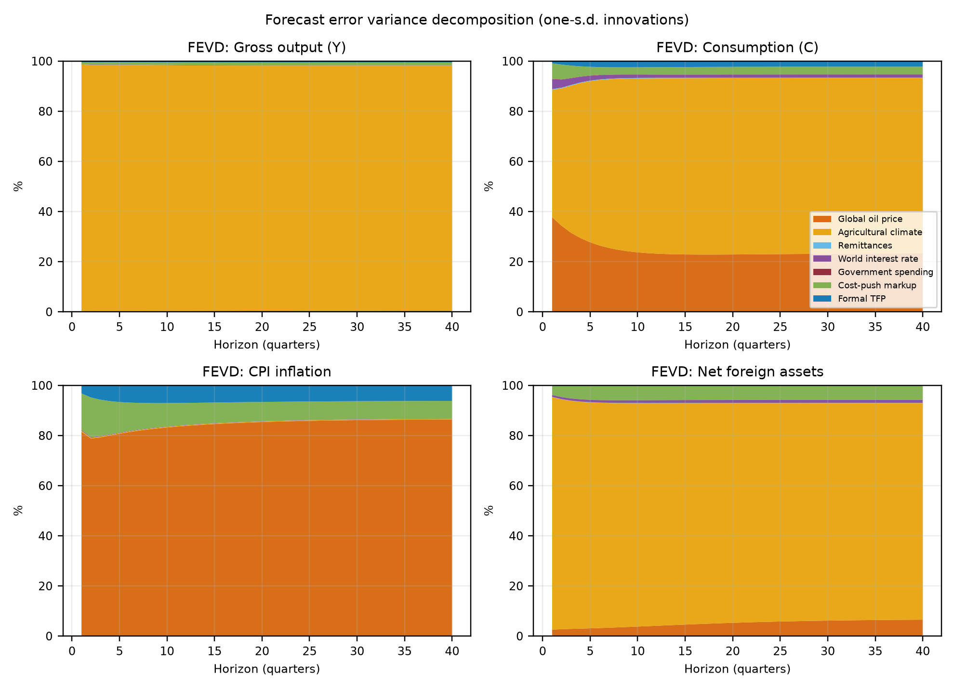
Figure S1. Forecast error variance decomposition across macroeconomic variables

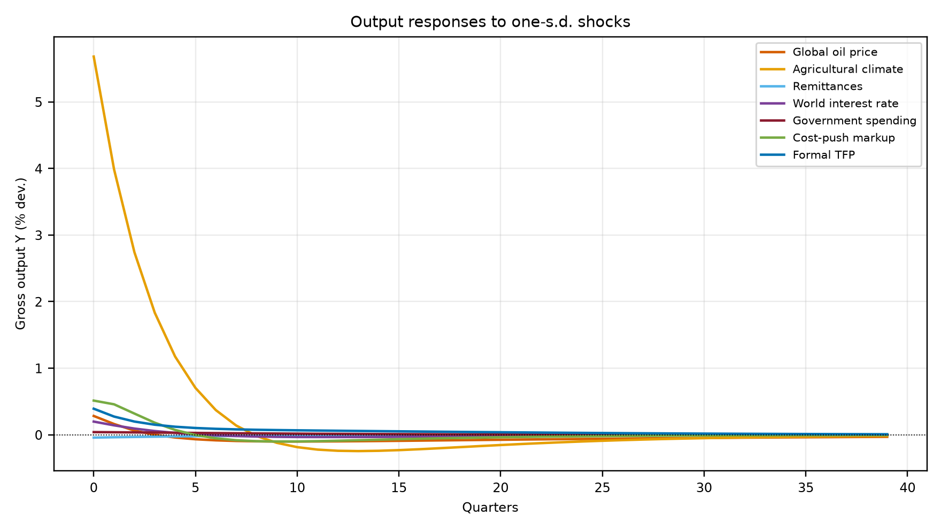
Figure S2. Impact output responses across structural shocks

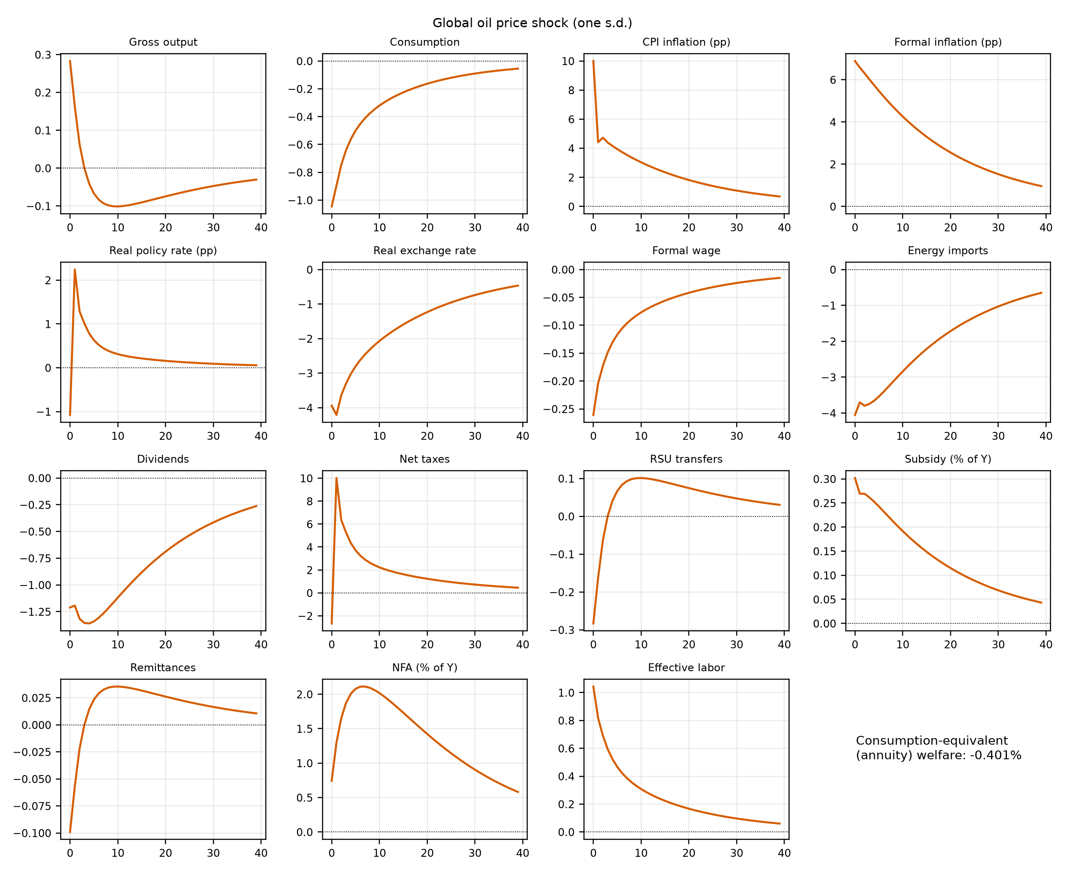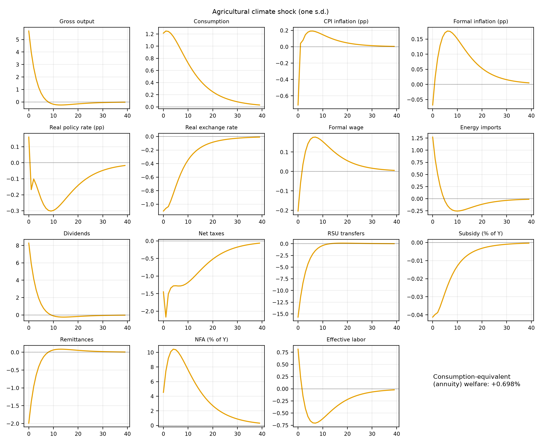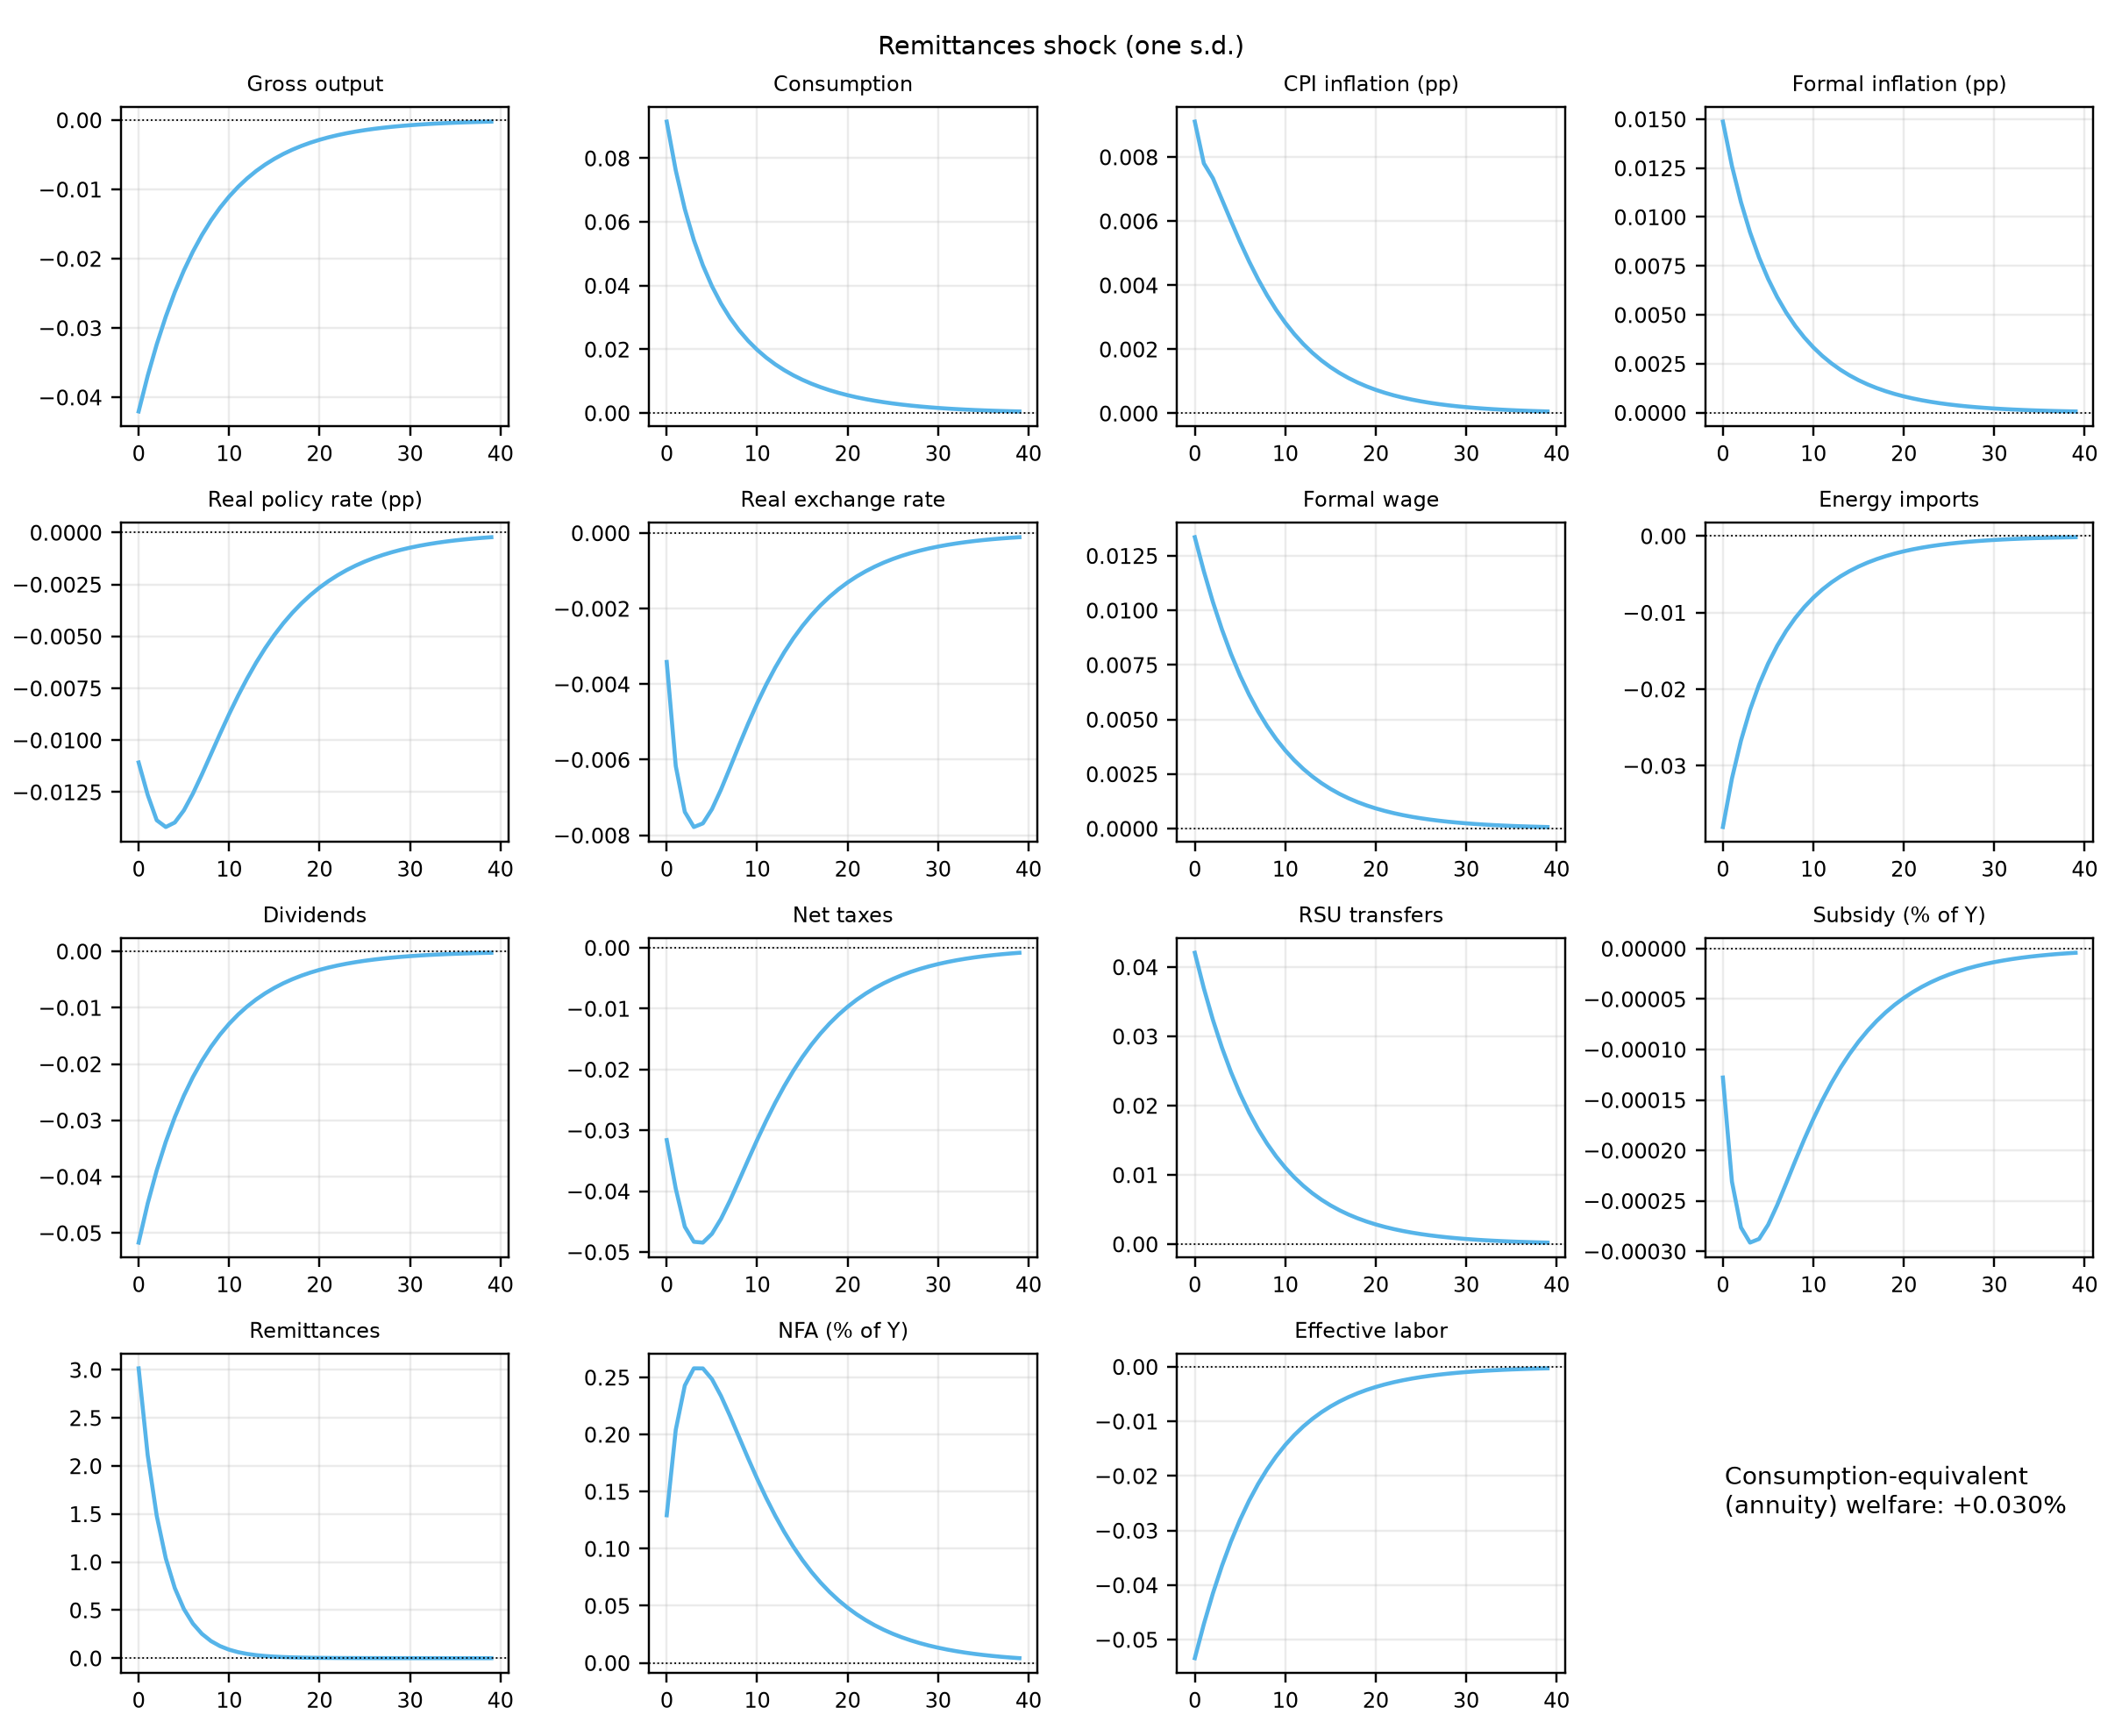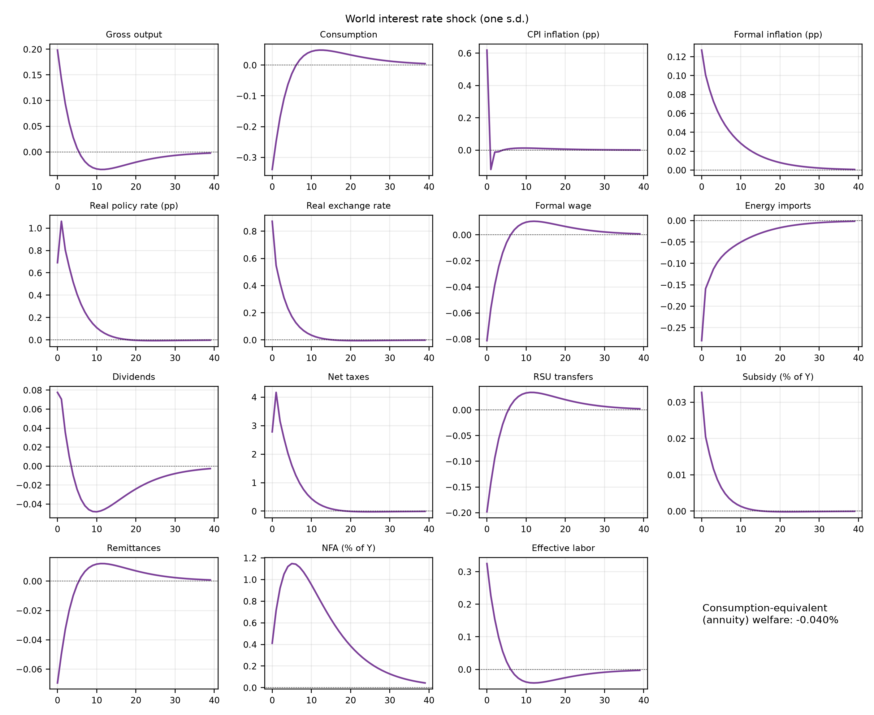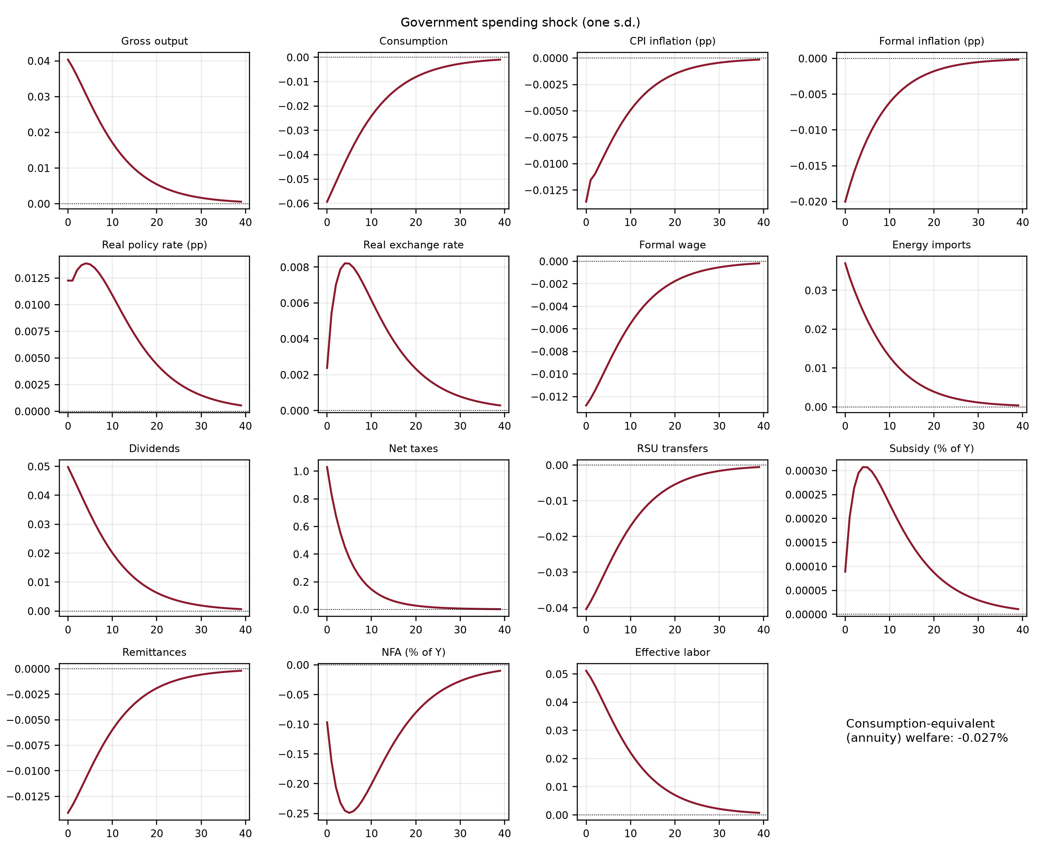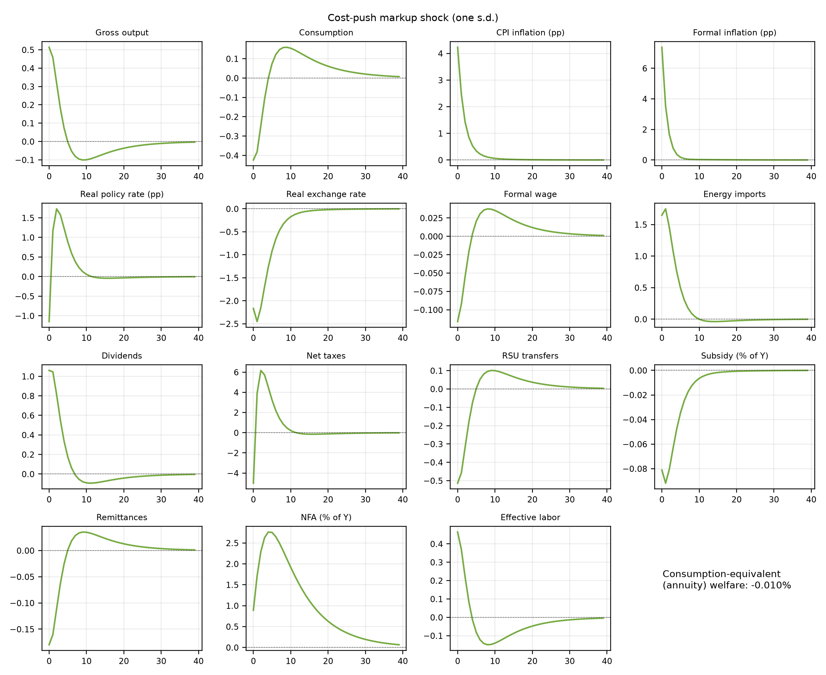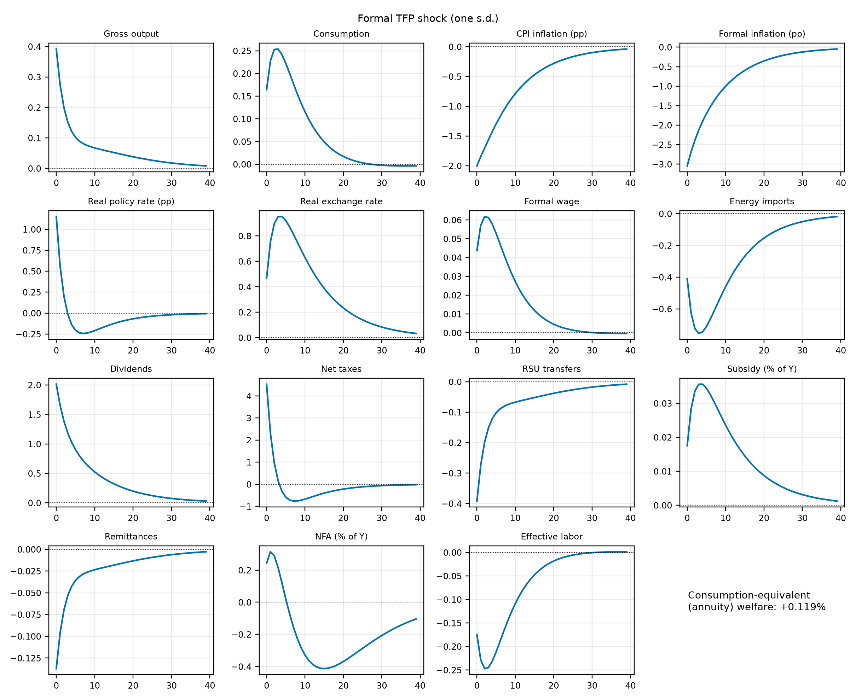
Figure S3. Impulse responses to each of the seven structural shocks (one standard deviation), baseline economy. Rates in annualized percentage points, other variables in percent of steady state; NFA and the subsidy outlay in percent of quarterly GDP.

