Supplementary Material
Supplementary methods
The multicolinearity of the metals were evaluated by using the Variance Inflation Factor (VIF), which is the inverse of 1–R² and shows how much the variance of the coefficient estimate is inflated by multi-collinearity in the model. A VIF greater than 5 was defined as indicative of colinearity in accordance with published recommendations ^{[1,2]}. Testing for multicollinearity revealed satisfactory values of the VIF, The overall metal’s VIF were below the limit of 5, blood Cd, Pb and Hg as well as urine Cd, Pb, Hg and As were 1.502, 2.285, 1.785, 2.232, 3.247, 1.819 and 1.745, respectively. There is no multicollinearity among metals and the results are reliable.

Supplementary references
- Hocking RR. Methods and Applications of Linear Models; regression and the analysis of variance. 2nd ed. New Jersey: John Wiley and Sons; 2003.
- O`Brian RM. A Caution Regarding Rules of Thumb of Variance Inflation Factors. Quality and Quantity. 2007; 41: 673–690.

Table S1 Adjusted β (95% CI) from single metal linear regression models and multiple metals linear regression models of SUA level stratified by gender.
 | All (n=4,794) |  | Men(n=2,452) |  | Women(n=2,342)
 | β [95% CI] | P | β [95% CI] | P | β [95% CI] | P
Single metal linear regression models ^{a,b}
log_{e} blood Cd (ug/L) | -0.677 [-0.840, -0.514] | <0.001 | -0.025 [-0.242, 0.191] | 0.817 | 0.214 [0.036, 0.392] | 0.019
log_{e} blood Pb (ug/L) | 0.950 [0.791, 1.109] | <0.001 | 0.207 [-0.007, 0.421] | 0.058 | 0.375 [0.150, 0.599] | 0.001
log_{e} blood Hg (ug/L) | 0.139 [0.006, 0.271] | 0.040 | 0.079 [-0.054, 0.212] | 0.241 | 0.090 [-0.048, 0.227] | 0.199
log_{e} urinary Cd (ug/L) | 0.020 [-0.090, 0.129] | 0.722 | 0.147 [0.022, 0.273] | 0.022 | 0.218 [0.089, 0.346] | 0.001
log_{e} urinary Pb (ug/L) | 0.252 [0.151, 0.353] | <0.001 | 0.076 [-0.035, 0.187] | 0.176 | -0.024 [-0.155, 0.106] | 0.711
log_{e} urinary Hg (ug/L) | 0.056 [-0.037, 0.149] | 0.232 | 0.039 [-0.085, 0.164] | 0.530 | 0.038 [-0.080, 0.156] | 0.524
log_{e} urinary As (ug/L) | 0.276 [0.161, 0.392] | <0.001 | 0.246 [0.139, 0.354] | <0.001 | 0.055 [-0.064, 0.174] | 0.357
Multiple metals linear regression models ^{a,c}
log_{e} blood Cd (ug/L) | -0.983 [-1.146, -0.729] | <0.001 | -0.175 [-0.437, 0.088] | 0.188 | -0.100 [-0.317, 0.118] | 0.365
log_{e} blood Pb (ug/L) | 1.553 [1.319, 1.788] | <0.001 | 0.513 [0.162, 0.864] | 0.005 | 0.756 [0.485, 1.026] | <0.001
log_{e} blood Hg (ug/L) | -0.126 [-0.272, 0.020] | 0.089 | -0.051 [-0.219, 0.116] | 0.544 | 0.014 [-0.151, 0.179] | 0.866
log_{e} urinary Cd (ug/L) | 0.295 [0.103, 0.487] | 0.003 | 0.208 [0.008, 0.409] | 0.042 | 0.444 [0.246, 0.641] | <0.001
log_{e} urinary Pb (ug/L) | -0.690 [-0.873, -0.507] | <0.001 | -0.393 [-0.656, -0.129] | 0.004 | -0.587 [-0.808, -0.366] | <0.001
log_{e} urinary Hg (ug/L) | 0.028 [-0.095, 0.150] | 0.653 | -0.047 [-0.223, 0.129] | 0.594 | 0.012 [-0.141, 0.164] | 0.878
log_{e} urinary As (ug/L) | 0.344 [0.205, 0.484] | <0.001 | 0.328 [0.189, 0.467] | <0.001 | 0.071 [-0.089, 0.231] | 0.379
β: partial regression coefficient; CI: confidence interval.
ª Adjusted for age, race/ethnicity, education, PIR, smoking, drinking, serum cotinine, fish eaten during the past 30 days, BMI, eGFR, gout, diabetes, and hypertension. ^{b} Each metal predicts SUA/SCr outcome separately.
^{c}All metals are included together in the same model.

Table S2 Posterior inclusion probabilities (PIPs) for group models using Bayesian Kernel Machine Regression (BKMR) models.
Metals | SUA/SCr |  | SUA
Metals | Men | Women | Men | Women
In whole blood, ug/L
Cd | 0.802 | 0.650 | 0.000 | 0.010
Pb | 0.926 | 1.000 | 0.758 | 0.820
Hg | 0.486 | 0.432 | 0.000 | 0.096
In urine, ug/L
Cd | 0.786 | 1.000 | 0.000 | 0.730
Pb | 0.868 | 1.000 | 0.564 | 0.728
Hg | 0.332 | 0.434 | 0.000 | 0.206
As | 1.000 | 0.722 | 0.832 | 0.274
PIPs indicate the posterior probability that an exposure grouping was included into the model from the multiple iterations (1,000) of the MCMC sampler.

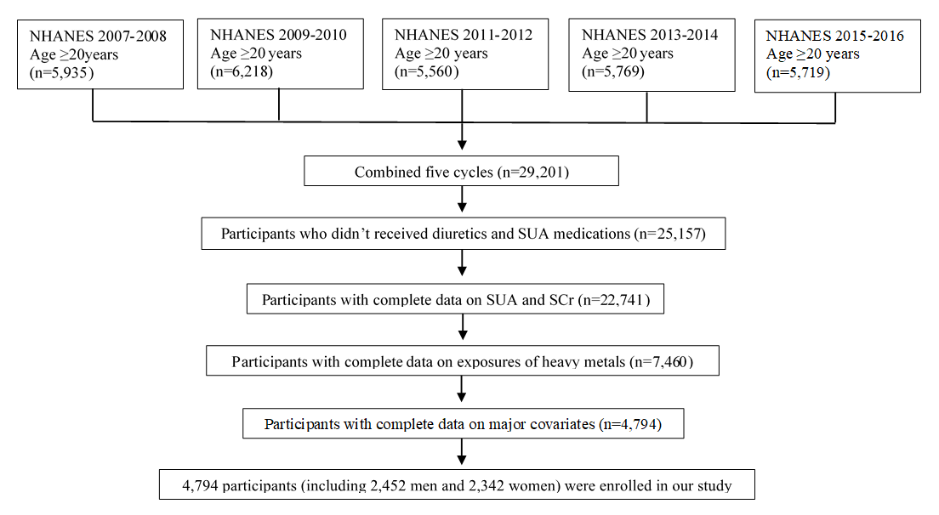
Figure S1. Flowchart of analytical sample selection.

Figure S2 Interactive effects, defined as the change in the single-exposure health effects when all of the remaining exposures are fixed at the 25th percentile compared to when they are fixed at the 75th percentile. (A) Interactive effects for SUA/SCr among men; (B) Interactive effects for SUA/SCr among women; (C) Interactive effects for SUA among men; (D) Interactive effects for SUA among women.
“U” indicates metals in urinary, “B” indicates metals in blood.

Figure S3. The BKMR analysis for the associations of SUA and multiple metals in men, where suffix “_U” indicates the metals in urinary and “_B” in blood.
(A) Spearman correlation matrix for metals; (B) Joint effects of exposure to a mixture of multiple heavy metals on SUA, comparing various percentiles of the mixture to the median (50th percentile); (C) Univariate exposure-response function and 95% confidence bands for each metal with the other metals fixed at the median; (D) Single metal effect on SUA comparing the upper quartile to the lower quartile level of a particular metal while fixing the other metals at the 25th, 50th, and 75th percentile.

Figure S4. The BKMR analysis for the associations of SUA and multiple metals in women, where suffix “_U” indicates the metals in urinary and “_B” in blood.
(A) Spearman correlation matrix for metals; (B) Joint effects of exposure to a mixture of multiple heavy metals on SUA, comparing various percentiles of the mixture to the median (50th percentile); (C) Univariate exposure-response function and 95% confidence bands for each metal with the other metals fixed at the median; (D) Single metal effect on SUA comparing the upper quartile to the lower quartile level of a particular metal while fixing the other metals at the 25th, 50th, and 75th percentile.
Figure S5. The BKMR analysis for the associations of SUA/SCr and multiple metals in men (sensitivity analysis), where suffix “_U” indicates the metals in urinary and “_B” in blood.
(A) Spearman correlation matrix for metals; (B) Joint effects of exposure to a mixture of multiple heavy metals on SUA/SCr, comparing various percentiles of the mixture to the median (50th percentile); (C) Univariate exposure-response function and 95% confidence bands for each metal with the other metals fixed at the median; (D) Single metal effect on SUA/SCr comparing the upper quartile to the lower quartile level of a particular metal while fixing the other metals at the 25th, 50th, and 75th percentile.

Figure S6. The BKMR analysis for the associations of SUA/SCr and multiple metals in women (sensitivity analysis), where suffix “_U” indicates the metals in urinary and “_B” in blood.
(A) Spearman correlation matrix for metals; (B) Joint effects of exposure to a mixture of multiple heavy metals on SUA/SCr, comparing various percentiles of the mixture to the median (50th percentile); (C) Univariate exposure-response function and 95% confidence bands for each metal with the other metals fixed at the median; (D) Single metal effect on SUA/SCr comparing the upper quartile to the lower quartile level of a particular metal while fixing the other metals at the 25th, 50th, and 75th percentile.

Figure S7. The BKMR analysis for the associations of SUA and multiple metals in men (sensitivity analysis), where suffix “_U” indicates the metals in urinary and “_B” in blood.
(A) Spearman correlation matrix for metals; (B) Joint effects of exposure to a mixture of multiple heavy metals on SUA, comparing various percentiles of the mixture to the median (50th percentile); (C) Univariate exposure-response function and 95% confidence bands for each metal with the other metals fixed at the median; (D) Single metal effect on SUA comparing the upper quartile to the lower quartile level of a particular metal while fixing the other metals at the 25th, 50th, and 75th percentile.

Figure S8. The BKMR analysis for the associations of SUA and multiple metals in women (sensitivity analysis), where suffix “_U” indicates the metals in urinary and “_B” in blood.
(A) Spearman correlation matrix for metals; (B) Joint effects of exposure to a mixture of multiple heavy metals on SUA, comparing various percentiles of the mixture to the median (50th percentile); (C) Univariate exposure-response function and 95% confidence bands for each metal with the other metals fixed at the median; (D) Single metal effect on SUA comparing the upper quartile to the lower quartile level of a particular metal while fixing the other metals at the 25th, 50th, and 75th percentile.

