APH-1A and CDK5 Expression Correlates with Tau Hyperphosphorylation and Its Attenuation by Brahmi and Donep-M in STZ induced Alzheimer’s Disease Model.
Umesh Prasad Sah Hathi¹, Abhishek Kumar¹, Jyotsna Arora^{1, 2}, Suneel Kateriya^{1, $}
¹Laboratory of Optobiotechnology, School of Biotechnology, Jawaharlal Nehru University, New Delhi-110067, India.
²Centre for Ayurveda Biology, School of Sanskrit and Indic Studies, Jawaharlal Nehru University, New Delhi-110067, India.
$Correspondance: Suneel Kateriya (skateriya@jnu.ac.in)

Supplementary Information (SI)
1. Identification of common genes among AD, PD and Primary Cilia
In order to elucidate the relationship between differentially expressed genes (DEGs) in AD (Fig. S1C) and PD (Fig. S1D), we first identified the common genes from the online databases (Genecard, CTD, and OpenCards) and compared the identified common genes with upregulated and downregulated DEGs with primary cilia-associated DEGs (Fig. S1E) genes (CiliaCarta) available in online databases. The Venn diagram analysis demonstrated a considerable overlap, highlighting a set of common candidate genes potentially relevant to AD, PD and primary cilia (Fig. S1A). To further investigate the biological significance of these common genes (811) among AD, PD, and primary ciliary complex network, a protein-protein interaction (PPI) network was constructed using Cytoscape (Fig. S1D and see supplementary sheet 7). Network clustering through the MCODE plugin revealed a highly interconnected module (Fig. S1E), suggesting functional enrichment of genes within this cluster. Additionally, hub gene analysis using the CytoHubba plugin identified several key nodes, with the highest-ranked hub genes highlighted in red, indicating their central role in the network and potential involvement in AD and PD pathology and major role of primary cilia (Fig. 1B and 1G).

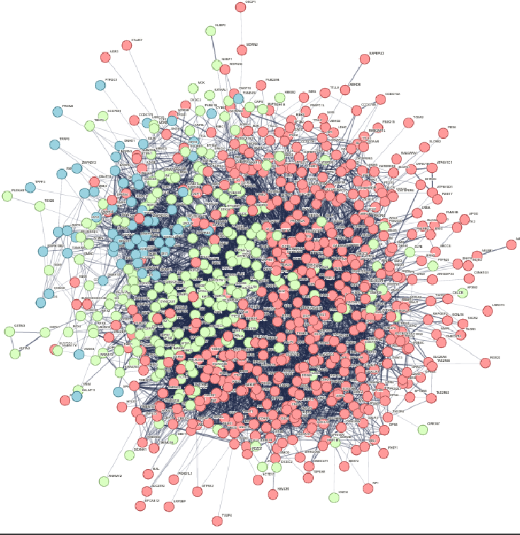
F.

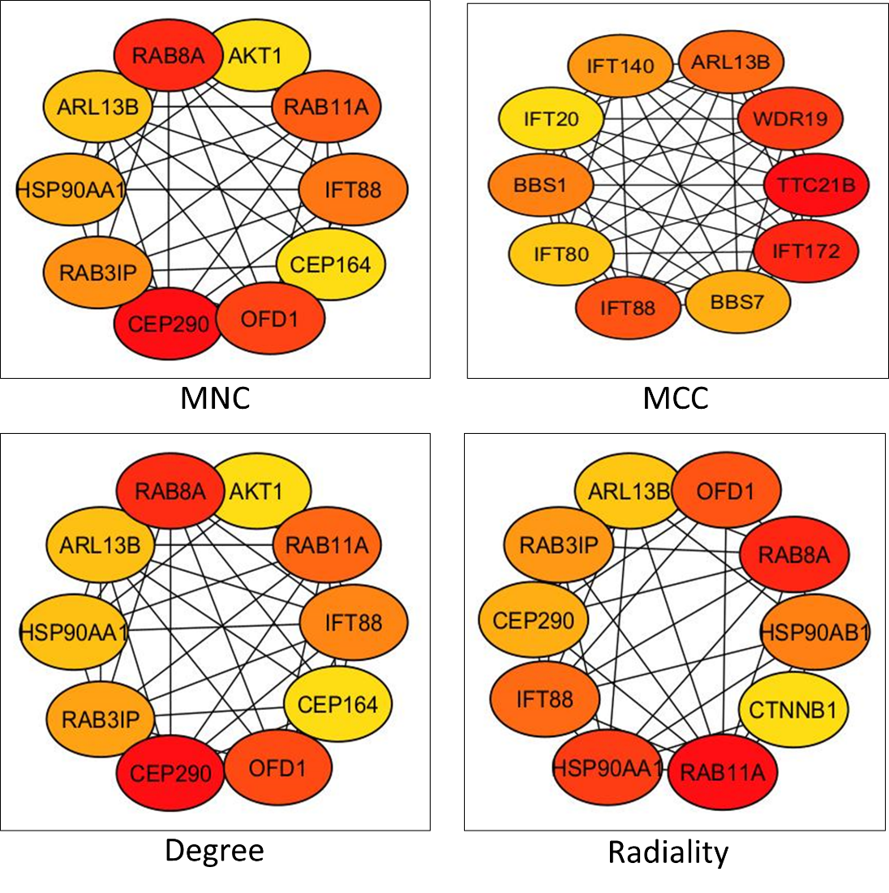
G.

Fig. SI1: (A) Venn diagram illustrating the overlap between AD, PD and primary cilia. Volcano plot of DEGs genes (C) GSE33000 (AD vs Control), (D) GSE7621 (PD vs Control) and (E) GSE196807 (Cilia vs Control). (F) PPI network constructed of 811 common genes among AD, PD and primary cilia.was identified using the MCODE plugin of Cytoscape. (B and G) Hub genes based on Cytohubba plugins with different algorithms (MNC, MCC, Degree and Radiality) were predicted (red ellipse = higher rank)
2. Biological roles of the common genes identified among AD, PD and Primary cilia
Further to understand the biological roles of the common genes identified among AD, PD and primary cilia, we performed Gene Ontology (GO) enrichment analysis across the three major categories: Biological Process, Molecular Function, and Cellular Component. The most significantly enriched GO terms were visualized using both bar graphs and pie charts, providing an overview of the functional distribution of these genes (Fig. SI2A, SI2B). A network-based representation further illustrated the relationships between GO categories, where ellipses denote biological processes, hexagons indicate cellular components, and octagon nodes represent molecular functions (Fig. SI2C). In addition, pathway enrichment analysis was conducted using multiple databases, including KEGG, Reactome, and WikiPathways. The top enriched pathways were summarized through bar graphs and pie charts (Fig. SI2D, SI2E). A pathway network map was also generated to depict interconnections, with rectangle corresponding to KEGG pathways, triangle to WikiPathways, and “V”-shaped nodes to Reactome pathways (Fig. SI2F). Together, these analyses highlight the functional and pathway-level relevance of the identified genes common to AD, PD and primary cilia.
A.
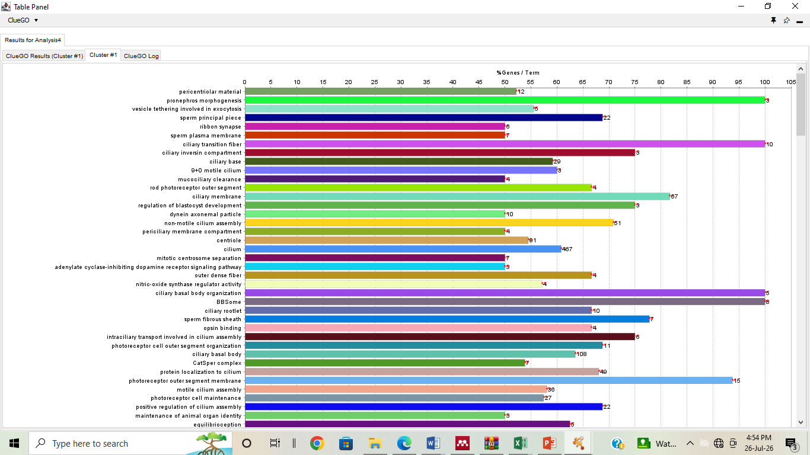
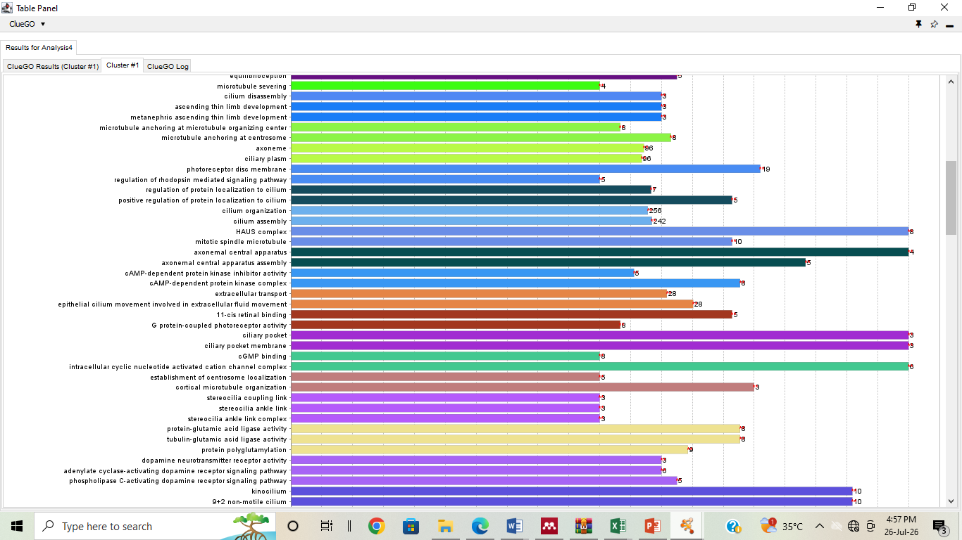

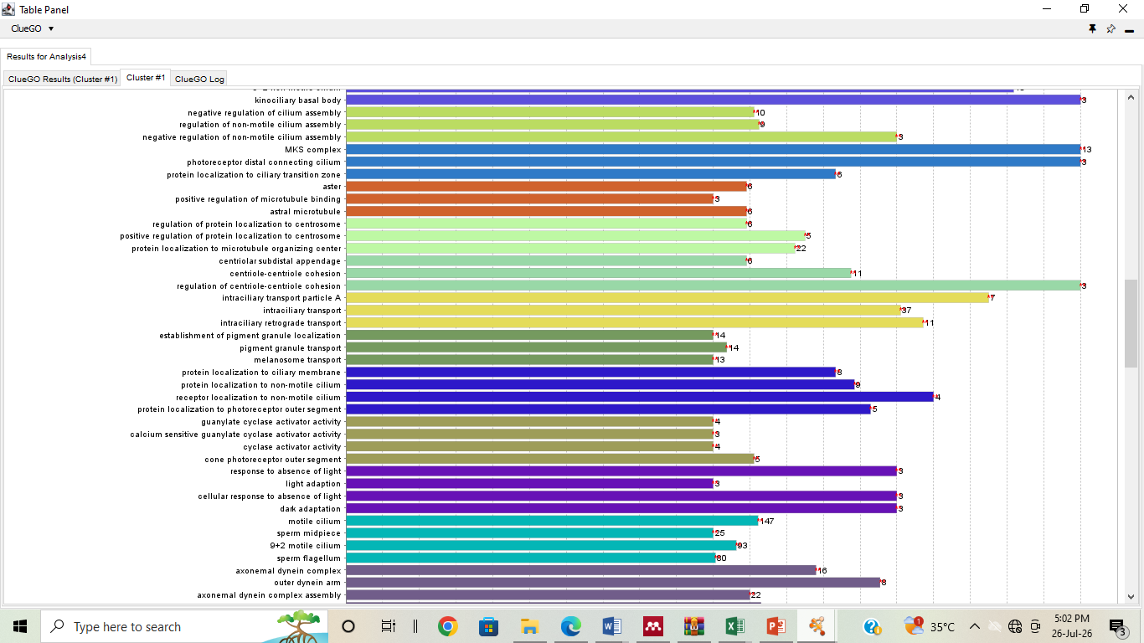
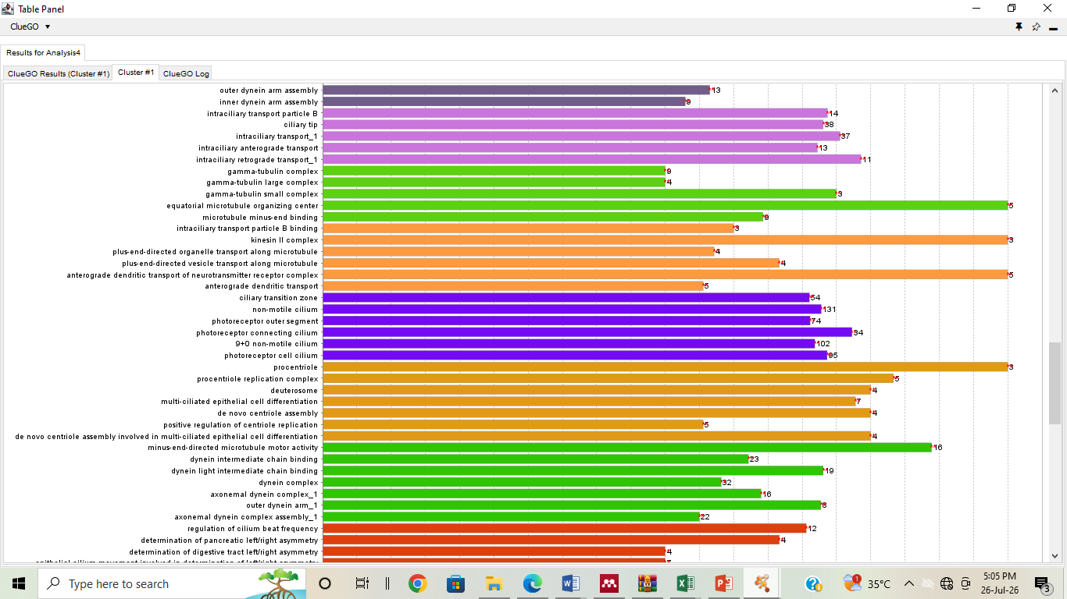
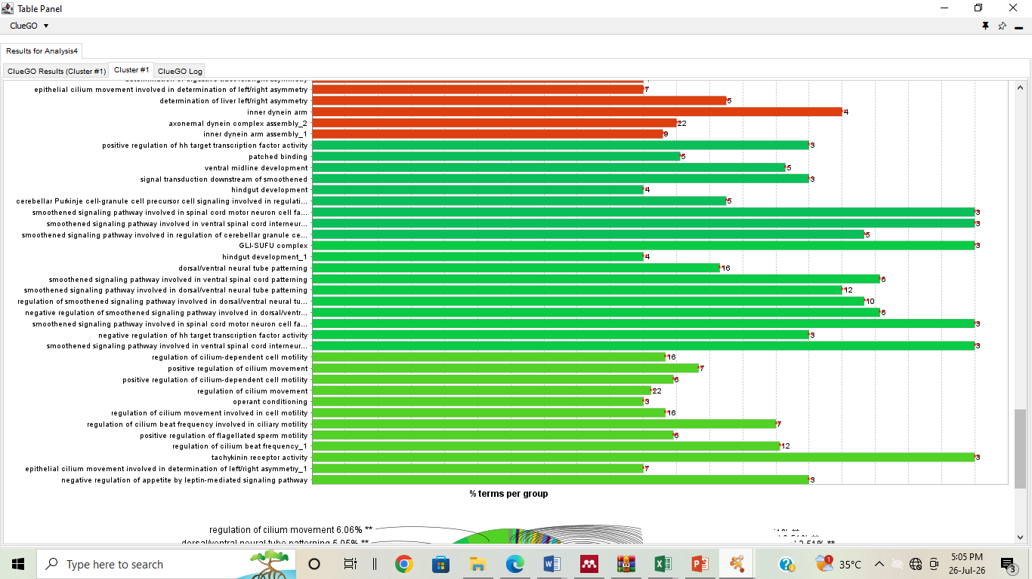

B.
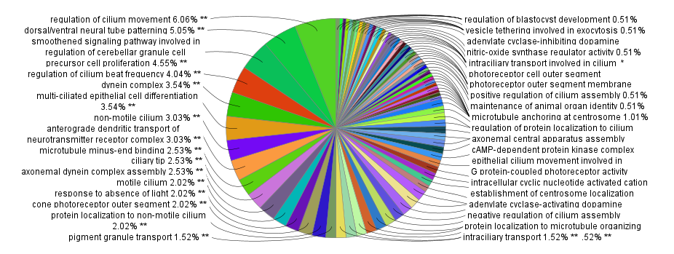

C.
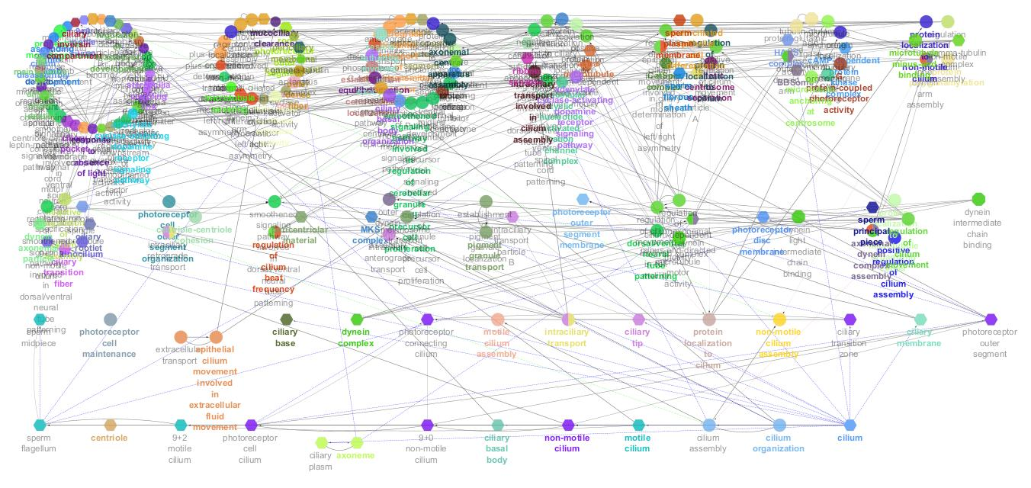
D.
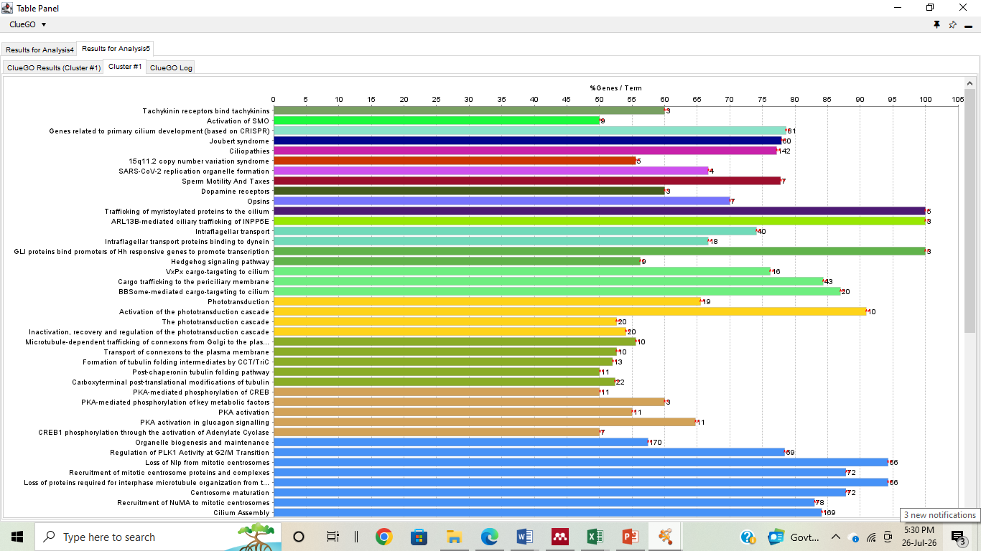
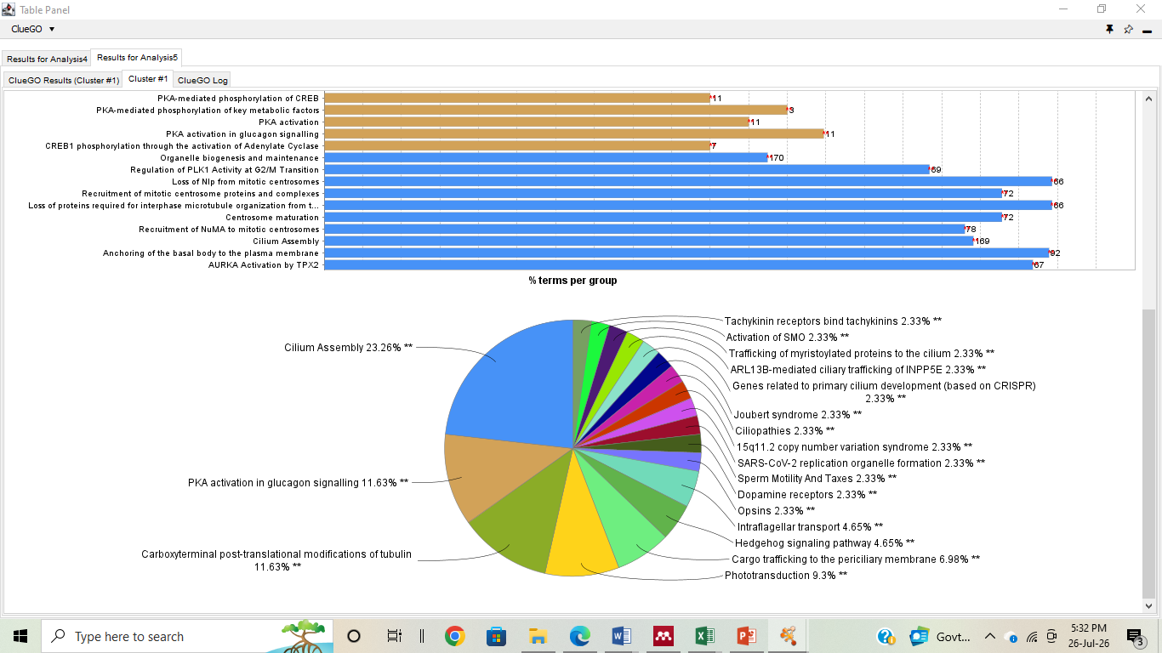

E.
F.
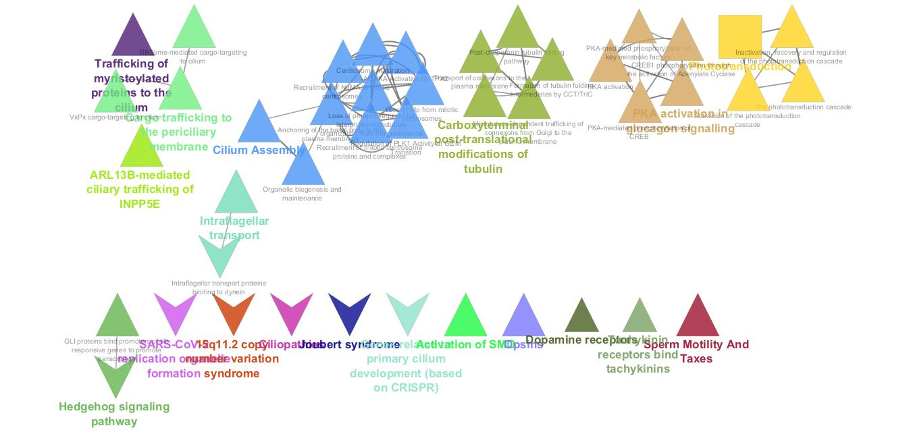
Fig. SI2. (A) Bar graph of GO analysis of 811 common genes identified among AD, PD and primary cilia (B) Pie chart of GO analysis (C) GO analysis (Biological Process-Ellipse, Cellular component-Hexagon, Molecular Function- Octagon) (D) Bar graph of Pathway analysis (E) Pie chart of Pathway analysis (F) Pathway enrichment analysis (KEGG gene enrichment analysis- Rectangle, Reactome pathways- Triangle, WikiPathways- V).
3. Profiling of phytochemicals of Bacopa monnieri (Brahmi)
The constituents compound of Brahmi are well characterized and in order to reconfirm the presence of bioactive molecules, peaks were analysed via (i) UV-Vsible spectrophotometer, (ii) GC-MS and (iii) LC-MS. Molecules peaks indicating the masses were identified by comparing the mass library database and listed down in the tables.
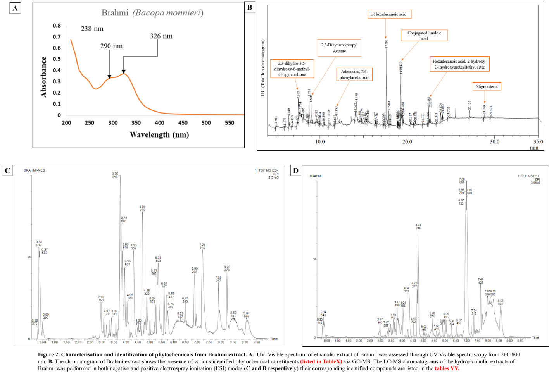

Fig. SI3. Characterisation and identification of phytochemicals from Brahmi extract. A. UV- Visible spectrum of ethanolic extract of Brahmi was assessed through UV-Visible spectroscopy from 200-800 nm. B. The chromatogram of Brahmi extract shows the presence of various identified phytochemical constituents listed in Table1 via GC-MS. The LC-MS chromatograms of the hydroalcoholic extracts of Brahmi was performed in both negative and positive electrospray ionisation (ESI) modes (C and D respectively) their corresponding identified compounds are listed in the tables 2-3.

4. Molecular Docking Brahmi’s Phytochemicals against APH-1A and CDK5
The molecular docking was performed to understand the interaction of Brahmi’s phytochemicals against our experimental validated and transcriptomics derived biomarkers (CDK5 and APH-1A) of AD pathology. We used an opensource software PyRx (Dallakyan and Olson 2015) for docking of active phytochemical of Brahmi with CDK5 and APH-1A. The 3D structure of CDK5(Tarricone et al. 2002) and APH1A(Bai et al. 2015) were downloaded from protein data base (PDB)(Berman 2000). Two independent docking was performed with the phytochemicals obtained from IMPPAT (https://cb.imsc.res.in/imppat/home). The structure of molecular docking was analysed by Discovery studios (Biovia, D.S. (2019) Discovery Studio Visualizer. San Diego) and based on interaction properties, Stigmasterol shows list binding energy among all other phytochemicals of Brahmi (Table 4)having better binding affinity with APH1A. On the other hand, CDK5 has shown better binding affinity with Bacoside B (Table 5)
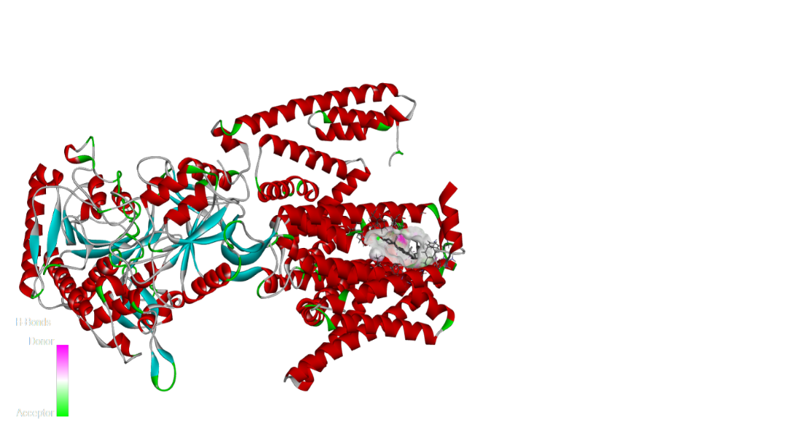
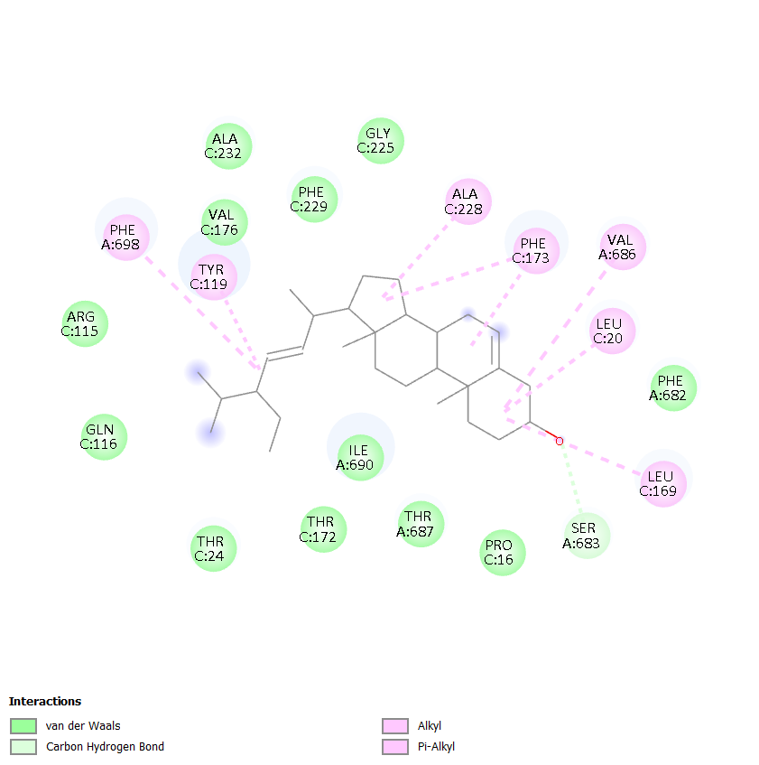
A B

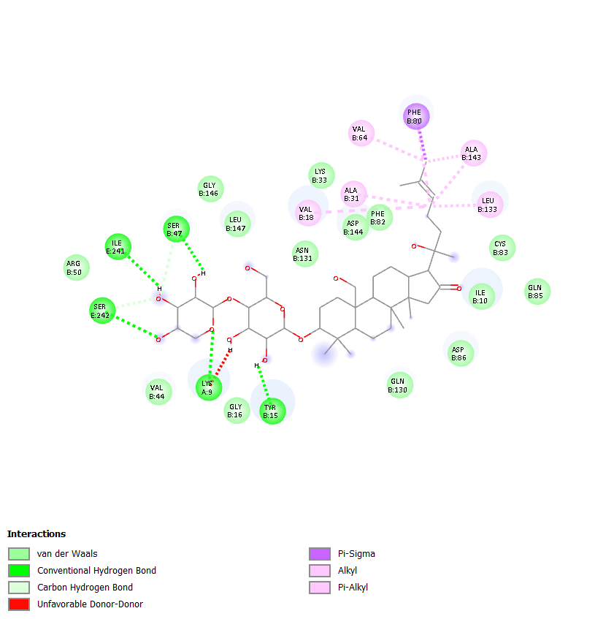
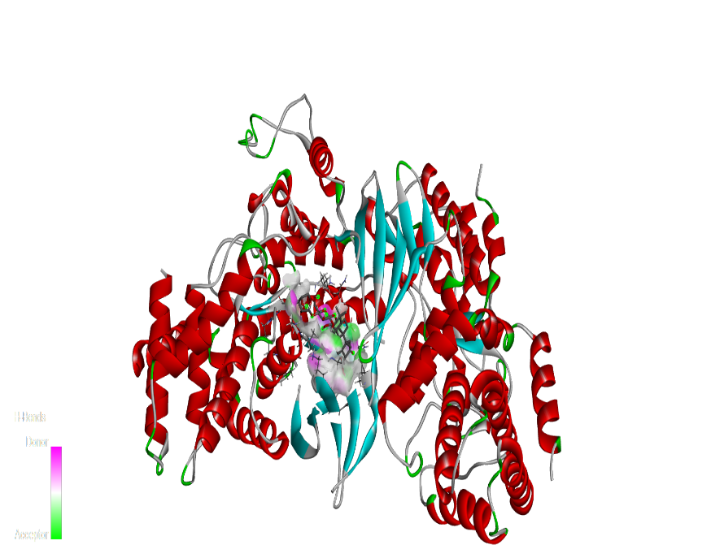
C D

Fig. S4. Structure of APH-1A (A) Two-dimensional (2-D) and (B) Three dimensional (3-D) and Structure of CDK5 (A) Two-dimensional (2-D) and (B) Three dimensional (3-D)
Table I: Phytochemical constituents identified in Brahmi Extract by GC-MS
Retention time (min) | Area % | Phytochemical identified
7.547 | 3.80 | 4H-Pyran-4-one, 2,3-dihydro-3,5-dihydroxy-6-methyl
8.095 | 0.40 | Cyclohexanol, 5- Methyl-2-(1-Methylethyl)
8.761 | 9.20 | 2-Furancarboxaldehyde,5-(Hydoxymethyl)
8.992 | 4.90 | 2,3-Dihydroxypropyl Acetate
11.883 | 9.49 | Adenosine, N6-phenylacetic acid
17.591 | 12.12 | n-Hexadecenoic acid
19.239 | 6.44 | 10(E),12(Z)-Conjugated linoleic acid
19.484 | 1.27 | 9,12-Octadecadienoic acid
20.357 | 0.38 | 5,8,11,14-Eicosatetraenoic acid, ethyl ester
22.459 | 2.82 | Hexadecanoic acid, 2-hydroxy-1-(hydroxymethyl)ethyl ester
23.829 | 3.24 | 3.24 9,12-Octadecadienoic acid (Z, Z)-, 2,3-dihydroxypropyl ester
28.799 | 0.98 | Stigmasterol

Table II: LC-MS Analysis of Brahmi Extract in ESI Negative Mode
Retention time (min) | Major m/z | Analysed phytochemical class | Analysed compound | Reported biological activities
8.247 | 559.4582, 581.4498, 704.3537, 938.7130 | Deprotonated triterpenoid saponins | Bacoside-related glycosides (Rastogi et al., 2005) | Memory enhancing, antioxidant, neuroprotective effects (Kongkeaw et al. 2014)
6.515 | 529.3248, 325.0779 | Saponin-derived metabolites | Bacoside fragment ions (Nuengchamnong, Sookying, and Ingkaninan 2016) | Anti-inflammatory and adaptogenic activities (Aguiar and Borowski 2013)
5.610 | 487.2963, 485.2797 | Triterpenoid aglycone fragments | Bacogenin/jujubogenin derivatives (Garai et al., 1996) | Neuroprotective and anxiolytic effects (Russo and Borrelli 2005)
5.369 | 503.2978, 504.3017 | Glycosylated triterpenoids | Bacopaside-related metabolites (Chakravarty et al. 2001) | Antioxidant and cognitive enhancing activities (Kongkeaw et al., 2014)
3.382 | 533.1033, 625.1551 | Polar glycosidic phytoconstituents | Polar bacoside derivatives (Nuengchamnong et al., 2016) | Free radical scavenging and anti-stress activities (Russo & Borrelli, 2005)

Table III: LC-MS Analysis of Brahmi Extract in ESI Positive Mode
Retention time (min) | Major m/z | Analysed phytochemical class | Analysed compound | Reported biological activities
7.659 | 820.6747, 878.7369, 922.7806 | Triterpenoid saponins | Bacoside/bacopaside derivatives (Chakravarty et al., 2001) | Neuroprotective, antioxidant, memory enhancing, anti-inflammatory activities (Kongkeaw et al., 2014)
7.001 | 664.4881, 620.4479, 576.4084 | Pseudojujubogenin glycosides | Bacopaside-type pseudojujubogenin derivatives (Pawar, Khan, and Khan 2007) | Cognitive enhancement, anti-Alzheimer’s, antioxidant properties (Russo & Borrelli, 2005)
5.382 | 451.2826, 469.2983 | Aglycone triterpenoids | Jujubogenin/pseudojujubogenin fragments (Nuengchamnong et al., 2016) | Adaptogenic, anxiolytic, neuroprotective activity (Aguiar & Borowski, 2013)
4.745 | 519.3116, 597.0639, 707.1624 | Glycosylated triterpenoid saponins | Fragmented bacopaside derivatives (Chakravarty et al., 2001) | Antioxidant and anti-inflammatory activities (Russo & Borrelli, 2005)
3.595 | 692.4385, 675.4069 | Bacopaside glycosides | Bacopaside I/II-like compounds (Chakravarty et al., 2001) | Nootropic, anti-stress and neurocognitive effects (Kongkeaw et al., 2014)

Table IV. List of binding affinities of Brahmi’s phytochemicals against APH-1A
Ligands | Binding Affinity | Remarks
Stigmasterol | -10.9 (Best Pose) | Antioxidant and neuroprotective activities; may support neuronal membrane stability and reduce oxidative neuronal damage(Pratiwi et al. 2021)
Pseudojujubogenin | -9.6 | Neuroprotective, antioxidant and anti-inflammatory activities; serves as the aglycone component of several bacopaside-type saponins(Gościniak et al. 2025)
Bacopaside 1 | -9 | Anti-Alzheimer’s, neuroprotective and cognitive-enhancing activities; promotes β-amyloid clearance and protects neurons against oxidative or ischemic injury(Karati, Mukherjee, and Roy 2025; Holcomb et al. 2006; Kumari et al. 2023)
Bacoside A3 | -8.8 | Neuroprotective and antioxidant activities, contributes to the anti-Alzheimer’s potential(Abdul Manap et al. 2019; Karati, Mukherjee, and Roy 2025; Holcomb et al. 2006)
Bacoside A | -8.7 | Anti-amyloidogenic, neuroprotective, antioxidant and anti-inflammatory activities; inhibits Aβ cytotoxicity(Karati, Mukherjee, and Roy 2025; Holcomb et al. 2006; Malishev et al. 2017; Kumari et al. 2023)
Betulinic acid | -8.6 | Anti-Alzheimer’s, neuroprotective and anti-inflammatory activities; improves memory, protects the blood–brain barrier(Navabi et al. 2018; Planchard et al. 2012)
Jujubogenin | -8.5 | Neuroprotective and anti-Alzheimer’s activities; protects against Aβ-induced neuronal toxicity, reduces apoptosis(Gościniak et al. 2025)
Bacoside B | -8.4 | Exhibits antioxidant and anti-inflammatory properties; inhibits acetylcholinesterase (AChE) activity(Abdul Manap et al. 2019; Karati, Mukherjee, and Roy 2025; Holcomb et al. 2006; Kumari et al. 2023)

Table V. List of binding affinities of Brahmi’s phytochemicals against CDK5
Ligands | Binding Affinity | Function (Source)
Bacoside B | -9.5 (Best Pose) | Exhibits antioxidant and anti-inflammatory properties; inhibits acetylcholinesterase (AChE) activity. (Abdul Manap et al. 2019; Karati, Mukherjee, and Roy 2025; Holcomb et al. 2006; Kumari et al. 2023)
Bacopaside 1 | -9.1 | Anti-Alzheimer’s, neuroprotective and cognitive-enhancing activities; promotes β-amyloid clearance and protects neurons against oxidative (Karati, Mukherjee, and Roy 2025; Holcomb et al. 2006; Kumari et al. 2023)
Stigmasterol | -8.9 | Antioxidant and neuroprotective activities; may support neuronal membrane stability and reduce oxidative neuronal damage (Pratiwi et al. 2021)
Bacoside A | -8.7 | Anti-amyloidogenic, neuroprotective, antioxidant and anti-inflammatory activities; inhibits Aβ cytotoxicity(Karati, Mukherjee, and Roy 2025; Holcomb et al. 2006; Malishev et al. 2017; Kumari et al. 2023)
Bacoside A3 | -8.7 | Neuroprotective and antioxidant activities, contributes to the anti-Alzheimer’s potential(Abdul Manap et al. 2019; Karati, Mukherjee, and Roy 2025; Holcomb et al. 2006)
Pseudojujubogenin | -8.5 | Neuroprotective, antioxidant and anti-inflammatory activities; serves as the aglycone component of several bacopaside-type saponins (7
Betulinic acid | -8.3 | Anti-Alzheimer’s, neuroprotective and anti-inflammatory activities; improves memory, protects the blood–brain barrier (5, 9)
Jujubogenin | -8.3 | Neuroprotective and anti-Alzheimer’s activities; protects against Aβ-induced neuronal toxicity, reduces apoptosis (7

5. Molecular Dynamics
5.1 Fibril model and ligand preparation for molecular docking.
The atomic model of the Alzheimer's amyloid-β fibril was taken from the Protein Data Bank (PDB 2LMN), a two-fold-symmetric Aβ(1–40) polymorph determined by solid-state NMR (Paravastu et al., 2008). The first deposited model was used, yielding a twelve-chain protofilament segment six cross-β layers of two Aβ(9–40) peptides each, arranged as two laterally packed columns (5,724 protein atoms). All hetero-atoms and crystallographic waters were removed, and hydrogens were rebuilt during topology generation.
Bacopaside I (PubChem CID 21599442; C₄₆H₇₄O₂₀S, 979 Da), a dammarane-type triterpenoid saponin of Bacopa monnieri, and (−)-epigallocatechin-3-gallate (EGCG) (CID 65064; C₂₂H₁₈O₁₁, 458 Da), an established amyloid-remodelling polyphenol used here as a positive control², were retrieved from PubChem. Three-dimensional conformers were generated and protonated at pH 7.4 with Open Babel 3.1³. The sulfate monoester of Bacopaside I is fully ionized at physiological pH and was therefore modelled deprotonated (C₄₆H₇₃O₂₀S⁻, net charge −1, 140 atoms); EGCG was modelled neutral (51 atoms).
5.2 Molecular docking of amyloid B protofilament with bacopaside1
Ligands were docked to the complete twelve-chain fibril with AutoDock Vina v1.2.7 (Trott & Olson, 2010; Eberhardt et al., 2021). Receptor and ligand PDBQT files retained polar hydrogens and Gasteiger charges. A search box of 87 × 63 × 66 Å³ centred on the fibril (x = 63.2, y = 22.7, z = 74.6 Å) permitted unbiased placement across all fibril surfaces and termini, with exhaustiveness 16 and 20 retained modes. Top-ranked poses (Bacopaside I, −9.0 kcal mol⁻¹; EGCG, −7.7 kcal mol⁻¹) both localized to grooves of the cross-β core and were retained for simulation. Vina reports united-atom coordinates, so the docked Bacopaside I pose was reconstructed to full atomic detail by template matching, transferring bond orders and formal charges from the reference structure, and adding hydrogens at their geometric positions, preserving the docked heavy-atom coordinates, using RDKit 2024.09 (Landrum, 2024).
5.3 Ligand parametrization
General AMBER Force Field 2 (GAFF2)6 was used to assign atom types with antechamber (AmberTools7) and AM1-BCC8 partial charges were calculated at the docked geometry as a single point (maxcyc = 0) on the MMFF94-minimized conformer. No bonded parameters were missing from GAFF2 for either ligand, as found by parmchk2. The topologies in GROMACS format were generated with acpype 2023.10 9 ; the total partial charges summed to -1.0000 (Bacopaside I) and 0.0000 (EGCG), which is consistent with the protonation states used.
5.4 Simulated systems
Five systems were prepared under identical conditions, differing only in ligand identity and stoichiometry:
System Composition Ligand placement
(i) Apo control, fibril
(ii) Bacopaside I (1:12), fibril + 1 ligand, top docked pose
(iii) EGCG (1:12) fibril + 1 ligand, top docked pose
(iv) Bacopaside I (10:12) fibril + 10 ligands random in solution
(v) EGCG (10:12) fibril + 10 ligands random in solution
Single-copy systems used the docked pose. Ten-copy systems, matching the ligand:peptide ratios at which EGCG-induced β-sheet loss has been reported¹⁰, were built by inserting ten ligand copies at random, non-overlapping positions in the solvent shell surrounding the fibril (gmx insert-molecules), allowing the ligands to locate their own binding sites during the simulation rather than imposing a pose.
The protein was described with the AMBER99SB-ILDN force field and solvated with TIP3P water. Each system was placed in a rhombic-dodecahedral box with a minimum solute–wall distance of 1.0 nm, neutralized, and brought to 0.15 M NaCl, giving 77,637–77,817 atoms. Ion counts confirmed the intended ligand charges (94 Na⁺ for the ten-copy Bacopaside I system versus 84 Na⁺ for its EGCG counterpart, consistent with ten additional −1 charges).
All simulations were carried out with GROMACS 2025.2 with GPU offload of non-bonded, PME and bonded interactions. The systems were energy minimised using steepest descent until the maximum force was <1000kJ mol⁻¹ nm⁻¹ . The systems were then equilibrated for 100ps in the NVT and 1ns in the NPT ensemble, with harmonic position restraints (1000kJ mol⁻¹ nm⁻² ) on all protein and ligand heavy atoms, temperature was kept at 310 K. with the velocity-rescaling thermostat¹⁴ (τ_T = 0.1 ps) and pressure at 1 bar with the C-rescale barostat¹⁵ (τ_P = 2 ps; isothermal compressibility 4.5 × 10⁻⁵ bar⁻¹). Restraints were then released and a single unbiased 200 ns production trajectory was propagated for each system in the NPT ensemble.
The equations of motion were integrated with a 2 fs time step using the leap-frog algorithm and constraints on bonds to hydrogen atoms were imposed using LINCS16. Long-range electrostatics were treated using particle-mesh Ewald 17 (1.0 nm real-space cutoff, 0.16 nm grid spacing) and van der Waals interactions with a 1.0 nm cutoff, a Verlet neighbour list and an analytical long-range dispersion correction. Coordinates were saved every 10 ps and equilibration was checked via the NPT averages (310.0 1.2 K, 1.9 bar, 1000 kg m-3).
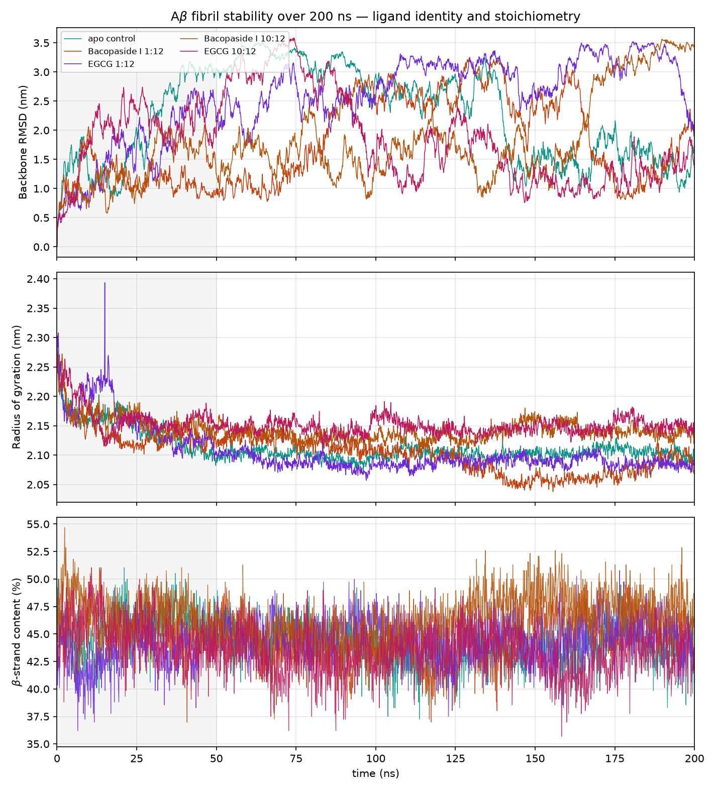
All five systems remained intact over the 200 ns trajectories, with backbone RMSD values fluctuating between 1.86 and 2.86 nm and radii of gyration converging to 2.09–2.15 nm; in no case did individual peptides dissociate from the fibril. Both ligands stayed stably associated with the fibril throughout: minimum protein–ligand distances averaged 0.154–0.179 nm over the 50–200 ns analysis window, and the ten-copy systems accumulated 10,235 (Bacopaside I) and 12,404 (EGCG) contacts within 0.6 nm, indicating extensive surface engagement rather than transient binding. At a 1:12 ligand:peptide ratio neither compound reduced the cross-β content of the fibril relative to the apo control (43.9 ± 6.8%); β-strand content was marginally higher in the presence of Bacopaside I (44.5 ± 8.2%, +2.4 ± 2.4 residues, not significant) and of EGCG (44.8 ± 7.2%, +3.5 ± 1.4 residues). Raising the stoichiometry to 10:12 separated the two compounds. EGCG lowered β-strand content to 43.1 ± 7.8% (−2.9 ± 1.8 residues) and produced the largest radius of gyration of any system (2.148 ± 0.011 nm against 2.102 ± 0.009 nm for the apo control), a combination of modest β-sheet loss with fibril expansion that reproduces the direction and approximate magnitude reported for EGCG acting on Aβ42 protofibrils (Fang et al., 2022). Bacopaside I acted in the opposite sense, raising β-strand content to 46.4 ± 8.3% (+9.7 ± 2.6 residues, significant). The difference between the two ligands at matched stoichiometry, 12.6 ± 2.7 β-strand residues or 3.3% of the fibril, exceeded the combined block standard error by a factor of 4.7. Bacopaside I therefore binds the Aβ fibril stably but stabilises rather than disrupts its cross-β architecture, in contrast to EGCG, which trended towards β-sheet loss under identical conditions. Because a single trajectory was propagated per system, the EGCG trend did not reach the significance threshold applied here, and the individual effect sizes should be regarded as provisional (Fig. S6).
A)

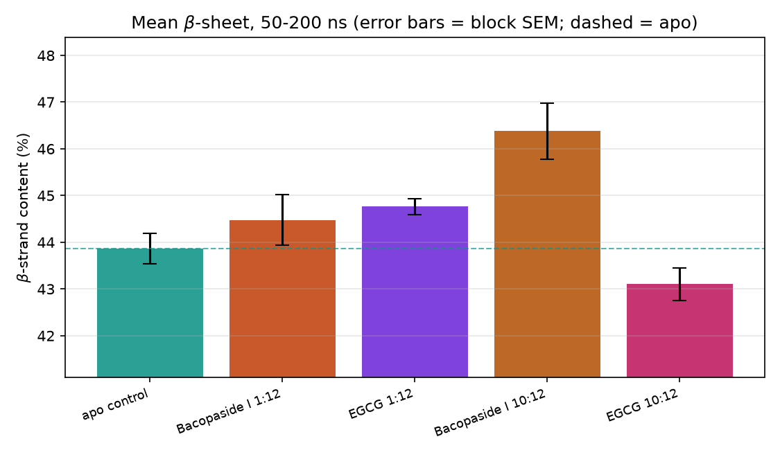
B)

Fig. S5 Molecular dynamics (A) 200 ns time series for all five systems (RMSD, Rg, β-sheet) and (B) mean β-sheet with block-SEM error bars. The dashed line is the apo control at 43.9%. The two single-copy systems and Bacopaside I at ten copies all sit above the line. EGCG at ten copies is the only bar below it, at 43.1% the direction we expected from a compound that loosens the cross-β network. Bacopaside I and EGCG differ by 12.6 β-strand residues — 3.3% of the fibril — which is 4.7 times the combined standard error. That gap is solid. So the conclusion is not what we expected going in: Bacopaside I binds the amyloid fibril tightly and stays there, but it stabilises the cross-β core rather than dissolving it.
Table VI. Summary of Molecular Dynamics (MD) optimization.
Ligand | Target | Best score | Source
R-roscovitine (control) | CDK5–p25 ATP site | −9.19 | Verified, (PDB ID :1UNL)
Bacopaside I | Aβ fibril (2LMN) | −9.02 | UCSF Chimera  AutoDock Vina 1.2.7
EGCG (control) | Aβ fibril (2LMN) | −7.70 | UCSF Chimera  AutoDock Vina 1.2.7
Bacopasaponin C | CDK5–p25 | −7.59 | UCSF Chimera  AutoDock Vina 1.2.7
Bacopaside I | CDK5–p25 | −7.54 | UCSF Chimera  AutoDock Vina 1.2.7

# | Target | Ligand | Atoms | Length | Ligand min dist (nm) | Key outcome
1 | Aβ fibril (2LMN) | None | 77,715 | 200 ns | — | β-strand 43.9 ± 6.8 % baseline
2 | Aβ fibril | Bacopaside I, 1:12 | 77,817 | 200 ns | 0.179 ± 0.013 | β +2.4 ± 2.4 res, n.s.
3 | Aβ fibril | EGCG, 1:12 (control) | 77,700 | 200 ns | 0.166 ± 0.014 | β +3.5 ± 1.4 res, wrong sign
4 | Aβ fibril | Bacopaside I, 10:12 | 77,739 | 200 ns | 0.172 ± 0.009 | β +9.7 ± 2.6 res — INCREASED
5 | Aβ fibril | EGCG, 10:12 (control) | 77,637 | 200 ns | 0.154 ± 0.004 | β −2.9 ± 1.8 res, n.s.
6 | IFT80 (AlphaFold) | None | 198,039 | 200 ns | — | site RMSF 0.205 nm baseline
7 | IFT80 | Bacopasaponin C, 1:1 | 198,167 | 200 ns | 0.185 ± 0.016 | site RMSF 0.205 nm — no change
8 | CDK5–p25 (1UNL) | None | 76,365 | 200 ns | — | interface 1601 ± 115 contacts
9 | CDK5–p25 | Bacopasaponin C, pose 1 | 76,385 | 200 ns | 0.176 ± 0.017 | interface +178 ± 32 — TIGHTER
10 | CDK5–p25 | Bacopasaponin C, pose 2 | 76,433 | 200 ns | 0.189 ± 0.090 | interface +302 ± 31; left docked site
Table VII. Summary of Molecular Dynamics (MD)

References
Abdul Manap, Aimi Syamima, Shantini Vijayabalan, Priya Madhavan, Yoke Yin Chia, Aditya Arya, Eng Hwa Wong, Farzana Rizwan, Umesh Bindal, and Shajan Koshy. 2019. “Bacopa Monnieri , a Neuroprotective Lead in Alzheimer Disease: A Review on Its Properties, Mechanisms of Action, and Preclinical and Clinical Studies.” Drug Target Insights 13 (January): 117739281986641. https://doi.org/10.1177/1177392819866412.
Aguiar, Sebastian, and Thomas Borowski. 2013. “Neuropharmacological Review of the Nootropic Herb Bacopa Monnieri.” Rejuvenation Research 16 (4): 313–26. https://doi.org/10.1089/rej.2013.1431.
Bai, Xiao-chen, Chuangye Yan, Guanghui Yang, Peilong Lu, Dan Ma, Linfeng Sun, Rui Zhou, Sjors H. W. Scheres, and Yigong Shi. 2015. “An Atomic Structure of Human γ-Secretase.” Nature 525 (7568): 212–17. https://doi.org/10.1038/nature14892.
Berman, H. M. 2000. “The Protein Data Bank.” Nucleic Acids Research 28 (1): 235–42. https://doi.org/10.1093/nar/28.1.235.
Chakravarty, Ajit K, Tapas Sarkar, Kazuo Masuda, Kenji Shiojima, Takahisa Nakane, and Nobuo Kawahara. 2001. “Bacopaside I and II: Two Pseudojujubogenin Glycosides from Bacopa Monniera.” Phytochemistry 58 (4): 553–56. https://doi.org/10.1016/S0031-9422(01)00275-8.
Dallakyan, Sargis, and Arthur J. Olson. 2015. “Small-Molecule Library Screening by Docking with PyRx.” In , 243–50. https://doi.org/10.1007/978-1-4939-2269-7_19.
Gościniak, Anna, Anna Stasiłowicz-Krzemień, Marta Szeląg, Jakub Pawlak, Izabela Skiera, Hanna Kwiatkowska, Natasza Nowak, et al. 2025. “Bacopa Monnieri: Preclinical and Clinical Evidence of Neuroactive Effects, Safety of Use and the Search for Improved Bioavailability.” Nutrients 17 (11): 1939. https://doi.org/10.3390/nu17111939.
Holcomb, Leigh A., Muralikrishnan Dhanasekaran, Angie R. Hitt, Keith A. Young, Mark Riggs, and Bala V. Manyam. 2006. “Bacopa Monniera Extract Reduces Amyloid Levels in PSAPP Mice.” Journal of Alzheimer’s Disease 9 (3): 243–51. https://doi.org/10.3233/JAD-2006-9303.
Karati, Dipanjan, Swarupananda Mukherjee, and Souvik Roy. 2025. “The Antioxidant Potential of Bacoside and Its Derivatives in Alzheimer’s Disease: The Molecular Mechanistic Paths and Therapeutic Prospects.” Toxicology Reports 14 (June): 101945. https://doi.org/10.1016/j.toxrep.2025.101945.
Kongkeaw, Chuenjid, Piyameth Dilokthornsakul, Phurit Thanarangsarit, Nanteetip Limpeanchob, and C. Norman Scholfield. 2014. “Meta-Analysis of Randomized Controlled Trials on Cognitive Effects of Bacopa Monnieri Extract.” Journal of Ethnopharmacology 151 (1): 528–35. https://doi.org/10.1016/j.jep.2013.11.008.
Kumari, Annu, Ashwani Kumar, Sudhamoy Mandal, Partha Roy, and Debabrata Sircar. 2023. “A Metabolic Reprogramming in Bacopa Monnieri Plants Induced by Methyl-Jasmonate and Enhanced Biosynthesis of Triterpene Saponins.” Industrial Crops and Products 204 (November): 117241. https://doi.org/10.1016/j.indcrop.2023.117241.
Malishev, Ravit, Shira Shaham-Niv, Sukhendu Nandi, Sofiya Kolusheva, Ehud Gazit, and Raz Jelinek. 2017. “Bacoside-A, an Indian Traditional-Medicine Substance, Inhibits β-Amyloid Cytotoxicity, Fibrillation, and Membrane Interactions.” ACS Chemical Neuroscience 8 (4): 884–91. https://doi.org/10.1021/acschemneuro.6b00438.
Navabi, Seyedeh Parisa, Alireza Sarkaki, Esrafil Mansouri, Mohammad Badavi, Ata Ghadiri, and Yaghoob Farbood. 2018. “The Effects of Betulinic Acid on Neurobehavioral Activity, Electrophysiology and Histological Changes in an Animal Model of the Alzheimer’s Disease.” Behavioural Brain Research 337 (January): 99–106. https://doi.org/10.1016/j.bbr.2017.10.002.
Nuengchamnong, Nitra, Sontaya Sookying, and Kornkanok Ingkaninan. 2016. “LC-ESI-QTOF-MS Based Screening and Identification of Isomeric Jujubogenin and Pseudojujubogenin Aglycones in Bacopa Monnieri Extract.” Journal of Pharmaceutical and Biomedical Analysis 129 (September): 121–34. https://doi.org/10.1016/j.jpba.2016.06.052.
Pawar, Rahul, Shabana Khan, and Ikhlas Khan. 2007. “Glycosides of 20-Deoxy Derivatives of Jujubogenin and Pseudojujubogenin from Bacopa Monniera.” Planta Medica 73 (4): 380–83. https://doi.org/10.1055/s-2007-967163.
Planchard, Matthew S., Michael A. Samel, Amit Kumar, and Vijayaraghavan Rangachari. 2012. “The Natural Product Betulinic Acid Rapidly Promotes Amyloid-β Fibril Formation at the Expense of Soluble Oligomers.” ACS Chemical Neuroscience 3 (11): 900–908. https://doi.org/10.1021/cn300030a.
Pratiwi, Reny, Chanin Nantasenamat, Waralee Ruankham, Wilasinee Suwanjang, Virapong Prachayasittikul, Supaluk Prachayasittikul, and Kamonrat Phopin. 2021. “Mechanisms and Neuroprotective Activities of Stigmasterol Against Oxidative Stress-Induced Neuronal Cell Death via Sirtuin Family.” Frontiers in Nutrition 8 (May). https://doi.org/10.3389/fnut.2021.648995.
Russo, A., and F. Borrelli. 2005. “Bacopa Monniera, a Reputed Nootropic Plant: An Overview.” Phytomedicine 12 (4): 305–17. https://doi.org/10.1016/j.phymed.2003.12.008.
Tarricone, C., R. Dhavan, J. Peng, L.B. Areces, L.-H. Tsai, and A. Musacchio. 2002. “Structure and Regulation of the CDK5-P25(Nck5a) Complex.” Worldwide Protein Data Bank. https://doi.org/10.2210/pdb1h4l/pdb.

