Supplementary material
Table S1. All 36 edge estimates and regularized estimates
Node pair | Zero-order  r | Partial rₚ | Pointwise 95% CI | EBICglasso
EF–SF | .687 | .538 | [.503, .572] | .533
WHO–DEP | −.535 | −.358 | [−.394, −.321] | −.364
NT–PT | .618 | .356 | [.313, .398] | .350
D–DEP | .332 | .301 | [.270, .335] | .293
NE–PE | .591 | .295 | [.252, .335] | .291
PT–PE | .608 | .293 | [.248, .339] | .286
EF–WHO | .537 | .262 | [.225, .299] | .262
NE–PT | .591 | .234 | [.190, .275] | .238
NT–NE | .544 | .217 | [.179, .259] | .210
PE–EF | .504 | .173 | [.132, .216] | .164
D–SF | .097 | .162 | [.129, .196] | .154
NT–WHO | .341 | .120 | [.081, .160] | .108
NT–D | .057 | .117 | [.080, .156] | .097
NE–DEP | −.125 | .117 | [.077, .157] | .096
PE–DEP | −.308 | −.115 | [−.157, −.077] | −.107
NT–DEP | −.258 | −.114 | [−.155, −.073] | −.099
D–WHO | −.188 | −.104 | [−.139, −.070] | −.094
SF–WHO | .430 | .100 | [.063, .134] | .094
PT–WHO | .230 | −.090 | [−.127, −.051] | −.072
NT–PE | .531 | .088 | [.046, .131] | .094
PE–WHO | .382 | .074 | [.034, .111] | .066
PT–EF | .412 | .070 | [.030, .113] | .072
NE–SF | .322 | .066 | [.027, .104] | .049
SF–DEP | −.270 | −.064 | [−.094, −.031] | −.054
PE–D | −.058 | −.051 | [−.087, −.017] | −.048
NE–D | .017 | −.046 | [−.084, −.009] | −.023
PT–D | .063 | .040 | [.003, .076] | .039
NT–EF | .408 | .034 | [−.008, .072] | .031
NE–EF | .393 | .032 | [−.009, .074] | .037
PT–DEP | −.158 | .029 | [−.015, .074] | .021
PT–SF | .324 | .029 | [−.011, .068] | .013
PE–SF | .366 | −.026 | [−.068, .015] | .000
EF–DEP | −.340 | −.026 | [−.059, .007] | −.025
NT–SF | .316 | −.023 | [−.062, .019] | .000
EF–D | .007 | .017 | [−.015, .051] | .008
NE–WHO | .245 | −.005 | [−.043, .035] | .000
Note. Edges are sorted in descending order of absolute edge weight in the primary analysis. EBICglasso was estimated with γ = .50 and thresholding disabled. The confidence intervals refer to the unregularized primary analysis, not the regularized estimates. Values are presented to three decimal places.
Table S2. Exploratory centrality
Node | Strength | One-step expected influence
NT | 1.070 | 0.795
NE | 1.012 | 0.910
PT | 1.141 | 0.961
PE | 1.116 | 0.731
EF | 1.155 | 1.102
D | 0.839 | 0.437
SF | 1.009 | 0.782
WHO | 1.114 | -0.001
DEP | 1.126 | -0.231
Note. Indices were calculated using all edges and are unstandardized. One-step expected influence retains the signs of edge weights. Because nodes differ in content and the meaning of higher scores, the magnitude of expected influence should not be directly interpreted as indicating health benefits or clinical importance.

Fig. S1. Case-dropping stability of exploratory centrality
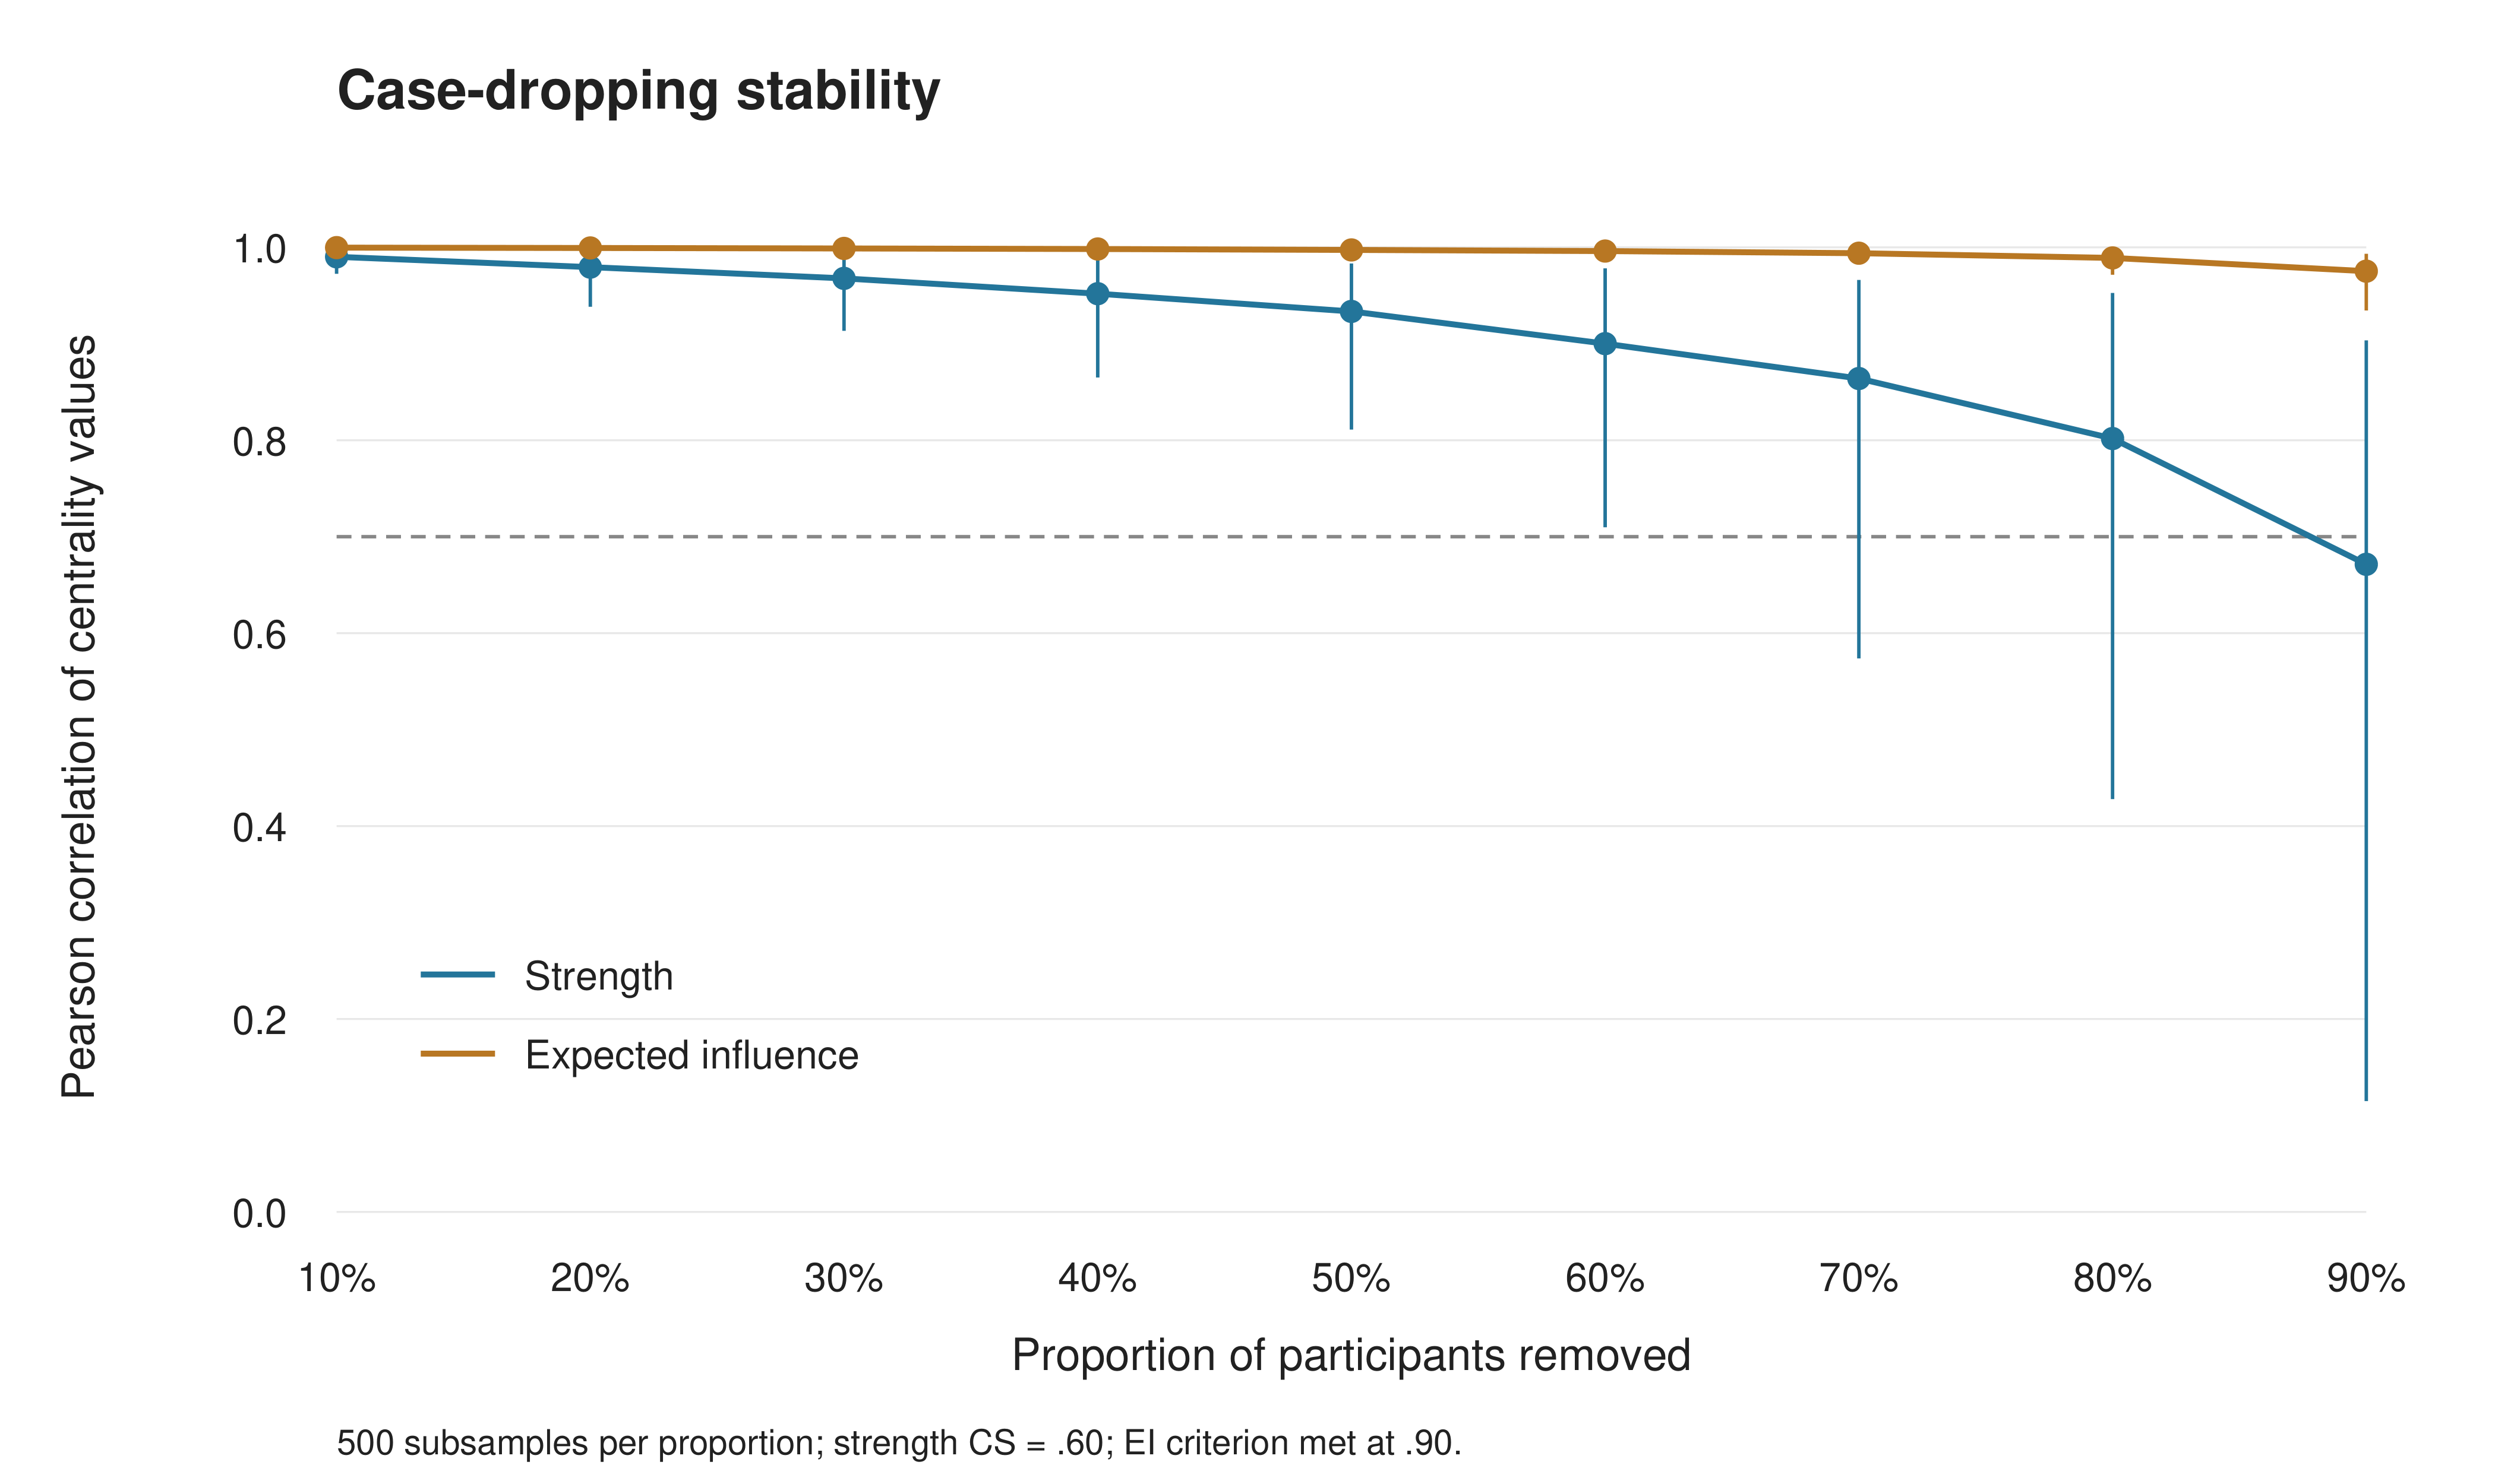
Note. Each case-dropping proportion was evaluated using 500 repetitions. Lines show the median Pearson correlation between subsample and full-sample centrality values; error bars indicate the 2.5th and 97.5th percentiles. The horizontal dashed line indicates r = .70. The CS criterion requires correlations of at least .70 in at least 95% of repetitions; it is not defined by the lower bound of the plotted 95% interval.

Fig. S2. All 36 edges and pointwise confidence intervals
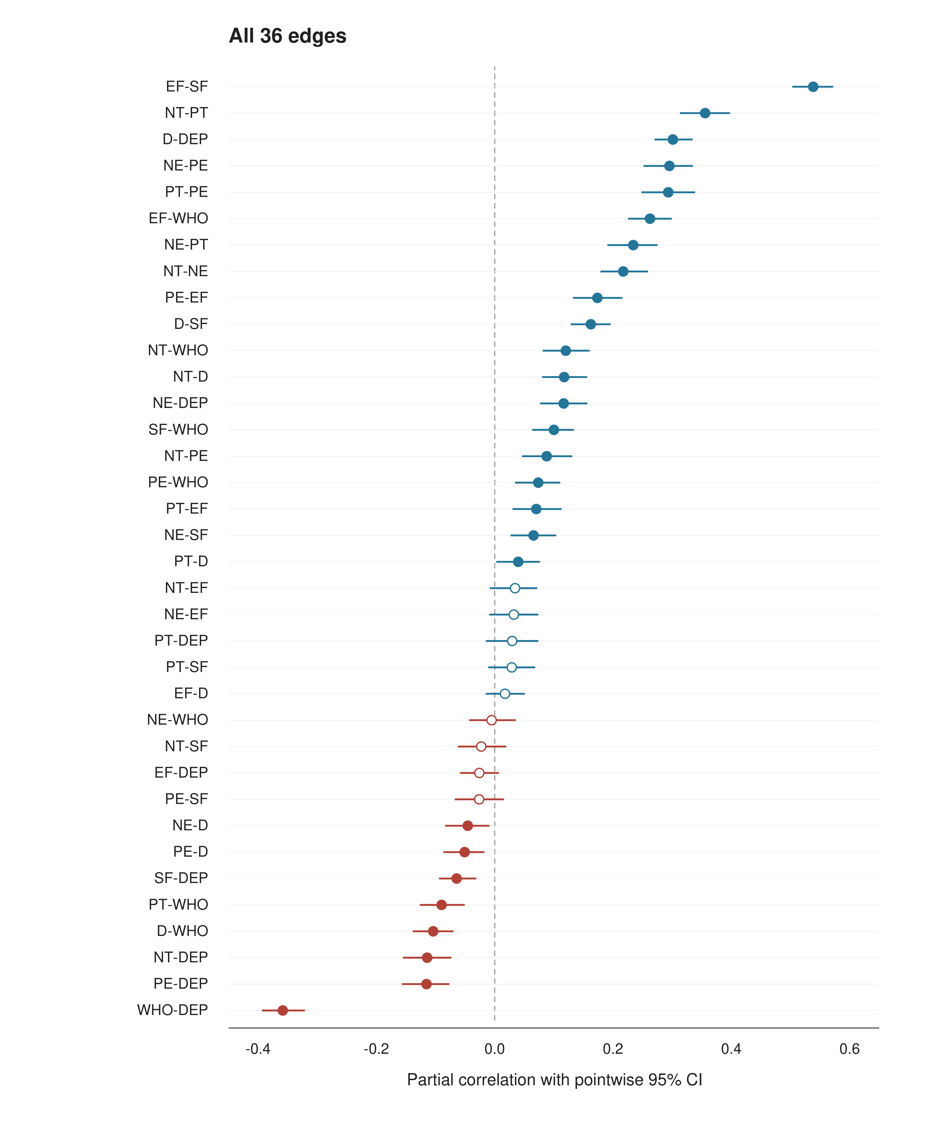
Note. All edges are shown, including those hidden in the main network figure because |rₚ| < .05. Open circles indicate pointwise confidence intervals that include zero. Intervals were not adjusted for multiple comparisons, and no edge-weight difference tests were performed. Abbreviations are the same as in Fig. 1.

Table S3. Changes in edge weights across sensitivity analyses relative to the primary analysis
Model | Mean absolute difference | Maximum absolute difference | Nonzero edges
Spearman partial correlations | 0.0162 | 0.0576 | 36
EBICglasso γ = .50 | 0.0095 | 0.0264 | 33
EBICglasso with thresholding | 0.0137 | 0.0456 | 27
Sex-adjusted | 0.0031 | 0.0116 | 36
Depression item 9 excluded | 0.0004 | 0.0020 | 36
Note. All comparisons used the same 2,766 participants and 36 unique node pairs. The primary analysis used unregularized Pearson partial correlations. The number of nonzero edges depends on the estimator and does not represent the number of statistically significant edges or true associations in the population.

