Table 1 Composition of Sea-water BG-11 medium (SWBG-11)
Compound | (gm L⁻¹)
Raw Salt | 32
Sodium Nitrate | 1.5
Dipotassium hydrogen phosphate | 0.04
Magnesium sulphate | 0.075
Calcium chloride | 0.036
Citric acid | 0.006
Ferric ammonium citrate | 0.006
Disodium EDTA | 0.001
Sodium carbonate | 0.2
Dihydrogen borate | 0.00286
Manganese chloride | 0.00181
Zinc sulphate | 0.000222
Sodium molybdate | 0.000390
Copper sulphate | 0.000079
Cobalt nitrate | 0.0000494
Dechlorinated Tapwater | 1000 mL

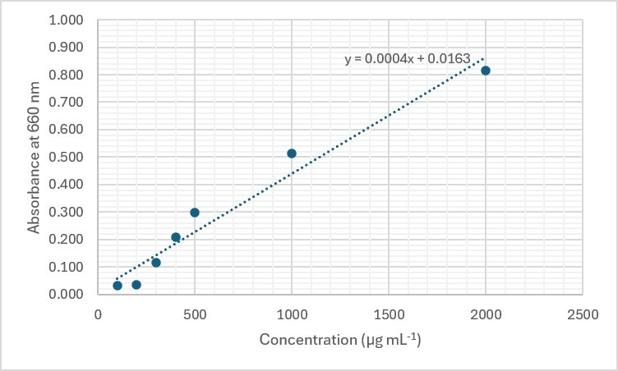
Fig. 1 Standard Curve for Protein Estimation

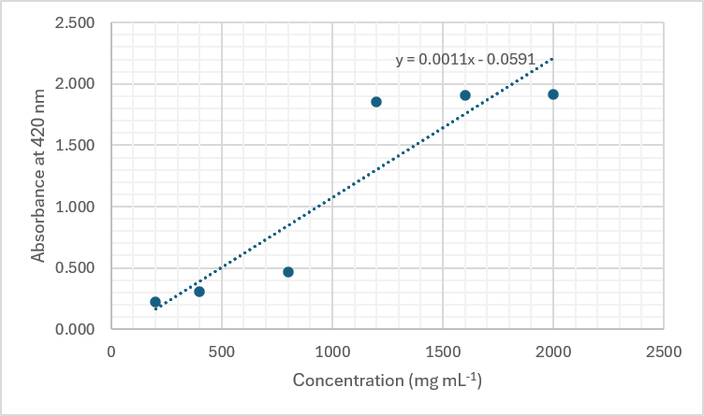
Fig. 2 Standard Curve for Sulphate Estimation

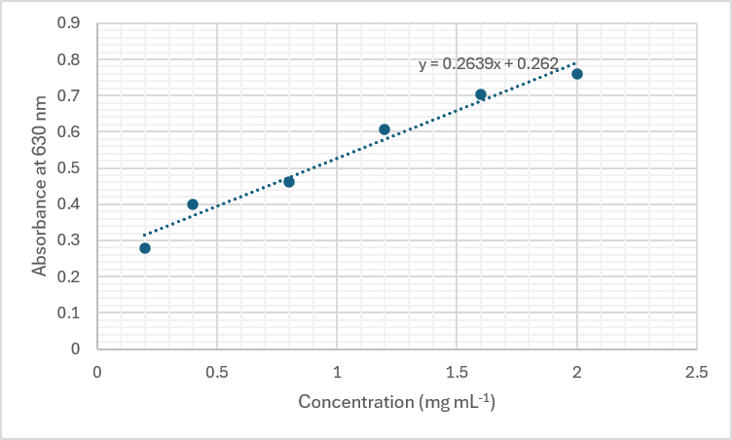
Fig. 3 Standard Curve for Carbohydrate Estimation

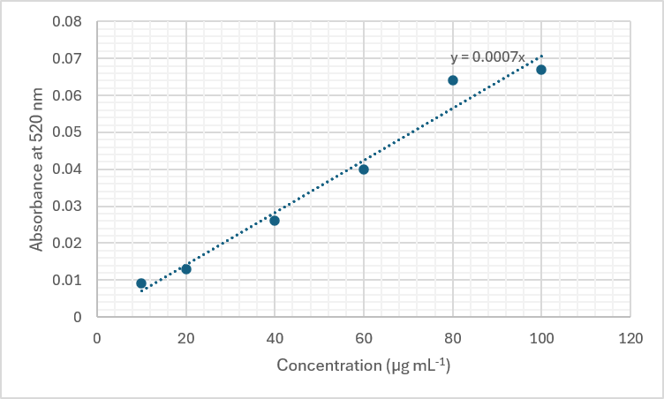
Fig. 4 Standard Curve for Uronic acid Estimation

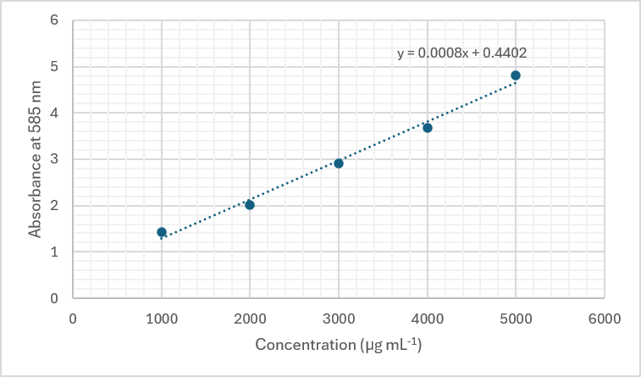
Fig. 5 Standard Curve for Dopamine Estimation

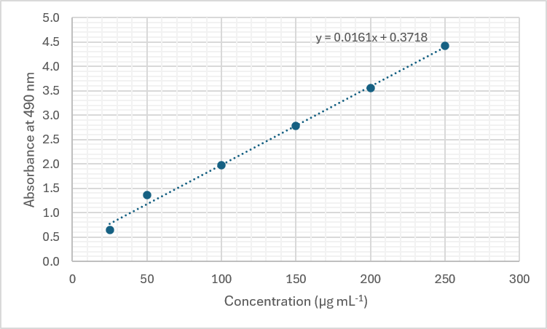
Fig. 6 Standard Curve for Epinephrine Estimation

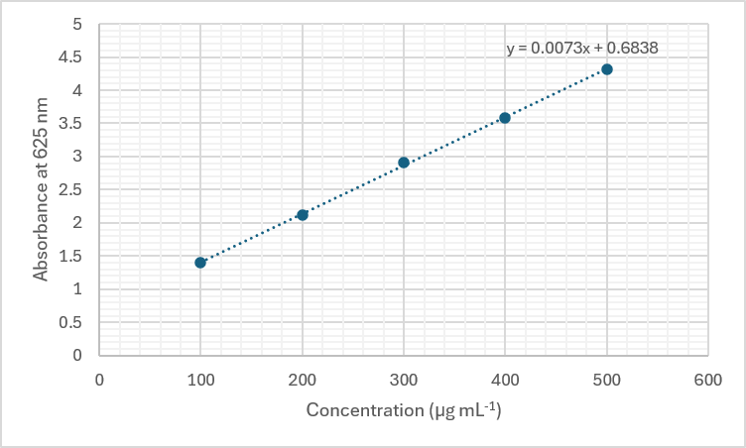
Fig. 7 Standard Curve for Serotonin Estimation

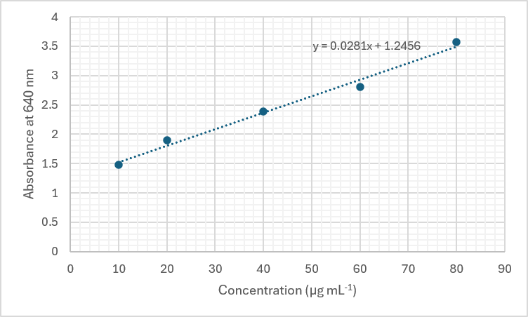
Fig. 8 Standard Curve for inorganic phosphate (iP) estimation for ATPase activity

