Supporting Information for
Repurposing TACE-Induced Hypoxia to Activate Biocatalytic Hydrogen Production and Potentiate Tirapazamine Chemoimmunotherapy Against Hepatocellular Carcinoma

Materials and Reagents
Synechocystis sp. PCC 6803 (Sp) was obtained from the Freshwater Algae Culture Collection at the Institute of Hydrobiology. Tirapazamine (TPZ, ≥98 %), hyaluronidase (HAase, from bovine testes), methylene blue (MB), JC‑1 staining kit, CCK‑8 assay kit, and FITC‑labelled antibodies were purchased from Sigma‑Aldrich. Hyaluronic acid (HA, molecular weight 1.2 MDa) was supplied by Macklin Biochemical. 1,4‑butanediol diglycidyl ether (BDE, crosslinker), Span‑80, mineral oil were obtained from Sigma‑Aldrich. Calreticulin (CRT), HMGB1, HSP70, γH2AX, Ki‑67, HIF‑1α primary antibodies were obtained from Abcam. Flow cytometry antibodies (CD86, CD206, F4/80, iNOS, CD3, CD8) were purchased from BD Biosciences. ELISA kits for TNF‑α, IL‑6, CCL22, IL‑10 were acquired from R&D Systems. Trizol reagent, RNA‑easy RNA isolation kit, mRNA capture beads, strand‑specific library construction kits were obtained from Thermo Fisher Scientific. All other analytical‑grade chemical reagents were used without further purification. HepG2 human hepatocellular carcinoma cell line was purchased from the American Type Culture Collection (ATCC). Vx2 tumor tissue for rabbit orthotopic HCC model was obtained from the laboratory‑preserved tumor bank. New Zealand white rabbits (male, 2.5‑3.0 kg) were purchased from the Laboratory Animal Center. All animal experiments were approved by the Institutional Animal Care and Use Committee (IACUC), and all operations complied with institutional guidelines.
Cultivation of Sp
Sp cells were cultured in BG‑11 liquid medium under continuous white‑light illumination (30 μmol photons m⁻² s⁻¹), at 28 °C with shaking at 120 rpm. For anaerobic hydrogen‑production assays, logarithmic‑phase Sp suspensions were purged with high‑purity N₂ for 30 min to establish anaerobic conditions. Oxygen‑rich groups were continuously aerated with compressed air. Cell density was monitored by measuring optical density at 730 nm (OD₇₃₀). For gas‑collection experiments, Sp suspensions were transferred into sealed gas‑tight vials; headspace gas was sampled at preset time points, and hydrogen concentration was quantified via gas‑phase mass spectrometry. Methylene‑blue redox assays were performed to detect reducing metabolites derived from Sp anaerobic metabolism: MB solution was mixed with Sp suspensions under aerobic/anaerobic conditions, and UV‑Vis absorbance spectra (400–700 nm) were recorded.
Microfluidic fabrication of hyaluronidase‑degradable Sp/TPZ@MNs
Monodisperse Sp/TPZ@MNs microspheres were generated via a flow‑focusing PDMS microfluidic chip for water‑in‑oil (W/O) droplet generation. Dispersed phase (aqueous phase): 4 % (w/v) hyaluronic acid was dissolved in sterile PBS (pH 7.4). Log‑phase Sp cells were harvested by centrifugation (3000 g, 5 min), washed twice with sterile PBS, and gently resuspended in HA aqueous solution. TPZ powder was pre‑dissolved in DMSO and incorporated into the Sp‑containing HA solution (final DMSO concentration < 0.5 %, v/v). The mixture was homogenized gently at low speed to avoid cyanobacterial damage, yielding the bioactive dispersed phase containing live Sp and TPZ prodrug. Continuous phase (oil phase): Mineral oil supplemented with 2 % (v/v) Span‑80 was prepared as the continuous oil phase.
The PDMS flow‑focusing microfluidic chip (orifice size: 100 μm) was mounted on an inverted microscope. Two syringe pumps were applied to infuse the dispersed phase and continuous phase into respective chip inlets. The flow rates were optimized as: dispersed phase = 150 μL h⁻¹, continuous phase = 1200 μL h⁻¹. Under stable shear‑focusing conditions, uniform W/O aqueous droplets containing Sp and TPZ were continuously generated at the flow‑focusing junction.
Droplets flowed out from the chip outlet and were collected into a glass vial pre‑filled with pre‑cooled mineral‑oil medium containing dissolved crosslinker 1,4‑butanediol diglycidyl ether (BDE). Crosslinking reaction proceeded under gentle shaking at 37 °C for 3 h to form covalently cross‑linked HA hydrogel microspheres. After crosslinking completion, microspheres were recovered by centrifugation (800 g, 3 min). Residual oil phase and surfactant were removed by repeated washing with n‑hexane followed by sterile cold PBS‑BG‑11 mixed buffer.
Control groups including blank MNs, Sp@Ms and TPZ@Ms were fabricated under identical microfluidic parameters, with corresponding payload omitted. All microspheres were stored at 4 °C in sterile PBS supplemented with diluted BG‑11 medium to maintain Sp viability and metabolic activity. For confocal visualization of payload distribution, TPZ was replaced by FITC‑dextran with comparable molecular weight.
Physicochemical characterizations of Sp/TPZ@MNs
Scanning electron microscopy (SEM): Purified Sp cells and lyophilized Sp/TPZ@MNs were fixed onto conductive adhesive tapes, sputter‑coated with platinum, and imaged under a field‑emission SEM (Zeiss Sigma 300) to record surface morphology. Laser confocal scanning microscopy (LCSM): Sp intrinsic red autofluorescence (phycobiliprotein, Ex = 550 nm, Em = 620–680 nm) and FITC‑labelled payload green fluorescence (Ex = 488 nm, Em = 500–540 nm) were detected under confocal microscope. Particle‑size distribution statistics were analyzed from confocal and optical‑microscopy images using ImageJ software. The coefficient of variation (CV) of microsphere diameter was calculated to evaluate monodispersity of microfluidic‑prepared microspheres. Sp viability and hydrogen‑production assay post‑encapsulation: Free Sp and Sp encapsulated within Sp/TPZ@MNs were incubated for 48 h under identical culture conditions. Sp viability was quantified via live/dead bacterial staining. Hydrogen production was measured by gas‑phase mass spectrometry in sealed anaerobic vials. Enzyme‑responsive degradation assay: Sp/TPZ@MNs were immersed in PBS containing 0, 25, 50 U mL⁻¹ hyaluronidase at 37 °C. At predetermined time intervals, residual microsphere weight was recorded, and residual weight percentage was calculated (n = 3 biological replicates). Rheological characterization: Rheological measurements were performed on a rotational rheometer (TA Instruments). Shear‑rate sweep (0.1–100 s⁻¹) was applied to record viscosity‑shear‑rate curves. Oscillatory strain sweep was conducted to acquire storage modulus (G′) and loss modulus (G′′). Compression mechanical test: Compression force‑deformation curves of blank MNs and Sp/TPZ@MNs were measured using a universal mechanical tester.
In‑vitro cell experiments
Cell culture: HepG2 cells were cultured in DMEM complete medium supplemented with 10 % fetal bovine serum, 100 U mL⁻¹ penicillin and 100 μg mL⁻¹ streptomycin, incubated at 37 °C under 5 % CO₂. Normoxic condition: 21 % O₂, 5 % CO₂; hypoxic condition: 1 % O₂, 5 % CO₂, 94 % N₂.
All in‑vitro cellular assays were performed under both normoxia and hypoxia conditions with identical treatment groups, including (1) Control: culture medium only, (2) Blank MNs: blank hyaluronic acid microspheres (without Sp and TPZ) (3) Sp@Ms: microspheres encapsulating only Sp, (4) TPZ@Ms: microspheres encapsulating only tirapazamine TPZ, and (5) Sp/TPZ@MNs: microspheres co‑encapsulating Sp and TPZ. Microsphere dosage was normalized to an identical mass concentration across all groups. Each group contained at least three biological replicates for phenotype detection.
CCK‑8 cell viability assay: HepG2 cells were seeded into 96‑well plates. After attachment, culture medium was replaced with medium containing different microsphere formulations, and cells were incubated under normoxia/hypoxia. After 24 h incubation, CCK‑8 reagent was added into each well. Absorbance at 450 nm was measured by microplate reader to calculate relative cell viability (n = 5 biological replicates).
Apoptosis detection by flow cytometry: HepG2 cells after different treatments were harvested, washed with pre‑cooled PBS, stained with Annexin V‑FITC/PI apoptosis detection kit according to manufacturer’s instructions. Apoptosis proportions were analyzed by flow cytometry.
Live/dead confocal staining: After treatment, HepG2 cells were stained with Calcein‑AM (live cells, green fluorescence) and PI (dead cells, red fluorescence). Confocal laser scanning microscope was used to acquire fluorescence images.
DNA‑damage γH2AX immunofluorescence staining: Cells were fixed with 4 % paraformaldehyde, permeabilized with 0.1 % Triton X‑100, blocked with 5 % BSA, incubated with anti‑γH2AX primary antibody overnight at 4 °C, followed by fluorophore‑conjugated secondary antibody. DAPI stained cell nuclei. Fluorescence intensity of γH2AX foci was quantified by ImageJ software.
Mitochondrial‑membrane‑potential (ΔΨm) detection by JC‑1 staining: JC‑1 working solution was added into treated HepG2 cells, incubated at 37 °C for 20 min. Cells were washed with JC‑1 staining buffer, and red‑green fluorescence signals were imaged under confocal microscope. Decrease in red/green fluorescence ratio indicates mitochondrial depolarization.
Detection of immunogenic cell death (ICD) markers: After microsphere treatment under normoxia or hypoxia, HepG2 cells were fixed and stained for ICD markers: surface calreticulin (CRT), extracellular HMGB1 and HSP70. Immunofluorescence images were captured by confocal microscopy, and mean fluorescence intensity (MFI) was quantified.
Co‑culture system for immune‑cell activation: umor‑cell‑conditioned medium (TCM) was collected from HepG2 cells receiving different treatments. Macrophage polarization assay: RAW264.7 macrophages were incubated with collected TCM for 24 h. Cells were harvested, stained with F4/80, CD86 (M1 marker), CD206 (M2 marker), and macrophage polarization profiles were analyzed by flow cytometry. Dendritic‑cell maturation assay: Bone‑marrow‑derived dendritic cells (BMDCs) from C57BL/6 mice were co‑cultured with TCM for 24 h. Cells were stained for CD80/CD86 maturation markers and analyzed via flow cytometry. Cell‑culture supernatants were collected for ELISA quantification of TNF‑α, IL‑6, CCL22 and IL‑10.
In‑vivo animal experiments
Establishment of rabbit orthotopic Vx2 HCC model: New Zealand white rabbits were anesthetized via intravenous injection of pentobarbital sodium. Abdominal laparotomy was performed to expose liver lobe. Small Vx2 tumor tissue fragments (~1 mm³) were surgically implanted into liver parenchyma. The abdominal cavity was closed layer‑by‑layer. After 12–14 days of tumor growth, T2‑weighted MRI was applied to confirm tumor formation before interventional embolization.
In‑vivo animal grouping: Rabbits bearing orthotopic Vx2 HCC tumors were randomly assigned to five experimental groups (n = 3 per group): (1) Control: TACE operation with sterile PBS infusion, (2) Blank MNs: embolization with blank hyaluronic acid microspheres, (3) Sp@Ms: embolization with Sp‑loaded microspheres, (4) TPZ@Ms: embolization with TPZ‑loaded microspheres, and (5) Sp/TPZ@MNs: embolization with Sp/TPZ co‑loaded microspheres. All groups received identical interventional surgical procedures; microsphere injection volume was standardized for each animal.
Interventional TACE operation: Under digital subtraction angiography (DSA) guidance, 2.7 F microcatheter was inserted through femoral artery and superselectively cannulated into tumor‑feeding hepatic artery. Corresponding microsphere suspensions were slowly infused for embolization. After embolization, catheter was withdrawn, femoral artery was compressed for hemostasis. Rabbits received postoperative analgesia and antibiotic prophylaxis.
Ex‑vivo optical tissue clearing: At predefined time‑points after TACE, tumor‑bearing liver tissues were harvested. Tissue‑clearing procedure was performed according to published protocols to remove tissue scattering. Red autofluorescence signal originating from Sp inside cleared liver tissues was visualized by near‑infrared fluorescence imaging.
In‑vivo biosafety evaluation: Peripheral blood was collected at day 0, 7, 15, 30 post‑TACE. Serum biochemical indicators including ALT, AST, BUN, Cre, GGT, CHO were measured to evaluate liver and kidney function; routine blood parameters (WBC, RBC) were also detected. Major organs (heart, liver, spleen, lung, kidney) were harvested, fixed in 4 % paraformaldehyde, embedded in paraffin, sectioned and stained with H&E for histological pathological assessment.
In‑vivo therapeutic efficacy assessment: T2‑weighted MRI scans were performed on day 0, 7, 14 after TACE. Tumor volume was calculated from MRI images. Individual tumor‑growth curves and average tumor‑growth curves were plotted. Harvested tumor tissues were fixed, paraffin‑embedded, sectioned and subjected to H&E, TUNEL, Ki‑67 and HIF‑1α immunohistochemical/immunofluorescence staining according to standard protocols. Quantitative analysis of fluorescence intensity and positive‑cell proportion was conducted with ImageJ. Tumor tissues were dissociated into single‑cell suspensions for flow‑cytometry immune‑cell profiling (mature DCs, M1/M2‑TAMs, CD8⁺ T cells). Immunofluorescence staining (CRT, HMGB1, HSP70, F4/80‑iNOS, CD3‑CD8) was performed on frozen tumor sections. Lung metastatic nodules were quantified from H&E‑stained whole‑lung sections.
Transcriptome RNA‑seq and detailed bioinformatic procedures: 1. Sample collection and total RNA extraction: At 14 days post‑TACE, tumor tissues from the Control group and Sp/TPZ@MNs group were rapidly dissected, rinsed with pre‑cooled sterile PBS, immediately frozen in liquid nitrogen, and stored at −80 °C. Three biological replicate tumor samples were collected for each group. Total RNA was isolated using Trizol reagent following manufacturer protocols. Briefly, tumor tissue was ground under liquid‑nitrogen cooling; TRIzol lysis buffer was added for homogenization; chloroform phase separation was performed; RNA was precipitated with isopropanol, washed with 75 % ethanol, and dissolved in RNase‑free water. RNA integrity was assessed by Agilent 2100 Bioanalyzer (RIN > 7.0 was required for subsequent library construction). RNA purity and concentration were quantified using Nanodrop and Qubit fluorometer. 2. mRNA enrichment and library construction: mRNA was enriched from total RNA using oligo‑dT magnetic beads to capture poly‑A‑containing mRNA molecules. Purified mRNA was fragmented into short fragments (200‑300 bp) under high‑temperature metal‑ion conditions. First‑strand cDNA was synthesized using random hexamer primers and reverse transcriptase. Second‑strand cDNA was synthesized with dNTP, DNA polymerase I and RNase H. End‑repair, A‑tailing and adapter ligation were performed sequentially. After adapter ligation, cDNA fragments were purified, followed by PCR amplification to construct strand‑specific RNA‑seq libraries. Library quality was validated by Agilent 2100 and qPCR quantification. 3. Illumina high‑throughput sequencing: Qualified libraries were loaded onto Illumina NovaSeq 6000 platform for paired‑end 150 bp (PE150) sequencing. Raw sequencing reads were generated. 4. Raw data filtering and genome mapping: Raw reads were processed by fastp software to remove adapter sequences, low‑quality reads and reads containing N base. Clean reads were mapped to the rabbit reference genome (OryCun2.0) using HISAT2 software. Gene expression level was calculated as fragments per kilobase of transcript per million mapped reads (FPKM). 5. Differential gene expression analysis: DESeq2 R package was used for differential‑expression analysis between Control and Sp/TPZ@MNs groups. Screening thresholds for differentially expressed genes (DEGs): |log₂(fold‑change)| > 1, adjusted *P*‑value < 0.05. Volcano plot and expression heatmap were generated to visualize DEG profiles. 6. Functional enrichment and GSEA: ClusterProfiler R package was applied for Gene Ontology (GO) biological‑process, cellular‑component, molecular‑function enrichment and KEGG pathway enrichment analysis, with adjusted *P* < 0.05 considered significantly enriched. Gene Set Enrichment Analysis (GSEA) was performed using pre‑ranked gene list to identify perturbed signaling pathways; normalized enrichment score (NES) and nominal P‑value were reported.
Statistical analysis: All quantitative data were presented as mean ± standard deviation (SD). Statistical comparisons were performed using GraphPad Prism 9. Student’s t‑test was applied for two‑group comparison; one‑way or two‑way ANOVA followed by Tukey’s post‑hoc test was used for multi‑group comparisons. P < 0.05 was considered statistically significant. ns, not significant; *P < 0.05, **P < 0.01, ***P < 0.001, ****P < 0.0001.
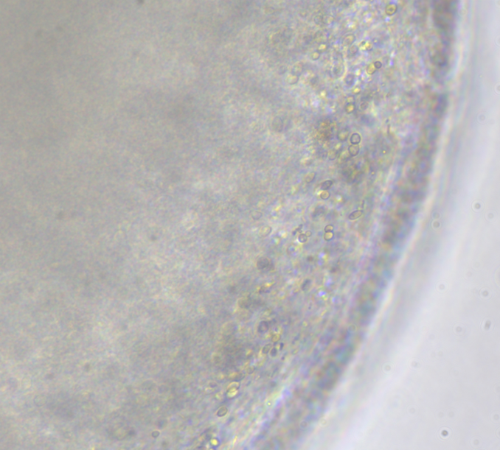
Figure S1. Optical microscope image of Sp/TPZ@MNs.

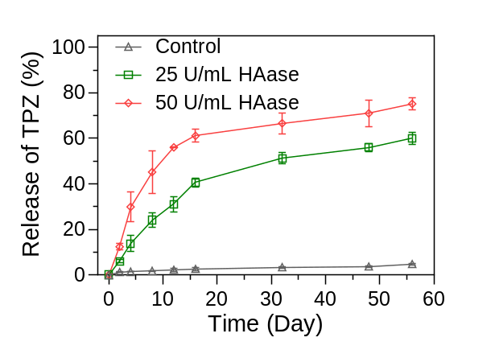
Figure S2. Degradation profiles of Sp/TPZ@MNs at hyaluronidase (HAase) concentrations of 25 and 50 U/mL (n = 3 biological samples).

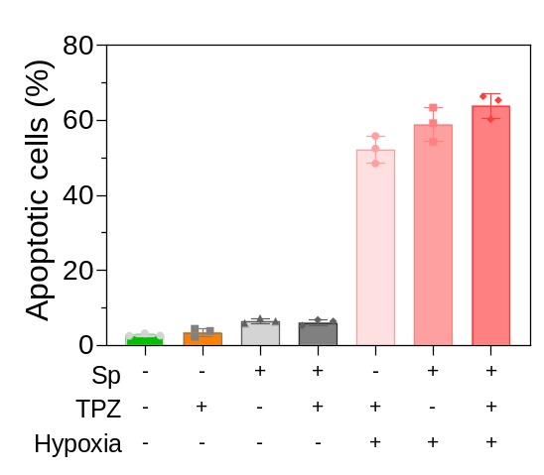
Figure S3. Quantitative flow‑cytometric analysis of apoptosis in HepG2 cells treated with different gel systems under varied experimental conditions.

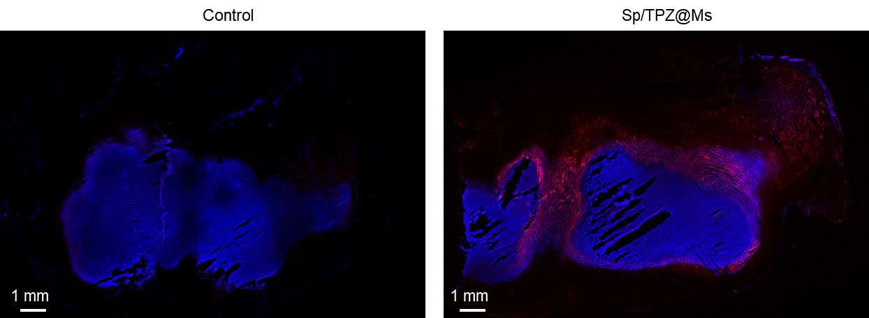
Figure S4. Immunofluorescence micrographs of tumor tissue sections displaying intrinsic Sp autofluorescence within tumor parenchyma.

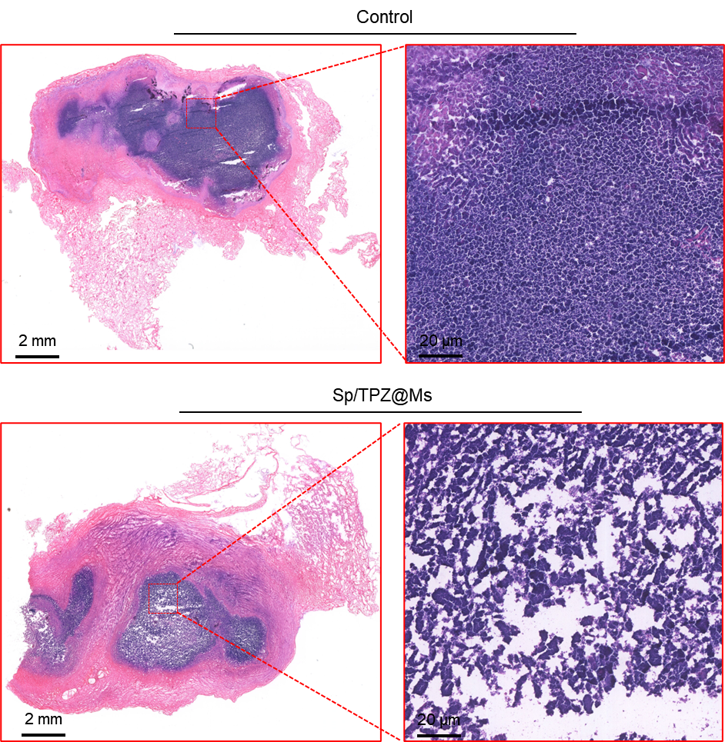
Figure S5. H&E-stained liver sections of tumor-bearing rabbits before and post-embolization with Sp/TPZ@MNs.

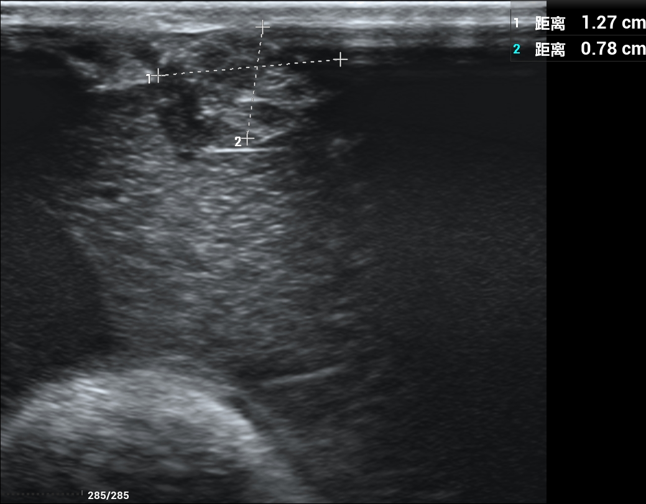
Figure S7. Representative in‑vivo ultrasound image of the tumor. The cross‑calipers indicate the longitudinal (1.27 cm) and transverse (0.78 cm) dimensions of the tumor lesion.
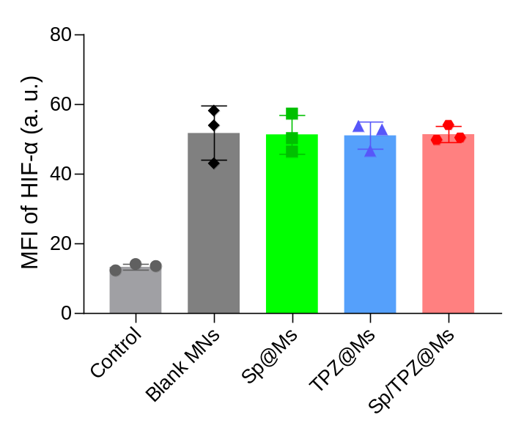
Figure S8. Quantitative statistical analysis of the relative fluorescence intensity of HIF-α from immunofluorescence-stained tumor sections. Data are presented as mean ± SD.
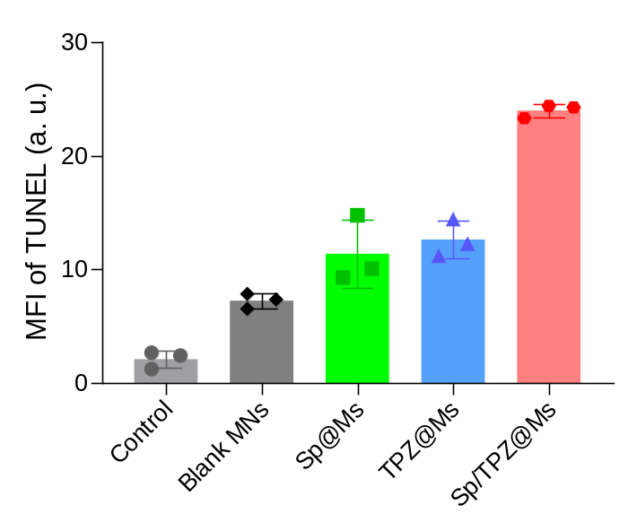
Figure S9. Quantitative statistical analysis of the relative fluorescence intensity of TUNEL from immunofluorescence-stained tumor sections. Data are presented as mean ± SD.
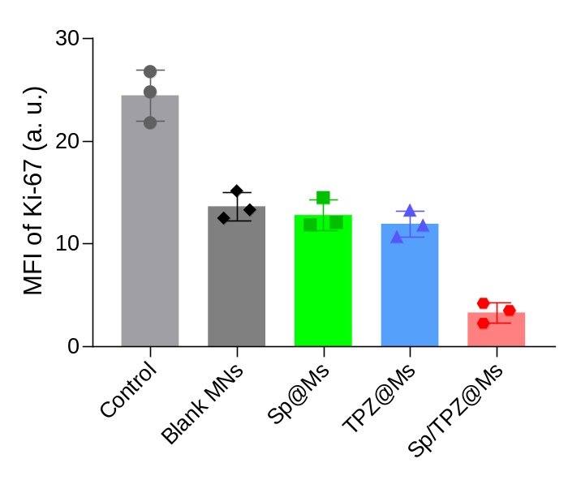
Figure S10. Quantitative statistical analysis of the relative fluorescence intensity of Ki-67 from immunofluorescence-stained tumor sections. Data are presented as mean ± SD.

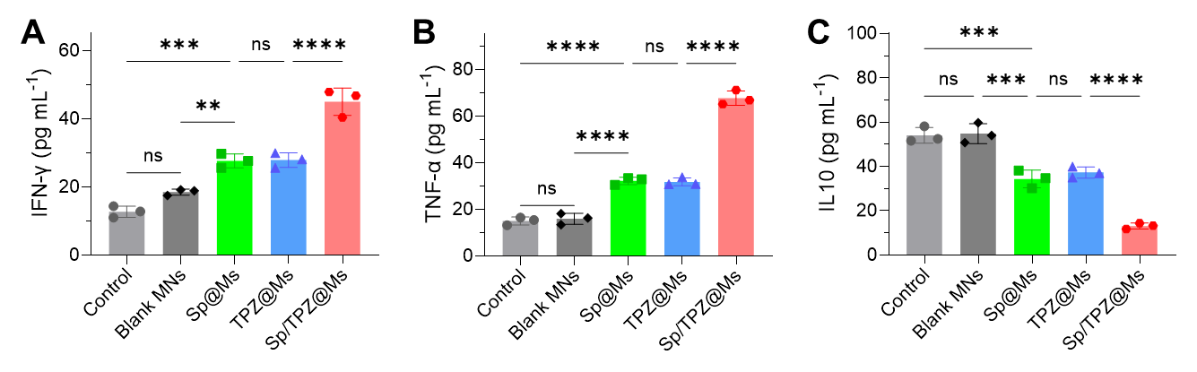
Figure S11. (A‑C) ELISA measurements of pro‑inflammatory IFN‑γ (A), TNF‑α (B) and anti‑inflammatory IL‑10 (C) across different experimental groups. Elevated pro‑inflammatory cytokines and decreased IL‑10 indicate the activation of anti‑tumor immune responses. Data are mean ± SD. ns, not significant. **p < 0.01, ***p < 0.001, ****p < 0.0001.

