Supplementary Information: Phonon-mode-specific spin-flip scattering dictated ultrafast demagnetization in a van der Waals ferromagnet
Yuting Gong^{1, 2, 3, 8}, Zhaobo Zhou^{4, 8}, Pengfei Yan^{1, 2, 3}, Yu Liu^{1, 2, 3}, Qi Liu^{1, 2, 3}, Yongkang Xu^{1, 2, 3}, Chenyin Jiao⁵, Jiaze Qin⁵, Yu Yan², Yao Li^{1, 2}, Liang He^{1, 2}, Jing Wu^{6, 7}, Shenghai Pei⁵, Juan Xia^{5,*}, Junjie He^{4,*}, Yongbing Xu^{1, 2, 3, 7, *}, Xianyang Lu^{1, 2, 3, *}
¹State Key Laboratory of Spintronics, Nanjing University, Suzhou 215163, China.
²Jiangsu Provincial Key Laboratory of Advanced Photonic and Electronic Materials, School of Electronic Science and Engineering, Nanjing University, Nanjing 210093, China.
³School of Integrated Circuits, Nanjing University, Suzhou 215163, China.
⁴Faculty of Science, Charles University, 12843 Prague, Czech Republic
⁵Institute of Fundamental and Frontier Sciences, University of Electronic Science and Technology of China, Chengdu 610054, China.
⁶School of Integrated Circuits, Guangdong University of Technology, Guangzhou 510006, China.
⁷York-Nanjing International Center for Spintronics (YNICS), School of Physics, Engineering and Technology, University of York, York YO10 5DD, UK.
⁸These authors contributed equally: Yuting Gong, Zhaobo Zhou.
* Authors to whom correspondence should be addressed: juanxia@uestc.edu.cn, junjie.he@natur.cuni.cz, ybxu@nju.edu.cn and xylu@nju.edu.cn.
- Temperature-dependent magnetic properties
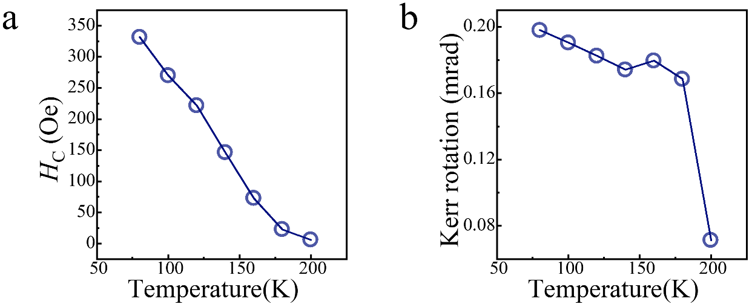
Fig. S1 Temperature dependence of a coercive field $H_{C}$ and b Kerr rotation derived from the MOKE hysteresis loops in Fig. 1d.

- Density functional theory (DFT) calculation
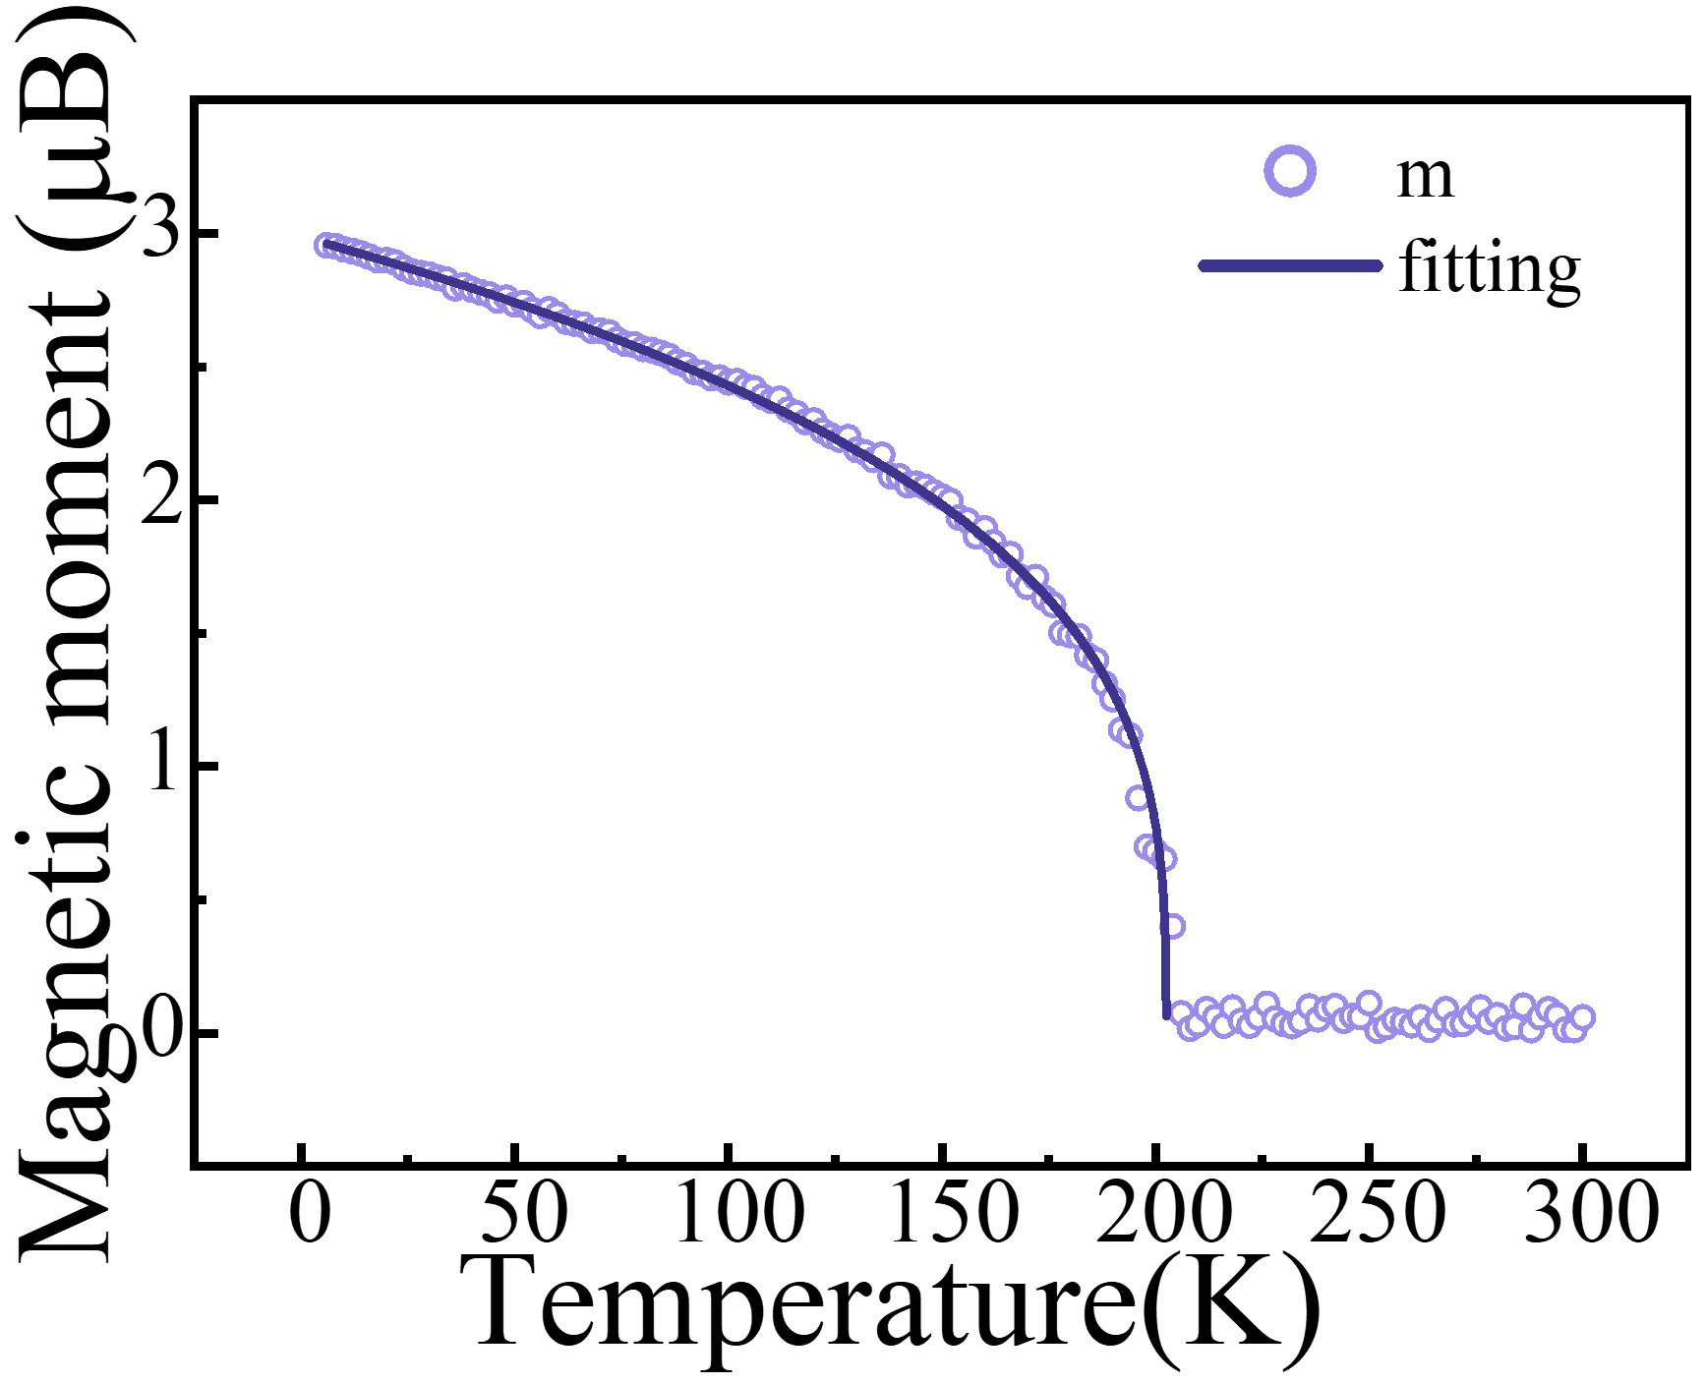
Fig. S2 The Monte Carlo simulated temperature-dependent magnetic moment of ${CrTe}_{2}$. The solid line is the scaling law fitting curve, as described in the text.
The DFT calculation in this work was performed using the Vienna Ab initio Simulation Package (VASP). The k-point density with the Monkhorst-Pack scheme is 16×16×1, and the cutoff energy is 500 eV. The Perdew-Burke-Ernzerhof (PBE) of generalized gradient approximation (GGA) was employed as the exchange-correlation functional. Then, the maximally localized Wannier function was obtained by the Wannier90 code. The magnetic exchange parameters of ${CrTe}_{2}$ were extracted using TB2J and used as input for Monte Carlo simulations performed with the VAMPIRE atomistic spin dynamics code. The simulation cell contained 24,215 Cr sites. As depicted in Supplementary Fig. S2, the temperature dependence of the magnetic moment is obtained through Monte Carlo simulations. Below the Curie temperature, the magnetic moment was fitted using the scaling law $M∝{\left(T_{C}-T\right)}^{β}$, as a result of the spontaneous magnetization. The fitted result is represented by the solid line in Fig. S2 with $T_{C}=202.4±0.5$ K. The critical exponent $β$ was deduced to be $0.304±0.005$, close to the value of 0.325 for 3D-Ising model, also comparable to the experimental value of 0.301 deduced from the temperature-dependent demagnetization relaxation time in Fig. S3b¹.

- Additional M3TM fitting results and the power-law analysis of $τ_{M}$
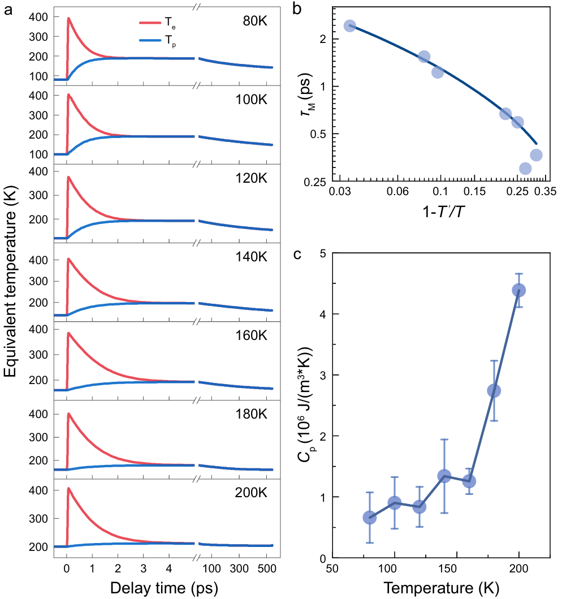
Fig. S3 a Time evolution of the electron temperature $T_{e}$ (red) and phonon temperature $T_{p}$ (blue) obtained from the M3TM fitting at temperatures from 80 to 200 K. b Log-log plot of temperature-dependent demagnetization relaxation time $τ_{M}$ as a function of $1-\frac{T^{'}}{T_{C}}$. The solid line is a power-law fit near $T_{C}$, ${\left(1-\frac{T^{'}}{T_{C}}\right)}^{-zv}$ yielding $zv=0.301±0.046$. c Temperature dependence of the lattice heat capacity $C_{p}$ extracted from the M3TM fitting. The error bars represent the standard errors obtained from the least squares fitting procedure.
Fig. S3a presents the time evolutions of $T_{e}$ and $T_{p}$ at different initial temperatures from 80 to 200 K, obtained by fitting the TRMOKE traces using the M3TM equations given in the main text. Immediately after laser pulse excitation, $T_{e}$ rises rapidly and then relaxes towards $T_{p}$ through electron–phonon energy transfer, while $T_{p}$ increases more gradually and approaches a quasi-equilibrium state with the electron subsystem. Fig. S3b shows the power-law fitting of $τ_{M}$, plotted log-log as a function of $1-{T^{'}}/{T_{C}}$, where $T^{'}$ describes the quasiequilibrium temperature between electron and phonon. According to the second order phase transition described by the dynamical scaling theory, $τ_{M}$ is proportional to ${\left(T_{C}-T^{'}\right)}^{-zv}$ in the vicinity of $T_{C}$, where $v$ and $z$ represent the critical exponent of the correlation length and the dynamical critical exponent, respectively². As shown in Fig. S3b, the data near $T_{C}$ are well described by a power-law fit, yielding $zv=0.301±0.046$. This value is close to the reported value of approximately 0.325 for the 3D-Ising model¹. Fig. S3c shows the temperature dependence of $C_{p}$ obtained from the M3TM fitting.$C_{p}$ remains relatively small at low temperatures and increases markedly as the temperature approaches $T_{C}$.

- Time-resolved reflectivity of ${CrTe}_{2}$
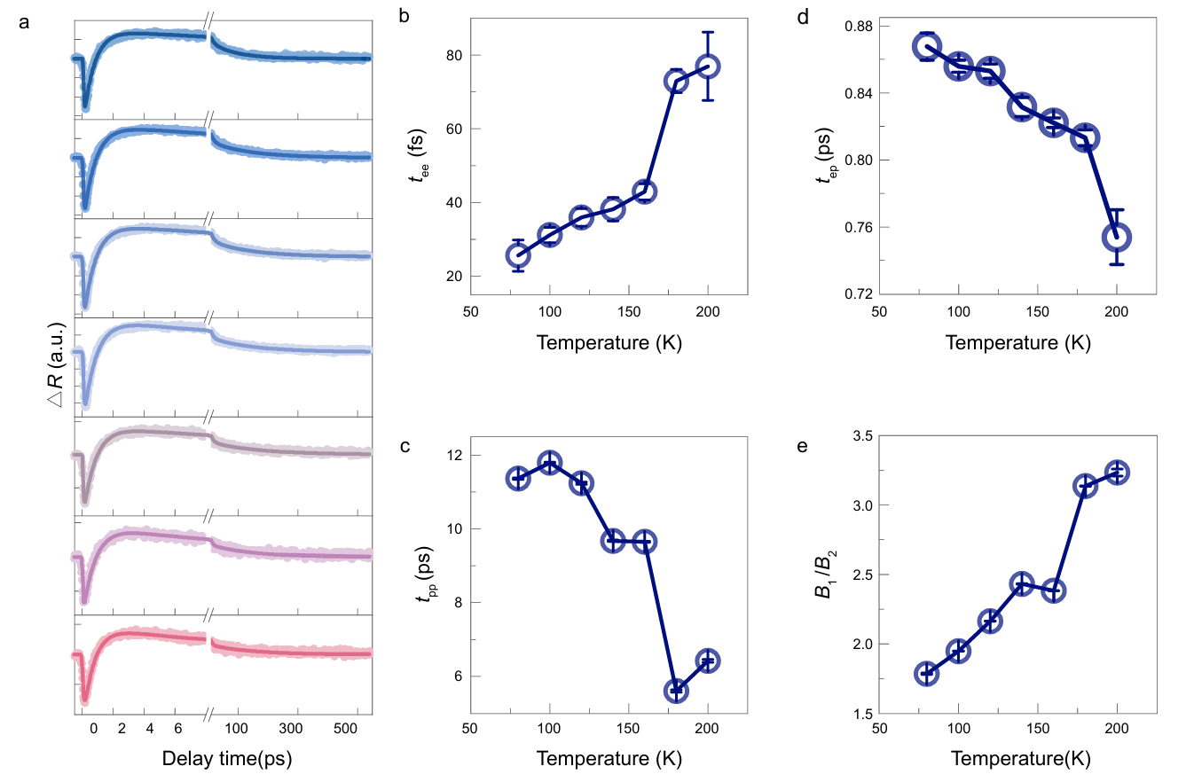
Fig. S4 a Transient reflectivity changes, $∆R$, measured for a 10-layer ${CrTe}_{2}$ film at temperatures from 80 to 200 K. The symbols represent the experimental data, and the solid curves are the best fits obtained using the phenomenological relaxation model described below. Temperature dependences of the fitted b e-e thermalization time constants, c p-p coupling time constants, d e-p coupling time constants and e relative amplitude ratio $B_{1}/B_{2}$.
Fig. S4a shows the transient reflectivity changes $∆R$ within a temperature range of 80-200 K. Immediately after optical excitation at zero time-delay, $∆R$ exhibits a negative response. This rapid response corresponds to the rapid redistribution and thermalization of the photoexcited carriers through electron–electron (e-e) scattering with the small heat capacity of electron system³. After this initial electronic response, the hot electron population transfers energy to the lattice through electron–phonon (e-p) coupling, producing a slower recovery and rise over several picoseconds.
To fully capture the complex lattice dynamics, the phonon subsystem was divided phenomenologically into optical- and acoustic-phonon contributions. Energy transfer from the optical phonon subsystem to lower-energy acoustic phonons was described by phonon–phonon (p-p) coupling^{4, 5}. Additionally, heat dissipation to the substrate cannot be ignored, because the investigated sample is a 10-layer ${CrTe}_{2}$(6 nm). To quantitatively describe these four processes, the following phenomenological model is applied to fit $∆R$^{3, 6}:
$$\begin{aligned}∆R=\left[A\left(1-e^{-\frac{t}{t_{ee}}}\right)e^{-\frac{t}{t_{ep}}}+B_{1}\left(1-e^{-\frac{t}{t_{ep}}}\right)e^{-\frac{t}{t_{pp}}}+B_{2}\left(1-e^{-\frac{t}{t_{pp}}}\right)\right]e^{-\frac{t}{t_{th}}}\#\#\#( LISTNUM NumberDefault \end{aligned}$$
where the first term characterizes the initial electronic response with e-e coupling time constant $t_{ee}$, and $t_{ep}$ describes the subsequent transfer of energy from the electronic subsystem to the lattice. The second and third terms account for the optical- and acoustic-phonon related responses, respectively, with $t_{pp}$ characterizing energy transfer between the two phonon subsystems.
The long timescale heat dissipation to the substrate is characterized by $t_{th}$. The coefficients $A, B_{1}, B_{2}$ denote the amplitudes of the corresponding electronic, optical-phonon and acoustic-phonon contributions. The fitting function was convoluted with a Gaussian-shaped temporal profile accounting for the cross-correlated time width (~ 110 fs) of the laser pulses. The solid curves in Fig. S4a reproduce the measured $∆R$ over the full delay time range.
The extracted relaxation parameters are summarized in Fig. S4b–e. Because $t_{ee}$ is comparable to or shorter than the pulse duration (~ 50 fs), its absolute value cannot be determined independently with high precision and should therefore be regarded as an effective e-e thermalization time. Nevertheless, its magnitude is comparable to values reported for other vdW materials^{7, 8}. $t_{ep}$ (Fig. S4d) is used to estimate the spin-unresolved thermal e-p coupling parameter $λ_{R}$, as described in the following section. The $t_{pp}$ plotted in Fig. S4c exhibits a decreasing trend with increasing temperature, arising from the increased thermal population of phonons and the associated increase in anharmonic scattering processes. Meanwhile, the amplitude ratio $B_{1}/B_{2}$ increases with temperature (Fig. S4e), indicating an enhanced relative contribution of the optical phonon related component to the transient reflectivity response.

- Temperature-dependent Raman spectra and Fano line-shape analysis
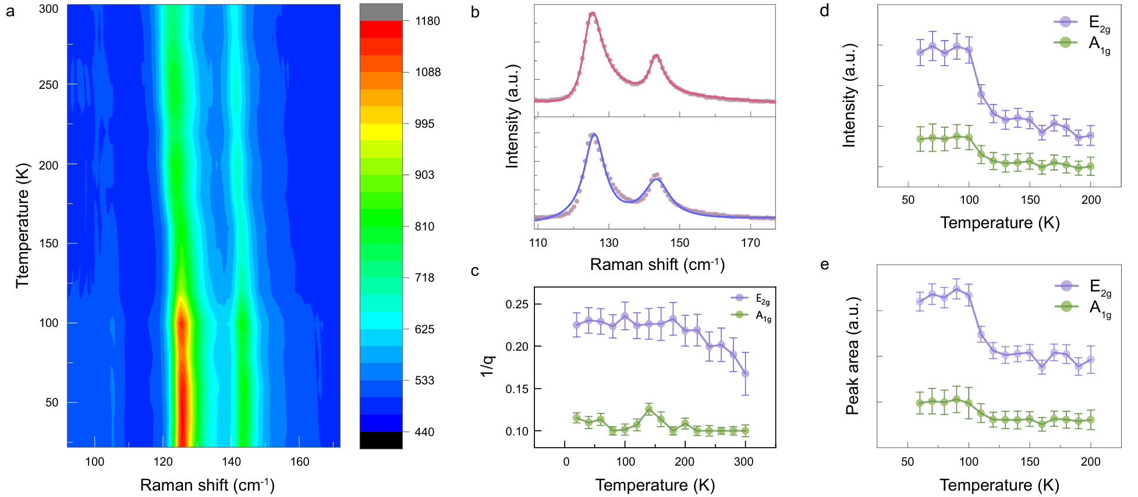
Fig. S5 a Temperature map of the Raman spectra of the 10-layer ${CrTe}_{2}$ film measured from 20 to 300 K. b Representative Raman spectra measured at 120 K and analyzed using Lorentzian and Fano line profiles. The symbols represent the experimental data, and the solid curves denote the corresponding fits. Temperature dependences of the fitted c, inverse Fano asymmetry parameters $1/q$, d, Raman peak intensities and e, peak areas for the $E_{2g}$ and $A_{1g}$ modes. Error bars represent the standard errors obtained from the least squares fitting procedure.

Supplementary Fig. S5 presents the temperature-dependent Raman spectra and the corresponding analysis. Fig. S5a shows the evolution of the $E_{2g}$ and $A_{1g}$ Raman modes between 20 and 300 K. Both modes remain clearly resolved throughout the measured temperature range. To determine an appropriate fitting function, a representative Raman spectrum measured at 120 K was analysed using both symmetric Lorentzian and asymmetric Fano profiles. As shown in Fig. S5b, the Lorentzian function does not fully reproduce the asymmetric spectral line shapes, whereas the Fano profile provides a visibly improved description of both Raman peaks. The Fano function was therefore used to extract the temperature-dependent Raman parameters:
$$I(ω)=A\frac{{\left(q+ε(ω)\right)}^{2}}{1+ε^{2}}$$
$$ε(ω)=2(ω-ω_{0})/Γ$$
where $A$ is an intensity scale factor, $ω_{0}$ is the resonance frequency, $Γ$ is the Fano linewidth parameter and $q$ is the asymmetry parameter. The magnitude of $q$ determines the degree of line-shape asymmetry. Accordingly, $1/q$ was used to represent the temperature evolution of the Fano asymmetry, with a larger $1/q$ corresponding to a more pronounced asymmetric line shape.
The fitted peak intensities and peak areas of the $E_{2g}$ and $A_{1g}$ modes are summarized in Fig. S5d and e, respectively. Both quantities exhibit a pronounced reduction over the intermediate temperature range. Fig. S5c shows the inverse Fano asymmetry parameter $1/q$. The $E_{2g}$ mode exhibits a larger $1/q$ than the $A_{1g}$ mode over most of the investigated temperature range, indicating a more pronounced asymmetric line shape. Here, $1/q$ is used as a measure of the spectral asymmetry and is not interpreted independently as a direct quantitative measure of the e-p coupling strength.

- Temperature-dependent spin-unresolved electron–phonon coupling extracted from transient reflectivity
To estimate the temperature-dependent e-p coupling associated with the transient reflectivity response, we applied Allen’s model, which has been widely used to analyze ultrafast laser-induced electronic energy relaxation ^{6, 9-11}:
$$λ_{R}=\frac{2πk_{B}T_{e}^{Peak}}{3ℏt_{ep}ω_{D}^{2}},$$
where $t_{ep}, T_{e}^{Peak} and ω_{D}$ represent the e–p energy relaxation time extracted from the transient reflectivity dynamics, the electronic peak temperature and the Debye frequency, respectively. The frequency used here is a characteristic phonon frequency which could be replaced by maximum phonon frequency or the average phonon frequency⁶. The temperature dependence of Debye frequency was neglected to simplify the analysis. $ω_{D}$ is estimated using the equation$k_{B}Θ_{D}=ℏω_{D}$, with the Debye temperature $Θ_{D}$ of ${CrTe}_{2}$ found to be 217 K¹². As for $T_{e}^{Peak}$, we estimated this parameter from the absorbed laser energy density by using the equation: $E_{a}=γ\left({\left(T_{e}^{Peak}\right)}^{2}-T_{0}^{2}\right)/2$, where $T_{0}$ represents the ambient temperature and $γ$ is the electronic specific heat of ${CrTe}_{2}$⁶. The absorbed laser energy per unit volume $E_{a}$ is estimated with $E_{a}=\left[1-e^{-d/λ}\right]ϕ\left(1-R\right)/d$, in which $ϕ$ is the incident laser fluence of ${0.126 mJ}/{{cm}^{2}}$, $R$ is the reflectivity of ${CrTe}_{2}$, $d=6$nm is the film thickness and $λ\sim 20$ nm is the skin depth of pump fluence¹³. This model is based on an assumption that the e-e thermalization occurs much faster than e-p energy relaxation, allowing the electronic subsystem to establish an effective temperature before substantial energy is transferred to the lattice ^{10, 14, 15}. The extracted timescales in Fig. S4b and d support this approximation, thereby validating the applicability of Allen’s theory for estimating $λ_{R}$ in ${CrTe}_{2}$.
Fig. S6 compares $λ_{R}$ with the mode-resolved coupling constants $λ_{E_{2g}}$ and $λ_{A_{1g}}$ obtained from the Raman spectra (detailed in the main text). Because $λ_{R}$ is derived from the spin-unresolved electronic relaxation time, it characterizes the effective energy transfer from electrons to the lattice, including scattering events that either conserve or reverse the electronic spin. In contrast, $λ_{Kerr}$ is obtained from the magnetic response and therefore represents a demagnetization sensitive effective e–p coupling associated with the spin-flip scattering. Between 80 and 200 K, $λ_{R}$ remains substantially closer to $λ_{A_{1g}}$, while increasing moderately with temperature. Its proximity to $λ_{A_{1g}}$ is consistent with a stronger contribution of the $A_{1g}$ phonon to electronic energy relaxation, whereas its gradual increase suggests a growing contribution from $E_{2g}$-related scattering. This contrasting temperature dependence of $λ_{R}$ and $λ_{Kerr}$ demonstrate that the $E_{2g}$ and $A_{1g}$ phonons carry different relative weights in mediating electronic energy relaxation and spin relaxation, reinforcing the phonon-mode-specific picture of the spin-flip scattering discussed in the main text.
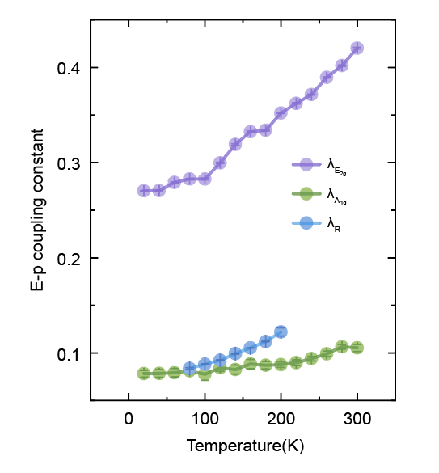
Fig. S6 Temperature dependence of the dimensionless mode-resolved e-p coupling constant $λ_{E_{2g}}$ and $λ_{A_{1g}}$, extracted from Raman spectra, and $λ_{R}$ estimated from time-resolved reflectivity.

1. Zheng, H., et al. Two-dimensional van der Waals ferromagnetic thin film CrTe₂ with high Curie temperature and metallic conductivity. Appl. Phys. Lett. 122, 023103 (2023).
2. Kise, T., et al. Ultrafast Spin Dynamics and Critical Behavior in Half-Metallic Ferromagnet: Sr₂FeMoO₆. Phys. Rev. Lett. 85, 1986-1989 (2000).
3. Carpene, E., et al. Dynamics of electron-magnon interaction and ultrafast demagnetization in thin iron films. Phys. Rev. B 78, 174422 (2008).
4. Stange, A., et al. Hot electron cooling in graphite: Supercollision versus hot phonon decay. Phys. Rev. B 92, 184303 (2015).
5. Scheuch, M., et al. Temperature dependence of ultrafast phonon dynamics in graphite. Appl. Phys. Lett. 99, 211908 (2011).
6. Lu, X., et al. Sub-100 femtosecond time scale spin dynamics in epitaxial Fe₃O₄ thin film. Appl. Surf. Sci. 572, 151456 (2022).
7. Karni, O., Esin, I. & Dani, K. M. Through the Lens of a Momentum Microscope: Viewing Light-Induced Quantum Phenomena in 2D Materials. Adv. Mater. 35, e2204120 (2023).
8. Takeda, K. S., et al. Ultrafast Electron-Electron Scattering in Metallic Phase of 2H-NbSe₂ Probed by High Harmonic Generation. Phys. Rev. Lett. 132, 186901 (2024).
9. Allen, P. B. Empirical electron-phonon λ values from resistivity of cubic metallic elements. Phys. Rev. B 36, 2920-2923 (1987).
10. Zhang, Q., et al. Simultaneous capturing phonon and electron dynamics in MXenes. Nat. Commun. 13, 7900 (2022).
11. Tian, Y. C., et al. Ultrafast Dynamics Evidence of High Temperature Superconductivity in Single Unit Cell FeSe on SrTiO₃. Phys. Rev. Lett. 116, 107001 (2016).
12. Freitas, D. C., et al. Ferromagnetism in layered metastable 1T-CrTe₂. J. Phys. Condens. Matter 27, 176002 (2015).
13. Zhou, H., Zhang, Y. & Zhao, W. Tunable Tunneling Magnetoresistance in van der Waals Magnetic Tunnel Junctions with 1T-CrTe₂ Electrodes. ACS Appl. Mater. Interfaces 13, 1214-1221 (2021).
14. Brorson, S. D., et al. Femtosecond room-temperature measurement of the electron-phonon coupling constant γ in metallic superconductors. Phys. Rev. Lett. 64, 2172-2175 (1990).
15. Gadermaier, C., et al. Electron-Phonon Coupling in High-Temperature Cuprate Superconductors Determined from Electron Relaxation Rates. Phys. Rev. Lett. 105, 257001 (2010).

