Supplementary Information
Supplemental Fig. 1A Selected ion chromatogram corresponding of 4-OH-2-CB with PAPS-activated (A) and deactivated (B) incubated in human liver cytosol for 40 minutes. Selected ion chromatogram corresponding of m/z 203.0269 and isotope mass (C). Selected ion chromatogram corresponding of m/z 282.9834 and isotope mass (D). The fragment ions of 4-OH-2-CBS (E).
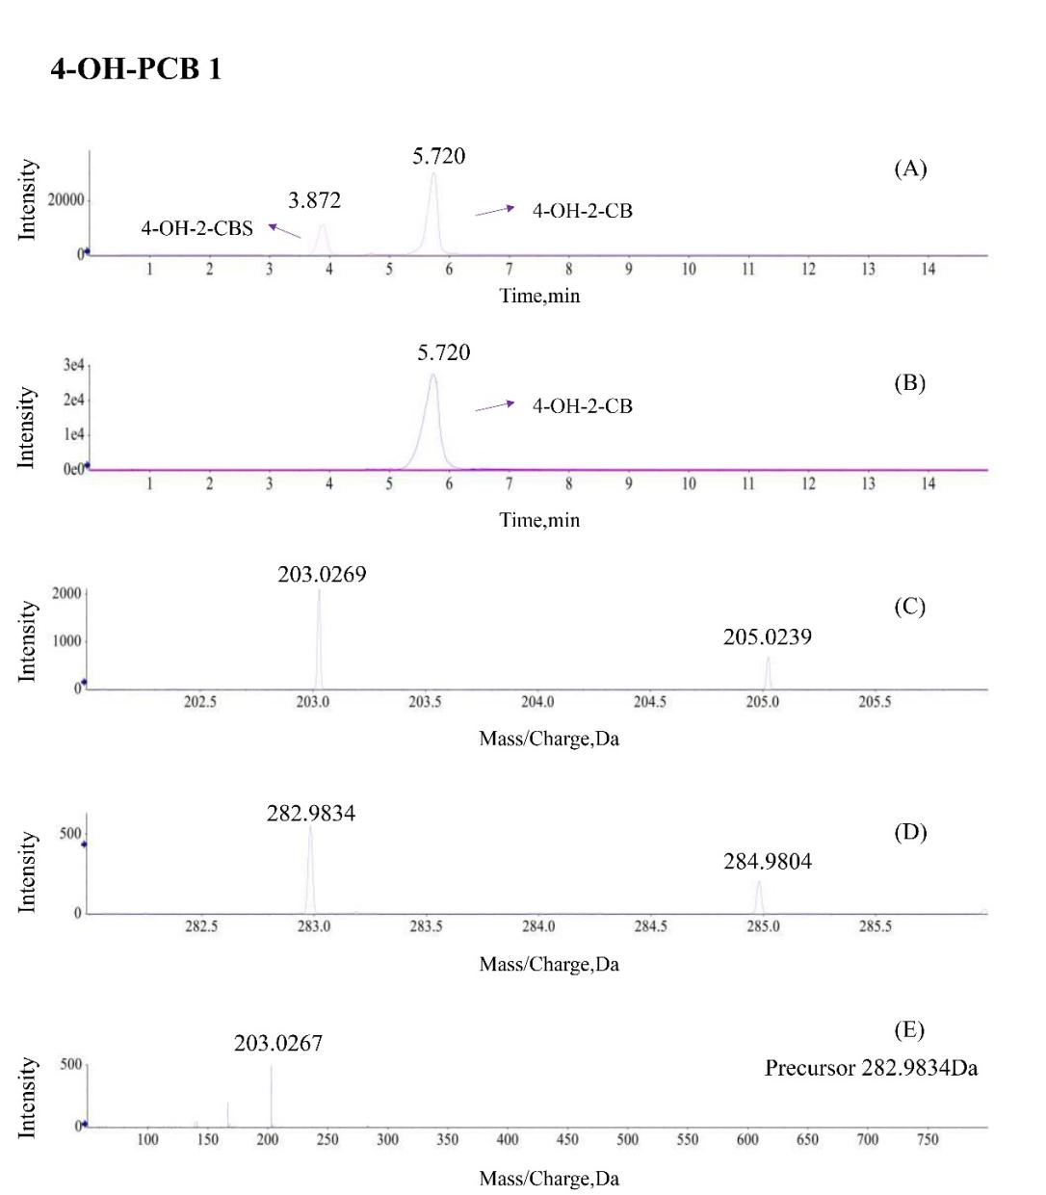

Supplemental Fig. 1B Selected ion chromatogram corresponding of 3'-OH-2,5-diCB with PAPS-activated (A) and deactivated (B) incubated in human liver cytosol for 40 minutes. Selected ion chromatogram corresponding of m/z 236.9874 and isotope mass (C). Selected ion chromatogram corresponding of m/z 316.9436 and isotope mass (D). The fragment ions of 3'-OH-2,5-diCBS (E).
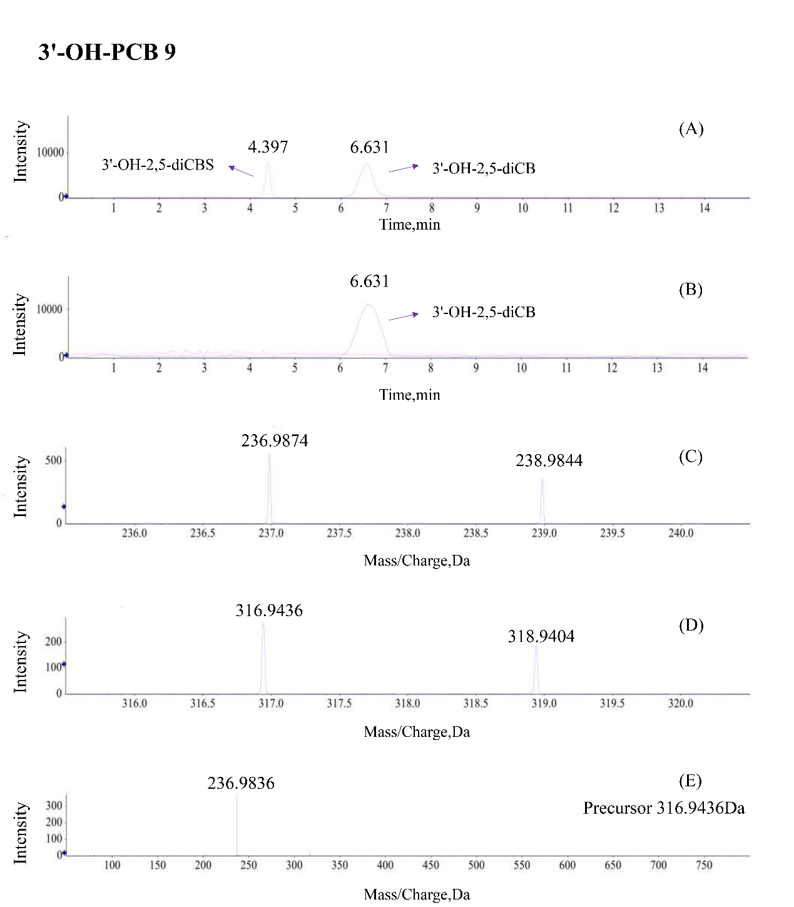

Supplemental Fig. 1C Selected ion chromatogram corresponding of 3'-OH-2,4,6-triCB with PAPS-activated (A) and deactivated (B) incubated in human liver cytosol for 40 minutes. Selected ion chromatogram corresponding of m/z 270.9489 and isotope mass (C). Selected ion chromatogram corresponding of m/z 350.9055 and isotope mass (D). The fragment ions of 3'-OH-2,4,6-triCBS (E).
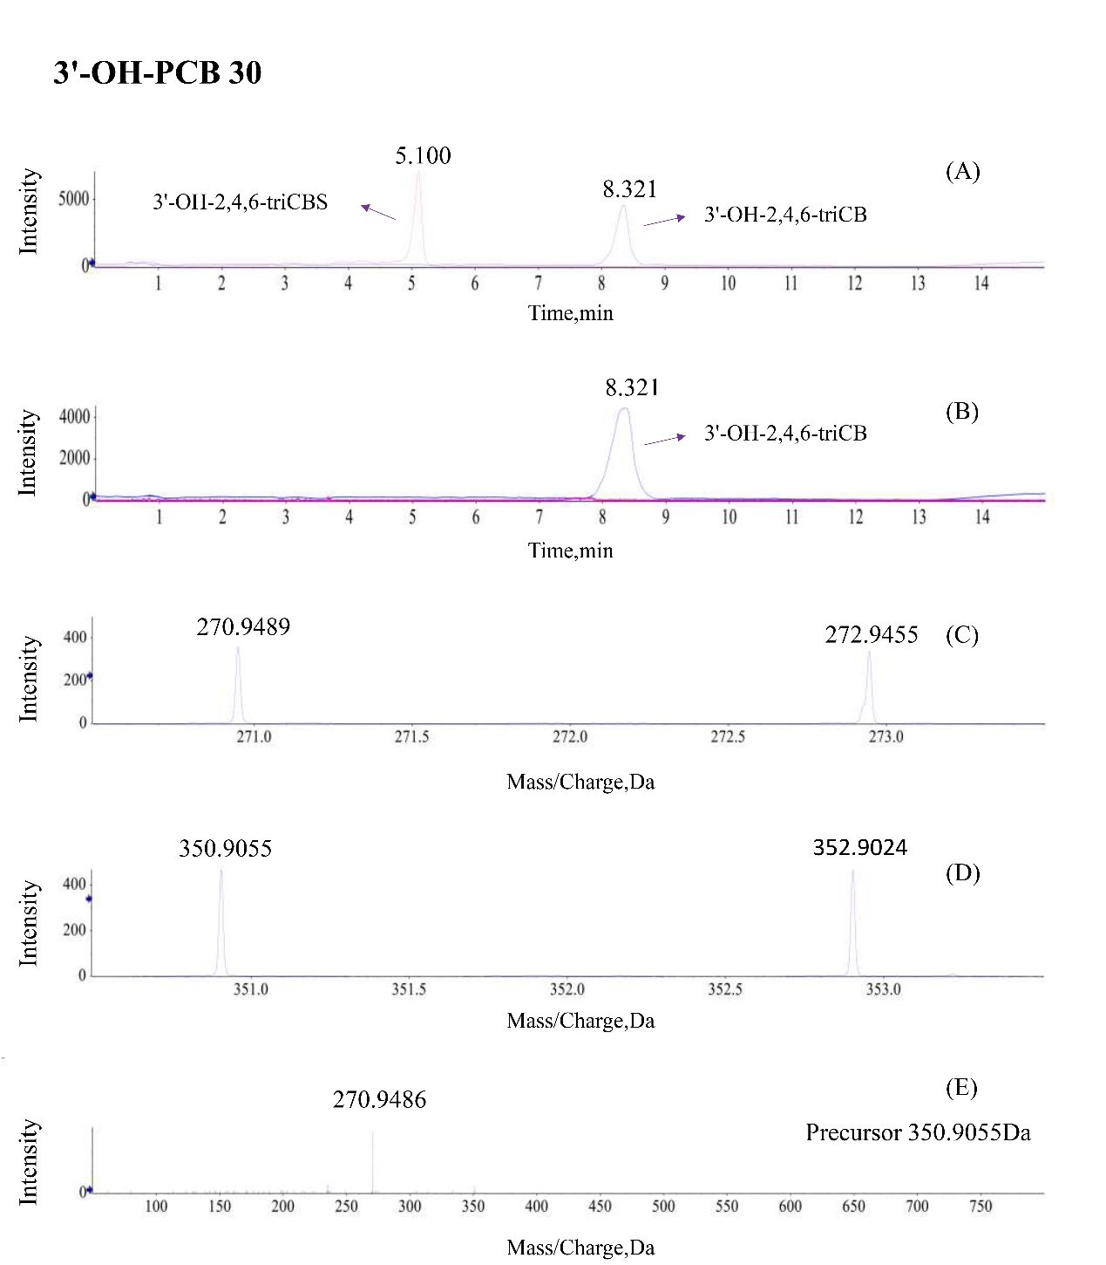

Supplemental Fig. 1D Selected ion chromatogram corresponding of 3'-OH-2,3,5,6-tetraCB with PAPS-activated (A) and deactivated (B) incubated in human liver cytosol for 40 minutes. Selected ion chromatogram corresponding of m/z 306.9065 and isotope mass (C). Selected ion chromatogram corresponding of m/z 386.8623 and isotope mass (D). The fragment ions of 3'-OH-2,3,5,6-tetraCBS (E).
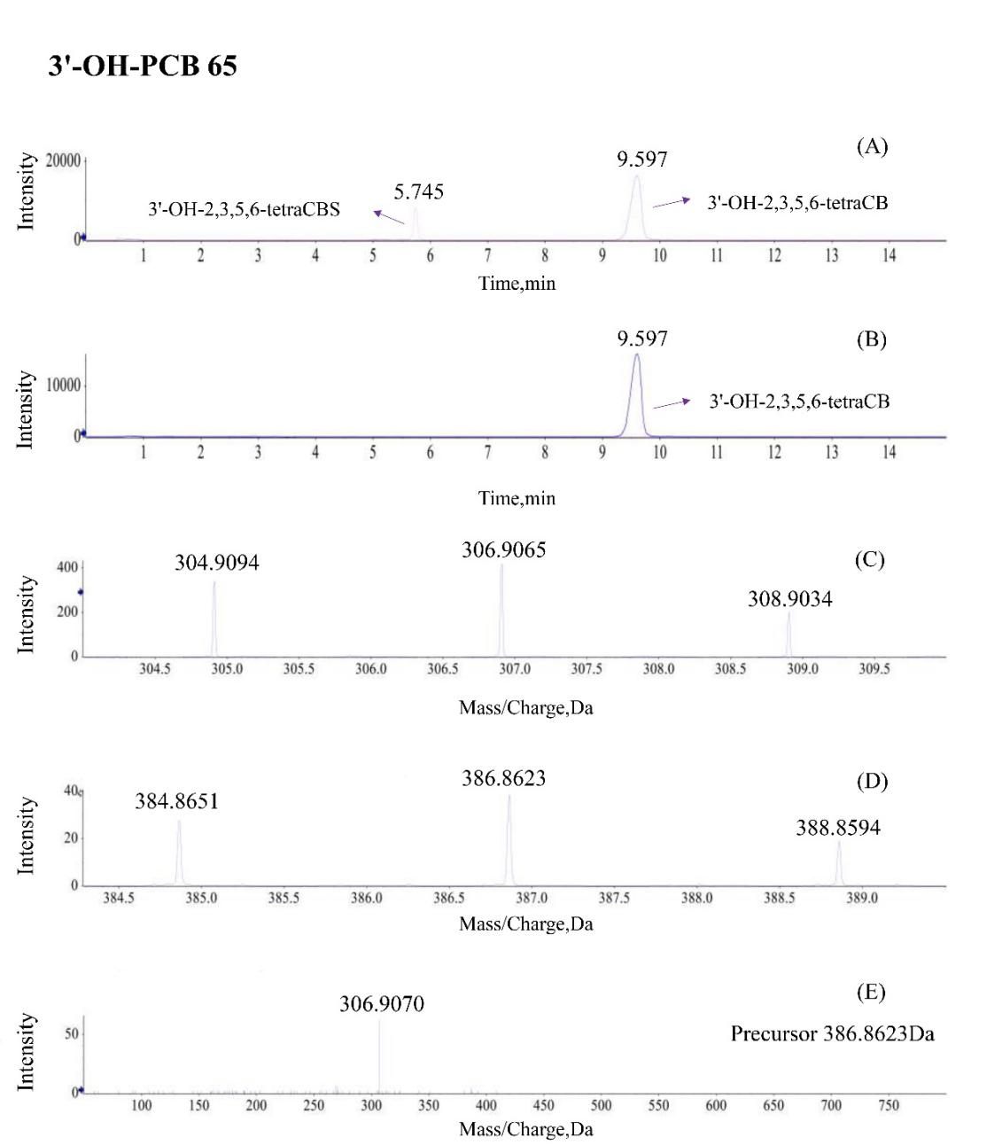

Supplemental Fig. 1E Selected ion chromatogram corresponding of 4'-OH-2,3,5,6-tetraCB with PAPS-activated (A) and deactivated (B) incubated in human liver cytosol for 40 minutes. Selected ion chromatogram corresponding of m/z 306.9068 and isotope mass (C). Selected ion chromatogram corresponding of m/z 386.8626 and isotope mass (D). The fragment ions of 4'-OH-2,3,5,6-tetraCBS (E).
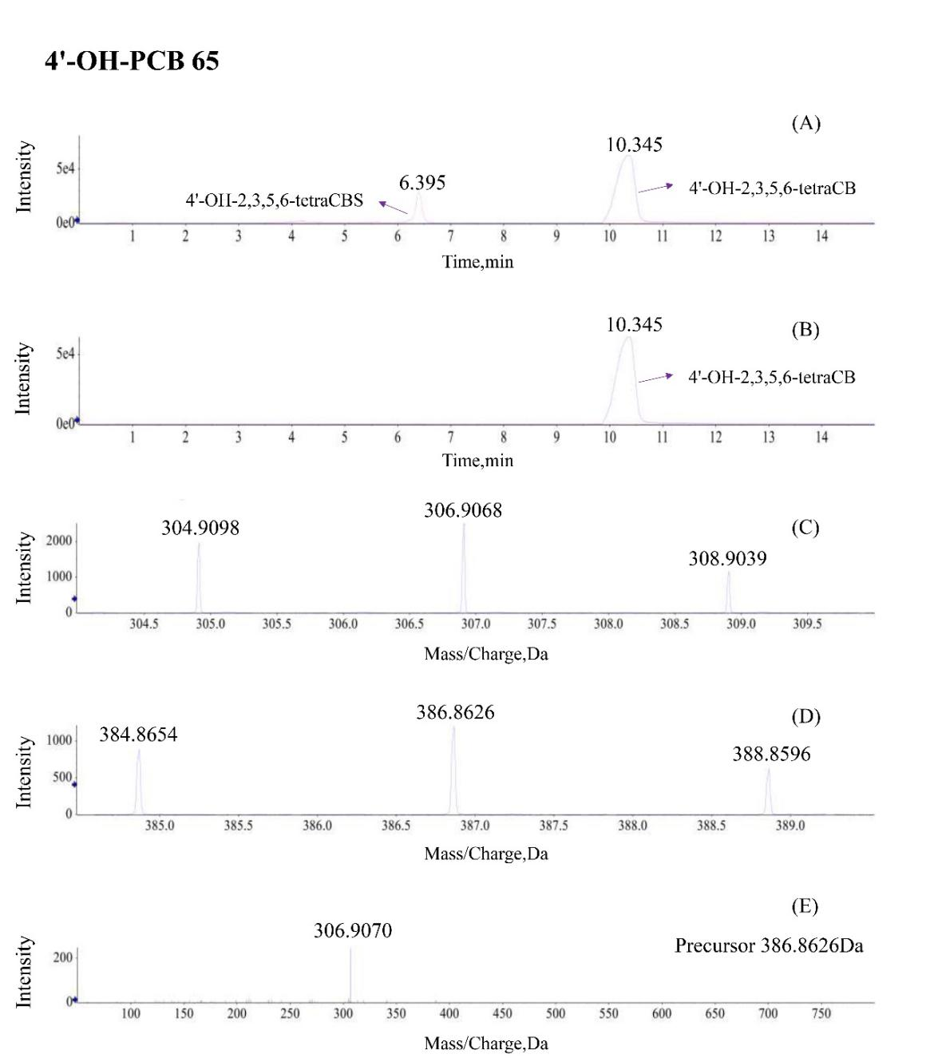

Supplemental Fig. 1F Selected ion chromatogram corresponding of 4'-OH-2,2',4,6-tetraCB with PAPS-activated (A) and deactivated (B) incubated in human liver cytosol for 40 minutes. Selected ion chromatogram corresponding of m/z 306.9065 and isotope mass (C). Selected ion chromatogram corresponding of m/z 386.8627 and isotope mass (D). The fragment ions of 4'-OH-2,2',4,6-tetraCBS (E).
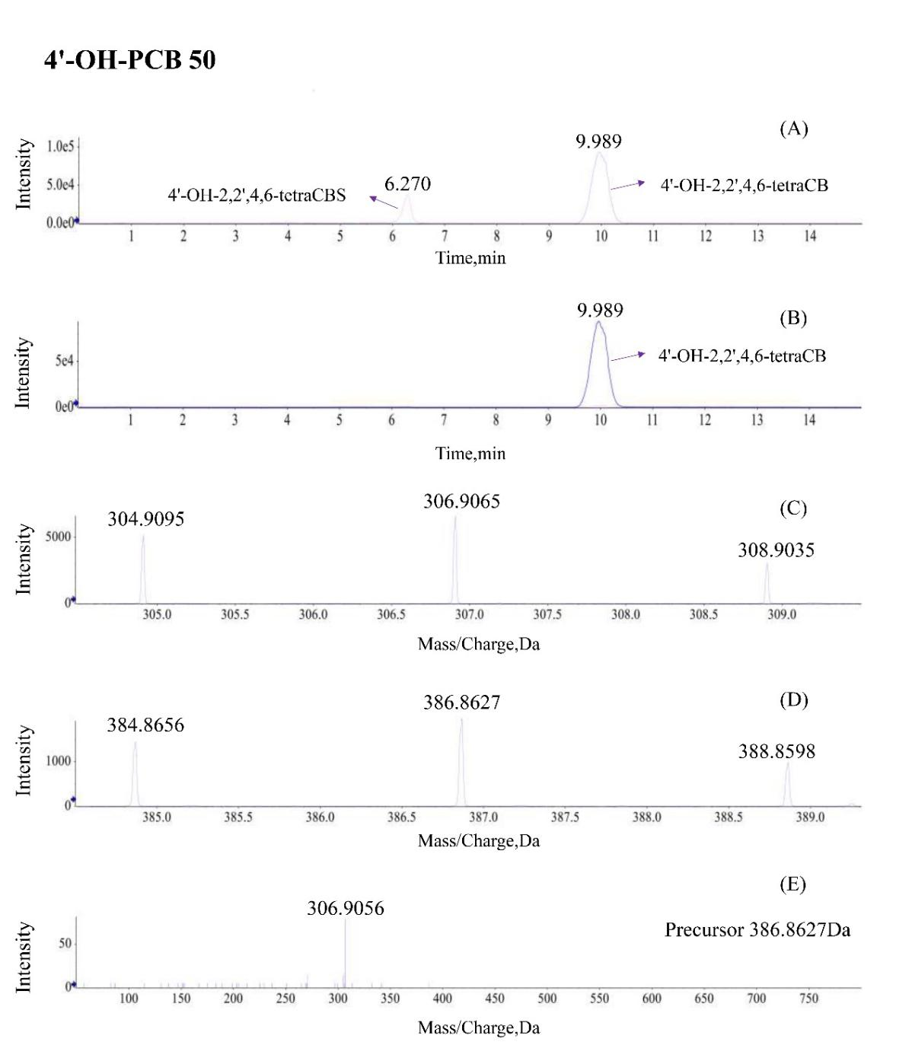

Supplemental Fig. 1G Selected ion chromatogram corresponding of 4'-OH-2,3',4,6-tetraCB with PAPS-activated (A) and deactivated (B) incubated in human liver cytosol for 40 minutes. Selected ion chromatogram corresponding of m/z 306.9065 and isotope mass (C). Selected ion chromatogram corresponding of m/z 386.8628 and isotope mass (D). The fragment ions of 4'-OH-2,3',4,6-tetraCBS (E).
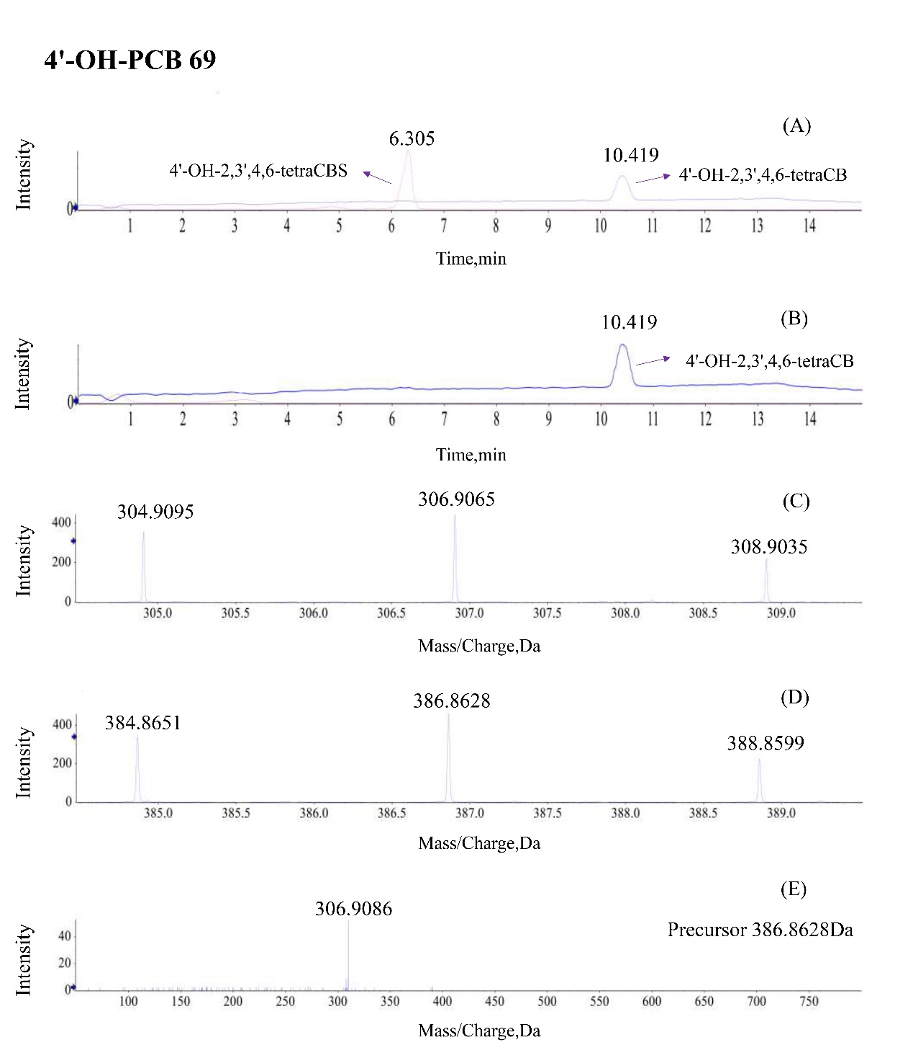

Supplemental Fig. 1H Selected ion chromatogram corresponding of 4'-OH-2,2',3,5,6-pentaCB with PAPS-activated (A) and deactivated (B) incubated in human liver cytosol for 40 minutes. Selected ion chromatogram corresponding of m/z 340.8680 and isotope mass (C). Selected ion chromatogram corresponding of m/z 420.8245 and isotope mass (D). The fragment ions of 4'-OH-2,2',3,5,6-pentaCBS (E).
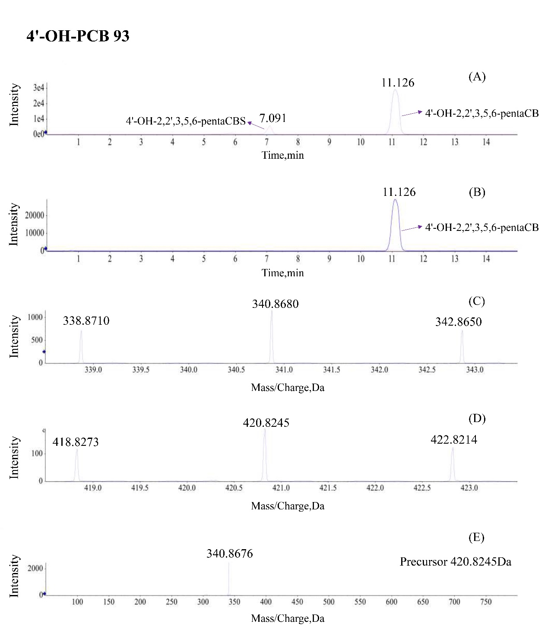

Supplemental Fig. 2A Kinetic analysis of 4-OH-PCB 1 sulfation by HLMs(A) and recombinant SULT1A1 (E); catalytic efficiency of SULT isoforms (B); metabolic contributions normalized to hepatic expression at 0.6 μM (C) and 6 μM (D); chemical inhibition in human liver cytosol using selective inhibitors: nimesulide (10 μM), ibuprofen (1 mM), quercetin (25 μM), DCNP (0.5 μM), DHEA (30 μM), and GA (30 μM) (F).
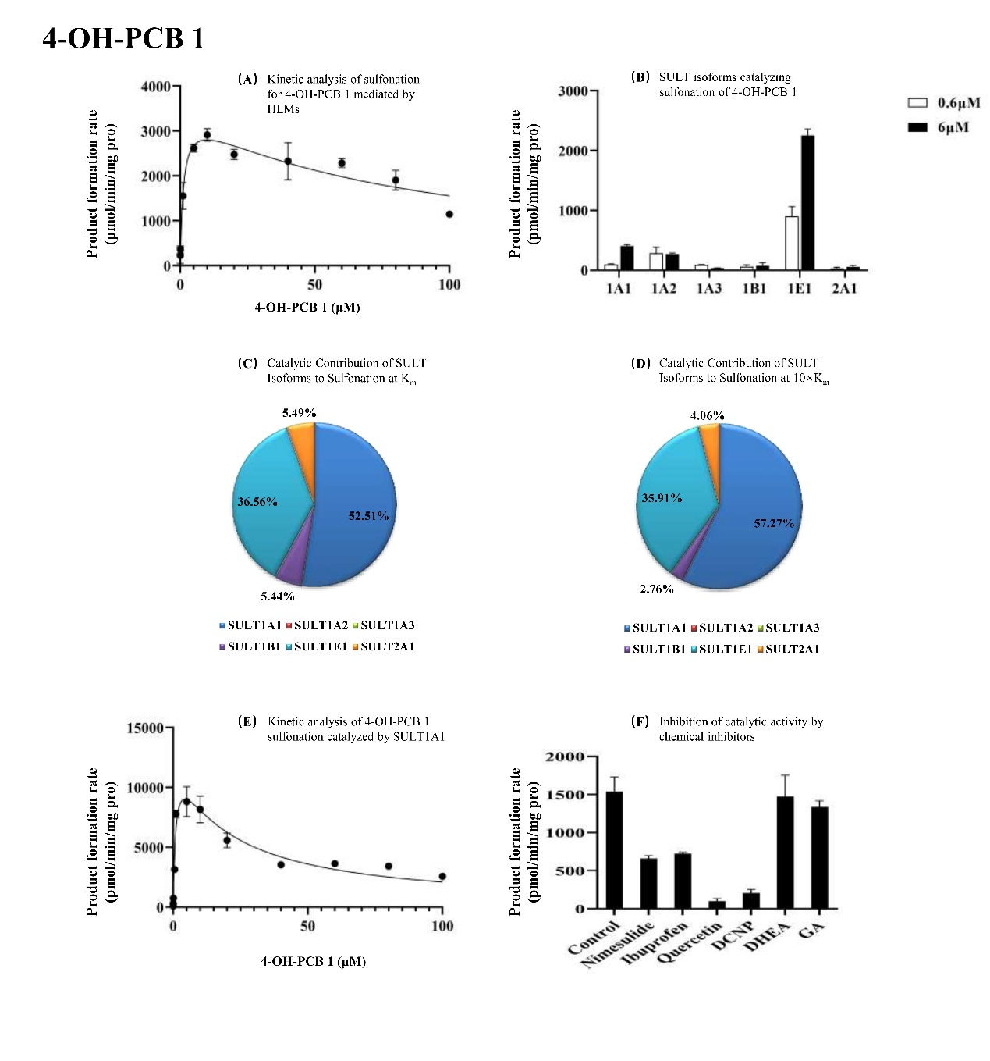

Supplemental Fig. 2B Kinetic analysis of 3'-OH-PCB 9 sulfation by HLMs(A) and recombinant SULT1A1 (E); catalytic efficiency of SULT isoforms (B); metabolic contributions normalized to hepatic expression at 1 μM (C) and 10 μM (D); chemical inhibition in human liver cytosols using selective inhibitors: nimesulide (10 μM), ibuprofen (1 mM), quercetin (25 μM), DCNP (0.5 μM), DHEA (30 μM), and GA (30 μM) (F).
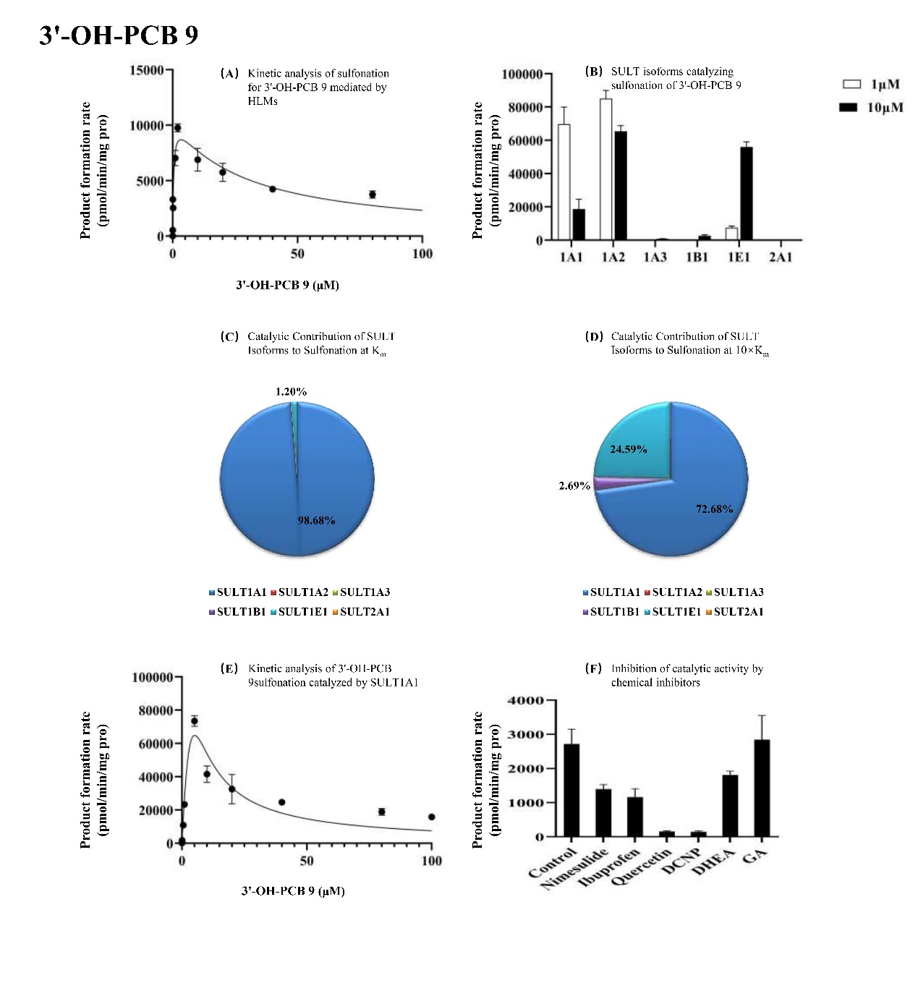

Supplemental Fig. 2C Kinetic analysis of 3'-OH-PCB 30 sulfation by HLMs(A) and recombinant SULT1A1 (E); catalytic efficiency of SULT isoforms (B); metabolic contributions normalized to hepatic expression at 5 μM (C) and 50 μM (D); chemical inhibition in human liver cytosol using selective inhibitors: nimesulide (10 μM), ibuprofen (1 mM), quercetin (25 μM), DCNP (0.5 μM), DHEA (30 μM), and GA (30 μM) (F).
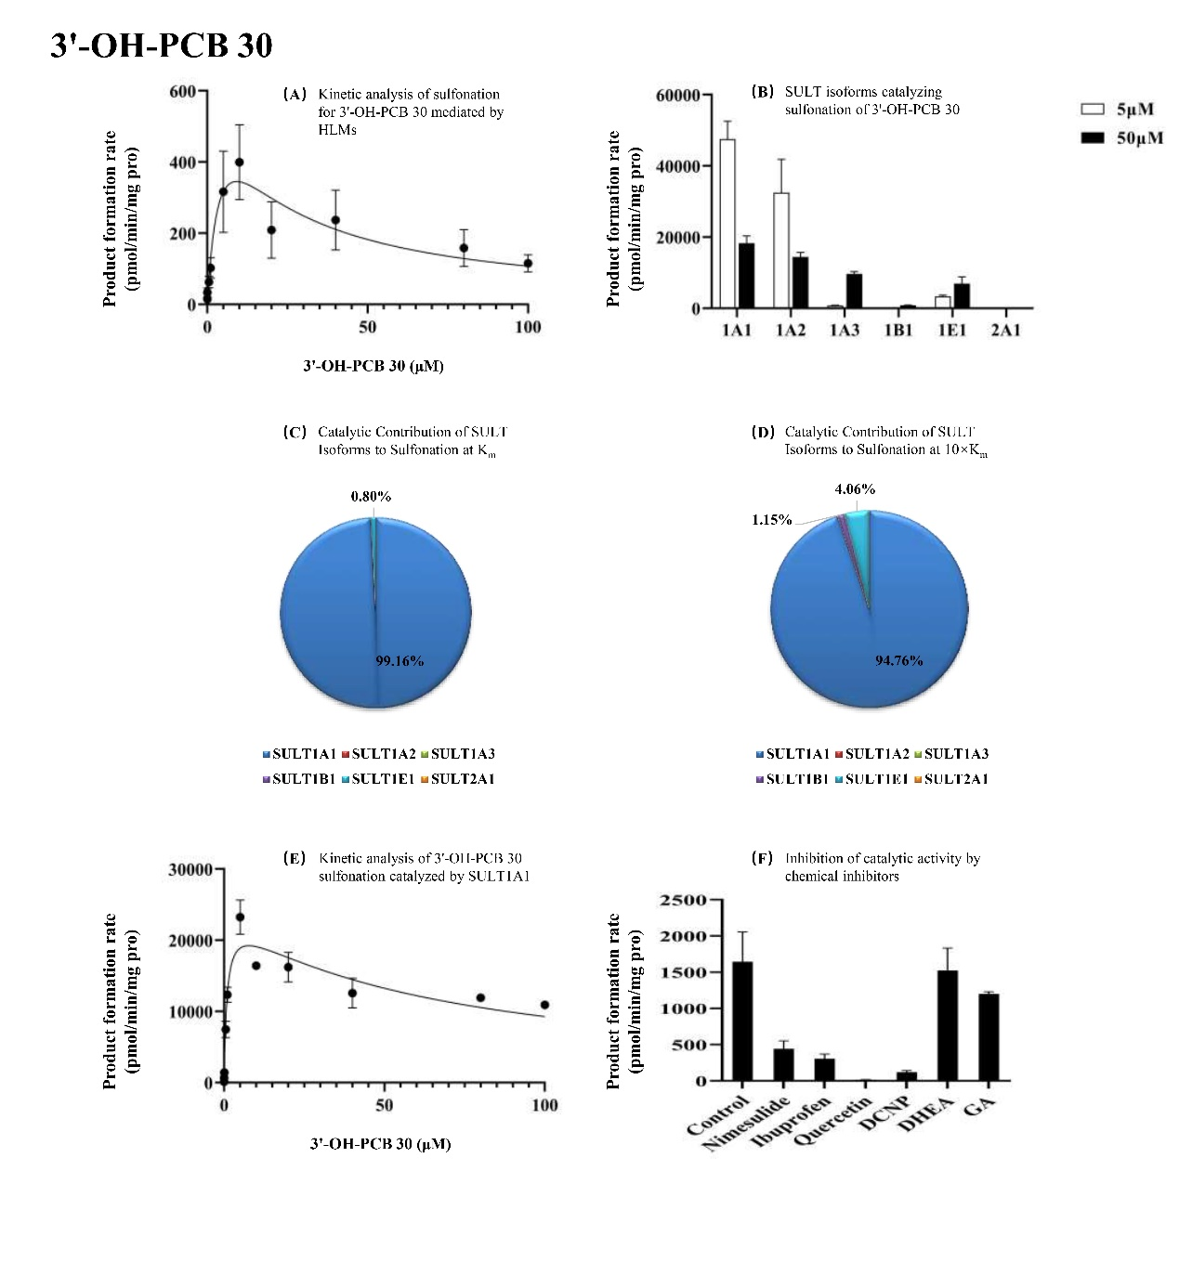

Supplemental Fig. 2D Kinetic analysis of 3'-OH-PCB 65 sulfation by HLMs(A) and recombinant SULT1A1 (E); catalytic efficiency of SULT isoforms (B); metabolic contributions normalized to hepatic expression at 2 μM (C) and 20 μM (D); chemical inhibition in human liver cytosol using selective inhibitors: nimesulide (10 μM), ibuprofen (1 mM), quercetin (25 μM), DCNP (0.5 μM), DHEA (30 μM), and GA (30 μM) (F).
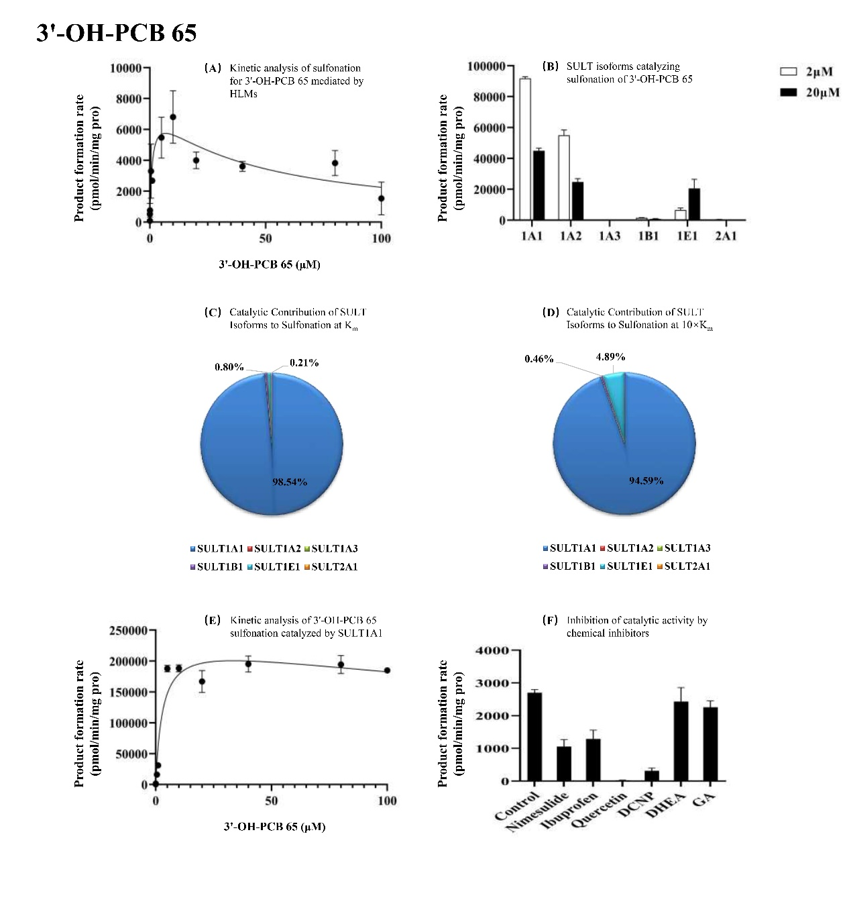

Supplemental Fig. 2E Kinetic analysis of 4'-OH-PCB 65 sulfation by HLMs(A) and recombinant SULT1A1 (E); catalytic efficiency of SULT isoforms (B); metabolic contributions normalized to hepatic expression at 5 μM (C) and 50 μM (D); chemical inhibition in human liver cytosol using selective inhibitors: nimesulide (10 μM), ibuprofen (1 mM), quercetin (25 μM), DCNP (0.5 μM), DHEA (30 μM), and GA (30 μM) (F).
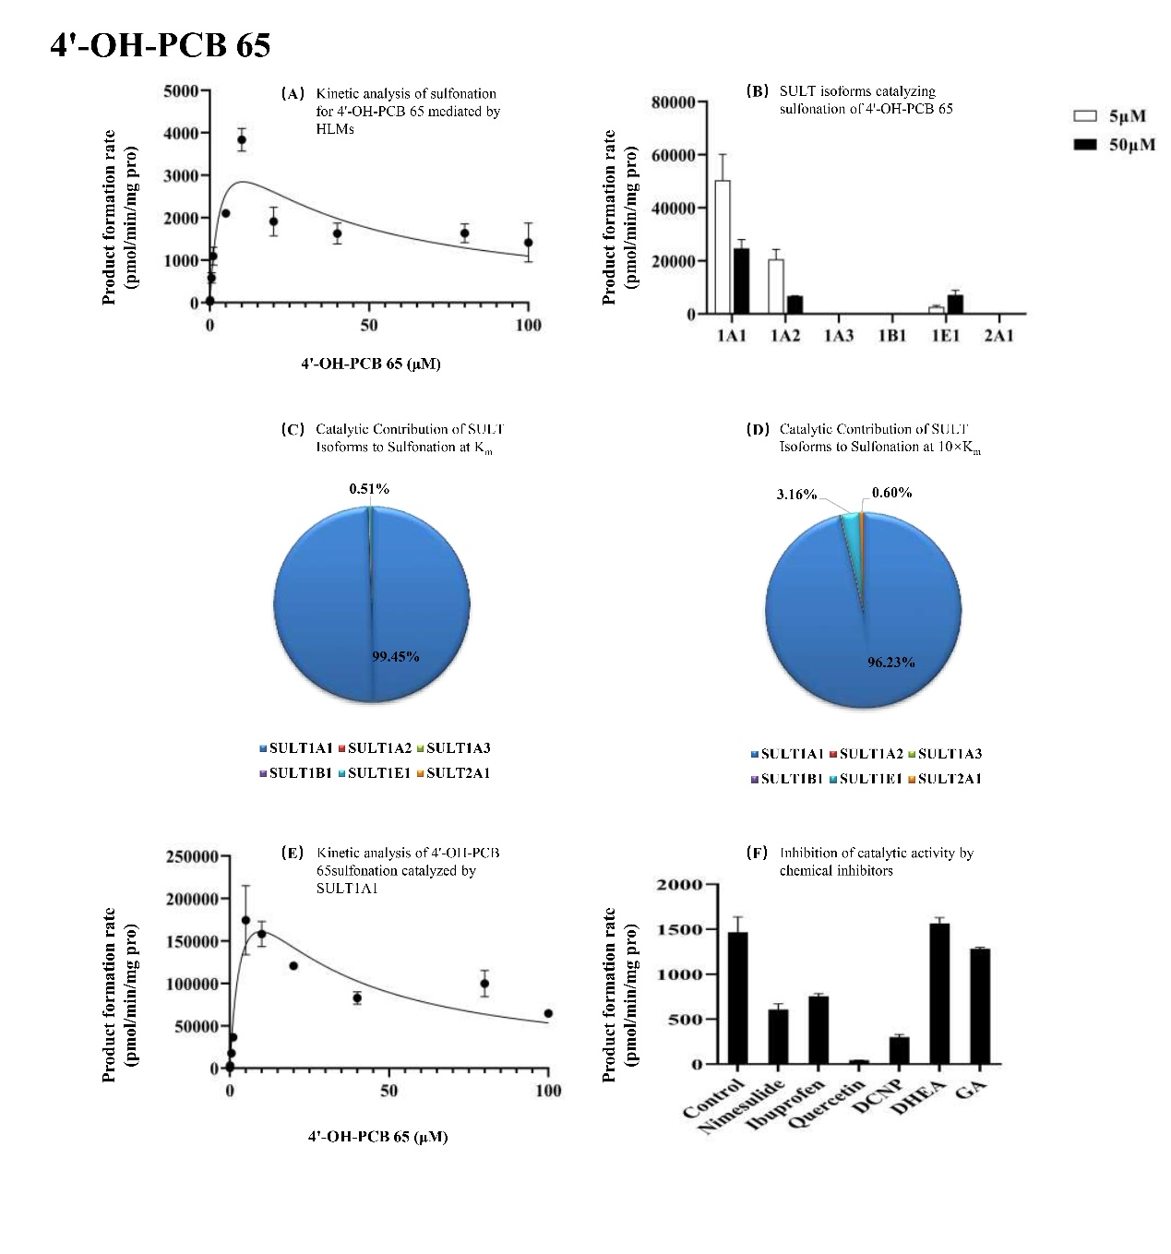

Supplemental Fig. 2F Kinetic analysis of 4'-OH-PCB 50 sulfation by HLMs(A) and recombinant SULT1A1 (E); catalytic efficiency of SULT isoforms (B); metabolic contributions normalized to hepatic expression at 15 μM (C) and 150 μM (D); chemical inhibition in human liver cytosol using selective inhibitors: nimesulide (10 μM), ibuprofen (1 mM), quercetin (25 μM), DCNP (0.5 μM), DHEA (30 μM), and GA (30 μM) (F).
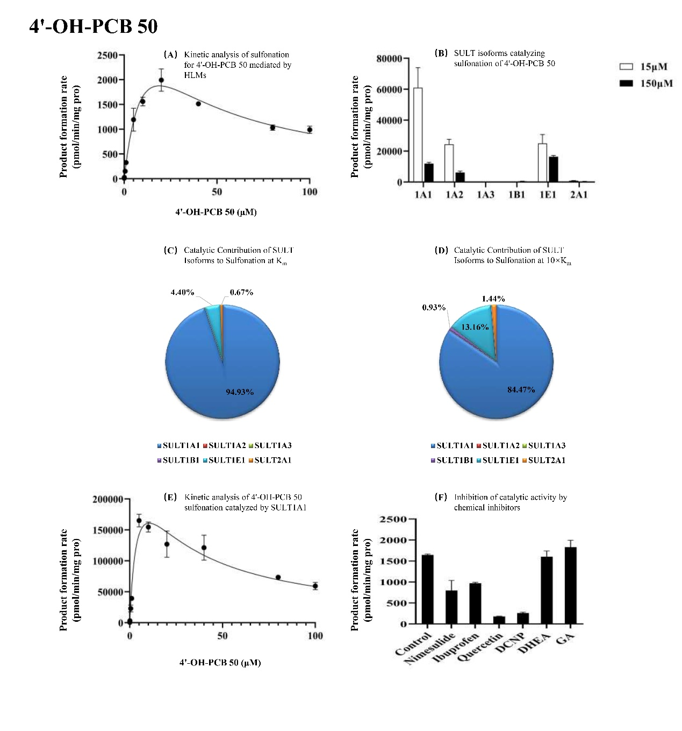

Supplemental Fig. 2G Kinetic analysis of 4'-OH-PCB 69 sulfation by HLMs(A) and recombinant SULT1A1 (E); catalytic efficiency of SULT isoforms (B); metabolic contributions normalized to hepatic expression at 0.5 μM (C) and 5 μM (D); chemical inhibition in human liver cytosol using selective inhibitors: nimesulide (10 μM), ibuprofen (1 mM), quercetin (25 μM), DCNP (0.5 μM), DHEA (30 μM), and GA (30 μM) (F).
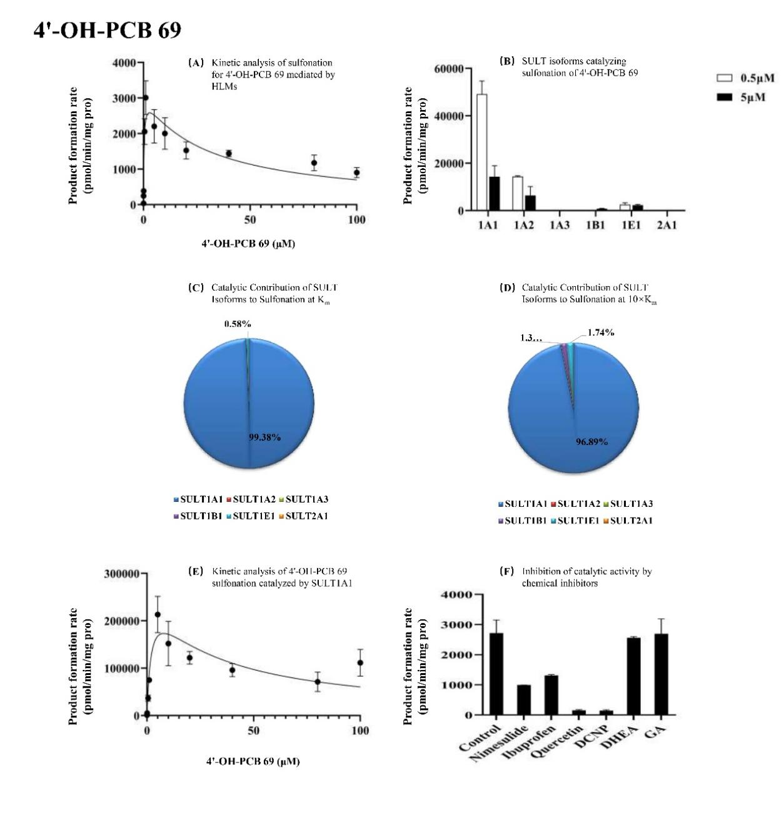

Supplemental Fig. 2H Kinetic analysis of 4'-OH-PCB 93 sulfation by HLMs(A) and recombinant SULT1A1 (E); catalytic efficiency of SULT isoforms (B); metabolic contributions normalized to hepatic expression at 30 μM (C) and 300 μM (D); chemical inhibition in human liver cytosol using selective inhibitors: nimesulide (10 μM), ibuprofen (1 mM), quercetin (25 μM), DCNP (0.5 μM), DHEA (30 μM), and GA (30 μM) (F).
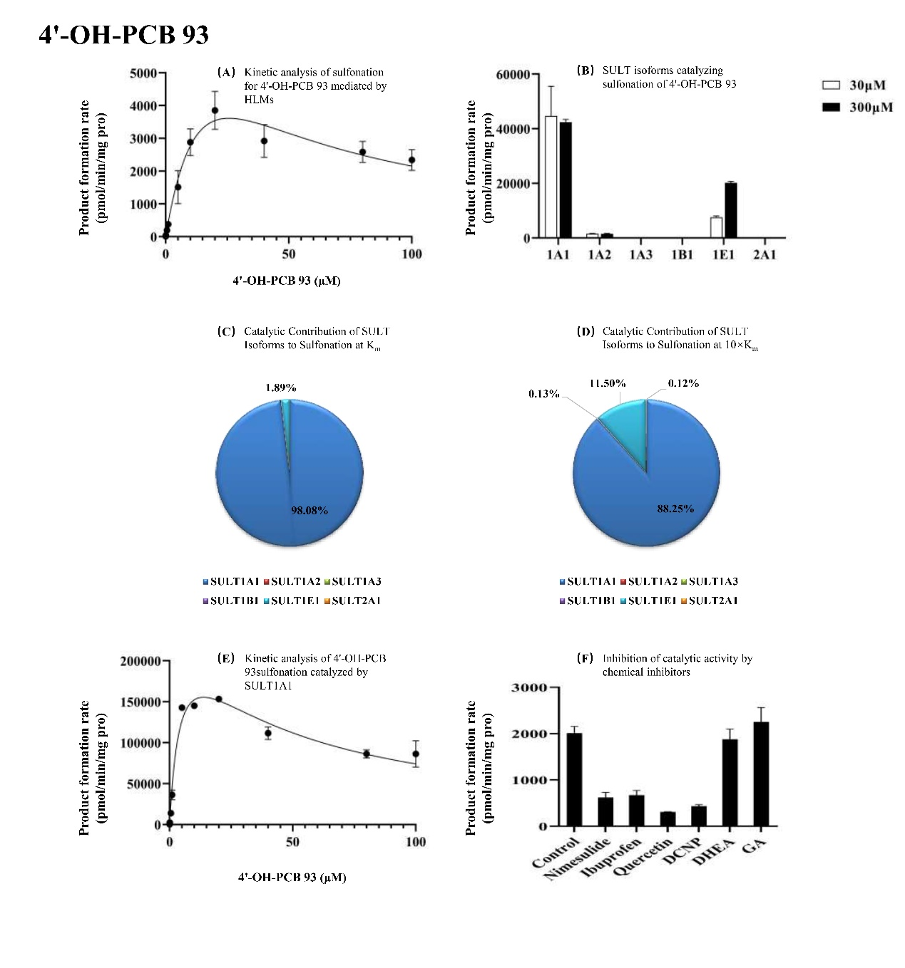

Supplemental Fig. 3 The substrate concentration is shown on a logarithmic scale to display the full concentration range (0.01-100 µM). Symbols represent the mean of two replicates, error bars show SD, and solid curves show the selected nonlinear fit.
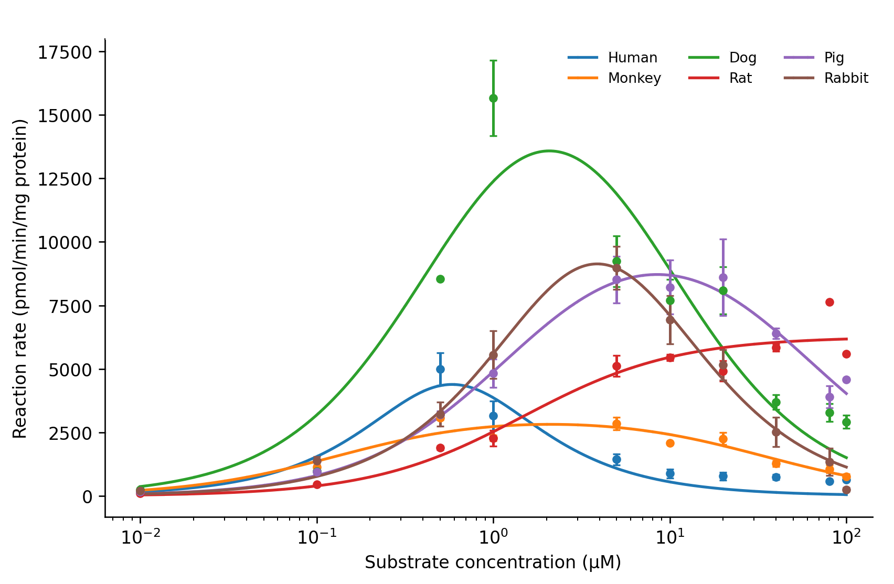
Supplemental Fig.3A Enzyme kinetic profiles of 4-OH-PCB 2 across six species.
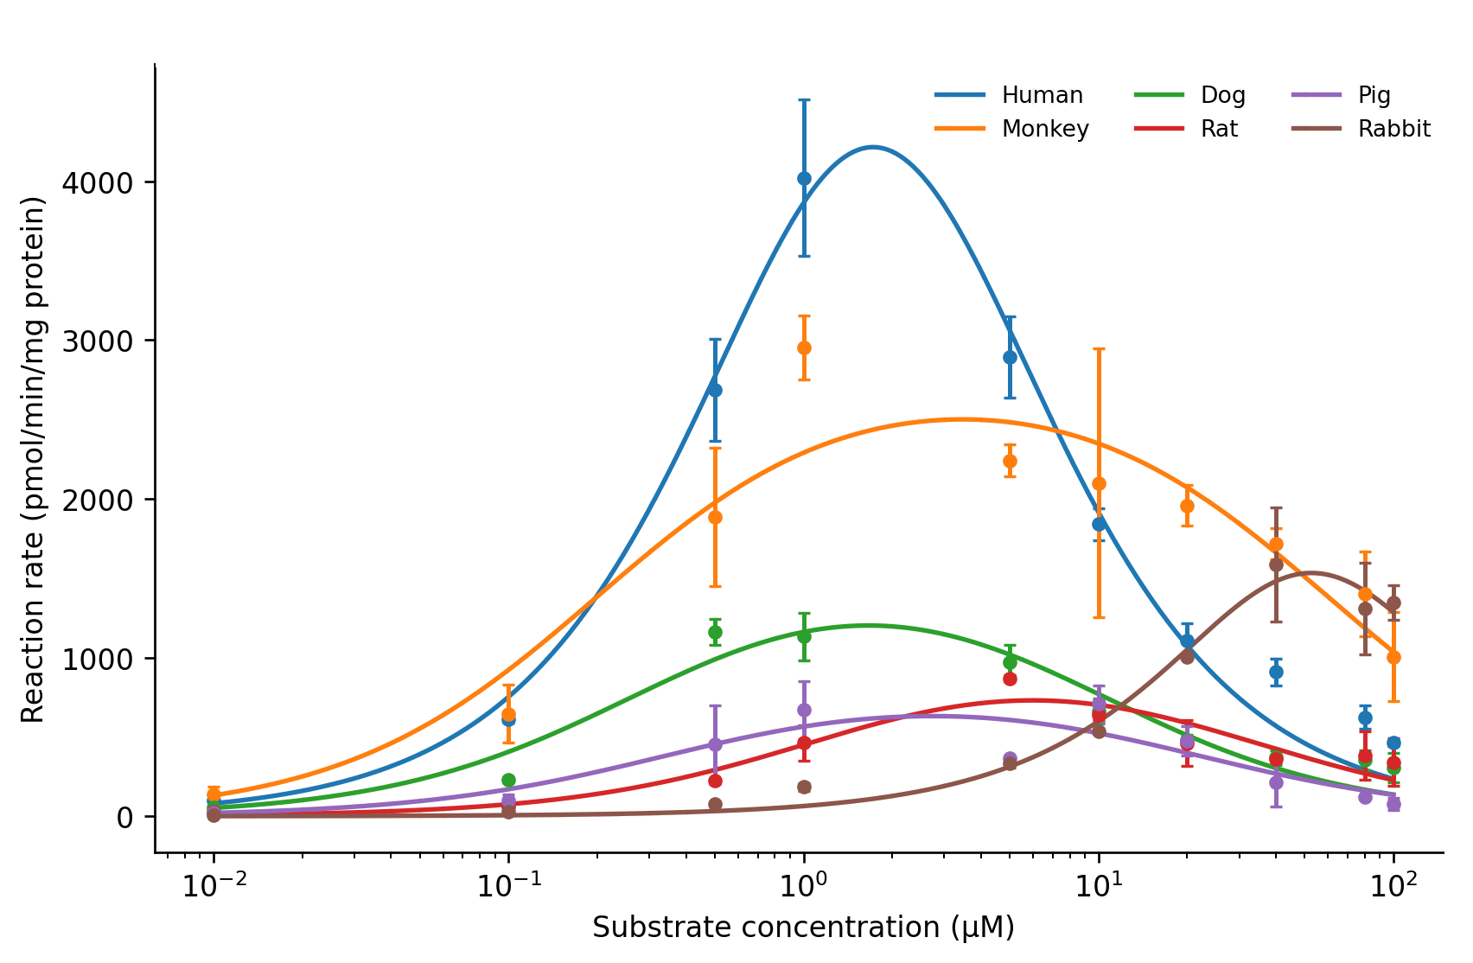
Supplemental Fig.3B Enzyme kinetic profiles of 4-OH-PCB 1 across six species.
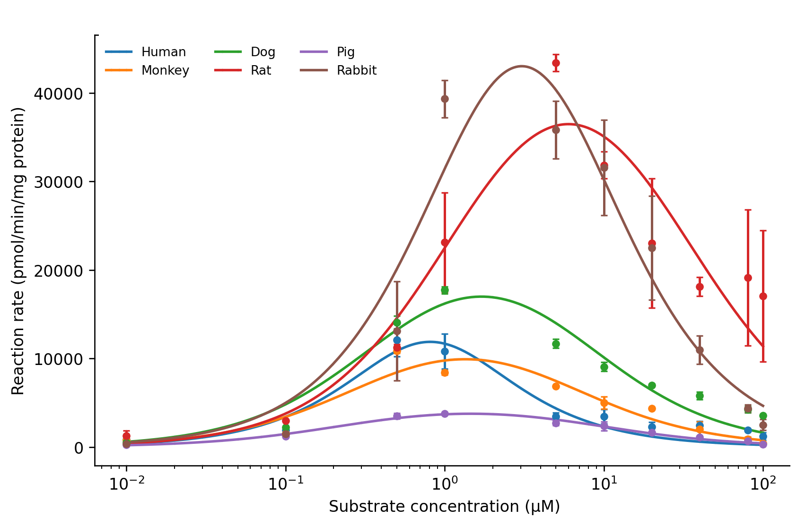
Supplemental Fig.3C Enzyme kinetic profiles of 3'-OH-PCB 9 across six species.
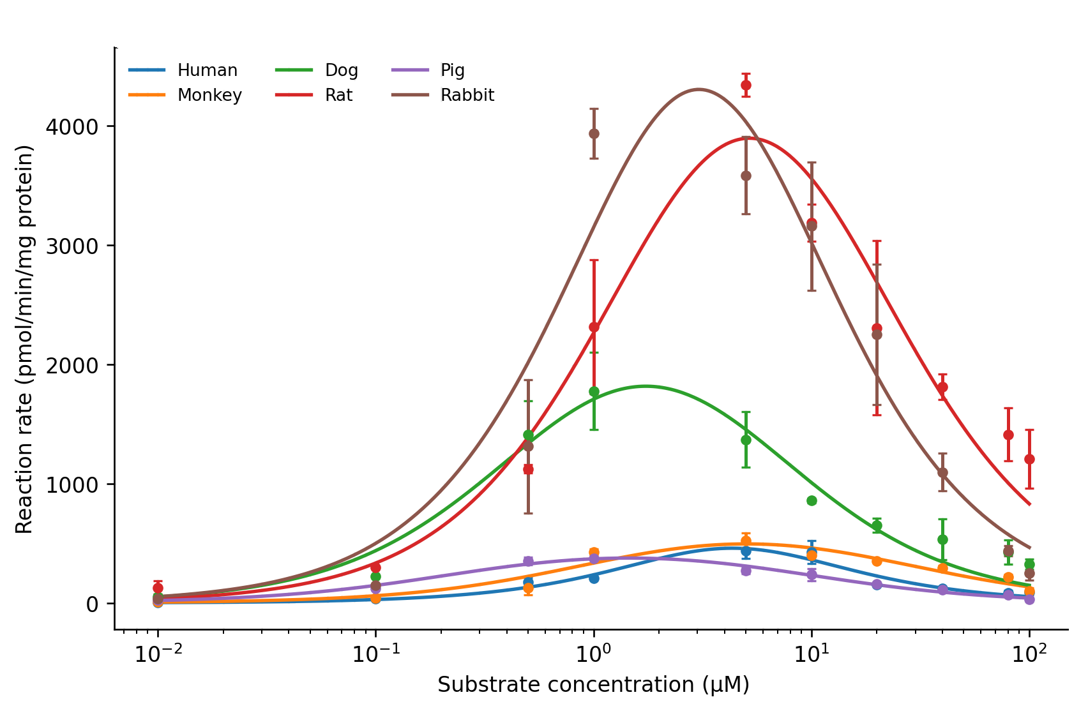
Supplemental Fig.3D Enzyme kinetic profiles of 3'-OH-PCB 30 across six species.
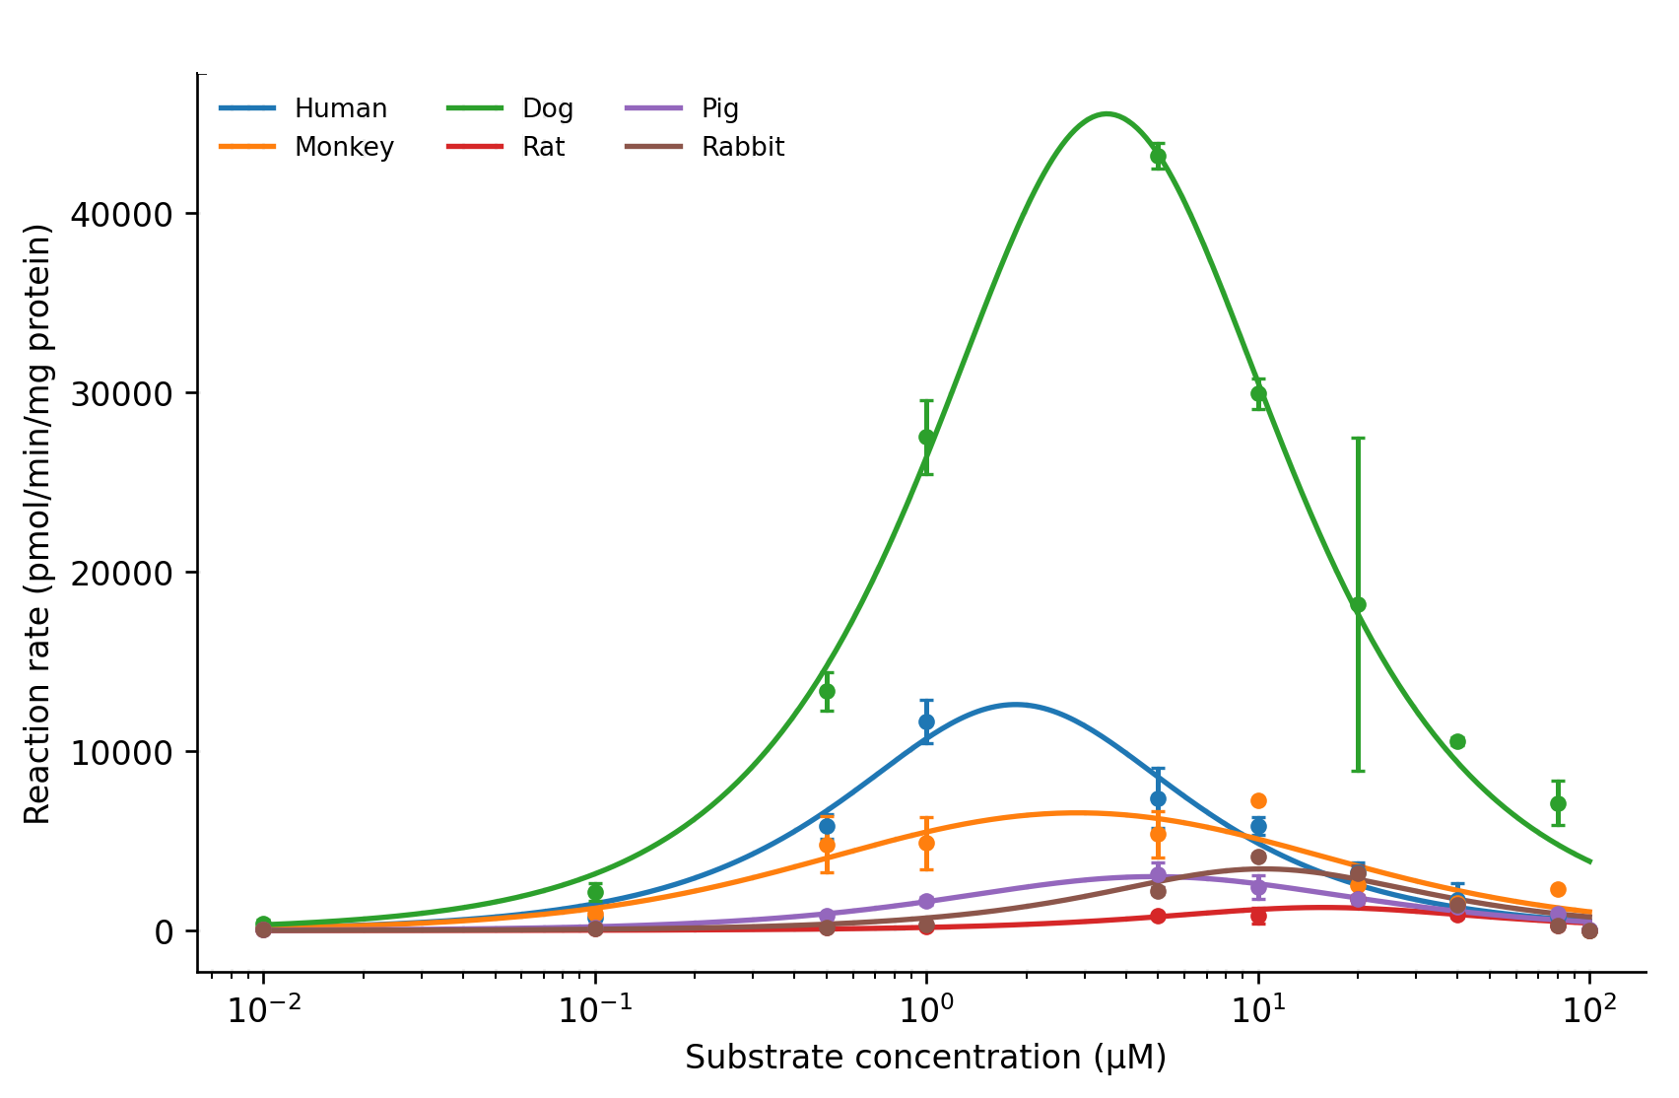
Supplemental Fig.3E Enzyme kinetic profiles of 3'-OH-PCB 65 across six species.

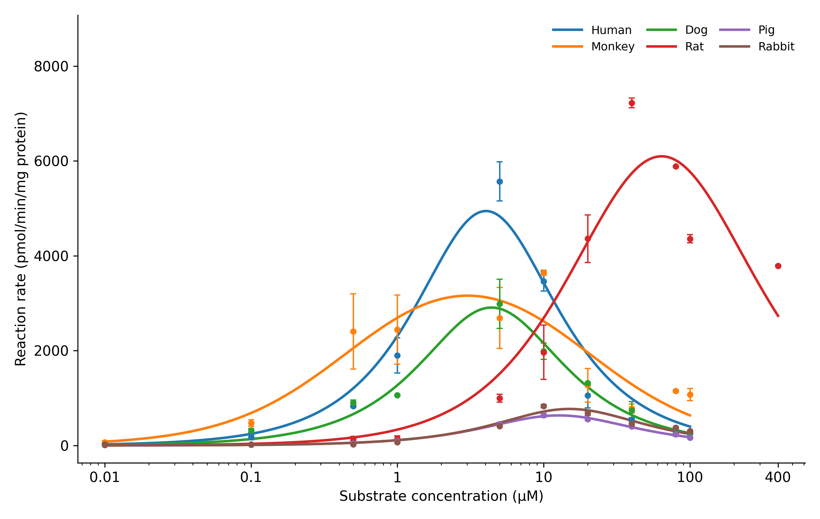Supplemental Fig.3F Enzyme kinetic profiles of 4'-OH-PCB 65 across six species.

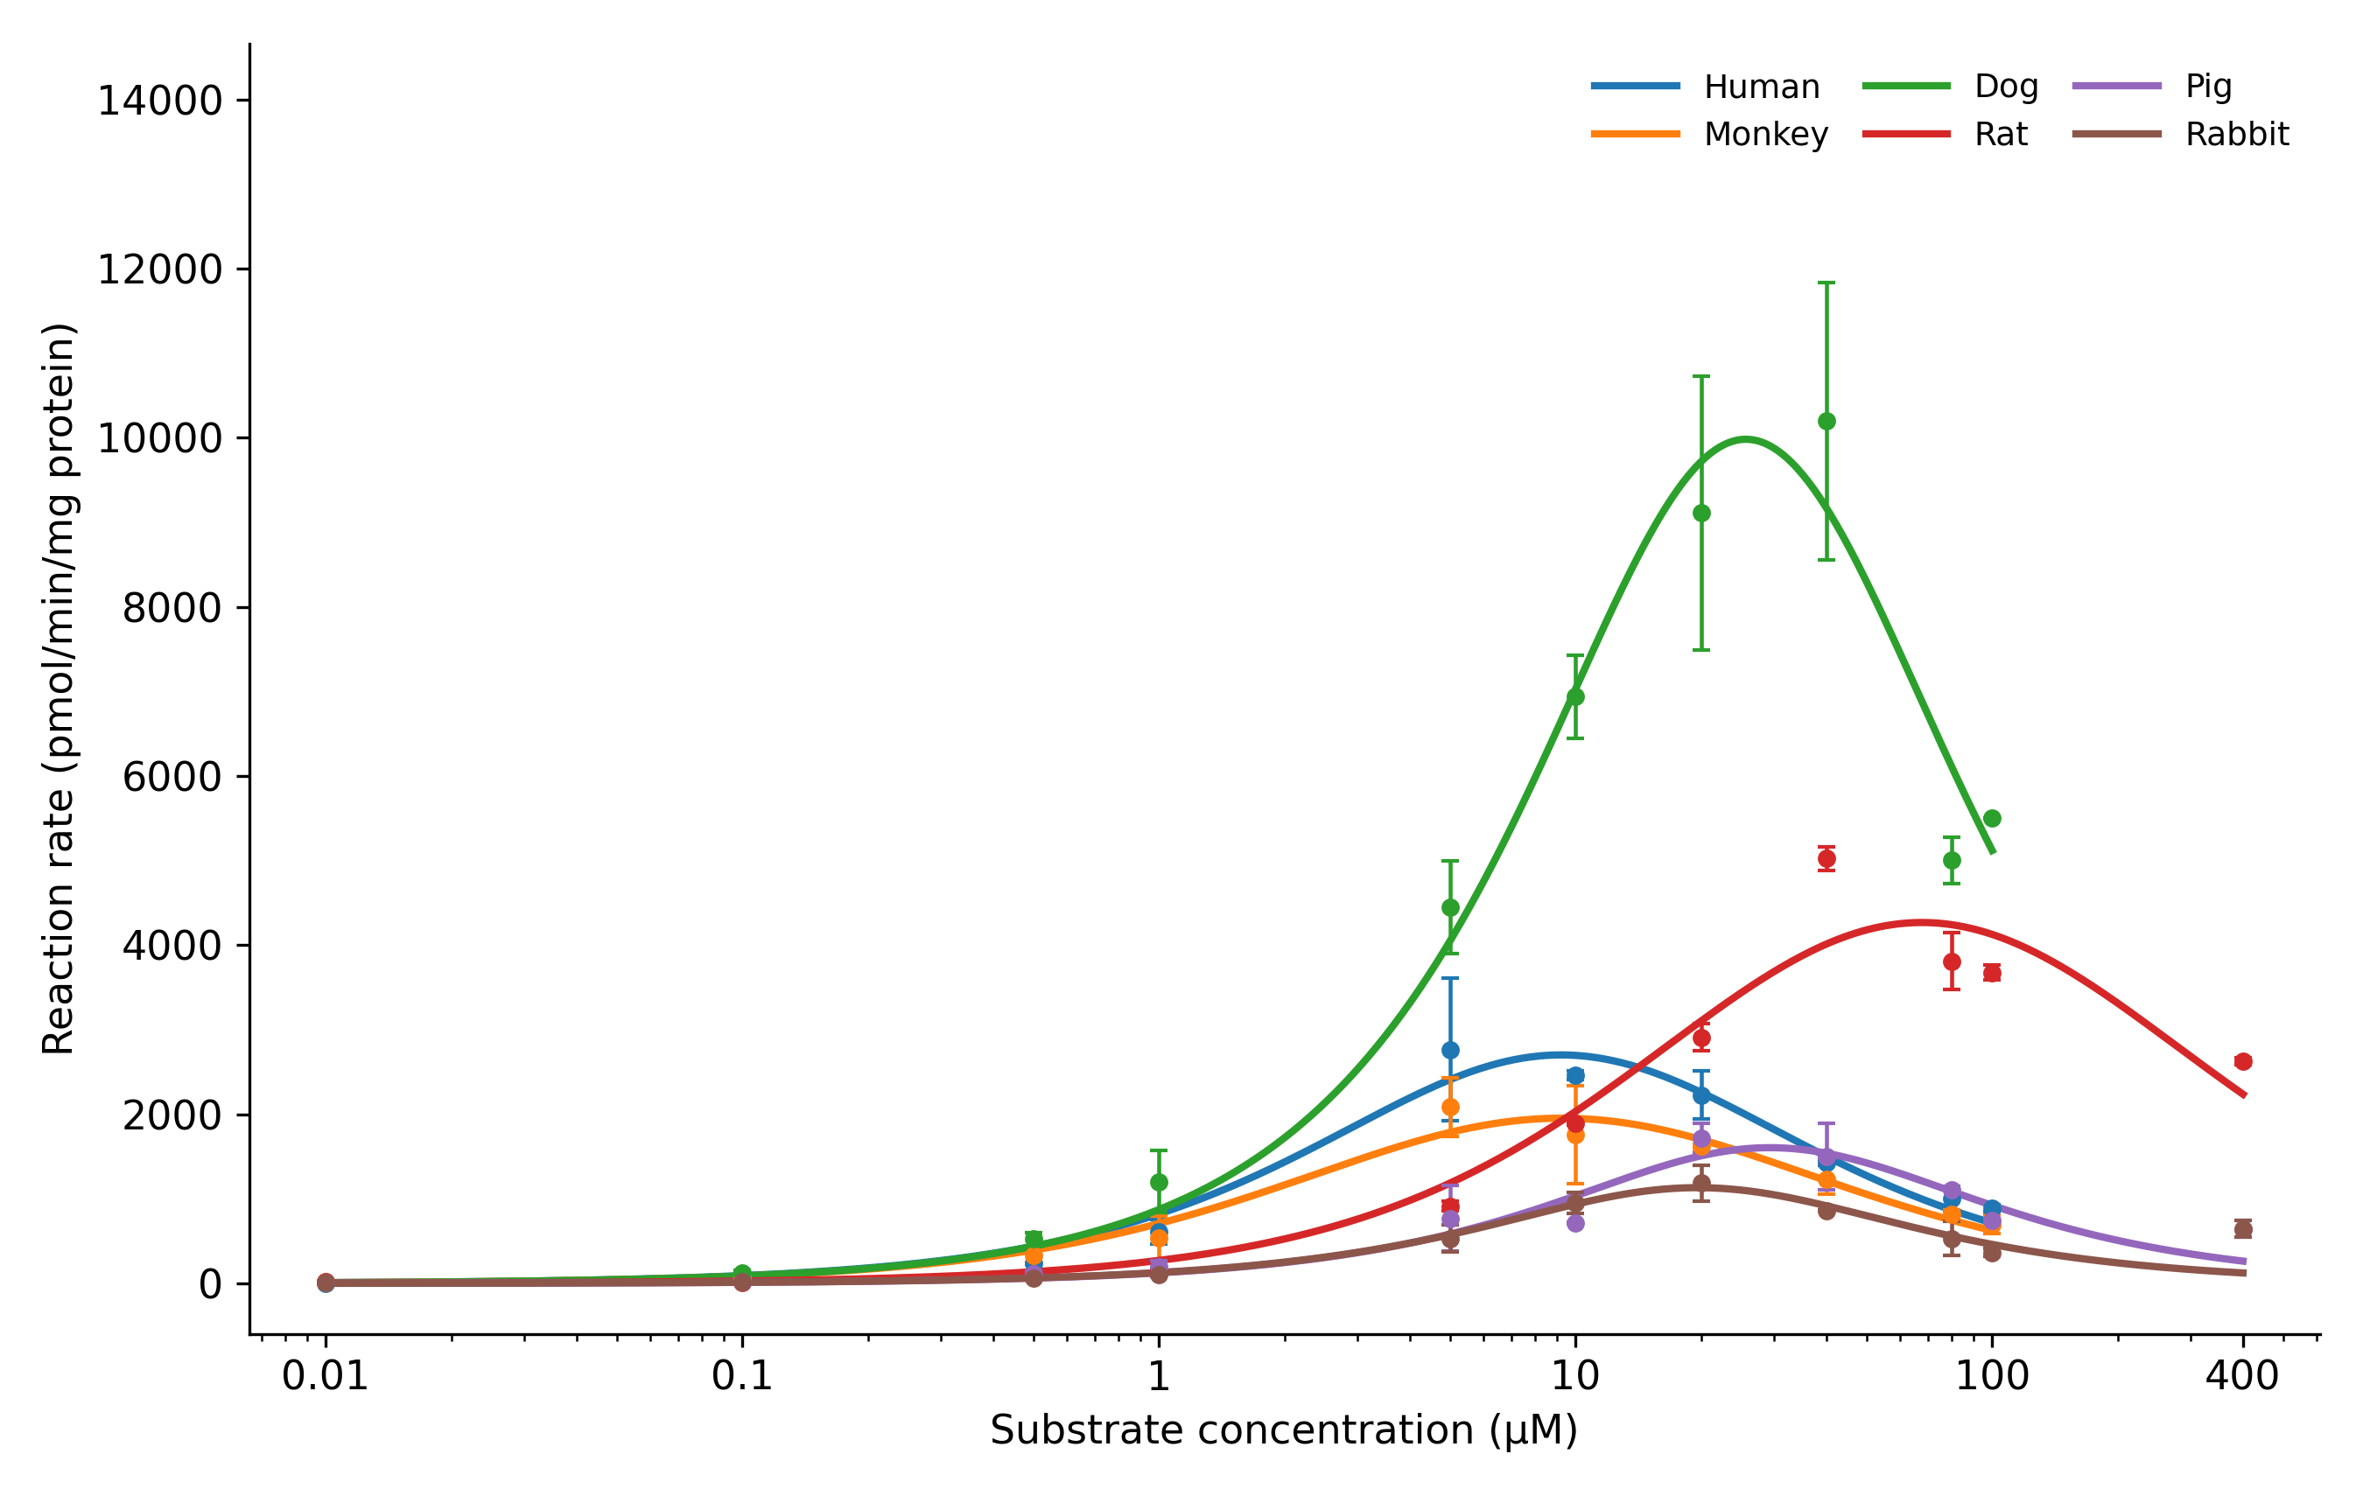
Supplemental Fig.3G Enzyme kinetic profiles of 4'-OH-PCB 50 across six species.
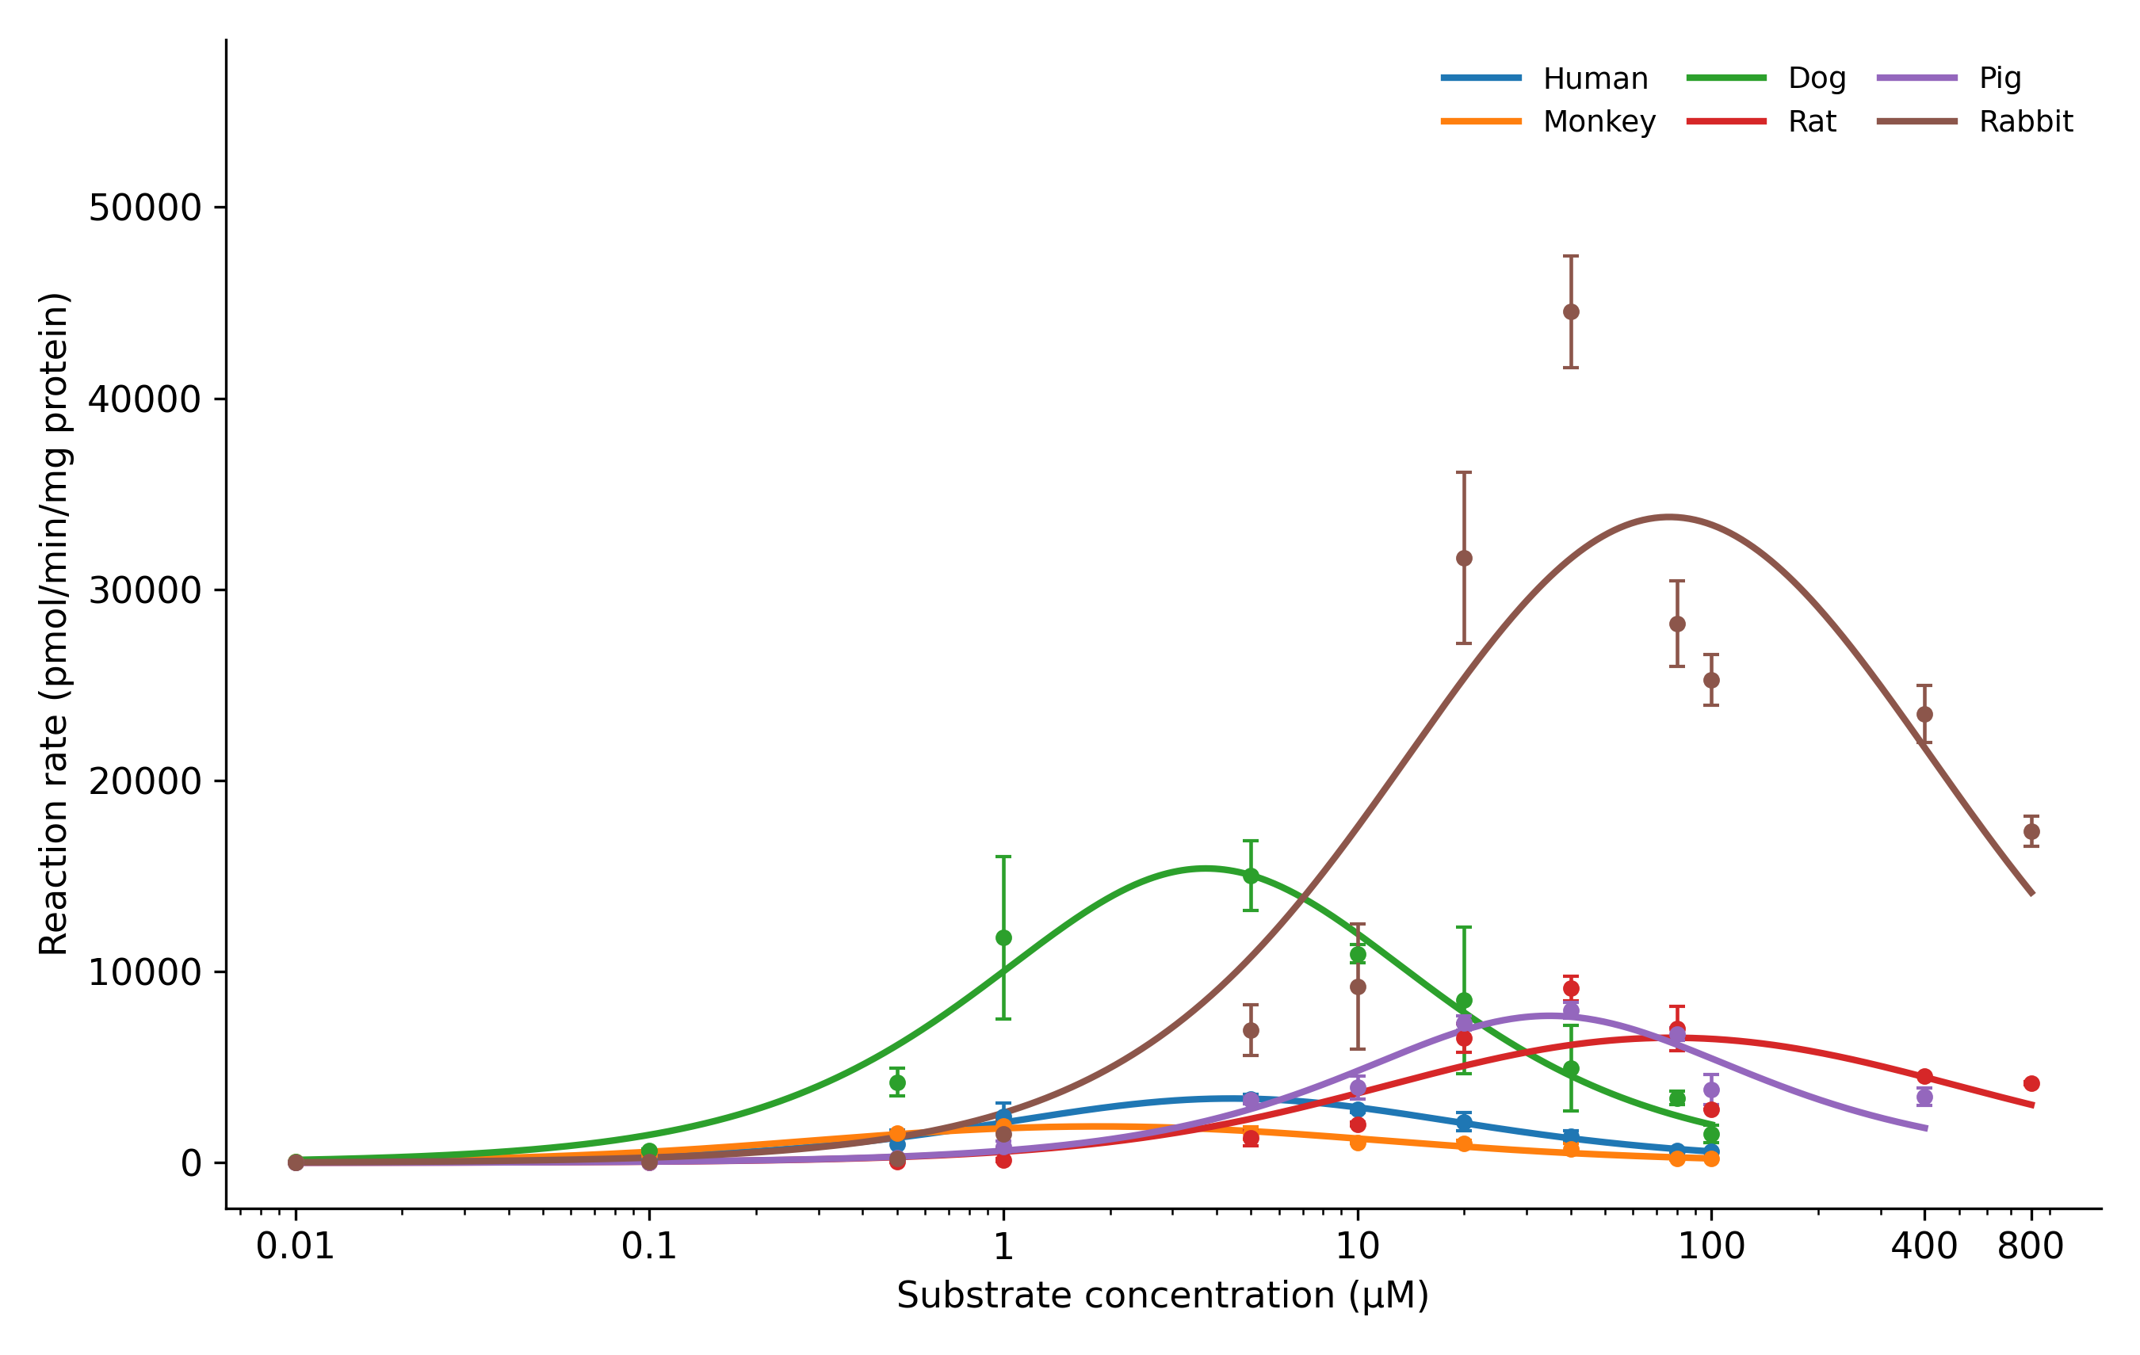
Supplemental Figure 3H. Enzyme kinetic profiles of 4'-OH-PCB 69 across six species.
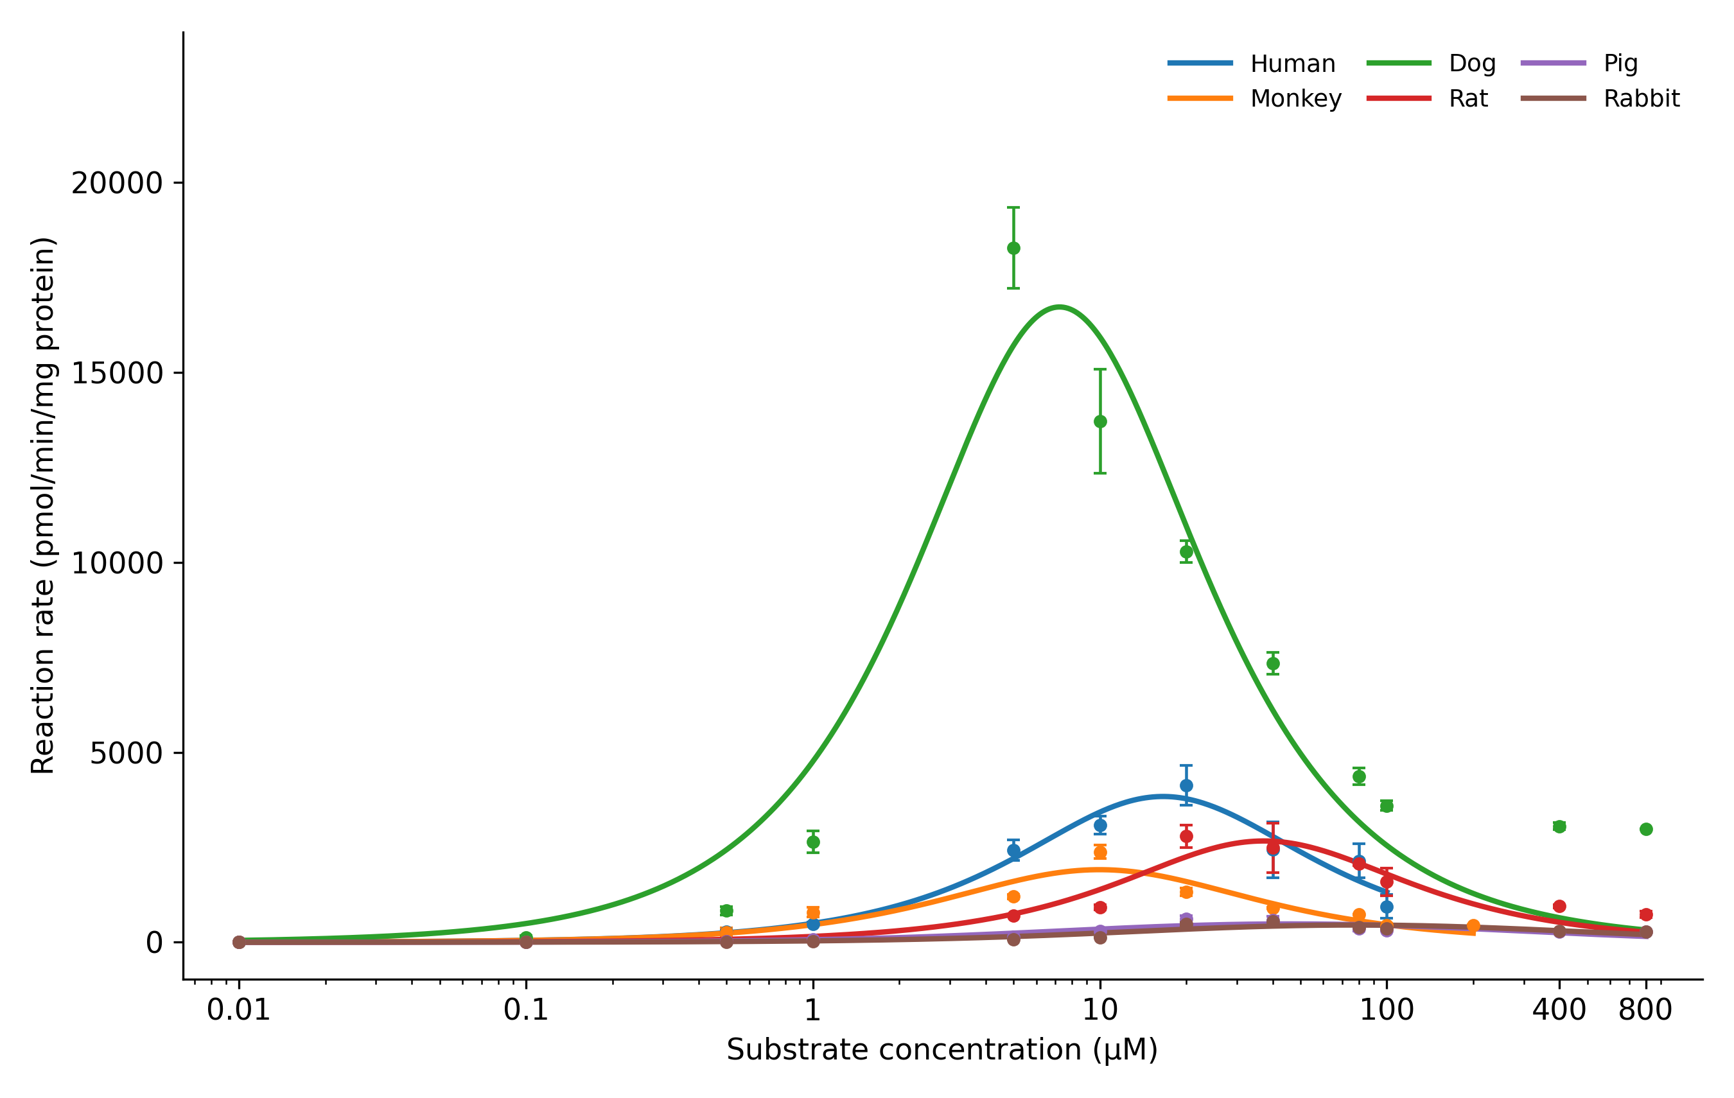
Supplemental Figure 3I. Enzyme kinetic profiles of 4'-OH-PCB 93 across six species.

