A novel biological parcellation of anterior cingulate cortex as identified by a functional reversal point in error monitoring

Brain Structure and Function
Camila Dias,^{1,2,3} Teresa Sousa,^{1,2,4,5} Assunta Ciarlo,^{6,7} Michael Lührs,^{6,7} Rainer Goebel,^{6,7} and Miguel Castelo-Branco¹⁻⁵*
¹CIBIT – Coimbra Institute for Biomedical Imaging and Translational Research, University of Coimbra, Coimbra, Portugal
²ICNAS – Institute for Nuclear Sciences Applied to Health, University of Coimbra, Coimbra, Portugal
³ICNAS PHARMA Unipessoal, Lda, Ed. ICNAS, Pólo das Ciências da Saúde, University of Coimbra, Coimbra, Portugal
⁴FMUC – Institute of Physiology, Faculty of Medicine, University of Coimbra, Coimbra, Portugal
⁵LASI – Intelligent Systems Associate Laboratory
⁶Department of Cognitive Neuroscience, Faculty of Psychology and Neuroscience, Maastricht University, Maastricht, The Netherlands
⁷Research Department, Brain Innovation BV, Maastricht, The Netherlands
*Correspondence: mcbranco@fmed.uc.pt

Supplementary information
Supplementary Table S1: Behavioural results. A mixed-effects model revealed significant effects of instruction and the interaction between condition and run order on error rate (%). Post hoc tests were conducted to compare error rates: (1) across runs within each condition and (2) across instructions. Significant differences (p < 0.05, Bonferroni-corrected) are denoted by an asterisk and highlighted with bold lettering. Numbers following the ± sign represent the standard error of the mean (SEM), and effect sizes correspond to Cohen’s d.
Error rate (%)
Parameter | Estimate | p | Effect size
Condition × Run:
Run 1 – Run 2 (Response) | 24.07 ± 5.52 | 3.58 × ${10}^{-4}$* | 1.38
Run 1 – Run 3 (Response) | 28.12 ± 5.27 | 5.00 × ${10}^{-6}$* | 1.69
Run 1 – Run 4 (Response) | 30.75 ± 4.92 | 6.10 × ${10}^{-8}$* | 1.98
Run 1 – Run 5 (Response) | 22.62 ± 4.75 | 6.60 × ${10}^{-5}$* | 1.51
Run 1 – Run 6 (Response) | 35.89 ± 7.93 | 1.78 × ${10}^{-4}$* | 1.43
Run 2 – Run 3 (Response) | 4.05 ± 5.17 | 1.000 | 0.25
Run 2 – Run 4 (Response) | 6.68 ± 5.28 | 1.000 | 0.40
Run 2 – Run 5 (Response) | -1.45 ± 4.43 | 1.000 | -0.10
Run 2 – Run 6 (Response) | 11.82 ± 8.10 | 1.000 | 0.46
Run 3 – Run 4 (Response) | 2.63 ± 5.35 | 1.000 | 0.16
Run 3 – Run 5 (Response) | -5.50 ± 3.98 | 1.000 | -0.44
Run 3 – Run 6 (Response) | 7.77 ± 7.15 | 1.000 | 0.34
Run 4 – Run 5 (Response) | -8.12 ± 4.90 | 1.000 | -0.52
Run 4 – Run 6 (Response) | 5.14 ± 8.04 | 1.000 | 0.20
Run 5 – Run 6 (Response) | 13.27 ± 7.46 | 1.000 | 0.56
Run 1 – Run 2 (Feedback) | 2.70 × 10⁻³ ± 5.20 | 1.000 | 1.64 × 10⁻⁴
Run 1 – Run 3 (Feedback) | 16.77 ± 5.28 | 0.027* | 1.00
Run 1 – Run 4 (Feedback) | 7.03 ± 4.67 | 1.000 | 0.48
Run 1 – Run 5 (Feedback) | 19.60 ± 6.09 | 0.023* | 1.02
Run 1 – Run 6 (Feedback) | 15.92 ± 4.21 | 0.003* | 1.20
Run 2 – Run 3 (Feedback) | 16.76 ± 5.65 | 0.052 | 0.94
Run 2 – Run 4 (Feedback) | 7.03 ± 5.27 | 1.000 | 0.42
Run 2 – Run 5 (Feedback) | 19.60 ± 5.78 | 0.013* | 1.07
Run 2 – Run 6 (Feedback) | 15.92 ± 4.84 | 0.019* | 1.04
Run 3 – Run 4 (Feedback) | 9.73 ± 5.66 | 1.000 | 0.54
Run 3 – Run 5 (Feedback) | 2.83 ± 5.88 | 1.000 | 0.15
Run 3 – Run 6 (Feedback) | -0.85 ± 4.59 | 1.000 | -0.06
Run 4 – Run 5 (Feedback) | 12.57 ± 6.34 | 0.739 | 0.63
Run 4 – Run 6 (Feedback) | 8.89 ± 4.88 | 1.000 | 0.58
Run 5 – Run 6 (Feedback) | -3.68 ± 5.73 | 1.000 | -0.20
Instruction:
Sad red – Happy green | 11.25 ± 2.55 | 1.20 × ${10}^{-4}$* | 1.40
Sad red – Sad green | 11.67 ± 2.55 | 6.10 × ${10}^{-5}$* | 1.45
Sad red – Happy red | 1.04 ± 2.55 | 1.000 | 0.13
Happy red – Happy green | 10.21 ± 2.55 | 6.00 × ${10}^{-4}$* | 1.27
Happy red – Sad green | 10.63 ± 2.55 | 3.19 × ${10}^{-4}$* | 1.32
Sad green – Happy green | -0.42 ± 2.55 | 1.000 | -0.05
Supplementary Table S2: ACC response to errors depending on the error monitoring condition, subregion, and performance. The mixed-effects analysis performed to study the effect of condition, ACC subregion, and performance on neural activity revealed a significant interaction between all three factors. Results of the post hoc tests comparing correct and error events within each condition and ACC subregion are shown. Significant differences (p < 0.05, Bonferroni-corrected) are signalled with an asterisk and highlighted with bold lettering. Numbers following the ± sign represent the SEM and effect sizes correspond to Cohen’s d.
ACC signal change (%)
Condition | Subregion | Comparison | Estimate | p | Effect size
Response | A | Error – Correct | -0.51 ± 0.30 | 0.093 | -0.54
Response | B | Error – Correct | -0.31 ± 0.30 | 0.299 | -0.33
Response | C | Error – Correct | -0.60 ± 0.30 | 0.046* | -0.63
Response | D | Error – Correct | -0.61 ± 0.30 | 0.044* | -0.64
Response | E | Error – Correct | -0.66 ± 0.30 | 0.029* | -0.70
Response | F | Error – Correct | -0.34 ± 0.30 | 0.260 | -0.36
Response | G | Error – Correct | 0.32 ± 0.30 | 0.295 | 0.34
Response | H | Error – Correct | 0.71 ± 0.30 | 0.019* | 0.75
Response | I | Error – Correct | 0.52 ± 0.30 | 0.084 | 0.55
Response | J | Error – Correct | 0.18 ± 0.30 | 0.543 | 0.19
Feedback | A | Error – Correct | -1.30 ± 0.33 | 9.86 × 10⁻⁵* | -1.25
Feedback | B | Error – Correct | -0.24 ± 0.32 | 0.459 | -0.24
Feedback | C | Error – Correct | -0.69 ± 0.33 | 0.034 | -0.66
Feedback | D | Error – Correct | -0.85 ± 0.32 | 0.008 | -0.84
Feedback | E | Error – Correct | 0.35 ± 0.32 | 0.284 | 0.35
Feedback | F | Error – Correct | 1.02 ± 0.32 | 0.002* | 1.01
Feedback | G | Error – Correct | 1.89 ± 0.32 | 5.10 × 10⁻⁹* | 1.87
Feedback | H | Error – Correct | 1.80 ± 0.32 | 2.83 × 10⁻⁸* | 1.78
Feedback | I | Error – Correct | 1.34 ± 0.32 | 3.35 × 10⁻⁵* | 1.32
Feedback | J | Error – Correct | 0.61 ± 0.32 | 0.059 | 0.60
Observation | A | Error – Correct | -0.65 ± 0.28 | 0.021* | -0.73
Observation | B | Error – Correct | -0.64 ± 0.27 | 0.018* | -0.75
Observation | C | Error – Correct | -0.63 ± 0.27 | 0.022* | -0.74
Observation | D | Error – Correct | -0.79 ± 0.27 | 0.004* | -0.93
Observation | E | Error – Correct | -0.63 ± 0.27 | 0.020* | -0.74
Observation | F | Error – Correct | -0.35 ± 0.27 | 0.197 | -0.41
Observation | G | Error – Correct | -0.28 ± 0.27 | 0.303 | -0.33
Observation | H | Error – Correct | -0.26 ± 0.27 | 0.350 | -0.30
Observation | I | Error – Correct | -0.07 ± 0.27 | 0.804 | -0.08
Observation | J | Error – Correct | 0.06 ± 0.27 | 0.830 | 0.07

Supplementary Table S3: ACC activity associated with response without feedback and response before feedback. The mixed-effects analysis performed to study the effect of condition (response without feedback and response before feedback), performance, and ACC subregion on neural activity revealed significant interactions between condition and ACC subregion, and between performance and ACC subregion. Results of the post hoc tests comparing (1) conditions and (2) performance within each ACC subregion are shown. Significant differences (p < 0.05, Bonferroni-corrected) are signalled with an asterisk and highlighted with bold lettering. Numbers following the ± sign represent the SEM and effect sizes correspond to Cohen’s d.
ACC signal change (%)
Parameter | Estimate | p | Effect size
Condition × ACC subregion:
No feedback - Feedback (A) | -0.42 ± 0.15 | 0.005* | -0.89
No feedback - Feedback (B) | 0.25 ± 0.14 | 0.074 | 0.56
No feedback - Feedback (C) | 0.38 ± 0.14 | 0.009* | 0.86
No feedback - Feedback (D) | 0.16 ± 0.14 | 0.250 | 0.36
No feedback - Feedback (E) | 0.29 ± 0.14 | 0.045* | 0.66
No feedback - Feedback (F) | 0.42 ± 0.14 | 0.003* | 0.95
No feedback - Feedback (G) | 0.39 ± 0.14 | 0.006* | 0.88
No feedback - Feedback (H) | 0.38 ± 0.14 | 0.008* | 0.86
No feedback - Feedback (I) | 0.11 ± 0.14 | 0.433 | 0.25
No feedback - Feedback (J) | 0.16 ± 0.14 | 0.258 | 0.36
Performance × ACC subregion:
Error – Correct (A) | -0.35 ± 0.16 | 0.034* | -0.69
Error – Correct (B) | -0.20 ± 0.16 | 0.210 | -0.40
Error – Correct (C) | -0.23 ± 0.16 | 0.155 | -0.45
Error – Correct (D) | -0.26 ± 0.16 | 0.096 | -0.51
Error – Correct (E) | -0.36 ± 0.16 | 0.023* | -0.71
Error – Correct (F) | -0.08 ± 0.16 | 0.606 | -0.16
Error – Correct (G) | 0.31 ± 0.16 | 0.053 | 0.61
Error – Correct (H) | 0.68 ± 0.16 | 1.78 × 10⁻⁵* | 1.34
Error – Correct (I) | 0.59 ± 0.16 | 1.96 × 10⁻⁴* | 1.17
Error – Correct (J) | 0.19 ± 0.16 | 0.219 | 0.38

Supplementary Table S4: Winner maps. Details regarding the ACC subregions associated with error commission, error feedback, and error observation, identified using a winner map approach. With this method, each voxel of the ACC was attributed to the condition – response, feedback, or observation – that showed the highest statistical value for the contrast between error and correct trials, with a threshold of p < 0.05.
Winner maps
Error > Correct
Condition | Cluster size (voxels) | Peak voxel (MNI) |  |  | Region (peak voxel) | T | p
Condition | Cluster size (voxels) | x | y | z | Region (peak voxel) | T | p
Response | 219 | 0 | 33 | 25 | dACC | 2.79 | 0.021
Feedback | 309 | 5 | 20 | 24 | dACC | 4.47 | 0.002
Observation
Correct > Error
Condition | Cluster size (voxels) | Peak voxel (MNI) |  |  | Region (peak voxel) | T | p
Condition | Cluster size (voxels) | x | y | z | Region (peak voxel) | T | p
Response | 99 | -16 | 41 | 13 | pgACC | 3.28 | 0.009
Feedback | 97 | -10 | 32 | -12 | pgACC | 4.07 | 0.003
Observation | 1753 | -3 | 24 | -11 | pgACC | 9.55 | 5 × 10⁻⁶

Supplementary Table S5: SCR elicited during the task. SCR frequency and amplitude for correct and error trials across all conditions – response, feedback, and observation.
 | Response |  | Feedback |  | Observation
 | Frequency (%) | Amplitude (µS) | Frequency (%) | Amplitude (µS) | Frequency (%) | Amplitude (µS)
Correct | 7.85 ± 2.14 | 0.07 ± 0.02 | 6.53 ± 2.14 | 0.07 ± 0.02 | 6.74 ± 2.19 | 0.09 ± 0.02
Error | 11.53 ± 2.14 | 0.05 ± 0.03 | 8.60 ± 2.20 | 0.09 ± 0.03 | 4.93 ± 2.20 | 0.07 ± 0.03

Supplementary Table S6: ACC correlates of skin conductance. ACC regions where BOLD activity correlated with the tonic and phasic components of skin conductance (p < 0.05).
EDA
Component | Cluster size (voxels) | Peak voxel (MNI) |  |  | Region (peak voxel) | T | p
Component | Cluster size (voxels) | x | y | z | Region (peak voxel) | T | p
Phasic | 193 | 11 | 38 | -2 | pgACC | 5.04 | 7.05 × 10⁻⁴
Tonic | 609 | 4 | 45 | 12 | pgACC | -5.35 | 4.60 × 10⁻⁴

Supplementary Figure S1: ACC activity associated with response without feedback and response before feedback. Estimated marginal means of ACC PSC betas for correct (green dashed line) and error events (red solid line) across ACC subregions for these two conditions. Error bars represent the SEM. Significant differences (p < 0.05, Bonferroni-corrected) between correct and error responses are signalled with an asterisk. The reversal points ─ where correct and error lines intersect ─ are highlighted in blue.
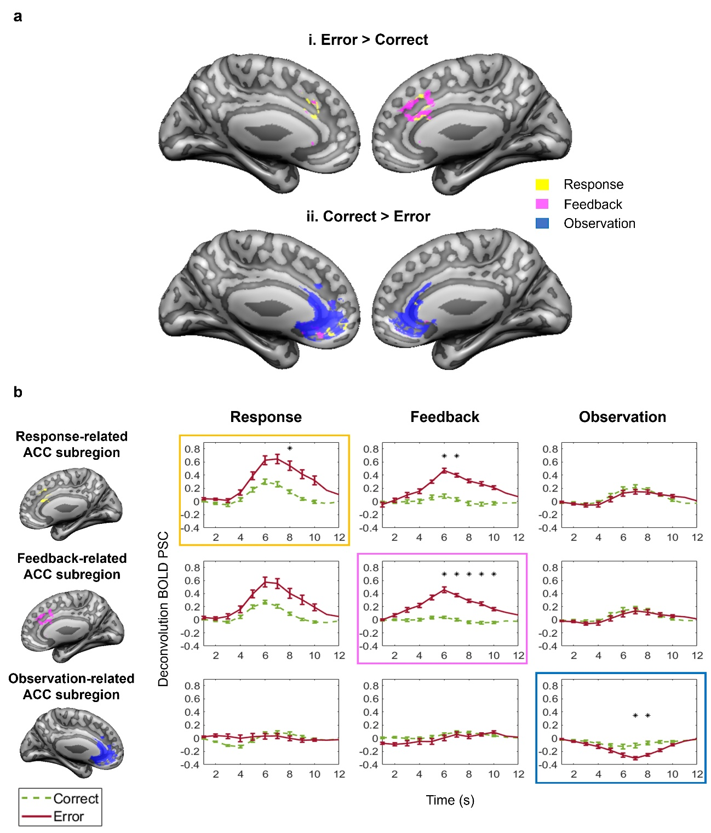
Supplementary Figure S2: Group-level winner maps. (A) Each voxel of the ACC was attributed to the condition – response (yellow), feedback (pink), or observation (blue) – associated with the highest statistical value for the contrasts (i) error > correct and (ii) correct > error. A threshold of p < 0.05 was applied. (B) ROI-specific ACC hemodynamic responses for all conditions (response, feedback, and observation). For each condition, the largest cluster from the contrasts error > correct and error < correct was selected, and its hemodynamic response across all conditions is illustrated. Supplementary Figure S3 shows the ACC hemodynamic responses of the remaining clusters.
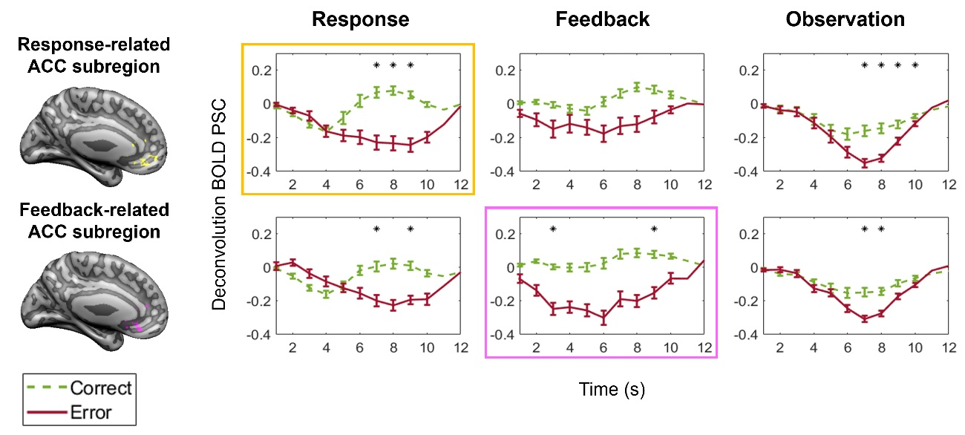
Supplementary Figure S3: ACC hemodynamic responses to different error monitoring processes. Using winner maps, each voxel of the ACC was attributed to the condition associated with the highest statistical value for the contrasts error > correct and correct > error, with a threshold of p < 0.05. For each condition, the largest cluster from these contrasts was selected, and its hemodynamic response across all conditions was previously shown in Supplementary Figure S2B. The current figure displays the remaining clusters.
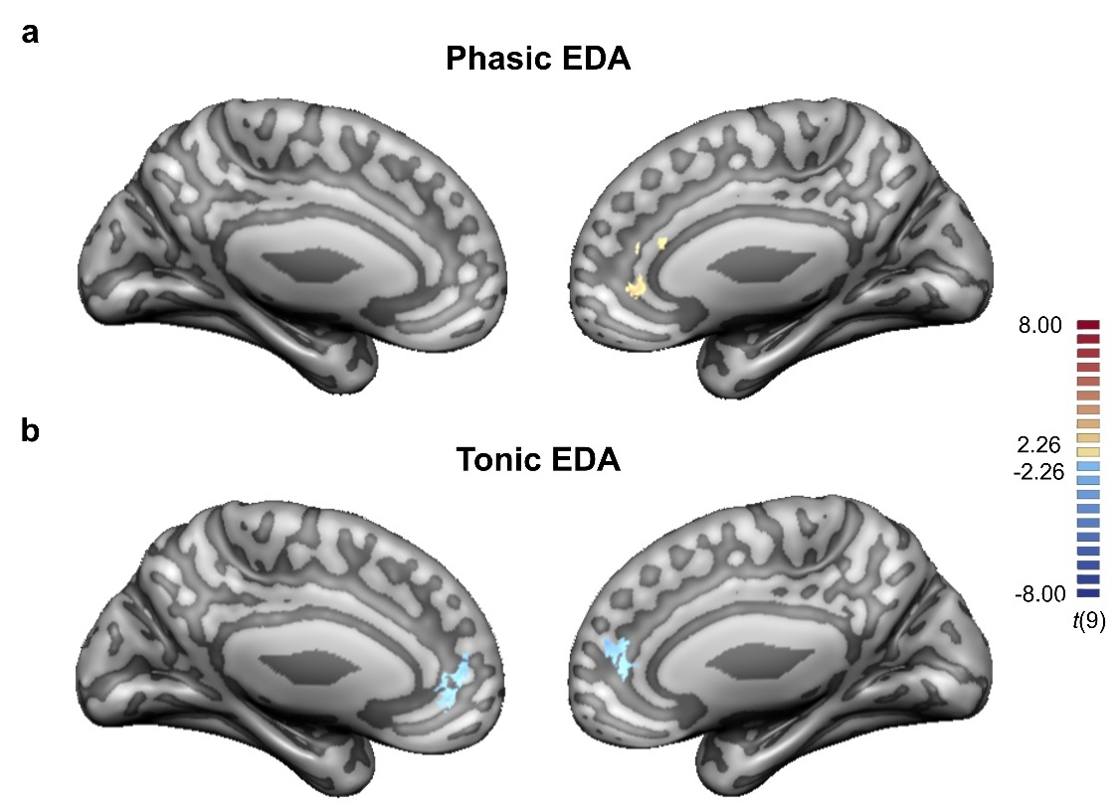
Supplementary Figure S4: EDA results. Group-level general linear model (GLM)-based correlation maps of ACC activity with the (A) phasic and (B) tonic components of skin conductance. A threshold of p < 0.05 was applied. These components correlated with neural activity in areas of the pgACC. While the phasic component exhibited a positive correlation with pgACC activity, the tonic component showed an inverse correlation.

