Supplementary figures
Plant diversity effects on herbivory are mediated by soil biodiversity and plant chemistry

Christian Ristok^{1,2}, Alexander Weinhold^{1,2}, Marcel Ciobanu³, Yvonne Poeschl^{1,4}, Christiane Roscher^{5,1}, Fredd Vergara^{1,2}, Nico Eisenhauer^{1,6 ‡}, Nicole M. van Dam^{1,2 * ‡}

¹German Centre for Integrative Biodiversity Research (iDiv) Halle-Jena-Leipzig, Leipzig, Germany
²Institute of Biodiversity, Friedrich Schiller University Jena, Jena, Germany
³Institute of Biological Research, Branch of the National Institute of Research and Development for Biological Sciences, Cluj-Napoca, Romania
⁴Institute of Computer Science, Martin Luther University Halle-Wittenberg, Halle, Germany
⁵Department of Physiological Diversity, Helmholtz Centre for Environmental Research (UFZ), Leipzig, Germany
⁶Leipzig University, Leipzig, Germany

‡ Jointly supervised the work.
* Author of correspondence:
Nicole M. van Dam
German Centre for Integrative Biodiversity Research (iDiv) Halle-Jena-Leipzig, Puschstraße 4, D-04103 Leipzig, Germany
nicole.vandam@idiv.de

Figure S1 The plant-individual herbivory rate (log-transformed) on grasses only in response to (a) community spatial resource acquisition strategy (F_{1,179} = 3.93; p = 0.049) and (b) community temporal resource acquisition strategy (F_{1,133} = 6.32; p = 0.013) of the Trait-Based Experiment. The relationship in August is displayed in circles and red colour. The relationship in May is displayed in triangles and black colour. Regression line estimates are based on linear mixed effect models with plot nested in block, and species identity as independent random terms. The shaded band displays the standard error.

Figure S2 The plant-individual herbivory rate (log-transformed) on forbs only in response to (a) community spatial resource acquisition strategy (F_{1,127} = 0.42; p = 0.519) and (b) community temporal resource acquisition strategy (F_{1,251} = 0.98; p = 0.324) of the Trait-Based Experiment. The relationship in August is displayed in circles and red colour. The relationship in May is displayed in triangles and black colour. Regression line estimates are based on linear mixed effect models with plot nested in block, and species identity as independent random terms. The shaded band displays the standard error.

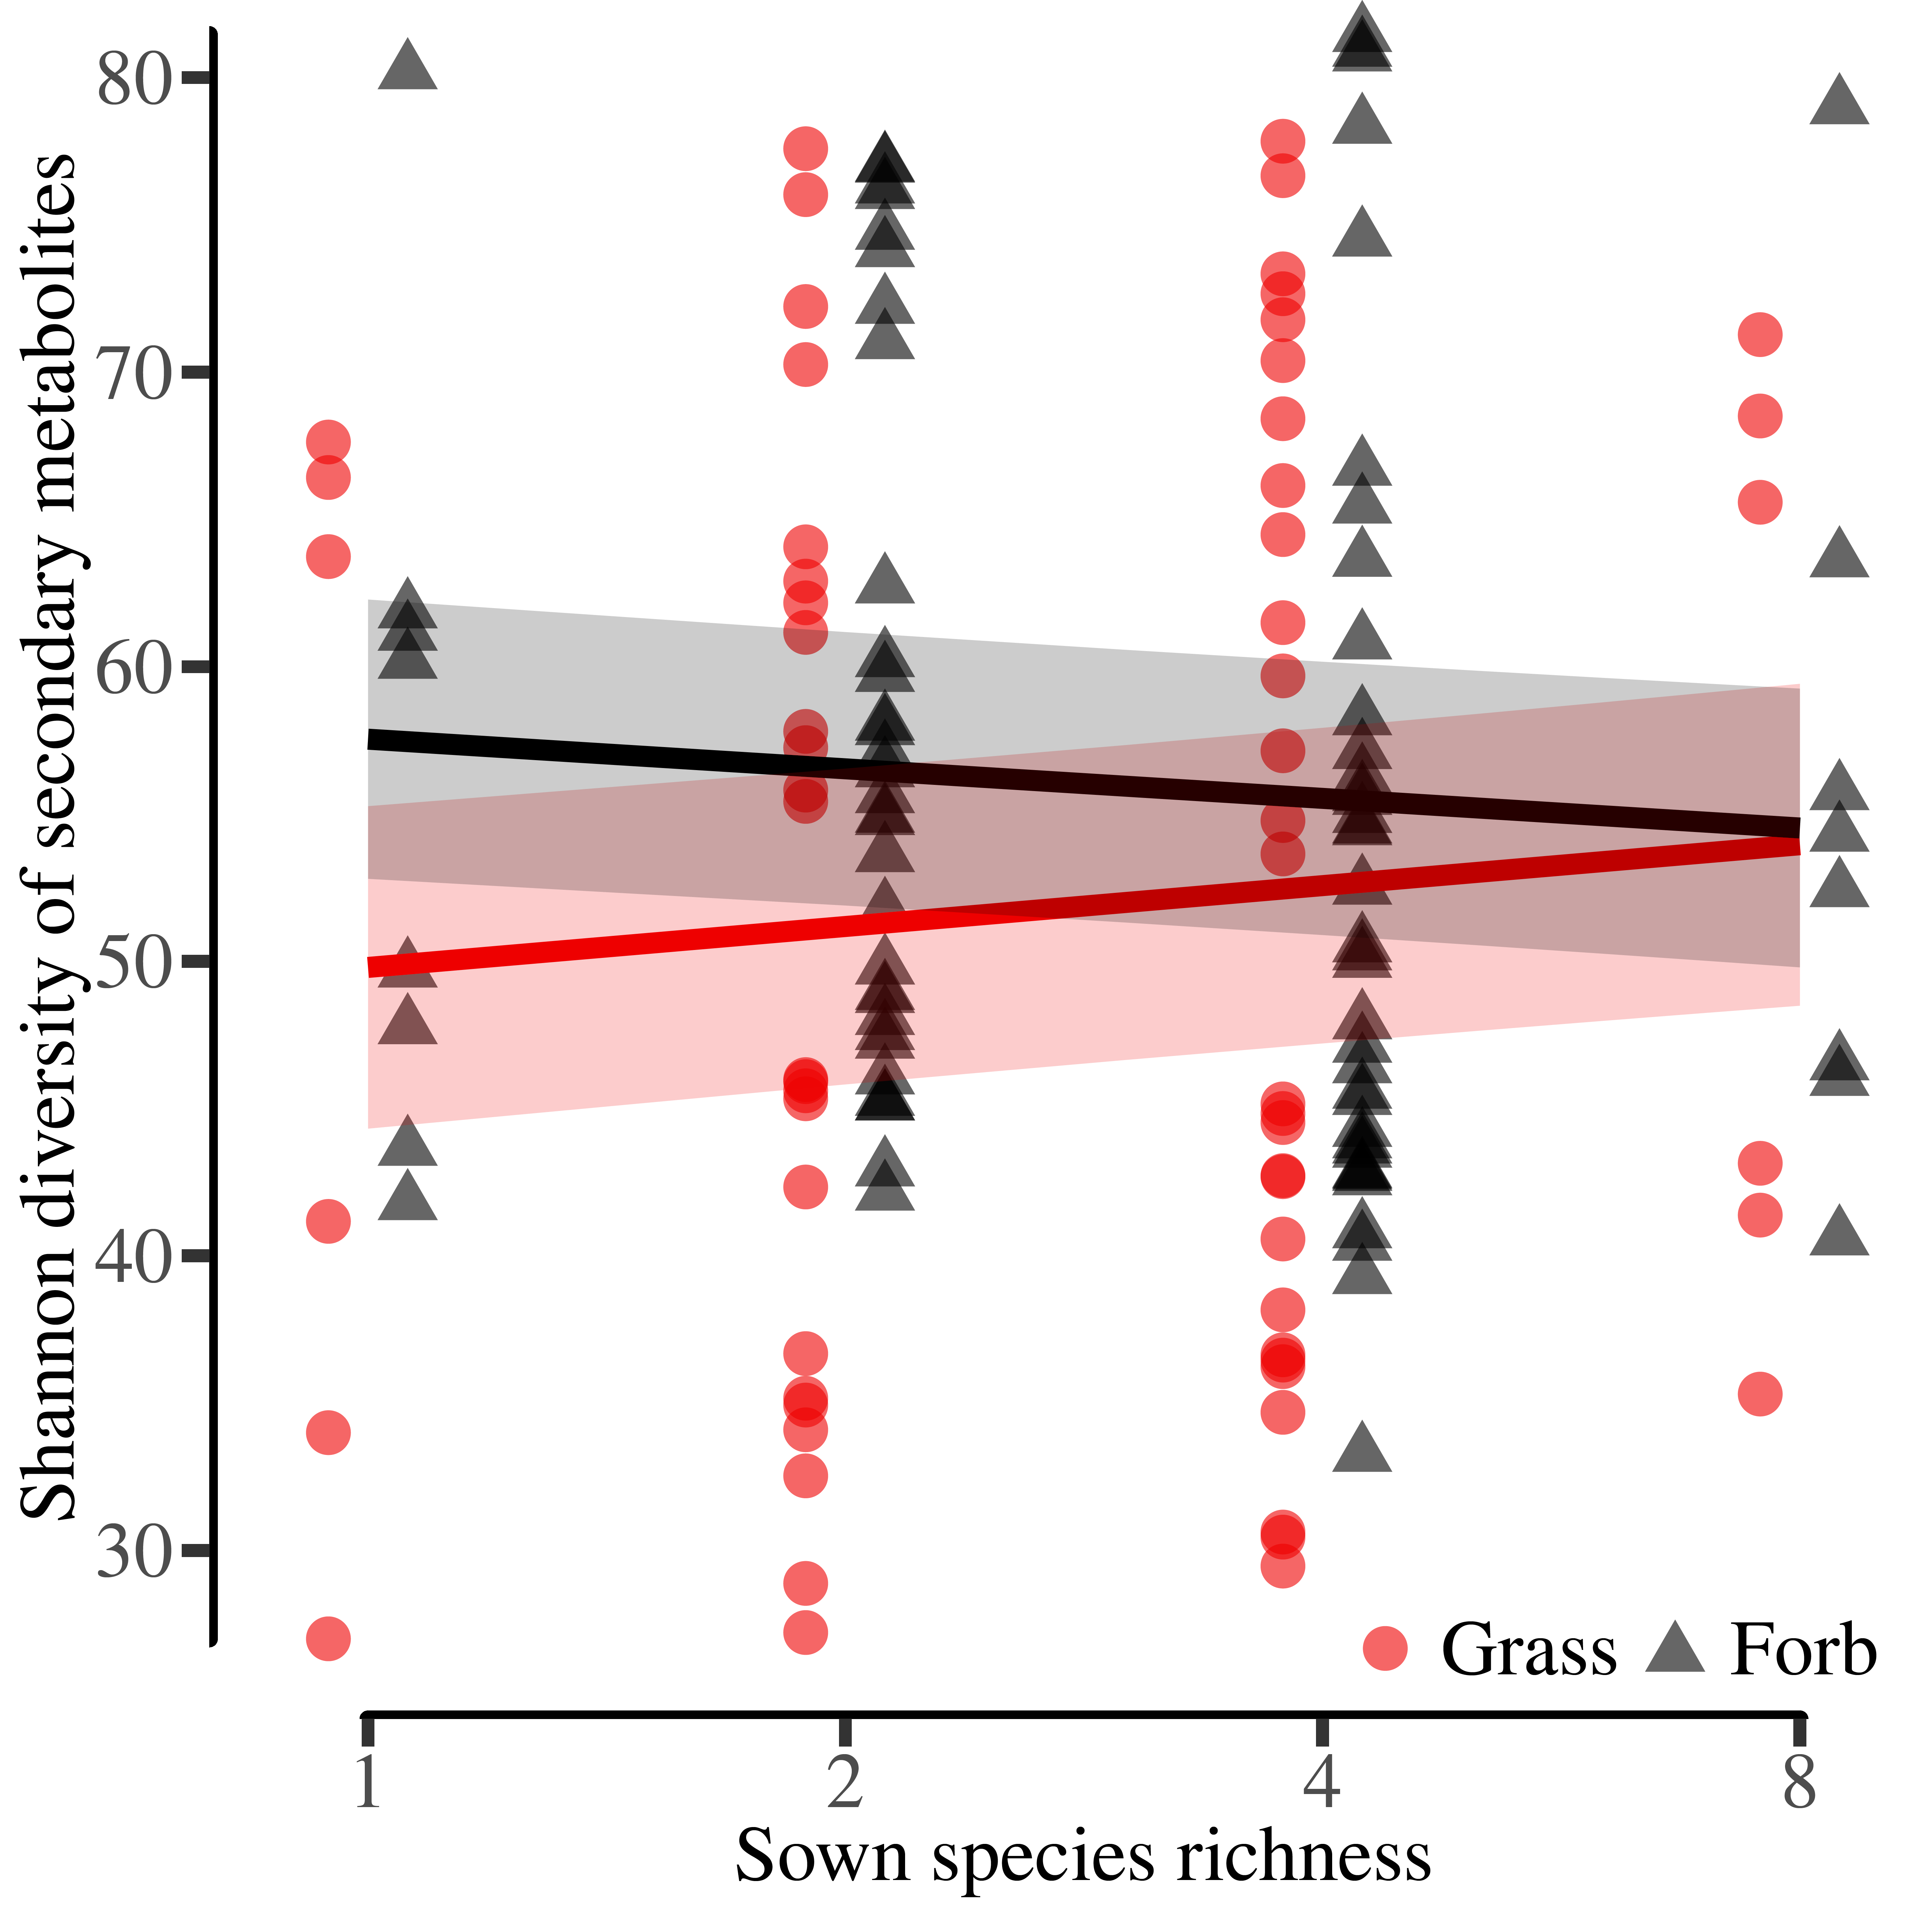
Figure S3 The Shannon diversity of secondary metabolites in response to sown species richness (F_{1,138} = 5.35; p = 0.022) of the Trait-Based Experiment. For clarity, the placement of the symbols corresponding to the functional group identity have been slightly shifted along the x-axis. The relationship in grasses is displayed in circles and red colour. The relationship in forbs is displayed in triangles and black colour. Regression line estimates are based on linear mixed effect models with plot nested in block, and species identity as independent random terms. The shaded band displays the standard error.

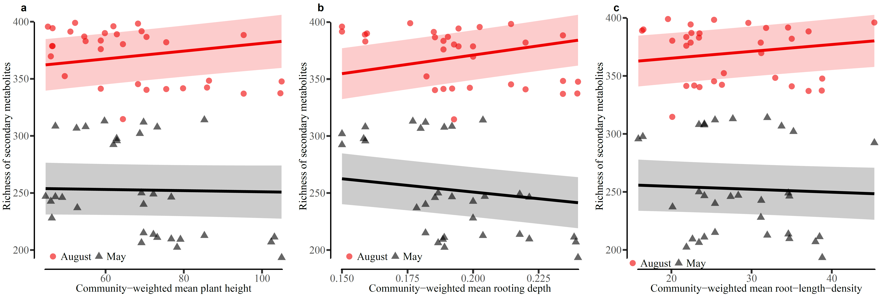
Figure S4 The richness of secondary metabolites in grasses only in response to (a) community-weighted mean plant height, (b) community-weighted mean rooting depth, and (c) community-weighted mean root-length-density of the Trait-Based Experiment. The relationship in August is displayed in circles and red colour. The relationship in May is displayed in triangles and black colour. Regression line estimates are based on linear mixed effect models with plot nested in block, and species identity as independent random terms. The shaded band displays the standard error.
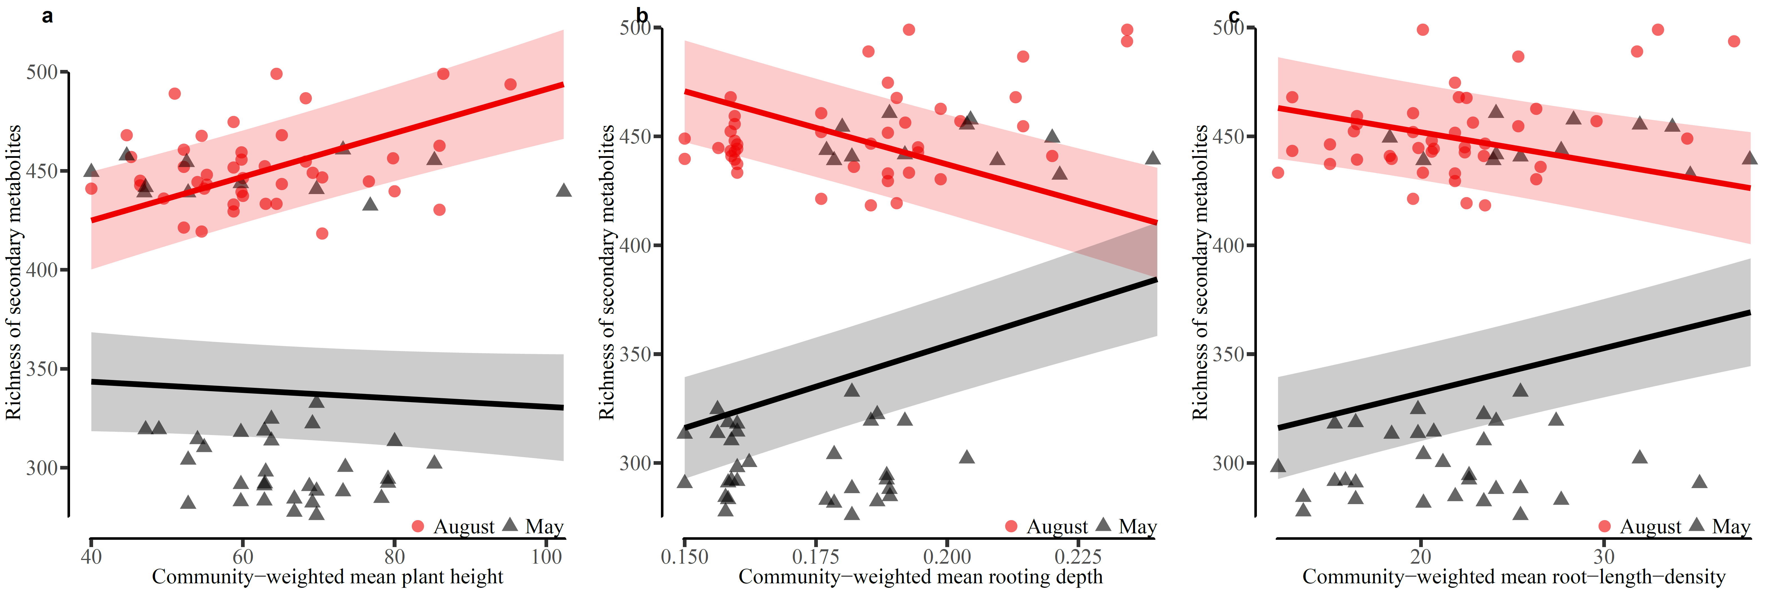
Figure S5 The richness of secondary metabolites in forbs only in response to (a) community-weighted mean plant height, (b) community-weighted mean rooting depth, and (c) community-weighted mean root-length-density of the Trait-Based Experiment. The relationship in August is displayed in circles and red colour. The relationship in May is displayed in triangles and black colour. Regression line estimates are based on linear mixed effect models with plot nested in block, and species identity as independent random terms. The shaded band displays the standard error.
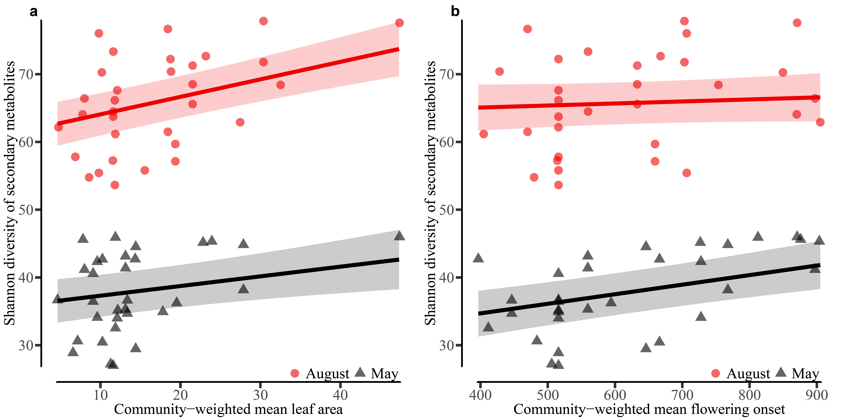
Figure S6 The Shannon diversity of secondary metabolites in grasses only in response to (a) community-weighted mean leaf area and (b) community-weighted mean flowering onset of the Trait-Based Experiment. The relationship in August is displayed in circles and red colour. The relationship in May is displayed in triangles and black colour. Regression line estimates are based on linear mixed effect models with plot nested in block, and species identity as independent random terms. The shaded band displays the standard error.
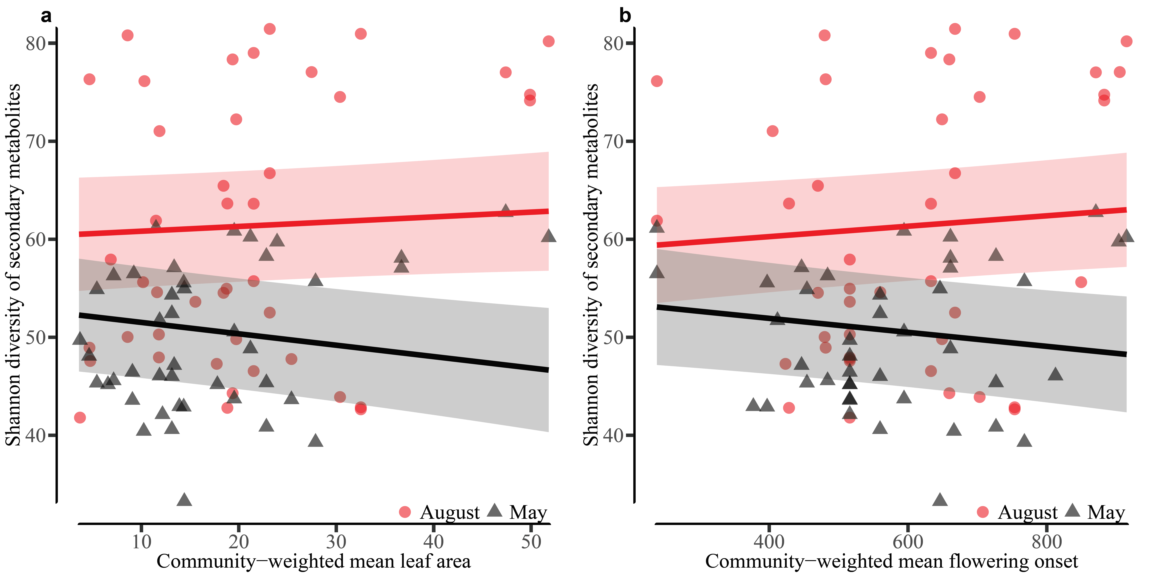
Figure S7 The Shannon diversity of secondary metabolites in forbs only in response to (a) community-weighted mean leaf area and (b) community-weighted mean flowering onset of the Trait-Based Experiment. The relationship in August is displayed in circles and red colour. The relationship in May is displayed in triangles and black colour. Regression line estimates are based on linear mixed effect models with plot nested in block, and species identity as independent random terms. The shaded band displays the standard error.
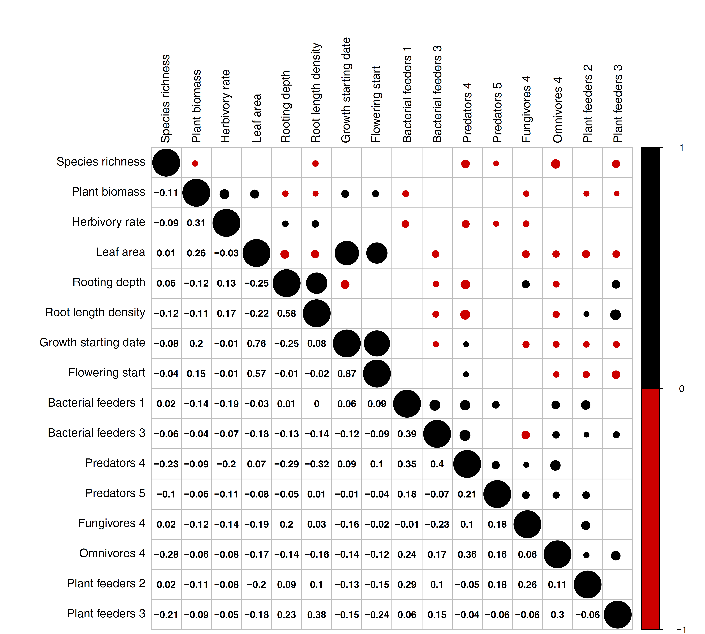
Figure S8 Correlation between plant species richness, plant individual biomass, herbivory rate, selected community-weighted mean traits and functional nematode guilds of the Trait-Based Experiment. The selection is based on the important moderators in the most parsimonious full-model PLS-PM. The upper triangle displays positive Pearson correlations in black circles and negative Pearson correlations in red circles. The size of the circle corresponds to the strength of the correlation. Empty cells display non-significant correlations. The lower triangle displays the Pearson correlation coefficients. The number at the end of each functional nematode guild represents their c-p score on the colonization-persistence gradient.
Figure S9 Predicted metabolite structure of sinapic acid extracted from Dactylis glomerata through the comparison of LC-MS data with literature references. We submitted high-resolution mass-to-charge values to the MassBank of North America (MoNA, http://mona.fiehnlab.ucdavis.edu/) spectral database. We used a mass tolerance of 0.5 D for comparison. In addition, we calculated high-resolution molecular weights, molecular formulae for putative molecular ions in neutral form, and particle weights for mass spectrometry generated fragments using ChemDraw Ultra 8.0 (www.cambridgesoft.com). For more details see Supplementary Table S3.
Figure S10 Predicted metabolite structures of flavone 1 and dilignan extracted from Dactylis glomerata through the comparison of LC-MS data with literature references. We submitted high-resolution mass-to-charge values to the MassBank of North America (MoNA, http://mona.fiehnlab.ucdavis.edu/) spectral database. We used a mass tolerance of 0.5 D for comparison. In addition, we calculated high-resolution molecular weights, molecular formulae for putative molecular ions in neutral form, and particle weights for mass spectrometry generated fragments using ChemDraw Ultra 8.0 (www.cambridgesoft.com). For more details see Supplementary Table S3.
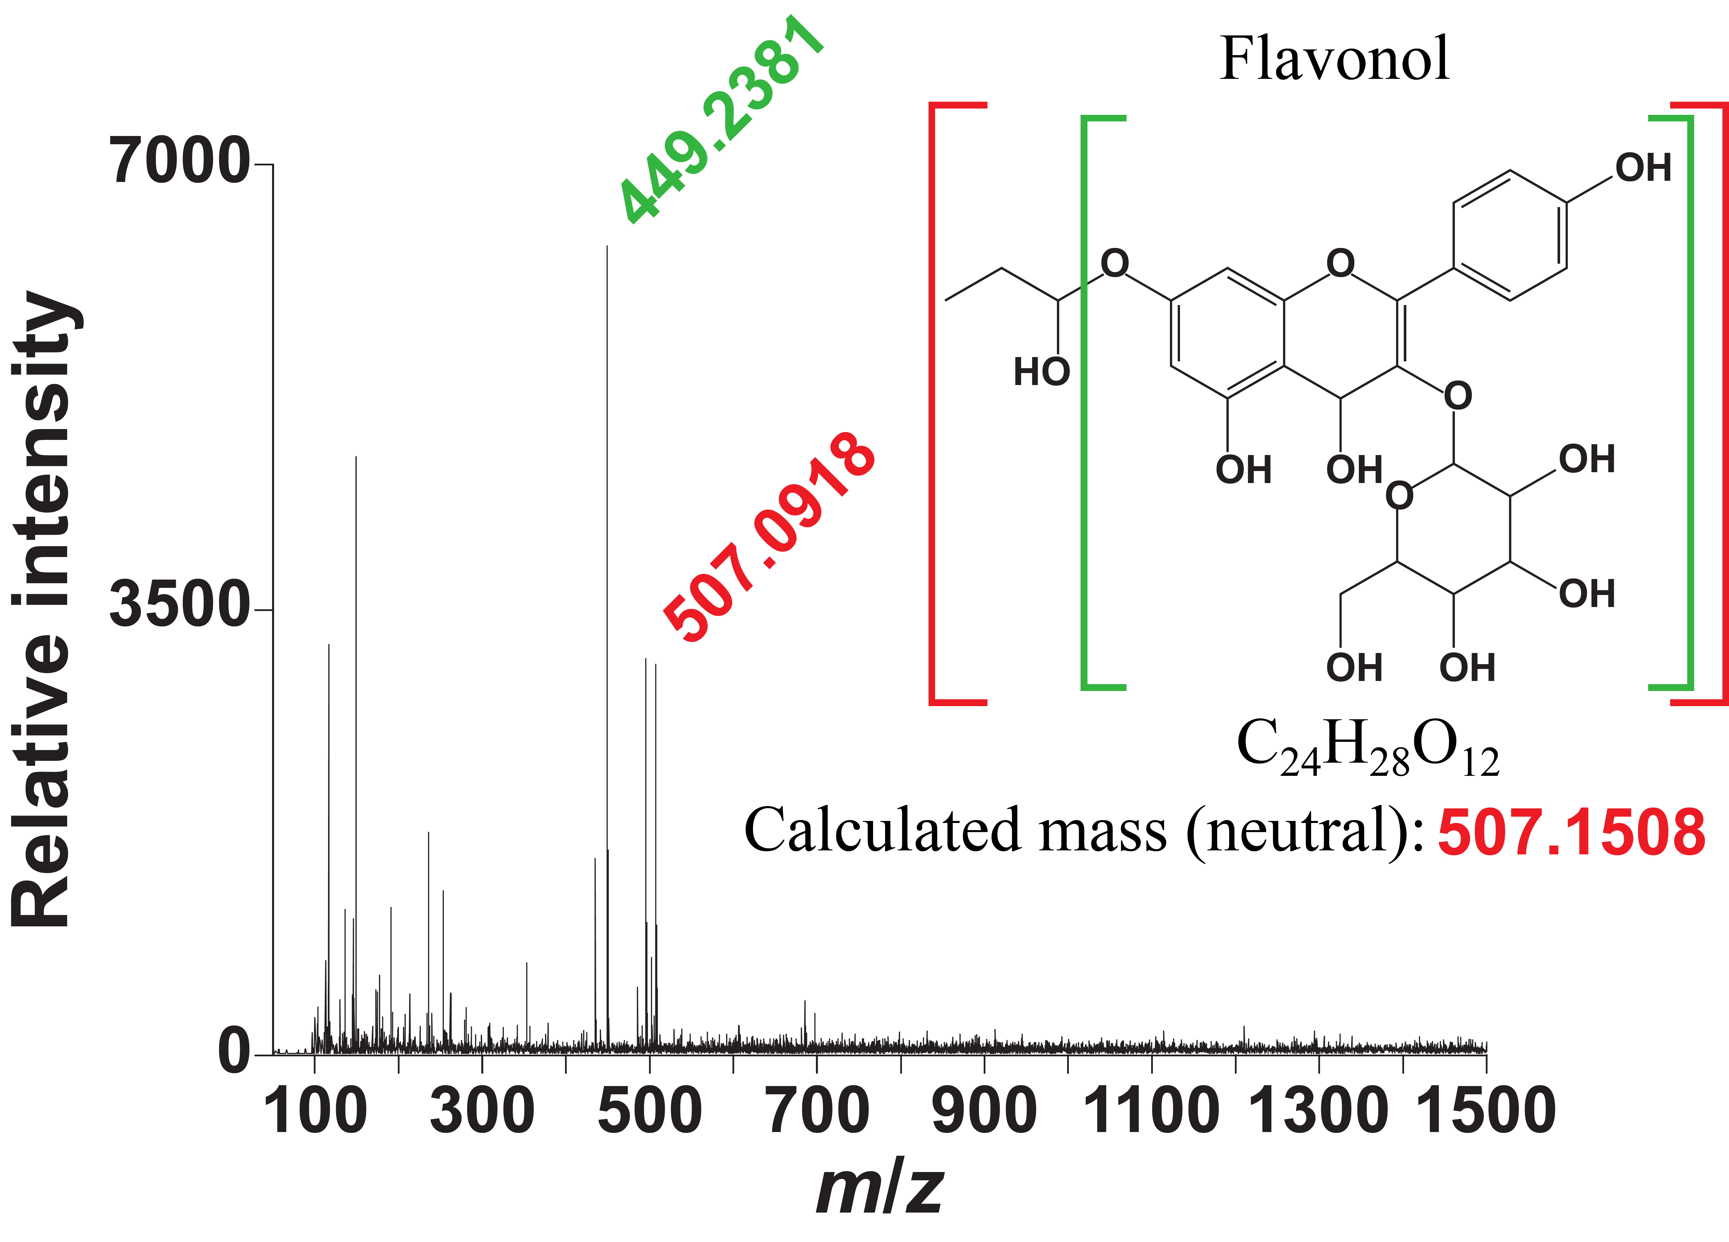
Figure S11 Predicted metabolite structure of flavonol extracted from Dactylis glomerata through the comparison of LC-MS data with literature references. We submitted high-resolution mass-to-charge values to the MassBank of North America (MoNA, http://mona.fiehnlab.ucdavis.edu/) spectral database. We used a mass tolerance of 0.5 D for comparison. In addition, we calculated high-resolution molecular weights, molecular formulae for putative molecular ions in neutral form, and particle weights for mass spectrometry generated fragments using ChemDraw Ultra 8.0 (www.cambridgesoft.com). For more details see Supplementary Table S3.
Figure S12 Predicted metabolite structure of flavone 2 extracted from Dactylis glomerata through the comparison of LC-MS data with literature references. We submitted high-resolution mass-to-charge values to the MassBank of North America (MoNA, http://mona.fiehnlab.ucdavis.edu/) spectral database. We used a mass tolerance of 0.5 D for comparison. In addition, we calculated high-resolution molecular weights, molecular formulae for putative molecular ions in neutral form, and particle weights for mass spectrometry generated fragments using ChemDraw Ultra 8.0 (www.cambridgesoft.com). For more details see Supplementary Table S3.
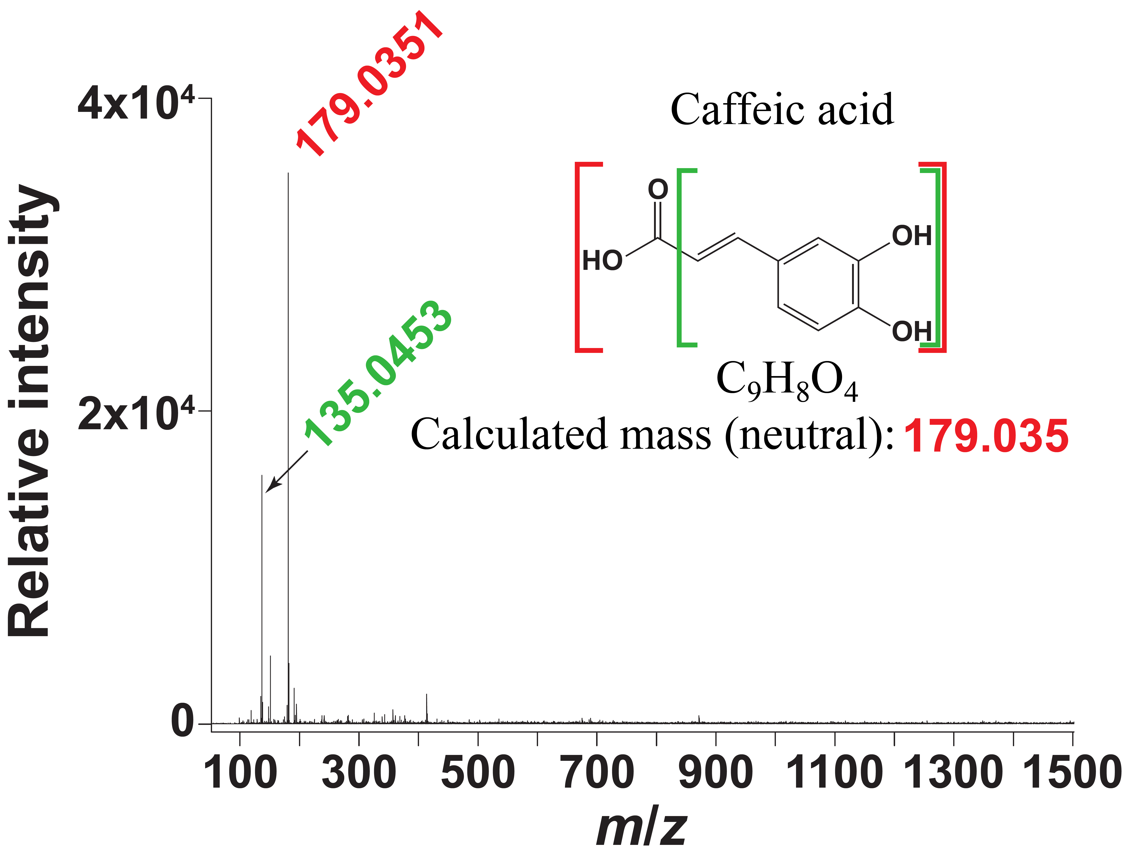
Figure S13 Predicted metabolite structure of caffeic acid extracted from Dactylis glomerata through the comparison of LC-MS data with literature references. We submitted high-resolution mass-to-charge values to the MassBank of North America (MoNA, http://mona.fiehnlab.ucdavis.edu/) spectral database. We used a mass tolerance of 0.5 D for comparison. In addition, we calculated high-resolution molecular weights, molecular formulae for putative molecular ions in neutral form, and particle weights for mass spectrometry generated fragments using ChemDraw Ultra 8.0 (www.cambridgesoft.com). For more details see Supplementary Table S3.
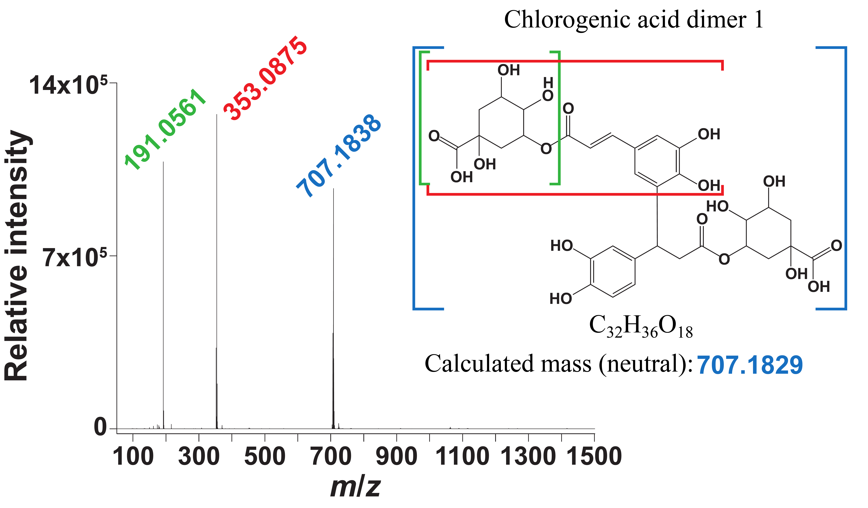
Figure S14 Predicted metabolite structure of chlorogenic acid 1 extracted from Leucanthemum vulgare through the comparison of LC-MS data with literature references. We submitted high-resolution mass-to-charge values to the MassBank of North America (MoNA, http://mona.fiehnlab.ucdavis.edu/) spectral database. We used a mass tolerance of 0.5 D for comparison. In addition, we calculated high-resolution molecular weights, molecular formulae for putative molecular ions in neutral form, and particle weights for mass spectrometry generated fragments using ChemDraw Ultra 8.0 (www.cambridgesoft.com). For more details see Supplementary Table S3.
Figure S15 Predicted metabolite structure of chlorogenic acid 2 extracted from Leucanthemum vulgare through the comparison of LC-MS data with literature references. We submitted high-resolution mass-to-charge values to the MassBank of North America (MoNA, http://mona.fiehnlab.ucdavis.edu/) spectral database. We used a mass tolerance of 0.5 D for comparison. In addition, we calculated high-resolution molecular weights, molecular formulae for putative molecular ions in neutral form, and particle weights for mass spectrometry generated fragments using ChemDraw Ultra 8.0 (www.cambridgesoft.com). For more details see Supplementary Table S3.
Figure S16 Predicted metabolite structure of flavonol dimer extracted from Leucanthemum vulgare through the comparison of LC-MS data with literature references. We submitted high-resolution mass-to-charge values to the MassBank of North America (MoNA, http://mona.fiehnlab.ucdavis.edu/) spectral database. We used a mass tolerance of 0.5 D for comparison. In addition, we calculated high-resolution molecular weights, molecular formulae for putative molecular ions in neutral form, and particle weights for mass spectrometry generated fragments using ChemDraw Ultra 8.0 (www.cambridgesoft.com). For more details see Supplementary Table S3.
Figure S17 Predicted metabolite structure of chlorogenic acid dimer 3 extracted from Leucanthemum vulgare through the comparison of LC-MS data with literature references. We submitted high-resolution mass-to-charge values to the MassBank of North America (MoNA, http://mona.fiehnlab.ucdavis.edu/) spectral database. We used a mass tolerance of 0.5 D for comparison. In addition, we calculated high-resolution molecular weights, molecular formulae for putative molecular ions in neutral form, and particle weights for mass spectrometry generated fragments using ChemDraw Ultra 8.0 (www.cambridgesoft.com). For more details see Supplementary Table S3.
Figure S18 Predicted metabolite structure of chlorogenic acid dimer 4 extracted from Leucanthemum vulgare through the comparison of LC-MS data with literature references. We submitted high-resolution mass-to-charge values to the MassBank of North America (MoNA, http://mona.fiehnlab.ucdavis.edu/) spectral database. We used a mass tolerance of 0.5 D for comparison. In addition, we calculated high-resolution molecular weights, molecular formulae for putative molecular ions in neutral form, and particle weights for mass spectrometry generated fragments using ChemDraw Ultra 8.0 (www.cambridgesoft.com). For more details see Supplementary Table S3.
Figure S19 Predicted metabolite structure of flavan alcohol dimer extracted from Leucanthemum vulgare through the comparison of LC-MS data with literature references. We submitted high-resolution mass-to-charge values to the MassBank of North America (MoNA, http://mona.fiehnlab.ucdavis.edu/) spectral database. We used a mass tolerance of 0.5 D for comparison. In addition, we calculated high-resolution molecular weights, molecular formulae for putative molecular ions in neutral form, and particle weights for mass spectrometry generated fragments using ChemDraw Ultra 8.0 (www.cambridgesoft.com). For more details see Supplementary Table S3.
Figure S20 Predicted metabolite structure of chlorogenic acid dimer 5 extracted from Leucanthemum vulgare through the comparison of LC-MS data with literature references. We submitted high-resolution mass-to-charge values to the MassBank of North America (MoNA, http://mona.fiehnlab.ucdavis.edu/) spectral database. We used a mass tolerance of 0.5 D for comparison. In addition, we calculated high-resolution molecular weights, molecular formulae for putative molecular ions in neutral form, and particle weights for mass spectrometry generated fragments using ChemDraw Ultra 8.0 (www.cambridgesoft.com). For more details see Supplementary Table S3.
Figure S21 Predicted metabolite structure of quinic acid extracted from Plantago lanceolata through the comparison of LC-MS data with literature references. We submitted high-resolution mass-to-charge values to the MassBank of North America (MoNA, http://mona.fiehnlab.ucdavis.edu/) spectral database. We used a mass tolerance of 0.5 D for comparison. In addition, we calculated high-resolution molecular weights, molecular formulae for putative molecular ions in neutral form, and particle weights for mass spectrometry generated fragments using ChemDraw Ultra 8.0 (www.cambridgesoft.com). For more details see Supplementary Table S3.
Figure S22 Correlation between plant species richness, plant individual biomass, herbivory rate, selected functional nematode guilds and assigned plant compounds of the Trait-Based Experiment. The selection is based on the important moderators in the most parsimonious full-model PLS-PM. The upper triangle displays positive Pearson correlations in black circles and negative Pearson correlations in red circles. The size of the circle corresponds to the strength of the correlation. Empty cells display non-significant correlations. The lower triangle displays the Pearson correlation coefficients. The number at the end of each functional nematode guild represents their c-p score on the colonization-persistence gradient.

