Supplementary Information
Prognostic heterogeneity within cognitive stages: a nationwide cohort study of everyday functional difficulties and mortality in 202,508 older adults
Aging Clinical and Experimental Research
Wen-Chou Chi, Tsan-Hon Liou, Wei-Ming Wang, Chia-Feng Yen, Hua-Fang Liao, Wen-Ni Wennie Huang
Corresponding author: Wen-Ni Wennie Huang, PhD. Department of Physical Therapy, College of Medicine, I-Shou University, Kaohsiung 82445, Taiwan. E-mail: hwennie@isu.edu.tw

Contents
S1. Cohort construction and handling of missing data
S2. WHODAS 2.0 domain-level Cox model
S3. Item-level Cox model
S4. Mortality by number of everyday functional difficulties
S5. Discrimination and calibration
S6. Sensitivity analyses
S7. Comparison with alternative WHODAS-based summaries and with all 30 items
S8. Map of analyses to results
Supplementary Figures S1–S3
S1. Cohort construction and handling of missing data
Table S1.1. Cohort construction and the participants analyzed by each model
Step | n | Deaths
Aged ≥65 years, CDR 1–3, WHODAS 2.0 assessment, linked vital status | 202,575 | —
Excluded: non-positive follow-up time | −67 | —
Analytic cohort | 202,508 | 96,130 (47.5%)
Six-domain model (S2): complete on all six domain scores (excluded 13,407, 6.6%) | 189,101 | 86,108
Eleven-item model (S3): complete on all eleven items (excluded 31,769, 15.7%) | 170,739 | 80,310
Number-of-difficulties analyses (S4): complete on all four selected items (excluded 7,780, 3.8%) | 194,728 | 92,330
No covariate had a missing value, so every exclusion above is due to an unanswered WHODAS item; the education coding that makes this so is described in the Methods. The 13,407 excluded from the six-domain model are almost all assessments from 2012–2015, when the Life Activities items were seldom recorded (13,132 of the 13,407 lack that domain); their median follow-up is 4.09 years against 2.35 years in the model set, which is why the death fraction among them (74.8%) is higher than the cohort’s.
Table S1.2. Missing responses for all 30 WHODAS 2.0 items (n = 202,508 assessments)
WHODAS 2.0 item | Missing, %
D1.1 Concentrating for 10 minutes | 1.5
D1.2 Remembering | 1.1
D1.3 Problem-solving | 3.4
D1.4 Learning a new task | 12.6
D1.5 Understanding what people say | 0.9
D1.6 Conversation | 1.2
D2.1 Standing for 30 minutes | 3.3
D2.2 Rising from sitting | 0.9
D2.3 Moving around inside the home | 1.3
D2.4 Getting out of the home | 1.6
D2.5 Walking a long distance | 4.9
D3.1 Washing whole body | 0.8
D3.2 Getting dressed | 0.7
D3.3 Eating | 0.8
D4.1 Dealing with people not known | 5.4
D4.2 Maintaining a friendship | 4.3
D4.3 Getting along with people who are close | 1.1
D4.4 Making new friends | 16.6
D5.1 Household responsibilities | 6.6
D5.2 Most important household tasks well | 8.7
D5.3 Getting all household work done | 8.9
D5.4 Household work done as quickly as needed | 9.1
D6.1 Community activities | 13.8
D6.2 Barriers in the world around | 5.4
D6.3 Living with dignity | 4.0
D6.4 Time spent on the health condition | 1.5
D6.5 Emotional effect of the health condition | 7.6
D6.6 Financial drain | 7.5
D6.7 Effect on the family | 31.5
D6.8 Relaxation and pleasure | 35.4
Responses coded 9, blank or "Z" were treated as missing. No item response was imputed. A domain score is computed from the items answered within that domain (Table S1.4), so it is available whenever at least one item was answered and missing only when none was; the Cognition score rested on a partial set of items for 24,853 participants (12.3%) and the Mobility score for 10,134 (5.0%). The two Participation items D6.7 and D6.8 are the main reason the all-30-item model in S7.3 is fitted in fewer participants.
Table S1.3. Maximum-difficulty responses among participants with CDR 3
Item | Rated "extreme or cannot do", %
D2.1 Standing for 30 minutes | 52.0
D1.1 Concentrating for 10 minutes | 43.6
D2.2 Rising from sitting | 36.0
D1.5 Understanding what people say | 32.2
Among the 50,958 participants with CDR 3 and complete data on all four items.
Table S1.4. How the registry scores WHODAS 2.0
Domain | Items | Weight of each item | Weighted maximum
Cognition | 6 | 4, 4, 4, 4, 2, 2 | 20
Mobility | 5 | 4, 2, 2, 4, 4 | 16
Self-Care | 3 | 2, 4, 2 | 8
Getting Along | 4 | 2, 2, 2, 4 | 10
Life Activities | 4 | 2, 2, 2, 4 | 10
Participation | 8 | 2, 4, 2, 4, 4, 2, 4, 2 | 24
All six domains | 30 |  | 88
Each item is answered on the five-level scale shown in main-text Table 2 and recorded as that response. The registry additionally converts each response to a weighted score, whose maximum is the value shown; a domain score is the domain’s weighted item sum divided by its weighted maximum × 100, and the summary score is the unweighted mean of the six domain scores. Because the six domains are averaged with equal weight, an item in a three-item domain contributes more to the summary score than an item in an eight-item domain. Item-level analyses in this paper use the recorded five-level responses, not the weighted scores; domain and summary scores are used as the registry supplies them. This form omits two items of the WHO 32-item version (D3.4 and D4.5), giving 30 items and a weighted maximum of 88.
S2. WHODAS 2.0 domain-level Cox model
All six WHODAS 2.0 domains entered simultaneously, adjusted for age, sex, education, urbanicity and CDR stage.
Table S2.1. Domain hazard ratios (n = 189,101; 86,108 deaths)
WHODAS 2.0 domain | HR per 10 points (95% CI) | HR per 25 points | Wald χ²
Mobility | 1.0726 (1.0689–1.0763) | 1.192 | 1,586
Cognition | 1.0444 (1.0400–1.0489) | 1.115 | 402
Getting Along | 1.0164 (1.0126–1.0203) | 1.042 | 71
Life Activities | 0.9982 (0.9959–1.0006) | 0.996 | 2
Participation | 0.9977 (0.9942–1.0012) | 0.994 | 2
Self-Care | 1.0008 (0.9981–1.0035) | 1.002 | 0
Domain scores are 0–100, higher indicating greater disability. Domains are ordered by Wald χ², which does not depend on item scaling. "HR per 25 points" expresses the same coefficient over a quarter of the domain range, for comparison with the item tables.
S3. Item-level Cox model
The eleven individual Mobility and Cognition items entered simultaneously, with the same covariate adjustment.
Table S3.1. Item hazard ratios (n = 170,739; 80,310 deaths)
WHODAS 2.0 item | HR per 10 points (95% CI) | HR per response level | Wald χ² | Selected
D2.2 Rising from sitting | 1.047 (1.043–1.051) | 1.121 | 551 | ✓
D1.1 Concentrating for 10 minutes | 1.022 (1.017–1.026) | 1.055 | 105 | ✓
D1.5 Understanding what people say | 1.018 (1.014–1.023) | 1.046 | 67 | ✓
D2.1 Standing for 30 minutes | 1.014 (1.009–1.018) | 1.034 | 34 | ✓
D1.6 Starting/maintaining a conversation | 1.011 (1.006–1.015) | 1.027 | 24
D2.3 Moving around inside the home | 1.011 (1.007–1.016) | 1.028 | 24
D2.4 Getting out of the home | 0.994 (0.990–0.998) | 0.985 | 10
D1.2 Remembering | 0.993 (0.989–0.998) | 0.984 | 9
D2.5 Walking a long distance | 1.005 (1.001–1.010) | 1.013 | 6
D1.3 Problem-solving | 1.006 (1.001–1.010) | 1.014 | 6
D1.4 Learning a new task | 1.000 (0.996–1.005) | 1.001 | 0
Items are ordered by Wald χ². The four marked items were carried forward into the number of difficulties described in main-text Table 2. "HR per response level" expresses the same coefficient per single step of the five-level response scale (none / mild / moderate / severe / extreme or cannot do), which is the scale a clinician sees. The seven remaining items, including the more complex mobility tasks of moving around the home and getting out of the home, each contributed a Wald χ² of 25 or less.
Table S3.2. The fitted four-item model and the number-of-difficulties model (n = 194,728; 92,330 deaths)
Term | Hazard ratio (95% CI) | Wald χ²
— Four-item model —
Age, per year | 1.035 (1.034–1.036) | 5,046
Female sex | 0.649 (0.640–0.657) | 3,960
Education >6 years | 0.884 (0.869–0.899) | 203
Rural residence | 1.049 (1.033–1.065) | 37
CDR 2 (vs CDR 1) | 1.180 (1.160–1.200) | 368
CDR 3 (vs CDR 1) | 1.354 (1.328–1.381) | 943
D2.2 Rising from sitting, per 10 points | 1.049 (1.047–1.052) | 1,177
D1.1 Concentrating for 10 minutes, per 10 points | 1.024 (1.021–1.027) | 217
D1.5 Understanding what people say, per 10 points | 1.025 (1.021–1.028) | 238
D2.1 Standing for 30 minutes, per 10 points | 1.023 (1.020–1.026) | 225
— Number-of-difficulties model, same participants —
Age, per year | 1.035 (1.034–1.036) | 5,216
Female sex | 0.652 (0.643–0.661) | 3,868
Education >6 years | 0.881 (0.866–0.896) | 213
Rural residence | 1.044 (1.028–1.061) | 30
CDR 2 (vs CDR 1) | 1.181 (1.161–1.201) | 369
CDR 3 (vs CDR 1) | 1.499 (1.471–1.527) | 1,860
Number of difficulties (0–4), per difficulty | 1.229 (1.223–1.236) | 6,140
Both models are fitted in the full four-item cohort, and these are the coefficients the manuscript quotes. The evaluations in S5 and S6 refit the same specifications in their own development sets and apply them unchanged to the evaluation set, so the C-indices reported there are not apparent performance of the models tabulated here. The hazard ratio per single response level is 1.128 for D2.2, 1.060 for D1.1, 1.063 for D1.5 and 1.057 for D2.1. The two models are alternatives, not nested: the first keeps the items as continuous scores, the second replaces them with the 0–4 count.
Table S3.3. Stability of the item selection (eleven-item cohort, n = 170,739)
WHODAS 2.0 item | Selected in top four, % of 1,026 resamples | Rank: whole cohort | Rank: 2012–2018 only | Rank: random 70% only
D2.2 Rising from sitting | 100.0 | 1 | 1 | 1
D1.1 Concentrating for 10 minutes | 100.0 | 2 | 2 | 2
D1.5 Understanding what people say | 98.4 | 3 | 3 | 3
D2.1 Standing for 30 minutes | 61.1 | 4 | 4 | 4
D1.6 Starting/maintaining a conversation | 20.4 | 5 | 8 | 5
D2.3 Moving around inside the home | 18.8 | 6 | 6 | 6
D2.4 Getting out of the home | 0.0 | 7 | 10 | 8
D1.2 Remembering | 0.5 | 8 | 11 | 10
D2.5 Walking a long distance | 0.8 | 9 | 7 | 9
D1.3 Problem-solving | 0.0 | 10 | 9 | 7
D1.4 Learning a new task | 0.0 | 11 | 5 | 11
The eleven items were re-ranked by Wald χ² in 1,026 bootstrap resamples of the eleven-item cohort, and separately within two of its subsets: the participants first assessed in 2012–2018 (n = 72,219) and the randomly allocated 70% (n = 119,484). These are subsets of the eleven-item cohort and are therefore smaller than the development sets used in S5, which are defined on the four-item cohort. Both returned the same four items in the same order as the whole cohort. Across resamples the four were selected together in 59.7%; the next most frequent sets replaced standing for 30 minutes with starting and maintaining a conversation (19.0%) or with moving around inside the home (18.4%), and a further 1.2% replaced understanding what people say with starting and maintaining a conversation. Eight distinct sets occurred in all, and rising from sitting ranked first in every resample.
S4. Mortality by number of everyday functional difficulties
Table S4.1. One- and three-year mortality by number of difficulties, within each CDR stage
CDR stage | Difficulties | n | Deaths | 1-year mortality, % (95% CI) | 3-year mortality, % (95% CI)
CDR 1 | 0 | 23,652 | 5,712 | 4.6 (4.3–4.8) | 21.0 (20.4–21.6)
 | 1 | 14,822 | 4,591 | 5.7 (5.3–6.1) | 23.6 (22.9–24.4)
 | 2 | 14,110 | 5,213 | 8.0 (7.6–8.5) | 28.5 (27.6–29.3)
 | 3 | 9,817 | 4,222 | 10.3 (9.7–11.0) | 32.8 (31.8–33.8)
 | 4 | 9,184 | 4,559 | 16.3 (15.6–17.1) | 41.0 (39.9–42.1)
Adjusted HR per additional difficulty within this stage: 1.1939 (1.1833–1.2046)
CDR 2 | 0 | 10,036 | 3,205 | 7.9 (7.3–8.4) | 26.8 (25.8–27.8)
 | 1 | 9,491 | 3,820 | 8.5 (7.9–9.1) | 30.1 (29.1–31.1)
 | 2 | 15,037 | 6,787 | 10.4 (9.9–10.9) | 34.2 (33.3–35.0)
 | 3 | 14,805 | 7,699 | 12.9 (12.3–13.4) | 39.4 (38.6–40.3)
 | 4 | 22,816 | 13,343 | 19.4 (18.8–19.9) | 48.3 (47.6–49.0)
Adjusted HR per additional difficulty within this stage: 1.1969 (1.1873–1.2065)
CDR 3 | 0 | 2,620 | 936 | 9.6 (8.5–10.8) | 26.8 (25.0–28.7)
 | 1 | 2,118 | 947 | 11.1 (9.8–12.5) | 30.5 (28.5–32.6)
 | 2 | 5,158 | 2,821 | 15.0 (14.0–16.0) | 41.2 (39.7–42.6)
 | 3 | 6,818 | 4,353 | 18.1 (17.2–19.1) | 47.4 (46.1–48.6)
 | 4 | 34,244 | 24,122 | 27.1 (26.7–27.6) | 59.0 (58.5–59.6)
Adjusted HR per additional difficulty within this stage: 1.3340 (1.3192–1.3490)
Kaplan–Meier estimates with 95% confidence intervals. Within-stage hazard ratios are adjusted for age, sex, education and urbanicity (CDR terms are not included, since the model is fitted within a single stage). These are the data plotted in main-text Fig. 1.
Table S4.2. Tertiles of the four-item mean score as an alternative summary
Tertile of four-item mean score (0–100) | n | 1-year mortality, % (95% CI) | 3-year mortality, % (95% CI) | Adjusted HR (95% CI)
Lowest | 69,995 | 6.5 (6.3–6.7) | 25.0 (24.7–25.4) | 1.00 (reference)
Middle | 67,859 | 12.4 (12.2–12.7) | 37.6 (37.2–38.0) | 1.48 (1.45–1.50)
Highest | 56,874 | 24.4 (24.0–24.7) | 54.6 (54.2–55.0) | 2.13 (2.09–2.17)
Per +10 points |  |  |  | 1.129 (1.126–1.132)
Kaplan–Meier estimates; hazard ratios adjusted for age, sex, education, urbanicity and CDR stage. Groups are unequal in size because the four-item mean takes few distinct values, so tertile boundaries fall on ties. The gradient is comparable to that of the 0–4 number of difficulties reported in main-text Table 3. The final row gives the hazard ratio per 10 points of the same continuous mean score, a different quantity from the tertile contrasts above it and reported to one more decimal place.
S5. Discrimination and calibration
Table S5.1. Discrimination (Harrell's C-index) in the random and temporal evaluations
Evaluation | n (validation) | Covariate model | + 0–4 number of difficulties (ΔC) | + continuous item scores (ΔC)
Random 70/30 split | 58,419 | 0.6393 | 0.6562 (+0.0168) | 0.6624 (+0.0231)
Temporal (2012–2018 → 2019–2024) | 109,865 | 0.6552 | 0.6627 (+0.0075) | 0.6695 (+0.0144)
Covariate model = age, sex, education, urbanicity and CDR stage. The 0–4 number of difficulties recovers part of the increment obtained from the continuous item scores; Harrell's C-index uses all available follow-up and requires no fixed horizon. The random evaluation is fitted in 136,309 participants (64,526 deaths) and evaluated in the remaining 58,419 (27,804 deaths); the temporal evaluation is fitted in the 84,863 first assessed in 2012–2018 (56,628 deaths) and evaluated in the 109,865 first assessed in 2019–2024 (35,702 deaths). Differences are computed before rounding, so they may differ in the last digit from the difference of the rounded C-indices.
Table S5.2. Calibration
Set | n | Observed (Kaplan–Meier) | Predicted (mean) | Calibration slope
Random validation set (3 years) | 58,419 | 38.4% | 38.2% | 0.998
Temporal validation set (3 years) | 109,865 | 39.4% | 34.6% | 1.077
Temporal validation set (1 year) | 109,865 | 14.3% | 12.1% | —
Observed mortality is estimated by Kaplan–Meier over the whole validation set, so that participants censored before the horizon still contribute their observed follow-up. Calibration in the random split is close. In the temporal split the model fitted in 2012–2018 underestimates mortality in 2019–2024 (39.4% observed against 34.6% predicted, slope 1.077).
Table S5.3. Fixed-horizon complete-case restriction compared with Kaplan–Meier estimation
Set | Horizon | Retained by complete-case restriction | Observed mortality, complete-case | Observed mortality, Kaplan–Meier (full set) | Predicted (full set)
Random validation set | 1 year | 90% | 14.5% | 13.8% | 14.0%
Random validation set | 3 years | 76% | 43.2% | 38.4% | 38.2%
Temporal validation set | 1 year | 82% | 15.8% | 14.3% | 12.1%
Temporal validation set | 3 years | 57% | 51.1% | 39.4% | 34.6%
Restricting to participants with a known outcome at a fixed horizon discards those censored earlier, who are disproportionately survivors, and so inflates apparent mortality: at three years in the random validation set the restriction retains 76% of participants and raises observed mortality from 38.4% to 43.2%.
S6. Sensitivity analyses
Table S6.1. Discrimination with and without adjustment for CDR stage
Model | Baseline C-index | C-index with four items | ΔC
Baseline including CDR stage | 0.6393 | 0.6624 | +0.0231
Baseline omitting CDR stage | 0.6082 | 0.6589 | +0.0507
Both models are fitted and evaluated in the same participants, so the two increments are directly comparable.
Table S6.2. Discrimination within each CDR stage
CDR stage | n (validation) | Baseline C-index | With four items | ΔC
CDR 1 | 21,422 | 0.6058 | 0.6368 | +0.0309
CDR 2 | 21,622 | 0.5965 | 0.6244 | +0.0278
CDR 3 | 15,375 | 0.5825 | 0.6235 | +0.0410
Baseline here contains age, sex, education and urbanicity; CDR is constant within each stratum. The four items add discrimination at every stage. Differences are computed before rounding, so they may differ in the last digit from the difference of the rounded C-indices.
Table S6.3. Subgroups
Subgroup | n (validation) | Baseline C-index | With four items | ΔC
Community-dwelling | 46,408 | 0.6355 | 0.6590 | +0.0235
Institutional residence | 12,011 | 0.6154 | 0.6290 | +0.0136
Women | 35,734 | 0.6358 | 0.6601 | +0.0243
Men | 22,685 | 0.6233 | 0.6494 | +0.0261
Age <80 years | 23,195 | 0.6206 | 0.6480 | +0.0274
Age ≥80 years | 35,224 | 0.6256 | 0.6512 | +0.0255
The six rows form three two-way partitions of the same random validation set. Differences are computed before rounding, so they may differ in the last digit from the difference of the rounded C-indices.
Table S6.4. Collinearity between CDR stage and the selected items
Term | Spearman ρ with CDR stage
D2.2 Rising from sitting | 0.43
D1.1 Concentrating for 10 minutes | 0.46
D1.5 Understanding what people say | 0.47
D2.1 Standing for 30 minutes | 0.36
Cognition domain score | 0.50
Mobility domain score | 0.42
CDR stage is moderately correlated with the selected items and with the Cognition domain score, and the two most strongly correlated item pairs are D1.1 with D1.5 (ρ = 0.74) and D2.1 with D2.2 (ρ = 0.73), both above any item’s correlation with CDR stage. In the four-item model the variance inflation factors are 2.34–2.54 for the items and 1.43 for CDR stage, with a condition number of 3.7; in the number-of-difficulties model no factor exceeds 1.65. These are below the levels at which estimates become unstable.
Table S6.5. Mobility–mortality association by residence
Setting | n | HR per 1 SD of Mobility score (95% CI)
Community-dwelling | 159,105 | 1.336 (1.326–1.346)
Institutional residence | 41,750 | 1.178 (1.162–1.194)
Analyzed n is the number with a complete Mobility score and covariates in each setting; the two do not sum to the full cohort because records without a Mobility score are excluded. The standard deviation is the whole-cohort one (30.9 points), so the two settings are expressed on the same scale. Adjusted for age, sex, education, urbanicity and CDR stage.
Table S6.6. Proportional-hazards assumption
Term | Correlation of residual with ranked event time | Grambsch–Therneau χ² (1 df); p
Age | −0.0124 | 14.6; <0.001
Female sex | +0.0378 | 130.7; <0.001
Education >6 years | −0.0146 | 19.7; <0.001
Rural residence | +0.0040 | 1.5; 0.219
CDR 2 (vs 1) | −0.0084 | 6.5; 0.011
CDR 3 (vs 1) | −0.0424 | 160.6; <0.001
Number of difficulties (0–4) | −0.0297 | 79.6; <0.001
Model: age, sex, education, urbanicity, CDR stage and the number of difficulties, fitted in the 194,728 participants with complete data on all four items (92,330 deaths). Residuals are aligned to the event time of the death they belong to. The Grambsch–Therneau statistic uses the rank transform and is the formal test; the correlation column gives the size of the same trend. For the number of difficulties the correlation is −0.030 and the statistic 79.6 (p < 0.001). Table S6.7 expresses the departure on an interpretable scale.
Table S6.7. Hazard ratio per additional difficulty within follow-up intervals
Follow-up interval | Participants at risk; deaths in interval | Adjusted HR per additional difficulty (95% CI)
0–1 year | 194,728; 25,558 | 1.34 (1.32–1.35)
1–3 years | 149,127; 38,136 | 1.18 (1.17–1.19)
After 3 years | 83,629; 28,636 | 1.22 (1.21–1.23)
Cox models with delayed entry at the start of each interval and administrative censoring at its end, with the same adjustment. The association is strongest in the first year and lower afterwards, though not monotonically so.
Table S6.8. Adding type of residence to the covariates (n = 194,728; 92,330 deaths)
Model | HR per additional difficulty (95% CI)
Age, sex, education, urbanicity, CDR stage | 1.229 (1.223–1.236)
+ institutional versus community residence | 1.215 (1.209–1.222)
Urbanicity (rural versus urban) is in both models; this analysis adds type of residence (institutional versus community-dwelling), for which the hazard ratio is 1.204 (1.186–1.223). The gradient in the number of difficulties is essentially unchanged.
S7. Comparison with alternative WHODAS-based summaries and with all 30 items
Table S7.1. Alternative summaries in the random validation subset with a complete summary score (n = 55,502)
Model | C-index (95% CI) | Difference vs the four items (95% CI)
Covariate model | 0.6399 (0.6364–0.6437) | −0.0241 (−0.0262 to −0.0219)
Registry summary score | 0.6580 (0.6545–0.6616) | −0.0060 (−0.0071 to −0.0049)
Six domain scores | 0.6617 (0.6582–0.6652) | −0.0023 (−0.0030 to −0.0017)
Two items (D2.2, D1.1) | 0.6628 (0.6592–0.6665) | −0.0011 (−0.0016 to −0.0007)
Four items (D2.2, D1.1, D1.5, D2.1) | 0.6640 (0.6605–0.6676) | —
All models share the same clinical baseline (age, sex, education, urbanicity, CDR stage) and are evaluated in the same random validation participants (n = 55,502) — those with a complete summary score, which requires all six domains. Confidence intervals are the bootstrap percentile intervals described in the Methods. These comparisons are plotted in Supplementary Fig. S1. Differences are computed before rounding, so they may differ in the last digit from the difference of the rounded C-indices.
Table S7.2. What the remaining four domains would have added (n = 55,502)
Model | C-index | ΔC vs the four items
Covariate model | 0.6399 | −0.0241
Covariate model + four items | 0.6640 | —
Covariate model + four items + Getting Along | 0.6641 | +0.0001
Covariate model + four items + all four other domains | 0.6641 | +0.0001
Here the other four domains enter as domain scores; Table S7.4 repeats the comparison at item level. Added to the four items they change discrimination by 0.0001 or less. Getting Along remains statistically associated when added to the four items (HR 1.017 per 10 points, 1.013–1.021; χ² = 59), but contributes no discrimination.
Table S7.3. All 30 items entered together (n = 90,083; 51,990 deaths)
Rank | Item | Domain | HR per 10 points (95% CI) | Wald χ²
1 | D2.2 Rising from sitting † | Mobility | 1.0358 (1.0306–1.0410) | 187.1
2 | D4.3 Getting along with people who are close | Getting Along | 1.0198 (1.0150–1.0246) | 67.5
3 | D1.1 Concentrating for 10 minutes † | Cognition | 1.0177 (1.0124–1.0230) | 43.2
4 | D6.5 Emotional effect of the health condition | Participation | 0.9869 (0.9830–0.9908) | 42.3
5 | D3.3 Eating | Self-Care | 1.0158 (1.0108–1.0209) | 38.1
6 | D5.4 Household work done as quickly as needed | Life Activities | 0.9618 (0.9499–0.9739) | 37.6
7 | D5.3 Getting all household work done | Life Activities | 1.0449 (1.0302–1.0597) | 37.1
8 | D2.1 Standing for 30 minutes † | Mobility | 1.0183 (1.0123–1.0243) | 36.2
9 | D6.7 Effect on the family | Participation | 0.9909 (0.9868–0.9950) | 18.7
10 | D1.5 Understanding what people say † | Cognition | 1.0121 (1.0064–1.0179) | 17.4
11 | D2.3 Moving around inside the home | Mobility | 1.0109 (1.0049–1.0170) | 12.5
12 | D6.2 Barriers in the world around | Participation | 1.0058 (1.0025–1.0091) | 12.0
13 | D2.4 Getting out of the home | Mobility | 0.9913 (0.9861–0.9966) | 10.5
14 | D6.6 Financial drain | Participation | 1.0062 (1.0020–1.0103) | 8.5
15 | D2.5 Walking a long distance | Mobility | 1.0073 (1.0017–1.0128) | 6.6
16 | D1.6 Starting and maintaining a conversation | Cognition | 1.0056 (0.9997–1.0114) | 3.5
17 | D4.1 Dealing with people not known | Getting Along | 1.0050 (0.9997–1.0103) | 3.4
18 | D3.2 Getting dressed | Self-Care | 0.9926 (0.9843–1.0009) | 3.0
19 | D1.4 Learning a new task | Cognition | 1.0055 (0.9990–1.0121) | 2.7
20 | D1.2 Remembering | Cognition | 0.9957 (0.9902–1.0013) | 2.2
21 | D6.1 Community activities | Participation | 0.9973 (0.9932–1.0015) | 1.6
22 | D4.4 Making new friends | Getting Along | 0.9963 (0.9903–1.0023) | 1.5
23 | D6.8 Relaxation and pleasure | Participation | 1.0018 (0.9980–1.0057) | 0.9
24 | D6.4 Time spent on the health condition | Participation | 0.9986 (0.9949–1.0023) | 0.6
25 | D5.2 Most important household tasks well | Life Activities | 1.0046 (0.9904–1.0191) | 0.4
26 | D6.3 Living with dignity | Participation | 0.9990 (0.9952–1.0028) | 0.3
27 | D3.1 Washing whole body | Self-Care | 0.9987 (0.9911–1.0063) | 0.1
28 | D4.2 Maintaining a friendship | Getting Along | 1.0009 (0.9951–1.0068) | 0.1
29 | D5.1 Household responsibilities | Life Activities | 0.9985 (0.9892–1.0080) | 0.1
30 | D1.3 Problem-solving | Cognition | 1.0002 (0.9943–1.0062) | 0.0
All 30 items on their recorded five-level responses, entered simultaneously with the same covariate adjustment, among participants with complete data on every item. † marks the four items carried forward in the main analysis. Wald χ² does not depend on item scaling. Several items return hazard ratios just below one, which should be read as in the main text.
Table S7.4. What items outside Mobility and Cognition add (validation n = 27,040; 15,621 deaths)
Model | C-index (95% CI) | Difference vs the four items (95% CI)
Covariate model | 0.6310 (0.6262–0.6355) | −0.0281 (−0.0311 to −0.0251)
Covariate model + the four items | 0.6591 (0.6544–0.6635) | —
Covariate model + the four items + D4.3 | 0.6594 (0.6548–0.6638) | +0.0003 (−0.0001 to +0.0007)
Covariate model + the four items + the other four domains’ 19 items | 0.6607 (0.6562–0.6651) | +0.0016 (+0.0010 to +0.0023)
Covariate model + all 30 items | 0.6607 (0.6563–0.6652) | +0.0016 (+0.0010 to +0.0023)
Same random 70/30 split by participant identifier, among the participants with complete data on all 30 items; confidence intervals as in the Methods. D4.3 is the item outside Mobility and Cognition most strongly associated with death, ranking second of 30, yet its increment over the four items is not distinguishable from zero. Complete data on all 30 items require the two Participation items D6.7 and D6.8 (Supplementary Table S1.2), which are seldom recorded after 2021, so this subset is almost entirely pre-2022: median follow-up in this subset is 3.73 years against 1.70 years in the participants it excludes, which is why its death fraction (57.7%) is higher than the cohort’s (47.5%). The comparison between models is internal to this subset and is unaffected.
S8. Map of analyses to results

Table S8.1. Analysis steps and the results each produced
Analysis step | Results produced
Cohort construction, missing data and instrument scoring | Table 1; S1.1–S1.4
Domain and item Cox models, the tertile summary, and the random and temporal evaluations | S2.1, S3.1, S4.2, S5.1, S5.2, S6.1–S6.5
Selection of the four items and the counting rule | Table 2; S3.1–S3.3
Mortality by number of difficulties, overall and within CDR stage, with confidence intervals | Table 3; S4.1; Figs 1 and 2
Kaplan–Meier calibration and the effect of fixed-horizon restriction | S5.3; Fig. S2
Proportional-hazards check, hazard ratios within follow-up intervals, and the residence-adjusted model | S6.6–S6.8; Fig. S3
Domain-score comparison alongside the four items | S7.2
All 30 items entered together, and bootstrap comparison of discrimination | S7.1, S7.3, S7.4; Fig. S1
Random split seed: 42. Rows were sorted by participant identifier before assignment, so the split is reproducible. Software and data availability are stated in the main text.

Supplementary Figures
Supplementary Figure S1. Alternative WHODAS-based summaries
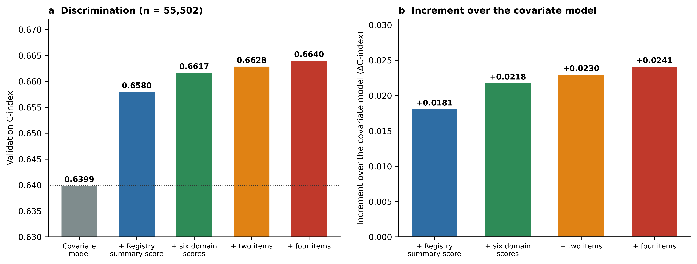
Panel (a) gives the validation C-index of the covariate model (age, sex, education, urbanicity and CDR stage) and of that model with, in turn, the registry summary score, the six domain scores, the two-item variant and the four items; panel (b) gives each increment over the covariate model. All are evaluated in the same random validation participants (n = 55,502; Supplementary Table S7.1).
Supplementary Figure S2. Calibration and the effect of fixed-horizon restriction
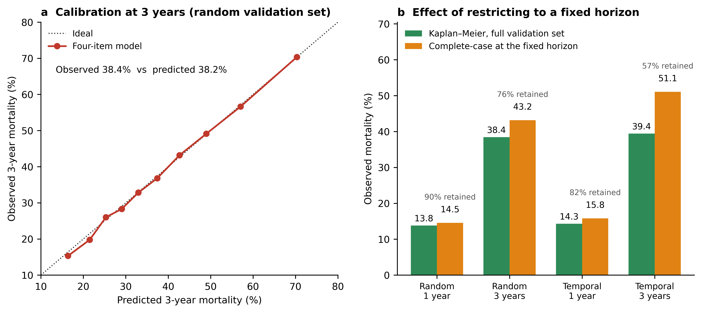
Panel (a): observed (Kaplan–Meier) versus predicted three-year mortality by decile of predicted risk in the random validation set. Panel (b): observed mortality estimated by Kaplan–Meier over the full validation set compared with the complete-case estimate obtained after restricting to participants with a known outcome at the horizon, at one and three years, in both the random and the temporal evaluation. S5.3 gives the corresponding figures. Panel (b) prints, for each set and horizon, the percentage of participants retained by the fixed-horizon restriction.
Supplementary Figure S3. Proportional-hazards check for the number of difficulties
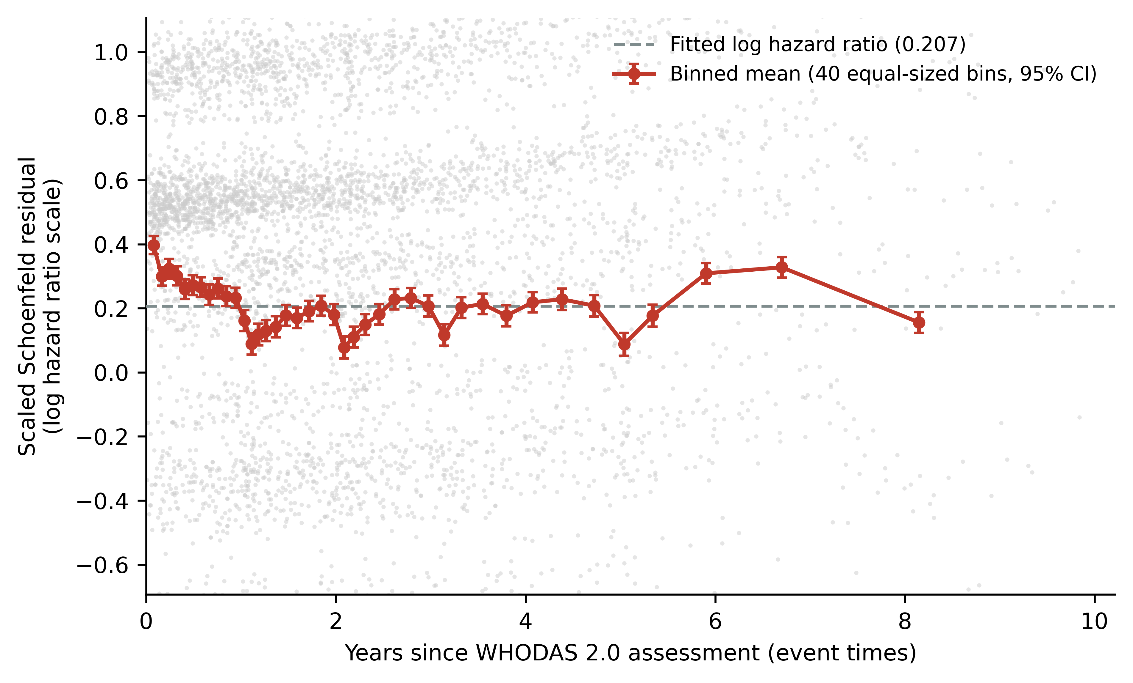
Scaled Schoenfeld residuals for the number of difficulties (0–4), on the log hazard ratio scale, with the fitted value (0.207) drawn as a horizontal line, against the event times of the 92,330 deaths (the statistic reported here uses the rank of that time); a random 6,000 residuals are shown as points and the red line joins the means of 40 equal-sized bins of event time with 95% confidence intervals. A flat line would indicate proportional hazards. The residuals decline slightly over follow-up (correlation with ranked event time r = −0.030; Grambsch–Therneau χ² = 79.6 on 1 df, p < 0.001), consistent with the interval estimates in Table S6.7.
Supplementary Figures S1–S3 are shown above. All five figures, main text and supplementary, are also supplied separately as EPS and as 600 dpi TIFF: Fig1_cdr_by_count and Fig2_KM_count (main text), and FigS1_summary_comparison, FigS2_calibration_horizon and FigS3_ph_residuals.

