Fabrication of polyaniline encapsulated NVO for high performance zinc ions storage
Jiacheng Huang ^{a＃}, Xiaoran Guo ^{a＃}, Menglong Zhu ^{a＃}, Xiaojie Zhang ^{b}*, Xuan Zhao ^{c}, Ruiwen Tang ^{b}, You Qi ^{b}, Xiaoyan Gao ^{b}, Yong Yang ^{c}, Yuyu Sun ª
a National & Local Joint Engineering Research Center for Mineral Salt Deep Utilization, Huaian University, Huaian 223003, China
b Jiangsu Provincial Key Laboratory of Palygorskite Science and Applied Technology, Huaian University, Huaian 223003, PR China
c Institute of Green Chemistry and Process Enhancement Technology, Huaian University, Huaian 223003, PR China
＃ These authors have contributed equally to this work.
* Corresponding authors.
E-mail addresses: xjzhang@hyit.edu.cn (X. Zhang)

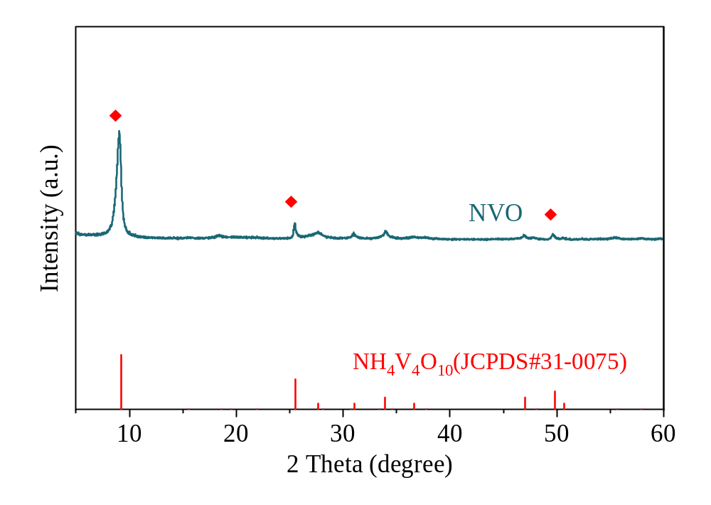
Fig. S1 XRD pattern of NVO.

Fig. S2 SEM of bare NVO.
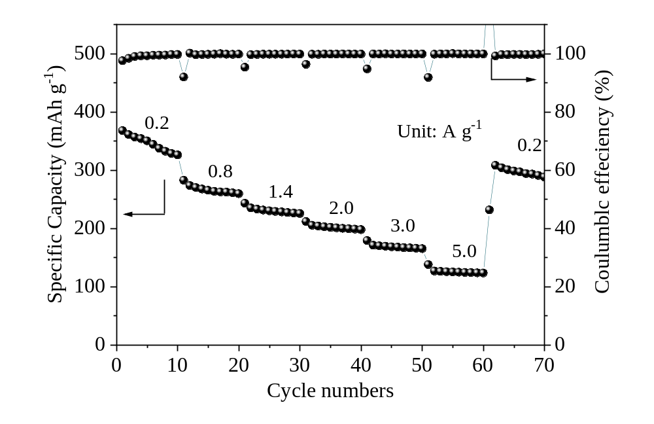
Fig. S3 Rate performance of NVO at various current densities.

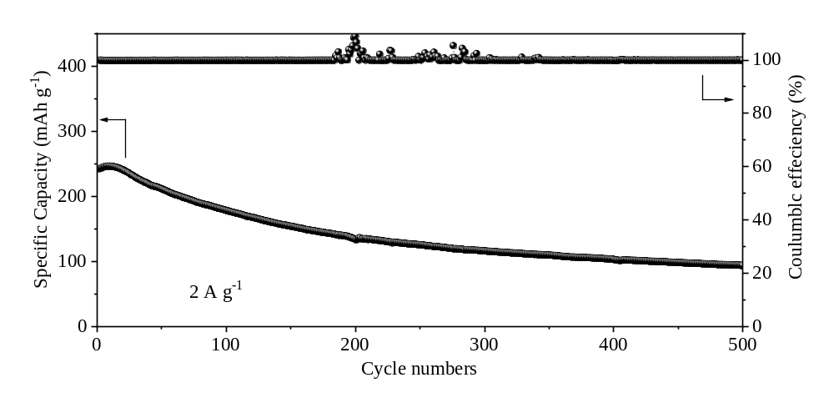
Fig. S4 Long cycling of NVO at 2 A g⁻¹ for 500 cycles.

Fig. S5 (a) CV curves at various scan rates, (b) log (i) vs. log v plot at specific peak currents, (c) Capacitive contribution ratio at different scan rates for NVO.

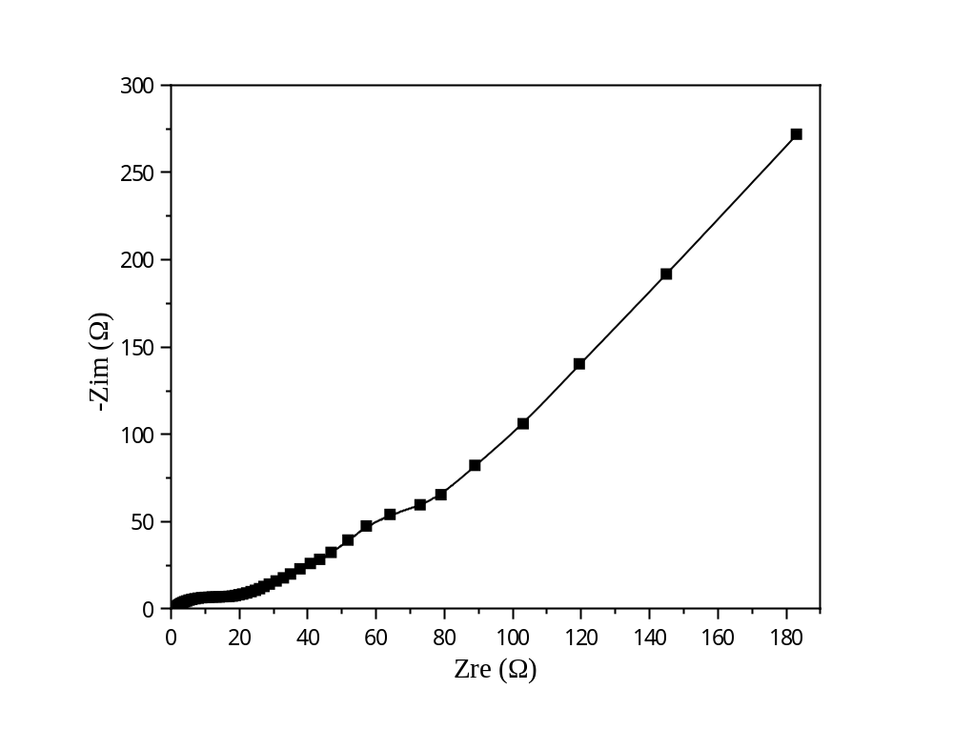
Fig. S6 EIS for NVO.

