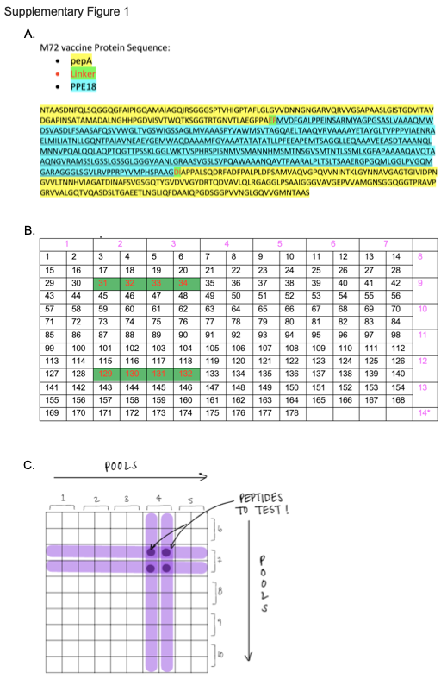
Supplementary Figure 1: M72 vaccine peptide pool matrix design and individual peptide deconvolution approach. (A) M72 vaccine protein sequence showing full-length PPE18 (Rv1196) (cyan) flanked by the C-terminus of PepA (Rv0125) (yellow) to the left and the N-terminus of PepA to the right, with two amino acid linker sequences at each joining region (green with red font). (B) 178 15-mer individual peptides (overlapping by 11 amino acids) covering the entire M72 vaccine sequence were designed into 14 peptide pools (border, pink font). Each peptide pool consists of 24-28 individual peptides, except for pool 14, which contains 10 peptides. Green cells with red font represent peptide sequences containing linker amino acids – ‘Glutamate-Phenylalanine -EF’ on the vaccine N-terminus (peptide sequences 31 – 34) and ‘Aspartate-Isoleucine -DI’ linker on the vaccine C-terminus (peptide sequences 129 – 132). (C) Hypothetical individual peptide deconvolution from peptide pool matrix designed as in B. In this example, pool #4 and pool #7 generate detectable responses, but the individual peptides are masked. In the deconvolution step, the peptides shared by both pool #4 and #7 are selected for further testing of peptide-level response.

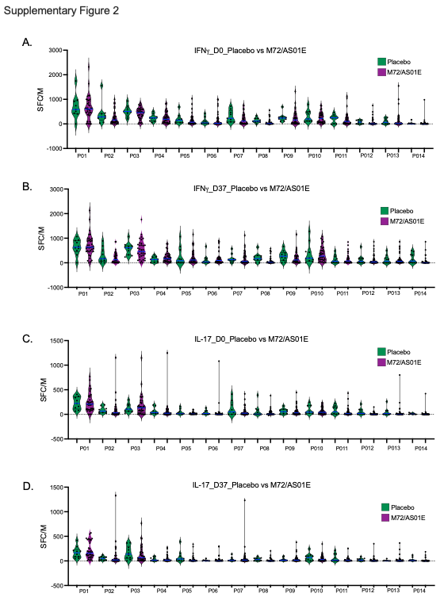
Supplementary Figure 2: Responses to peptide pools of the M72 vaccine antigen. Peptide pool responses described in Figure 1 were compared between placebo (n= 9) and vaccine recipients (n=36) at Day 0 and Day 37 for IFNγ (A-B) and IL-17 (C-D).
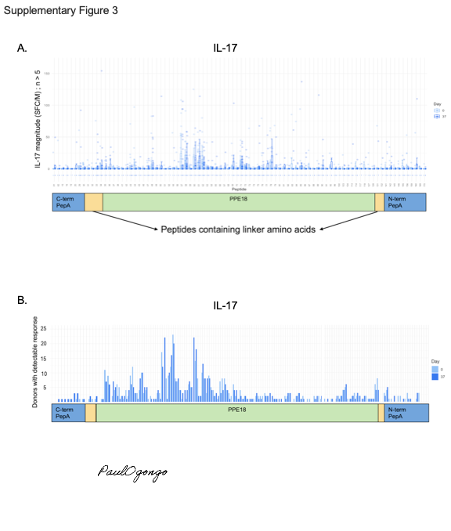
Supplementary Figure 3: Peptides in the PPE18 (Mtb39A) region of the M72 vaccine construct induce the highest magnitude and prevalence responses. IL-17 responses to individual peptides, measured as described in Figure 2, were mapped to their position in the M72 vaccine construct, magnitude of response (A), and prevalence of response (B). Only peptides measured in >5 participants are shown.

Supplementary Table 1: Peptide sequences with significant changes between D0 and D37 responses in the vaccine arm (defined as vaccine effect)

Peptide# | Peptide | Mtb Protein | # of donors tested | Cytokine | Paired AUROC | p-value | FDR q-value
61 | VPPPVIAENRAELMI | PPE18 | 33 | IFNγ | 0.72 | 0.032 | 0.36
50 | SAGLMVAAASPYVAW | PPE18 | 33 | IFNγ | 0.73 | 0.022 | -
64 | LMILIATNLLGQNTP | PPE18 | 33 | IFNγ | 0.71 | 0.04 | -
67 | NTPAIAVNEAEYGEM | PPE18 | 33 | IL-17 | 0.71 | 0.03 | -
77 | EEAPEMTSAGGLLEQ | PPE18 | 33 | IFNγ | 0.67 | 0.084 | -
77 | EEAPEMTSAGGLLEQ | PPE18 | 33 | IL-17 | 0.73 | 0.023 | -
Comparison of samples from M72 recipients Day 37 vs. Day 0. Statistics: Wilcoxon signed-rank test comparing pairs of values from each donor. FDR-q values were only tested for responses that were detected in at least 35% of samples (across groups and time points)

