Integrated Plasmodium falciparum Transcriptomics Reveals Coordinated Stress Adaptation and Metabolic Remodeling in Severe Malarial Anemia

Clinton O. Onyango ^{1,2}, Shamim W. Osata ^{1,2}, Sharley A. Wasena ^{1,2}, Ivy Hurwitz ¹, Philip D. Seidenberg ^{1,3}, Collins Ouma ^{2,4}, Samuel B. Anyona ^{4,5}, Kristan A. Schneider ^{1,6}, Benjamin H. McMahon ^{1,7}, Qiuying Cheng ¹, Douglas J. Perkins ^{1,4}*

¹Center for Global Health, Department of Internal Medicine, University of New Mexico, Albuquerque, NM 87131, USA.
²Department of Biomedical Sciences and Technology, School of Public Health and Community Development, Maseno University, Maseno 40100, Kenya.
³Department of Emergency Medicine, School of Medicine, University of New Mexico, Albuquerque, NM 87131, USA.
⁴University of New Mexico-Kenya Global Health Programs, University of New Mexico, Kisumu and Siaya 40100, Kenya.
⁵Department of Medical Biochemistry, School of Medicine, Maseno University, Maseno 40100, Kenya.
⁶Department of Internal Medicine, Division of Translational Informatics, University of New Mexico, Albuquerque, NM 87131, USA
⁷Theoretical Biology and Biophysics Group, Los Alamos National Laboratory, Theoretical Division, Los Alamos, NM 87545, USA.

*Corresponding author: dperkins@salud.unm.edu

Supplementary Table 1. WGCNA module characteristics and hub-gene connectivity
Module | Parasite genes | Correlation Coefficient (SMA) | p-value | Hub gene_ID | Hub Gene Description | kWithin | MM
M0 | 839
M1 | 495 | -0.27 | 0.105 | PFKE01_040014300 | Conserved Plasmodium protein, unknown function | 125.50 | 0.98
M2 | 358 | -0.21 | 0.227 | PFKE01_060020500 | Organic anion transporter | 43.41 | 0.95
M3 | 223 | -0.28 | 0.161 | PFKE01_110014700 | Conserved Plasmodium membrane protein, unknown function | 22.44 | 0.93
M4 | 215 | -0.12 | 0.582 | PFKE01_060028900 | Leucine--tRNA ligase, putative | 9.41 | 0.95
M5 | 213 | 0.03 | 0.142 | PFKE01_140006600 | Early transcribed membrane protein 14.1 | 31.60 | 0.91
M6 | 208 | -0.33 | 0.084 | PFKE01_060023100 | Conserved Plasmodium membrane protein, unknown function | 26.41 | 0.95
M7 | 174 | 0.04 | 0.886 | PFKE01_110025600 | Conserved Plasmodium protein, unknown function | 9.59 | 0.93
M8 | 122 | -0.14 | 0.515 | PFKE01_140070600 | 40S ribosomal protein S3 | 7.92 | 0.95
M9 | 120 | -0.37 | 0.038 | PFKE01_090011900 | ATP-dependent protease ATPase subunit ClpY | 18.70 | 0.97
M10 | 105 | -0.34 | 0.028 | PFKE01_110038600 | Heat shock protein 70 | 19.00 | 0.97
The table summarizes the WGCNA modules, the number of parasite genes assigned to each module, their association with SMA, and the connectivity and module membership of the most highly connected (hub) gene in each module. kWithin represents intramodular connectivity, defined as the sum of a gene’s topological overlap–based connections with other genes within the same module. Module membership represents the correlation between a gene’s expression profile and the module eigengene, reflecting Hub gene ID and Hub Gene Description provide the identifier and functional annotation of the most highly connected gene within each module.
Supplementary Table 2. Functional Enrichment Analysis of DEGs
Validation data (DEGs=428) |  | Functional Term name | Padj | Term size
Validation data (DEGs=428) | GO:MF | RNA binding | 3.60e-10 | 80/460
Validation data (DEGs=428) | GO:MF | Nucleic acid binding | 1.42e-09 | 109/749
Validation data (DEGs=428) | GO:MF | Catalytic activity, acting on RNA | 1.41e-04 | 44/256
Validation data (DEGs=428) | GO:MF | RNA helicase activity | 4.10e-04 | 16/53
Validation data (DEGs=428) | GO:MF | ATP-dependent activity, acting on RNA | 4.10e-04 | 16/53
Validation data (DEGs=428) | GO:BP | RNA metabolic process | 3.64e-21 | 121/678
Validation data (DEGs=428) | GO:BP | RNA biosynthetic process | 3.84e-21 | 113/602
Validation data (DEGs=428) | GO:BP | Nucleic acid biosynthetic process | 1.23e-20 | 114/619
Validation data (DEGs=428) | GO:BP | RNA processing | 1.83e-19 | 88/406
Validation data (DEGs=428) | GO:BP | Nucleobase-containing compound biosynthetic process | 7.04e-18 | 118/703
Validation data (DEGs=428) | GO:CC | Nucleus | 7.35e-16 | 146/1018
Validation data (DEGs=428) | GO:CC | Nucleolus | 3.36e-10 | 37/136
Validation data (DEGs=428) | GO:CC | Spliceosomal complex | 9.08e-10 | 32/108
Validation data (DEGs=428) | GO:CC | Nuclear protein-containing complex | 2.26e-09 | 64/355
Validation data (DEGs=428) | GO:CC | Ribonucleoprotein complex | 6.78e-08 | 66/401
Validation data (DEGs=428) | KEGG | Spliceosome | 1.34e-06 | 21/95
Pf. Transcriptomics (DEGs=566) | GO:MF | Threonine-type peptidase activity | 2.43e-05 | 11/392
Pf. Transcriptomics (DEGs=566) | GO:MF | Threonine-type endopeptidase activity | 2.43e-05 | 111/392
Pf. Transcriptomics (DEGs=566) | GO:MF | Protein dimerization activity | 0.022 | 16/392
Pf. Transcriptomics (DEGs=566) | GO:BP | Proteasomal ubiquitin-independent protein catabolic process | 9.98e-07 | 12/15
Pf. Transcriptomics (DEGs=566) | GO:BP | Cellular process | 1.31e-06 | 360/2711
Pf. Transcriptomics (DEGs=566) | GO:BP | Proteasomal protein catabolic process | 1.6e-05 | 29/83
Pf. Transcriptomics (DEGs=566) | GO:BP | Proteasome-mediated ubiquitin-dependent protein catabolic process | 5.11e-05 | 24/64
Pf. Transcriptomics (DEGs=566) | GO:BP | Ubiquitin-dependent protein catabolic process | 5.83e-05 | 34/112
Pf. Transcriptomics (DEGs=566) | GO:CC | Proteasome complex | 1.37e-12 | 26/44
Pf. Transcriptomics (DEGs=566) | GO:CC | Peptidase complex | 2.56e-11 | 29/59
Pf. Transcriptomics (DEGs=566) | GO:CC | Endopeptidase complex | 3.89e-11 | 28/56
Pf. Transcriptomics (DEGs=566) | GO:CC | Cytosol | 5.05e-08 | 80/368
Pf. Transcriptomics (DEGs=566) | GO:CC | Intracellular anatomical structure | 1.62e-07 | 352/2690
Pf. Transcriptomics (DEGs=566) | KEGG | Proteasome | 1.60e-09 | 21/35
Pf. Transcriptomics (DEGs=566) | KEGG | Glycerophospholipid metabolism | 0.006 | 10/22
The table shows the functional enrichment analysis of the DEGs in both datasets. Significant functional enrichment terms associated with the DEGs are presented with their FDR-adjusted p-value, and term size. Terms are grouped by GO (Gene Ontology) [MF (Molecular Function), CC (Cellular Component), and BP (Biological Process)] and KEGG (Kyoto Encyclopedia of Genes. Enrichment terms with padj-values ≤0.050 were considered significant.

Supplementary Table 3. PPI Network Clusters Identified from P. falciparum Differentially Expressed Genes
Network | Scoreª | Nodes | Edges | Hub Node | Hub Node Description
Global network |  | 412 | 713 | PF3D7_0106700 | Small ribosomal subunit assembling AARP2 protein
Cluster 1 | 19.09 | 23 | 210 | PF3D7_0106700 | Small ribosomal subunit assembling AARP2 protein
Cluster 2 | 8.20 | 11 | 41 | PF3D7_0403700 | pre-mRNA-splicing factor CLF1, putative
Cluster 3 | 6.33 | 7 | 19 | PF3D7_0819000 | RIbonuclease, putative
Cluster 4 | 5.60 | 6 | 14 | PF3D7_0815600 | Eukaryotic translation initiation factor 3 subunit G, putative
Cluster 5 | 4.50 | 5 | 9 | PF3D7_1329000 | DNA-directed RNA polymerase III subunit RPC1, putative
Cluster 6 | 4.29 | 8 | 15 | PF3D7_0308900 | Splicing factor 3B subunit 1, putative
Cluster 7 | 4.00 | 5 | 8 | PF3D7_1247900 | U3 small nucleolar RNA-associated protein 11, putative
Cluster 8 | 3.00 | 3 | 3 | PF3D7_0610200 | RNA-binding protein 25, putative
Cluster 9 | 3.00 | 3 | 3 | PF3D7_0617100 | AP-2 complex subunit alpha, putative
The table summarizes highly interconnected PPI subnetworks identified by MCODE analysis of the validation dataset DEGs. Clusters are ranked according to MCODE scores. Node and edge counts represent cluster membership and protein interactions, respectively. Hub genes for the global PPI network and individual subnetworks were identified using CytoHubba based on 11 topological algorithms. ª MCODE scores.

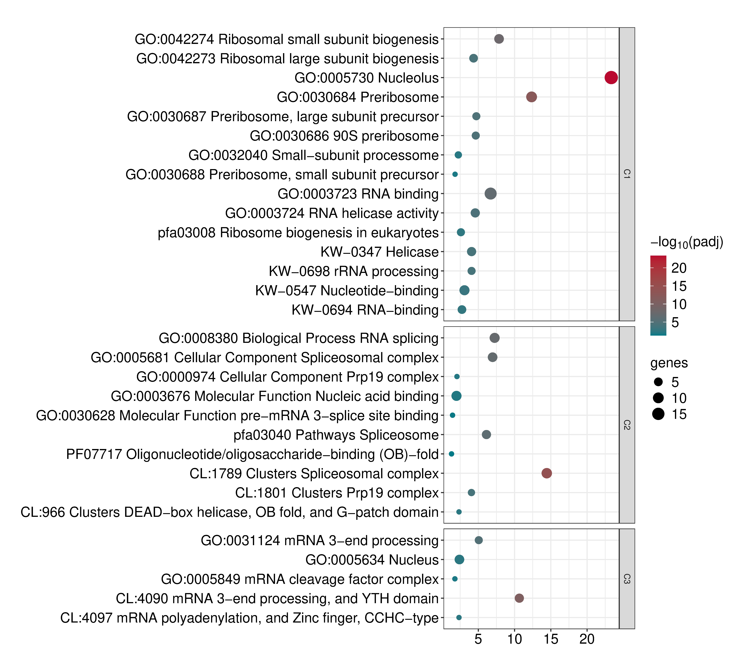
a

b
Supplementary Figure 1. Functional Enrichment Analysis of Validation Dataset PPI Subnetworks. Functional enrichment analysis of P. falciparum PPI subnetworks of the validation dataset. (a and b) Enrichment results for subnetworks 1-3 and 4-9, respectively. The x-axis represents –log₁₀(FDR-adjusted p-value), and the y-axis shows enriched functional terms. Enrichment databases include Gene Ontology (GO), Gene Ontology Cellular Component (GOCC), KEGG Plasmodium falciparum annotation (pfa), Reactome Plasmodium falciparum annotation (PFA), UniProt Keywords (KW), InterPro Protein Domains (IPR), and STRING cluster databases (CL).

Supplementary Table 4. PPI Functional Concordance between the Present Study and the Independent Validation dataset
Functional theme | Present SMA vs non-SMA | Validation Dataset
Ribosome/translation | C1: ribosome, ribosomal proteins, translation | C1: ribosome biogenesis, preribosome
RNA processing/splicing | C5, C9, C10 | C2, C3, C6, C7, C8
Protein degradation/turnover | C2: proteasome, ubiquitin-related degradation | -
tRNA / protein synthesis machinery | C6: aminoacyl-tRNA biosynthesis | C4: translation initiation
Protein folding/stress response | C7, C13 | -
DNA/chromatin | C3, C11 | C5 has transcription/RNA Pol III
Vesicular trafficking/endocytosis | C4, C14 | C9: clathrin-mediated endocytosis
Metabolism | C8, C12, C15 | -
The table summarizes the major biological processes and transcriptional signatures identified in the present P. falciparum SMA vs. non-SMA analysis compared with those identified in the validation dataset. Shared biological processes are highlighted to indicate areas of concordance between studies.

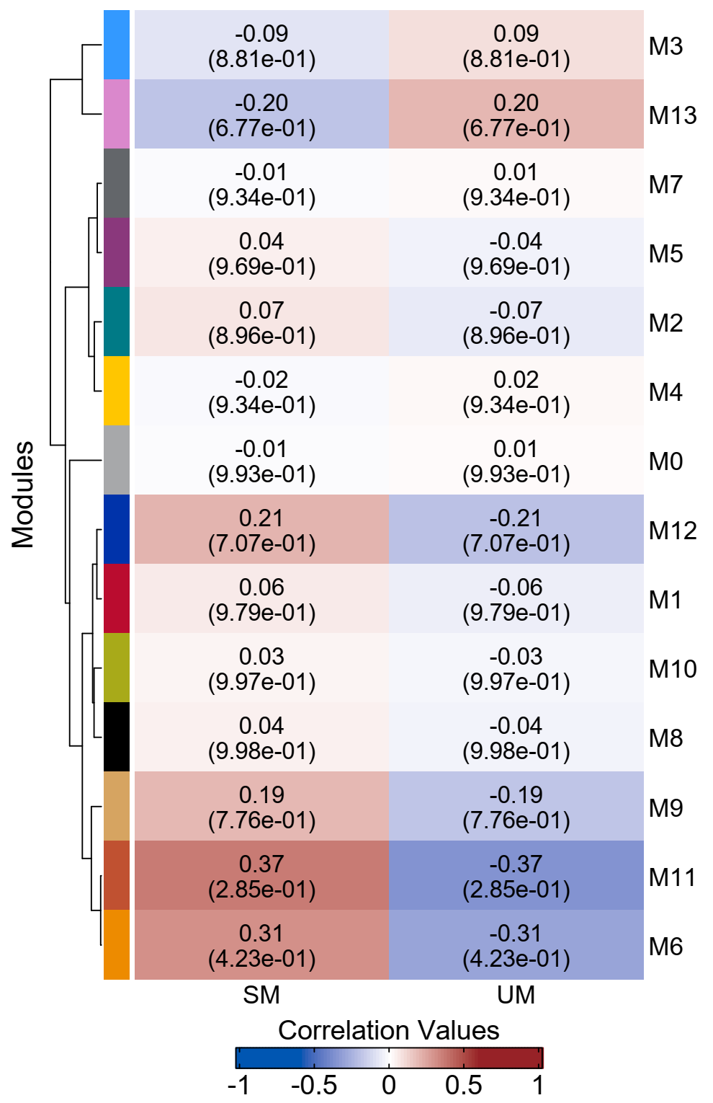
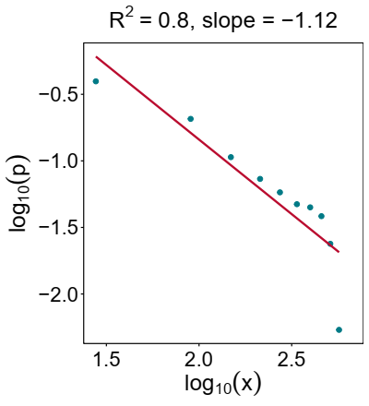
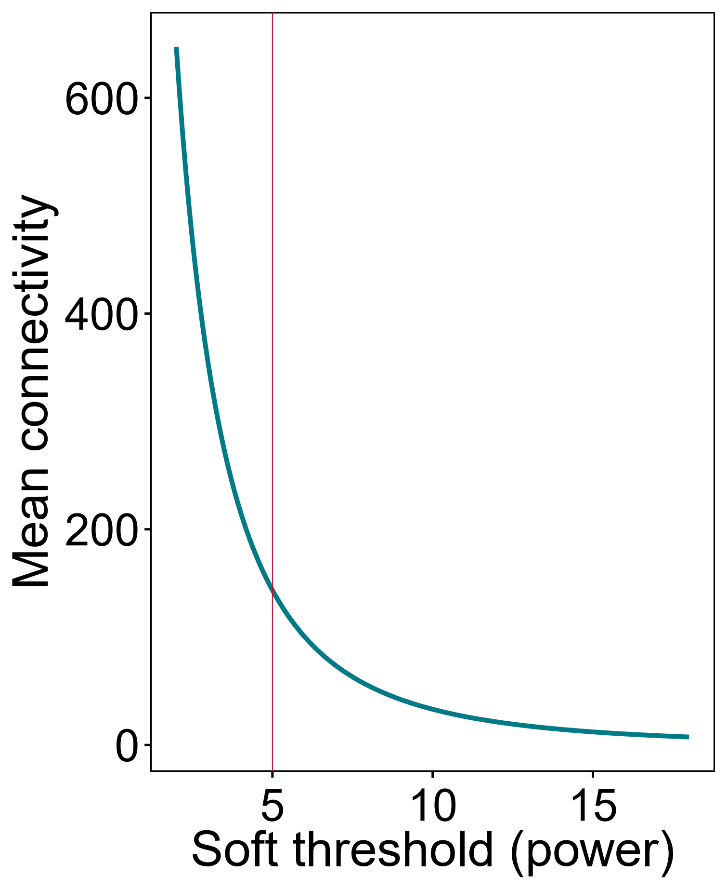
c
a
b
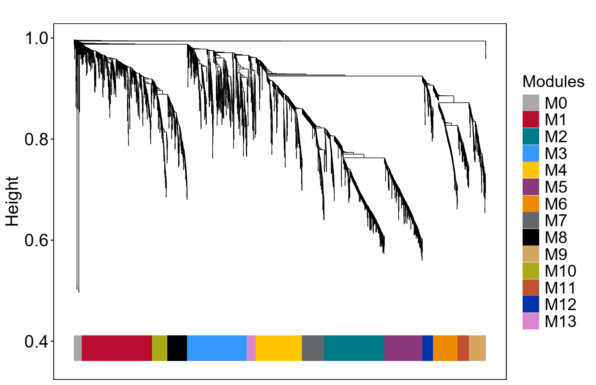

Supplementary Figure 2. WGCNA of Annotated P. falciparum Genes in the Validation. (a) Determination of soft-thresholding power in the WGCNA. Mean connectivity plot showing mean connectivity analysis of various soft-thresholding powers (β) and power law plot showing a negative correlation between connectivity (k) and the probability distribution of connectivity (p) (correlation coefficient 0.80). (b) Gene dendrogram and module colors. The hierarchical clustering tree represents the clustering of genes based on the TOM-based dissimilarity matrix (1-TOM) as the distance measure. The branches represent clusters of highly connected genes, and each vertical line represents a single gene. The colors in the horizontal bar represent the 14 gene co-expression modules identified using the dynamic tree cutting algorithm. (c) Heatmap of module-clinical trait relationships. The heatmap shows the correlation between WGCNA module eigengenes and SMA status. Each cell contains the correlation coefficient, and Benjamini-Hochberg adjusted p-value in parentheses. Rows and columns represent modules and clinical features, respectively. The color intensity represents the strength of the correlation. Red indicates a positive correlation, while blue represents a negative correlation. *Indicates a significant module-trait relationship.
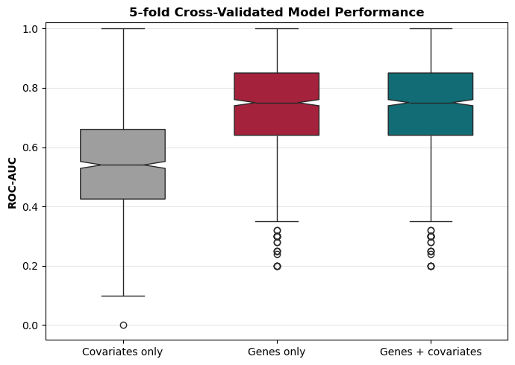
Supplementary Figure 3. XGBoost Analyses of the validation dataset performance in SM Classification. Cross-validated performance of XGBoost models predicting SMA. Notched boxplots show median area under the receiver operating characteristic curve (AUC) across stratified 5-fold cross-validation repeated 200 times, with interquartile range (IQR) error bars. Covariates only: median (IQR), 0.540(0.425-0.660), Genes only: 0.750(0.640-0.850), and Genes + Covariates: 0.750(0.640-0.850). Covariates: age, sex, and sickle-cell status.

