SUPPLEMENTARY INFORMATION
Magnet-free reconfigurable alterspin photonics at optical frequencies
Zhe Wang^{1,†}, Shuihua Yang^{1,†}, Jianfeng Chen¹, Mengqi Liu¹, Kaixuan Li¹, Mingjun Chen², Yue Wen³, Li Zhang⁴, Xuezhi Ma⁵, Cheng-Wei Qiu^{1,2,}*
¹Department of Electrical and Computer Engineering, National University of Singapore, Singapore, Singapore
²Department of Physics, National University of Singapore, Singapore, Singapore
³Department of Mechanical Engineering, National University of Singapore, Singapore, Singapore
⁴Institute for Health Innovation & Technology, National University of Singapore, Singapore, Singapore
⁵A*STAR Quantum Innovation Centre, Agency for Science, Technology and Research, Singapore, Singapore
†These authors contributed equally to this work
*Author to whom correspondence should be addressed: chengwei.qiu@nus.edu.sg
Table of Contents
Supplementary Note 1 | Optical limitations of the gyromagnetic route 3
Supplementary Note 2 | Maxwell-Hamiltonian derivation 5
Supplementary Note 3 | Dry-state reference and thickness compensation 18
Supplementary Note 4 | Details for two glass-based configurations 21
References 24

Supplementary Note 1 | Optical limitations of the gyromagnetic route
If a strong gyromagnetic permeability could persist at optical frequencies, the microwave route demonstrated by Chen et al¹ would remain capable of producing an alterspin texture. In practice, however, the relative permeability becomes effectively scalar at optical frequencies², while magneto-optical gyrotropy instead appears in the permittivity tensor. Reported optical off-diagonal permittivities are only of order 10⁻⁴ for yttrium iron garnet^{3,4} and reach 0.016 for bismuth iron garnet⁵, yet this stronger response remains insufficient to produce a discernible alterspin texture in the photonic-crystal structure used in the main text. We verify this below.
We retain the same suspended photonic-crystal slab used in the main text, with air on both sides. As illustrated in Fig. S1A, the square unit cell is divided into four regions: the upper-right and lower-left quadrants are labeled $A$, and the upper-left and lower-right quadrants are labeled $B$. The gyrotropic off-diagonal terms have opposite signs in $A$ and $B$. Assuming that such nanoscale magnetic patterning is feasible and that a strong gyromagnetic response persists at optical frequencies, the constitutive tensors are written as
$$ε=\left[\begin{matrix}ε_{r} & 0 & 0 \\ 0 & ε_{r} & 0 \\ 0 & 0 & ε_{r}\end{matrix}\right], μ^{A/B}= \left[\begin{matrix}μ_{r} & ∓iμ_{k} & 0 \\ ±iμ_{k} & μ_{r} & 0 \\ 0 & 0 & μ_{r}\end{matrix}\right]$$ | (1)
Here and below, the upper and lower signs correspond to regions $A$ and $B$, respectively. We first retain the diagonal relative permittivity $ε_{r}=4$ and adopt the microwave parameters of Chen et al¹, setting $μ_{r}=0.79$ and $μ_{k}=0.74$. The calculated $S_{3}$ map in Fig. S1B exhibits a clear two-period alterspin texture. Thus, if a comparably strong gyromagnetic permeability were available at optical frequencies, the same mechanism would remain effective. The two-period form differs from the four-period alterspin texture in the main text primarily because staggered magnetic bias reduces the in-plane symmetry, allowing a lower-order angular dependence in momentum space. The different constitutive couplings and symmetries of the two systems further determine the angular form of $S_{3}$, as detailed in Supplementary Note 2.
For conventional magneto-optical materials, the relative permeability becomes effectively scalar at optical frequencies², while the gyrotropy is described predominantly by antisymmetric off-diagonal elements of the permittivity tensor⁶. The corresponding optical constitutive tensors can therefore be written as
$$ε^{A/B}=\left[\begin{matrix}ε_{r} & ∓iε_{g} & 0 \\ ±iε_{g} & ε_{r} & 0 \\ 0 & 0 & ε_{r}\end{matrix}\right], μ= \left[\begin{matrix}μ_{r} & 0 & 0 \\ 0 & μ_{r} & 0 \\ 0 & 0 & μ_{r}\end{matrix}\right]$$ | (2)
For yttrium iron garnet^{3,4}, reported optical off-diagonal coefficients are approximately 3 × 10⁻⁴. Bismuth iron garnet provides a substantially stronger response, with an off-diagonal coefficient of 0.016 in the optical regime⁵. We therefore use this stronger response as a favorable optical benchmark. Here, $μ=I$ (that is, $μ_{r}=1$) reflects the effective scalar permeability at optical frequencies, while $ε_{r}=4$ is retained to match the photonic-crystal structure used in the main text. As shown in Fig. S1C, no discernible alterspin texture is obtained. Thus, although optical gyrotropy remains available through the permittivity tensor, its experimentally reported magnitude is insufficient to reproduce the gyromagnetic alterspin texture in the present photonic-crystal structure. This material constraint motivates the all-dielectric route developed in the main text, where alterspin order is controlled by an out-of-plane dielectric perturbation rather than an intrinsic magnetic response.

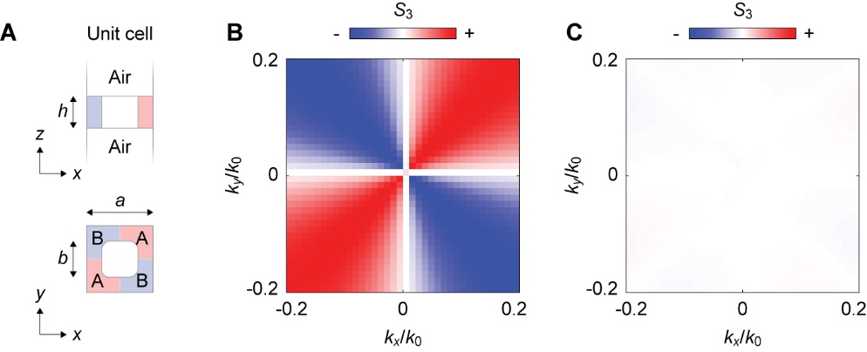
Fig. S1 | Extension of the gyromagnetic route from microwave to optical frequencies. A, Unit cell of the suspended square-lattice photonic-crystal slab, with the same geometry and structural parameters as in the main text and air above and below the slab. The in-plane unit cell is divided into $A$ and $B$ regions with opposite signs of the gyrotropic off-diagonal terms. B, Calculated $S_{3}$ for the hypothetical optical-frequency extension of the microwave gyromagnetic route, with $ε_{r}=4$, $μ_{r}=0.79$, and $μ_{k}=0.74$. The off-diagonal permeability terms are $∓iμ_{k}$ and $±iμ_{k}$ in regions A and B, respectively. A clear two-period alterspin texture is obtained. C, Calculated $S_{3}$ for $ε_{r}=4$, $ε_{g}=0.016$, and $μ_{r}=1$. The off-diagonal permittivity terms are $∓iε_{g}$ and $±iε_{g}$ in regions A and B, respectively. No discernible alterspin texture is obtained.

Supplementary Note 2 | Maxwell-Hamiltonian derivation
This note derives the Maxwell origin of the alterspin texture discussed in the main text. The in-plane square-lattice symmetry fixes the four-period angular form, whereas an out-of-plane dielectric perturbation controls its sign and amplitude. The normal electric field $E_{z}$ couples the dielectric configuration above and below the slab to the relative phase between the in-plane magnetic-field components. We then compare this all-dielectric route with the gyromagnetic route discussed in Supplementary Note 1.

A. Bloch-Maxwell eigenproblem and out-of-plane dielectric perturbation
We consider the same suspended square-lattice SiN_{x} photonic-crystal slab used in the main text. The constituent media are nonmagnetic dielectrics, with scalar permittivity and $μ_{r}=1$. In the air-SiN_{x}-air reference configuration, the dielectric profile satisfies $ε\left(x,y,z\right)=ε\left(x,y,-z\right)$, so the out-of-plane mirror $M_{z}$ is preserved together with the in-plane mirrors $M_{x}$, $M_{y}$, and $M_{d}$. Replacing one surrounding medium with water or glass gives $n_{1}≠n_{2}$, breaking $M_{z}$ while leaving the in-plane lattice symmetry unchanged. Within this note, $k=\left(k_{x},k_{y}\right)$ denotes the dimensional in-plane Bloch vector; the experimental momentum axes are normalized as $k_{x}/k_{0}$ and $k_{y}/k_{0}$, with $k_{0}=2π/λ$.
We take the harmonic time dependence as $e^{-iωt}$, where $ω$ is the angular frequency. For a source-free nonmagnetic dielectric with $μ_{r}=1$, Maxwell’s equations are
$$\begin{matrix}∇×E=iωμ_{0}H \\ ∇×H=-iωε_{0}ε\left(r\right)E\end{matrix}$$ | (3)
where $E$ is the electric field, $H$ the magnetic field, $μ_{0}$ the vacuum permeability, $ε_{0}$ the vacuum permittivity, $ε\left(r\right)$ the spatially dependent relative permittivity, and $∇×$ the curl operator. Eliminating the electric field gives the magnetic-field eigenvalue equation
$$\begin{aligned}∇×\frac{1}{ε\left(r\right)}∇×H=\frac{ω^{2}}{c^{2}}H\end{aligned}$$ | (4)
where $c=1/\sqrt{μ_{0}ε_{0}}$ is the speed of light in vacuum. Because the photonic crystal is periodic in the $x$ and $y$ directions, we write $r=(ρ,z)$, with $ρ=\left(x,y\right)$, and express the magnetic field in Bloch form as
$$\begin{aligned}H_{k}\left(r\right)=e^{ik∙ρ}u_{k}\left(r\right) \end{aligned}$$ | (5)
where $u_{k}\left(r\right)$ is periodic over the in-plane lattice. Substitution into the magnetic-field eigenproblem replaces $∇$ by $∇+ik$
$$\begin{aligned}∇×H_{k}=e^{ik∙ρ}\left(∇+ik\right)×u_{k} \end{aligned}$$ | (6)
The Bloch-form Maxwell eigenvalue problem then becomes
$$\begin{aligned}\hat{L}\left(k\right)u_{k}=\frac{ω^{2}\left(k\right)}{c^{2}}u_{k}\end{aligned}$$ | (7)
where $\hat{L}\left(k\right)=\left(∇+ik\right)×\frac{1}{ε\left(r\right)}\left(∇+ik\right)×$ is the Bloch Maxwell operator. To isolate the effect of the out-of-plane dielectric perturbation, we define $η\left(r\right)={ε\left(r\right)}^{-1}$ and decompose it into parts that are even and odd under $M_{z}$
$$\begin{aligned}η\left(r\right)=η_{e}\left(r\right)+η_{o}\left(r\right)\end{aligned}$$ | (8)
with
$$\begin{aligned}\begin{matrix}η_{e}\left(x,y,z\right)=\frac{η\left(x,y,z\right)+η\left(x,y,-z\right)}{2} \\ η_{o}\left(x,y,z\right)=\frac{η\left(x,y,z\right)-η\left(x,y,-z\right)}{2}\end{matrix}\end{aligned}$$ | (9)
For the vertically symmetric reference, $η_{o}=0$. When $n_{1}≠n_{2}$, the out-of-plane dielectric perturbation introduces a $z$-odd component $η_{o}≠0$, while the in-plane symmetry constraints remain unchanged.

B. Projected Maxwell Hamiltonian and $S_{3}$ coupling
For the TM₁ mode considered in the main text, the relevant field components are the in-plane magnetic fields $H_{x}$ and $H_{y}$, together with the normal electric field $E_{z}$. We define the modal magnetic Stokes parameters from $H_{x}$ and $H_{y}$ as
$$\begin{aligned}\begin{matrix}S_{1,H}=\frac{{\left|H_{x}\right|}^{2}-{\left|H_{y}\right|}^{2}}{{\left|H_{x}\right|}^{2}+{\left|H_{y}\right|}^{2}} \\ S_{2,H}=\frac{2Re\left(H_{x}H_{y}^{*}\right)}{{\left|H_{x}\right|}^{2}+{\left|H_{y}\right|}^{2}} \\ S_{3,H}=-\frac{2Im\left(H_{x}H_{y}^{*}\right)}{{\left|H_{x}\right|}^{2}+{\left|H_{y}\right|}^{2}}\end{matrix}\end{aligned}$$ | (10)
where the subscript $H$ denotes the modal magnetic representation. Experimentally, the radiated polarization is obtained from the far-field electric Jones vector, for which the circular Stokes component is
$$S_{3,ff}=-\frac{2Im\left({E_{x,ff}E_{y,ff}}^{*}\right)}{{\left|E_{x,ff}\right|}^{2}+{\left|E_{y,ff}\right|}^{2}}$$ | (11)
where the subscript $ff$ denotes the far-field electric representation. For each outgoing plane-wave channel, the transverse electric and magnetic fields satisfy
$$H_{ff}=Z^{-1}\hat{q}×E_{ff}, E_{ff}=-Z\hat{q}×H_{ff}$$ | (12)
where $Z=\sqrt{μ/ε}$ is the wave impedance of the surrounding medium and $\hat{q}$ is the unit propagation direction. For a fixed radiative direction and a consistent circular-polarization convention, the modal and far-field Stokes parameters therefore describe the same circular-polarization channel through the radiative projection of the Bloch mode
$$sgn\left[S_{3,ff}\left(k\right)\right]≃sgn\left[S_{3,H}\left(k\right)\right]$$ | (13)
Having established this correspondence, we use $S_{3}$ without subscripts below unless the modal and far-field representations need to be distinguished.
We next project the Bloch-Maxwell eigenproblem onto the two linearly polarized magnetic basis states associated with $H_{x}$ and $H_{y}$
$$\begin{aligned}\left|\left.x\right\rangle \right.∼H_{x}, \left|\left.y\right\rangle \right.∼H_{y}\end{aligned}$$ | (14)
An arbitrary state in this two-component subspace can be written as
$$\begin{aligned}\left|\left.ψ\right\rangle \right.=c_{x}\left|\left.x\right\rangle \right.+c_{y}\left|\left.y\right\rangle \right.\end{aligned}$$ | (15)
where $c_{x}$ and $c_{y}$ are complex coefficients that determine the amplitudes and relative phase of the two basis components. Projecting $\hat{L}\left(k\right)$ into this subspace gives the matrix elements^{7,8}
$$\begin{aligned}H_{ij}\left(k\right)=\left\langle i | \hat{L}\left(k\right) | j\right\rangle , i,j=x,y\end{aligned}$$ | (16)
and the corresponding effective Maxwell Hamiltonian
$$\begin{aligned}H_{eff}\left(k\right)=\left[\begin{matrix}H_{xx} & H_{xy} \\ H_{yx} & H_{yy}\end{matrix}\right]\end{aligned}$$ | (17)
This effective Hamiltonian is the matrix representation of the Maxwell eigenvalue operator in the $\left(H_{x},H_{y}\right)$ basis; its eigenvalues correspond to $ω^{2}/c^{2}$. We denote its matrix elements by $H_{ij}$, with diagonal terms describing the two basis-state self-contributions and off-diagonal terms describing their coupling. In weak form
$$\begin{aligned}H_{ij}\left(k\right)=\int{d^{3}r{\left[\left(∇+ik\right)×u_{i}\right]}^{*}∙}η\left(r\right)\left[\left(∇+ik\right)×u_{j}\right]\end{aligned}$$ | (18)
and the contribution associated with the out-of-plane dielectric perturbation is
$$\begin{aligned}δH_{ij}\left(k\right)=\int{d^{3}r{\left[\left(∇+ik\right)×u_{i}\right]}^{*}∙}η_{o}\left(r\right)\left[\left(∇+ik\right)×u_{j}\right]\end{aligned}$$ | (19)
The perturbation therefore modifies both the eigenfrequency and the coupling between the two in-plane magnetic components. The Hamiltonian can be decomposed in the Pauli basis as
$$\begin{aligned}H_{eff}\left(k\right)=d_{0}\left(k\right)I+d_{x}\left(k\right)σ_{x}+d_{y}\left(k\right)σ_{y}+d_{z}\left(k\right)σ_{z}\end{aligned}$$ | (20)
with
$$\begin{aligned}\begin{matrix}\begin{matrix}d_{0}=\frac{H_{xx}+H_{yy}}{2} \\ d_{x}=\frac{H_{xy}+H_{yx}}{2}\end{matrix} \\ \begin{matrix}d_{y}=\frac{H_{yx}-H_{xy}}{2i} \\ d_{z}=\frac{H_{xx}-H_{yy}}{2}\end{matrix}\end{matrix}\end{aligned}$$ | (21)
The scalar term $d_{0}$ sets the average eigenvalue and hence the band dispersion. In the $\left(H_{x} , H_{y}\right)$ basis, $d_{z}$ describes the amplitude imbalance between the two components and corresponds to $S_{1}$, while $d_{x}$ describes their real symmetric coupling and corresponds to $S_{2}$. The key coefficient $d_{y}$ is the imaginary antisymmetric coupling that sets the relative phase between $H_{x}$ and $H_{y}$, and therefore controls $S_{3}$. Importantly, $d_{y}$ arises from coupling between Maxwell field components rather than from a gyromagnetic material response. The Pauli-Stokes correspondence follows from
$$\begin{aligned}\begin{matrix}〈σ_{x}〉=\frac{\left\langle ψ | σ_{x} | ψ\right\rangle }{\left\langle ψ | ψ\right\rangle }=\frac{\left[\begin{matrix}c_{x}^{*} & c_{y}^{*}\end{matrix}\right]\left[\begin{matrix}0 & 1 \\ 1 & 0\end{matrix}\right]\left[\begin{matrix}c_{x} \\ c_{y}\end{matrix}\right]}{{\left|c_{x}\right|}^{2}+{\left|c_{y}\right|}^{2}}=\frac{2Re\left(c_{x}^{*}c_{y}\right)}{{\left|c_{x}\right|}^{2}+{\left|c_{y}\right|}^{2}} \\ 〈σ_{y}〉=\frac{\left\langle ψ | σ_{y} | ψ\right\rangle }{\left\langle ψ | ψ\right\rangle }=\frac{\left[\begin{matrix}c_{x}^{*} & c_{y}^{*}\end{matrix}\right]\left[\begin{matrix}0 & -i \\ i & 0\end{matrix}\right]\left[\begin{matrix}c_{x} \\ c_{y}\end{matrix}\right]}{{\left|c_{x}\right|}^{2}+{\left|c_{y}\right|}^{2}}=\frac{2Im\left(c_{x}^{*}c_{y}\right)}{{\left|c_{x}\right|}^{2}+{\left|c_{y}\right|}^{2}} \\ 〈σ_{z}〉=\frac{\left\langle ψ | σ_{z} | ψ\right\rangle }{\left\langle ψ | ψ\right\rangle }=\frac{\left[\begin{matrix}c_{x}^{*} & c_{y}^{*}\end{matrix}\right]\left[\begin{matrix}1 & 0 \\ 0 & -1\end{matrix}\right]\left[\begin{matrix}c_{x} \\ c_{y}\end{matrix}\right]}{{\left|c_{x}\right|}^{2}+{\left|c_{y}\right|}^{2}}=\frac{{\left|c_{x}\right|}^{2}-{\left|c_{y}\right|}^{2}}{{\left|c_{x}\right|}^{2}+{\left|c_{y}\right|}^{2}}\end{matrix}\end{aligned}$$ | (22)
which, together with the Stokes definitions above, gives
$$\begin{aligned}S_{1}∼〈σ_{z}〉, S_{2}∼〈σ_{x}〉, S_{3}∼〈σ_{y}〉\end{aligned}$$ | (23)
For an approximately Hermitian two-component model, the Stokes vector follows the corresponding Pauli vector⁹⁻¹¹
$$\begin{aligned}{\left(S_{1},S_{2},S_{3}\right)}_{±}∼±\frac{\left(d_{z}\left(k\right),d_{x}\left(k\right),d_{y}\left(k\right)\right)}{\sqrt{d_{x}^{2}\left(k\right)+d_{y}^{2}\left(k\right)+d_{z}^{2}\left(k\right)}}\end{aligned}$$ | (24)
Thus, the circular-polarization component is controlled by $d_{y}$. The origin of this coupling can be traced to the normal electric field. From Maxwell’s curl equation $∇×H=-iωε_{0}ε\left(r\right)E$, the $z$ component for a Bloch mode is
$$\begin{aligned}E_{z}=\frac{i}{ωε_{0}ε\left(r\right)}\left[\left(∂_{x}+ik_{x}\right)H_{y}-\left(∂_{y}+ik_{y}\right)H_{x}\right]\end{aligned}$$ | (25)

Thus, $E_{z}$ couples $H_{x}$ and $H_{y}$ and contains the phase factor required for a finite $d_{y}$. Because $E_{z}$ samples the dielectric media above and below the slab, this coupling is sensitive to the out-of-plane dielectric configuration. For $n_{1}=n_{2}$, the upper and lower field distributions are related by $M_{z}$. Their contributions to the imaginary off-diagonal coupling have opposite parity and cancel
$$\begin{aligned}ImH_{xy}^{top}+ImH_{xy}^{bottom}=0\end{aligned}$$ | (26)
Consequently, $d_{y}$ vanishes in the vertically symmetric limit and the circular-polarization component is suppressed
$$\begin{aligned}H_{eff}\left(k\right)=d_{0}\left(k\right)I+d_{x}\left(k\right)σ_{x}+d_{z}\left(k\right)σ_{z}\end{aligned}$$ | (27)
When $n_{1}≠n_{2}$, this cancellation is no longer enforced. The $z$-odd dielectric perturbation allows a finite imaginary antisymmetric coupling between $H_{x}$ and $H_{y}$, and hence a finite $S_{3}$. Writing $H_{xy}=A-iB$ and $H_{yx}=A+iB$ gives $d_{x}=A, d_{y}=B$. The real part contributes to the linear-polarization coupling, whereas the imaginary part allows a finite circular-polarization component. This effect is expected to be stronger for TM-like modes with a substantial $E_{z}$ component. For TM₁, $E_{z}$ samples both sides of the slab and couples the out-of-plane dielectric configuration to the relative phase between $H_{x}$ and $H_{y}$. Modes dominated by in-plane electric fields are expected to respond more strongly through frequency shifts and to exhibit weaker imaginary coupling, giving the qualitative hierarchy
$$\begin{aligned}\left|d_{y}^{TM}\right|≫\left|d_{y}^{TE}\right|\end{aligned}$$ | (28)

C. Four-period angular form enforced by in-plane symmetries
The out-of-plane dielectric perturbation controls whether $d_{y}$ is finite, whereas its momentum dependence is constrained by the in-plane square-lattice symmetry. Although $M_{z}$ is broken, the rounded-square lattice preserves $M_{x}$, $M_{y}$, and the diagonal mirror $M_{d}$. Their actions on $k=\left(k_{x},k_{y}\right)$ are
$$\begin{aligned}\begin{matrix}{ M}_{x}: \left(k_{x},k_{y}\right)→\left(k_{x},-k_{y}\right) \\ { M}_{y}: \left(k_{x},k_{y}\right)→\left(-k_{x},k_{y}\right) \\ { M}_{d}: \left(k_{x},k_{y}\right)→\left(k_{y},k_{x}\right)\end{matrix}\end{aligned}$$ | (29)
In the $\left(H_{x} , H_{y}\right)$ basis, $d_{y}$ is odd under all three mirror operations. For completeness, the parities of the four Pauli coefficients are summarized below
Coefficient | $${ M}_{x}: k_{y}→-k_{y}$$ | $${ M}_{y}: k_{x}→-k_{x}$$ | $${ M}_{d}: k_{x}↔k_{y}$$
$$d_{0}$$ | + | + | +
$$d_{x}$$ | - | - | +
$$d_{y}$$ | - | - | -
$$d_{z}$$ | + | + | -
Here, + and − denote even and odd parity, respectively. To construct analytic momentum dependences consistent with these constraints, we introduce
$$\begin{aligned}X=k_{x}^{2}, Y=k_{y}^{2}\end{aligned}$$ | (30)
The coefficients $d_{0}$ and $d_{z}$ are even in both $k_{x}$ and $k_{y}$, whereas $d_{x}$ and $d_{y}$ are odd in both variables. Analyticity therefore requires $d_{x}$ and $d_{y}$ to contain the factor $k_{x}k_{y}$. Under $M_{d}$, corresponding to the exchange $k_{x}↔k_{y}$, $d_{0}$ and $d_{x}$ are symmetric, whereas $d_{z}$ and $d_{y}$ are antisymmetric. A symmetric analytic function of $X=k_{x}^{2}$ and $Y=k_{y}^{2}$ can be written in terms of
$$\begin{aligned}\begin{matrix}s=X+Y=k_{x}^{2}+k_{y}^{2} \\ p=XY=k_{x}^{2}k_{y}^{2}\end{matrix}\end{aligned}$$ | (31)
The most general analytic forms allowed by these mirror symmetries are therefore
$$\begin{aligned}\begin{matrix}\begin{matrix}d_{0}\left(k\right)=F_{0}\left(s,p\right) \\ d_{x}\left(k\right)=k_{x}k_{y}F_{x}\left(s,p\right)\end{matrix} \\ \begin{matrix}d_{y}\left(k\right)=k_{x}k_{y}\left(k_{x}^{2}-k_{y}^{2}\right)F_{y}\left(s,p\right) \\ d_{z}\left(k\right)=\left(k_{x}^{2}-k_{y}^{2}\right)F_{z}\left(s,p\right)\end{matrix}\end{matrix}\end{aligned}$$ | (32)
where the coefficient functions are analytic and may be expanded as
$$\begin{aligned}F_{j}\left(s,p\right)=\sum_{m,n≥0}^{ }{c_{mn}^{\left(j\right)}}s^{m}p^{n}\end{aligned}$$ | (33)
The leading symmetry-allowed terms relevant to the polarization texture are then
$$\begin{aligned}\begin{matrix}d_{x}\left(k\right)∝k_{x}k_{y} \\ d_{y}\left(k\right)∝k_{x}k_{y}\left(k_{x}^{2}-k_{y}^{2}\right) \\ d_{z}\left(k\right)∝\left(k_{x}^{2}-k_{y}^{2}\right)\end{matrix}\end{aligned}$$ | (34)
Using $S_{1}↔d_{z}$, $S_{2}↔d_{x}$, and $S_{3}↔d_{y}$, the lowest-order terms already fix the nodal structure shown in Fig. S2A. $S_{1}$ changes sign across $k_{x}=±k_{y}$, $S_{2}$ changes sign across $k_{x}=0$ and $k_{y}=0$, and $S_{3}$ combines both nodal structures. With $k_{x}=k\cos{φ}$ and $k_{y}=k\sin{φ}$
$$\begin{aligned}S_{3}\left(φ\right)∝\sin{4φ}\end{aligned}$$ | (35)
This leading dependence gives the four-period angular form of the alterspin texture. Higher-order terms in $F_{j}\left(s,p\right)$ can modify the amplitude and detailed contour shape at larger momentum without changing the mirror-enforced nodal structure.
To describe the texture beyond the lowest-order regime, we include higher-order terms allowed by the same mirror symmetries. Over the measured momentum range, terms up to twelfth order in $F_{j}\left(s , p\right)$ reproduce the observed high-momentum deformation and sign reversal. These corrections modify the amplitude and contour shape while preserving the four-period angular form and its symmetry-enforced nodal lines. Figs. S2B and S2C show the corresponding calculated $S_{3}$ textures for $n_{1}=n_{2}$ and $n_{1}≠n_{2}$, respectively, using the same datasets as Fig. 2A of the main text. For $n_{1}=n_{2}$, the preserved $M_{z}$ symmetry suppresses $d_{y}$ and hence $S_{3}$. When $n_{1}≠n_{2}$, this cancellation is removed and a finite $S_{3}$ develops while retaining the four-period angular form.

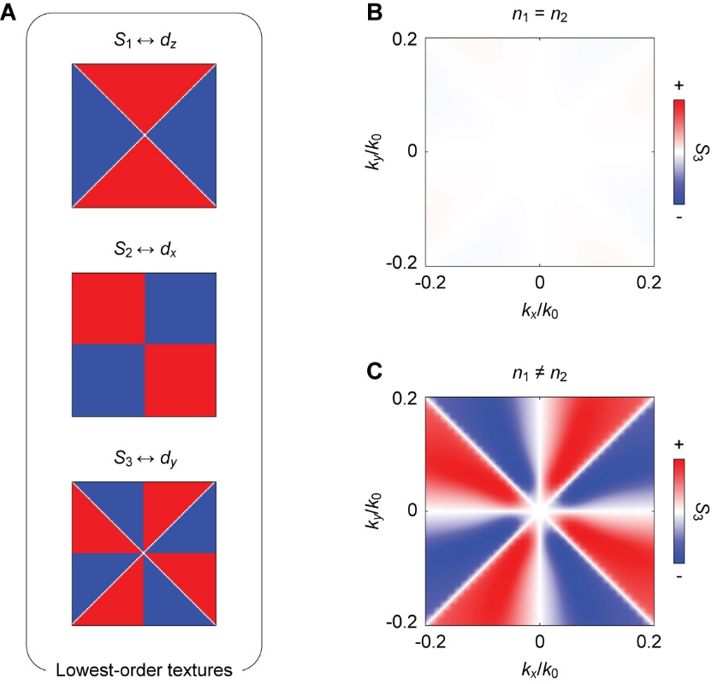
Fig. S2 | Symmetry-constrained Stokes textures. A, Lowest-order Pauli and Stokes sign textures, with $S_{1}↔d_{z}$, $S_{2}↔d_{x}$, and $S_{3}↔d_{y}$. The leading symmetry-allowed forms determine the corresponding nodal lines and sign partitions in momentum space. B, C, Calculated $S_{3}$ textures for $n_{1}=n_{2}$ and $n_{1}≠n_{2}$, respectively, using the same datasets as Fig. 2A of the main text. For $n_{1}=n_{2}$, $S_{3}$ is strongly suppressed by the preserved out-of-plane mirror symmetry. For $n_{1}≠n_{2}$, breaking $M_{z}$ allows a finite $S_{3}$ with the symmetry-constrained four-period angular form.

D. Relation to the gyromagnetic route
Supplementary Note 1 considers the gyromagnetic route to alterspin photonics. At the level of momentum-space polarization, both the gyromagnetic and all-dielectric routes can produce circular-polarization states whose sign changes with momentum direction. Their Maxwell origins, however, are different. In a gyromagnetic system^{1,12}, the circular-polarization splitting originates from the antisymmetric material tensor and time-reversal-symmetry breaking. In our dielectric slab, by contrast, the out-of-plane dielectric perturbation enables a finite $S_{3}$ through Maxwell coupling between the in-plane magnetic-field components, while the in-plane symmetry determines its angular form.
For a gyromagnetic system, the frequency-domain Maxwell equations are
$$\begin{aligned}\begin{matrix}∇×E=iωμ_{0}μ\left(r\right)H \\ ∇×H=-iωε_{0}ε\left(r\right)E\end{matrix} \end{aligned}$$ | (36)
For a magnetization along the $z$ direction, the permeability tensor contains antisymmetric off-diagonal components and can be written as
$$\begin{aligned}μ\left(r\right)=\left[\begin{matrix}μ_{r}\left(r\right) & ∓iμ_{k}\left(r\right) & 0 \\ ±iμ_{k}\left(r\right) & μ_{r}\left(r\right) & 0 \\ 0 & 0 & μ_{z}\left(r\right)\end{matrix}\right]\end{aligned}$$ | (37)
where the off-diagonal component changes sign under magnetization reversal and explicitly breaks time-reversal symmetry. Eliminating the magnetic field gives the electric-field eigenvalue equation
$$\begin{aligned}∇×{μ\left(r\right)}^{-1}∇×E=\frac{ω^{2}}{c^{2}}ε\left(r\right)E\end{aligned}$$ | (38)
For a TM mode with $E\left(r\right)=E_{z}\left(r\right)\hat{z}$, after the Bloch substitution $∇→∇+ik≡D_{k}$, the in-plane inverse permeability tensor can be written as
$$\begin{aligned}μ_{t}^{-1}=\left[\begin{matrix}α\left(r\right) & ±iβ\left(r\right) \\ ∓iβ\left(r\right) & α\left(r\right)\end{matrix}\right]\end{aligned}$$ | (39)
where $α\left(r\right)={μ_{r}}/{\left(μ_{r}^{2}-μ_{k}^{2}\right)}$ denotes the diagonal component of the inverse permeability tensor, and $β\left(r\right)={μ_{k}}/{\left(μ_{r}^{2}-μ_{k}^{2}\right)}$ represents the gyrotropic off-diagonal response. The off-diagonal terms $±iβ\left(r\right)$ change sign under magnetization reversal, while $β\left(r\right)$ vanishes in the absence of gyrotropy. Substituting this tensor into the Maxwell operator separates the eigenvalue problem into ordinary and gyrotropic parts
$$\begin{aligned}\hat{L}\left(k\right)={\hat{L}}_{o}\left(k\right)+{\hat{L}}_{g}\left(k\right)\end{aligned}$$ | (40)
where ${\hat{L}}_{o}\left(k\right)$ is mainly determined by $α\left(r\right)$, while the gyrotropic part takes the simplified form
$$\begin{aligned}{\hat{L}}_{g}\left(k\right)∼-i\left[D_{x}β\left(r\right)D_{y}-D_{y}β\left(r\right)D_{x}\right]\end{aligned}$$ | (41)
This expression highlights the essential difference between the gyromagnetic and all-dielectric routes. In magnetic photonic crystals, the antisymmetric off-diagonal elements of $μ$ generate an intrinsic $iβ\left(r\right)$-type term in the Maxwell operator. This term directly distinguishes opposite circular-polarization states. Thus, circular-polarization splitting in magnetic systems is encoded in the material’s gyrotropic constitutive relation rather than in structural asymmetry.
This Maxwell-level description can be connected to a tight-binding picture by projecting the continuous Maxwell operator onto localized photonic modes or Wannier-like basis states. In a circular-polarization basis
$$\begin{aligned}\left|\left.L\right\rangle \right.=\frac{\left|\left.x\right\rangle \right.+i\left|\left.y\right\rangle \right.}{\sqrt{2}}, \left|\left.R\right\rangle \right.=\frac{\left|\left.x\right\rangle \right.-i\left|\left.y\right\rangle \right.}{\sqrt{2}}\end{aligned}$$ | (42)
the gyrotropic Maxwell operator naturally produces an effective Hamiltonian of the form
$$\begin{aligned}H_{mag}\left(k\right)=Ω_{0}\left(k\right)I+m\left(k\right)σ_{z}\end{aligned}$$ | (43)
Here, $σ_{z}$ distinguishes the $\left|\left.R\right\rangle \right.$ and $\left|\left.L\right\rangle \right.$ modes and therefore corresponds to circular polarization, or equivalently to $S_{3}$. The tight-binding coefficient $m\left(k\right)$ is not an independent phenomenological parameter; it originates from projected matrix elements of the gyrotropic Maxwell operator ${\hat{L}}_{g}$. If the magnetization is spatially uniform and the structure imposes no additional alternating symmetry constraints, $m\left(k\right)$ is approximately constant, $m\left(k\right)≈m_{0}$. This gives an ordinary Zeeman-like circular-polarization splitting: the two circular-polarization modes are separated with the same sign throughout momentum space. Such a response is magnetic but does not form an alterspin texture.
An alterspin texture requires the gyromagnetic splitting to become momentum dependent through spatial symmetry or sublattice engineering. In a tight-binding representation, this means that $m\left(k\right)$ arises from the Fourier transform of polarization-dependent onsite terms and intercell couplings. In a square lattice, a minimal form can be written as
$$\begin{aligned}m\left(k\right)=m_{0}+2t_{x}^{g}cos\left(k_{x}a\right)+2t_{y}^{g}cos\left(k_{y}a\right)+…\end{aligned}$$ | (44)
where $m_{0}$, $t_{x}^{g}$ and $t_{y}^{g}$ are not phenomenological parameters inserted by hand, but projected matrix elements of the gyrotropic Maxwell operator ${\hat{L}}_{g}$. If the magnetic unit cell cancels the uniform term and imposes opposite gyrotropic hopping along the x and y directions, namely
$$\begin{aligned}m_{0}=0, t_{x}^{g}=-t_{y}^{g}\end{aligned}$$ | (45)
then
$$\begin{aligned}m_{AM}\left(k\right)∼cos\left(k_{x}a\right)-cos\left(k_{y}a\right) \end{aligned}$$ | (46)
This term changes sign between the $k_{x}$ and $k_{y}$ directions, converting the gyromagnetic circular-polarization splitting into an alterspin texture. The gyromagnetic material response therefore provides the spin splitting, while the spatial symmetry determines how that splitting alternates in momentum space.
Our all-dielectric slab follows a different route. With $μ=I$, it has no gyromagnetic Maxwell term analogous to ${\hat{L}}_{g}$. Instead, the out-of-plane dielectric perturbation modifies the Maxwell coupling between $H_{x}$ and $H_{y}$, allowing a finite $d_{y}$ and hence a finite $S_{3}$. The preserved in-plane square-lattice symmetry then constrains its momentum dependence to the four-period angular form. The two routes can therefore be summarized as
$$\begin{aligned}{\hat{L}}_{g}\left(k\right)∼m\left(k\right)σ_{z}\end{aligned}$$ | (47)
for the gyromagnetic system, and
$$\begin{aligned}η_{o}\left(z\right)∼d_{y}\left(k\right)σ_{y}\end{aligned}$$ | (48)
for the all-dielectric system. Both routes can produce alterspin textures, but they separate the required ingredients differently. In the gyromagnetic route, the material response supplies circular-polarization splitting, and the magnetic arrangement makes it momentum-dependent. In our system, the in-plane lattice fixes the four-period angular form, while the out-of-plane dielectric perturbation controls the texture’s sign and amplitude. The two-period form in Supplementary Note 1 and the four-period form in the main text therefore arise from their different in-plane symmetries: the staggered magnetic bias lowers the in-plane symmetry and allows a lower-order angular dependence, whereas our system preserves the square-lattice mirrors and therefore retains the four-period form.

Supplementary Note 3 | Dry-state reference and thickness compensation
Fig. S3 shows the dry suspended photonic-crystal sample used for the water-droplet measurements in the main text before any water is applied. The front-side and back-side optical micrographs both show the photonic-crystal arrays. The back-side image also shows the sloped silicon etch opening formed during KOH release. Water was then applied to either side of this same sample to realize the water-SiN_{x}-air and air-SiN_{x}-water configurations, from which the measurements shown in Fig. 3 of the main text were obtained.

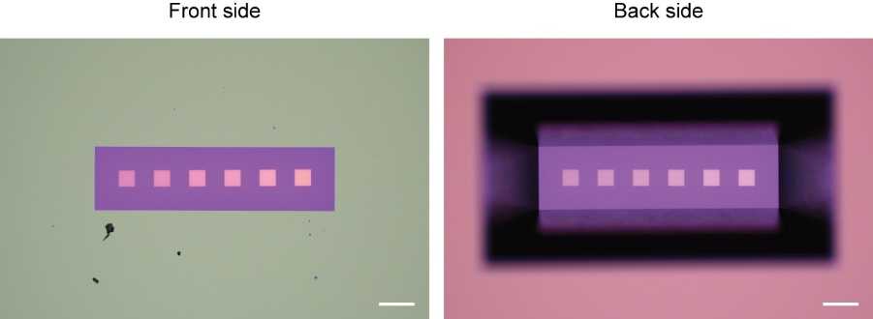
Fig. S3 | Optical micrographs of the dry suspended photonic-crystal sample. Front-side and back-side optical microscope images of the suspended sample acquired before water was applied. Scale bars, 200 μm.

After the water-droplet measurements, we removed the water and measured the same sample in the dry air-SiN_{x}-air configuration. As shown in Fig. S4A, the TM₁ band shifts by approximately 40 nm toward shorter wavelengths compared with the momentum-resolved spectra in Fig. 3A of the main text. We refer to this sample as Sample 1. To bring the TM₁ band edge back to the original spectral window in the dry configuration, we fabricated a second sample, Sample 2, with its thickness adjusted using an empirical compensation relation $h=270-345{\left(n_{1}-n_{2}\right)}^{2}$ nm.
Figs. S4B and S4C show the $S_{3}$ slices from Samples 1 and 2 within the 740–800 nm measurement window. Aside from the spectral shift, Samples 1 and 2 show similar weak residual $S_{3}$ patterns, and neither shows the four-period alterspin texture observed under an out-of-plane dielectric perturbation. The angular profiles show a systematic residual in the experiment, with gray open circles deviating from the near-zero theoretical response shown by the black dashed curves. Such a residual can arise from linear-to-circular Stokes crosstalk in nonideal polarization analysis¹³. Retardance mismatch of the quarter-wave element and imperfect analyzer settings can leak the linear Stokes components $S_{1}$ and $S_{2}$ into the measured $S_{3}$ signal. This effect becomes more apparent when the underlying $S_{3}$ signal is weak. The residual signal exhibits a weak two-period angular dependence. It is therefore consistent with a small linear-to-circular polarization leakage, while remaining clearly different from the four-period angular form of the alterspin texture. When quantified using $C_{alt}$ as defined in the main text, this residual gives values close to zero, consistent with the air-SiN_{x}-air results in Fig. 4A. It therefore does not affect the subsequent quantitative analysis.

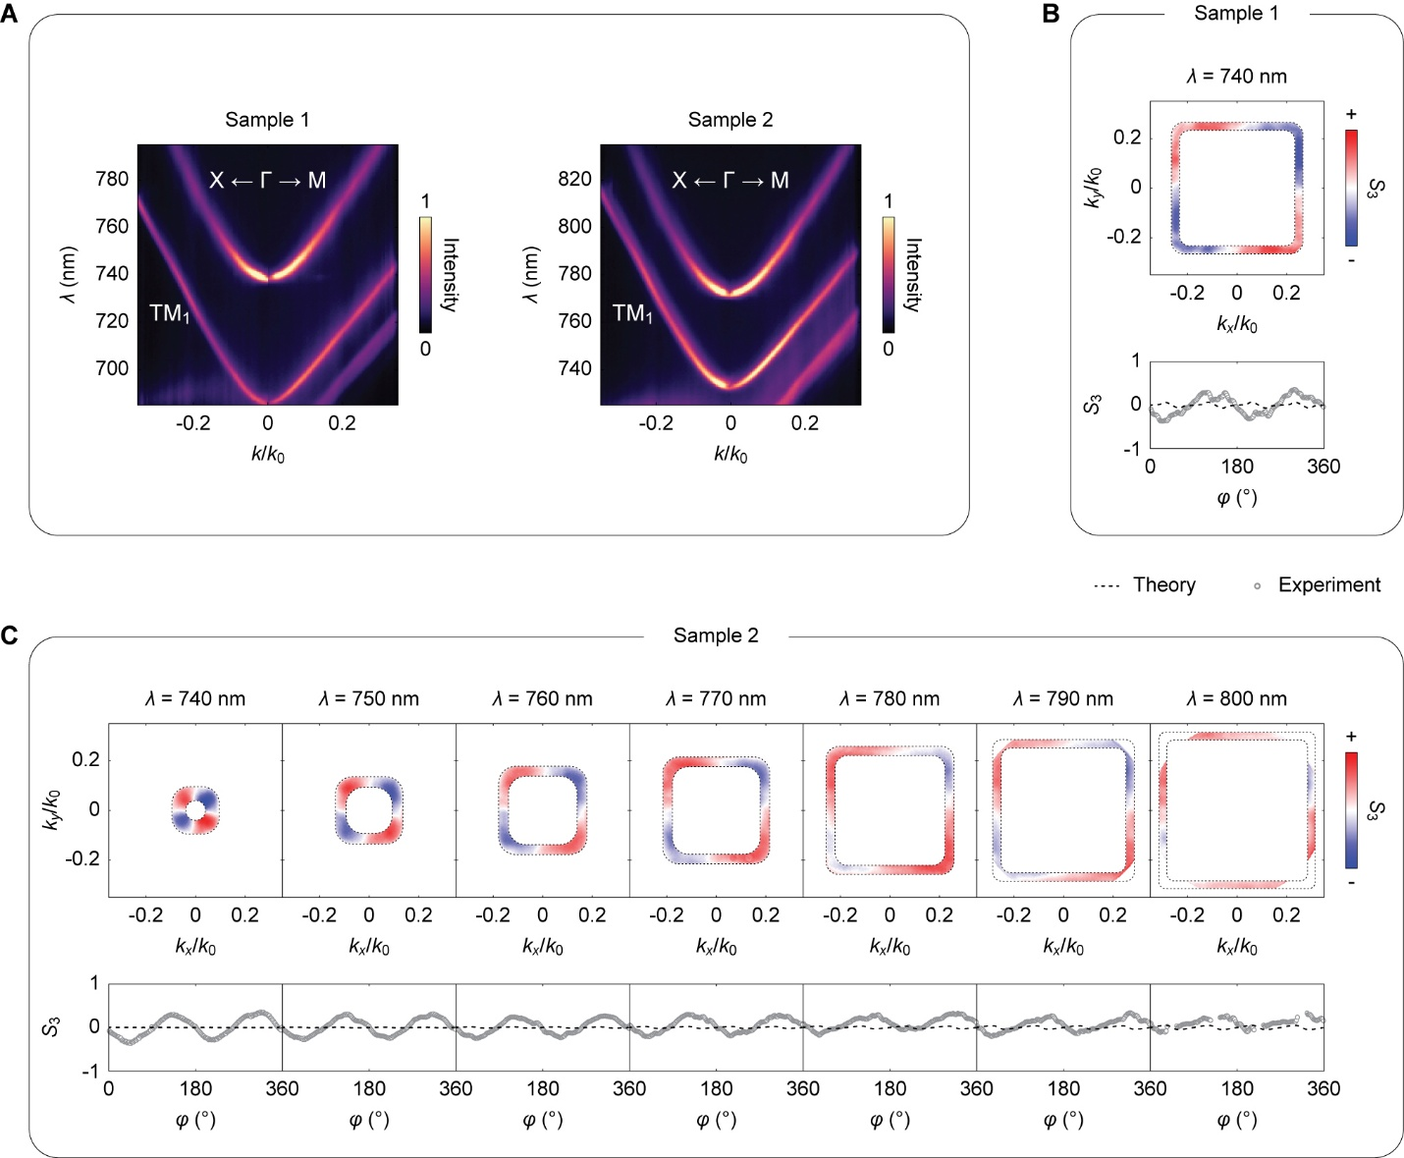
Fig. S4 | Dry-state spectral shift and thickness compensation. A, Measured momentum-resolved spectra of Sample 1 and the thickness-compensated Sample 2 along $X←Γ→M$. The fabrication-set SiN_{x} thicknesses are $h$ = 232 nm and 270 nm for Samples 1 and 2, respectively. B, $S_{3}$ map and corresponding angular profile $S_{3}\left(φ\right)$ for Sample 1 at $λ$ = 740 nm. C, $S_{3}$ slices for Sample 2 across 740–800 nm in 10-nm steps, together with the corresponding angular profiles $S_{3}\left(φ\right)$. Gray open circles denote the experiment, and black dashed curves denote the theory.

Supplementary Note 4 | Details for two glass-based configurations
Water provides a particularly convenient dielectric perturbation because it can be added, removed, and transferred between the two sides of the suspended sample. We nevertheless fabricated an additional glass-based sample for two reasons. First, glass has a higher refractive index than water. It therefore extends the accessible dielectric contrast, allowing us to test the dielectric-contrast trend established with the water configurations over a larger range. Second, while water enables reversible control, a glass-supported platform is more compatible with conventional substrate-based photonic integration. Related theoretical studies of planar dielectric structures have also considered glass-like substrates with a refractive index around 1.45¹⁴.
For this sample, SiN_{x} was deposited on a 500-μm-thick silica glass substrate. We patterned the photonic crystal using the same lithography and SiN_{x} etching procedure described in the Methods section of the main text. The same glass-supported sample was then measured from opposite sides, corresponding to the air-SiN_{x}-glass and glass-SiN_{x}-air configurations shown in Figs. S5A and S5B, respectively. Across 740–800 nm, both configurations exhibit the same four-period alterspin texture, while reversing the sample orientation reverses the sign of the texture, consistent with the reversal observed with water in the main text. These two measurement configurations provide the additional experimental points in the dielectric-contrast comparison in Fig. 4 of the main text.
As discussed in the main text, the measured $S_{3}$ magnitudes for the glass-based configurations are systematically smaller than the corresponding theoretical values. To make the angular trend easier to compare, we uniformly scale the theoretical angular profiles by 0.5 at all wavelengths for both glass configurations. We use this scaling only for visual comparison of the angular dependence. It is not a quantitative fit and is not used in the $C_{alt}$ analysis; all quantitative comparisons use the original, unscaled theoretical data. With this display scaling, the common four-period angular form and its spectral evolution are easier to compare.

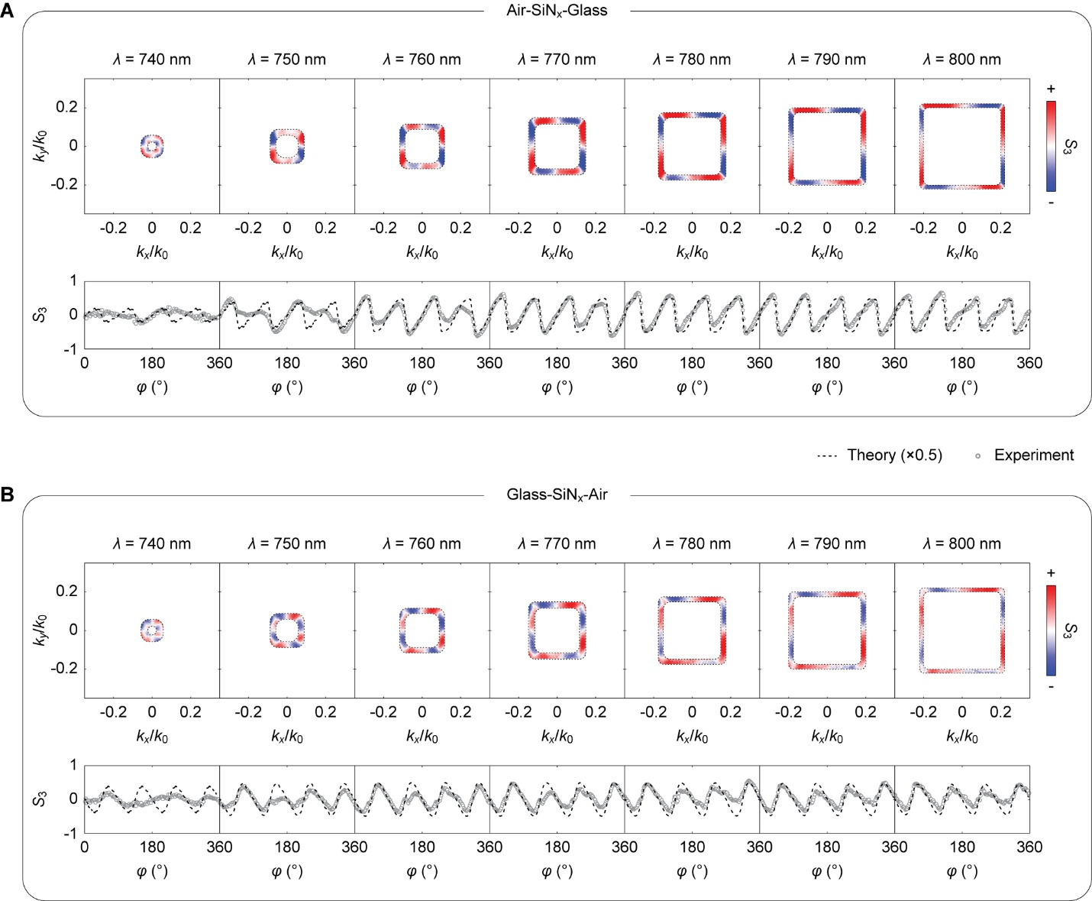
Fig. S5 | Alterspin texture in a glass-supported photonic-crystal sample. A, B, Air-SiN_{x}-glass and glass-SiN_{x}-air configurations, respectively, obtained by measuring opposite sides of the same glass-supported sample. The photonic crystal used the same $a=480$ nm and $b=260$ nm, with a SiN_{x} thickness of $h=200$ nm. For each configuration, the upper row shows momentum-space $S_{3}$ slices across 740–800 nm in 10-nm steps, and the lower row shows the corresponding angular profiles $S_{3}\left(φ\right)$. Gray open circles denote experiment, and black dashed curves denote theory. For the angular profiles, the theory is uniformly scaled by 0.5 at all wavelengths for both configurations. This scaling is used only for visual comparison.

References
1 Chen, J., Zheng, Y., Li, Z.-Y. & Qiu, C.-W. Altermagnetic photonic crystals. Nature Physics (2026).
2 Landau, L. D. & Lifshitz, E. M. Electrodynamics of continuous media. (American Institute of Physics, 1961).
3 Eliseeva, S. V., Nasedkina, Y. F. & Sementsov, D. I. Giant Faraday rotation in one-dimensional photonic crystal with magnetic defect. Progress In Electromagnetics Research M 51, 131–138 (2016).
4 Liu, L., Zhao, J. & Zhang, C. Integrated Low-Loss, High-Isolation, and Broadband Magneto-Optical Isolator with TE-Mode Input. Micromachines 16, 315 (2025).
5 Chin, J. Y. et al. Nonreciprocal plasmonics enables giant enhancement of thin-film Faraday rotation. Nature Communications 4, 1599 (2013).
6 Yang, W. et al. Observation of optical gyromagnetic properties in a magneto-plasmonic metamaterial. Nature Communications 13, 1719 (2022).
7 Guddala, S. et al. Topological phonon-polariton funneling in midinfrared metasurfaces. Science 374, 225–227 (2021).
8 Li, M. et al. Experimental observation of topological Z2 exciton-polaritons in transition metal dichalcogenide monolayers. Nature Communications 12, 4425 (2021).
9 Ren, J. et al. Nontrivial band geometry in an optically active system. Nature Communications 12, 689 (2021).
10 Ming, Y. et al. Tailoring the photon spin via light–matter interaction in liquid-crystal-based twisting structures. NPJ Quantum Materials 2, 6 (2017).
11 Zhou, H. et al. Observation of bulk Fermi arc and polarization half charge from paired exceptional points. Science 359, 1009–1012 (2018).
12 Qiu, S. et al. Orbital altermagnetic photonic crystal. arXiv preprint arXiv:2605.28656 (2026).
13 Kihara, T. Stokes parameters measurement of light over a wide wavelength range by judicious choice of azimuthal settings of quarter-wave plate and linear polarizer. Optics communications 110, 529–532 (1994).
14 Gorkunov, M. V., Antonov, A. A., Mamonova, A. V., Muljarov, E. A. & Kivshar, Y. Substrate‐induced maximum optical chirality of planar dielectric structures. Advanced Optical Materials 13, 2402133 (2025).

