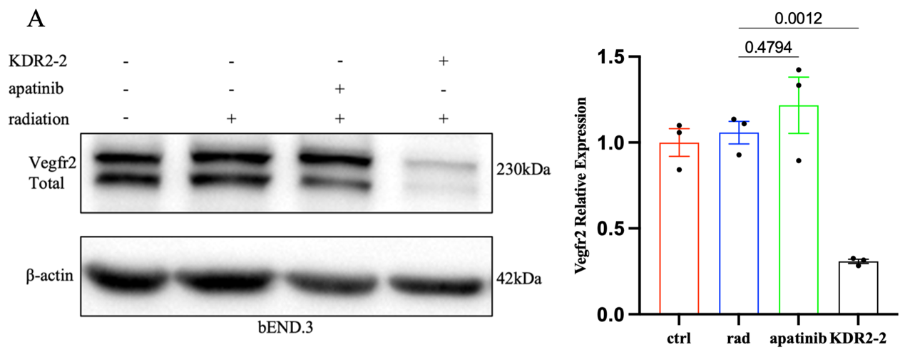
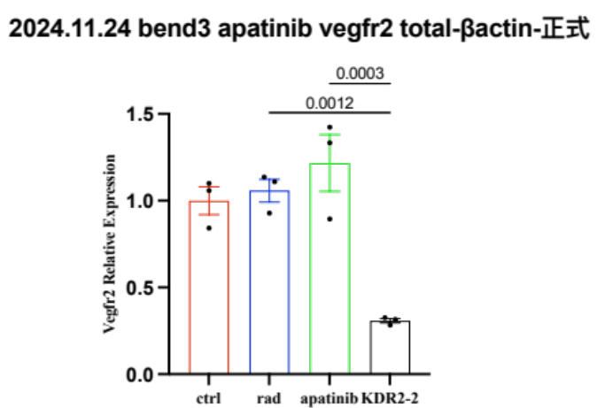
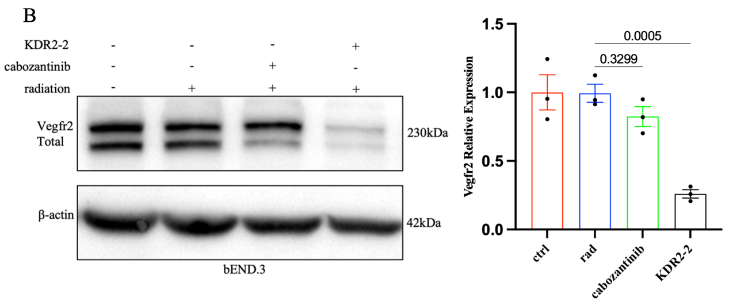
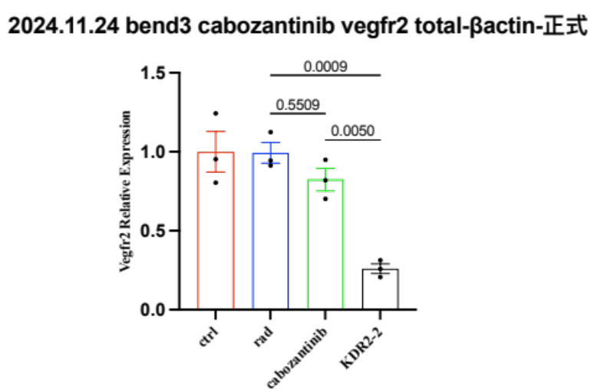
Supplementary materials
B
C
D

Supplementary Figure 1. KDR2-2 is a more potent VEGFR2 inhibitor relative to apatinib and cabozantinib
A, VEGFR2 expression in bEND.3 cells under indicated conditions. B, Quantification of VEGFR2/β-actin from (A) (Mean ± SEM, n=3). C, VEGFR2 expression in bEND.3 cells under indicated conditions. D, Quantification of VEGFR2/β-actin from (C) (Mean ± SEM, n=3).
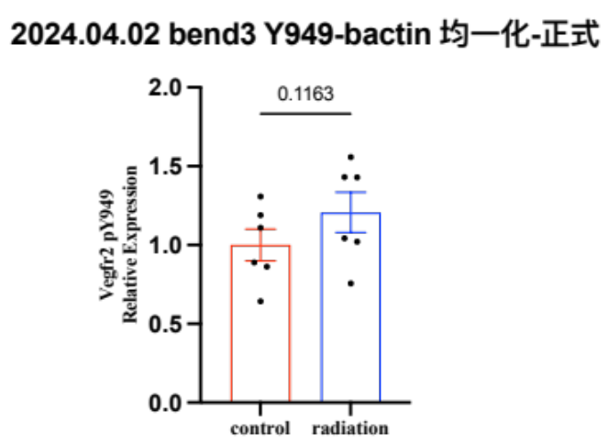
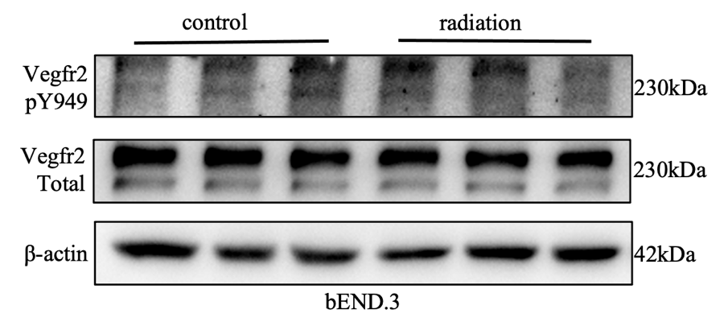
B
A

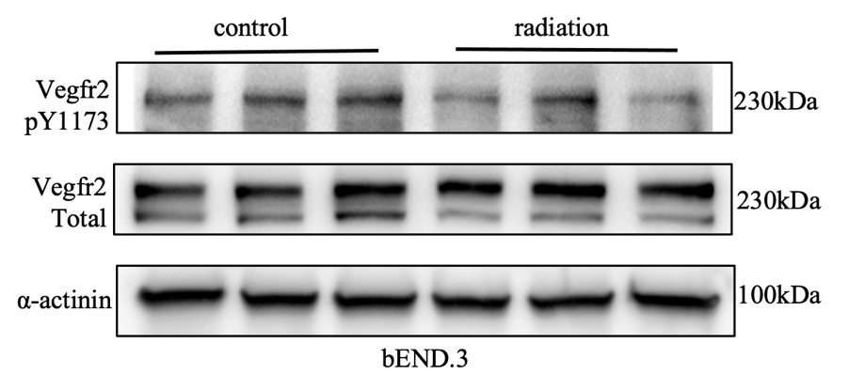
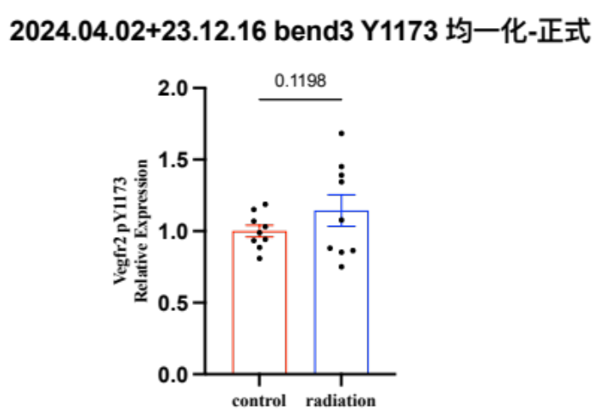
C
D

Supplementary Figure 2. Analysis of VEGFR2 Y949 and Y1173 phosphorylation in irradiated bEND.3 cells
A, Representative Western blots of VEGFR2 phosphorylation (Y949) and total VEGFR2 in bEND.3 cells with or without irradiation. B, Quantification of VEGFR2 pY949/VEGFR2 ratio (Mean ± SEM, n=6). C, Representative Western blots of VEGFR2 phosphorylation (Y1173) and total VEGFR2. D, Quantification of VEGFR2 pY1173/VEGFR2 ratio (Mean ± SEM, n=9).
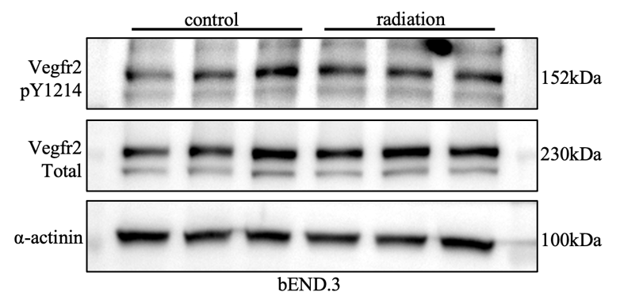
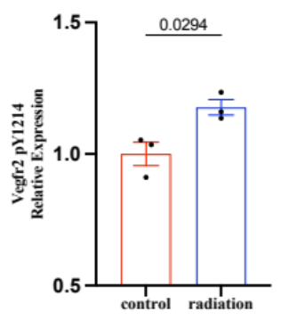
A

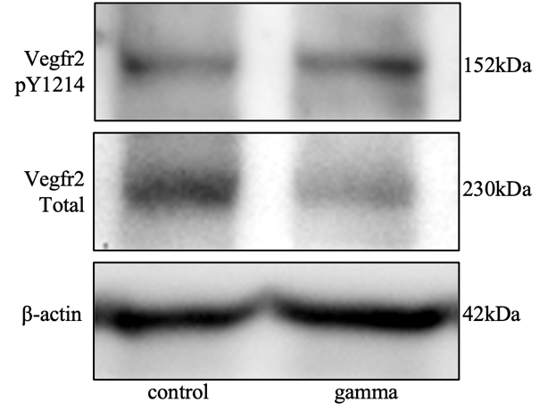
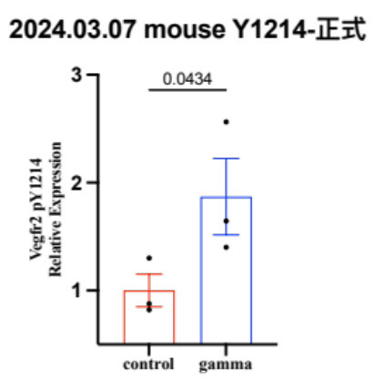
B

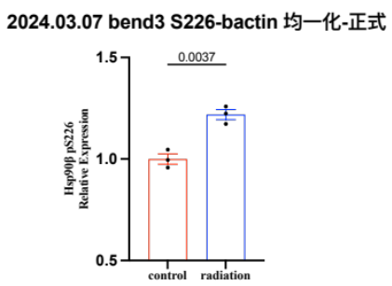
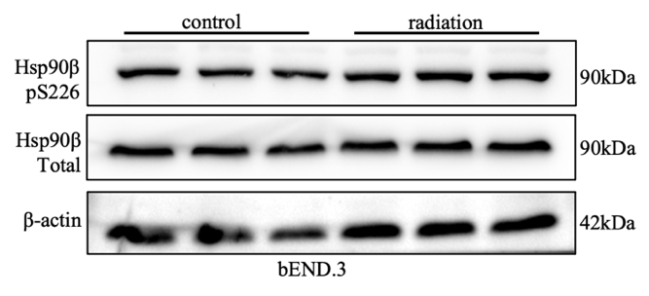
C

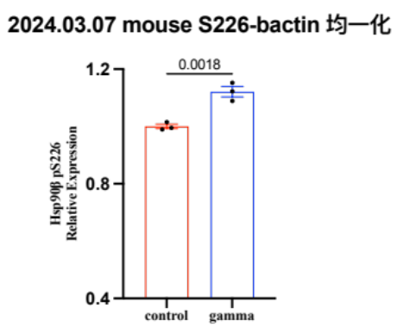
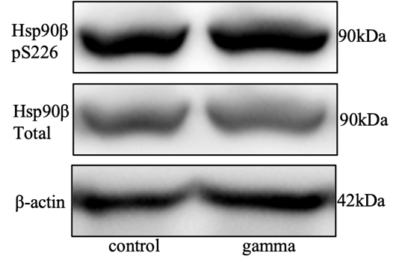
D

Supplementary Figure 3. Phosphorylation of VEGFR2 Y1214 and HSP90β S226 in Gamma Knife-irradiated mice and irradiated bEND.3 cells
A, VEGFR2 Y1214 phosphorylation in bEND.3 cells with representative western blots (left) and p-VEGFR2(Y1214)/VEGFR2 ratio quantification (right) (Mean ± SEM, n=3). B, VEGFR2 Y1214 phosphorylation in mouse brain tissue with representative blots (left) and p-VEGFR2(Y1214)/VEGFR2 ratio quantification (right) (Mean ± SEM, n=3). C, HSP90β S226 phosphorylation in bEND.3 cells with representative blots (left) and p-HSP90β(S226)/HSP90β ratio quantification (right) (Mean ± SEM, n=3). D, HSP90β S226 phosphorylation in mouse brain tissue with representative blots (left) and p-HSP90β(S226)/HSP90β ratio quantification (right) (Mean ± SEM, n=3).

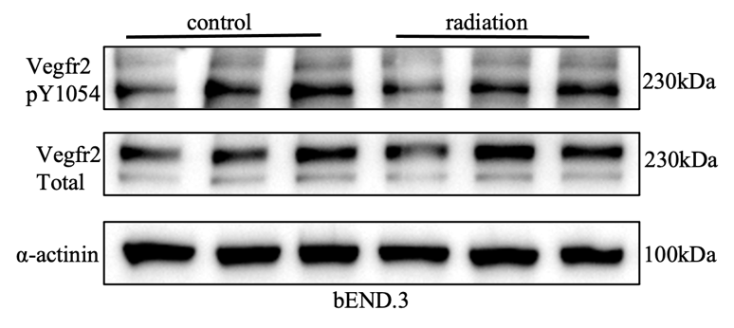
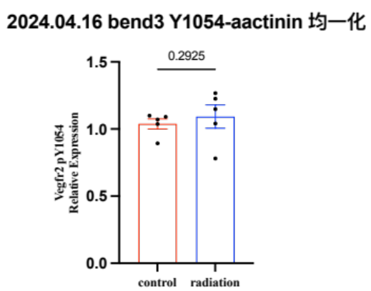
A

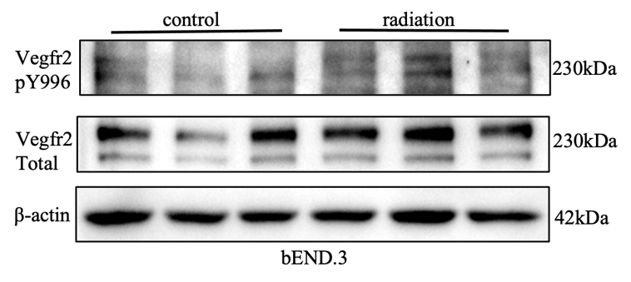
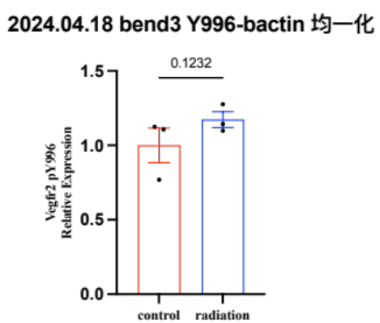
B

Supplementary Figure 4. Phosphorylation of VEGFR2 Y1054 and Y996 in irradiated bEND.3 cells
A, VEGFR2 Y1054 phosphorylation with representative blots (left) and p-VEGFR2 (Y1054)/VEGFR2 ratio quantification (right) (Mean ± SEM, n=5). B, VEGFR2 Y996 phosphorylation with representative blots (left) and p-VEGFR2 (Y996)/VEGFR2 ratio quantification (right) (Mean ± SEM, n=3).

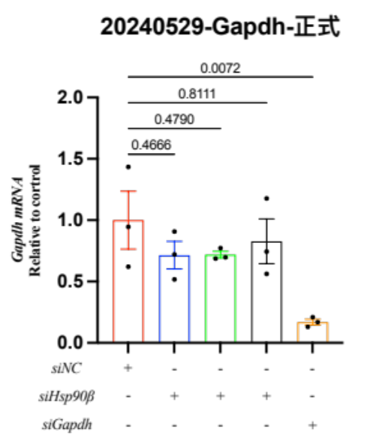
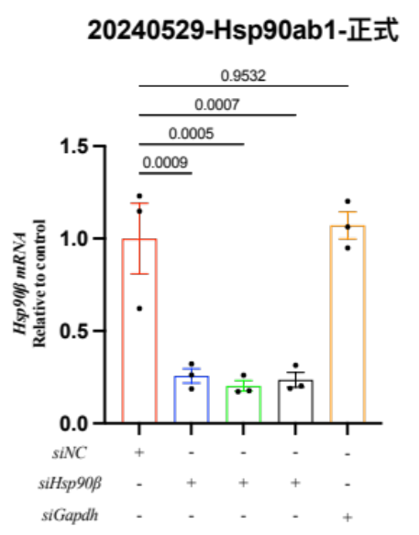
B
A

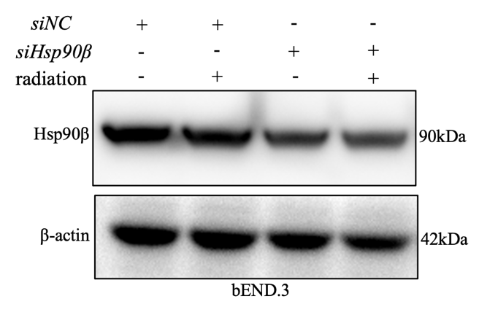
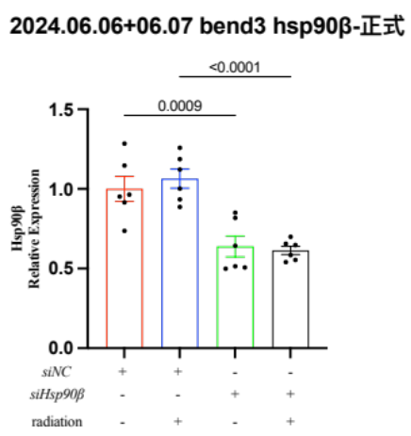
C
D

Supplementary Figure 5. Validation of Hsp90β knockdown in bEND.3 cells by qRT-PCR and Western blot
A, qRT-PCR analysis of Hsp90β mRNA levels following transfection with different siRNAs (Mean ± SEM, n=3). B, qRT-PCR analysis of Gapdh mRNA levels following transfection with different siRNAs (Mean ± SEM, n=3). C, Hsp90β protein expression with representative Western blots under different conditions following transfection. D, Quantification of Hsp90β protein levels normalized to β-actin (Mean ± SEM, n=6).

Table S1. ﻿The clinical characteristics of patients for brain tissue collection
Age (y) | Gender | Diagnosis | Months  after diagnosis | Reason  of surgery | Analysis
52 | M | RIBI | 5 | Risk of hernia | RNA-seq
32 | M | RIBI | 7 | Risk of hernia | RNA-seq
36 | M | RIBI | 36 | Risk of hernia | RNA-seq
23 | F | Epilepsy | 24 | Epileptic focus  resection | RNA-seq
20 | F | Epilepsy | 96 | Epileptic focus  resection | RNA-seq
14 | M | Epilepsy | 24 | Epileptic focus  resection | RNA-seq
47 | M | RIBI | 9 | Risk of hernia | Western blot
63 | F | RIBI | 3 | Risk of hernia | Western blot
41 | M | RIBI | 12 | Risk of hernia | Western blot
28 | F | Epilepsy | 38 | Epileptic focus  Resection | Western blot
24 | M | Traumatic  brain injury | 0 | Rishk of hernia | Western blot
52 | M | Traumatic  brain injury | 0 | Risk of hernia | Western blot

Table S2. Phosphoprotein profiling results of bEND.3 with and without radiation
Name | Gene Symbol | Fold Change (bEND.3+radiation vs.bEND.3)
Catalase (Phospho-Tyr385) | Cat | 2.44
HSP90B (Phospho-Ser226) | Hsp90ab1 | 2.07
Gab2 (Phospho-Tyr643) | Gab2 | 1.98
MAP3K7/TAK1 (Phospho-Thr184) | Map3k7 | 1.91
Actin Pan (a/b/g)(Phospho-Tyr55/53) | Actc1/Actg1/Actg2/Acta1 | 1.91
PI3-kinase p85-alpha (Phospho-Tyr607) | Pik3r1 | 1.89
Caspase 1 (Phospho-Ser376) | Casp1 | 1.86
GRK2 (Phospho-Ser29) | Grk2 | 1.83
HSP27 (Phospho-Ser82) | Hspb1 | 1.76
Caspase 9 (Phospho-Ser196) | Casp9 | 1.73
mTOR (Phospho-Ser2448) | Mtor | 1.63
Smad2 (Phospho-Ser467) | Smad2 | 1.62
IL-4R/CD124 (Phospho-Tyr497) | Il4r | 1.49
JAK2 (Phospho-Tyr221) | Jak2 | 1.48
Smad1 (Phospho-Ser187) | Smad1 | 1.43
Integrin beta-3 (Phospho-Tyr773) | Itgb3 | 1.42
14-3-3 theta/tau (Phospho-Ser232) | Ywhaq | 1.39
Smad3 (Phospho-Ser213) | Smad3 | 1.38
Tuberin/TSC2 (Phospho-Thr1462) | Tsc2 | 1.37
eNOS (Phospho-Ser615) | Nos3 | 1.34
Cyclin E1 (Phospho-Thr77) | Ccne1 | 1.32
Rb (Phospho-Ser807) | Rb1 | 1.31
Cyclin D1 (Phospho-Thr286) | Ccnd1 | 1.30
HDAC1 (Phospho-Ser421) | Hdac1 | 1.30
JAK2 (Phospho-Tyr1007) | Jak2 | 1.25
Calmodulin (Phospho-Thr79/Ser81) | Calm1 | 1.22
Chk2 (Phospho-Thr68) | Chek2 | 1.22
Smad2/3 (Phospho-Thr8) | Smad2/Smad3 | 1.22
STAT4 (Phospho-Tyr693) | Stat4 | 1.22
VEGFR2 (Phospho-Tyr1214) | Kdr | 1.19
BCL-2 (Phospho-Ser70) | Bcl2 | 1.19
BAD (Phospho-Ser136) | Bad | 1.19
FAK (Phospho-Ser910) | Ptk2 | 1.18
elF4E (Phospho-Ser209) | Eif4e | 1.17
Myc (Phospho-Ser62) | Myc | 1.17
CaMK2-beta/gamma/delta (Phospho-Thr287) | Camk2b/Camk2g/Camk2d | 1.17
Caspase 8 (Phospho-Ser347) | Casp8 | 1.16
PP2A-alpha (Phospho-Tyr307) | Ppp2ca | 1.15
BLNK (Phospho-Tyr96) | Blnk | 1.12
mTOR (Phospho-Ser2481) | Mtor | 1.12
EEF2 (Phospho-Thr56) | Eef2 | 1.10
GSK3 beta (Phospho-Ser9) | Gsk3b | 1.10
IkB-epsilon (Phospho-Ser22) | Nfkbie | 1.09
LCK (Phospho-Tyr393) | Lck | 1.08
CPI17 alpha (Phospho-Thr38) | Ppp1r14a | 1.08
Gab1 (Phospho-Tyr627) | Gab1 | 1.07
NFkB-p105/p50 (Phospho-Ser337) | Nfkb1 | 1.06
P70S6K (Phospho-Ser424) | Rps6kb1 | 1.06
CDC25C (Phospho-Ser216) | Cdc25c | 1.05
P73 (Phospho-Tyr99) | Tp73 | 1.05
CREB (Phospho-Ser133) | Creb1 | 1.04
STAT5A (Phospho-Tyr694) | Stat5a | 1.03
IRS-1 (Phospho-Ser312) | Irs1 | 1.03
FGFR1 (Phospho-Tyr654) | Fgfr1 | 1.03
CBL (Phospho-Tyr700) | Cbl | 1.03
PPAR-gamma (Phospho-Ser112) | Pparg | 1.02
HER2 (Phospho-Tyr1221/Tyr1222) | Erbb2 | 1.02
CrkII (Phospho-Tyr221) | Crk | 1.02
p44/42 MAP Kinase (Phospho-Tyr204) | Mapk3/mapk1 | 1.02
SRF (Phospho-Ser99) | Srf | 1.01
MDM2 (Phospho-Ser166) | Mdm2 | 1.01
PDGFR beta (Phospho-Tyr1021) | Pdgfrb | 1.00
STAT2 (Phospho-Tyr690) | Stat2 | 1.00
Shc (Phospho-Tyr349) | Shc1 | 1.00
PTEN (Phospho-Ser380/Thr392/Thr383) | Pten | 0.99
CDK1/CDC2 (Phospho-Tyr15) | Cdk1 | 0.99
Abl1 (Phospho-Thr754/735) | Abl1 | 0.99
IGF1R (Phospho-Tyr1165/1166) | Igf1r | 0.99
eEF2K (Phospho-Ser366) | Eef2k | 0.99
NFkB-p65 (Phospho-Ser311) | Rela | 0.98
STAT5B (Phospho-Ser731) | Stat5b | 0.97
HER2 (Phospho-Tyr1248) | Erbb2 | 0.97
FOXO1/3/4-pan (Phospho-Thr24/32) | Foxo1/3/4 | 0.97
ASK1 (Phospho-Ser966) | Map3k5 | 0.97
FADD (Phospho-Ser194) | Fadd | 0.96
BCL-XL (Phospho-Ser62) | Bcl2l1 | 0.96
MEK1 (Phospho-Ser217) | Map2k1 | 0.96
Rb (Phospho-Ser608) | Rb1 | 0.95
c-Abl (Phospho-Tyr412) | Abl1 | 0.95
P90RSK (Phospho-Thr359/Ser363) | Rps6ka1 | 0.95
IKK alpha/beta (Phospho-Ser180/181) | Chuk/Ikbkb | 0.95
Chk1 (Phospho-Ser286) | Chek1 | 0.95
MKK4/SEK1 (Phospho-Thr261) | Map2k4 | 0.95
Met (Phospho-Tyr1234) | Met | 0.95
PLK1 (Phospho-Thr210) | Plk1 | 0.94
BAX (Phospho-Thr167) | Bax | 0.93
NMDAR2A/B (Phospho-Tyr1246/1252) | Grin2a/Grin2b | 0.93
IKK-gamma (Phospho-Ser31) | Ikbkg | 0.93
STAT6 (Phospho-Thr645) | Stat6 | 0.93
B-RAF (Phospho-Ser446) | Braf | 0.93
PKC delta (Phospho-Ser645) | Prkcd | 0.93
MSK1 (Phospho-Ser376) | Rps6ka5 | 0.93
P70S6K (Phospho-Thr421) | Rps6kb1 | 0.93
NMDAR1 (Phospho-Ser897) | Grin1 | 0.92
RelB (Phospho-Ser552) | Relb | 0.92
VEGFR2 (Phospho-Tyr1175) | Kdr | 0.91
Trk B (Phospho-Tyr515) | Ntrk2 | 0.91
FKHRL1/FOXO3A (Phospho-Ser253) | Foxo3 | 0.91
AKT1S1 (Phospho-Thr246) | Akt1s1 | 0.91
p21Cip1 (Phospho-Thr145) | Cdkn1a | 0.90
IKK-beta (Phospho-Tyr199) | Ikbkb | 0.90
Interferon-gamma receptor alpha (Phospho-Tyr457) | Ifngr1 | 0.90
LKB1 (Phospho-Thr189) | Stk11 | 0.90
eIF2A (Phospho-Ser51) | Eif2s1 | 0.89
SYK (Phospho-Tyr348) | Syk | 0.89
PP1 alpha (Phospho-Thr320) | Ppp1ca | 0.88
DARPP-32 (Phospho-Thr34) | Ppp1r1b | 0.88
SHP-2 (Phospho-Tyr542) | Ptpn11 | 0.88
IKK-beta (Phospho-Tyr188) | Ikbkb | 0.87
AKT1 (Phospho-Ser473) | Akt1 | 0.87
PKC theta (Phospho-Thr538) | Prkcq | 0.87
ATF2 (Phospho-Ser62/44) | Atf2 | 0.86
Catenin beta (Phospho-Thr41/Ser45) | Ctnnb1 | 0.85
MEK1 (Phospho-Ser221) | Map2k1 | 0.85
RSK1/2/3/4 (Phospho-Ser221/227/218/232) | Rps6ka1/Rps6ka3/Rps6ka2/Rps6ka6 | 0.85
MITF (Phospho-Ser73) | Mitf | 0.85
AKT1 (Phospho-Thr308) | Akt1 | 0.85
PDK1 (Phospho-Ser241) | Pdpk1 | 0.84
GSK3 alpha/beta (Phospho-Tyr216/279) | Gsk3a/Gsk3b | 0.84
PAK1 (Phospho-Ser204) | Pak1 | 0.83
NFkB-p100/p52 (Phospho-Ser865) | Nfkb2 | 0.83
Raf1 (Phospho-Ser259) | Raf1 | 0.83
Lamin A/C (Phospho-Ser392) | Lmna | 0.83
Synuclein alpha (Phospho-Tyr136) | Snca | 0.82
JAK1 (Phospho-Tyr1022) | Jak1 | 0.82
BID (Phospho-Ser78) | Bid | 0.82
Elk1 (Phospho-Ser383) | Elk1 | 0.81
p53 (Phospho-Ser9) | Tp53 | 0.80
Ras-GRF1 (Phospho-Ser916) | Rasgrf1 | 0.80
PLCG1 (Phospho-Tyr783) | Plcg1 | 0.80
SAPK/JNK (Phospho-Tyr185) | Mapk8/Mapk9/Mapk10 | 0.80
4E-BP1 (Phospho-Thr45) | Eif4ebp1 | 0.79
STAT3 (Phospho-Tyr705) | Stat3 | 0.79
AKT2 (Phospho-Ser474) | Akt2 | 0.79
VASP (Phospho-Ser157) | Vasp | 0.79
HDAC2 (Phospho-Ser394) | Hdac2 | 0.78
ACC1 (Phospho-Ser80) | Acaca | 0.78
EGFR (Phospho-Tyr1172) | Egfr | 0.76
IL-10R-alpha (Phospho-Tyr496) | Il10ra | 0.75
p53 (Phospho-Ser315) | Tp53 | 0.75
EGFR (Phospho-Tyr869) | Egfr | 0.74
c-Jun (Phospho-Ser73) | Jun | 0.74
LYN (Phospho-Tyr507) | Lyn | 0.74
CaMK2A (Phospho-Thr286) | Camk2a | 0.72
BRCA1 (Phospho-Ser1423) | Brca1 | 0.71
Zap-70 (Phospho-Tyr319) | Zap70 | 0.69
P38 MAPK (Phospho-Thr180/Tyr182) | Mapk14 | 0.67
JunB (Phospho-Ser259) | Junb | 0.66
IkB-alpha (Phospho-Ser32/36) | Nfkbia | 0.66
Tau (Phospho-Ser396) | Mapt | 0.66
AMPKbeta1 (Phospho-Ser182) | Prkab1 | 0.64
NFkB-p65 (Phospho-Ser529) | Rela | 0.62
STAT1 (Phospho-Tyr701) | Stat1 | 0.61
p53 (Phospho-Ser15) | Tp53 | 0.61
HSP27 (Phospho-Ser15) | Hspb1 | 0.58
Tau (Phospho-Ser235) | Mapt | 0.55
Src (Phospho-Tyr418) | Src | 0.53

Table S3. List of siRNA and qPCR primers in this study
Gene | 5’ to 3’ Sequence
siHsp90ab1-Mus-243-F | GCCCUGGACAAGAUUCGAUTT
siHsp90ab1-Mus-243-R | AUCGAAUCUUGUCCAGGGCTT
siHSP90ab1-Mus-830-F | GGAGAAGCCUAAGAUUGAATT
siHSP90ab1-Mus-830-R | UUCAAUCUUAGGCUUCUCCTT
siHsp90ab1-Mus-1442-F | CCGCCUCUCUGAGCUCCUUTT
siHsp90ab1-Mus-1442-R | AAGGAGCUCAGAGAGGCGGTT
siRNA-negative control-F | UUCUCCGAACGUGUCACGUTT
siRNA-negative control-R | ACGUGACACGUUCGGAGAATT
siRNA-FAM negative control-F | UUCUCCGAACGUGUCACGUTT
siRNA-FAM negative control-R | ACGUGACACGUUCGGAGAATT
siGAPDH-Mus-positive control-F | AGAAUGGGAAGCUUGUCAUCAATT
siGAPDH-Mus-positive control-R  Mouse-Hsp90ab1-For  Mouse-Hsp90ab1-Rev  Mouse-GAPDH-For  Mouse-GADPH-Rev | UUGAUGACAAGCUUCCCAUUCUTT  GTCCGCCGTGTGTTCATCAT  GCACTTCTTGACGATGTTCTTGC  AGGTCGGTGTGAACGGATT  TGAGTGGAGTCATACTGGAACA

