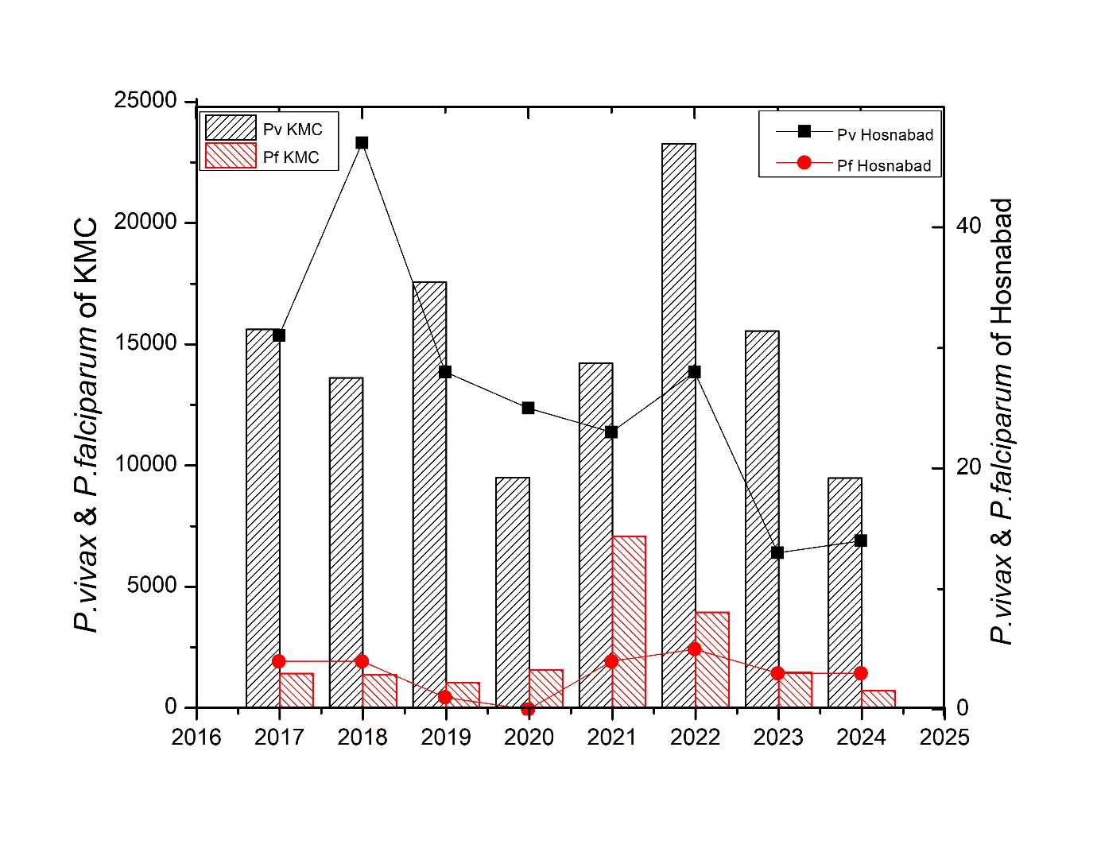
Figure S1. Comparison of P. vivax and P. falciparum distribution between KMC and Hosnabad HSC (2017-2024).

