Supplementary material
Parameter | Description
Elevation | 1,427 - 3,880 m a.s.l.
Mean temperature | 10.5 °C (General isotherm range: 6 °C - 18 °C)
Mean precipitation | 2,291.67 mm/year (Maximums of 2,500 - 3,000 mm/year; Minimums of 200 - 1,750 mm/year)
Climate | High mountain equatorial (> 3,000 m a.s.l.) and semi-humid mesothermal equatorial (< 3,200 m a.s.l.)
Soil type | Stony and rocky soils (high paramo zone); Andean black soils (middle and lower zones)
Geology | Non-metamorphosed sedimentary and volcanic rocks (Tertiary/Mesozoic) in middle and lower riverbanks
Table S1. Environmental and biophysical characteristics of the Tinajillas-Río Gualaceño protected area (Gobierno Municipal de Limón Indanza, 2024).

Reference:
Gobierno Municipal de Limón Indanza. (2024). Plan de Desarrollo y Ordenamiento Territorial Ordenanza 2024-2036. https://limonindanza.gob.ec/actualizacion-pdot-2024/

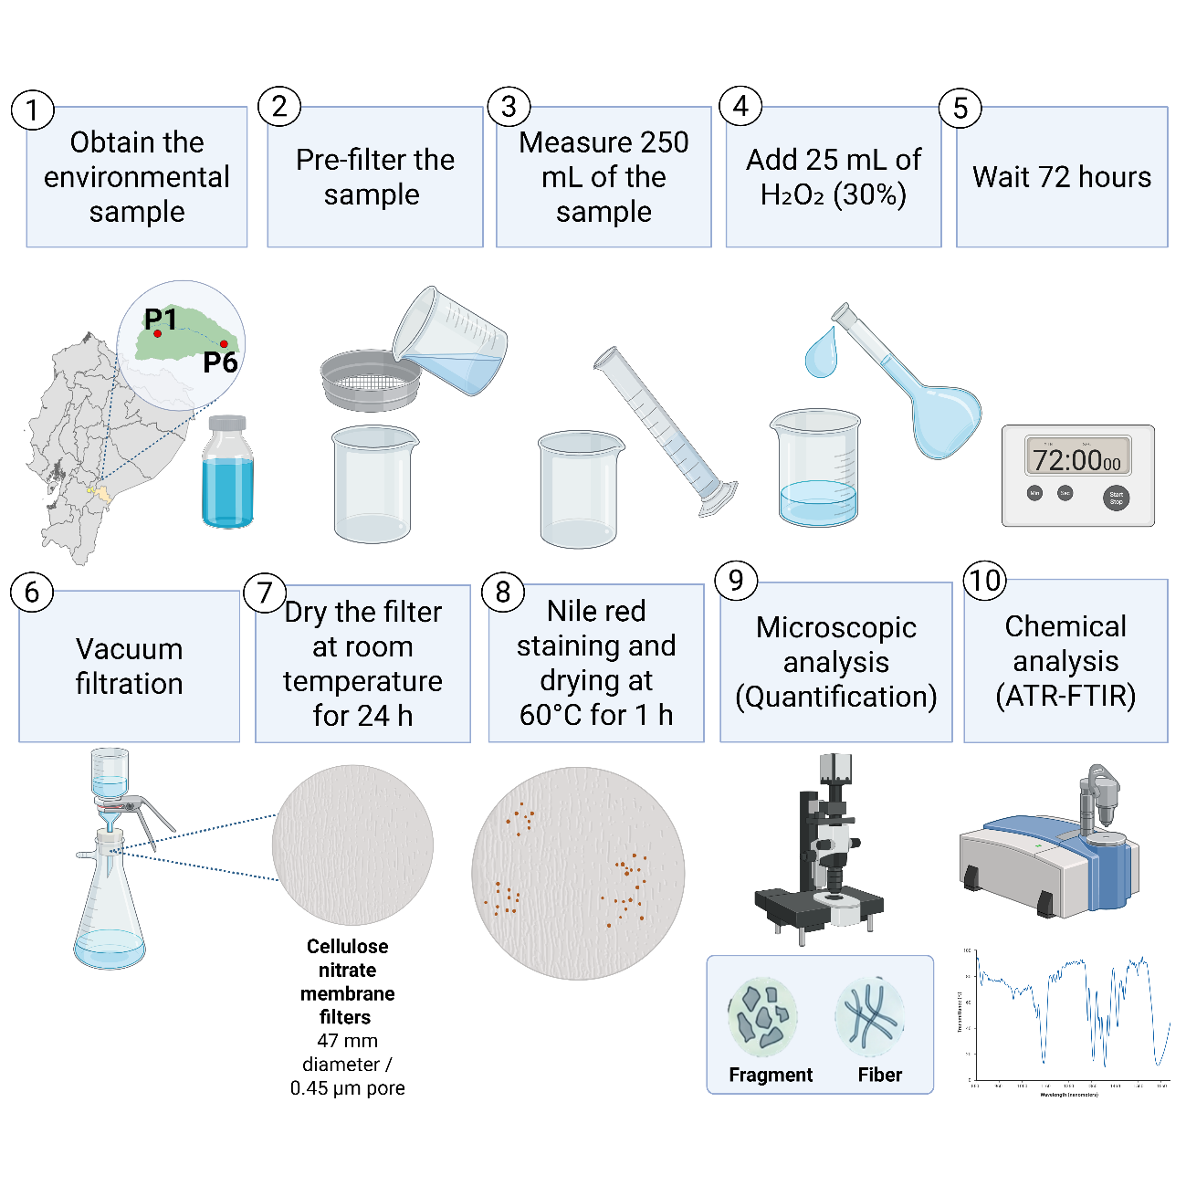
Fig. S1. Methodology used for the extraction, quantification and characterization of microplastics in environmental samples. Created with BioRender.com
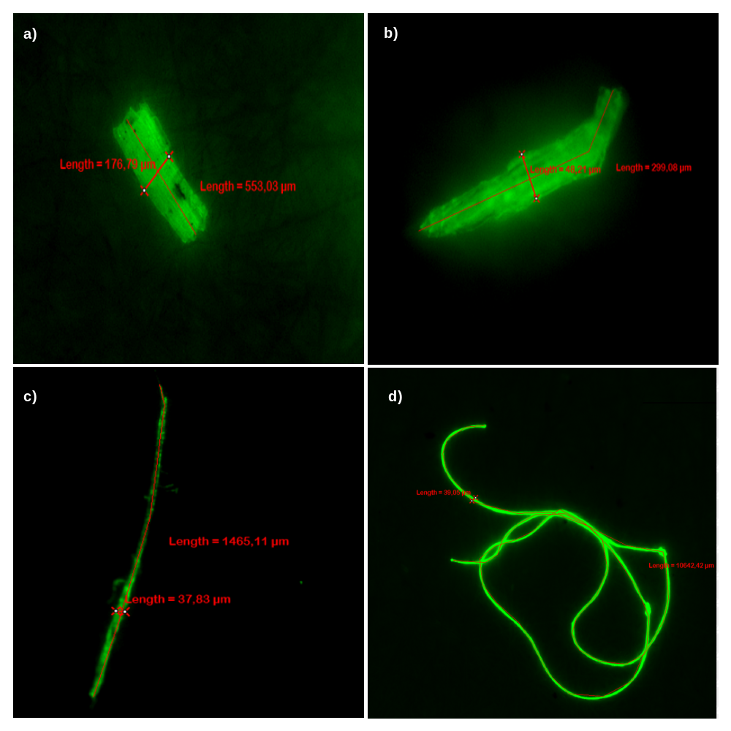
Fig. S2. Fluorescence microscopy images of representative microplastics isolated from surface water samples. P1: (a–b), showing fibers and fragments; and P6 (c–d), showing a fiber and a fragment, using an Eclipse Ti2-E inverted fluorescence microscope.

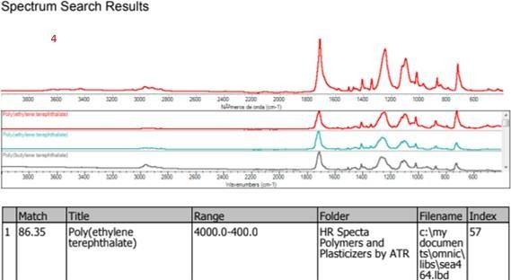
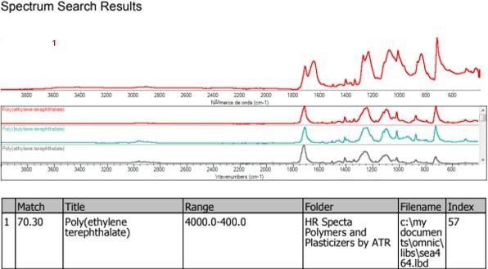
b)
a)

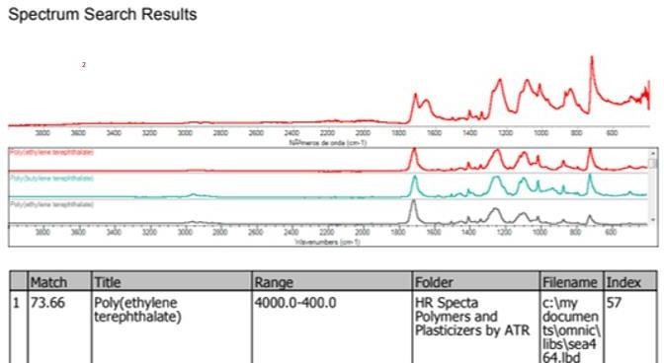
c)

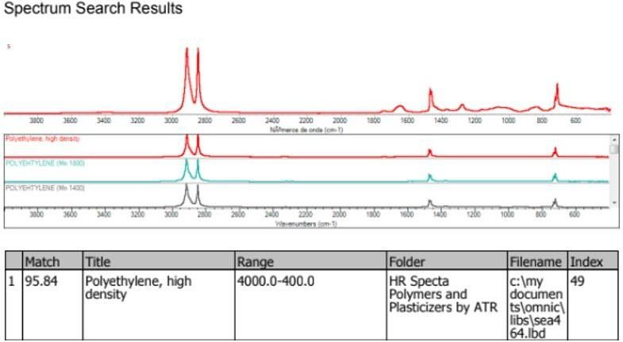
d)

Fig. S3. ATR-FTIR spectrums of the plastic polymer from monthly sampling. a) May-M1, b) April-M1, c) May-M2 and d) April-M2.

