Supplementary Material

Supplementary figures

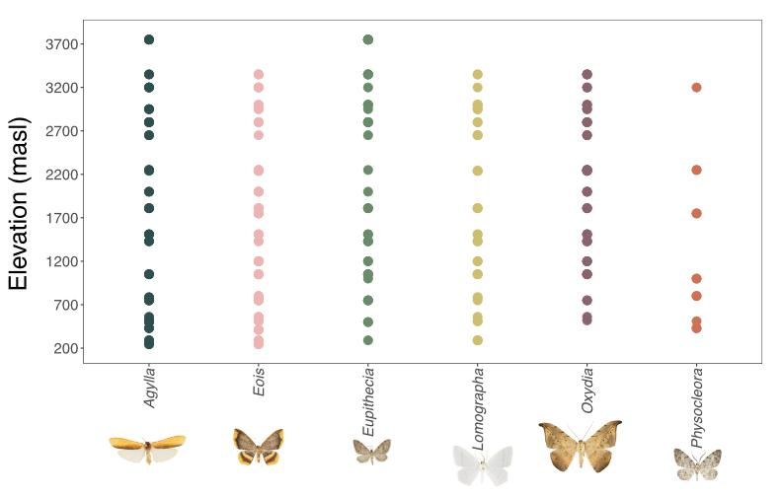

Supplementary Figure 1. Distribution of the six genera of moth samples collected along the elevation gradient. Eois (n = 66), Eupithecia (n = 43), Lomographa (n = 39), Oxydia (n = 45), Physocleora (n = 12)) and Agylla (n = 50).

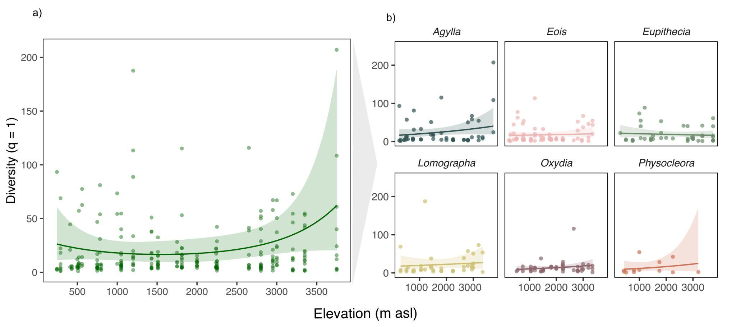

Supplementary Figure 2.﻿ Gut microbial diversity (q = 1) along the elevational gradient. a) microbial diversity throughout the overall dataset and b) by host genus. The trend lines along elevation were modeled with generalized linear models (gamma distribution, log-link function) and indicate the slope estimate. The shadows are 95% confidence intervals around the estimate.

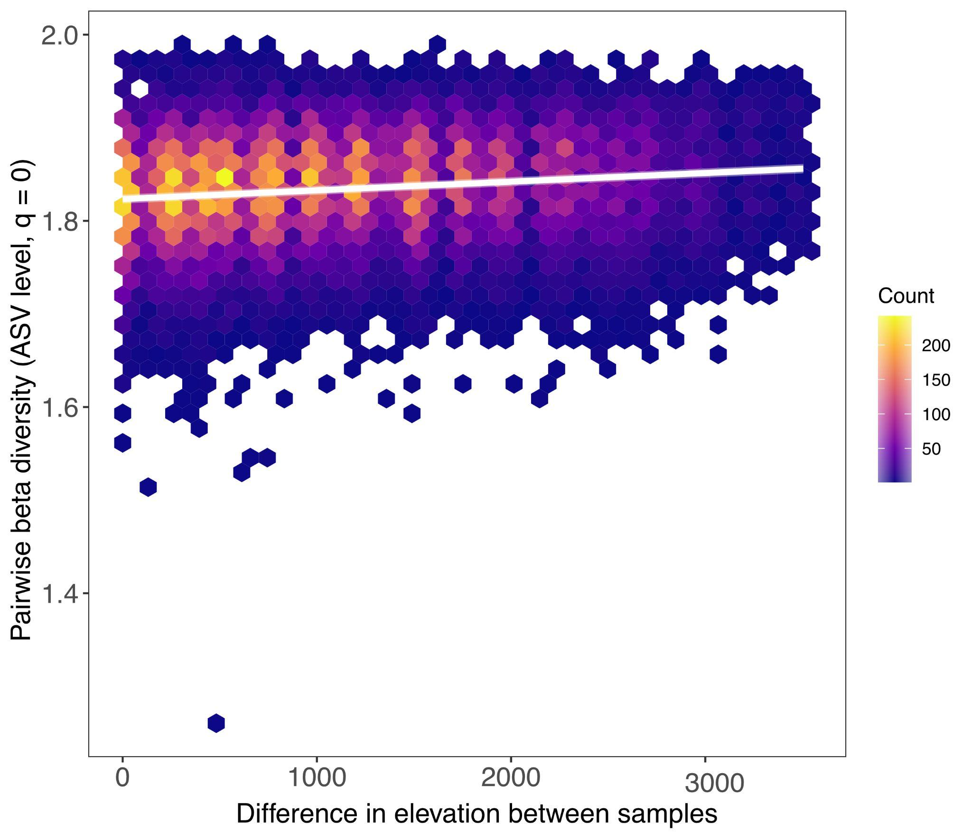

Supplementary figure 3. Relationship between distance in temperature and microbial community compositional turnover at Hill order q = 0 at ASV taxonomic rank. Hexagonal bins represent the density of pairwise comparisons between samples, visualized by colors. The solid line shows the predicted relationship from the linear mixed effects model, with the shaded band indicating the 95% confidence interval. Distance in temperature is defined as the absolute difference in temperature between sample pairs.

Supplementary tables

Supplementary Table 1. Significant results of the generalized linear models (GLM), showing the effects of elevation and host taxonomy on microbial Alpha diversity represented by q hill orders. (a) richness (q = 0) and (b) diversity (q = 1).
a)
Model Q0: glm(richness_q0_cov ~ elevation *host_genus,family = Gamma(link = "log")
Coefficients | Estimate | Std. Error | t value | Pr(>|t|) | R²
(Intercept) | 4.6244 | 0.159 | 29.081 | <2e-16 *** | 0.110
elevation | 0.2921 | 0.1467 | 1.991 | 0.0477 * | 0.110
Eois | -0.4426 | 0.2137 | -2.071 | 0.0394 * | 0.110
Eupithecia | -0.3167 | 0.241 | -1.314 | 0.1901 | 0.110
Lomographa | -0.2953 | 0.2402 | -1.23 | 0.22 | 0.110
Oxydia | -0.4917 | 0.2339 | -2.102 | 0.0366 * | 0.110
Physocleora | -0.3644 | 0.4082 | -0.893 | 0.3729 | 0.110
elevation-Eois | -0.1762 | 0.2095 | -0.841 | 0.4013 | 0.110
elevation-Eupithecia | -0.1978 | 0.2149 | -0.92 | 0.3583 | 0.110
elevation-Lomographa | -0.1557 | 0.2379 | -0.654 | 0.5135 | 0.110
elevation-Oxydia | 0.1531 | 0.2541 | 0.602 | 0.5475 | 0.110
elevation-Physocleora | -0.1912 | 0.4181 | -0.457 | 0.6479 | 0.110

b)

Model Q1: glm(diversity_q1_cov ~poly(elevation, 2) * host_genus,family = Gamma(link = "log")
Coefficient | Estimate | Std. Error | t value | Pr(>|t|) | R
(Intercept) | 3.11635 | 0.18994 | 16.407 | <2e-16*** | 0.195
poly(elevation, 2)1 | 3.34082 | 2.75179 | 1.214 | 0.2259 | 0.195
poly(elevation, 2)2 | 3.95884 | 2.7369 | 1.446 | 0.1494 | 0.195
Eois | -0.23315 | 0.25453 | -0.916 | 0.3606 | 0.195
Eupithecia | -0.16894 | 0.2857 | -0.591 | 0.5549 | 0.195
Lomographa | -0.02021 | 0.28481 | -0.071 | 0.9435 | 0.195
Oxydia | -0.66269 | 0.3019 | -2.195 | 0.0291* | 0.195
Physocleora | -1.0355 | 0.50088 | -2.067 | 0.0398* | 0.195
poly(elevation, 2)1:Eois | -1.42313 | 4.06017 | -0.351 | 0.7263 | 0.195
poly(elevation, 2)2:Eois | 1.73623 | 4.02546 | 0.431 | 0.6666 | 0.195
poly(elevation, 2)1:Eupithecia | -4.55949 | 4.41413 | -1.033 | 0.3027 | 0.195
poly(elevation, 2)2:Eupithecia | -4.11185 | 4.15186 | -0.99 | 0.323 | 0.195
poly(elevation, 2)1:Lomographa | -0.92501 | 4.5516 | -0.203 | 0.8391 | 0.195
poly(elevation, 2)2:Lomographa | -1.93733 | 4.90542 | -0.395 | 0.6932 | 0.195
poly(elevation, 2)1:Oxydia | 1.47382 | 4.83071 | 0.305 | 0.7606 | 0.195
poly(elevation, 2)2:Oxydia | -8.46968 | 5.3124 | -1.594 | 0.1122 | 0.195
poly(elevation, 2)1:Physocleora | -11.14179 | 9.12833 | -1.221 | 0.2235 | 0.195
poly(elevation, 2)2:Physocleora | -21.93995 | 8.49759 | -2.582 | 0.0104* | 0.195

Supplementary Table 2. Significant results of the generalized linear models (GLM), showing the effects of MAT and host taxonomy on microbial Alpha diversity represented by q hill orders. (a) richness (q = 0) and (b) diversity (q = 1).

a)

Model Q0: glm(richness_q0_cov ~ z_MAT *host_genus, family = Gamma(link = "log")
Term | Estimate | Std. Error | t value | Pr(>|t|) | R²
(Intercept) | 4.6199 | 0.159 | 29.061 | <2e-16 *** | 0.114
z_MAT | -0.3196 | 0.1455 | -2.196 | 0.0290 * | 0.114
Eois | -0.4387 | 0.2135 | -2.055 | 0.0410 * | 0.114
Eupithecia | -0.3219 | 0.2409 | -1.337 | 0.1826 | 0.114
Lomographa | -0.293 | 0.2401 | -1.22 | 0.2235 | 0.114
Oxydia | -0.4824 | 0.2342 | -2.06 | 0.0404 * | 0.114
Physocleora | -0.3689 | 0.4052 | -0.911 | 0.3634 | 0.114
z_MAT:Eois | 0.2043 | 0.2077 | 0.984 | 0.3262 | 0.114
z_MAT:Eupithecia | 0.2048 | 0.2137 | 0.958 | 0.3389 | 0.114
z_MAT:Lomographa | 0.1595 | 0.2406 | 0.663 | 0.508 | 0.114
z_MAT:Oxydia | -0.1127 | 0.2553 | -0.441 | 0.6594 | 0.114
z_MAT:Physocleora | 0.2372 | 0.4129 | 0.574 | 0.5662 | 0.114

b)

Model Q1: glm(diversity_q1_cov ~poly(z_MAT, 2) * host_genus, family = Gamma(link = "log")
Term | Estimate | Std. Error | t value | Pr(>|t|) | R²
Term | Estimate | Std. Error | t value | Pr(>|t|) | 0.19
(Intercept) | 3.147 | 0.19199 | 16.392 | <2e-16 *** | 0.19
poly(z_MAT, 2)1 | -3.90667 | 2.754 | -1.419 | 0.1573 | 0.19
poly(z_MAT, 2)2 | 2.99671 | 2.85232 | 1.051 | 0.2945 | 0.19
Eois | -0.26717 | 0.2568 | -1.04 | 0.2992 | 0.19
Eupithecia | -0.20966 | 0.28896 | -0.726 | 0.4688 | 0.19
Lomographa | -0.05144 | 0.28852 | -0.178 | 0.8586 | 0.19
Oxydia | -0.6547 | 0.29823 | -2.195 | 0.0291 * | 0.19
Physocleora | -1.03384 | 0.50043 | -2.066 | 0.0399 * | 0.19
poly(z_MAT, 2)1:Eois | 2.08023 | 4.0382 | 0.515 | 0.6069 | 0.19
poly(z_MAT, 2)2:Eois | 2.36466 | 4.11342 | 0.575 | 0.5659 | 0.19
poly(z_MAT, 2)1:Eupithecia | 3.35987 | 4.3285 | 0.776 | 0.4384 | 0.19
poly(z_MAT, 2)2: Eupithecia | -4.84215 | 4.16421 | -1.163 | 0.2461 | 0.19
poly(z_MAT, 2)1: Lomographa | 0.98133 | 4.65261 | 0.211 | 0.8331 | 0.19
poly(z_MAT, 2)2: Lomographa | -1.61541 | 4.91498 | -0.329 | 0.7427 | 0.19
poly(z_MAT, 2)1: Oxydia | -0.04878 | 4.88978 | -0.01 | 0.992 | 0.19
poly(z_MAT, 2)2: Oxydia | -6.84134 | 5.06807 | -1.35 | 0.1783 | 0.19
poly(z_MAT, 2)1: Physocleora | 9.91569 | 8.78843 | 1.128 | 0.2603 | 0.19
poly(z_MAT, 2)2: Physocleora | -20.46701 | 8.62754 | -2.372 | 0.0185 * | 0.19

Supplementary Table 3. PERMANOVA results showing the significant effect of MAT and host phylogeny across microbial taxonomic ranks. Df: degrees of freedom; SS: sum of squares; R2: mean sum of squares; F: F value by permutation and Pr(>F): p-values.
adonis2(bray ~ sam_k$z_elev + sam_k$host_genus)
PERMANOVA
Phylum
Variable | Df | SumOfSqs | R2 | F | Pr(>F)
sam_k$z_MAT | 1 | 0.034 | 0.00077 | 0.01979 | 0.972
sam_k$host_genus | 5 | 1.351 | 0.03062 | 1.5681 | 0.054.
Order
Variable | Df | SumOfSqs | R2 | F | Pr(>F)
sam_k$z_MAT | 1 | 0.707 | 0.00888 | 2.375 | 0.008 **
sam_k$host_genus | 5 | 4.867 | 0.0611 | 3.2628 | 0.001 ***
Family
Variable | Df | SumOfSqs | R2 | F | Pr(>F)
sam_k$z_MAT | 1 | 1.308 | 0.01386 | 3.7151 | 0.001 ***
sam_k$host_genus | 5 | 5.688 | 0.06024 | 3.2303 | 0.001 ***
Genus
Variable | Df | SumOfSqs | R2 | F | Pr(>F)
sam_k$z_MAT | 1 | 1.782 | 0.01747 | 4.7077 | 0.001 ***
sam_k$host_genus | 5 | 6.201 | 0.06079 | 3.2762 | 0.001 ***
ASV
Variable | Df | SumOfSqs | R2 | F | Pr(>F)
sam_k$z_MAT | 1 | 1.932 | 0.01732 | 4.646 | 0.001 ***
sam_k$host_genus | 5 | 6.302 | 0.0565 | 3.0305 | 0.001 ***

Supplementary table 4. ﻿Significant predictors in the RDA environmental fitting model of the bacterial communities along the environmental gradient. R2: mean sum of squares; Pr(>F): p-values, P-values are based on 999 permutations.
a)

Environmental fitting RDA
Phylum
Variable | RDA1 | RDA2 | r2 | Pr(>r)
z_MAT | -0.85599 | 0.51699 | 0.0363 | 0.013
host_genus |  |  | 0.1577 | 0.001
Order
Variable | RDA1 | RDA2 | r2 | Pr(>r)
z_MAT | -0.85599 | 0.51699 | 0.0363 | 0.007
host_genus |  |  | 0.1577 | 0.001
Family
Variable | RDA1 | RDA2 | r2 | Pr(>r)
z_MAT | -0.65235 | 0.75792 | 0.1643 | 0.001
host_genus |  |  | 0.146 | 0.001
Genus
Variable | RDA1 | RDA2 | r2 | Pr(>r)
z_MAT | -0.76369 | -0.64558 | 0.2436 | 0.001
host_genus |  |  | 0.1552 | 0.001
ASV
Variable | RDA1 | RDA2 | r2 | Pr(>r)
z_MAT | 0.84553 | 0.53392 | 0.3009 | 0.001
host_genus |  |  | 0.203 | 0.001

b)
Environmental fitting RDA
Factor | Centroid_RDA1 | Centroid_RDA2
Phylum
Agylla | 0.2756 | -0.085
Eois | -0.0094 | -0.1461
Eupithecia | 0.0172 | 0.2103
Lomographa | -0.1495 | -0.1243
Oxydia | -0.2353 | 0.0671
Physocleora | 0.2099 | 0.5564
Order
Agylla | 0.2756 | -0.085
Eois | -0.0094 | -0.1461
Eupithecia | 0.0172 | 0.2103
Lomographa | -0.1495 | -0.1243
Oxydia | -0.2353 | 0.0671
Physocleora | 0.2099 | 0.5564
Family
Agylla | 0.2796 | 0.0617
Eois | -0.0653 | -0.1095
Eupithecia | -0.005 | 0.1652
Lomographa | -0.0498 | -0.2145
Oxydia | -0.2259 | 0.032
Physocleora | 0.2208 | 0.3303
Genus
Agylla | 0.2378 | -0.1081
Eois | -0.0281 | -0.0289
Eupithecia | -0.0437 | -0.1354
Lomographa | -0.0196 | 0.2152
Oxydia | -0.2128 | 0.1767
Physocleora | 0.1817 | -0.2677
ASV
Agylla | -0.1473 | 0.1678
Eois | -0.0152 | 0.0685
Eupithecia | 0.0263 | 0.0804
Lomographa | 0.0319 | -0.2328
Oxydia | 0.2161 | -0.1571
Physocleora | -0.3108 | -0.018

Supplementary Table 5. ﻿Variance partitioning analysis to determine how MAT and host phylogeny explain variance in gut microbial communities. Results of follow-up analyses quantifying the real contribution (adjusted R²) of each retained predictor — individual and shared components reported separately for each taxonomic scale.

RDA model | Variance explained
Phylum
z_MAT+host_genus | 2.87
host_genus | 3.11
z_MAT | -0.28
Order
z_MAT+host_genus | 4.93
host_genus | 4.44
z_MAT | 0.65
Family
z_MAT+host_genus | 4.67
host_genus | 3.7
z_MAT | 1.06
Genus
z_MAT+host_genus | 5.02
host_genus | 3.66
z_MAT | 1.46
ASV
z_MAT+host_genus | 4.41
host_genus | 3.12
z_MAT | 1.43

Supplementary Table 6. Effects of difference in elevation on predicting microbial turnover at different taxonomic ranks. The table shows coefficients and significance values for Linear mixed-effects models (LMM). TD_beta: Dependent variable (beta diversity), rec_diff: Fixed effect (difference in temperature), (1 | site1) and (1 | site2): Random effects (account for variability between sites).

Phylum
lmer(TD_beta ~ rec_diff + (1 | site1) + (1 | site2))
Fixed effect | Hill oder q | t value | Pr(>r) | Random effect | Variance (%) | Std.Dev. | R2m | R2c
Difference in elevation | 0 | 5.68 | 1.36e-08 *** | site1 | 0.002 | 0.04 | 0.00 | 0.42
 |  |  |  | site2 | 0.002 | 0.04 | 0.00 | 0.42
Difference in elevation | 1 | -0.186 | 0.853 | site1 | 0.01 | 0.10 | 0.00 | 0.70
 |  |  |  | site2 | 0.01 | 0.09 | 0.00 | 0.70
Order
lmer(TD_beta ~ rec_diff + (1 | site1) + (1 | site2))
Fixed effect | Hill oder q | t value | Pr(>r) | Random effect | Variance (%) | Std.Dev. | R2m | R2c
Difference in elevation | 0 | 5.68 | 1.36e-08 *** | site1 | 0.002 | 0.04 | 0.00 | 0.47
 |  |  |  | site2 | 0.002 | 0.04 | 0.00 | 0.47
Difference in elevation | 1 | 4.527 | 5.99e-06 *** | site1 | 0.01 | 0.11 | 0.00 | 0.45
 |  |  |  | site2 | 0.01 | 0.10 | 0.00 | 0.45
Family
lmer(TD_beta ~ rec_diff + (1 | site1) + (1 | site2))
Fixed effect | Hill oder q | t value | Pr(>r) | Random effect | Variance (%) | Std.Dev. | R2m | R2c
Difference in elevation | 0 | 8.47 | < 2e-16 *** | site1 | 0.001 | 0.04 | 0.00 | 0.51
 |  |  |  | site2 | 0.002 | 0.04 | 0.00 | 0.51
Difference in elevation | 1 | 11.14 | < 2e-16 *** | site1 | 0.01 | 0.09 | 0.00 | 0.40
 |  |  |  | site2 | 0.01 | 0.08 | 0.00 | 0.40
Genus
lmer(TD_beta ~ rec_diff + (1 | site1) + (1 | site2))
Fixed effect | Hill oder q | t value | Pr(>r) | Random effect | Variance (%) | Std.Dev. | R2m | R2c
Difference in elevation | 0 | 16.84 | < 2e-16 *** | site1 | 0.001 | 0.03 | 0.01 | 0.46
 |  |  |  | site2 | 0.001 | 0.04 | 0.01 | 0.46
Difference in elevation | 1 | 18.52 | < 2e-16 *** | site1 | 0.01 | 0.08 | 0.01 | 0.36
 |  |  |  | site2 | 0.01 | 0.07 | 0.01 | 0.36
ASV
lmer(TD_beta ~ rec_diff + (1 | site1) + (1 | site2))
Fixed effect | Hill oder q | t value | Pr(>r) | Random effect | Variance (%) | Std.Dev. | R2m | R2c
Difference in elevation | 0 | 32.11 | < 2e-16 *** | site1 | 0.001 | 0.03 | 0.02 | 0.53
 |  |  |  | site2 | 0.001 | 0.02 | 0.02 | 0.53
Difference in elevation | 1 | 23.95 | < 2e-16 *** | site1 | 0.003 | 0.06 | 0.02 | 0.29
 |  |  |  | site2 | 0.003 | 0.05 | 0.02 | 0.29

