Supplementary material
Supplementary Information (1): Detailed scanning protocol for MRI
MRI scanning protocol at the two participating centers(First Hospital of Shanxi Medical University, Shanxi Provincial People's Hospital):
First Hospital of Shanxi Medical University: Preoperative MRI was performed on a 3.0-T scanner (Signa HDxt, GE Healthcare, USA) with an 8-channel array coil. The protocol included T2WI-FS (TR/TE, 3000/95 ms; FOV, 260 × 260 mm²; slice thickness, 5.0 mm; interslice gap, 2.0 mm; matrix, 256 × 256) and DWI (TR/TE, 3000/50 ms; FOV, 260 × 260 mm²; slice thickness, 5.0 mm; interslice gap, 2.0 mm; matrix, 256 × 256; b values, 0 and 1000 s/mm²).
Shanxi Provincial People’s Hospital: MRI was performed on a 3.0-T scanner (Discovery 750, GE Healthcare, USA) using an 8-channel phased-array coil. The protocol included T2WI-FS (TR/TE, 3000/95 ms; FOV, 280 × 280 mm²; slice thickness, 5.0 mm; interslice gap, 1.5 mm; matrix, 512 × 512) and DWI (TR/TE, 3000/65 ms; FOV, 380 × 380 mm²; slice thickness, 5.0 mm; interslice gap, 1.5 mm; matrix, 256 × 256; b values, 0 and 1000 s/mm²).

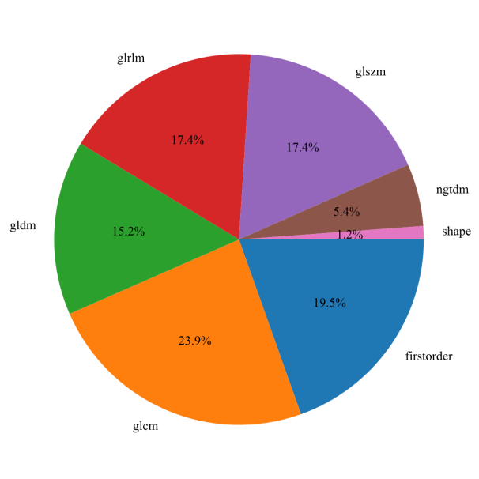
a
b

Supplementary Fig. S1. Distribution of extracted radiomics feature categories. (a) T2WI-FS. (b) DWI.

Supplementary Fig. S2. Performance evaluation of MRI-based single-sequence models across the training, internal validation, and external validation cohorts.
(a-c) ROC curves; (d-f) calibration curves; (g-i) decision curve analysis; Decision curve analysis illustrates the net benefit of each model compared with the “Treat All” and “Treat None” strategies across a range of threshold probabilities.
Supplementary Fig. S3. Radar plots of performance metrics for the radiomics models (T2WI-FS and DWI) and the stacking model across the training, internal validation, and external validation cohorts.
(a-c) T2WI-FS radiomics model; (d-f) DWI radiomics model; (g-i) stacking model; shown for the training, internal validation, and external validation cohorts, respectively. Metrics include AUC, accuracy, sensitivity, specificity, PPV, and NPV.
Supplementary Fig. S4. Pairwise DeLong test results for AUC comparisons among all predictive models in the training, internal validation, and external validation cohorts.
(a–c) DeLong test results for the training, internal validation, and external validation cohorts, respectively. The compared models included T2WI-FS- and DWI-based radiomics, 2D-DL, multichannel 2.5D-DL, and fusion models. Values indicate P values, with P < 0.05 considered statistically significant.

