Supplementary material
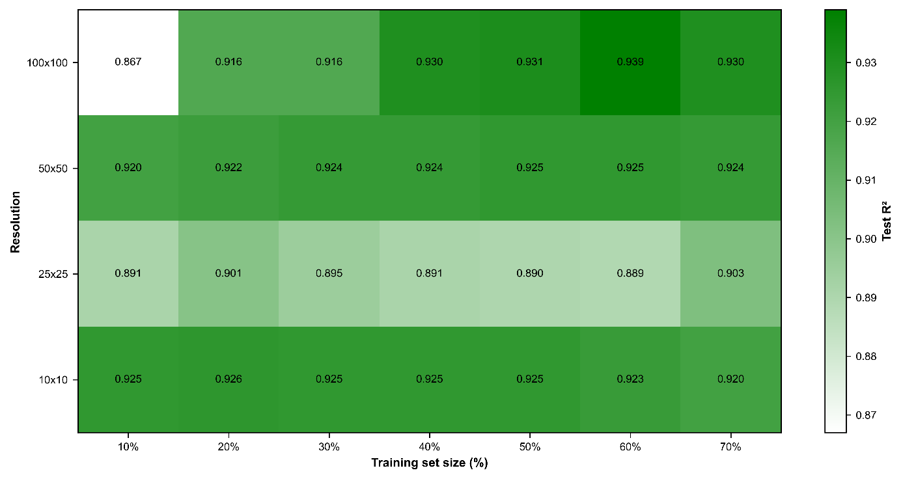
Supplementary Figure 1: Sensitivity of model performance to spatial resolution and training data availability.
Mean test R² scores across different training data fractions for four spatial grid configurations (10 × 10, 25 × 25, 50 × 50, and 100 × 100 pixels). The sensitivity analysis of spatial resolution revealed a non-linear relationship between grid size, training data availability, and model performance (Figure S1). The 100 × 100 configuration exhibited the highest data dependency, showing lower performance under limited training fractions but achieving the highest overall test R² when sufficient samples were available, indicating that fine-scale spatial patterns can be effectively learned with adequate data. In contrast, the 50 × 50 and 10 × 10 configurations demonstrated stable performance across training fractions, suggesting greater robustness under data-limited conditions, although with a lower performance ceiling. The 25 × 25 configuration showed comparatively weaker performance, potentially due to a scale-mismatch effect where spatial variability and aggregation benefits were not optimally represented. Based on the balance between predictive accuracy, spatial representation, and computational efficiency, the 50 × 50 configuration was selected as the preferred resolution for subsequent analyses.

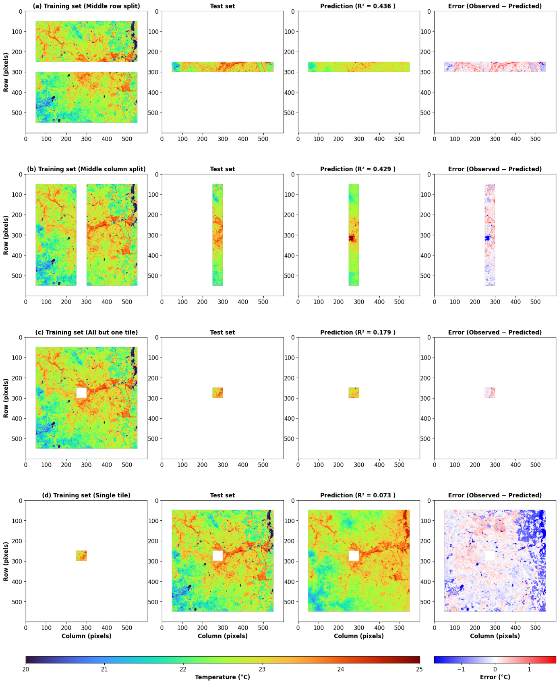
Supplementary Figure 2: Spatial cross-validation of fine-scale ADMS-Urban temperature gap-filling without using thermal admittance, surface resistance to evaporation, and surface roughness length. FS-MLF is trained only on albedo, normalised building volume, and terrain-elevation predictors to reconstruct ADMS-Urban surface temperature under four spatial train/test partitions of the full-resolution raster: (a) training on the northern and southern portions of the domain and predicting a central east–west strip (R² = 0.436, RMSE = 0.506 °C); (b) training on the western and eastern portions and predicting a central north–south strip (R² = 0.429, RMSE = 0.493 °C); (c) training on the full domain excluding a single held-out tile and predicting that tile (R² = 0.179, RMSE = 0.393 °C); and (d) the inverse configuration, training on only the single tile and predicting the remainder of the domain (R² = 0.073, RMSE = 0.690 °C). For each panel, columns show (from left to right) the training mask, the observed ADMS-Urban temperature field, the model prediction, and the prediction error (observed − predicted). Axes give pixel row/column indices. The removal of thermal admittance, surface resistance to evaporation, and surface roughness length as predictors leads to a substantial reduction in predictive accuracy relative to Figure 4.

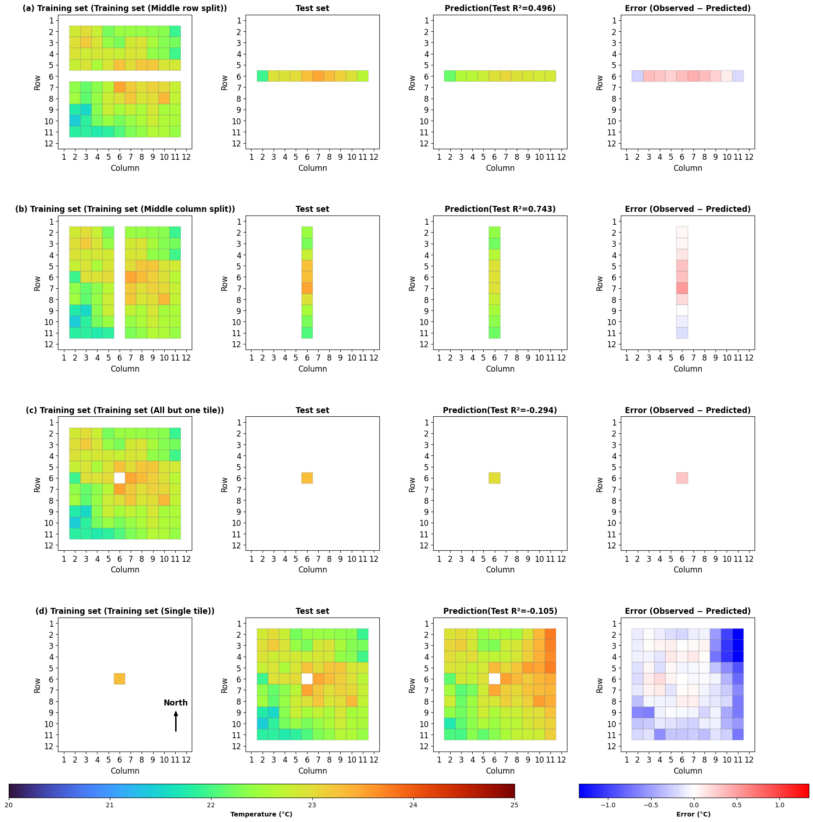
Supplementary Figure 3: Spatial cross-validation of coarse-scale ADMS-Urban temperature gap-filling experiment conducted using three inputs albedo, terrain height and thermal admittance. In this experiment we have not used thermal admittance, surface resistance to evaporation, and surface roughness length. CS-MLF is trained only on albedo, normalised building volume, and terrain-elevation predictors to reconstruct ADMS-Urban surface temperature under four spatial train/test partitions of the full-resolution raster: (a) training on tiles above and below a central row and predicting that middle row (R² = 0.649); (b) training on tiles to the left and right of a central column and predicting that middle column (R² = 0.892); (c) training on all tiles except one held-out tile and predicting that tile (R² = nan, undefined owing to the single-point test sample); and (d) training on only that single tile and predicting all remaining tiles (R² = 0.190). Columns show, from left to right, the training mask, the observed tile-aggregated temperature map, the predicted map, and the error map (observed − predicted). Temperature colour bar spans 20–25 °C; error colour bar spans −1.0 to 1.0 °C. Axes give tile row/column indices. The removal of thermal admittance, surface resistance to evaporation, and surface roughness length as predictors leads to a substantial reduction in predictive accuracy relative to Figure 6.

