Title: Genetic dissection of terminal heat-stress tolerance in wheat revealed by QTL mapping
Authors: Priyanka Parihar¹, Jai Prakash Jaiswal¹*, Mitali Tewari¹, Saurabh Kumar², Narendra Kumar Singh¹, Dinesh Pandey³, Kulvinder Singh Gill⁴
Affiliation:
¹ Department of Genetics and Plant Breeding, College of Agriculture, G.B. Pant University of Agriculture and Technology Pantnagar, Uttarakhand, India
² Department of Genetics and Plant Breeding, Chaudhary Charan Singh University, Meerut, Uttar Pradesh, India
³ Department of Molecular Biology & Genetic Engineering, College of Basic Sciences & Humanities, G.B. Pant University of Agriculture and Technology, Pantnagar, Uttarakhand, India
⁴ Department of Crop and Soil Sciences, Washington State University, Pullman, Washington, USA
*Corresponding authors Jai Prakash Jaiswal (Email Id: jpj.gbpu@gmail.com) (OrcidID: 00 00000301881850)
Journal: Theoretical and Applied Genetics
Year: 2026

SUPPLEMENTARY FIGURES:
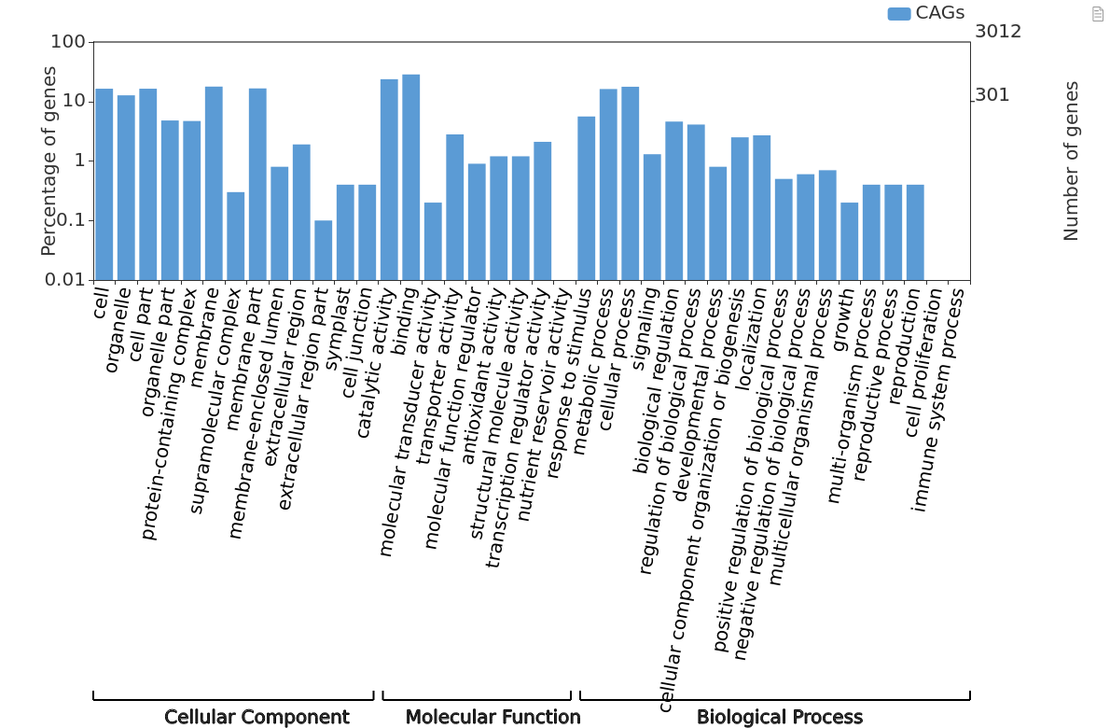
Fig. S1 Gene Ontology (GO) classification of candidate genes identified within the QTL regions. The candidate genes (CAGs) are categorized into cellular component, molecular function, and biological process classes. Bars represent the percentage of genes assigned to each GO term, with the corresponding number of genes indicated on the secondary y-axis.
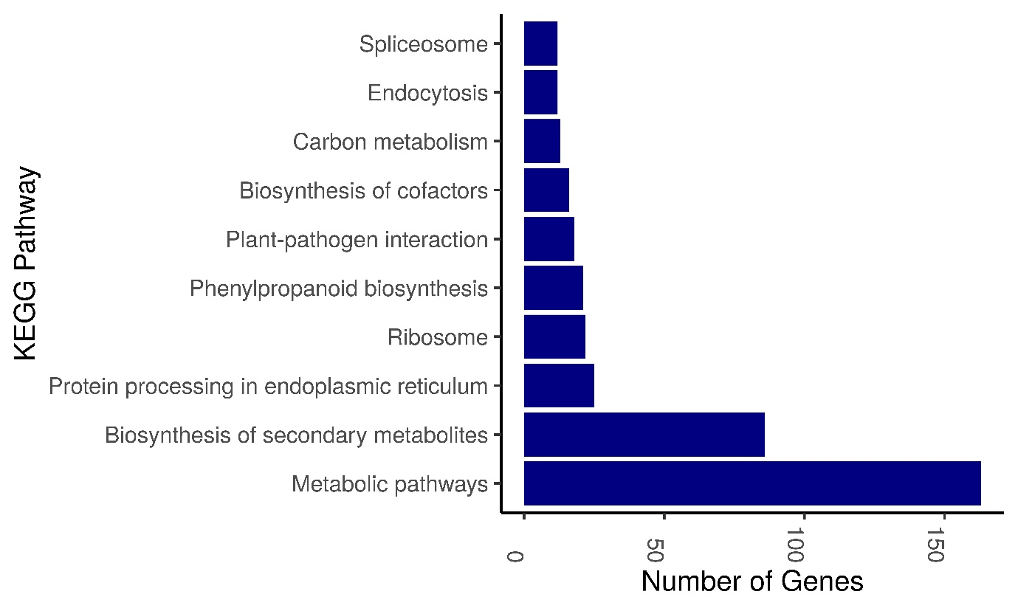
Fig. S2 KEGG pathway classification of candidate genes identified within the QTL regions. The bar plot shows the number of candidate genes associated with the major KEGG pathways, highlighting their involvement in metabolic, secondary metabolite, protein-processing, ribosomal, and stress-related pathways.

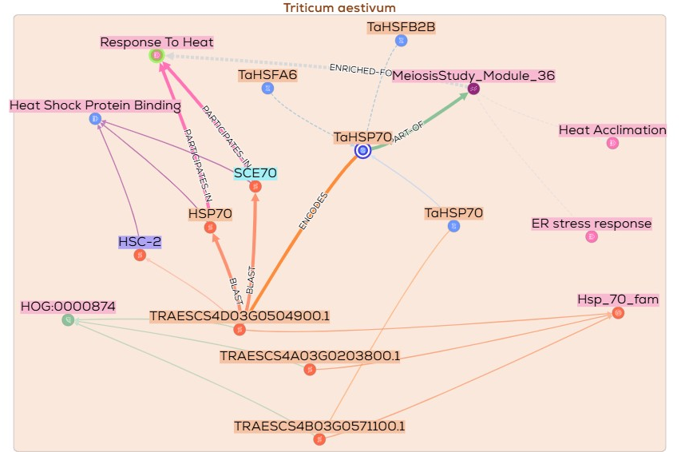
Fig. S3-a KnetMiner network illustrating the association of TraesCS4D03G0504900.1 with heat-shock protein-related components and heat-responsive processes in Triticum aestivum. The network connects the candidate gene with HSP70/HSC-2/SCE70-associated proteins, TaHSFA6, TaHSFB2B, heat-shock protein binding, heat response, heat acclimation, and endoplasmic reticulum stress response, supporting its prioritization as a putative heat-responsive candidate within qE_PL.gbpu-4D.1.
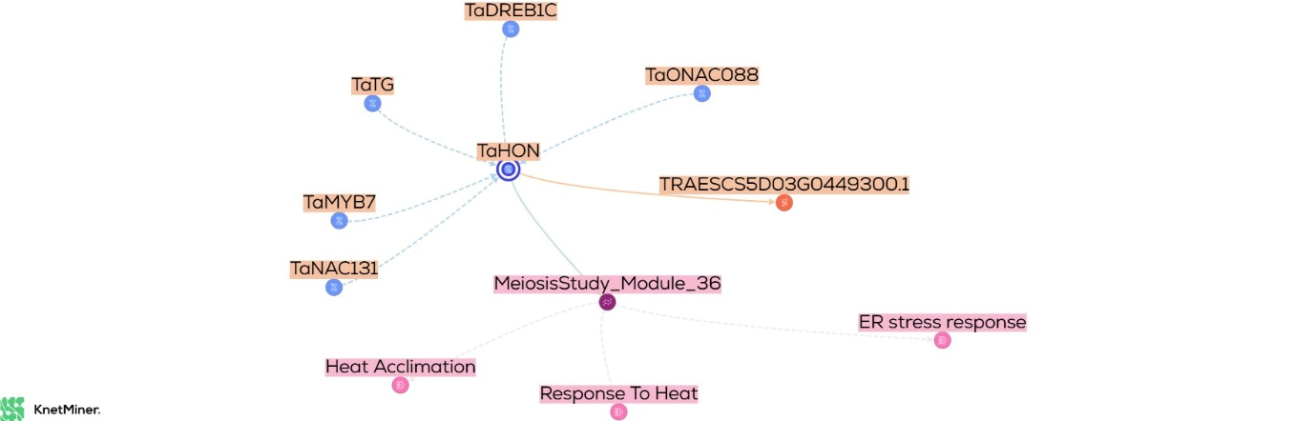
Fig. S3-b KnetMiner network illustrating the association of TraesCS5D03G0449300.1 (TaPP2C68) with heat-responsive and reproductive-development-related processes in Triticum aestivum. The network links TaPP2C68 with TaOHN and associated regulatory proteins, as well as MeiosisStudy_Module_36, which is connected to heat acclimation, heat response, and endoplasmic reticulum stress response. These associations support the prioritization of TaPP2C68 as a putative candidate within the co-localized qDA.gbpu-5D.1-qSPS.gbpu-5D region.
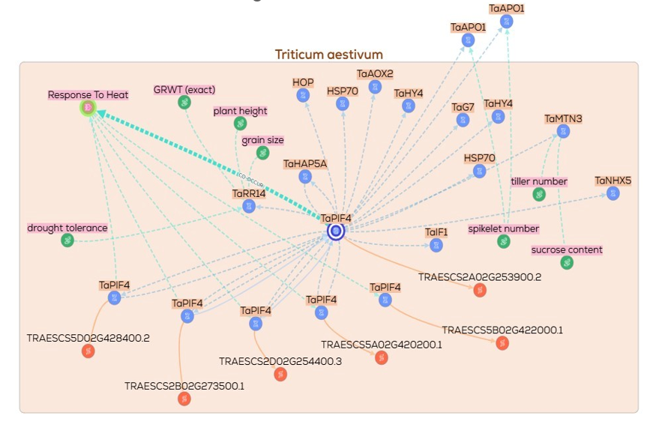
Fig. S3-c KnetMiner network illustrating the association of TraesCS2A03G0612500 (TaPIF4) with heat-responsive, developmental, and hormone-related processes in Triticum aestivum. The network connects TaPIF4 with heat response, HSP70-associated functions, and traits including plant height, tiller number, spikelet number, grain size, and sucrose content, supporting its prioritization as a putative candidate within qPL.gbpu-2A.
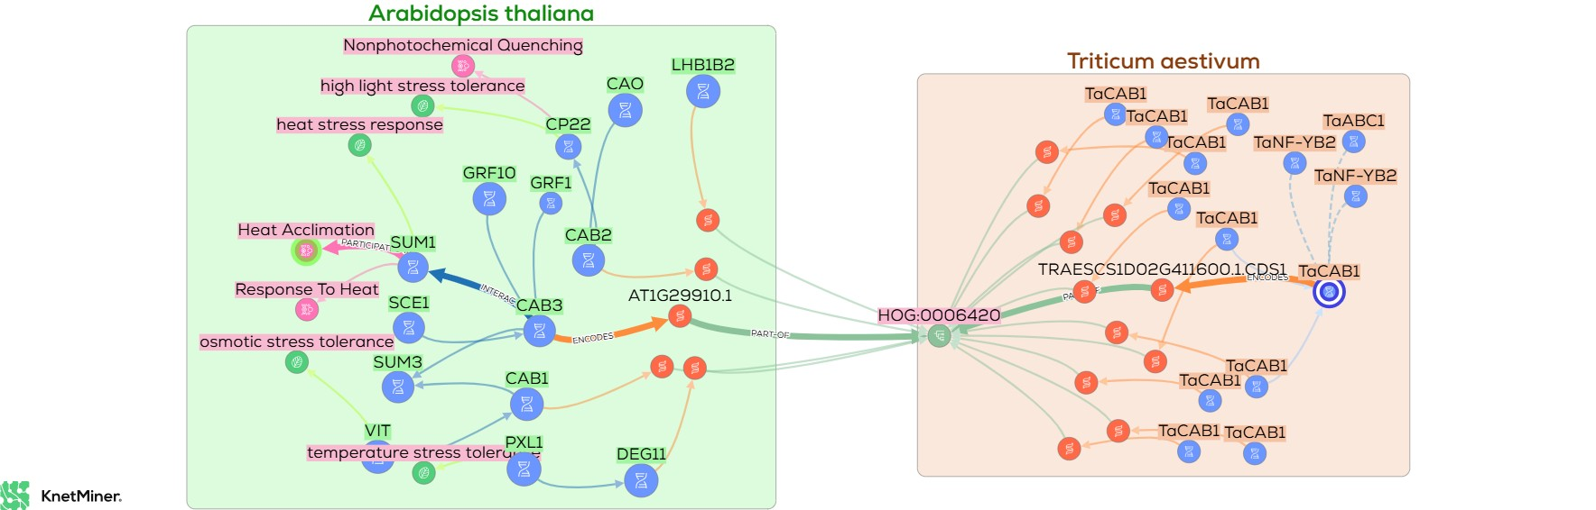
Fig. S3-d KnetMiner network linking CAB1-associated proteins with heat- and temperature-stress responses in Arabidopsis thaliana and Triticum aestivum. The network shows associations of the wheat candidate TraesCS1D02G411600.1 (TaCAB1) with CAB1-related proteins and orthologous Arabidopsis networks connected to heat stress response, heat acclimation, non-photochemical quenching, and temperature-stress tolerance. The network supports the prioritization of TaCAB1-associated candidates within the qDTH.gbpu-1D region.

