Supporting Information

An ROS-responsive photosynthetic biosystem disrupts the infectious‑inflammatory‑hypoxic cycle in pneumonia
DBRP：NCOMMS-26-082497

This file includes:
Fig.S1-S17

Supplementary Figures
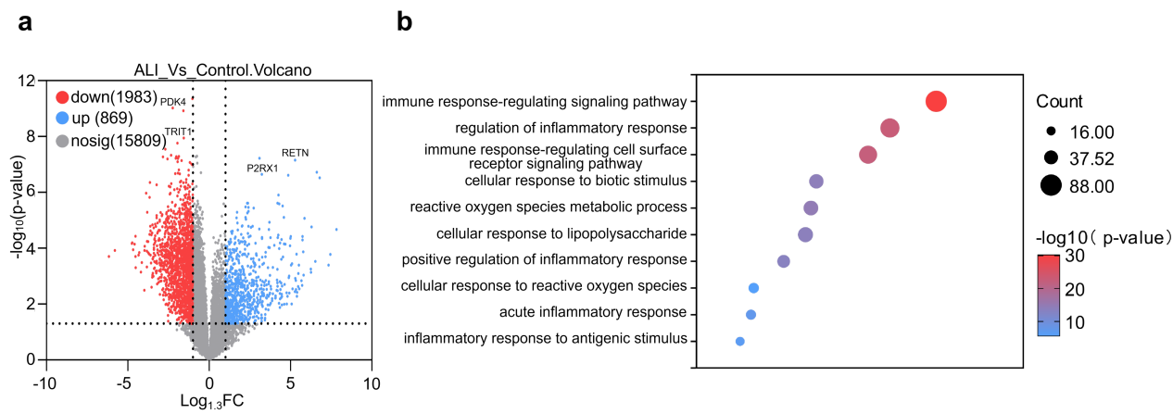
Figure S1. Bioinformatics analysis of transcriptome dataset GSE32707 comparing ALI patients and patients receiving normal mechanical ventilation. a. Volcano plot of ALI Patients vs normal mechanical ventilation controls. b. Gene Ontology (GO) analysis of the RNA-seq results.

Figure S2. Bioinformatics analysis of macrophage dataset in LPS-induced ALI. a-b. Balloon plots of gene changes in M1 macrophages (a) and M2 macrophages (b) after LPS induction.

Figure S3. Stacked bar chart depicting the relative abundance of microbial taxa at the Phylum level. A: Control and B: ALI.

Figure S4. Differential abundance analysis of selected bacterial genera between ALI and healthy groups. Data expressed as mean ± SD; n=6 independent samples, Statistical significance was determined by one-way ANOVA with Sidak’s multiple comparisons test; ***P< 0.001; ****P< 0.0001.

Figure S5. Cultivation and characterization of Hae. a. optical microscopy imaging of Hae under strong light stimulation for different weeks. b-c. the content of AST (b) and O₂ production (c) of Hae at each stage. Data are means ± SD; n=3 independent samples.

Figure S6. Quantification of CPPO in Hae@CC. a. The drug loading rate of CPPO on Hae. b. UV absorption standard curve of CPPO, Data expressed as mean ± SD; n=3 independent samples, Statistical significance was determined by one-way ANOVA with Sidak’s multiple comparisons test; ns, not significant.

Figure S7. Quantification of Cy5 in Hae@CC. a. The drug loading rate of Cy5 on Hae. b. UV absorption standard curve of Cy5. Data expressed as mean ± SD; n=3 independent samples, Statistical significance was determined by one-way ANOVA with Sidak’s multiple comparisons test; ns, not significant.

Figure S8. Oxygen production of each group at 10 min. Data expressed as mean ± SD; n=3 independent samples, Statistical significance was determined by one-way ANOVA with Sidak’s multiple comparisons test; ***P< 0.001.

Figure S9. Gating strategy for flow cytometry analysis. Live cells were firstly selected, cell aggregates were then excluded, and the gates were finally defined based on the blank group.

Figure S10. Flow cytometry analysis of apoptosis rate of LPS-induced A549 cells. a. Cells pre-treated with different concentrations of Hae@CC for 24 h were exposed to the indicated drugs for 24 h. Quadrants: Q1 (necrotic, Annexin V−/PI+), Q2 (late apoptotic, Annexin V+/PI+), Q3 (viable, Annexin V−/PI−), Q4 (early apoptotic, Annexin V+/PI−). i. Percentage of early apoptotic cells (Annexin V+/PI−) from (h). b. Percentage of early apoptotic cells (Annexin V+/PI−) from (a). Data are presented as mean ± SD; n = 3 independent samples. Statistical significance was determined by one-way ANOVA with Sidak’s multiple comparisons test; ns, not significant; **P< 0.01.

Figure S11 Apoptosis analysis of LPS-stimulated A549 cells with free astaxanthin control. Annexin V-FITC/PI flow-cytometry analysis and quantification of apoptotic A549 cells. The concentration of LPS used was 2 μg/mL, and the concentration of astaxanthin was 60 pg/mL. Hae and Hae@CC were used at a density of 10⁶ cells/mL, and the total astaxanthin content in these groups were equivalent to that of the free-astaxanthin group. Data are presented as mean ± SD; n = 3 independent samples. Statistical significance was determined by one-way ANOVA with Sidak’s multiple comparisons test; ****P< 0.0001.

Figure S12 Wound-healing assay of HUVECs with free astaxanthin control. Representative images and quantification of migration area after 24 h in wound-healing assays. Data are presented as mean ± SD; n = 3 independent samples. Statistical significance was determined by one-way ANOVA with Sidak’s multiple comparisons test; ***P< 0.001.

Figure S13. Gating strategy for flow cytometry analysis. Live cells were firstly selected, cell aggregates were then excluded, and the gates were defined according to the CD206 and CD86 double-negative population.

Figure S14. The consumption of H₂O₂ by different groups of drugs. After co-culturing LPS-induced A549 cells with different groups of drugs, the consumption of H₂O₂ by the different groups of drugs was detected using Amplex red and horseradish peroxidase, Data are presented as mean ± SD; n = 3 independent samples. Statistical significance was determined by one-way ANOVA with Sidak’s multiple comparisons test; ****P< 0.0001.

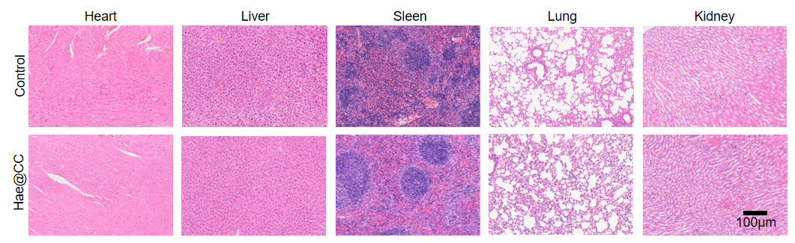
Figure S15. H&E staining of major organs. C57 healthy mice were given aerosol medication for 7 days with 10⁵ units of Hae@CC, and the heart, liver, spleen, lung, and kidneys of the mice were taken for HE sectioning. Scale bar=100 μm.

Figure S16. The Safety evaluation based on biochemical indicators. C57 healthy mice were given aerosol medication for 7 days with different concentrations of Hae@CC, and blood was collected from the retro-orbital sinus to measure the major biochemical indicators, including ALT, AST, and UREA. Significant differences were observed in AST when the dosage reached 10⁶ units of Hae@CC per mouse. Data are presented as mean ± SD; n = 3 independent samples. Statistical significance was determined by one-way ANOVA with Sidak’s multiple comparisons test; ns, not significant, *P< 0.05.

Figure S17. Gating strategy for flow cytometry analysis. Live cells were selected first, cell aggregates were then excluded. CD11b-positive macrophages were isolated, and the gates were defined based on the CD206 single-stained group.

