Drought risk conditions determine the recent evolution in crop insurance claims in France

Laurent Léa^{a, b,}*, Renan Le Roux^{c}, Albin Ullmannª, Thierry Castelª
ªBiogéosciences UMR 6282, Université Bourgogne Europe, CNRS, 21000 Dijon, France
^{b}Direction Actuariat Groupe, Groupama Assurances Mutuelles, 8 boulevard de Pesaro, 92000 Nanterre, France
^{c}INRAE, AgroClim, Avignon 84914, France
*Corresponding author. Email address: lea.laurent@u-bourgogne.fr; phone number: +33 3 80 39 38 22

Supplementary Information

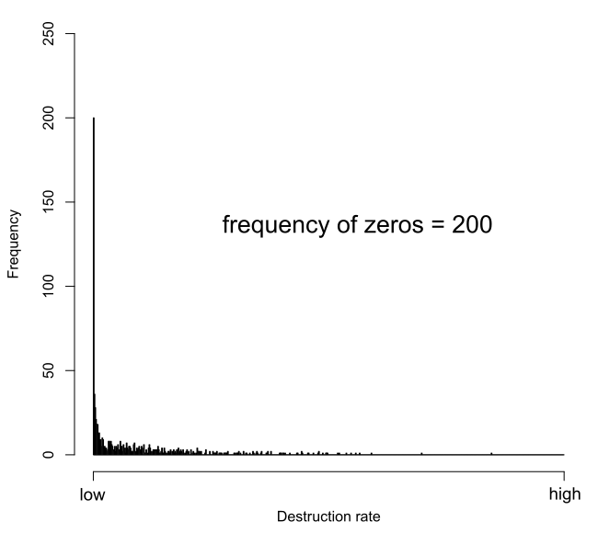
Supplementary Fig. 1 Histograms of destruction rate $DR$ at departmental scale over the entire French territory. The first bar represents the frequency of $0≤DR<0.001$, this frequency is written in the label inside each plot. $DR$ values have been modified for confidentiality reasons

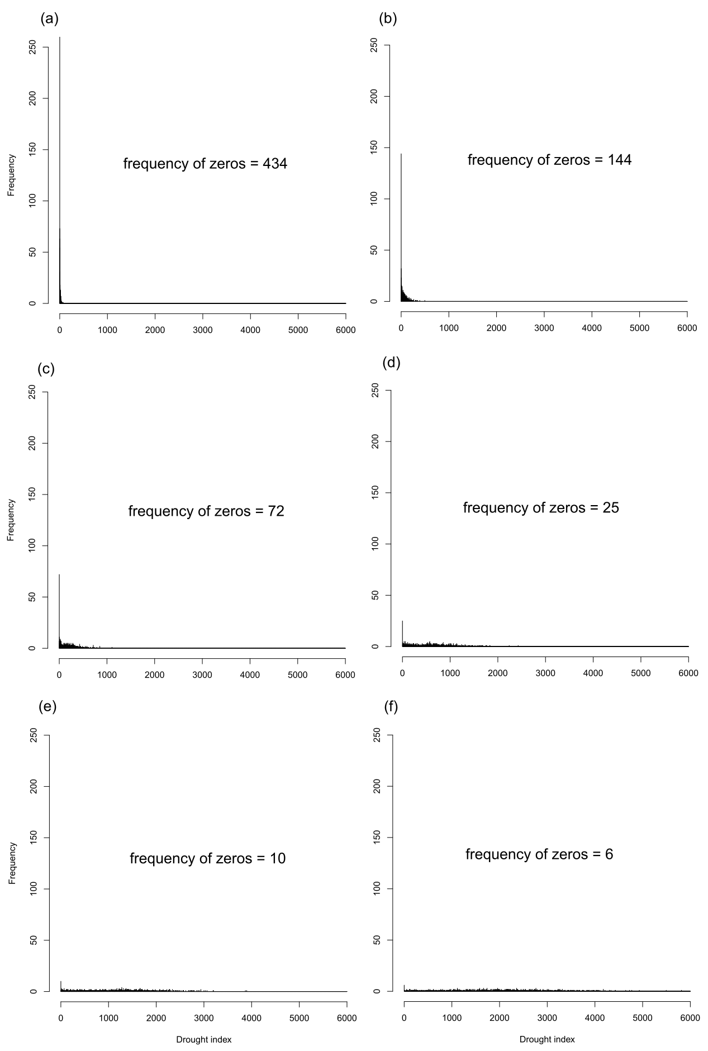
Supplementary Fig. 2 Histograms of drought index $DI$ at departmental scale over the entire French territory using different stress thresholds: (a) 1%, (b) 5%, (c) 10%, (d) 20%, (e) 30%, (f) 40%. The first bar represents the frequency of $0≤DI<1$, this frequency is written in the label inside each plot

