Title: Between competition and facilitation: seasonal spatio-temporal coexistence of leopard (Panthera pardus) and brown hyena (Parahyaena brunnea) in the hyper-arid landscape of southern Namibia.
Journal: European Journal of Wildlife Research
Authors: RAMELLO Veronica (corresponding), SOGLIANI Davide, AVESANI ZABORRA Federica, FRANCHINI Marcello, CICERO Maila, LE ROUX Len, DRAY Stéphane & AUGUGLIARO Claudio & DEVILLARD Sébastien
Corresponding author: RAMELLO Veronica Université Claude Bernard Lyon 1, LBBE, UMR 5558, CNRS, VAS, Villeurbanne, 69622, France. veronica.ramello@univ-lyon1.fr
Supplementary
Table S1 Breakdown of covariates selected for the multi-species occupancy analysis with associated predicted effects on leopard's and brown hyena's occupancy probability, rationale, and corresponding literature
Covariates | Definition | Predicted effect on P. pardus | Predicted effect on P. brunnea | References
Antidorcas marsupialis | Relative Abundance Index (RAI): Springbok | Positive - Most abundant medium sized ungulate in the area. Within the weight range of preferred prey items for leopards. | Positive - Reported common in brown hyena's diet. | Ramello et al. 2025; Hayward et al. 2006; Owens and Owens 1978
Lepus capensis | Relative Abundance Index (RAI): Cape hare | Positive - Commonly hunted by leopards in ecologically similar arid environments. | Positive - Within the weight range of prey items for brown hyenas. | Judas et al. 2006; Owens and Owens 1978.
Procavia capensis | Relative Abundance Index (RAI): Rock hyrax | Positive - Commonly hunted in ecologically similar desert environments. Alternative food item to medium-sized antelopes. | No effect. | Mills 2015; Martins and Harris 2013; Judas et al. 2006.
Large ungulates: Oryx gazella, Equus zebra, Tragelaphus strepsiceros | Relative Abundance Index (RAI): Gemsbok, Mountain zebra, and kudu | Positive - Proxy for scavenging opportunities and higher biomass. | Positive - Proxy for scavenging opportunities, higher biomass. | Augugliaro et al. 2026, unpubl. data.
Homo sapiens | Humans on foot | Negative – Human disturbance negatively affects leopard's distribution. | No effect. | Pitman et al. 2017; Ramello et al. 2025.
Vehicle | Motorised vehicles | Negative - Vehicle disturbance negatively affects leopard's distribution. | No effect. | Pitman et al. 2017; Ramello et al. 2025.
Higher elevation | As meters a.s.l. extracted from the SRTM Digital Elevation Model (30 m spatial resolution). | Negative - The lower elevation is preferred in similar environment and can offer more hunting opportunities. | Positive - Preferentially found on the upper plateau. | Farr et al. 2007; Edwards et al. 2018; Ramello et al. 2025.
Increasing Topographic Position Index (TPI) values | Index comparing the elevation of a pixel relative to the elevation of its neighborhood. More negative values indicate depressions, near-zero values flat areas, more positive values ridges or cliffs. Derived from the SRTM Digital Elevation Model (30 m spatial resolution). | Negative – Depressions and valley bottoms facilitate movements and increase hunting opportunities. | Negative - Depressions and valley bottoms facilitate movements and increase hunting opportunities. | Farr et al. 2007; Weiss 2001; Ramello et al. 2025.
Increasing Topographic Ruggedness Index (TRI) values | Index of topographic heterogeneity with higher values indicating rugged terrain and lower values indicating uniform terrain. Derived from the SRTM Digital Elevation Model (30 m spatial resolution). | Positive - Rugged terrain can provide cover and hunting/scavenging opportunities. | Positive - Rugged terrain can provide cover and hunting/scavenging opportunities. | Farr et al. 2007; Pitman et al. 2017; Verschueren et al. 2024.
Higher Normalized Difference Vegetation Index (NDVI) | Extracted from MOD13A2.061 downloaded from Google Earth Engine and included as a mean seasonal value over a six-months period. | Positive - Cover for hunting and higher prey densities (suitable habitats). | Positive - Cover from high temperatures (WS) and refuges. | Didan 2021; Murray et al. 1995; Verschueren et al. 2024.
Lower distance form water sources | Distance (km) from artificial waterholes and ephemeral riverbeds (i.e., Fish River and Konkiep river). | Positive - Source of attraction in a desert environment. | Positive - Source of attraction in a desert environment. | Edwards et al. 2016.

Table S2 Overall and seasonal (i.e., Dry and Wet) raw descriptors for target species and vehicles with related number of overall and seasonal number of detection events and occupied sites across the study area. Naïve occupancy (ψ_{naive}) was calculated as the number of detection sites for the species relative to the overall number of camera sites. The values correspond to the entire study area composed of 71 camera sites. Abbreviations: RAI = Relative Abundance Index; ψ_{naive} = Naive occupancy; DS = dry season; WS = wet season
 | Detection events |  |  | Sites |  |  | RAI |  |  | Ψ_{naive}
Species | Total | DS | WS | Total | DS | WS | Total | DS | WS | Total | DS | WS
Leopard | 139 | 81 | 58 | 31 | 26 | 22 | 0.36 | 0.41 | 0.31 | 0.44 | 0.37 | 0.31
Brown hyena | 146 | 101 | 45 | 32 | 27 | 19 | 0.38 | 0.52 | 0.24 | 0.45 | 0.38 | 0.27
Springbok | 7714 | 3668 | 4046 | 49 | 38 | 39 | 20.15 | 18.71 | 21.67 | 0.69 | 0.54 | 0.55
Cape hare | 705 | 602 | 103 | 42 | 38 | 21 | 1.84 | 3.07 | 0.55 | 0.59 | 0.54 | 0.30
Rock hyrax | 546 | 444 | 102 | 23 | 21 | 15 | 1.43 | 2.26 | 0.55 | 0.32 | 0.30 | 0.21
Moutain zebra | 4061 | 2786 | 1275 | 69 | 64 | 61 | 10.61 | 14.21 | 6.83 | 0.97 | 0.90 | 0.86
Greater kudu | 1743 | 934 | 809 | 64 | 54 | 57 | 4.55 | 4.76 | 4.33 | 0.90 | 0.76 | 0.80
Gemsbok | 2721 | 1405 | 1316 | 66 | 63 | 62 | 7.11 | 7.17 | 7.05 | 0.93 | 0.89 | 0.87
Homo sapiens | 1619 | 880 | 739 | 71 | 71 | 71 | 4.23 | 4.49 | 3.96 | 1.00 | 1.00 | 1.00
Vehicles | 1943 | 880 | 1063 | 28 | 25 | 22 | 5.08 | 4.49 | 5.69 | 0.39 | 0.35 | 0.31

Table S3 Proportion of observations recorded during daytime, nighttime, and crepuscular periods
Species | Sampling  period | Daytime records (%) | Twilight records (%) | Nighttime records (%) | Diel phenotype | Selected period(s)
Leopard | Dry season | 28.4 | 21 | 50.6 | Cathemeral | Night–Twilight
Leopard | Wet season | 40.4 | 19.3 | 40.4 | Cathemeral | Twilight
Brown hyena | Dry season | 2.0 | 15.7 | 82.4 | Nocturnal | Night–Twilight
Brown hyena | Wet season | 10.8 | 13.5 | 75.7 | Nocturnal | Night–Twilight
Humans | Dry season | 96.2 | 3.4 | 0.3 | Diurnal | Day
Humans | Wet season | 99.0 | 0.7 | 0.3 | Diurnal | Day
Vehicles | Dry season | 90.3 | 7.8 | 1.8 | Diurnal | Day–Twilight
Vehicles | Wet season | 98.5 | 1.1 | 0.4 | Diurnal | Day
Springbok | Dry season | 82.6 | 7.2 | 10.2 | Diurnal | Day–Twilight
Springbok | Wet season | 94.1 | 2.7 | 3.2 | Diurnal | Day
Greater kudu | Dry season | 68.2 | 10.3 | 21.5 | Diurnal–Nocturnal | Day–Twilight
Greater kudu | Wet season | 86.9 | 3.0 | 10.1 | Diurnal | Day
Gemsbok | Dry season | 55.8 | 14.0 | 30.2 | Cathemeral | Day–Twilight
Gemsbok | Wet season | 88.4 | 3.1 | 8.5 | Diurnal | Day
Mountain zebra | Dry season | 36.4 | 13.8 | 49.8 | Cathemeral | Night–Twilight
Mountain zebra | Wet season | 72.2 | 8.7 | 19.1 | Diurnal–Crepuscular | Day–Twilight
Cape hare | Dry season | 1.0 | 16.9 | 82.1 | Nocturnal | Night–Twilight
Cape hare | Wet season | 11.4 | 22.9 | 65.7 | Crepuscular | Night–Twilight
Rock hyrax | Dry season | 99.8 | 0.2 | 0 | Diurnal | Day
Rock hyrax | Wet season | 99.0 | 1.0 | 0 | Diurnal | Day

Table S4 Values of temporal overlap coefficients with 95% confidence intervals and Mardia-Watson-Wheeler test results
Species of the pairwise comparison | Sampling  period | Overlap Coefficient  value | 95% Confidence Intervals | MWW test  W (df = 2) | CompareCkern function
Leopard–Brown hyena | Dry season | Δ₄ = 0.68 | 95% CI = 0.57–0.79 | 29.71*** | ***
Leopard–Brown hyena | Wet season | Δ₁ = 0.68 | 95% CI = 0.53–0.82 | 11.30** | **
Leopard–Humans | Dry season | Δ₄ = 0.33 | 95% CI = 0.24–0.42 | 112.76*** | ***
Leopard–Humans | Wet season | Δ₄ = 0.32 | 95% CI = 0.22–0.42 | 79.84*** | ***
Leopard–Vehicles | Dry season | Δ₄ = 0.41 | 95% CI = 0.32–0.50 | 101.61*** | ***
Leopard–Vehicles | Wet season | Δ₄ = 0.32 | 95% CI = 0.22–0.42 | 79.91*** | ***
Brown hyena–Humans | Dry season | Δ₄ = 0.07 | 95% CI = 0.02–0.12 | 218.53*** | ***
Brown hyena–Humans | Wet season | Δ₁ = 0.10 | 95% CI = 0.04–0.17 | 76.51*** | ***
Brown hyena–Vehicles | Dry season | Δ₄ = 0.13 | 95% CI = 0.08–0.19 | 215.04*** | ***
Brown hyena–Vehicles | Wet season | Δ₁ = 0.11 | 95% CI = 0.04–0.18 | 75.81*** | ***
Leopard–Springbok | Dry season | Δ₄ = 0.49 | 95% CI = 0.40–0.57 | 88.92*** | ***
Leopard–Springbok | Wet season | Δ₄ = 0.45 | 95% CI = 0.35–0.56 | 65.74*** | ***
Leopard–Cape hare | Dry season | Δ₄ = 0.65 | 95% CI = 0.55–0.75 | 30.87*** | ***
Leopard–Cape hare | Wet season | Δ₄ = 0.67 | 95% CI = 0.55–0.78 | 22.85*** | ***
Leopard–Rock hyrax | Dry season | Δ₄ = 0.28 | 95% CI = 0.20–0.37 | 129.19*** | ***
Leopard–Rock hyrax | Wet season | Δ₄ = 0.34 | 95% CI = 0.23–0.46 | 58.39*** | ***
Leopard–Mountain zebra | Dry season | Δ₄ = 0.82 | 95% CI = 0.73–0.90 | 4.81 | 0.21
Leopard–Mountain zebra | Wet season | Δ₄ = 0.57 | 95% CI = 0.48–0.67 | 43.38*** | ***
Leopard–Gemsbok | Dry season | Δ₄ = 0.77 | 95% CI = 0.69–0.85 | 21.06*** | ***
Leopard–Gemsbok | Wet season | Δ₄ = 0.54 | 95% CI = 0.43–0.64 | 48.60*** | ***
Leopard–Greater kudu | Dry season | Δ₄ = 0.63 | 95% CI = 0.54–0.72 | 46.20*** | ***
Leopard–Greater kudu | Wet season | Δ₄ = 0.53 | 95% CI = 0.42–0.64 | 48.51*** | ***
Brown hyena–Springbok | Dry season | Δ₄ = 0.22 | 95% CI = 0.17–0.27 | 193.69*** | ***
Brown hyena–Springbok | Wet season | Δ₁ = 0.20 | 95% CI = 0.12–0.28 | 72.08*** | ***
Brown hyena–Cape hare | Dry season | Δ₄ = 0.85 | 95% CI = 0.77–0.92 | 5.89 | 0.22
Brown hyena–Cape hare | Wet season | Δ₁ = 0.88 | 95% CI = 0.76–0.97 | 1.45 | 0.23
Brown hyena–Rock hyrax | Dry season | Δ₄ = 0.05 | 95% CI = 0.01–0.09 | 222.74*** | ***
Brown hyena–Rock hyrax | Wet season | Δ₁ = 0.11 | 95% CI = 0.04–0.20 | 77.81*** | ***
Brown hyena–Mountain zebra | Dry season | Δ₄ = 0.64 | 95% CI = 0.58–0.71 | 57.63*** | ***
Brown hyena–Mountain zebra | Wet season | Δ₁ = 0.43 | 95% CI = 0.35–0.52 | 52.28*** | ***
Brown hyena–Gemsbok | Dry season | Δ₄ = 0.48 | 95% CI = 0.42–0.55 | 119.81*** | ***
Brown hyena–Gemsbok | Wet season | Δ₁ = 0.26 | 95% CI = 0.18–0.35 | 66.97*** | ***
Brown hyena–Greater kudu | Dry season | Δ₄ = 0.35 | 95% CI = 0.29–0.41 | 153.03*** | ***
Brown hyena–Greater kudu | Wet season | Δ₁ = 0.27 | 95% CI = 0.19–0.37 | 65.96*** | ***
Interseason leopard | Dry vs Wet | Δ₄ = 0.84 | 95% CI = 0.71–0.94 | 2.95 | 0.24
Interseason hyena | Dry vs Wet | Δ₁ = 0.88 | 95% CI = 0.76–0.97 | 0.94 | 0.50
*p-value <0.05, **p-value <0.01, ***p-value < 0.001.

Table S5 Model selection output, based on AICc, for environmental covariates fitted for the dry and wet season on marginal occupancy of leopard and brown hyena. In grey = competitor model, in bold = best model, italic = intercept model. Abbreviations: p = detection probability; $ψ$ = occupancy probability; TRI = Topographic Ruggedness Index; Elev = elevation; Dist.W = distance from water sources; leo = leopard; bh = brown hyena; TPI = Topographic Position Index; NDVI = Normalized Difference Vegetation Index; AICc = second order Akaike's Information Criterion; ModelLik = model likelihood; ωi = Akaike's weight; LL = log-likelihood
DS environmental models | K | AICc | ΔAICc | ModelLik | ωi | LL
p(effort), ψleo(TRI), ψbh(Elev+Dist.W) | 9 | 974.09 | 0.00 | 1.00 | 0.50 | -475.68
p(effort), ψleo(TRI+Dist.W), ψbh(Elev+Dist.W) | 10 | 974.91 | 0.82 | 0.66 | 0.33 | -474.48
p(effort), ψleo(TPI+TRI+Dist.W), ψbh(Elev+Dist.W+NDVI) | 12 | 976.29 | 2.20 | 0.33 | 0.17 | -471.69
p(effort), ψleo(Elev+TPI+TRI+Dist.W), ψbh(Elev+Dist.W+TPI+NDVI) | 14 | 982.38 | 8.29 | 0.02 | 0.01 | -470.83
p(effort), ψleo(Elev+TPI+TRI+Dist.W+NDVI), ψbh(Elev+Dist.W+TPI+TRI+NDVI) | 16 | 989.92 | 15.83 | 0.00 | 0.00 | -470.19
ψleo(.), ψbh(.) | 4 | 996.59 | 22.50 | 0.00 | 0.00 | -493.83
WS environmental models
p(effort), ψleo(TRI), ψbh(Elev+Dist.W) | 9 | 507.47 | 0.00 | 1.00 | 0.57 | -242.37
p(effort), ψleo(TPI+TRI), ψbh(Elev+Dist.W) | 10 | 509.74 | 2.27 | 0.32 | 0.18 | -241.90
ψleo(.), ψbh(.) | 4 | 510.20 | 2.72 | 0.26 | 0.15 | -250.63
p(effort), ψleo(TPI+TRI+Dist.W), ψbh(Elev+TRI+Dist.W) | 12 | 511.32 | 3.85 | 0.15 | 0.08 | -239.20
p(effort), ψleo(TPI+TRI+Dist.W+NDVI), ψbh(Elev+TRI+Dist.W+TPI) | 14 | 515.04 | 7.57 | 0.02 | 0.01 | -237.16
p(effort), ψleo(Elev+TPI+TRI+Dist.W+NDVI), ψbh(Elev+TRI+Dist.W+TPI+NDVI) | 16 | 523.73 | 16.26 | 0.00 | 0.00 | -237.09

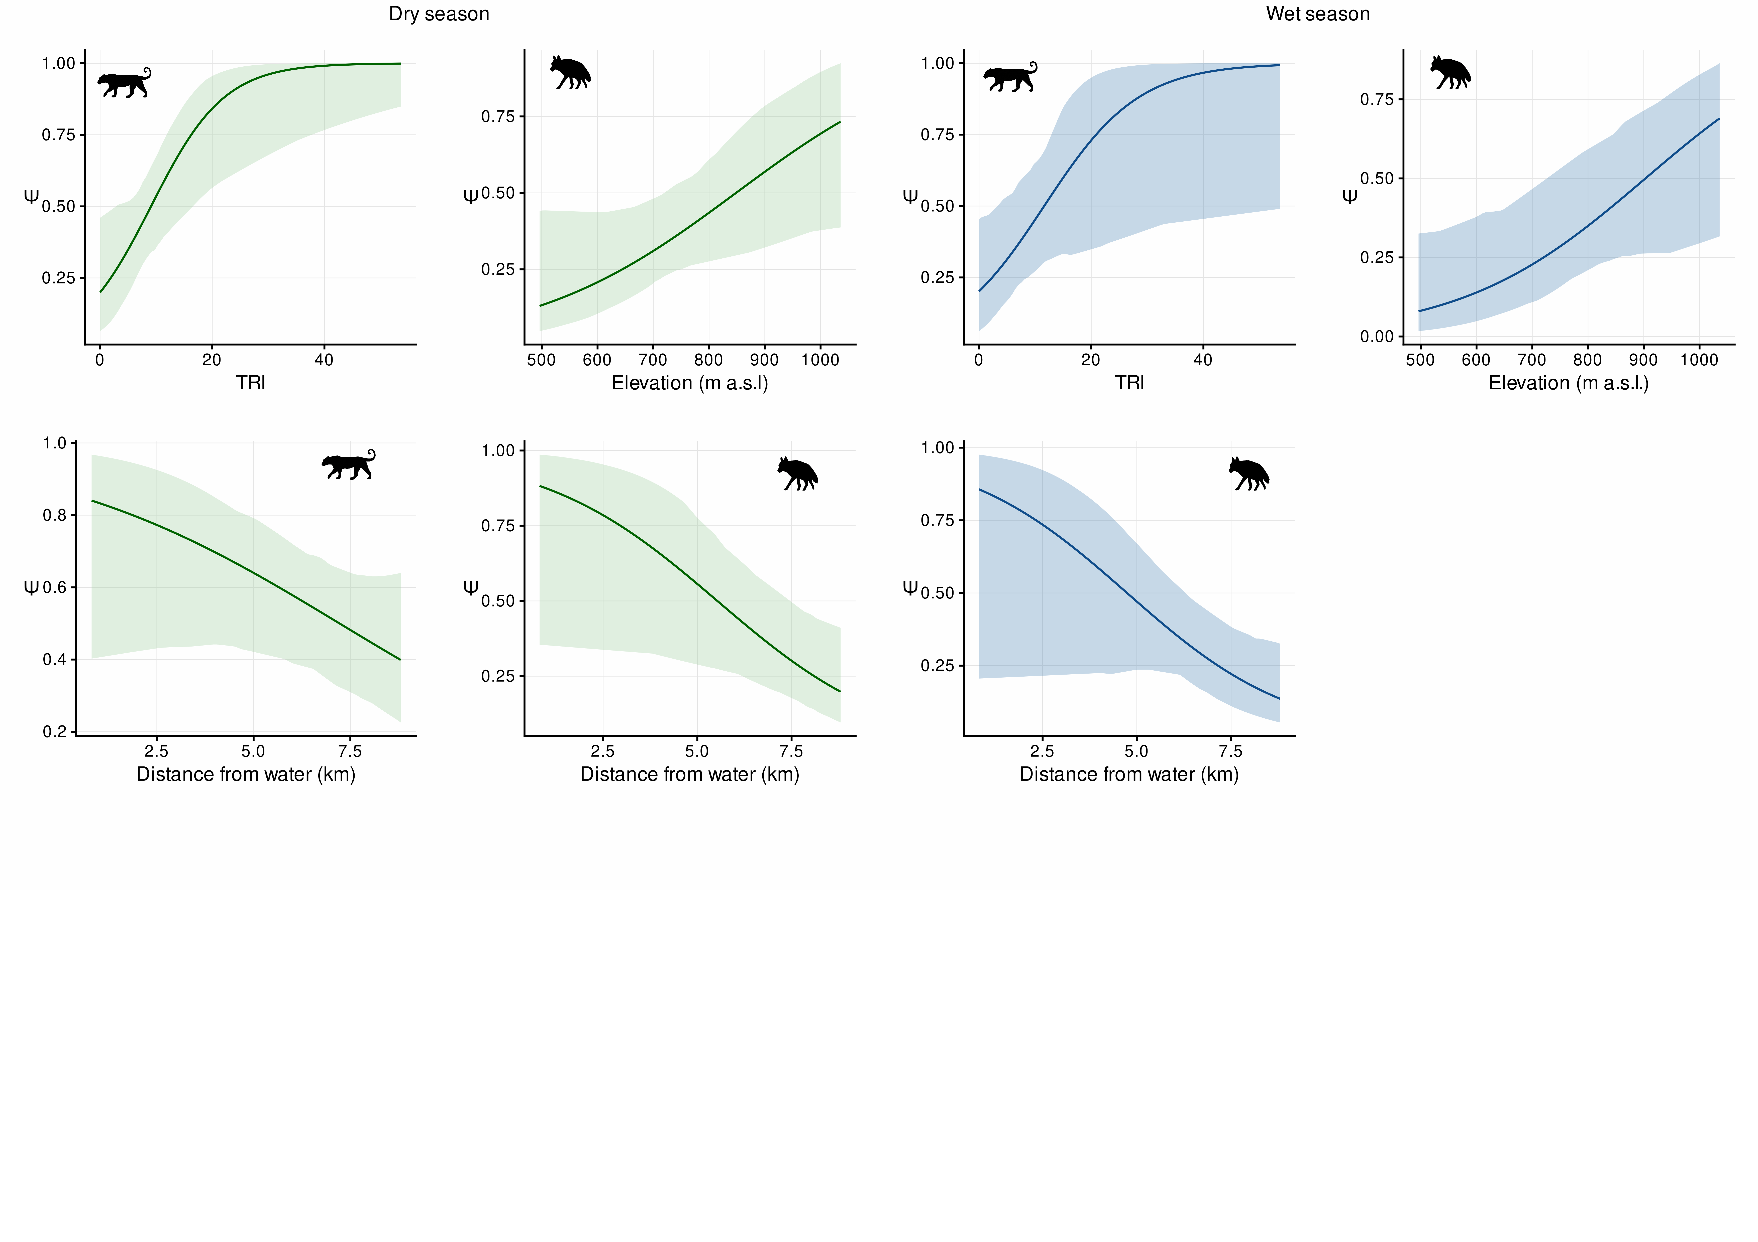
Fig. S1 Predicted environmental covariates effects on marginal occupancy of leopard and brown hyena during the dry season (green) and wet season (blue). Abbreviations: TRI = Topographic Position Index, ψ = occupancy probability
Table S6 Model selection based on AICc for biological RAI covariates fitted for the dry and wet season on marginal occupancy of leopard and brown hyena. In grey = competitor model, in bold = best model, italic = intercept model. Abbreviations: p = detection probability; ψ = occupancy probability; LargeUng = large ungulates; Hare = Cape hare; Hyrax = rock hyrax; Dist.W = distance from water sources; leo = leopard; bh = brown hyena; AICc = second order Akaike's Information Criterion; ModelLik = model likelihood; ωi = Akaike's weight; LL = log-likelihood
DS biological models | K | AICc | ΔAICc | ModelLik | ωi | LL
p(effort), leo(Hyrax+LargeUng), bh(LargeUng) | 9 | 966.45 | 0.00 | 1.00 | 0.64 | -471.86
p(effort), leo(Hyrax), bh(LargeUng) | 8 | 968.19 | 1.73 | 0.42 | 0.27 | -474.25
p(effort), leo(Hyrax+LargeUng+Hare), bh(Spring+LargeUng) | 11 | 970.39 | 3.94 | 0.14 | 0.09 | -470.53
p(effort), leo(Hyrax+LargeUng+Hare+Dist.W), bh(Spring+LargeUng+Hare) | 13 | 976.32 | 9.87 | 0.01 | 0.00 | -469.81
p(effort), leo(Hyrax+Spring+LargeUng+Hare+Dist.W), bh(Spring+LargeUng+Hare+Dist.W) | 15 | 983.39 | 16.94 | 0.00 | 0.00 | -469.19
leo(.), bh(.) | 4 | 996.59 | 30.13 | 0.00 | 0.00 | -493.83
WS biological models
p(effort), ψleo(Hare+LargeUng), ψbh(LargeUng) | 9 | 508.73 | 0.00 | 1.00 | 0.40 | -243.00
p(effort), ψleo(Hare), ψbh(LargeUng) | 8 | 508.84 | 0.11 | 0.95 | 0.38 | -244.57
ψleo(.), ψbh(.) | 4 | 510.20 | 1.47 | 0.48 | 0.19 | -250.63
p(effort), ψleo(Spring+LargeUng+Hare), ψbh(Hare+LargeUng) | 11 | 513.95 | 5.22 | 0.07 | 0.03 | -242.31
p(effort), ψleo(Spring+LargeUng+Hare+Dist.W), ψbh(LargeUng+Hare+Dist.W) | 13 | 520.60 | 11.87 | 0.00 | 0.00 | -241.95

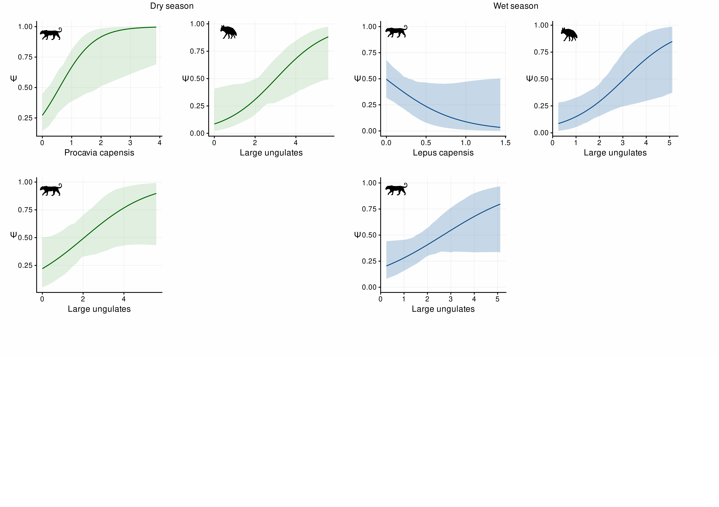
Fig. S2 Predicted biological covariates effects on marginal occupancy of leopard and brown hyena during the dry season (green) and wet season (blue). Abbreviations: ψ = occupancy probability
Table S7 Model selection based on AICc for biological RAI covariates fitted for the dry and wet season on marginal occupancy of leopard and brown hyena. In bold = best model, italic = intercept model. Abbreviations: p = detection probability; ψ = occupancy probability; Homo = Homo sapiens; leo = leopard; bh = brown hyena; AICc = second order Akaike's Information Criterion; ModelLik = model likelihood; ωi = Akaike's weight; LL = log-likelihood
DS anthropogenic models | K | AICc | ΔAICc | ModelLik | ωi | LL
p(effort), ψleo(Vehicle), ψbh(Homo) | 8 | 987.68 | 0.00 | 1.00 | 0.93 | -484.00
p(effort), ψleo(Vehicle+Homo), ψbh(Vehicle+Homo) | 10 | 993.08 | 5.40 | 0.07 | 0.06 | -483.57
ψleo(.), ψbh(.) | 4 | 996.59 | 8.90 | 0.01 | 0.01 | -493.83
WS anthropogenic models
p(effort), ψleo(Vehicle), ψbh(Homo) | 8 | 508.13 | 0.00 | 1.00 | 0.68 | -244.22
ψleo(.), ψbh(.) | 4 | 510.20 | 2.07 | 0.36 | 0.24 | -250.63
p(effort), ψleo(Vehicle+Homo), ψbh(Vehicle+Homo) | 10 | 512.57 | 4.44 | 0.11 | 0.07 | -243.31

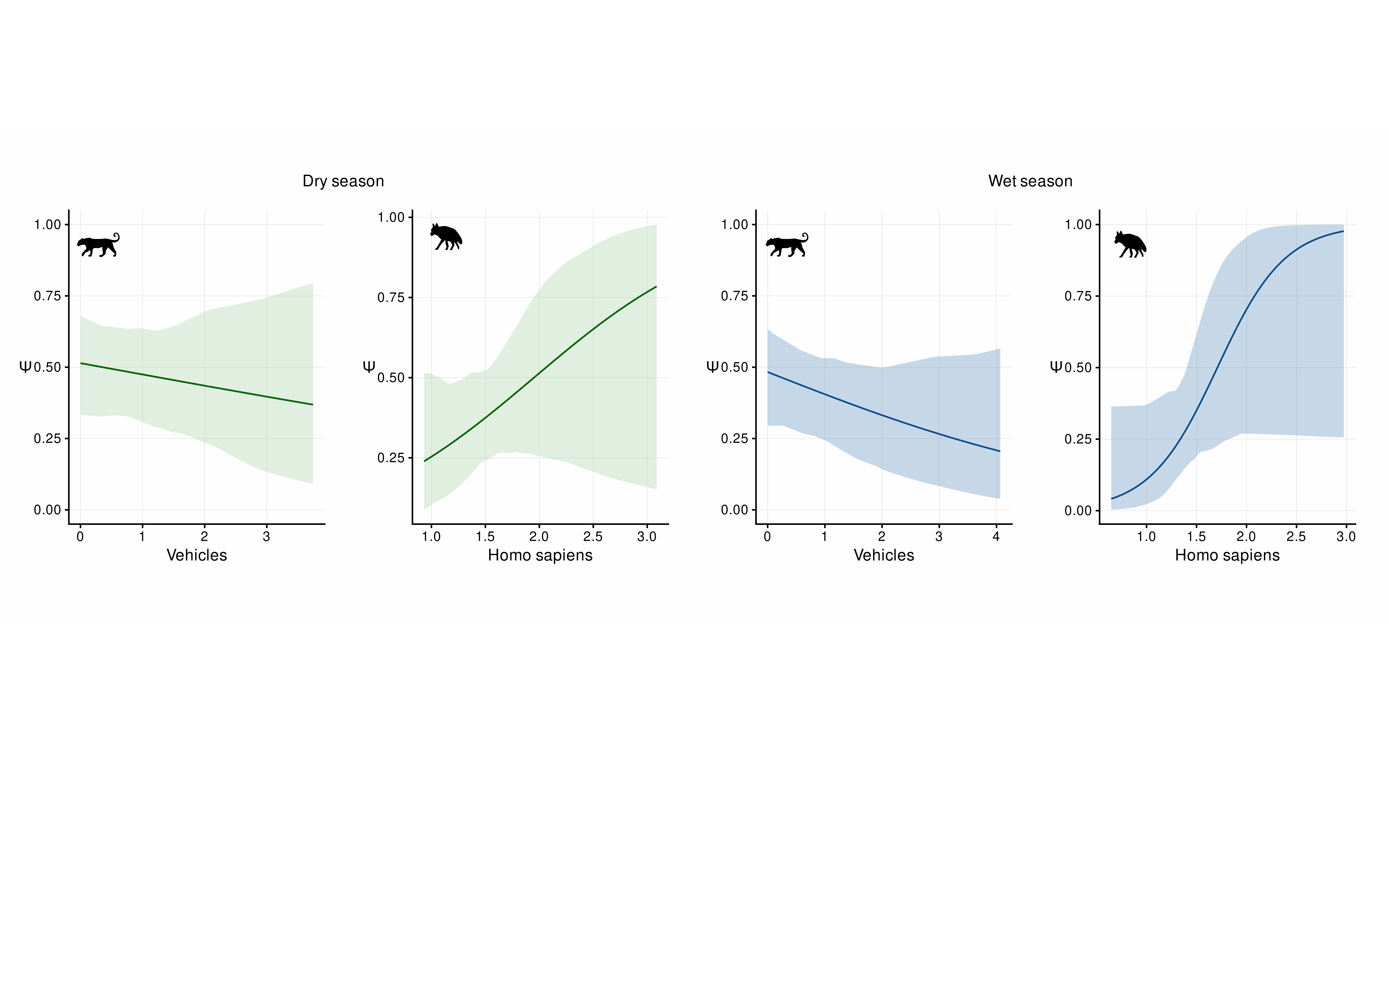
Fig. S3 Predicted anthropogenic covariates effects on marginal occupancy of leopard and brown hyena during the dry season (green) and wet season (blue). Abbreviations: ψ = occupancy probability
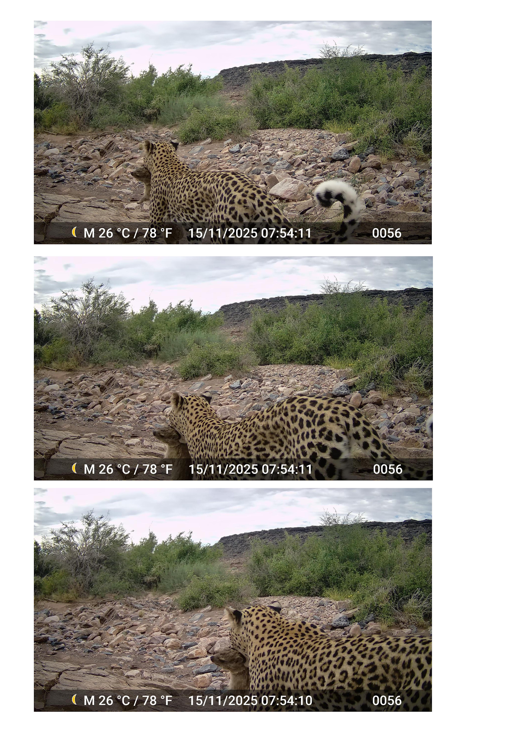
Fig. S4 Camera trap photographic sequence of a leopard carrying a rock hyrax kill during daylight hours

