Appendix 1.

Basic sequence for studying the effect of yoga in individuals with MS.

№ | Name of Pose | Duration, min | Number of Repetitions | Overall Duration, min
1 | Supta Baddha Konasana with roll under sacrum and feet | 5-10 | 1 | 5-10
2 | Vajrasana, with variations  а) feet together,  b) heels apart, toes together  c) pushing metatarsals off the floor | 0,5-0,7 | 3 | 2-3
3 | Urdhva Baddha Anguliasana, sitting on chair | 0,2-0,3 | 4 | 2
4 | Tadasana, with variations:  a) back against wall, chair in front,  b) facing wall, chair behind  c) with block between inner thighs  d) “marching”: lifting thighs as high as you can (sitting on chair is possible) | 0,5-1 | 4 | 5
5 | Utkatasana, with variations:  1) lifting and lowering body with back pressed against wall  2) facing wall, with chair behind. | 0,5-1 | 2 | 2
6 | Bharadvajrasana with chair, two repetitions each side | 0,5-0,7 | 4 | 3
7 | Ardha Uttanasana with palms on support, feet apart | 0,7-1 | 2 | 2
8 | Parsvattonasana with hands on support/ Walk with one leg while entering the pose, step with the other while coming out. | 0,7 | 2 | 2
8.1 | Adho Mukha Svanasana on ropes with support for head and hands | 2-3 | 1 | 2-3
9 | Virabhadrasana 1, with toes of front foot pressed against wall, focus on opening groin of back leg. | 0,5 | 1 | 1
9.1 | Supta Padangusthasana 1-2, 2 repetitions each side | 0,3 | 4 | 1,2
10 | Chatushpadasana, dynamically lifting pelvis and opening front groins. | Dynamics | 5-7 | 1
11 | Setu Bandha Sarvangasana with body along bolster, belts on thighs, feet against wall. | 4-8 | 1 | 8
11.1 | Setu Bandha Sarvangasana on bench with feet against wall, roll between legs, legs tied with belts. | 4-8 | 1 | 8
12 | Viparita Karani against wall with weights on feet. | 4-8 | 1 | 8
12.1 | Viparita Karani, easier variation, with shins on chair and bolster under pelvis. | 4-8 | 1 | 8
13 | Savasana, with variations:  - With blanket under back and feet touching support  - Additional bolster under thighs  - Shins on chair. | 10-15 | 1 | 15

Appendix 2.
Basic Complex pose illustrations.
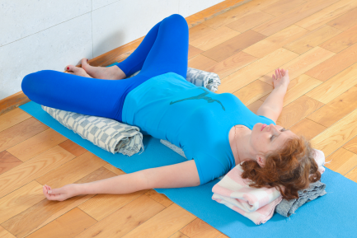 | 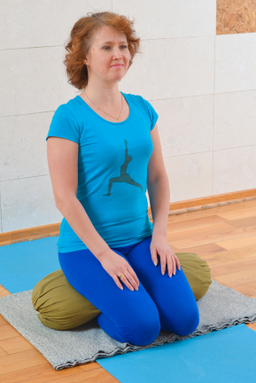 | 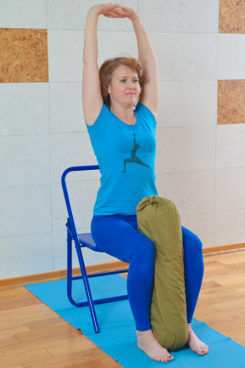
1 | 2 | 3
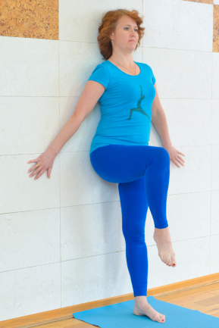 | 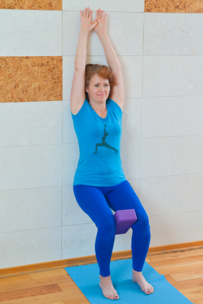 | 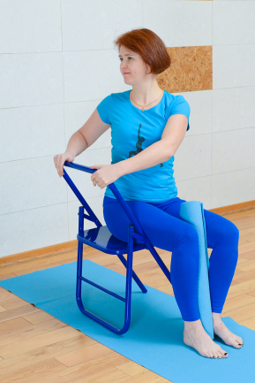
4 | 5 | 6
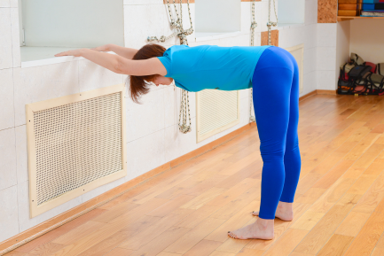 | 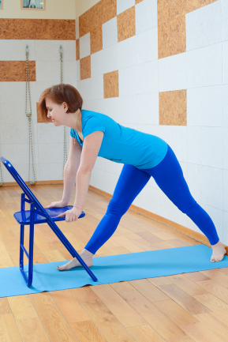 | 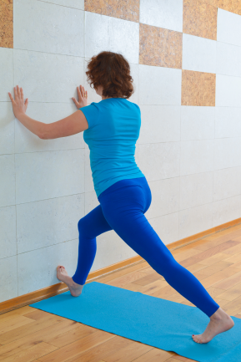
7 | 8 | 9
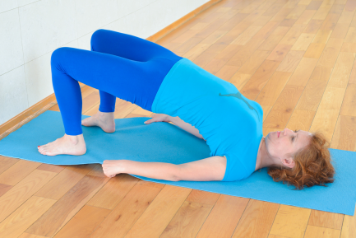 | 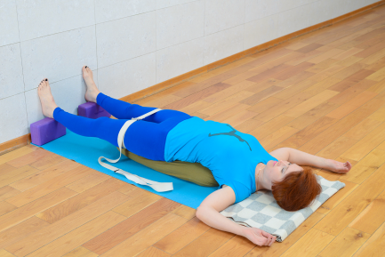 | 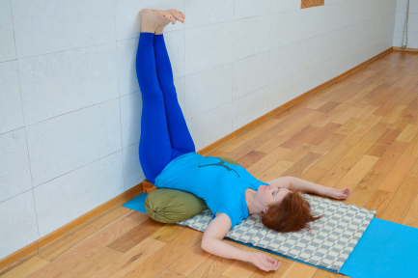
10 | 11 | 12
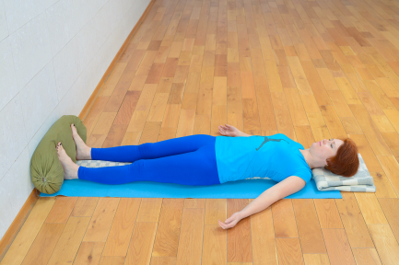 | 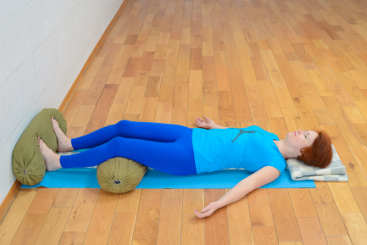 | 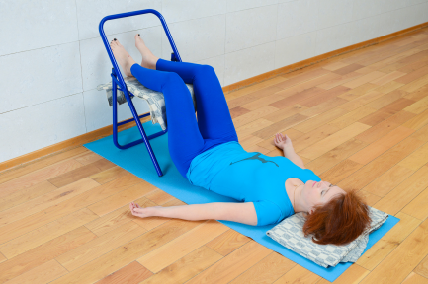
13, a) | 13, b) | 13, c)

