The hip radiographic magnification correlates with patient’s BMI.

Supplementary material

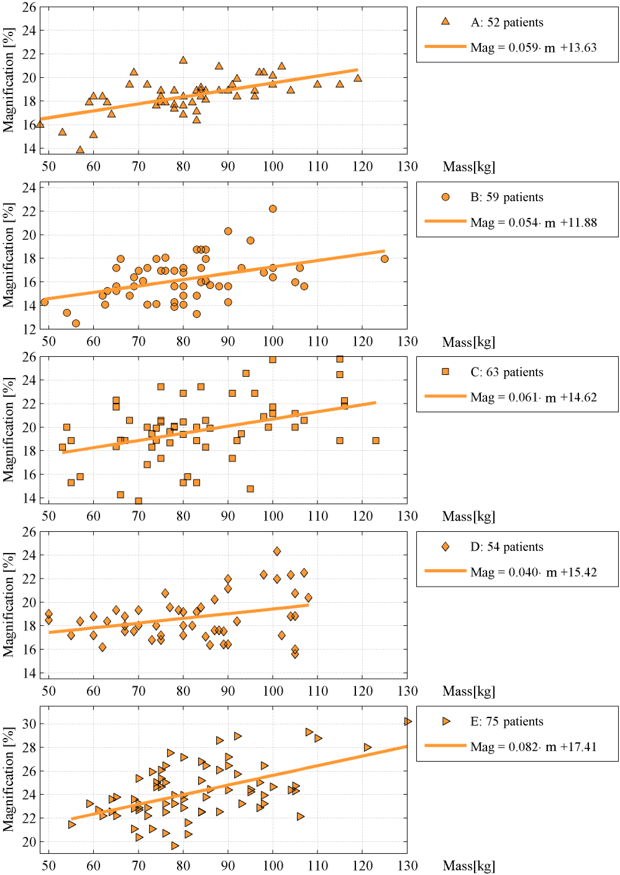
Figure S1: Relationship between patients’ mass and hip radiographic magnification M for each clinic (denoted A-E).
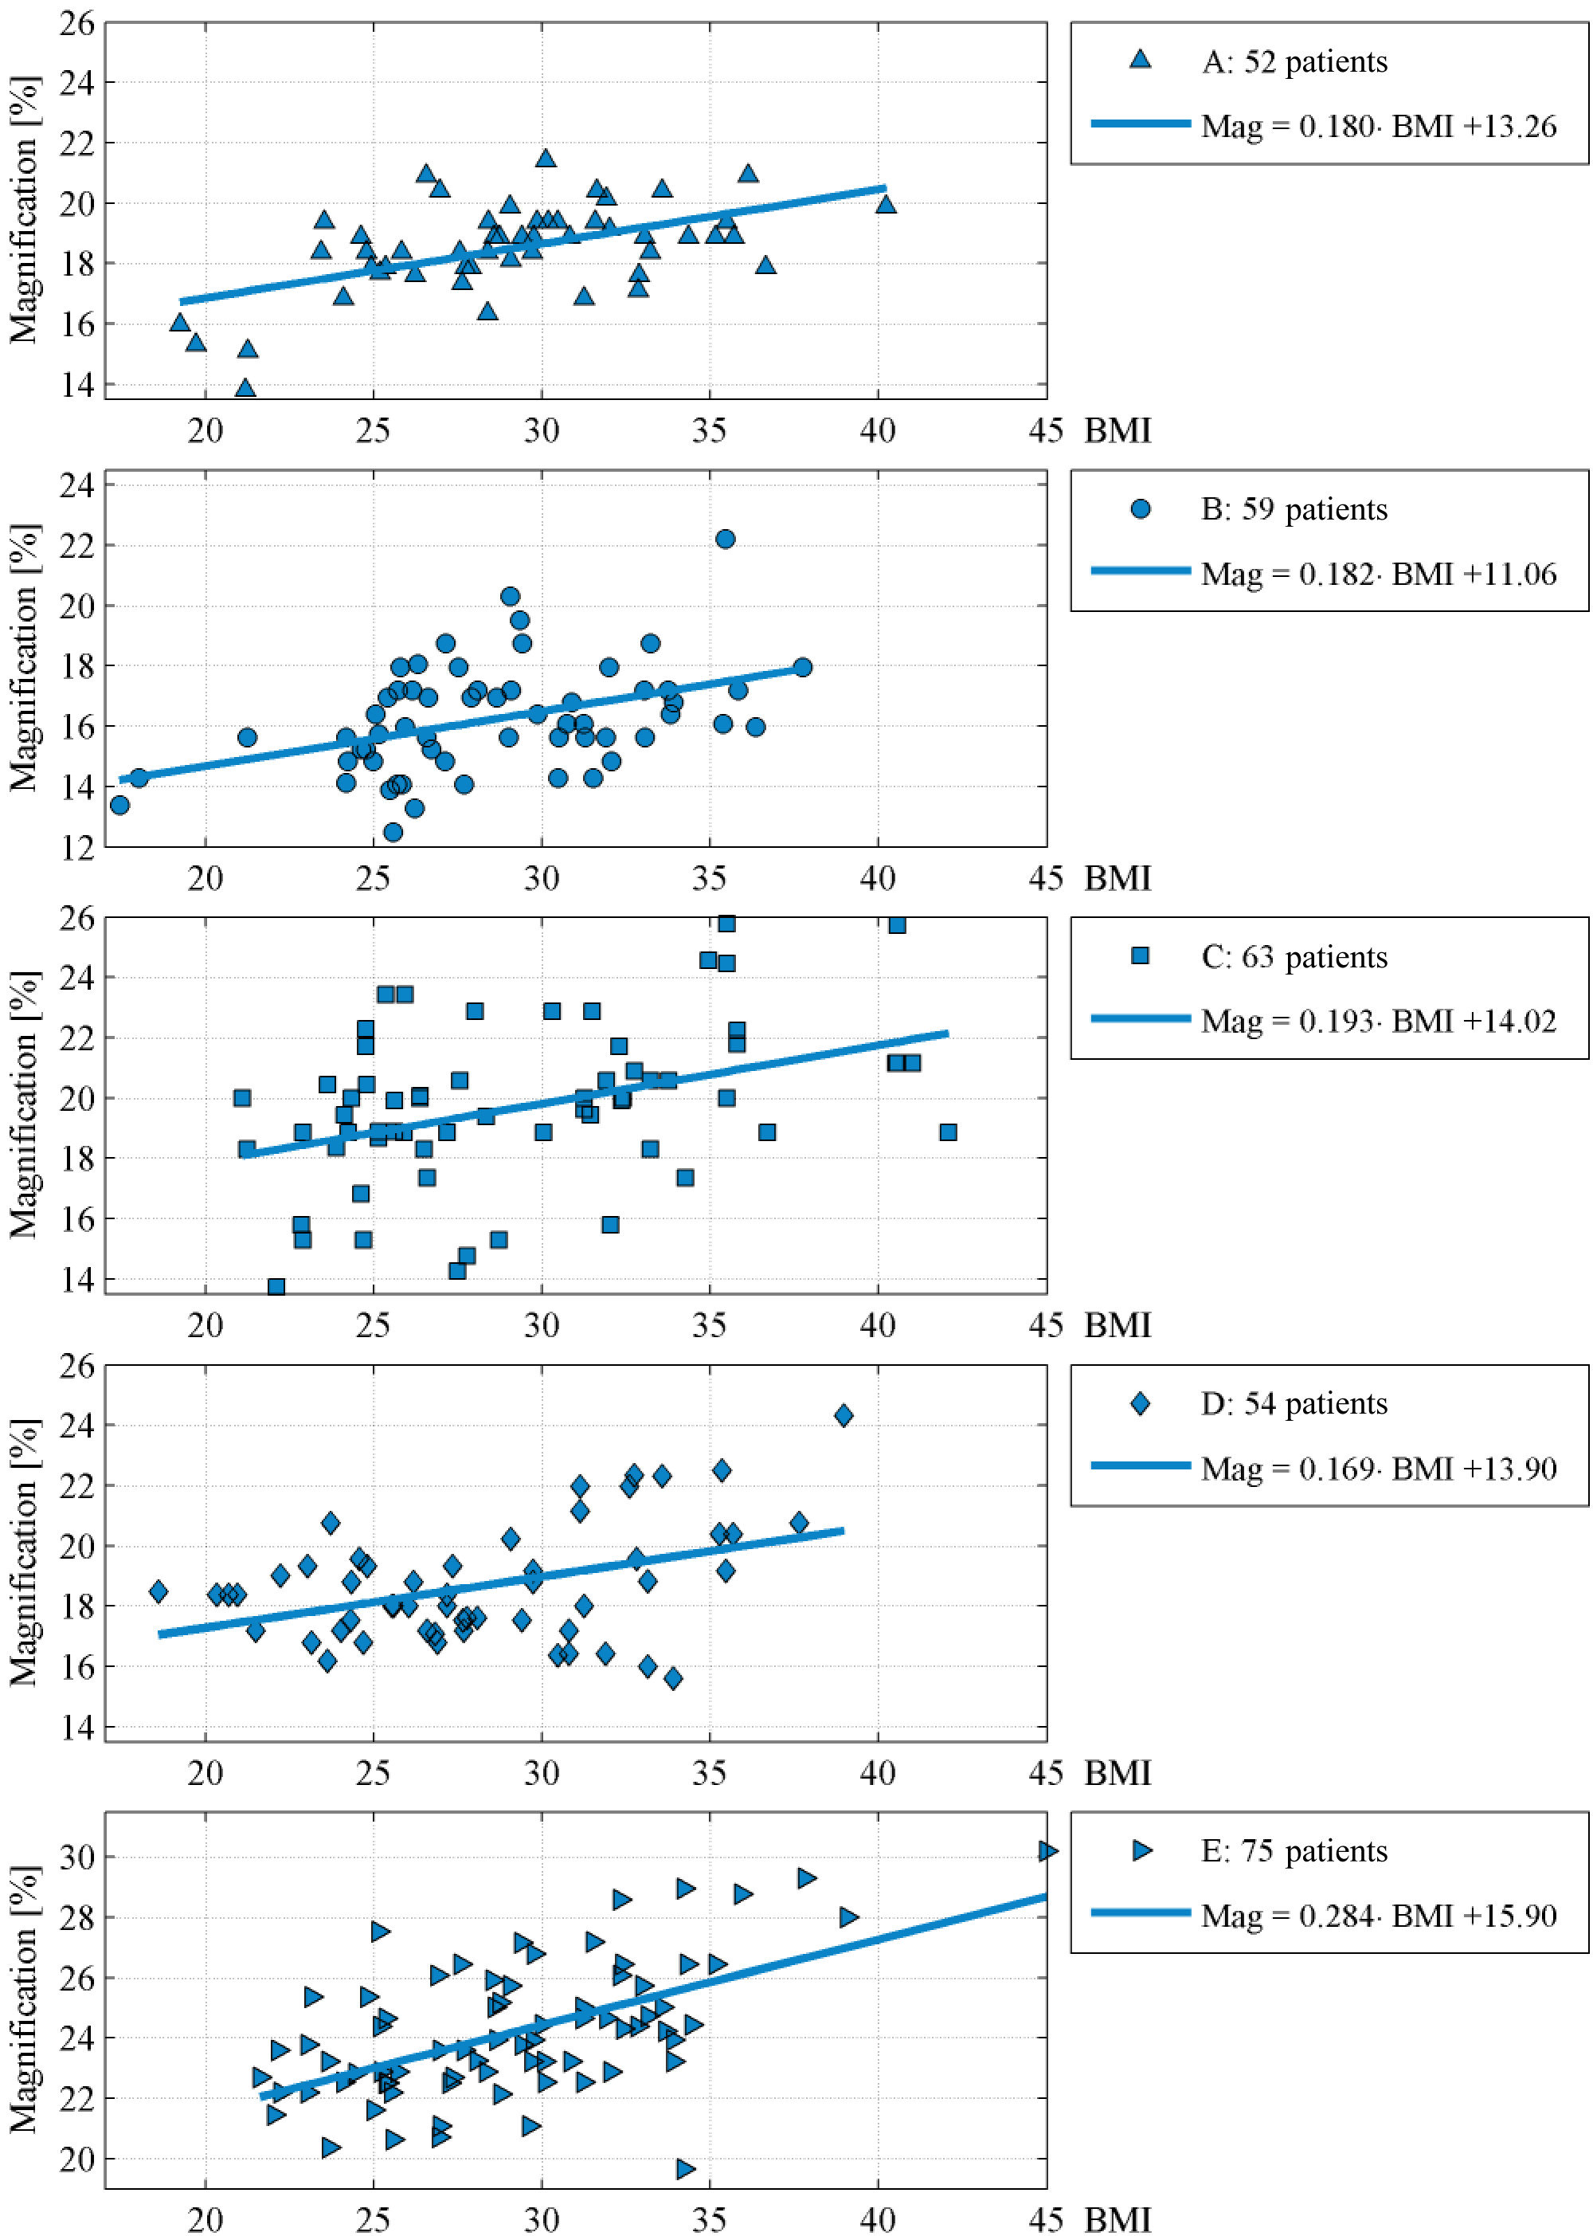
Figure S2: Relationship between patients’ BMI and hip radiographic magnification M for each clinic (denoted A-E).
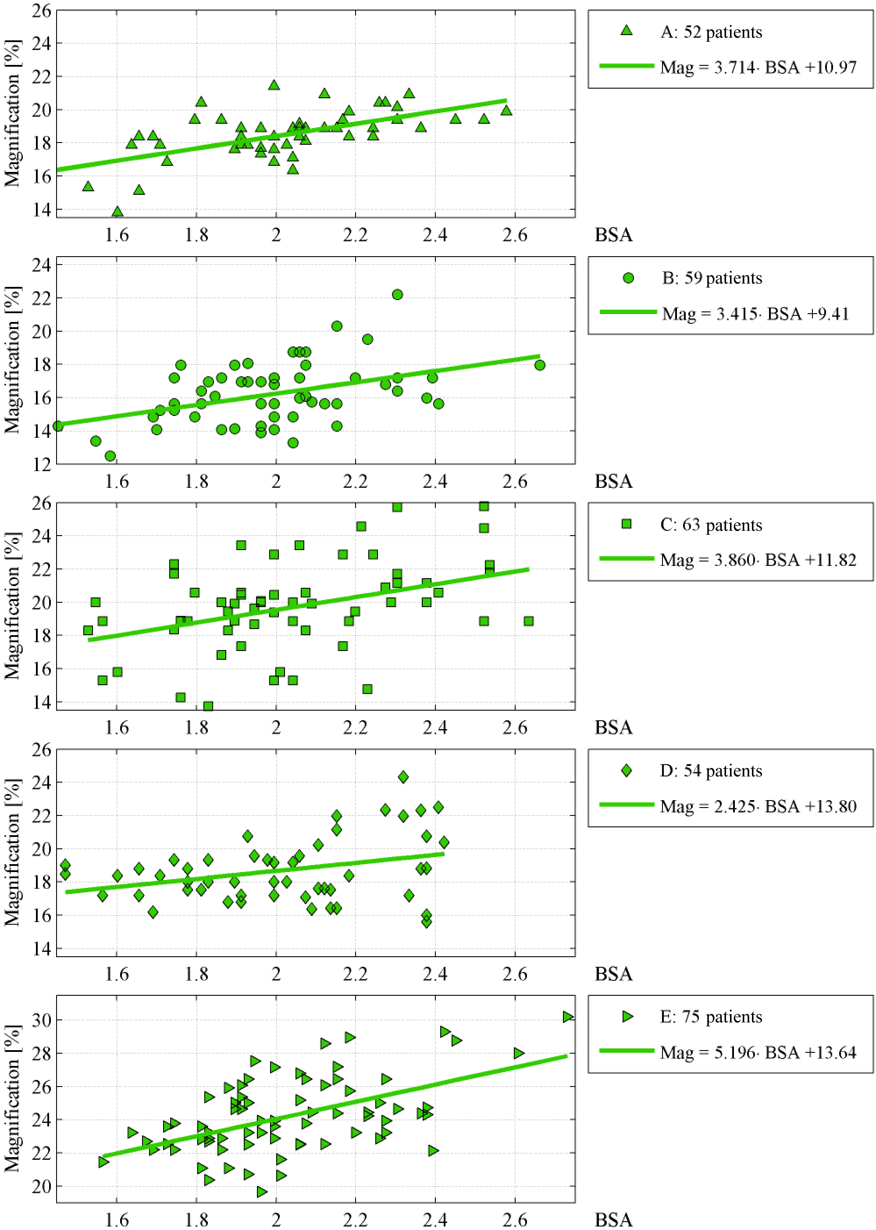
Figure S3: Relationship between patients’ BSA and hip radiographic magnification M for each clinic (denoted A-E).

