Post-Synthetic Modification to Access Two New Cobalt-Based Coordination Polymers
Miao Yu, Jia-Qi Li, Xiang He*
Department of Chemistry, College of Sciences, Shanghai University, Shanghai 200444, China
E-mail addresses: hxiang@shu.edu.cn (X. He).

Contents
Table S1. Selected bond distances (Å) and angles (º) for compounds 1-2
Figure S1. The 3D structure framework of 1, viewed down from c axis.
Figure S2. Effect of 4,4'-bipy dosage on crystal transformation
Figure S3. PXRD patterns of precursor, transition state and compound 1.
Figure S4. Possible transformation process from compound 1a to compound 1
Figure S5. The trinuclear Co unit in 1a, The dinuclear Co unit in 2.
Figure S6. Optical micrographs showing the crystal-to-crystal transformation from 1a to 2.
Figure S7. The FT-IR spectra of compounds 1-2.
Figure S8. The PXRD patterns of compounds 1-2 and the simulated spectra.
Figure S9. TG curves for compounds 1-2
Table S1. Selected bond distances (Å) and angles (º) for compounds 1-2
Compound 1
Co(1)-N(1) | 2.170(4) | O(1)-Co(1)-N(1) | 88.00(18) | O(11)-Co(1)-O(9) | 90.31(15)
Co(1)-N(3) | 2.149(5) | O(1)-Co(1)-N(3) | 90.85(18) | O(11)-Co(1)-O(10) | 90.99(15)
Co(1)-O(1) | 2.040(4) | O(1)-Co(1)-O(9) | 89.16(14) | N(2)#7-Co(2)-N(2)#8 | 180.00(16)
Co(1)-O(9) | 2.154(4) | O(1)-Co(1)-O(10) | 89.50(13) | O(4)#9-Co(2)-N(2)#8 | 91.41(13)
Co(1)-O(10) | 2.117(4) | O(9)-Co(1)-N(1) | 89.02(14) | O(4)-Co(2)-N(2)#7 | 91.42(13)
Co(1)-O(11) | 2.105(4) | O(10)-Co(1)-N(1) | 88.58(14) | O(4)-Co(2)-O(4)#9 | 180
Co(2)-N(2)#2 | 2.195(4) | O(10)-Co(1)-N(3) | 92.87(14) | O(4)-Co(2)-O(8) | 90.24(13)
Co(2)-O(4) | 2.067(4) | O(10)-Co(1)-O(9) | 177.29(13) | O(4)-Co(2)-O(8)#9 | 89.76(13)
Co(2)-O(8) | 2.117(4) | O(11)-Co(1)-N(1) | 91.14(19) | O(8)-Co(2)-N(2)#8 | 92.68(17)
N(3)-Co(1)-N(1) | 178.15(14) | O(11)-Co(1)-N(3) | 90.00(19) | O(8)-Co(2)-N(2)#7 | 87.32(17)
N(3)-Co(1)-O(9) | 89.51(14) | O(4)#9-Co(2)-N(2)#7 | 88.59(13) | O(8)#9-Co(2)-O(8) | 180
O(1)-Co(1)-O(11) | 178.99(13) | O(4)-Co(2)-N(2)#8 | 88.58(13)
Compound 2
Co(1)-O(6) | 2.036(6) | O(6)-Co(1)-O(11)#1 | 148.2(3) | O(13)#3-Co(2)-O(5)#3 | 59.1(2)
Co(1)-O(7) | 2.032(7) | O(6)-Co(1)-N(2) | 88.3(3) | O(13)#3-Co(2)-N(4) | 93.8(3)
Co(1)-O(10)#1 | 2.268(6) | O(6)-Co(1)-N(3)#2 | 89.7(3) | O(13)#3-Co(2)-N(5)#2 | 88.6(3)
Co(1)-O(11)#1 | 2.125(7) | O(7)-Co(1)-O(6) | 119.7(2) | N(4)-Co(2)-O(5)#3 | 84.4(3)
Co(1)-N(2) | 2.125(8) | O(7)-Co(1)-O(10)#1 | 151.5(2) | N(4)-Co(2)-N(5)#2 | 177.5(3)
Co(1)-N(3)#2 | 2.156(8) | O(7)-Co(1)-O(11)#1 | 92.1(3) | N(5)#2-Co(2)-O(5)#3 | 97.2(3)
Co(2)-O(3) | 2.068(6) | O(7)-Co(1)-N(2) | 88.0(3) | O(2)-Co(3)-O(1) | 59.5(3)
Co(2)-O(4) | 2.040(7) | O(7)-Co(1)-N(3)#2 | 89.7(3) | O(2)-Co(3)-O(9)#4 | 136.5(4)
Co(2)-N(4) | 2.122(8) | O(11)#1-Co(1)-O(10)#1 | 59.5(2) | O(2)-Co(3)-O(12)#4 | 86.4(4)
Co(2)-N(5)#2 | 2.195(9) | O(11)#1-Co(1)-N(2) | 90.9(3) | O(2)-Co(3)-N(1)#5 | 110.2(4)
Co(3)-O(1) | 2.330(10) | O(11)#1-Co(1)-N(3)#2 | 92.8(3) | O(2)-Co(3)-N(6) | 101.8(4)
Co(3)-O(2) | 2.042(8) | N(2)-Co(1)-O(10)#1 | 90.1(3) | O(9)#4-Co(3)-O(1) | 91.9(4)
Co(3)-O(9)#4 | 2.108(10) | N(2)-Co(1)-N(3)#2 | 175.8(3) | O(9)#4-Co(3)-O(12)#4 | 58.7(4)
Co(3)-O(12)#4 | 2.324(12) | N(3)#2-Co(1)-O(10)#1 | 93.6(3) | O(12)#4-Co(3)-O(1) | 88.4(4)
Co(3)-N(1)#5 | 2.087(10) | O(3)-Co(2)-O(5)#3 | 90.0(2) | N(1)#5-Co(3)-O(1) | 87.0(4)
Co(3)-N(6) | 2.068(10) | O(3)-Co(2)-O(13)#3 | 147.6(3) | N(1)#5-Co(3)-O(9)#4 | 99.1(4)
O(5)-Co(2)#1 | 2.274(7) | O(3)-Co(2)-N(4) | 92.4(3) | N(1)#5-Co(3)-O(12)#4 | 157.1(4)
O(9)-Co(3)#6 | 2.108(10) | O(3)-Co(2)-N(5)#2 | 85.7(3) | N(6)-Co(3)-O(1) | 161.4(4)
O(10)-Co(1)#3 | 2.268(6) | O(4)-Co(2)-O(3) | 121.5(3) | N(6)-Co(3)-O(9)#4 | 103.4(5)
O(11)-Co(1)#3 | 2.125(7) | O(4)-Co(2)-O(5)#3 | 148.3(2) | N(6)-Co(3)-O(12)#4 | 90.6(5)
O(12)-Co(3)#6 | 2.324(12) | O(4)-Co(2)-O(13)#3 | 90.2(3) | N(6)-Co(3)-N(1)#5 | 100.7(4)
O(13)-Co(2)#1 | 2.114(7) | O(4)-Co(2)-N(4) | 90.5(3)
O(6)-Co(1)-O(10)#1 | 88.7(2) | O(4)-Co(2)-N(5)#2 | 89.2(3)

Symmetry transformations used to generate equivalent atoms: #1 1-x,-y,-z, #2 1-x,1-y,1-z, #3 1+x,-1+y,+z, #4 2-x,-y,1-z, #5 -1+x,1+y,+z, #6 1-x,-y,-z, #7 1+x,-1+y,+z, #8 1-x,1-y,1-z, #9 2-x,-y,1-z, #10 -1+x,1+y,+z for 1. #1 x,-y+1/2,z+1/2, #2 x,y-1,z, #3 x,-y+1/2,z-1/2, #4 x+1,-y+1/2,z+1/2, #5 x,-y+3/2,z+1/2, #6 x-1,-y+1/2,z-1/2, #7 x,-y+3/2,z-1/2, #8 x,y+1,z for 2.

Figure S1. The 3D structure framework of 1, viewed down from c axis.

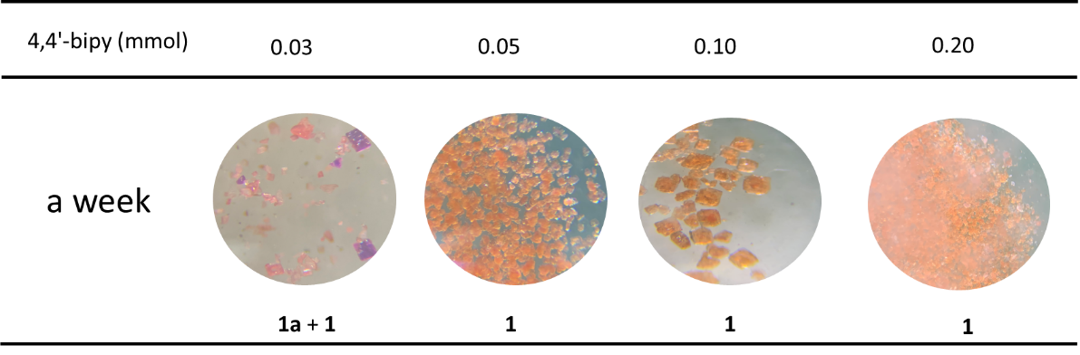
Figure S2. Effect of 4,4'-bipy dosage on crystal transformation

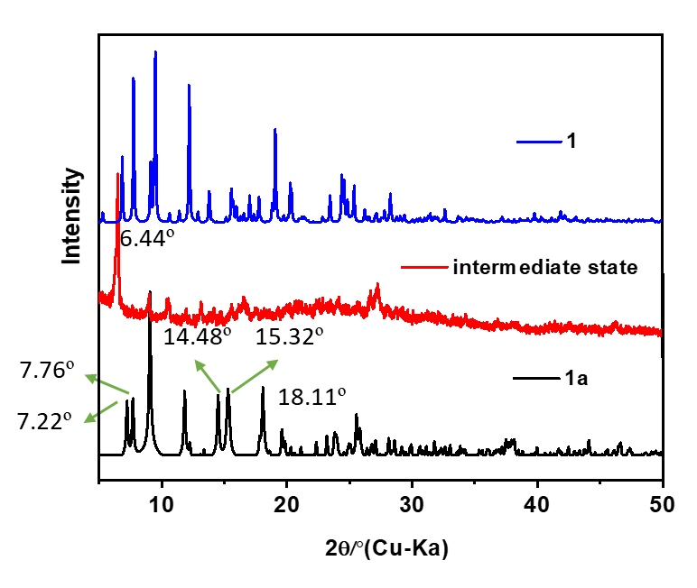
Figure S3. PXRD patterns of precursor, transition state and compound 1.

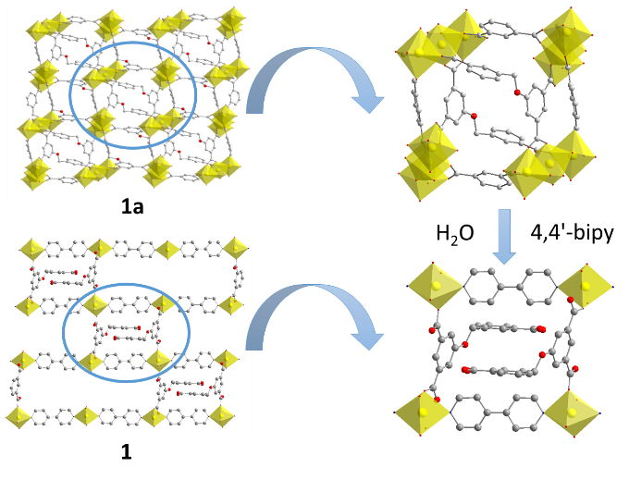
Figure S4. Possible transformation process from compound 1a to compound 1
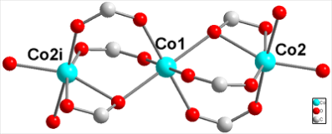
1a 2
Figure S5. The trinuclear Co unit in 1a, The dinuclear Co unit in 2.

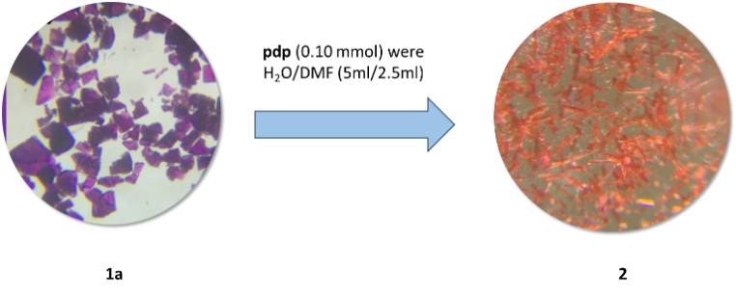
Figure S6. Optical micrographs showing the crystal-to-crystal transformation from 1a to 2.
1 | 2
Figure S7. The FT-IR spectra of compounds 1-2.
1 | 2
Figure S8. The PXRD patterns of compounds 1-2 and the simulated spectra.
1 | 2
Figure S9. TGA curves for compounds 1-2

