Supplementary Information
Supplementary Figure 1.
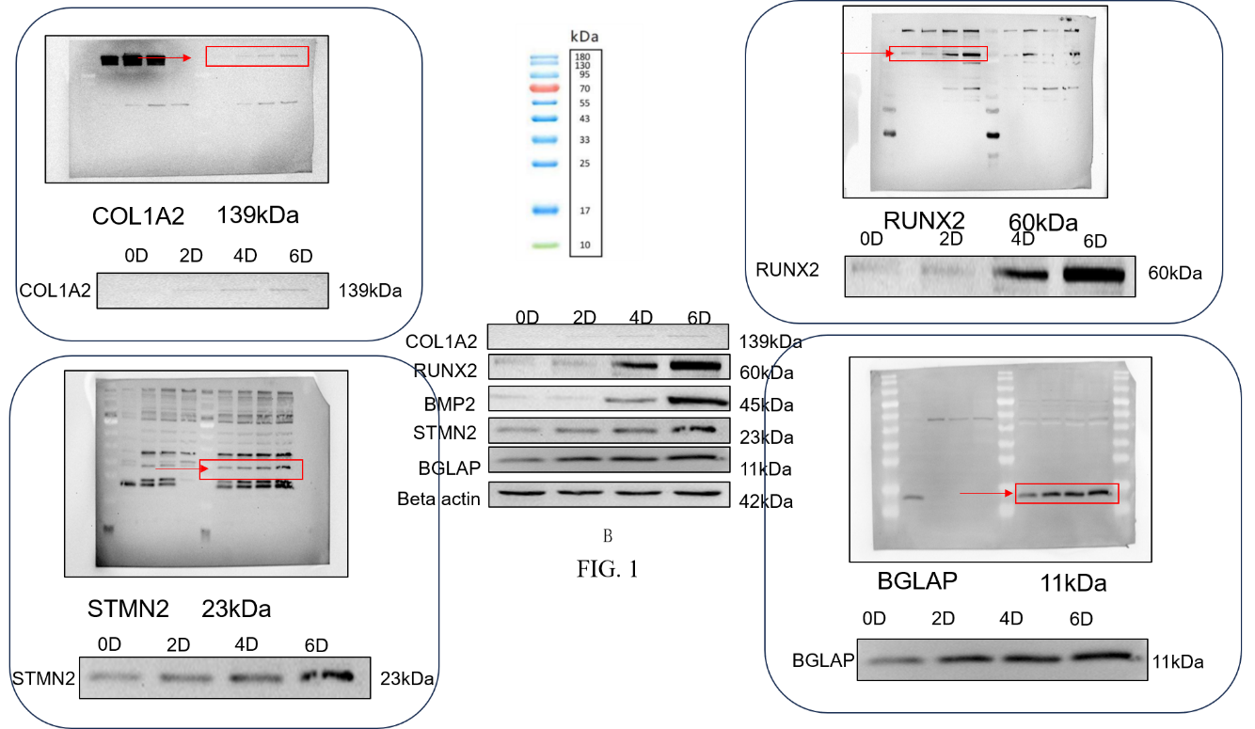
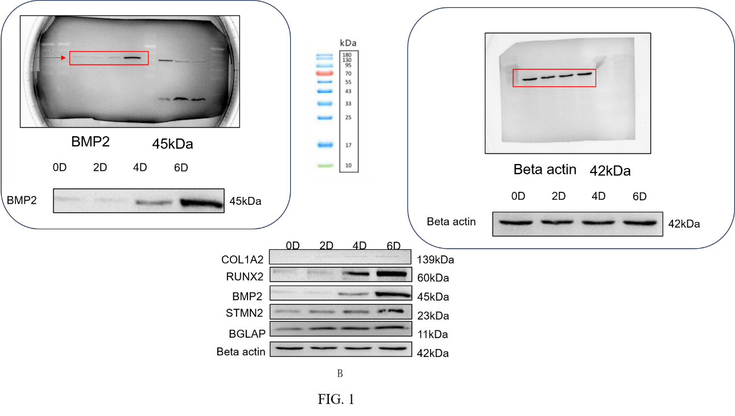
Supplementary Figure 1. Original Western blot membranes corresponding to Figure 1B, showing STMN2, BMP2, BGLAP, RUNX2, and COL1A2 protein levels during osteogenic differentiation of BMSCs.

Supplementary Figure 2.
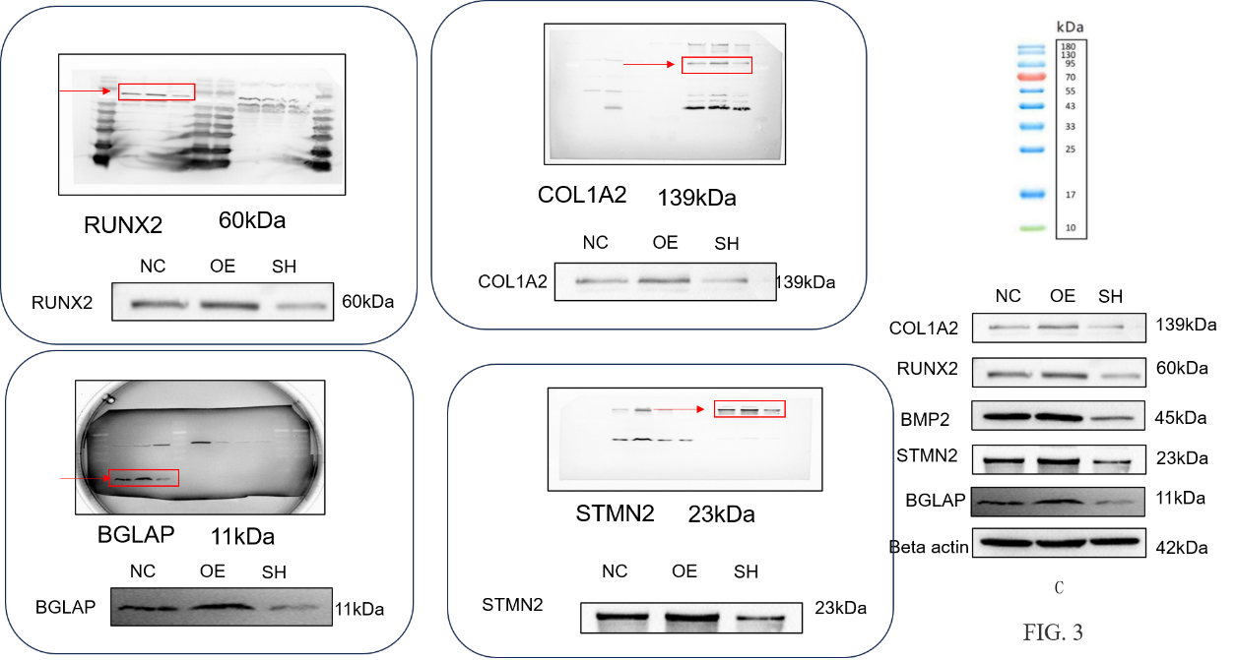
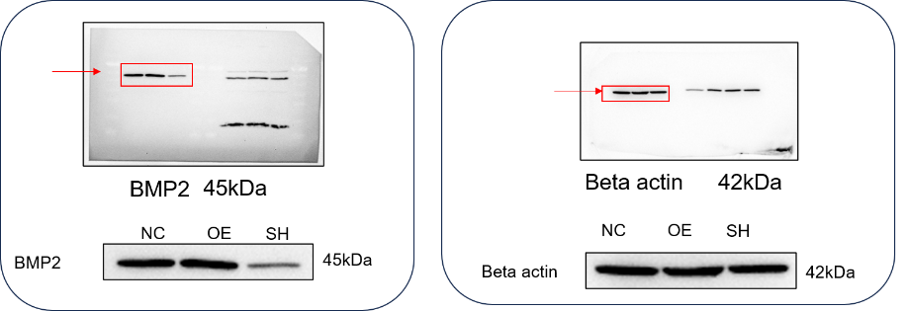
Supplementary Figure 2. Original Western blot membranes corresponding to Figure 3C, showing STMN2, BMP2, BGLAP, RUNX2, and COL1A2 protein levels in the STMN2-overexpressing group and the knockdown group.

Supplementary Figure 3.
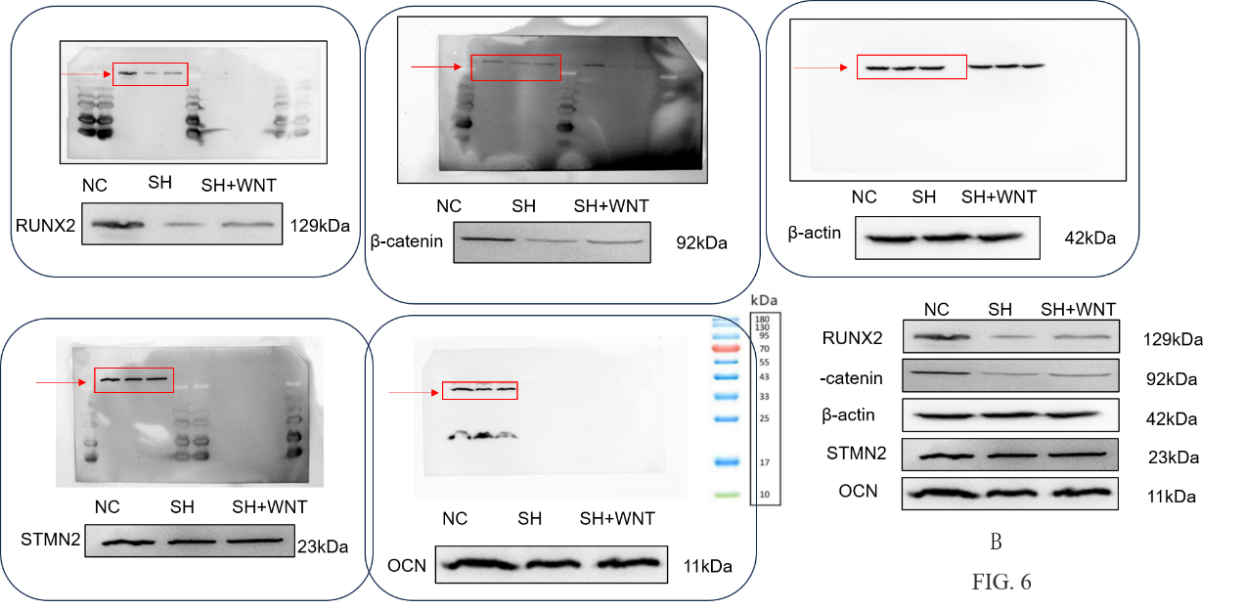

Supplementary Figure 3. Original Western blot membranes corresponding to Figure 6B, showing that the protein levels of β-catenin, RUNX2, and OCN were lower in the knockdown group, but this effect was partially reversed by treatment with a Wnt pathway agonist.

