Supplement to article: Spatially prioritizing wetland conservation decisions for climate adaptation: An Illinois case study

Authors and affiliations
Chelsea M. Peterson^{a,*}, Jeffrey W. Matthewsª
ªDepartment of Natural Resources and Environmental Sciences, University of Illinois Urbana-Champaign, Urbana, IL, USA

*Corresponding author
Chelsea M. Peterson
1102 S Goodwin Ave, Urbana, IL 61801, USA
cmptrsn2@illinois.edu

Updated policy scenarios
This appendix summarizes how our estimates for unprotected wetland area and stream length changed relative to Peterson et al. (2025) after updating stream flow permanence categories with data from Brinkerhoff et al. (2024); removing lakes and ponds that do not intersect intermittent or perennial flowlines; considering a narrower range of potential flow-permanence, buffer-distance, and flood-duration thresholds; and using 2024 instead of 2023 data from the National Land Cover Dataset (NLCD) to remove cropped and developed polygon inclusions. Along with state-level summaries for unprotected wetland area and stream length, we provide boxplots for the distributions of county-level unprotected wetland areas and percentages and wetland areas converted to row crops and impervious cover between 1987 and 2024 across six Illinois regions that approximate its major natural divisions (Figure A1).
To help explain spatial patterns in protected non-WOTUS wetland area, we also made county-level maps of non-WOTUS wetland area managed for biodiversity, managed for multiple uses, and regulated by county ordinances. Similarly, to explain spatial pattens in total non-WOTUS wetland area, we made county-level maps for the total area of wetlands behind a levee, geographically isolated from relatively permanent waters, and with flood durations that are not at least semipermanent. These maps rely on wetland areas averaged over four buffer-distance and flow-permanence thresholds that were used to evaluate uncertainty in the federal agency standard for relatively permanent waters.

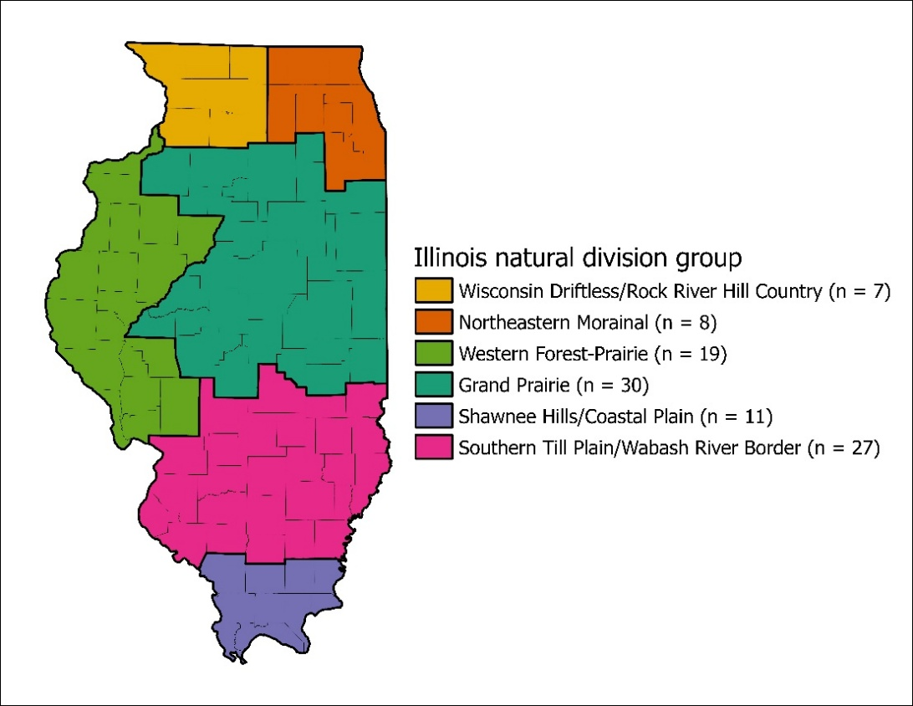
Figure A1. Six Illinois regions that approximate its major natural divisions: Wisconsin Driftless/Rock River Hill Country (n = 7), Northeastern Morainal (n = 8), Western Forest-Prairie (n = 19), Grand Prairie (n = 30), Southern Till Plain/Wabash River Border (n = 27), and Shawnee Hills/Coastal Plain (n = 11).
Table A1. Summary of which states are entirely reliant on WOTUS for wetland protection, have limited protection of non-WOTUS wetlands, and have broad protection of non-WOTUS wetlands based on the classifications in Kihslinger et al. (2023) and post-Sackett changes based on recently passed legislation.
State policy scope | Kihslinger et al. (2023) | Post-Sackett change | Post-Sackett total
Reliant on WOTUS | Alabama, Alaska, Arkansas, Colorado, Delaware, Georgia, Hawai’i, Idaho, Iowa, Kansas, Kentucky¹, Louisiana², Mississippi, Missouri, Montana, Nebraska, New Mexico, Nevada, North Dakota, Oklahoma, South Carolina, South Dakota, Texas, Utah (24 states) | +North Carolina³  ‒Colorado⁴  ‒Delaware⁵  ‒New Mexico⁶  Net change: ‒2 states | 22 states
Limited coverage non-WOTUS | Arizona, Illinois, Indiana⁷, North Carolina, Ohio, Washington D.C., West Virginia, Wyoming (7 states + D.C.) | +Tennessee⁸  ‒North Carolina  Net change: 0 states | 7 states + D.C.
Broad coverage non-WOTUS | California, Connecticut, Florida, Maine, Maryland⁹, Massachusetts, Michigan, Minnesota, New Hampshire, New Jersey, New York, Oregon, Pennsylvania, Vermont, Virginia, Rhode Island, Tennessee, Washington, Wisconsin (19 states) | +Colorado  +Delaware  +New Mexico  ‒Tennessee  Net change: +2 states | 21 states
¹Kentucky General Assembly (2025), ²Louisiana General Assembly (2025), ³North Carolina General Assembly (2023), ⁴Colorado General Assembly (2024), ⁵Delaware General Assembly (2026), ⁶New Mexico Legislature (2025), ⁷Indiana General Assembly (2024) ⁸Tennessee State Legislature (2025), ⁹Maryland General Assembly (2024)

State and county-level stream length estimates
When only considering National Hydrography Dataset Plus High Resolution (NHDPlus HR) attribute data, we estimated that 130,432 km (67.7%) of Illinois flowlines are nonperennial or isolated from the downstream network (Table A2). However, by updating the NHDPlus HR attributes with ephemeral stream data (Brinkerhoff et al., 2024), we revised this estimate to 135,159 km (70.1%). This change corresponded to a decrease in perennial length from 62,248 to 57,522 km (-2.5%), decrease in intermittent length from 126,675 to 49,067 km (-40.3%), and increase in ephemeral length from 2,266 to 84,600 km (+42.7%). Hence, there was a minimal change in the total ephemeral and intermittent stream length that could fall outside of federal jurisdiction, but there was a substantial change in the length of ephemeral streams, which are almost certain to be non-WOTUS. Although total nonperennial length increased for all counties, there were not strong spatial trends beyond the largest increases occurring in northwestern Illinois, along the Illinois River, and in southern Illinois (Figure A2).

Table A2. Comparison of total flowline lengths for Illinois in each flow permanence category (i.e., hydrologic classification) between NHD-based and Brinkerhoff-updated data
Flow permanence category  (hydrologic classification) | NHD-based |  | Brinkerhoff-updated |  | Difference (Brinkerhoff – NHD)
Flow permanence category  (hydrologic classification) | Length (km) | Percent of total (%) | Length (km) | Percent of total (%) | Length (km) | Percent of total (%)
Non-isolated perennial (1) | 62,248.1 | 32.3 | 57,521.5 | 29.9 | -4,726.6 | -2.5
Non-isolated intermittent (2) | 126,674.9 | 65.7 | 49,067.0 | 25.5 | -77,607.9 | -40.3
Non-isolated ephemeral (3) | 2,265.6 | 1.2 | 84,600.0 | 43.9 | +82,334.4 | +42.7
All isolated (4) | 1,491.5 | 0.8 | 1,491.5 | 0.8 | 0 | 0
Total isolated or nonperennial | 130,432.0 | 67.7 | 135,158.6 | 70.1 | +4,726.6 | +2.5

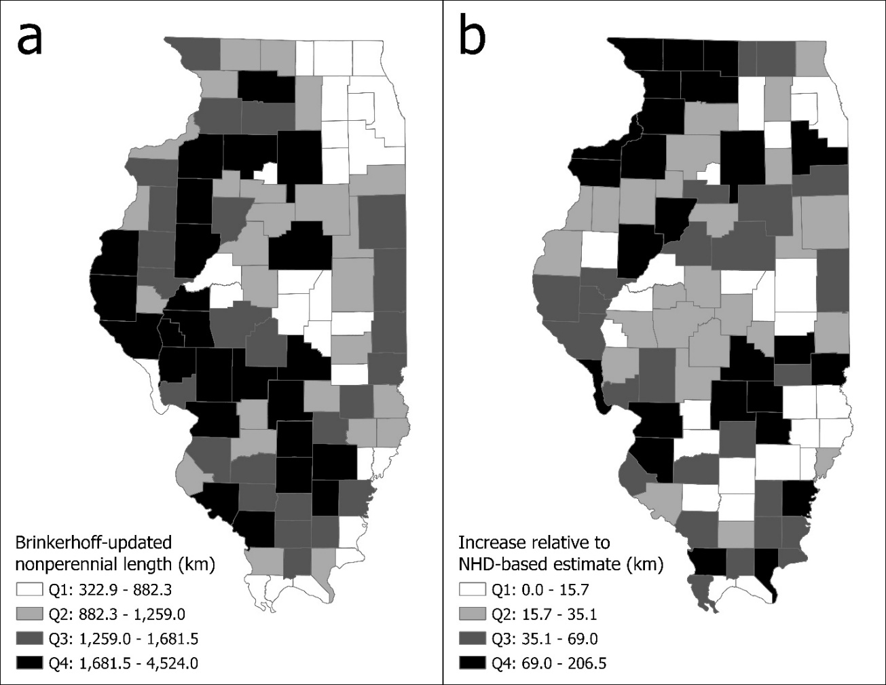
Figure A2. County-level estimates for (a) total and (b) increase in non-perennial flowline length after updating NHD-based flow permanence attributes with data from Brinkerhoff et al. (2024).

State- and county-level wetland area estimates
The updated flow permanence data and policy scenarios led to an estimated total non-WOTUS wetland area from 297,984 to 394,501 ha (75.3–99.7% of state wetland area) across wetland flood-duration cutoffs between Seasonally Flooded and Permanently Flooded (Figure A3; Table A3). Despite not influencing the spatial distribution across counties, this represents a change in estimated total non-WOTUS wetland area from -776 to 26,070 ha (-0.2–6.6% of state wetland area). Similarly, the non-WOTUS wetland area without another form of legal protection beyond the CWA (unprotected non-WOTUS wetland area) was increased to between 236,042 and 290,125 ha (59.6–73.3% of state wetland area), representing a change from -978 to 17,825 ha (-0.2–4.5% of state wetland area) (Figure A3; Table A4).

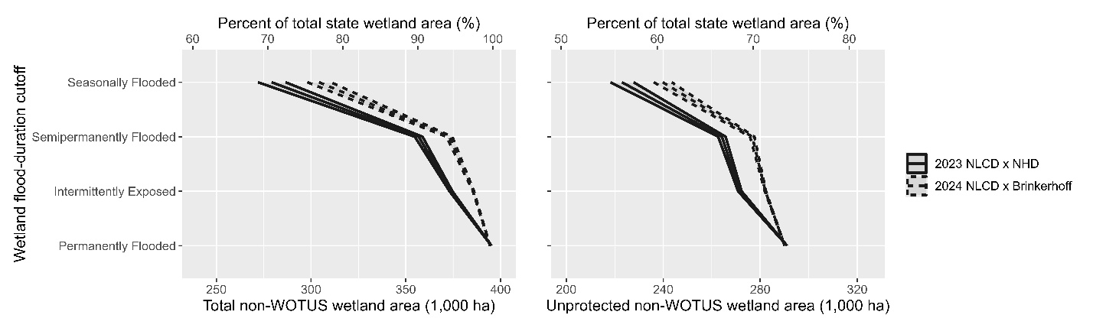
Figure A3. (a) Total and (b) unprotected non-WOTUS wetland area across wetland flood-duration cutoffs. The central line represents the mean at the given cutoff; the band represents the upper and lower bound at the same cutoff across four buffer-distance and flow-permanence cutoffs. The solid black lines represent the estimates based on NHD flow permanence attributes and the 2023 National Land Cover Dataset (NLCD); the dashed black lines represent the estimates based on Brinkerhoff-updated flow permanence attributes and the 2024 NLCD.

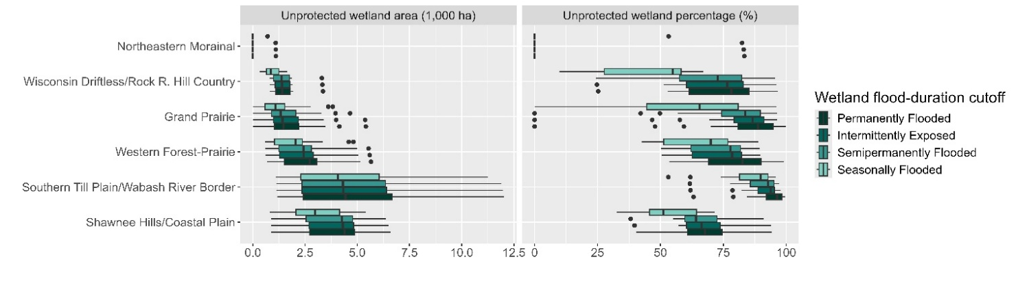
Figure A4. Boxplots illustrating distributions of county-level unprotected non-WOTUS wetland areas across wetland flood-duration cutoffs, averaged over four buffer-distance and flow-permanence cutoffs, within six Illinois regions that approximate its major natural divisions.

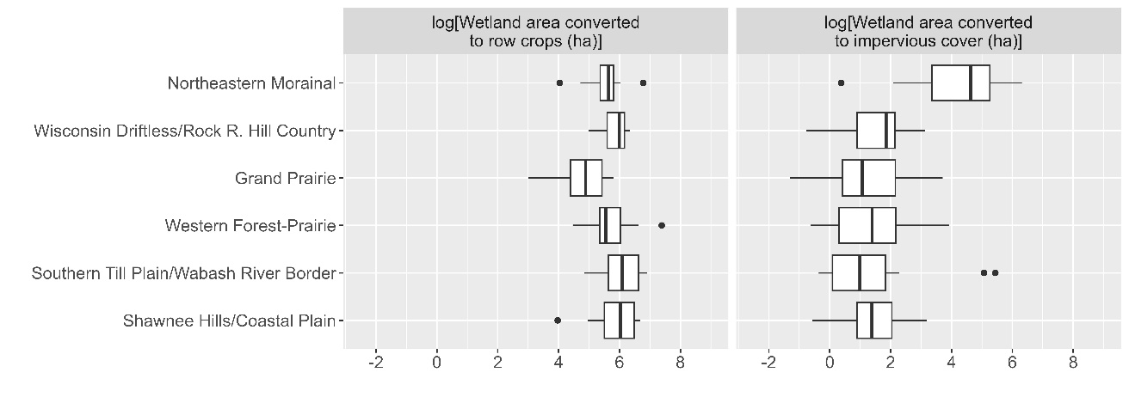
Figure A5. Boxplots illustrating distributions of total county-level wetland areas converted to row crops and medium or high intensity impervious cover between 1987 and 2024 within six Illinois regions that approximate its major natural divisions.

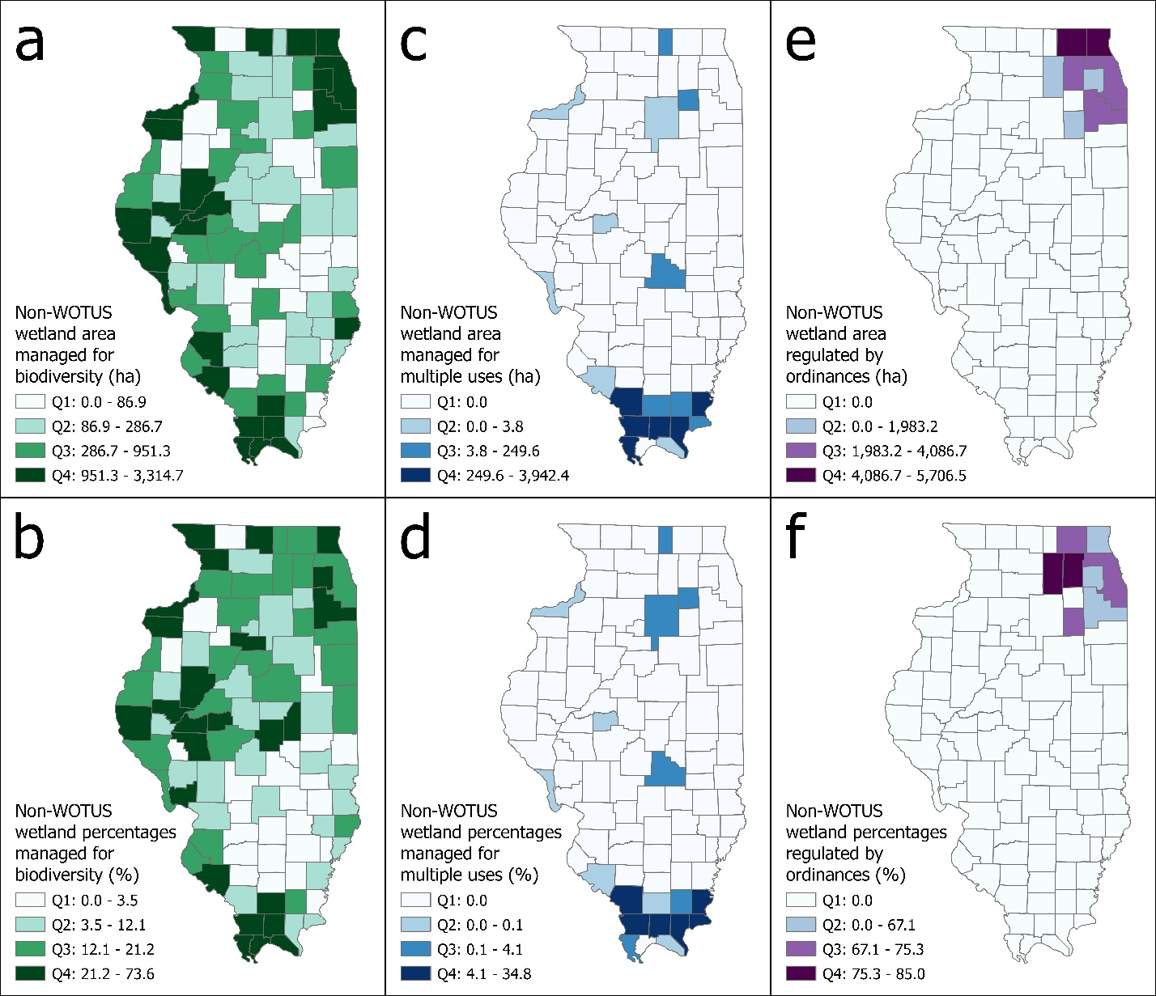
Figure A6. Average non-WOTUS wetland areas and percentages (a-b) managed for biodiversity, (c-d) managed for multiple uses, and (e-f) regulated by county ordinances with permitting and mitigation requirements if all wetlands without at least semipermanent flooding are excluded from WOTUS.

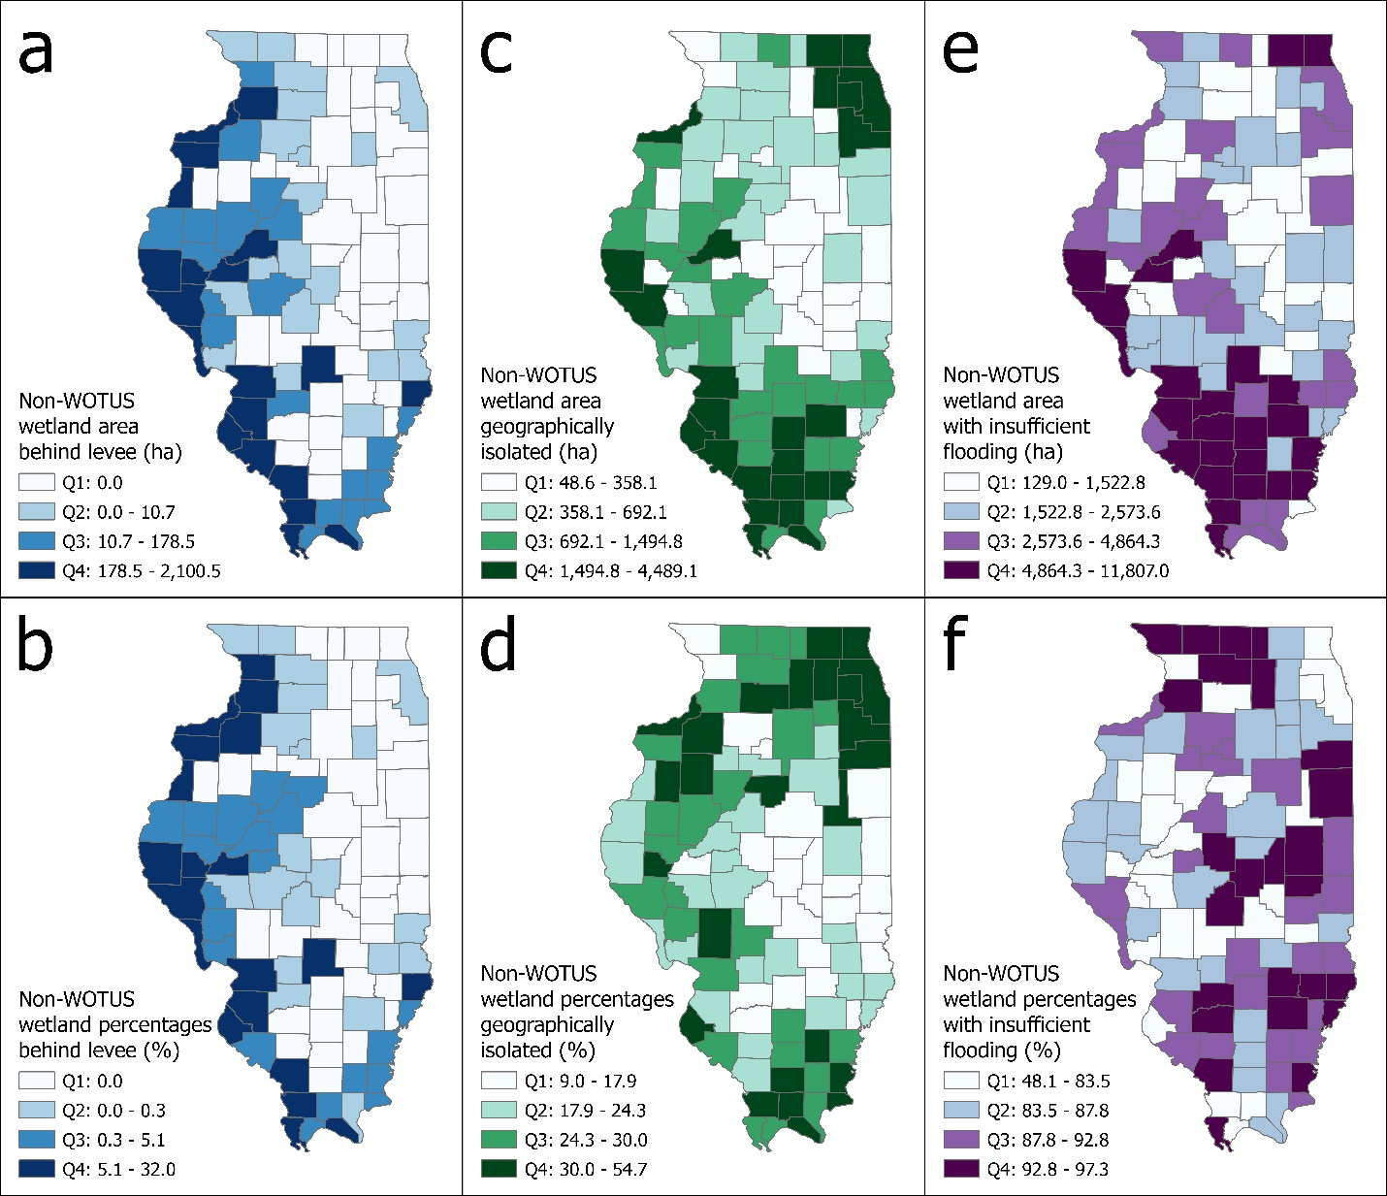
Figure A7. Average non-WOTUS wetland areas and percentages by reason for lack of federal jurisdiction: (a-b) within a leveed area, (c-d) geographically isolated from relatively permanent waters, and (e-f) flood duration less than semipermanent. Note that these criteria are not mutually exclusive, so multiple criteria could exclude the same wetland from CWA regulation.

Table A3. Comparison of average total non-WOTUS (T-NW) wetland area and percents of total state wetland area between NHD-based and Brinkerhoff-updated jurisdictional water network across wetland flood-duration cutoffs. The range in parentheses represents the minimum and maximum over four buffer-distance and flow-permanence cutoffs. The percentages are calculated out of the remaining total state wetland area (395,845 ha) based on the 2024 NLCD. The Brinkerhoff-updated scenarios also account for the removal of non-jurisdictional lakes and ponds in the NHD due to their lack of continuous surface connectivity to flowlines.
Flood-duration cutoff  (Drier → Wetter) | NHD-based with 2023 NLCD |  | Brinkerhoff-updated with 2024 NLCD |  | Change (Brinkerhoff - NHD)
Flood-duration cutoff  (Drier → Wetter) | Area (ha) | Percent of state wetland area (%) | Area (ha) | Percent of state wetland area (%) | Area (ha) | Percent of state wetland area (%)
Seasonally Flooded | 279,122.7  (271,913.8–286,474.4) | 70.5  (68.7–72.4) | 304,184.5 (297,984.0–310,394.0) | 76.8  (75.3–78.4) | 25,061.7 (23,919.5–26,070.2) | 6.3  (6.0–6.6)
Semipermanently Flooded | 356,796.8  (354,750.7–358,835.4) | 90.1  (89.6–90.7) | 373,002.0 (371,463.6–374,557.4) | 94.2  (93.8–94.6) | 16,205.3 (15,722.0–16,712.9) | 4.1  (4.0–4.2)
Intermittently Exposed | 373,844.7  (373,061.1–374,609.4) | 94.4  (94.2–94.6) | 385,715.1 (385,407.5–385,998.6) | 97.4  (97.4–97.5) | 11,870.4 (11,389.3–12,346.3) | 3.0  (2.9–3.1)
Permanently Flooded | 395,216.7  (395,175.3–395,256.3) | 99.8  (99.8–99.9) | 394,462.0 (394,425.0–394,500.5) | 99.7  (99.6–99.7) | -754.7  (-755.8–  -750.2) | -0.2  (-0.2– -0.2)

Table A4. Comparison of average unprotected non-WOTUS (UP-NW) wetland area and percents of total state wetland area between NHD-based and Brinkerhoff-updated jurisdictional water network across wetland flood-duration cutoffs. The range in parentheses represents the minimum and maximum over four buffer-distance and flow-permanence cutoffs. The percentages are calculated out of the remaining total state wetland area (395,845 ha) based on the 2024 NLCD. The Brinkerhoff-updated scenarios also account for the removal of non-jurisdictional lakes and ponds in the NHD due to their lack of continuous surface connectivity to flowlines.
Flood-duration cutoff  (Drier → Wetter) | NHD-based with 2023 NLCD |  | Brinkerhoff-updated with 2024 NLCD |  | Change (Brinkerhoff - NHD)
Flood-duration cutoff  (Drier → Wetter) | Area (ha) | Percent of state wetland area (%) | Area (ha) | Percent of state wetland area (%) | Area (ha) | Percent of state wetland area (%)
Seasonally Flooded | 222,943.3 (218,217.7–227,740.2) | 56.3  (55.1–57.5) | 239,782.0 (236,042.3 –243,475.1) | 60.6  (59.6–61.5) | 16,838.7 (15,734.9–17,824.7) | 4.3  (4.0–4.5)
Semipermanently Flooded | 264,194.2 (262,656.0–265,722.3) | 66.7  (66.4–67.1) | 276,705.8 (275,785.2–277,604.9) | 69.9  (69.7–70.1) | 12,511.6 (11,882.6–13,129.2) | 3.2  (3.0–3.3)
Intermittently Exposed | 271,604.6 (270,870.4–272,320.8) | 68.6  (68.4–68.8) | 282,135.1 (281,878.0–282,372.5) | 71.3  (71.2–71.3) | 10,530.5 (10,051.7–11,007.5) | 2.7  (2.5–2.8)
Permanently Flooded | 291,070.6 (291,036.0–291,103.4) | 73.5  (73.5–73.5) | 290,093.9 (290,064.5–290,125.1) | 73.3  (73.3–73.3) | -976.7  (-978.3–  -971.5) | -0.2  (-0.2– -0.2)

Ecosystem services
This appendix provides figures and tables summarizing the regional distributions of four wetland ecosystem services estimated at the county level: wetland-dependent plant species richness, wetland-dependent amphibian and reptile richness, total carbon storage in soil plus biomass, and aboveground flood storage capacity (total basin volume). We also provided a table summarizing the total number of wetland-dependent and state-threatened herpetofauna across different taxa (Table B1).

Table B1. Summary of the wetland-dependent and threatened or endangered status of Illinois herpetofauna, including amphibians (frogs, toads, salamanders) and reptiles (turtles, lizards, snakes), based on Illinois Natural History Survey species lists (INHS, 2026), International Union for Conservation of Nature habitat requirements (IUCN, 2026), and the official Illinois List of Endangered and Threatened Species (Endangered Species Protection Board, 2025).
Taxa | State total | Wetland-dependent | State threatened or endangered | Wetland-dependent and state threatened or endangered
Frogs/toads | 24 | 24 | 3 | 3
Salamanders | 21 | 16 | 6 | 5
Amphibian total | 45 | 40 | 9 | 8
Turtles | 17 | 11 | 7 | 4
Lizards/snakes | 48 | 29 | 9 | 5
Reptile subtotal | 65 | 40 | 16 | 9
Overall total | 110 | 80 | 25 | 17

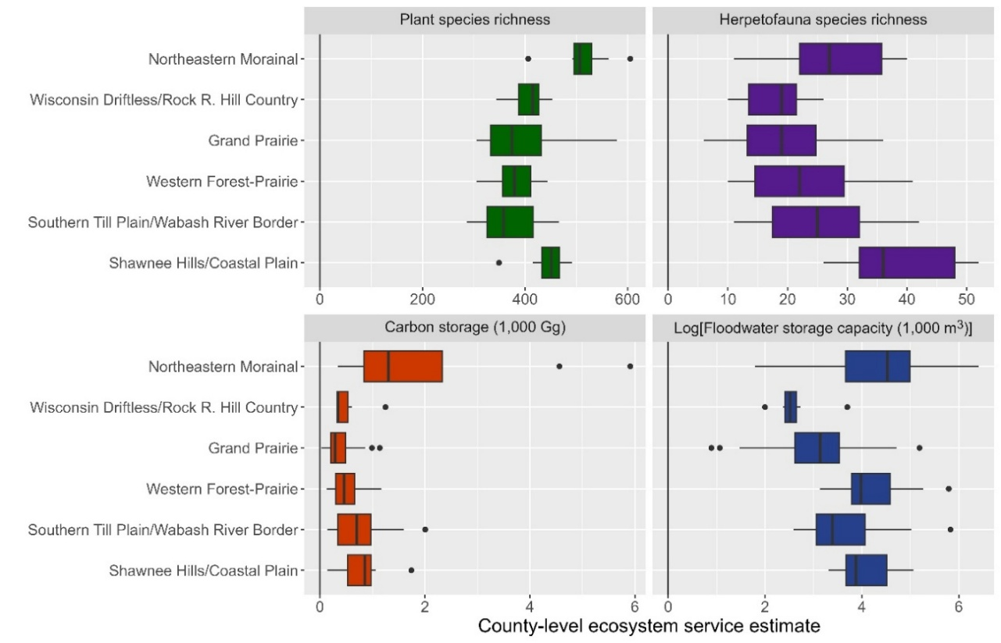
Figure B1. Boxplots illustrating distributions of four county-level ecosystem services within six Illinois regions that approximate its major natural divisions.

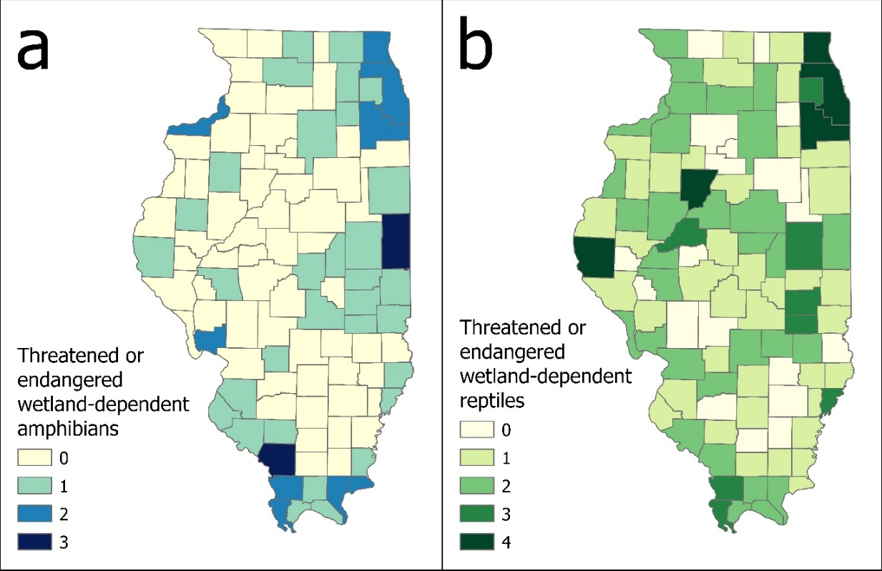
Figure B2. Total state threatened or endangered wetland-dependent (a) amphibians and (b) reptiles by county based on the official Illinois List of Endangered and Threatened Species (Endangered Species Protection Board, 2025).

Climate extremes
This appendix summarizes regional distribution of county-level projections of four climate extremes that we identified as posing risks to the four wetland services quantified. The four extremes include the projected reduction in annual frost days and increases in annual days with the maximum temperature exceeding 100°F [38°C], annual maximum dry spell length, and annual maximum wet spell length. To estimate these, we used Bayesian Model Averaging coefficients to take a weighted multi-model mean of 16 global climate models. Then, we subtracted the ensemble means during the historical period (1981-2010) from those during two future time intervals (2041-2070 and 2071-100) for two Shared Socioeconomic Pathways (SSP2-4.5 and SSP3-7.0).

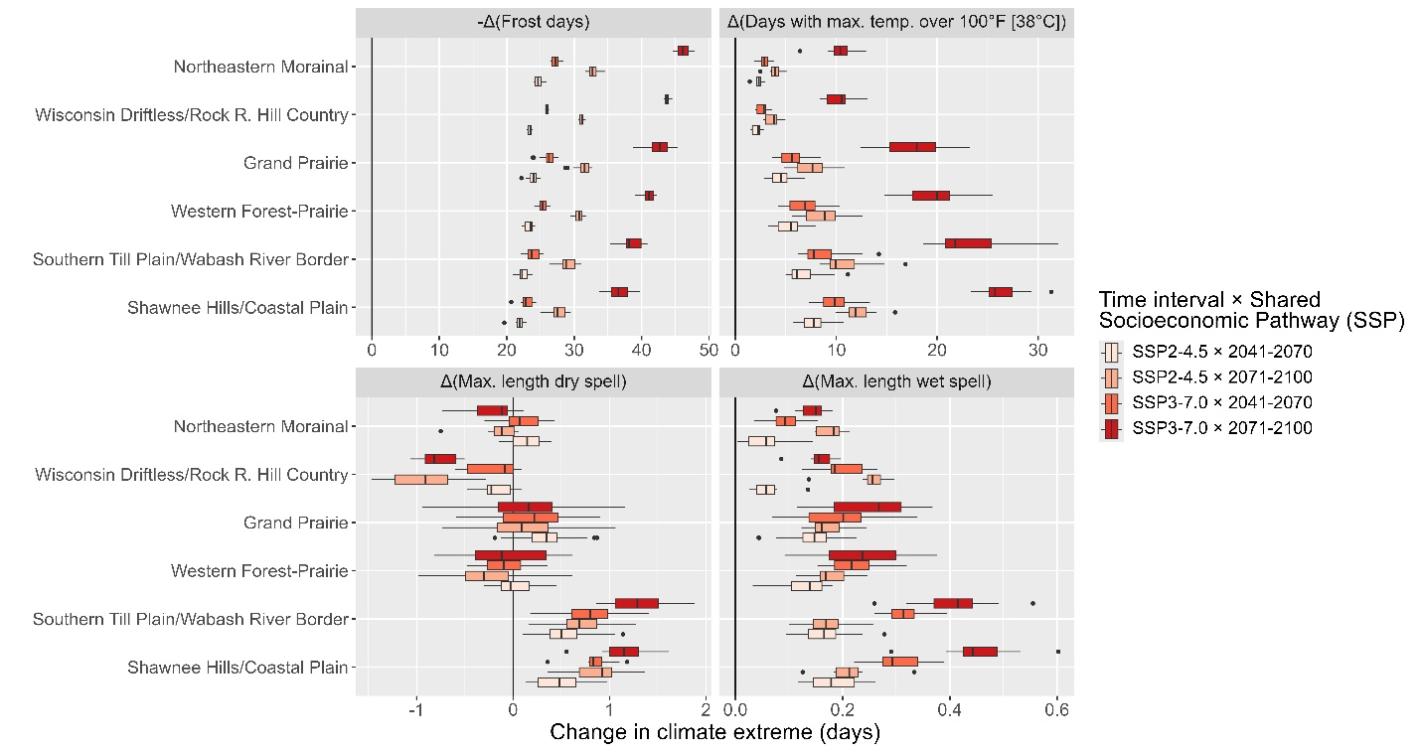
Figure C1. Boxplots illustrating distributions of changes in four county-averaged climate extremes or thresholds across two future climatology periods (2041-2070 and 2071-2100) and two shared socioeconomic pathways (SSP2-4.5 and SSP3-7.0) within six Illinois regions that approximate its major natural divisions.

Results supplement
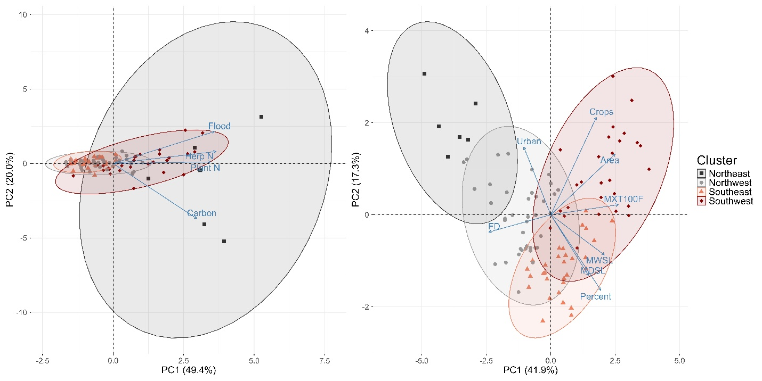
Figure D1. First two principal components of separate principal component analyses on the four service variables and eight risk variables. The abbreviations for the variables are reduction in frost days (FD), increase in days with maximum temperature over 100°F [38°C] (MXT100F), increase in maximum dry spell length (MDSL), and increase in maximum wet spell length (MWSL), plant species richness (Plant N), herpetofauna species richness (Herp N), carbon storage (Carbon), floodwater storage capacity (Flood), unprotected wetland area (Area) and percentage (Percent), and wetland area converted to row crops (Crops) and impervious cover (Urban) between 1987 and 2024.

References
Act 105, 94 SB (2025). https://legis.la.gov/legis/BillInfo.aspx?s=25RS&b=SB94&sbi=y
An Act Relating to Environmental Protection and Declaring an Emergency, 89 SB (2025). https://apps.legislature.ky.gov/record/25rs/sb89.html
An Act to Amend Tennessee Code Annotated, Title 4; Title 11, Chapter 14, Part 4; Title 66; Title 67, Chapter 4, Part 4 and Title 69, Relative to Wetlands, 670 SB (2025). https://legiscan.com/TN/drafts/SB0670/2025
An Act to Amend the Indiana Code Concerning Environmental Law, 1383 HB (2024). https://legiscan.com/IN/bill/HB1383/2024
Brinkerhoff, C. B., Gleason, C. J., Kotchen, M. J., Kysar, D. A., & Raymond, P. A. (2024). Ephemeral stream water contributions to United States drainage networks. Science, 384(6703), 1476–1482. https://doi.org/10.1126/science.adg9430
Clean Water Justice Act, 653 SB (2024).
Endangered Species Protection Board. (2025, October 31). The Illinois List of Endangered and Threatened Species. https://dnr.illinois.gov/espb/etlistandlistreviewandrevision/e-t-list-2025.html
Illinois Natural History Survey (INHS). (2026). INHS Herpetology Collection. Prairie Research Institute. Species Lists and Distributions. https://herpetology.inhs.illinois.edu/resources/species-lists/
International Union for Conservation of Nature (IUCN). (2026). The IUCN Red List of Threatened Species (Version 2025-2). https://www.iucnredlist.org/en
Kihslinger, R., McElfish, J. M., Luedke, H., & Ray, G. (2023). Strategies for states/tribes for protection of non-WOTUS waters: A taxonomy. Environmental Law Institute.
North Carolina Farm Act of 2023, 582 SB (2023). https://www.ncleg.gov/BillLookUp/2023/S582
Peterson, C. M., Nieset, J. E., Monson, J. L., Pociask, G. E., Wilm, B. W., Marcum, P. B., & Matthews, J. W. (2025). A national policy with local consequences: Quantifying the downstream effects of Sackett on Illinois wetlands and communities. Journal of Environmental Management, 392, 126931. https://doi.org/10.1016/j.jenvman.2025.126931
Pollutant Discharge Elimination System Act, 21 SB (2025). https://www.nmlegis.gov/Legislation/Legislation?Chamber=S&LegType=B&LegNo=21&year=25
Regulate Dredge & Fill Activities in State Waters, Pub. L. No. 1379, 24 HB (2024). https://leg.colorado.gov/bills/hb24-1379
The Wetlands Stewardship Act, 9 SB (2026). https://legis.delaware.gov/BillDetail/143028

