Supplementary Information for
Co-evaporated compositionally modulated interfaces in perovskite/Si tandems
Long-Hui Yang¹*, Qi-Bo Yuan¹*, Hong-Qiang Du^{1,5}*, Junke Jiang³, Min Zhang⁴, Jun-Gan Wang^{5,6}, Meng-Lei Xu^{5,6}, Gui-Jie Liang⁷, Keith McKenna³, Yi-Bing Cheng^{1,2}, Mathias Uller Rothmann²†, and Wei Li^{1,2}†
Affiliations:
¹State Key Laboratory of Advanced Technology for Materials Synthesis and Processing, Wuhan University of Technology, Wuhan, 430070, P. R. China.
²Foshan Xianhu Laboratory, Xianhu Hydrogen Valley, Foshan, 528200, P. R. China.
³School of Physics, Engineering and Technology, University of York, York, YO10 5DD, United Kingdom.
⁴Sichuan Yingfa Ruineng Technology CO., LTD., Yibin, Sichuan Province, China
⁵Jinko Solar Co., Ltd., Shangrao, 334100, P. R. China.
⁶Zhejiang Key Laboratory of Advanced Tandem Photovoltaic Technology, Jiaxing, 314416, P. R. China.
⁷Hubei Key Laboratory of Low-Dimensional Optoelectronic Materials and Devices Hubei University of Arts and Science Xiangyang 441053, China
†Corresponding author. Email: mathiasrothmann@xhlab.cn (M. U. R.), wei.li@whut.edu.cn (W. L.). *These authors contributed equally to this work.
Table of contents:
Supplementary Note S1 to Note S4
Figs. S1 to S32
Tables S1 to S2
References

Supplementary Note S1: First principles calculations
Density functional calculations were carried out with the projector augmented wave method and a plane wave basis set using the Vienna Ab initio Simulation Package (VASP) ^{1,2}. Using a similar approach to that employed in our previous work ³ we model the bulk FAPbI₃ structure using the slightly tetragonally distorted β-FAPbI₃ phase ⁴. We optimise the bulk FAPbI₃ structure using the PBESol exchange-correlation functional, a 6 × 6 × 4 gamma centered k-point grid for Brillouin zone sampling and a 500 eV plane wave cut-off to a force tolerance of 0.01 eVÅ⁻¹. The lattice constants obtained are a = 9.00 and c = 12.51 Å (corresponding to a pseudocubic structure with a = 6.36 and c = 6.23 Å, close to the experimental lattice constant for the room temperature cubic phase c = 6.36 Å).
Based on the STEM images an initial model for the FA₂PbI₄ phase is constructed from a supercell of the optimized β-FAPbI₃ phase by replacing selected Pb-I columns with FA columns. A commensurate interface between FA₂PbI₄ and FAPbI₃ and optimized using the PBESol exchange-correlation functional an equivalent k-point sampling density as for bulk β-FAPbI₃ (corresponding to a 4 x 1 x 1 k-point grid). We optimize at both constant volume and constant pressure to explore whether the FAI rich phase is constrained in a close to cubic structure close to the interface (as suggested by the STEM images) or has a tendency to deform. We do not find any significant change in the lattice parameters of the supercell (all change less than 0.1 Å or less than 1 degree) (Supplemental Figure 7).
Additionally, based on the STEM images and using the same approach as above we construct a model of a very thin layer of FAPbI₃ embedded within a larger region of FA₂PbI₄, again optimizing at both constant volume and constant pressure. In this case we also find only a small distortion from the cubic-like structure with all lattice parameter changes less than 0.1 Å or less than 2 degrees (Supplemental Figure 8).
We evaluated the electronic properties of the FA₂PbI₄/FAPbI₃ heterostructure models using DFTB calculations. This approach was chosen because hybrid functional or GW calculations for the full 3D/2D heterostructure models are computationally too expensive, while DFTB parameters developed for lead iodide perovskites have been shown to reproduce the band gaps, band edge orbital characters and band alignments of 3D and 2D lead iodide perovskites with reasonable accuracy ⁵. The projected density of states (PDOS) of the FAPbI₃/FA₂PbI₄ heterostructure shows no obvious additional states within the gap, indicating that the interface is electronically benign. The band edge charge densities are mainly localized in the FAPbI₃ region, showing that the frontier electronic states remain dominated by the 3D component. We note that the calculated heterostructure band gap of 1.74 eV is larger than that of the bulk FAPbI₃, due to finite thickness and confinement. In the 3D-in-2D nanostructure, the gap further increases to 2.05 eV and the region projected DOS shows stronger mixing between the 3D, interface and 2D components near the band edges, consistent with stronger confinement and interfacial hybridization. A bulk reference DFTB band edge analysis gives a small valence band offset (VBO) of approximately 0.02 eV and a much larger conduction band offset (CBO) of approximately 0.46 eV for FA₂PbI₄ relative to FAPbI₃ in the heterostructure. These results indicate that the FA₂PbI₄ phase mainly acts as an electron blocking barrier, while presenting favorable transfer for holes.
Electronic structure calculations for the FA₂PbI₄/FAPbI₃ 2D/3D heterostructure and 3D-in-2D nanostructure models were performed using the self-consistent charge density functional tight-binding method as implemented in DFTB ⁶. The lead iodide perovskite Slater-Koster parameter set “perov-1-0” was used ^{5,7–9}. Spin-orbit coupling (SOC) was included for the band structure and PDOS calculations. The SCC iterations were converged until the change in atomic charges between successive SCC cycles was below 1 × 10⁻⁷ e. The same parameter set and convergence criteria was used for the bulk FAPbI₃ and FA₂PbI₄ calculations and for the full heterostructure and nanostructure models. The Brillouin-zone sampling was chosen to maintain a comparable k-point density between the bulk and interfacial models.
For the region projected DOS analysis, atoms in the relaxed heterostructure and nanostructure models were assigned to 3D, interface and 2D regions according to their position in the structural model. In plane-wave DFT this is commonly obtained from the average electrostatic potential. In the present DFTB analysis, the corresponding shift is estimated from the difference between the PDOS onsets in the bulk reference and in the matching region of the heterostructure.
The valence-side and conduction-side PDOS-derived shifts are defined as:
$$ΔV_{D,V}^{3D−2D/3D}=E_{V,onset}^{3D−2D,3D}−E_{V,onset}^{3D,bulk}(1)$$
$$ΔV_{D,C}^{3D−2D/3D}=E_{C,onset}^{3D−2D, 3D}−E_{C,onset}^{3D,bulk}(2)$$
$$ΔV_{D,V}^{3D−2D/2D}=E_{V,onset}^{3D−2D,2D}−E_{V,onset}^{2D,bulk}(3)$$
$$ΔV_{D,C}^{3D−2D/2D}=E_{C,onset}^{3D−2D,2D}−E_{C,onset}^{2D,bulk}(4)$$
Here, $E_{V,onset}$ and $E_{C,onset}$ are the PDOS onsets on the valence and conduction sides, respectively. In practice, the onsets were identified from the energy at which the normalized PDOS rises above the band-edge background using the same onset criterion for the bulk reference and the corresponding region of the heterostructure. This avoids using the first non-zero DOS value, which is sensitive to numerical broadening and smearing.
The aligned local band edges in the heterostructure are then obtained from the bulk eigenvalue band edges:
$$E_{V}^{3D@3D−2D}=E_{VBM}^{3D,bulk}+ΔV_{D,V}^{3D−2D/3D} (5)$$
$$E_{C}^{3D@3D−2D}=E_{CBM}^{3D,bulk}+ΔV_{D,C}^{3D−2D/3D} (6)$$
$$E_{V}^{2D@3D−2D}=E_{VBM}^{2D,bulk}+ΔV_{D,V}^{3D−2D/2D} (7)$$
$$E_{C}^{2D@3D−2D}=E_{CBM}^{2D,bulk}+ΔV_{D,C}^{3D−2D/2D} (8)$$
Finally, the 2D-3D valence- and conduction-band offsets of the heterostructure are defined as:
$$ΔE_{V}^{3D−2D}=E_{V}^{2D@3D−2D}−E_{V}^{3D@3D−2D} (9)$$
$$ΔE_{C}^{3D−2D}=E_{C}^{2D@3D−2D}−E_{C}^{3D@3D−2D} (10)$$
The bulk eigenvalue of band edges was extracted directly from the bulk band calculation. The combination analysis of the bulk eigenvalue of band edges and PDOS gives the band alignment. For the FAPbI₃/FA₂PbI₄ heterostructure, the local 3D/2D band offsets were estimated using a PDOS-eigenvalue alignment procedure. The alignment between the isolated bulk references and the heterostructure regions was obtained from the corresponding PDOS onsets. The valence- and conduction-side PDOS-derived shifts were defined as the difference between the onset in the heterostructure region and that in the corresponding bulk reference. These shifts were applied to the bulk eigenvalue VBM and CBM obtained from the DFTB band eigenvalue. The resulting 3D/2D band offsets in heterostructure are $ΔE_{V}^{3D−2D}$ = 0.02 eV and $ΔE_{C}^{3D−2D}$= 0.46 eV, indicating an almost flat valence-band alignment and a substantial electron barrier associated with the 2D region.
Partial charge densities at the VBM and CBM were calculated without SOC using the same DFTB parameter set, because SOC resolved partial charge density analysis is not currently available in DFTB+. A technical correction to the C, N and H on-site energies was applied to remove spurious FA-derived molecular states from the inorganic band gap, this correction does not change the Pb- and I-dominated character of the frontier band edge states, which lead to successfully electronic structure prediction in the most recent paper ¹⁰.

Supplementary Note S2: STEM image simulations
STEM image simulations were performed using the multislice algorithm implemented in abTEM ¹¹. A [100]-oriented supercell of 2 × 2 × 2 unit cells was constructed from the refined crystal structure. The electrostatic potential was sampled on a grid of 0.045 Å per pixel. The probe-forming aperture was set to a convergence semi-angle of 25 mrad at an accelerating voltage of 300 kV, and the scan was performed with a pixel step of 0.5 Å. An annular dark-field detector spanning 25-200 mrad was used to collect the simulated HAADF-STEM signal. The simulated image was then compared with the experimental HAADF-STEM data to validate the atomic configuration at the 2D/3D heterojunction interface.

Supplementary Note S3: Geometric phase analysis (GPA) of HAADF-STEM images.
Strain maps were obtained from HAADF-STEM images using geometric phase analysis (GPA) ^{12,13}. The raw image (1024 × 1024 pixels, pixel size 0.0242 nm) was processed with a custom Python script. Two non-collinear Bragg reflections (g₁ and g₂, determined from the Fourier transform of the image) were selected for strain calculation. A circular Gaussian mask (σ = 4.0 pixels) was applied to each reflection in the Fourier domain. After inverse Fourier transform, the geometric phase was obtained by subtracting a reference phase plane fitted within an undistorted region of the crystal. The phase gradient method ¹⁴ was used to compute the local displacement gradient directly without phase unwrapping, yielding the in-plane strain tensor components ε_{xx}, ε_{yy}. A moderate Gaussian smoothing (σ = 2.0 pixels) was applied before differentiation to suppress noise. The final strain maps were cropped by 5% on each edge to remove FFT boundary artifacts, and are displayed with an RdBu diverging colour scale ranging from -5% (compressive) to +5% (tensile).

Supplementary Note S4: Calculation of V_{OC} loss
According to the reciprocity relationship between photovoltaic external quantum efficiency (EQE_{PV}) and electroluminescence (EL), the V_{OC} of a solar cell can be calculated with the equation listed below: ^{15,16}
$$V_{OC}=\frac{k_{B}T}{q}\ln\left(\frac{J_{SC}}{J_{0}}\right) (11)$$
where $q$ is the elemental charge, $k_{B}$ is the Boltzmann constant, $T$ is temperature, $J_{SC}$ is short-circuit current, and $J_{0}$ is dark saturation current. $J_{SC}$ and $J_{0}$ are expressed as the equations:
$$\begin{matrix} & J_{SC}=q∫_{0}^{∞} {EQE}_{PV}(E)ϕ_{AM1.5}(E)dE (12) \\ & J_{0}=\frac{q}{EQE_{EL}}∫_{0}^{∞} {EQE}_{PV}(E)ϕ_{BB}(E)dE (13)\end{matrix}$$
$$ϕ_{BB}\left(E\right)=\frac{2πE^{2}}{h^{3}c^{2}}\frac{1}{\exp\left(\frac{E}{k_{B}T}\right)−1} (14)$$
Where ${EQE}_{PV}$ is photovoltaic external quantum efficiency, ${EQE}_{EL}$ is electroluminescence external quantum efficiency, $ϕ_{AM1.5}$ is solar cell radiative spectrum, $ϕ_{BB}$ is black-body radiative spectrum, $c$ is light speed in vacuum. In the thermodynamic efficiency limit:
- The EQE_{PV} is described with a Heaviside step function, where
${EQE}_{PV}(E)=\left\{\begin{matrix}1,E≥E_{g} \\ 0,E<E_{g}\end{matrix}\right.(15)$;
(2) only the photons with energy larger than bandgap ($E_{g}$) can be absorbed;
(3) all recombination is radiative (${EQE}_{EL}$=1). Therefore, J_{SC} and J₀ in S-Q limit can be expressed by:
$$\begin{matrix} & J_{SC}^{SQ}=q∫_{E_{g}}^{∞} ϕ_{AM1.5}(E)dE (16) \\ & J_{0}^{SQ}=q∫_{E_{σ}}^{∞} ϕ_{BB}(E)dE (17)\end{matrix}$$
Therefore, the V_{OC} in the radiative limit is:
$${ V}_{OC}^{SQ}=\frac{k_{B}T}{q}\ln\left(\frac{J_{SC}^{SQ}}{J_{0}^{SQ}}\right) (18)$$
Considering the assumption of the radiative limit, $V_{OC}^{SQ}$ can be degraded to V_{OC} with 3 loss components. The first V_{OC} loss component, ${∆V}_{OC}^{SC}$ originates from the non-ideal ${EQE}_{PV}$, which is less than 100 %. In this condition, the short-circuit current density can be expressed by:
$$J_{SC}=q∫_{0}^{∞} {EQE}_{PV}(E)ϕ_{AM1.5}(E)dE (19)$$
$ΔV_{OC}^{SC}$ is listed below:
$$ΔV_{OC}^{SC}=V_{OC}^{SQ}−\frac{k_{B}T}{q}\ln\left(\frac{J_{SC}}{J_{0}^{SQ}}\right)=\frac{k_{B}T}{q}\ln\left(\frac{J_{SC}^{SQ}}{J_{SC}}\right) (20)$$
The second V_{OC} loss component, $ΔV_{OC}^{rad}$, is obtained from the energy loss associated with extra thermal radiation of a solar cell in dark. In experiments, the ${EQE}_{PV}$ extends into the sub-bandgap region, where the black-body radiation increases as the photo energy lowers. Thus, this sub-bandgap ${EQE}_{PV}$ increases the dark saturation current. The dark saturation current in this condition is written as:
$$J_{0}^{rad}=q∫_{0}^{∞} {EQE}_{PV}\left(E\right)ϕ_{BB}\left(E\right)dE (21)$$
therefore, the radiative V_{OC} loss, $ΔV_{OC}^{rad}$, is:
$$ΔV_{OC}^{rad}=\frac{k_{B}T}{q}\ln\left(\frac{J_{SC}}{J_{0}^{SQ}}\right)−\frac{k_{B}T}{q}\ln\left(\frac{J_{SC}}{J_{0}^{rad}}\right)=\frac{k_{B}T}{q}\ln\left(\frac{J_{0}^{rad}}{J_{0}^{SQ}}\right) (22)$$
The third V_{OC} loss component, $ΔV_{OC}^{nonrad}$, is due to the non-radiative recombination in device, which can be written as:
$$ΔV_{OC}^{nonrad}=\frac{k_{B}T}{q}\ln\left(\frac{J_{SC}}{J_{0}^{rad}}\right)−{ΔV}_{OC} (23)$$
Combining Equation 13 and Equation 21, we know that $J_{0}^{rad}$ =${EQE}_{EL}⋅ J_{0}$, so combining with Equation 11, Equation 23 can be rewritten as:
$$ΔV_{OC}^{nonrad}=\frac{k_{B}T}{q}\ln\left(\frac{J_{SC}}{{EQE}_{EL} ⋅ J_{0}}\right)−\frac{k_{B}T}{q}\ln\left(\frac{J_{SC}}{J_{0}}\right)=−\frac{k_{B}T}{q}\ln\left({EQE}_{EL}\right) (24)$$
Therefore, the V_{OC} loss can mainly be attributed to three factors:
$$\begin{matrix}qΔV & =E_{g}−qV_{OC} \\ & =\left(E_{g}−qV_{OC}^{SC}\right)+\left(qV_{OC}^{SC}−qV_{OC}^{rad}\right)+\left(qV_{OC}^{rad}−qV_{OC}\right) \\ & =\left(E_{g}−qV_{OC}^{SC}+qΔV_{OC}^{SC}\right)+ΔqV_{OC}^{rad}+ΔqV_{OC}^{non−rad} \\ & =q\left(ΔV_{1}+ΔV_{2}+ΔV_{3}\right)\end{matrix} (25)$$
Here, q represents the elementary charge, $ΔV$ denotes the total voltage loss, $E_{g}$ stands for the bandgap of the perovskite, $V_{OC}^{SC}$ corresponds to the radiative efficiency limit, $V_{OC}^{rad}$ represents the V_{OC} when only radiative recombination occurs in PSCs, $ΔV_{OC}^{SC}$ accounts for the V_{OC} loss attributed to the non-ideal EQE above the bandgap, $ΔV_{OC}^{rad}$ denotes the V_{OC} loss of the sub-bandgap radiative recombination, and $ΔV_{OC}^{non−rad}$ signifies the V_{OC} loss of non-radiative recombination.

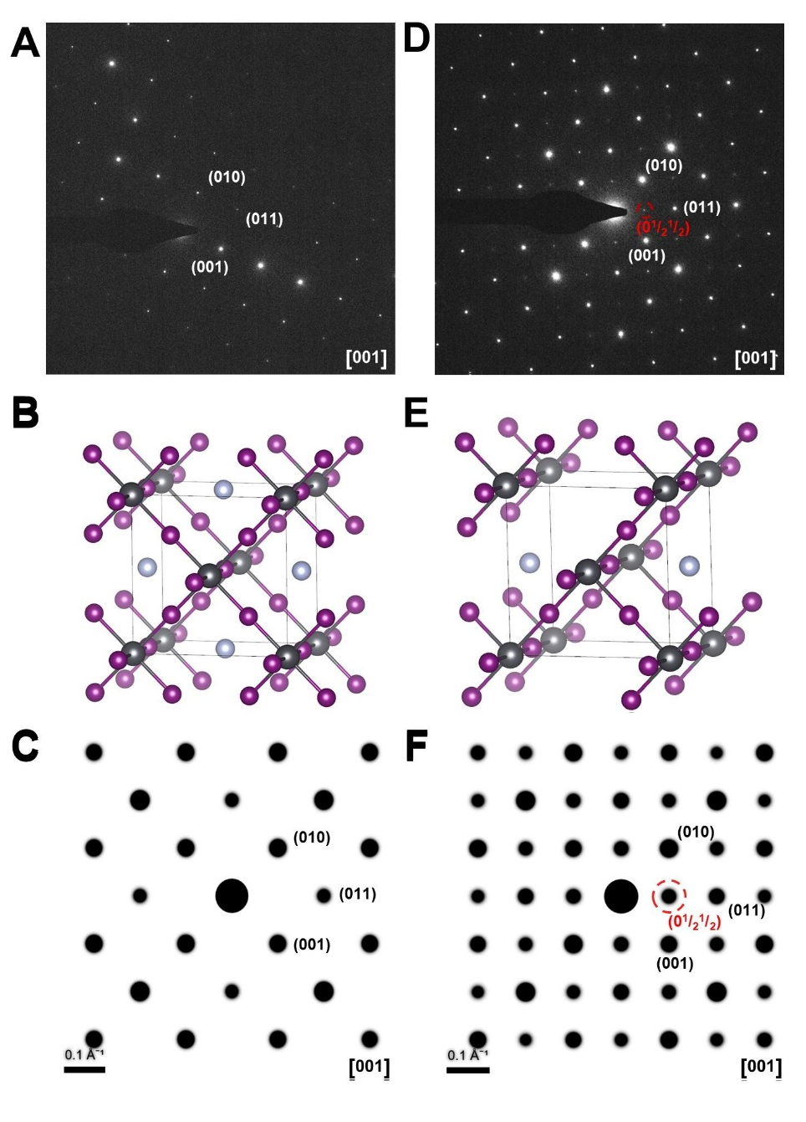
Fig. S1: (A) SAED pattern obtain from an FAI-rich (Cs, FA)Pb(I, Br)₃ film. (B) Crystal model illustrating the cubic unit cell of FAPbI₃. (C) Simulated electron diffraction pattern of cubic FAPbI₃ when viewed along the [001]_{c}. (D) SAED pattern obtained from a stoichiometric (Cs, FA)Pb(I, Br)₃ film. (E) Crystal model illustrating FA_{0.5}PbI_{2.5} with ordered FA⁺ and I⁻ vacancies ¹⁷. (F) Simulated diffraction pattern of FAPbI₃ with ordered vacancies viewed along [001]_{c}.

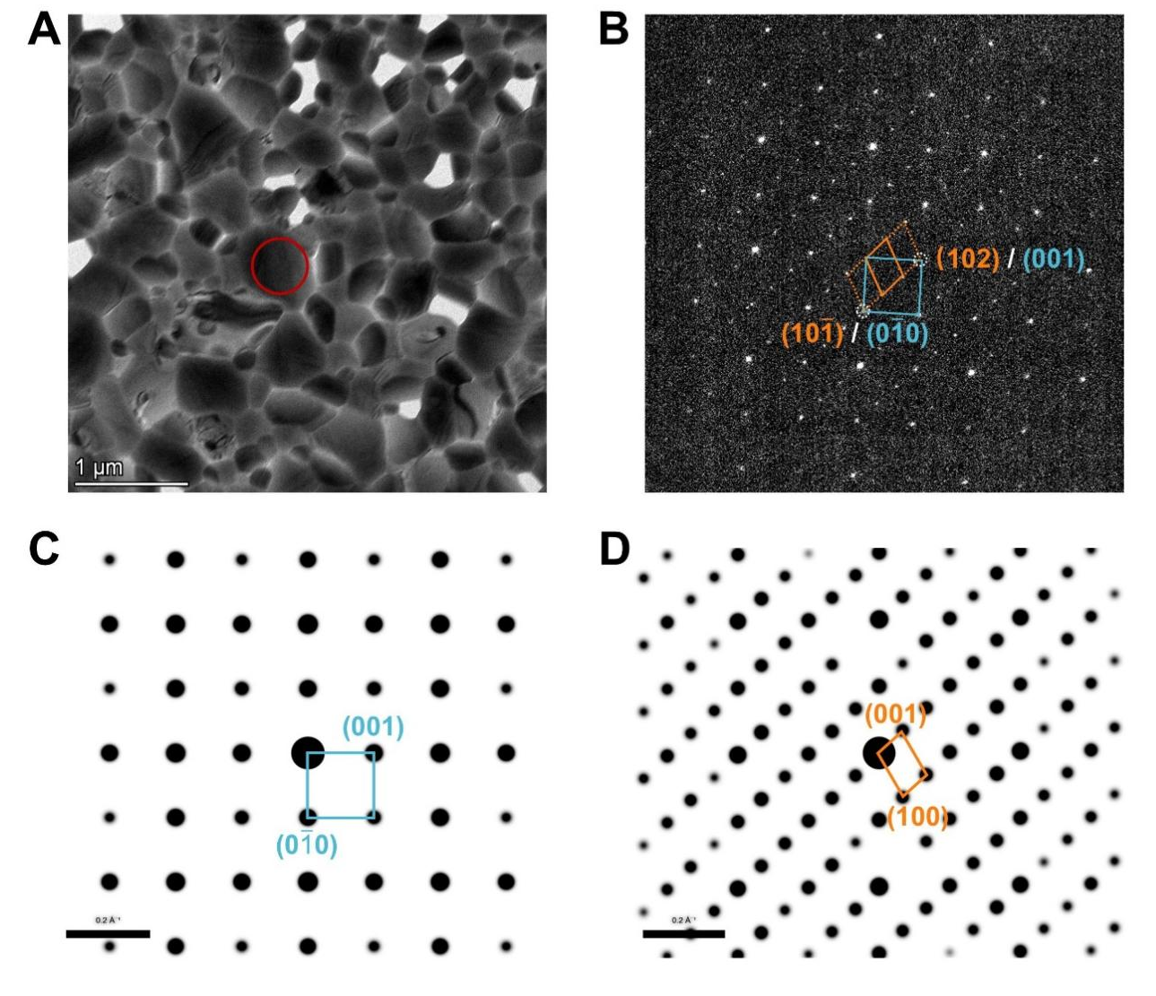
Fig. S2: (A) Bright-field TEM image of an FAI-rich (Cs, FA)Pb(I, Br)₃ film and (B) corresponding SAED pattern taken from the marked grain. (C,D) The SAED pattern contains spots from both (C) cubic 3D FAPbI₃ and (D) 2D perovskite as illustrated by the simulated SAED patterns of cubic FAPbI₃ along [100] and FA₂PbBr₄ along the [010] in (C,D), respectively ¹⁸.

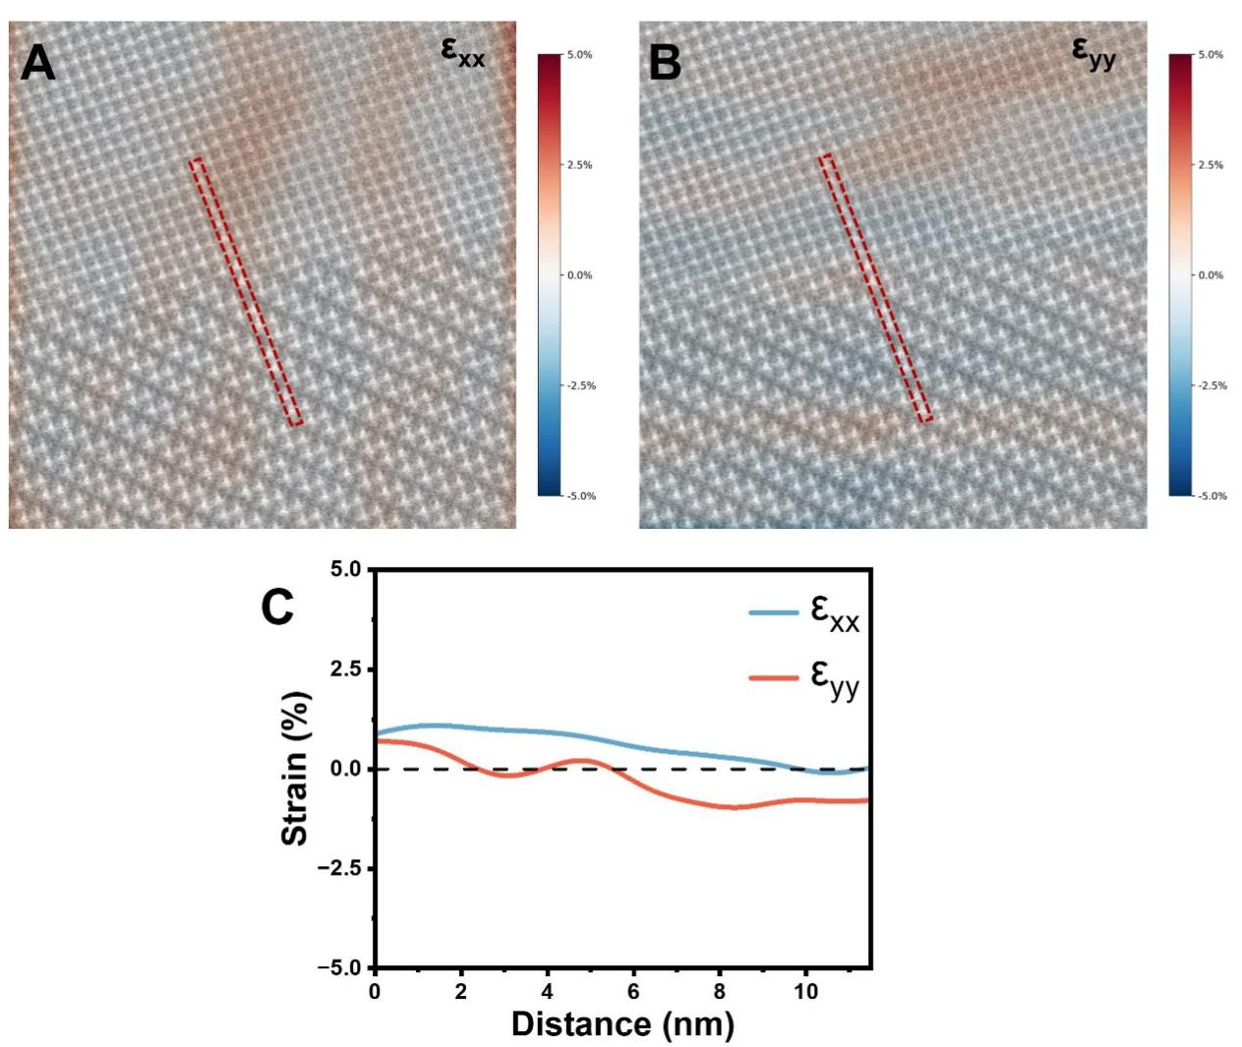
Fig. S3: Two-dimensional geometric phase analysis (GPA) strain maps across the 2D/3D interface derived from the HAADF-STEM image in Fig. 1B. (A) Normal strain component ε_{xx}. (B) Normal strain component ε_{yy}. (C) Line-profile strain distribution across the interface as indicated by the red rectangles. Scan length: 11.5 nm (red rectangles in Figure. A,B). The details of the GPA analysis are given in Supplementary Note S3.

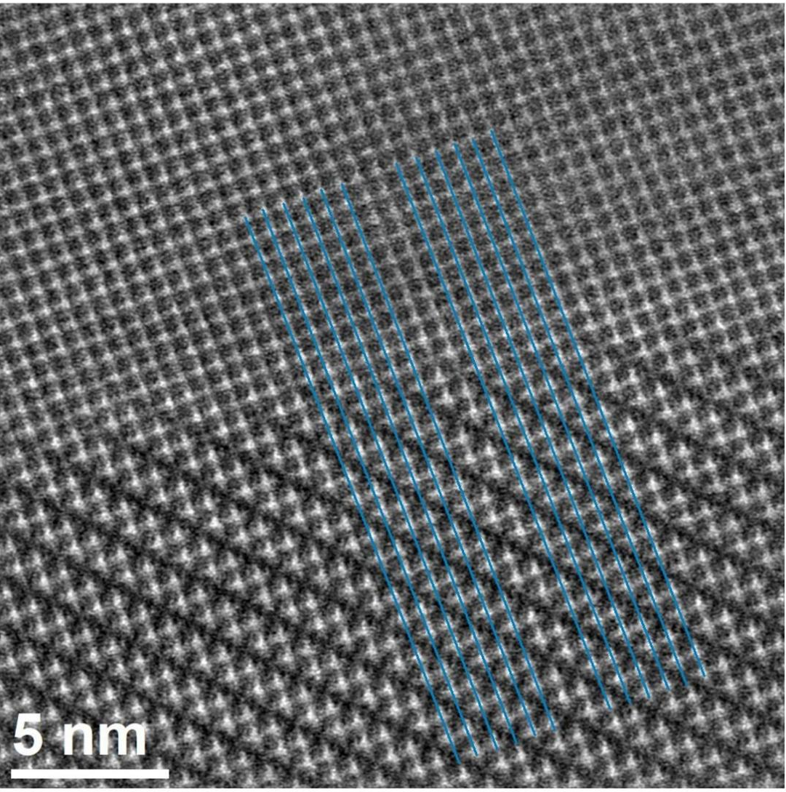
Fig. S4: Straight lines from the 3D phase to the 2D phase showing how the octahedra continue across the interface.

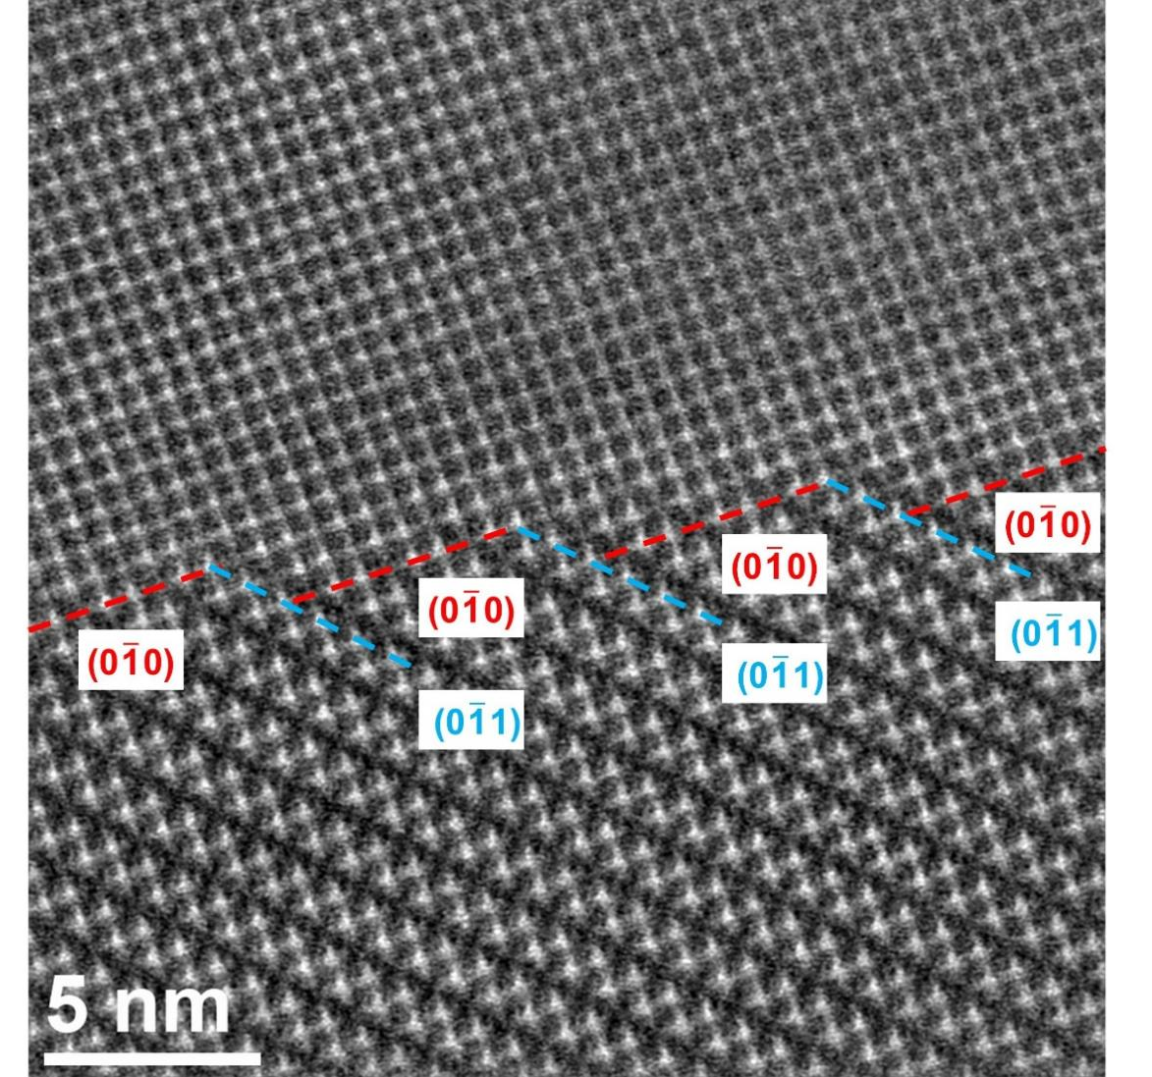
Fig. S5: {100} and {110} planes at the interface. The indices are in the crystal system of the cubic FAPbI₃ phase.

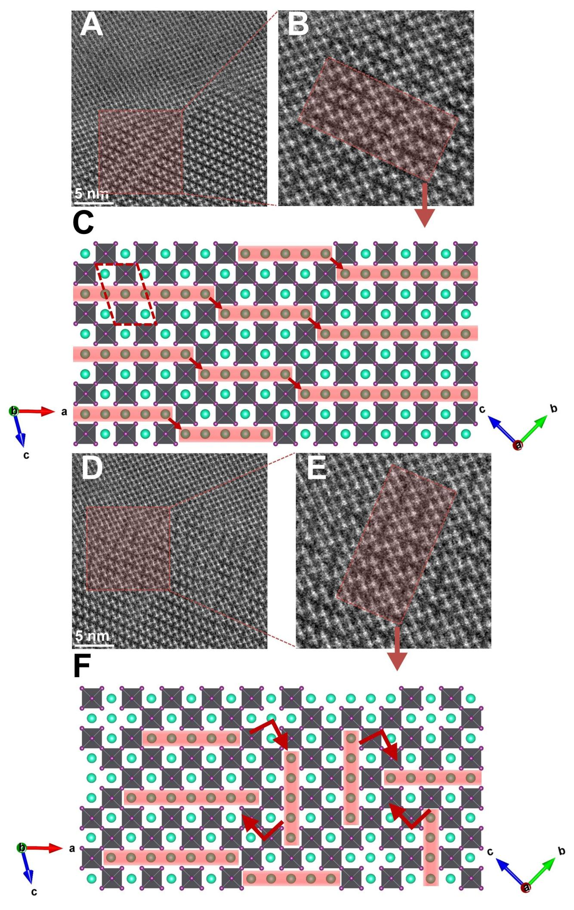
Fig. S6: (A, B) HAADF-STEM micrographs showing a domain that has undergone a half-unit-cell shift along the <101>_{t} direction of the 2D phase (equivalent to the <100>_{c} direction of the 3D parent phase). (C) Structural model showing the shift indicated by red arrows. The FA⁺⁻planes are highlighted in red to highlight the shift, and a red parallelogram outlines the 2D unit cell. (D, E) HAADF-STEM micrographs showing 90° orientational switching in the 2D phase. (F) Structural model showing the rotation indicated by red arrows. The FA⁺-planes are highlighted in red to highlight the rotation. Note that the octahedra are continuously connected across all the domains. The coordinate systems shown on the right and left correspond to the 3D and 2D phases, respectively.

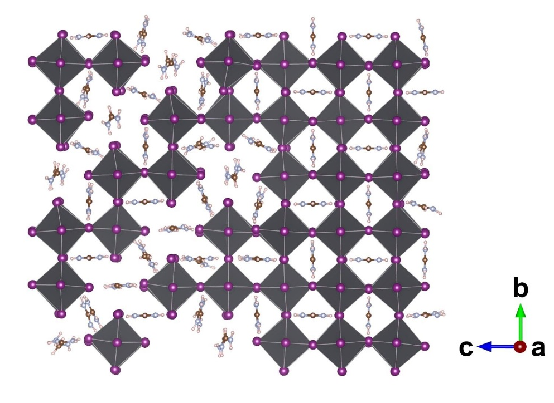
Fig. S7: DFT-predicted structure of the 2D/3D interface, here based on a FA₂PbI₄ /FAPbI₃ interface. The coordinate system is that of the cubic 3D phase.

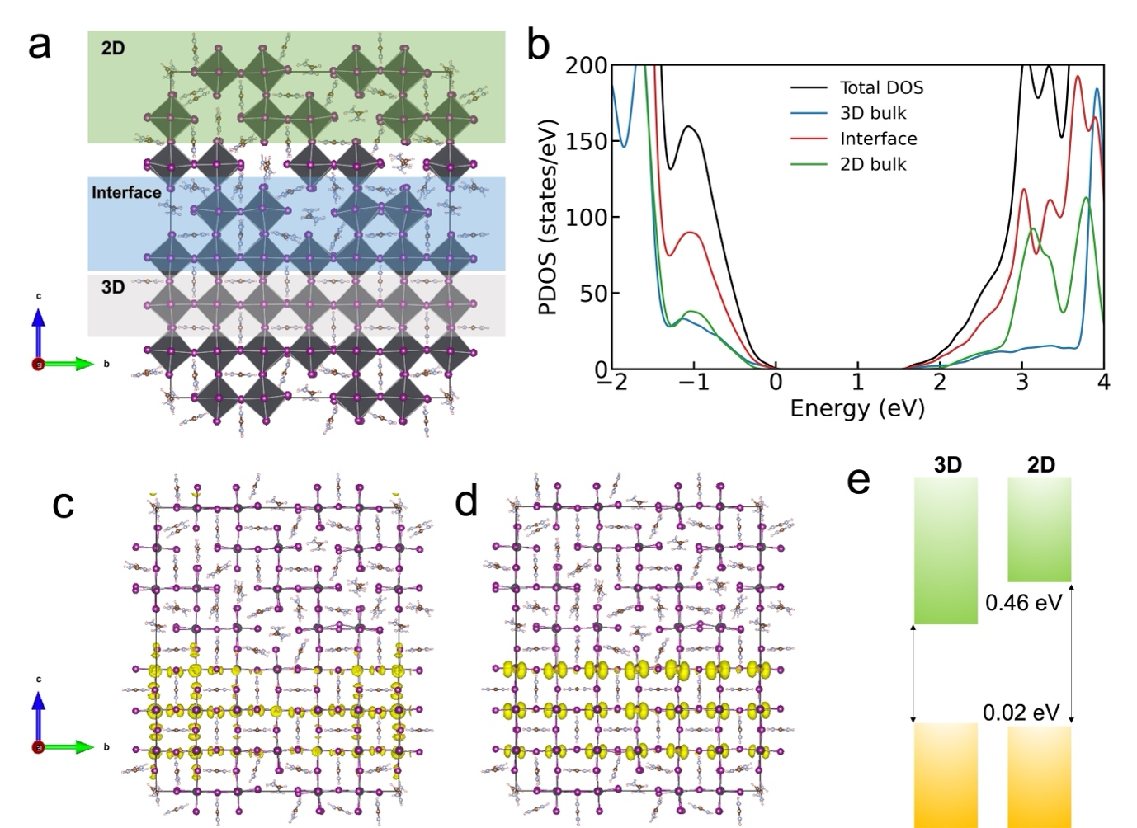
Fig. S8: Electronic structure and band alignment of the FAPbI₃/FA₂PbI₄ 3D/2D heterostructure. (A) Atomic model of the optimized heterostructure, with the 3D FAPbI₃ region, interfacial region, and 2D FA₂PbI₄ region highlighted. (B) DFTB+SOC region projected density of states (PDOS), showing the contributions from the 3D bulk, interface, and 2D bulk regions. The energy scale is aligned to the VBM, set to 0 eV. No in-gap states are introduced by the interface. (C,D) Partial charge densities of the VBM and CBM, respectively, showing that both frontier states are mainly localized within the 3D FAPbI₃ region. (E) Band offset diagram for the extended heterostructure. The 2D VBM is nearly aligned with the 3D VBM, with a small offset of 0.02 eV, whereas the 2D CBM lies 0.46 eV above the 3D CBM. This indicates that the 2D FA₂PbI₄ mainly acts as an electron blocking barrier while introducing little barrier for holes.

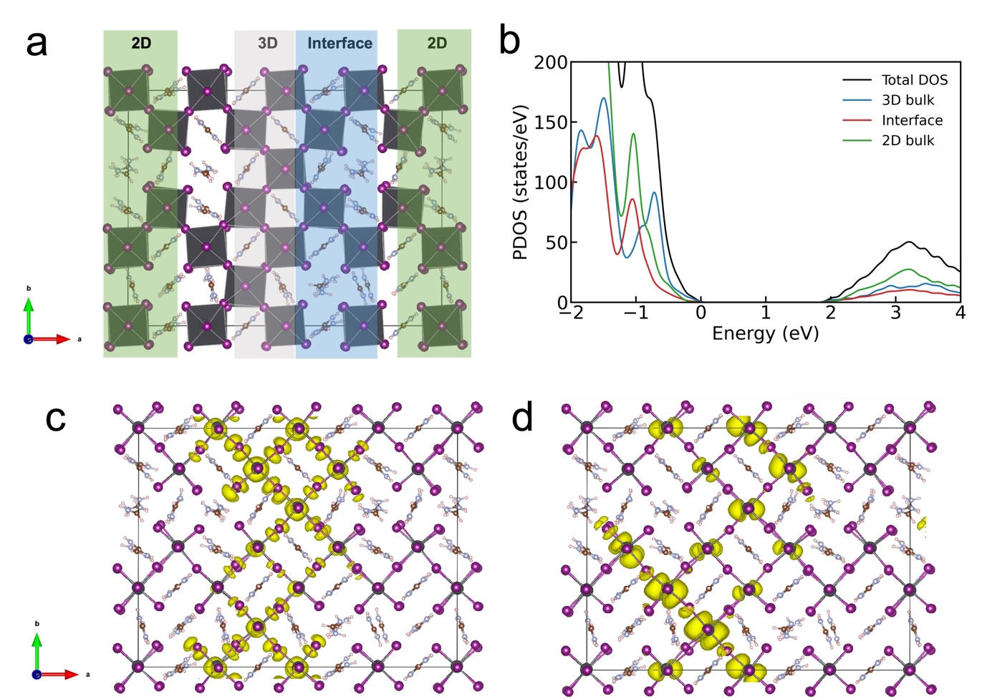
Fig. S9: Electronic structure of the FAPbI₃/FA₂PbI₄ 3D-in-2D nanostructure. (A) Atomic model of the optimized 3D-in-2D nanostructure, with the 2D FA₂PbI₄ region, interfacial region, and embedded 3D FAPbI₃ region highlighted. (B) DFTB+SOC region projected density of states (PDOS), showing contributions from the 3D bulk-like, interface, and 2D bulk-like regions. The energy scale is referenced to the VBM, set to 0 eV. The projected DOS near the band edges shows stronger overlap between the 3D, interface, and 2D components, indicating enhanced electronic mixing and confinement in the finite nanostructure. (C,D) Partial charge densities of the VBM and CBM, respectively. Both frontier states are mainly localized on the embedded FAPbI₃-like component, consistent with carrier confinement in the 3D region.

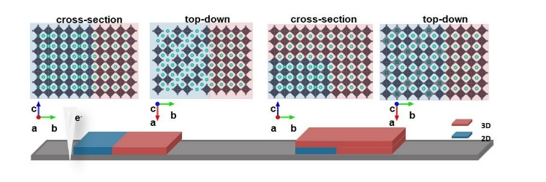
Fig. S10: Structural schematic diagrams of the cross-section and top-down plan-views of horizontal 2D/3D mixed-phase (left and middle left) and vertical 2D/3D mixed-phase (middle right and right).

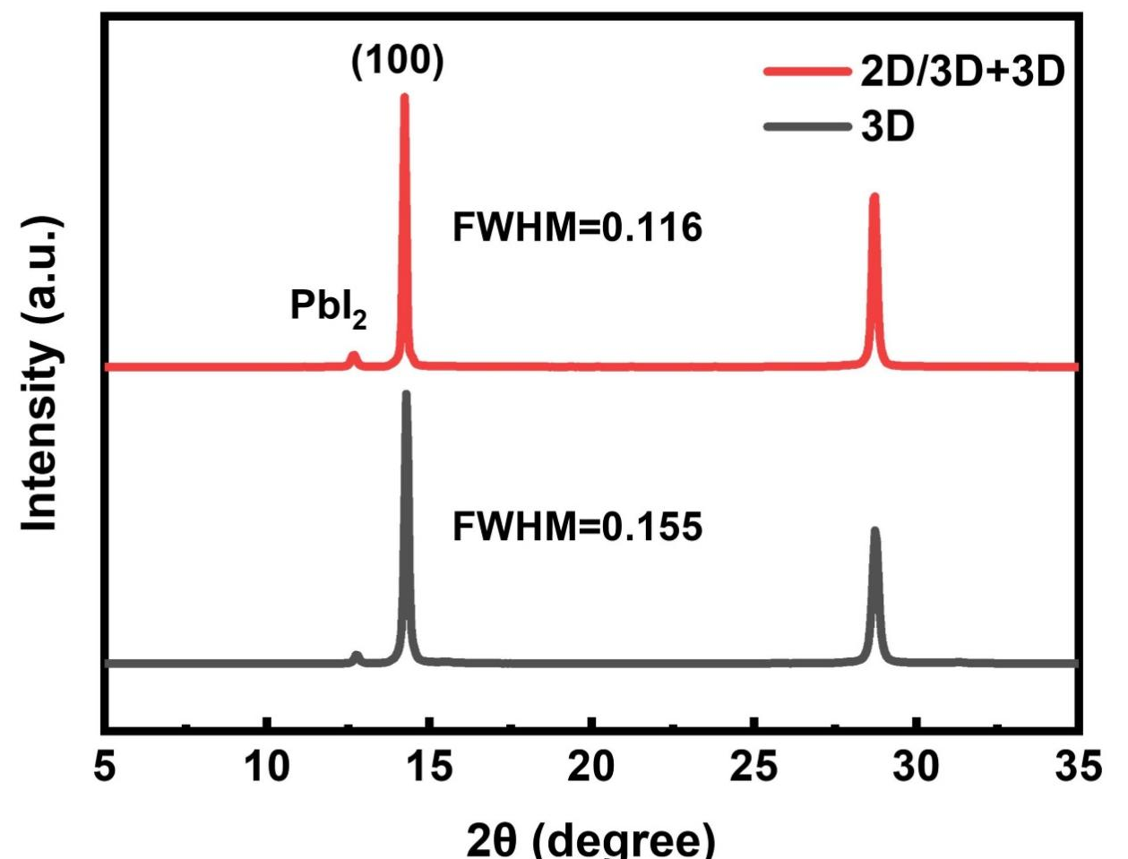
Fig. S11: X-ray diffraction (XRD) patterns of perovskite films on ITO/NiO_{X}/Me-4Pacz substrate.

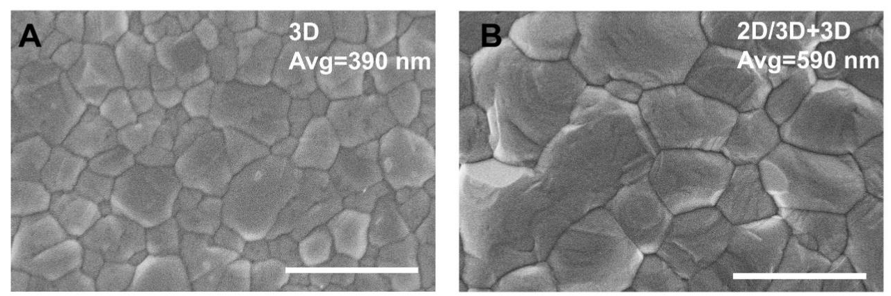
Fig. S12: (A) Scanning electron microscopy (SEM) micrograph of 3D perovskite film on ITO/NiO_{X}/Me-4Pacz substrate. (B) SEM micrograph of 2D/3D+3D perovskite film on ITO/NiO_{X}/Me-4Pacz substrate. Scale bar,1 μm.
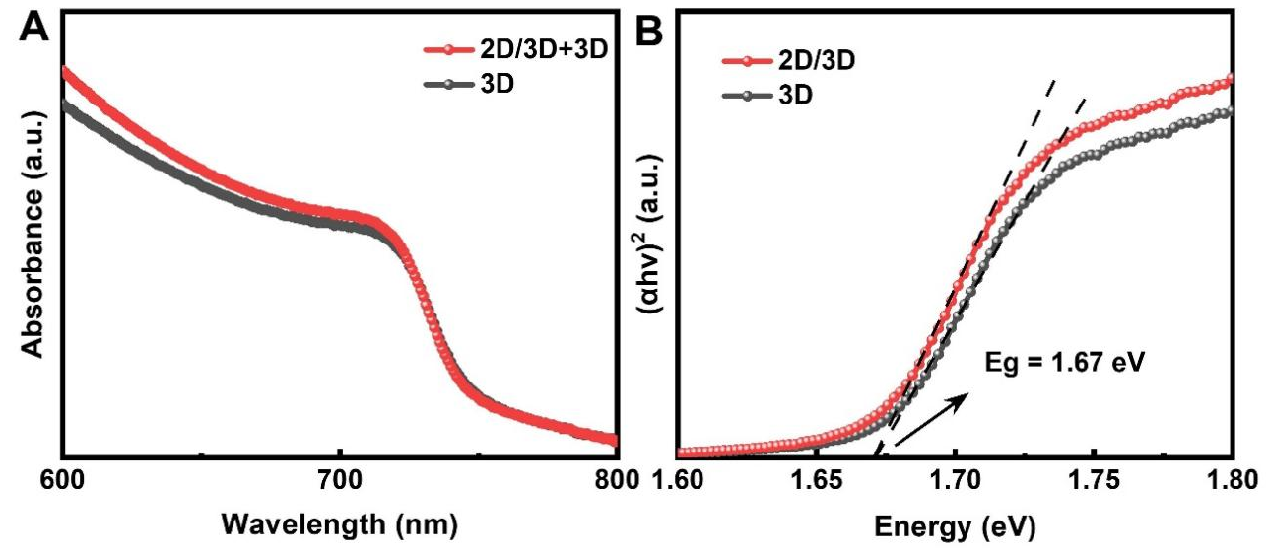
Fig. S13: (A) UV–vis absorption spectra for 2D/3D+3D and 3D films (B) Tauc plots of absorbance as a function of photon energy (hʋ) and associated extracted bandgaps of perovskite films.

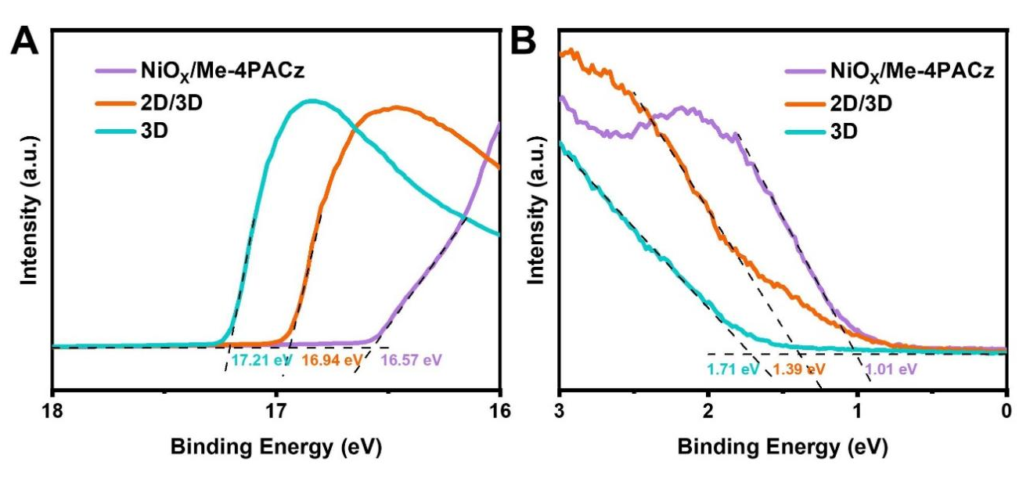
Fig. S14: UPS spectra of (A) NiO_{x}/Me-4PACz, (B) 2D/3D films, (C) 3D films.
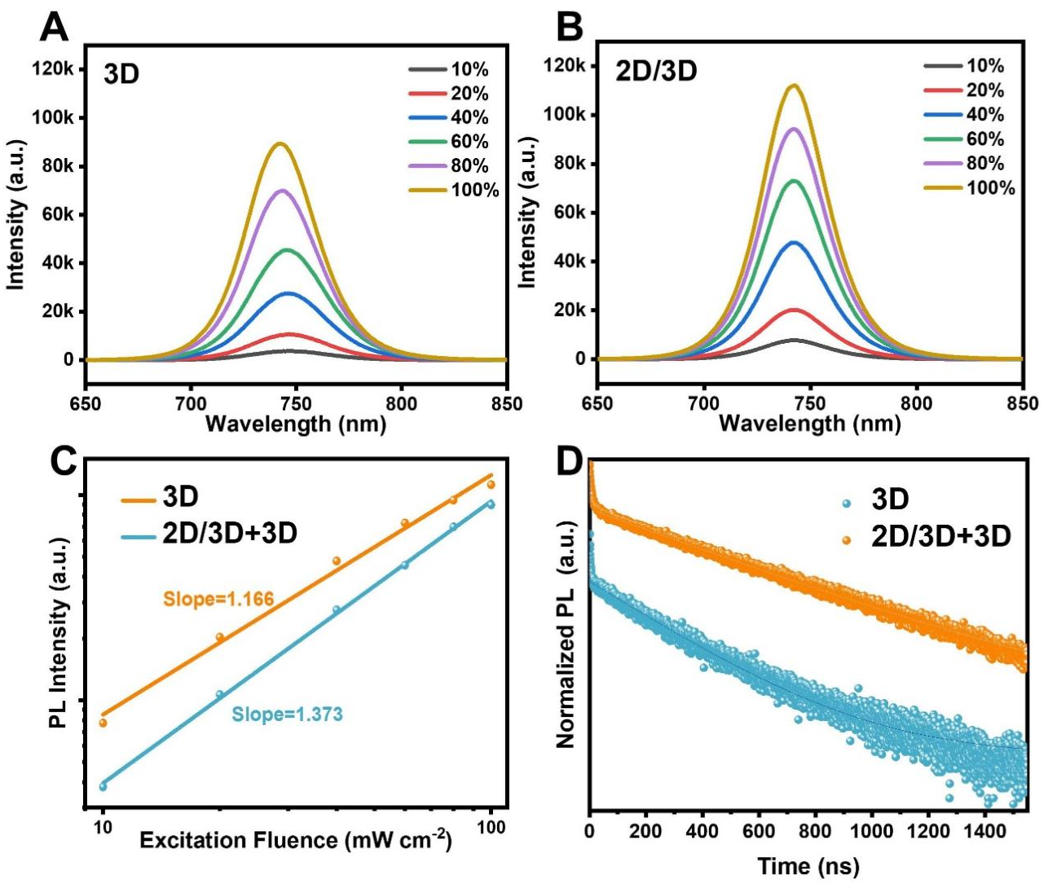
Fig. S15: (A, B) PL intensity of 3D and 2D/3D+3D films under different excitation fluences. The percentages refer to percentage of the maximum fluence of 100 mW cm⁻². (C) Fluence-dependent steady-state PL intensity measurement of 3D and 2D/3D+3D films. (D) TRPL decay traces obtained from 3D and 2D/3D+3D perovskite films.
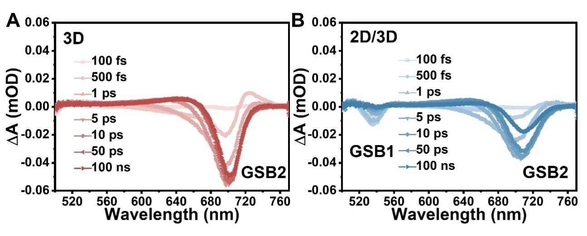
Fig. S16: (A, B) TAS plot at various pump-probe delay time of 3D and 2D/3D+3D films
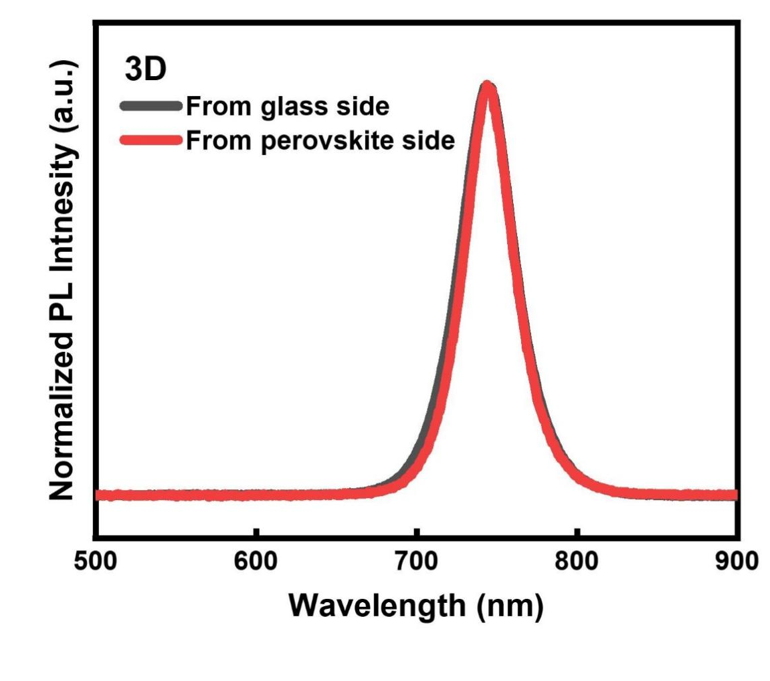
Fig. S17: Normalized PL spectra of the 3D film with different excitation directions from the glass side and top perovskite surface film.

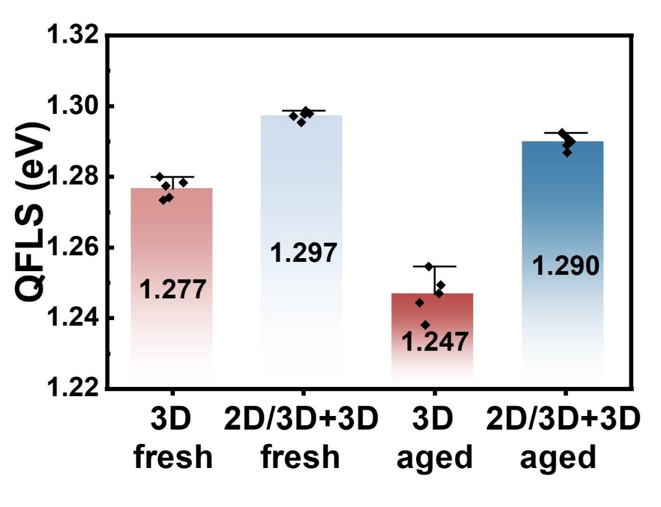
Fig. S18: Quasi-Fermi level splitting (QFLS) of fresh and aged 3D and 2D/3D+3D perovskite films calculated from the PLQY measurements.

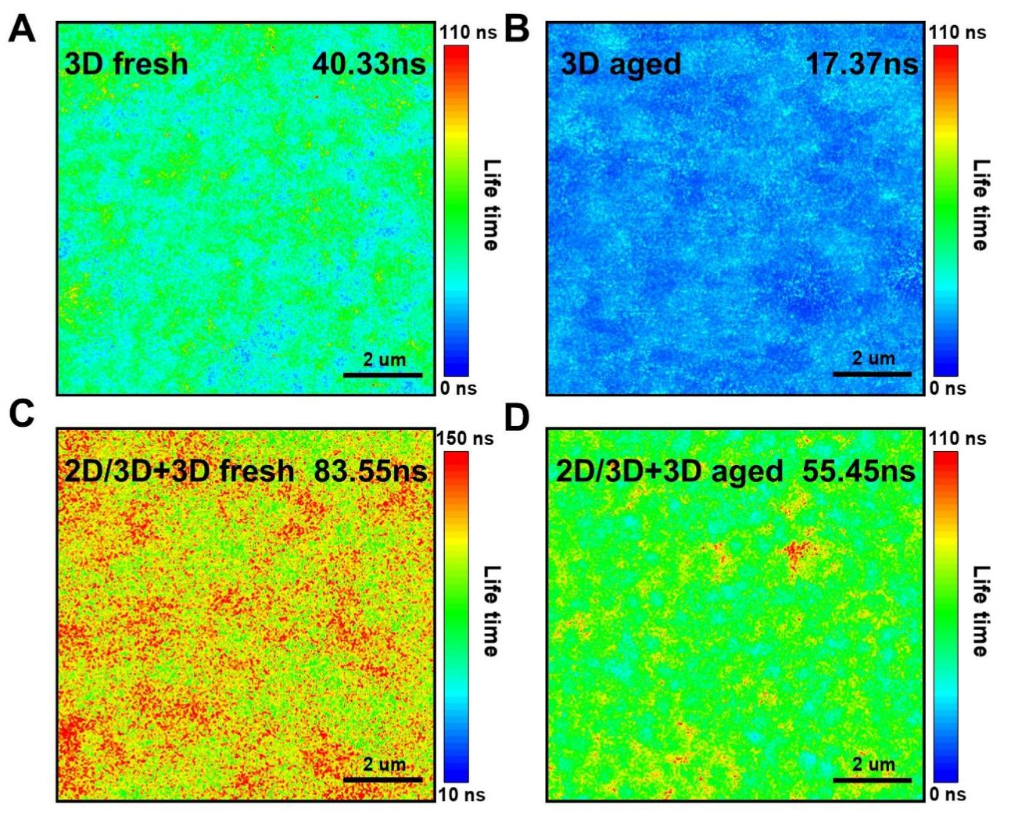
Fig. S19: Time-resolved photoluminescence (TRPL) mapping of fresh and aged 3D and 2D/3D+3D perovskite films under 2-sun illumination in N₂ atmosphere at 85 °C for 192 hours.

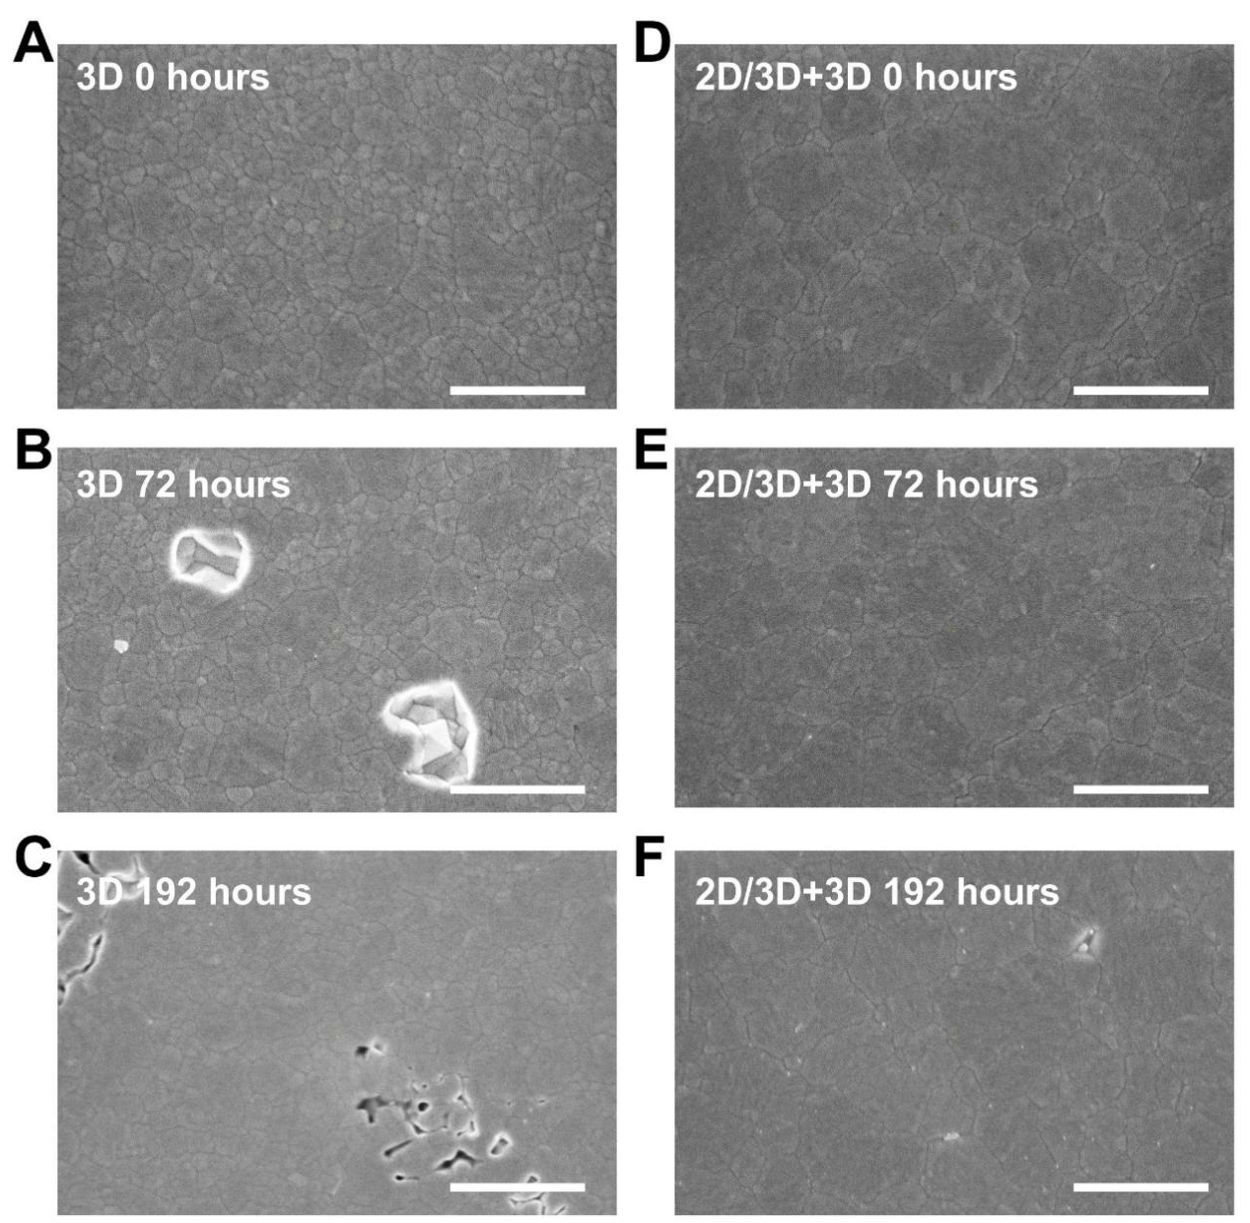
Fig. S20: SEM micrographs of the bottom of perovskite films on ITO/Me-4Pacz substrate after various aging times at 2-sun illumination at 85 °C in N₂ atmosphere, after being peeled off using UV-adhesive, showing the microstructure of the perovskite side of the perovskite/SAM interface on (A, B, C) 3D and (D, E, F) 2D/3D+3D films. Scale bar, 1μm.

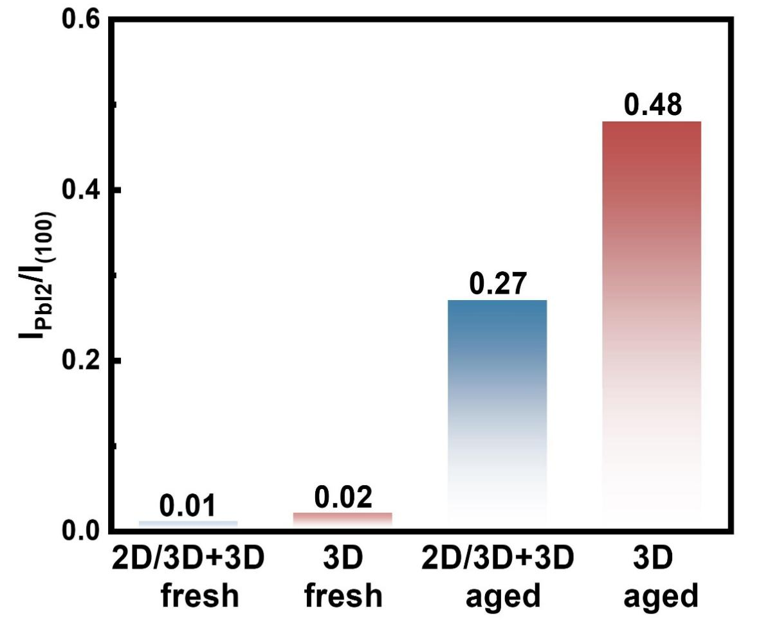
Fig. S21: The intensity ratio of the (100) perovskite peak to the (100) PbI₂ peak of the fresh and aged perovskite films on ITO/NiO_{X}/Me-4PACz substrate.
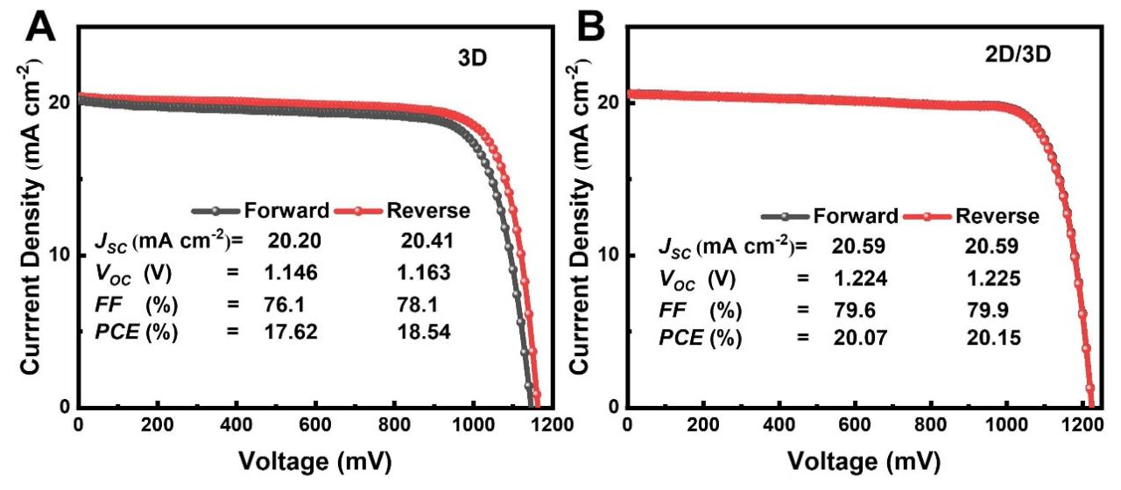
Fig. S22: J−V curves of the champion 3D and 2D/3D+3D perovskite solar cells.
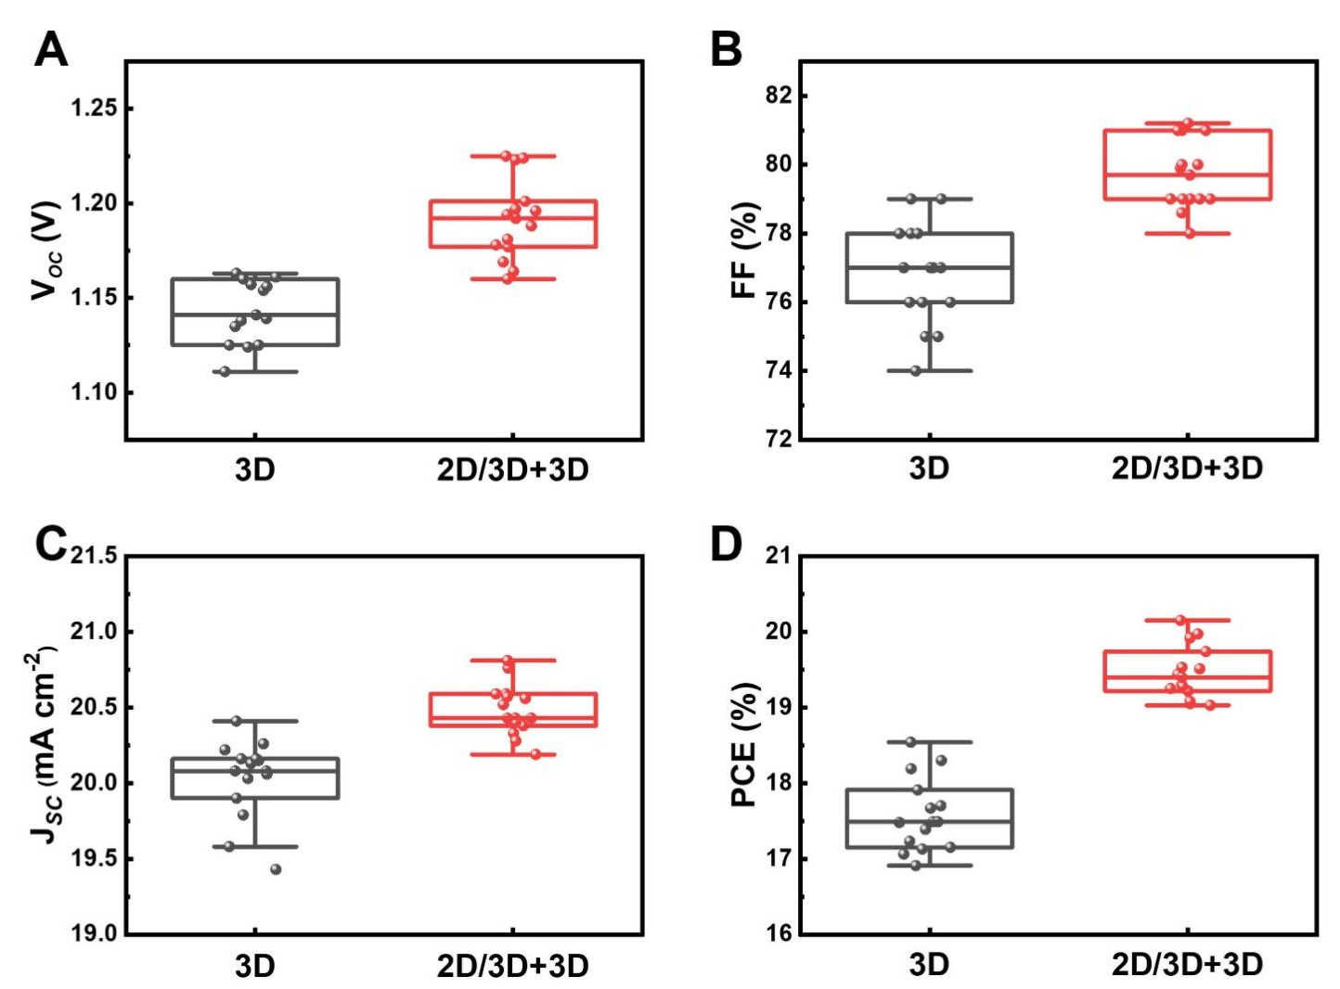
Fig. S23: Performance parameter statistics of perovskite solar cells devices prepared with the different films. (A) V_{OC}, (B) J_{SC}, (C) FF and (D) PCE from 15 individual devices.

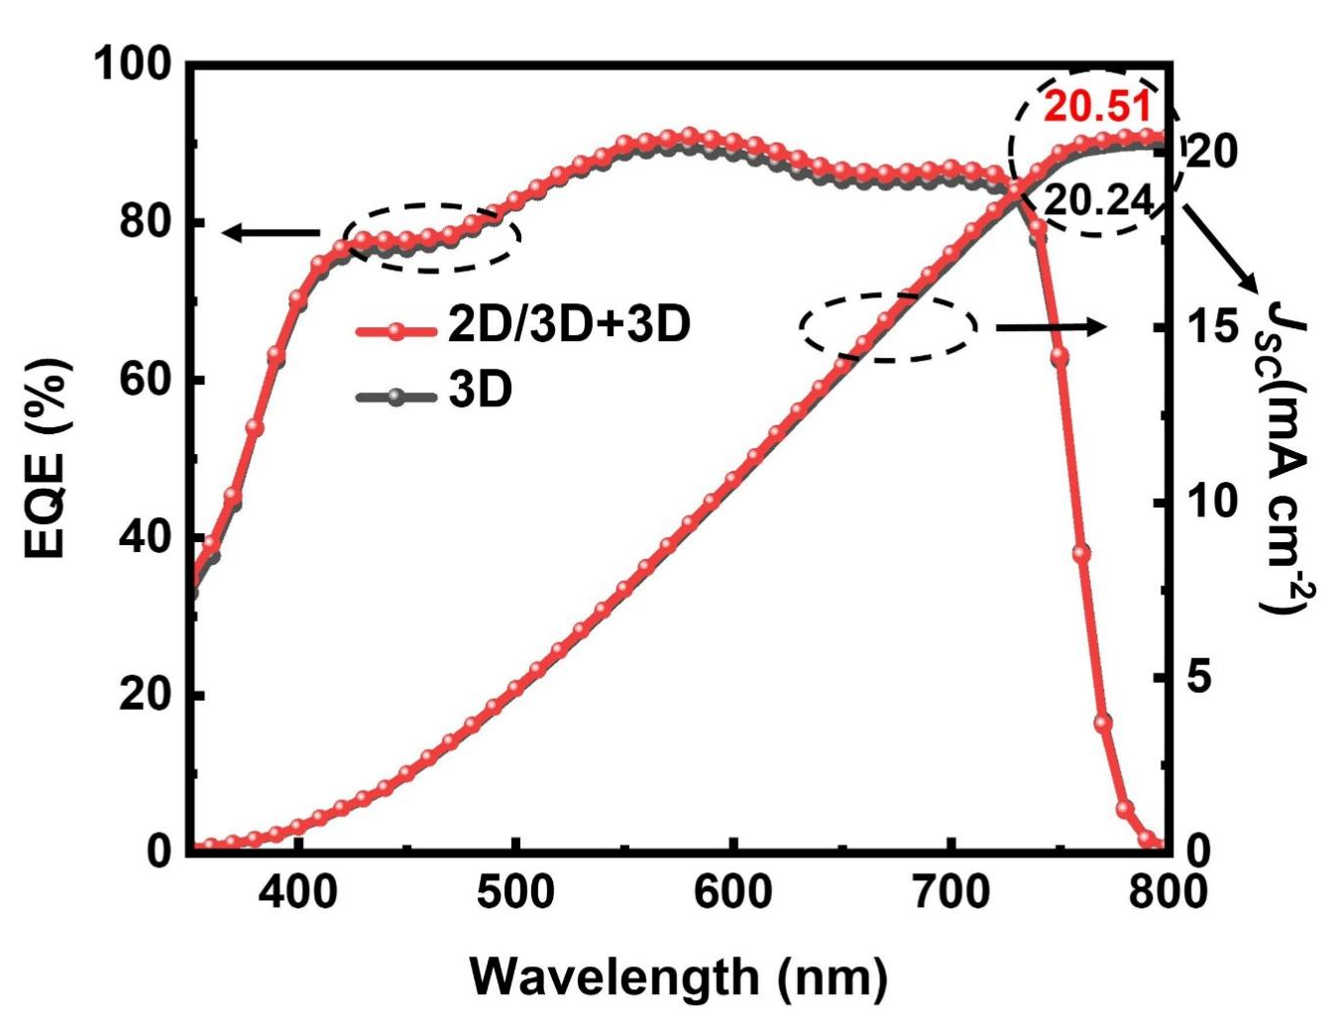
Fig. S24: EQE spectra of 3D and 2D/3D+3D perovskite solar cells.
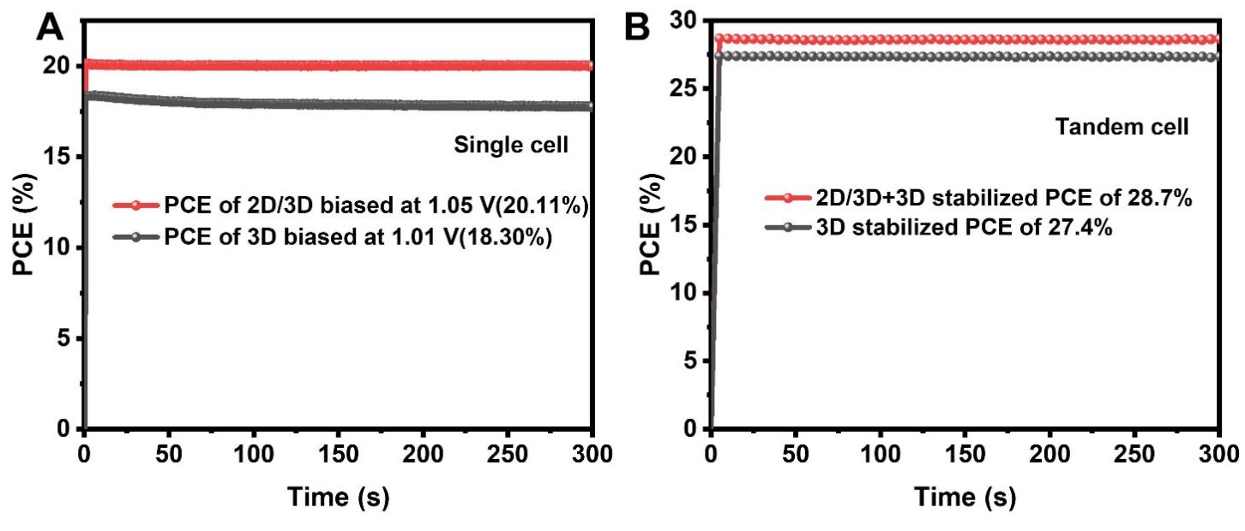
Fig. S25: Stabilized power output of the 3D and 2D/3D+3D (A) perovskite solar cells and (B) perovskite/silicon tandem solar cells.

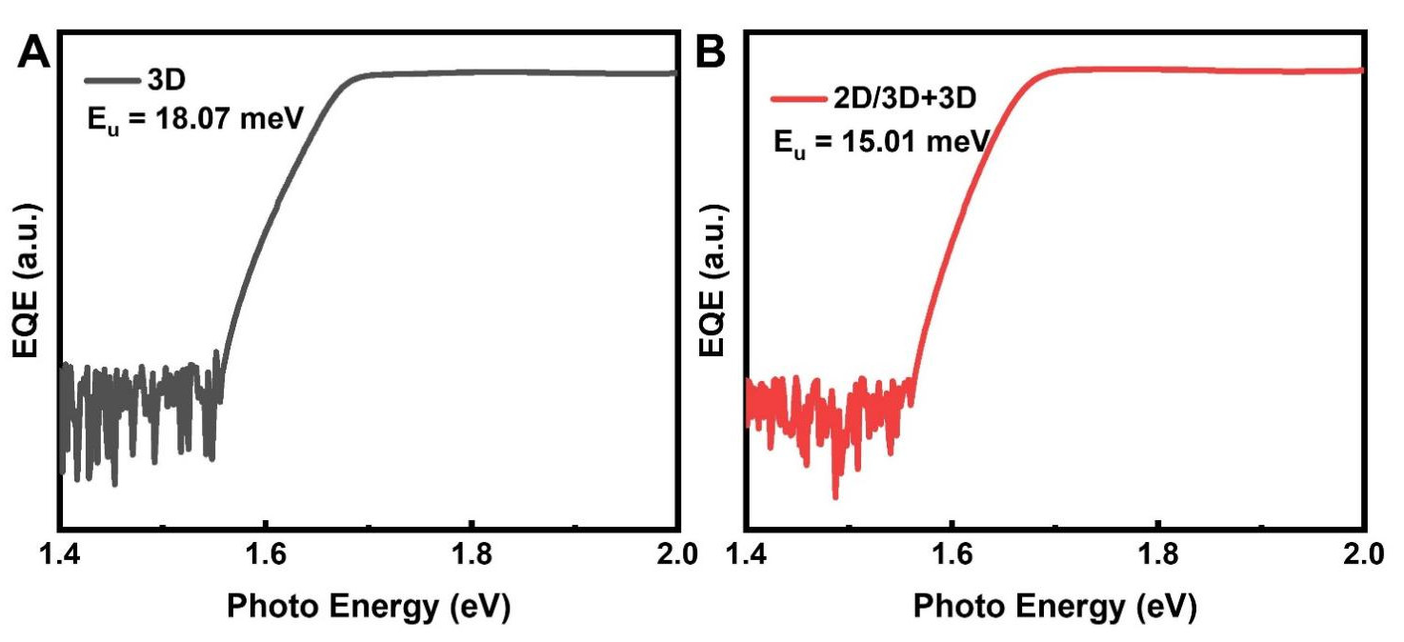
Fig. S26: Highly-sensitive EQE spectra and Urbach energies of the associated perovskite solar cell perovskite solar cells.
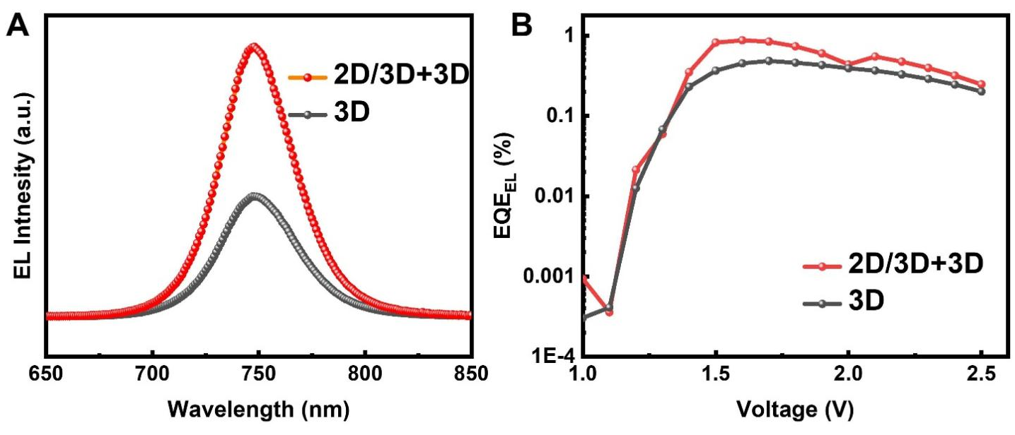
Fig. S27: (A) Electroluminescence spectra and (B) external quantum efficiency of electroluminescence (EQE_{EL}) graphs obtained from 3D and 2D/3D+3D perovskite solar cells.

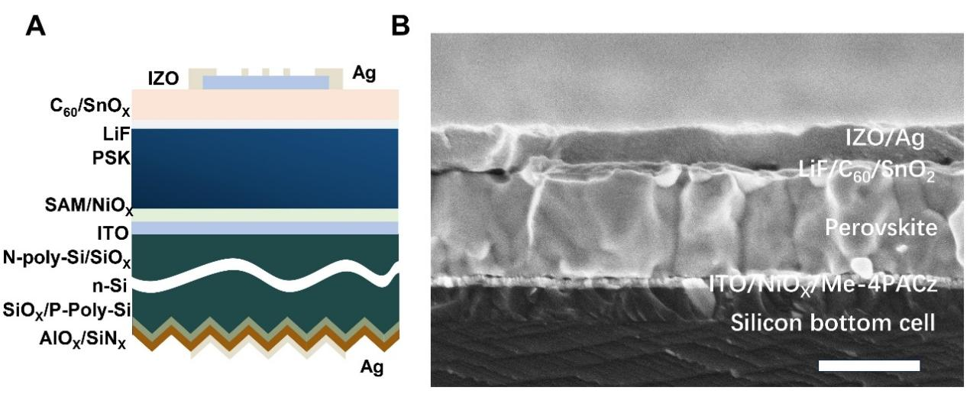
Fig. S28: (A) Schematic structure of the perovskite/TOPCon silicon tandem cells. PSK refers to the perovskite layer, SAM refers to the self-assembled molecules Me-4PACz. (B)Cross-sectional SEM micrograph of 2D/3D+3D perovskite/silicon tandem solar cells. The scale bar corresponds to 500 nm.

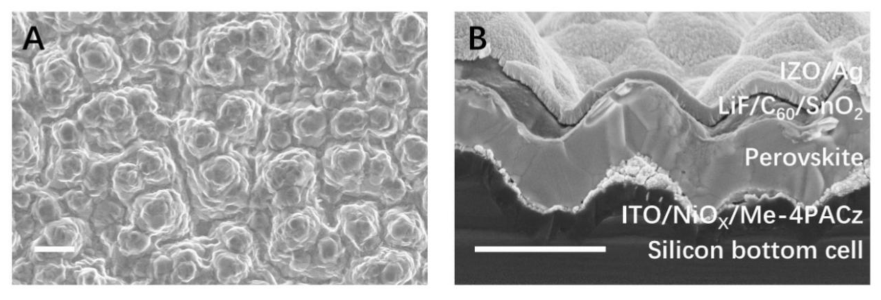
Fig. S29: (A) Surface SEM image of 2D/3D+3D perovskite on textured silicon/NiO_{X}/Me-4PAcz substrate. (B) Cross-sectional SEM images of 2D/3D+3D textured perovskite/silicon tandem solar cells. Scale bar, 1μm.

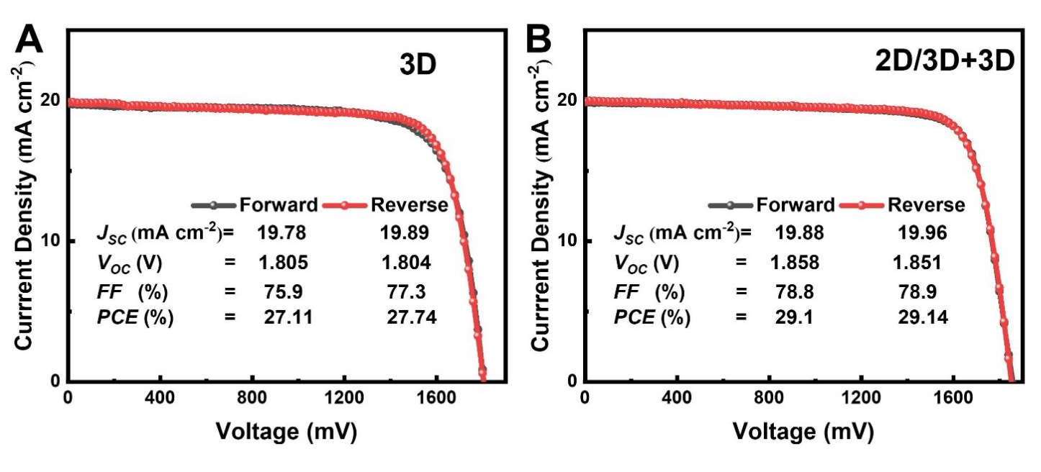
Fig. S30: (A, B) J−V curves of the champion 3D and 2D/3D+3D tandem solar cells.

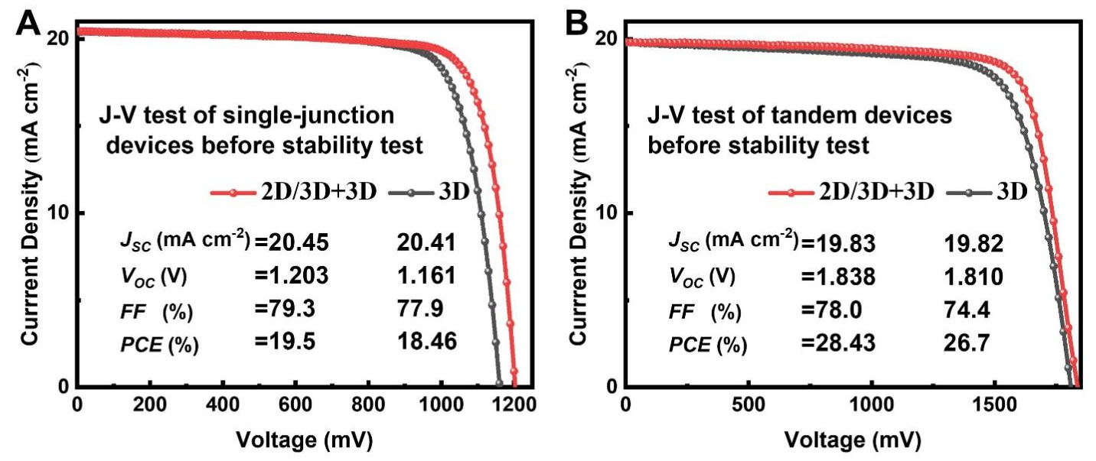
Fig. S31: J-V test before 1-sun illumination aging under MPP tracking. (A) single-junction devices. (B) tandem devices.
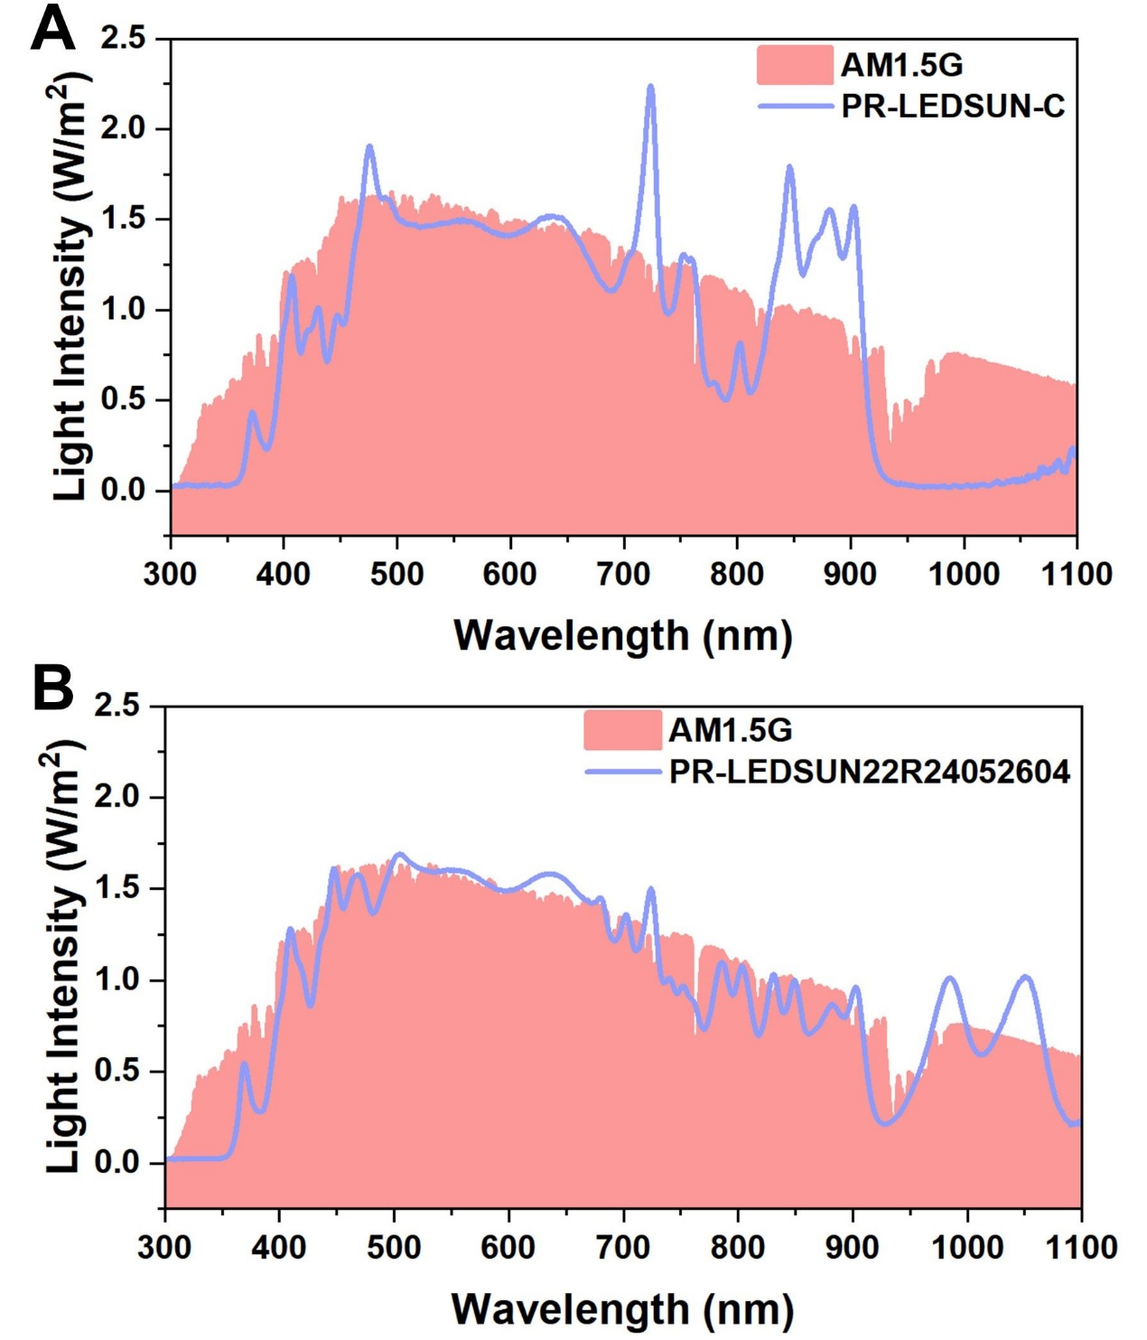
Fig. S32: The spectrum of LED light using for device aging (A)PR-LEDSUN-C and (B)PR-LEDSUN22R24052604.

Table S1. Calculated lifetimes based on TRPL measurements.
Sample | A₁ | τ1 (ns) | A₂ | τ2 (ns) | τavg (ns)
3D | 0.93 | 0.60 | 0.07 | 307.01 | 298.69
2D/3D+3D | 0.52 | 7.19 | 0.48 | 535.29 | 527.67

Table S2.V_{OC} loss analysis of the 3D and 2D/3D+3D devices.
Sample | $Eg$(eV) | $V_{OC}^{SC}$(V) | V_{OC}(V) | ΔV₁ (mV) | ΔV₂ (mV) | ΔV₃ (mV)
3D | 1.67 | 1.39 | 1.16 | 279 | 21 | 206
2D/3D+3D | 1.67 | 1.39 | 1.23 | 279 | 19 | 140

References
1. Kresse, G. & Furthmüller, J. Efficiency of ab-initio total energy calculations for metals and semiconductors using a plane-wave basis set. Comput. Mater. Sci. 6, 15–50 (1996).
2. Kresse, G. & Furthmüller, J. Efficient iterative schemes for ab initio total-energy calculations using a plane-wave basis set. Phys. Rev. B 54, 11169–11186 (1996).
3. Rothmann, M. U. et al. Atomistic Understanding of the Coherent Interface Between Lead Iodide Perovskite and Lead Iodide. Adv. Mater. Interfaces 10, 2300249 (2023).
4. Weber, O. J. et al. Phase Behavior and Polymorphism of Formamidinium Lead Iodide. Chem. Mater. 30, 3768–3778 (2018).
5. Jiang, J. et al. Flexible and efficient semiempirical DFTB parameters for electronic structure prediction of 3D, 2D iodide perovskites and heterostructures. Phys. Rev. Mater. 9, 023803 (2025).
6. Kühne, T. D. et al. CP2K: An electronic structure and molecular dynamics software package - Quickstep: Efficient and accurate electronic structure calculations. J. Chem. Phys. 152, 194103 (2020).
7. Kubillus, M., Kubař, T., Gaus, M., Řezáč, J. & Elstner, M. Parameterization of the DFTB3 Method for Br, Ca, Cl, F, I, K, and Na in Organic and Biological Systems. J. Chem. Theory Comput. 11, 332–342 (2015).
8. Kubař, T. et al. Parametrization of the SCC-DFTB Method for Halogens. J. Chem. Theory Comput. 9, 2939–2949 (2013).
9. Wahiduzzaman, M. et al. DFTB Parameters for the Periodic Table: Part 1, Electronic Structure. J. Chem. Theory Comput. 9, 4006–4017 (2013).
10. Zhao, Y. et al. Chiral structure induces spatial spiral arrangement of Fe3O4 nanoparticles to optimize electromagnetic wave dissipation. Appl. Phys. Lett. 124, 161901 (2024).
11. Madsen, J. & Susi, T. The abTEM code: transmission electron microscopy from first principles [version 2; peer review: 2 approved]. Open Res. Eur. 1, (2021).
12. Hÿtch, M. J., Snoeck, E. & Kilaas, R. Quantitative measurement of displacement and strain fields from HREM micrographs. Ultramicroscopy 74, 131–146 (1998).
13. Hÿtch, M. J., Putaux, J.-L. & Pénisson, J.-M. Measurement of the displacement field of dislocations to 0.03 Å by electron microscopy. Nature 423, 270–273 (2003).
14. Rouvière, J. L. & Sarigiannidou, E. Theoretical discussions on the geometrical phase analysis. Ultramicroscopy 106, 1–17 (2005).
15. Guo, J. et al. Ultralong Carrier Lifetime Exceeding 20 µs in Lead Halide Perovskite Film Enable Efficient Solar Cells. Adv. Mater. 35, 2212126 (2023).
16. Vandewal, K., Tvingstedt, K., Gadisa, A., Inganäs, O. & Manca, J. V. Relating the open-circuit voltage to interface molecular properties of donor:acceptor bulk heterojunction solar cells. Phys. Rev. B 81, 125204 (2010).
17. Yang, C.-Q. et al. Unveiling the Intrinsic Structure and Intragrain Defects of Organic–Inorganic Hybrid Perovskites by Ultralow Dose Transmission Electron Microscopy. Adv. Mater. 35, 2211207 (2023).
18. Fateev, S. A. et al. FA2PbBr4: Synthesis, Structure, and Unusual Optical Properties of Two Polymorphs of Formamidinium-Based Layered (110) Hybrid Perovskite. Chem. Mater. 33, 1900–1907 (2021).

