Supplementary Information
Supplementary Tables
Table S1 (Separate file) List of genes and associated COG IDs used to identify potential UV-resistance genes in MAGs.

Table S2 Read tracking through the DADA2 pipeline for air samples and associated controls.
Sample ID | Sample_name | reads in | filter/trim | sample inference | nonchimeric | final proportion
S293_S101 | Western Crater | 3135 | 3135 | 2383 | 1057 | 0.34
S294_S102 | Extraction control 1 | 120 | 120 | 65 | 50 | 0.42
S305_S113 | Tramway Ridge | 2616 | 2615 | 2151 | 798 | 0.31
S306_S114 | Reagent control 1 | 84 | 84 | 32 | 30 | 0.36
S318_S126 | Extraction control 2 | 35402 | 35398 | 26390 | 10985 | 0.31
S329_S137 | Scott Base | 44522 | 44509 | 41061 | 9916 | 0.22
S377_S185 | Reagent control 2 | 21 | 21 | 8 | 0 | 0.00

Table S3 (Separate file) MAG-specific and dataset-specific cANI thresholds used for determining the presence (ANI ≥96%) of a MAG in metagenomes from the branchwater dataset, based on YACHT results. For cANI thresholds <0.97, the SRA accession for the metagenome used in YACHT is provided in the column “accession”. A cANI of 0.97 was used as the default threshold as this is widely viewed as indicative of a MAG being present in a metagenome (see Methods).
Table S4 (Separate file) MAG characteristics for all MAGs used in this study. Num_locations: number of locations (samples <1km apart were consolidated) that the MAG is present in globally, using thresholds of: containment ≥30%, ANI ≥96%. Max_dist_km: for cosmopolitan MAGs, the distance between Mt. Erebus and the most distant metagenome in the SRA with a matching species (in km). Site: site binned from. Completeness: MAG completeness (%). Genome_Size: genome size given in Mbp, corrected for MAG completeness. Growth_rate: predicted maximal growth rate (d⁻¹). Salinity values are given as %, temp in units of °C. temp_optimum: predicted optimal growth temperature, °C, given as the mean of the predicted values from genomeSPOT and Tome.
Table S5 (Separate file) All raw data from branchwater, filtered to only include matching metagenomes with containment >0.3. All data is directly reported metadata from corresponding metagenomes in the sequence read archive (SRA).

Table S6 Mean and standard error for maximum cell densities (OD₆₀₅) of triplicate cultures, achieved at different growth temperatures for Calidithermus sp. nov and Thermus sp. nov. *: mean max OD with the OD at time 0 subtracted.
Thermus sp. SS11024-3 |  |  | Calidithermus sp. Yb
Temperature (°C) | Mean Max OD* | Standard Error | Temperature (°C) | Mean Max OD* | Standard Error
25 | 0.000 | 0.004 | 25 | 0.002 | 0.003
35 | 0.000 | 0.002 | 35 | 0.083 | 0.018
45 | 0.033 | 0.003 | 45 | 0.085 | 0.011
50 | 0.138 | 0.017 | 50 | 0.134 | 0.010
55 | 0.198 | 0.003 | 55 | 0.128 | 0.027
60 | 0.204 | 0.003 | 60 | 0.033 | 0.010
65 | 0.202 | 0.003 | 65 | 0.016 | 0.003
70 | 0.191 | 0.006 | -

Table S7 Description of core sections from the Fang Glacier ice core.
#sample | Core# | Top of cut (cm, from top of core) | Bottom cut (cm, from top of core) | Type
Fang1 | 7 | 23 | 28 | Tephra
Fang2 | 2 | 63.5 | 70 | Tephra
Fang3 | 6 | 87 | 92 | Tephra
Fang4 | 12 | 28 | 39 | Tephra
Fang5 | 1 | 20.5 | 29 | Ice
Fang6 | 7 | 31 | 35 | Tephra
Fang7 | 1 | 61.5 | 66.5 | Tephra
Fang8 | 4 | 49 | 57 | Tephra
Fang9 | 3 | 67 | 72 | Tephra
Fang10 | 7 | 13 | 17.5 | Tephra
Fang11 | 3 | 21 | 27 | Tephra
Fang12 | 5 | 91.2 | 99.5 | Ice
Fang13 | 6 | 18 | 31 | Tephra
Fang14 | 4 | 43 | 49 | Tephra
Fang15 | 11 | 66 | 75 | Tephra
Fang16 | 1 | 71 | 73.5 | Tephra
Fang17 | 2 | 38 | 52.5 | Ice
Fang18 | 9 | 44 | 45.5 | Tephra
Fang19 | 11 | 88 | 98 | Ice
Fang20 | 9 | 22 | 26 | Tephra
Fang21 | 9 | 91 | 100 | Ice
Fang22 | 8 | 0.5 | 4.5 | Tephra
Fang23 | 1 | 88 | 95 | Tephra
Fang24 | 2 | 52.5 | 57.5 | Tephra
Fang25 | 1 | 78 | 82 | Tephra

Table S8 (separate file) Raw water isotope data from the top 1m section of the Fang Glacier ice core, cut into ~2cm sections.
Table S9 (separate file) Amplicon sequence variants (ASVs) from the Fang Glacier ice core and associated data.
Table S10 (separate file) In the Fang Glacier ice core data, amplicon sequence variants (ASVs) shared between the samples and extraction blanks (EB) and/or No template controls (NTC) that were removed as contaminants. At the bottom of the table are four ASVs that were removed as being a likely result of contamination during the sampling process based on taxonomy.
Table S11 (separate file) Amplicon sequence variants (ASVs) from the Erebus air samples and associated data.

Supplementary Figures
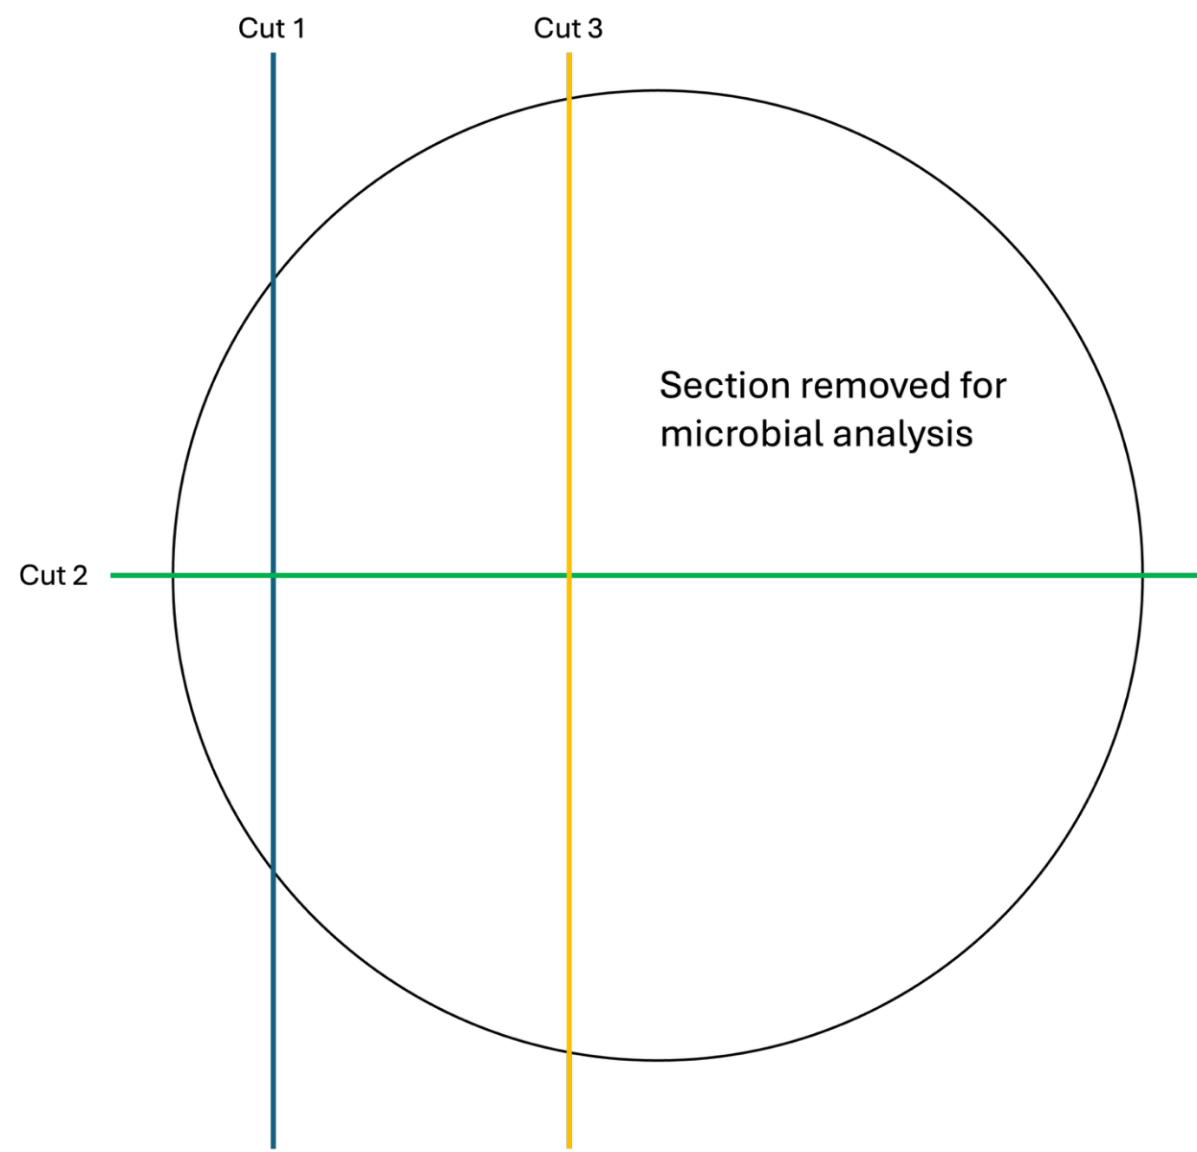
Figure S1 Cut diagram used to remove a section for microbial analysis. The remaining sections were all archived for future geochemical analysis.

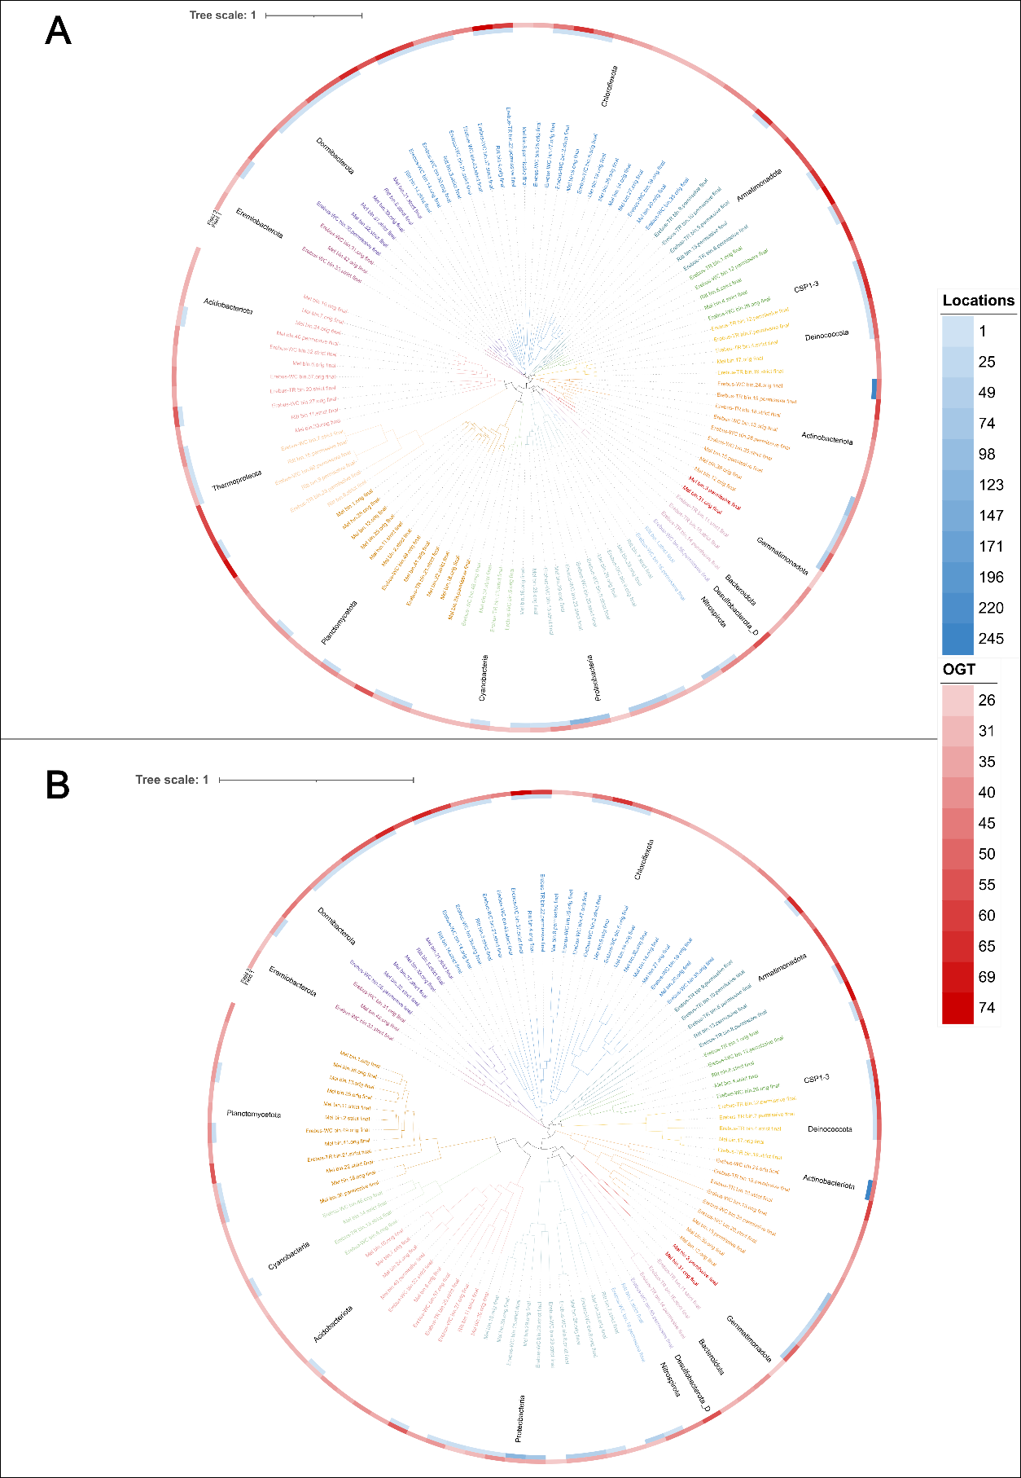
Figure S2 Phylogenomic tree of (A) archaeal and bacterial metagenome assembled genomes (MAGs) or (B) only bacterial MAGs from Antarctic geothermal sites; trees are approximately-maximum-likelihood phylogenetic trees (FastTree). Phylum annotations are given on the outside. The annotated heatmaps for each MAG are: (1) number of locations found in globally using branchwater and (2) predicted optimal growth temperature in °C.

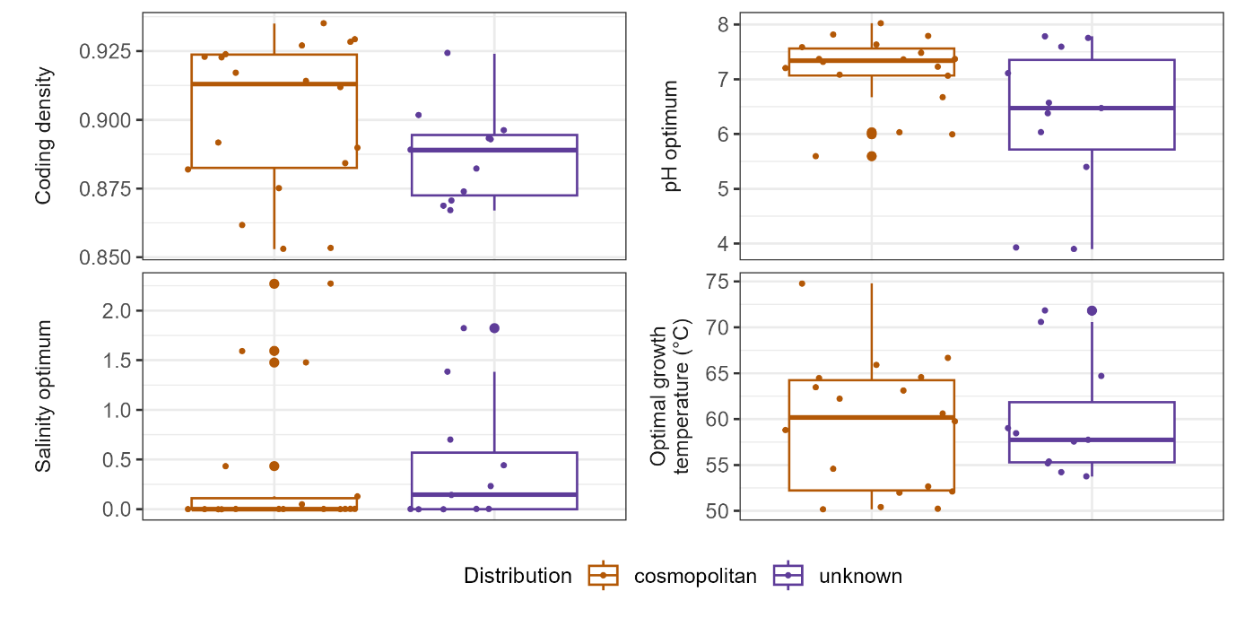
Figure S3 Predicted traits based on MAG sequences, compared between Antarctic geothermal cosmopolitan and non-cosmopolitan MAGs. There were no significant differences between any traits based on Wilcoxon tests (Benjamini-Hochberg adjusted for multiple tests; n = 18 for cosmopolitan, 11 for unknown).

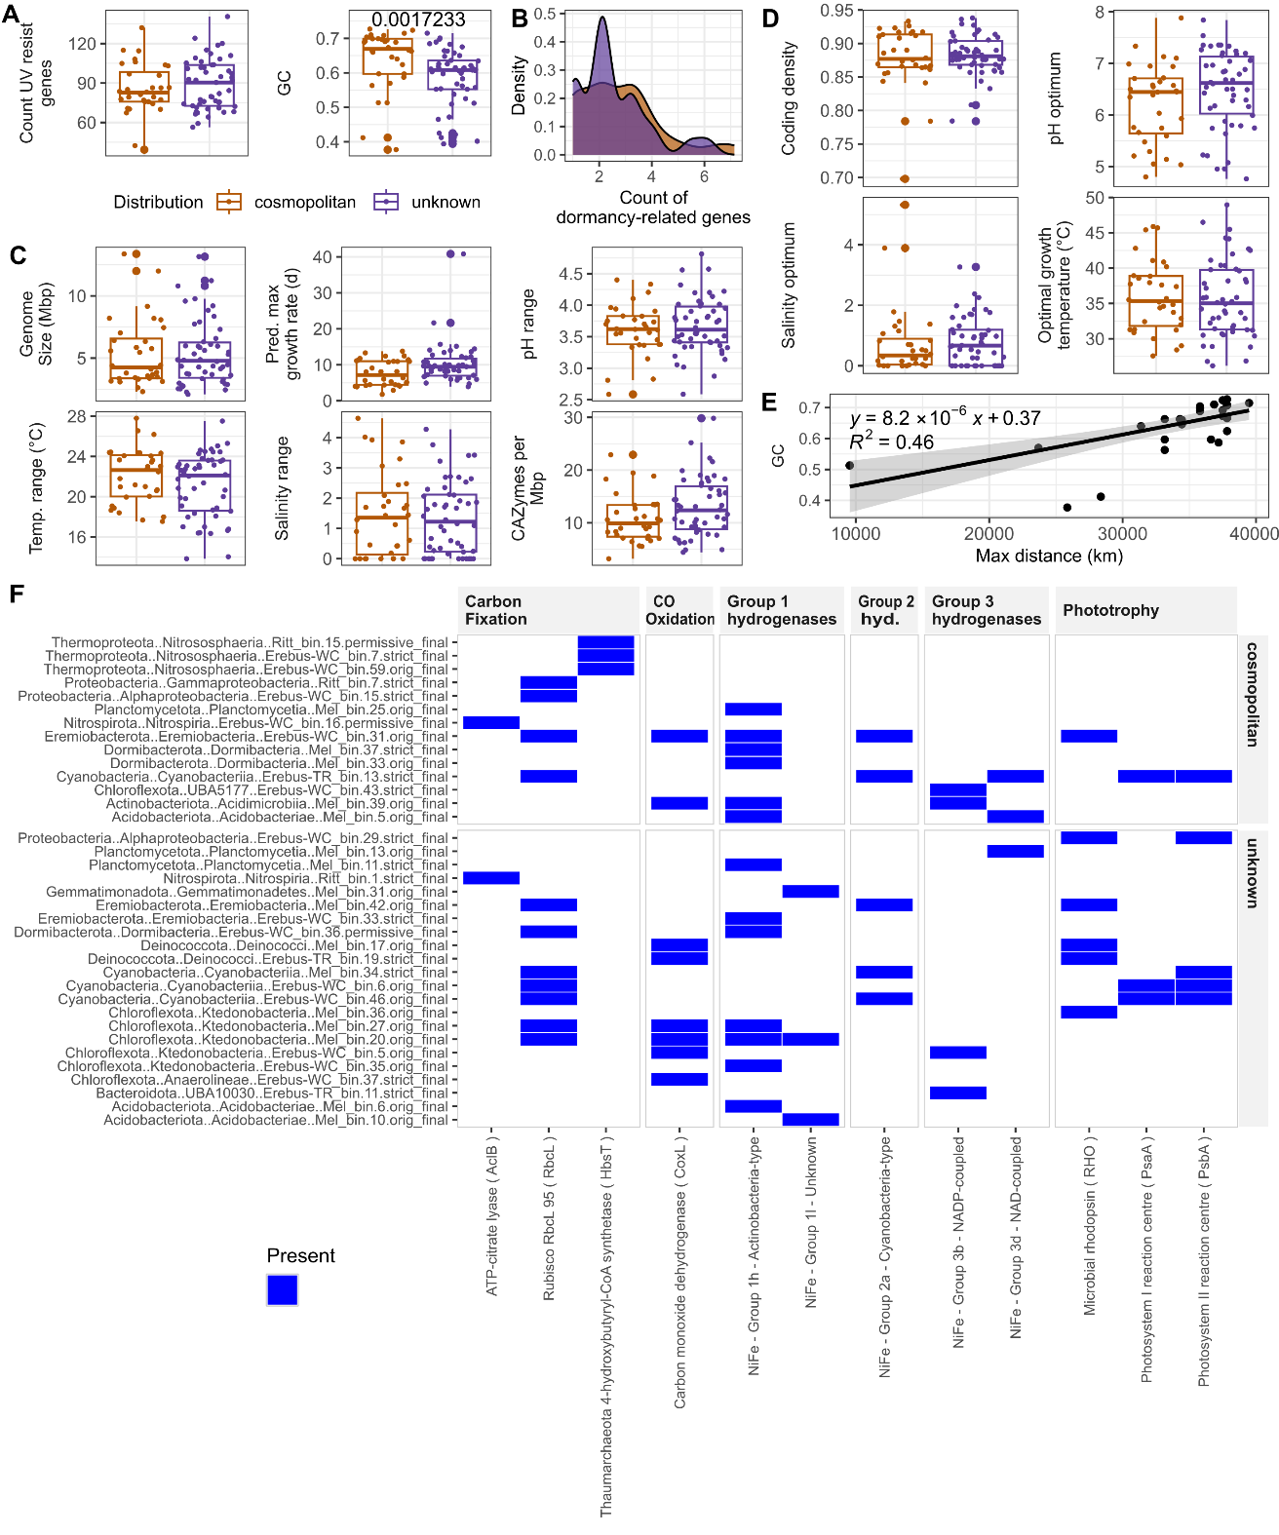
Figure S4 (A-D) Predicted traits based on MAG sequences, compared between mesophilic Antarctic geothermal cosmopolitan or unknown MAGs. (A-B) Traits predicted to be associated with dispersal success. (C) Traits predicted to be associated with colonization success. (D) Other traits not known to be associated with dispersal or colonization success. Presented p-values are the result of Wilcoxon tests (Benjamini-Hochberg adjusted for multiple tests; n = 32 for cosmopolitan, 50 for unknown). (E) Linear regression analysis for the variable identified from A-D as being significantly different between the two groups, correlated with the maximum distance between Mt. Erebus and the furthest distant metagenome from the SRA with a matching species (n = 32). (F) Predicted metabolic functions associated with dispersal success; only MAGs containing at least one of these predicted metabolisms are shown. Hyd: hydrogenases.

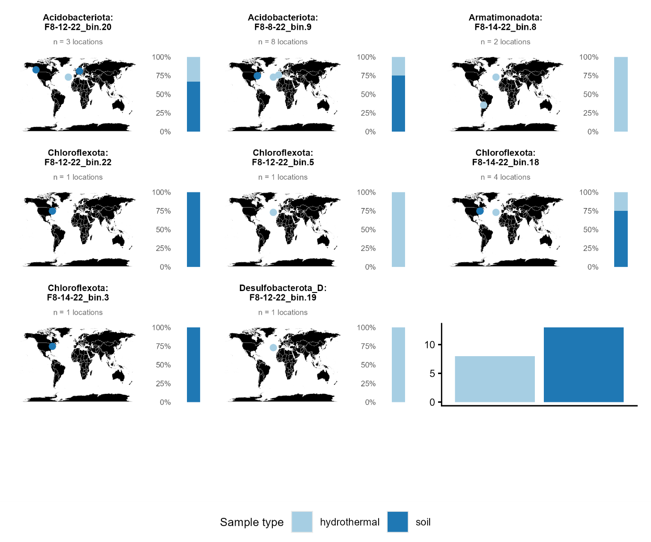
Figure S5 Maps for thermophiles from Fissure 8 samples with matching strains globally, identified by the phylum of origin and MAG name. Each dot represents a metagenome from the Sequence Read Archive (SRA) (with metagenomes within 10 m consolidated into a single location) identified as containing an identical strain (containment ≥0.99, cANI = 1). Habitats from the SRA metadata for each metagenome were condensed into 10 categories for ease of visualization. The stacked bar plot next to each MAG indicates the proportion of each sample type in which that MAG was found. Bottom right plot: across all MAGs, the frequency with which MAGs were identified in each type of habitat.

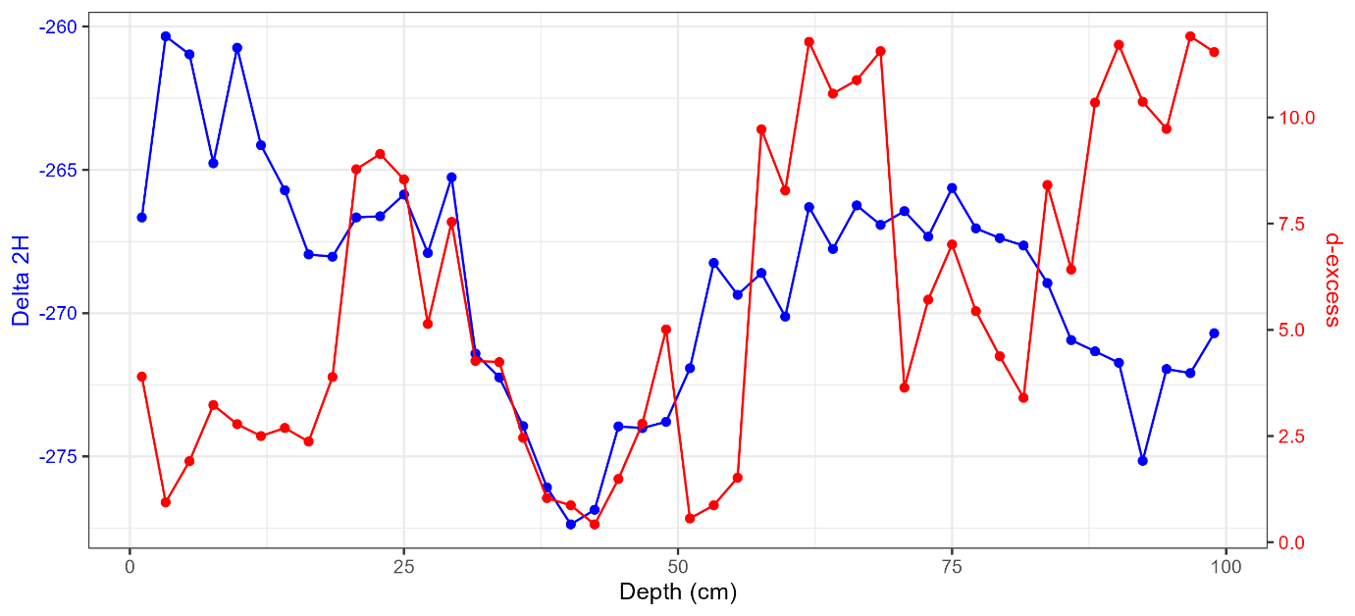
Figure S6 Water isotope data from the first 1m section of the Fang Glacier ice core to gain a first approximation of the age of the core.

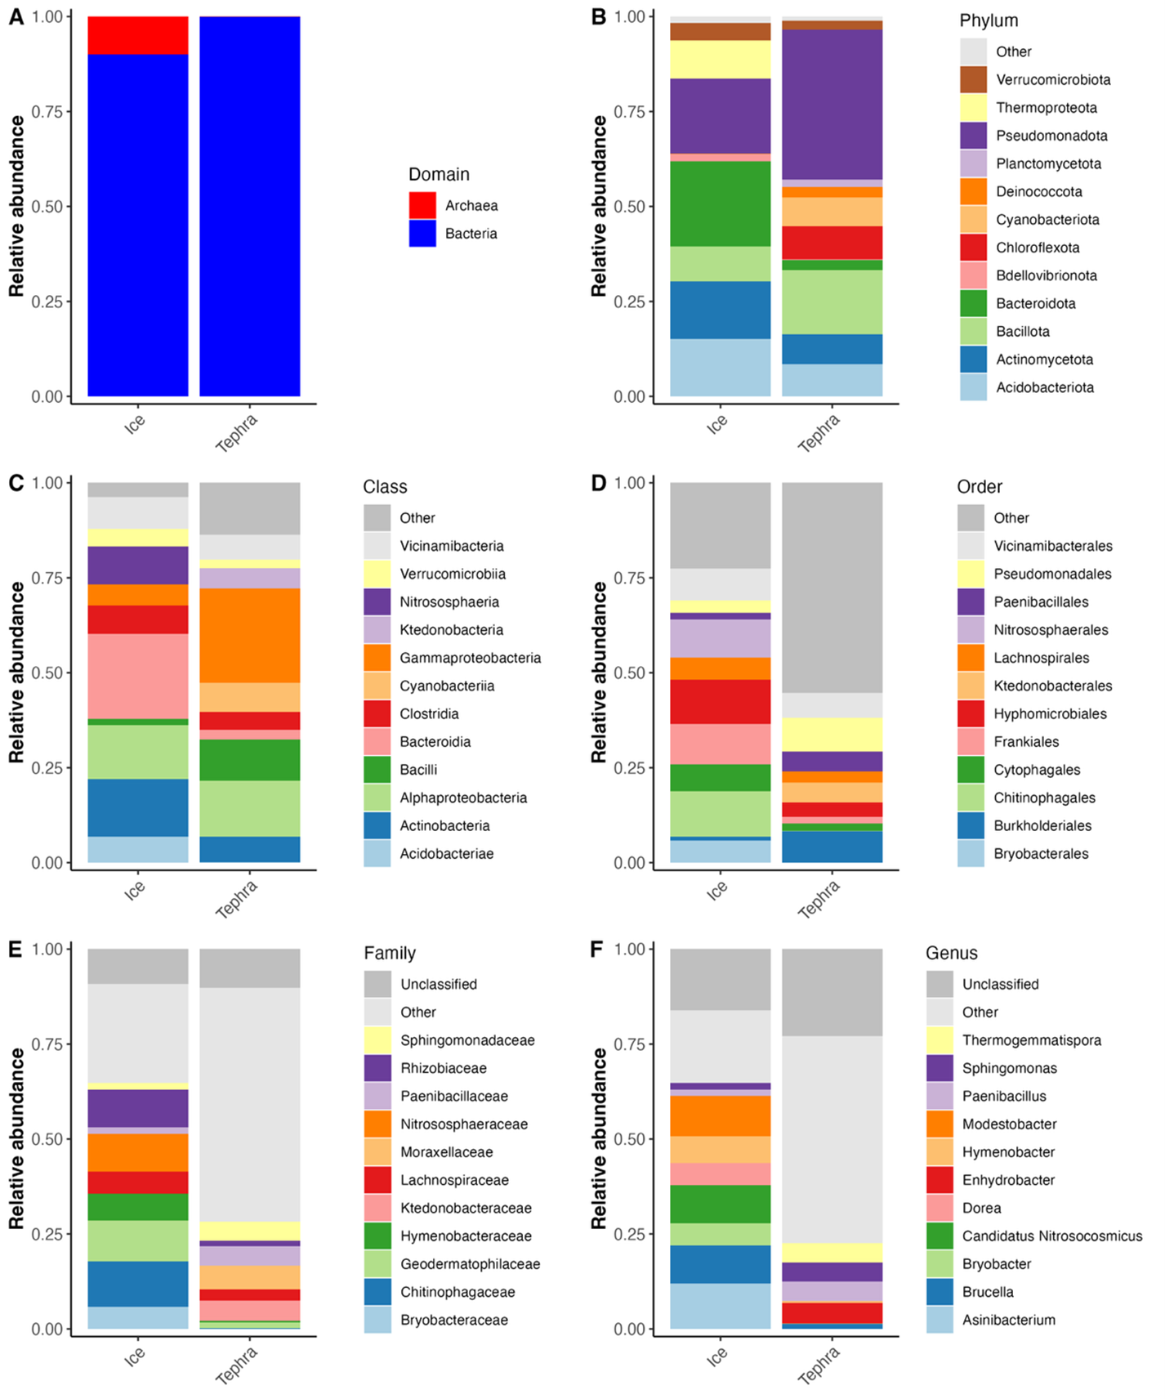
Figure S7 Microbial communities identified in ice sections (5) and tephra sections (20). (A) The relative abundance of Archaea and Bacteria across the core groups. (B) The 12 most abundant bacterial phyla. (C) The 12 most abundant bacterial classes. (D) The 12 most abundant bacterial orders. (E) The 11 most abundant bacterial families. (F) The 11 most abundant bacterial genera. For all plots, “Unclassified” are ASVs without a taxonomic identification at that level, while “Other” include all organisms not included in the taxa displayed in the plot.

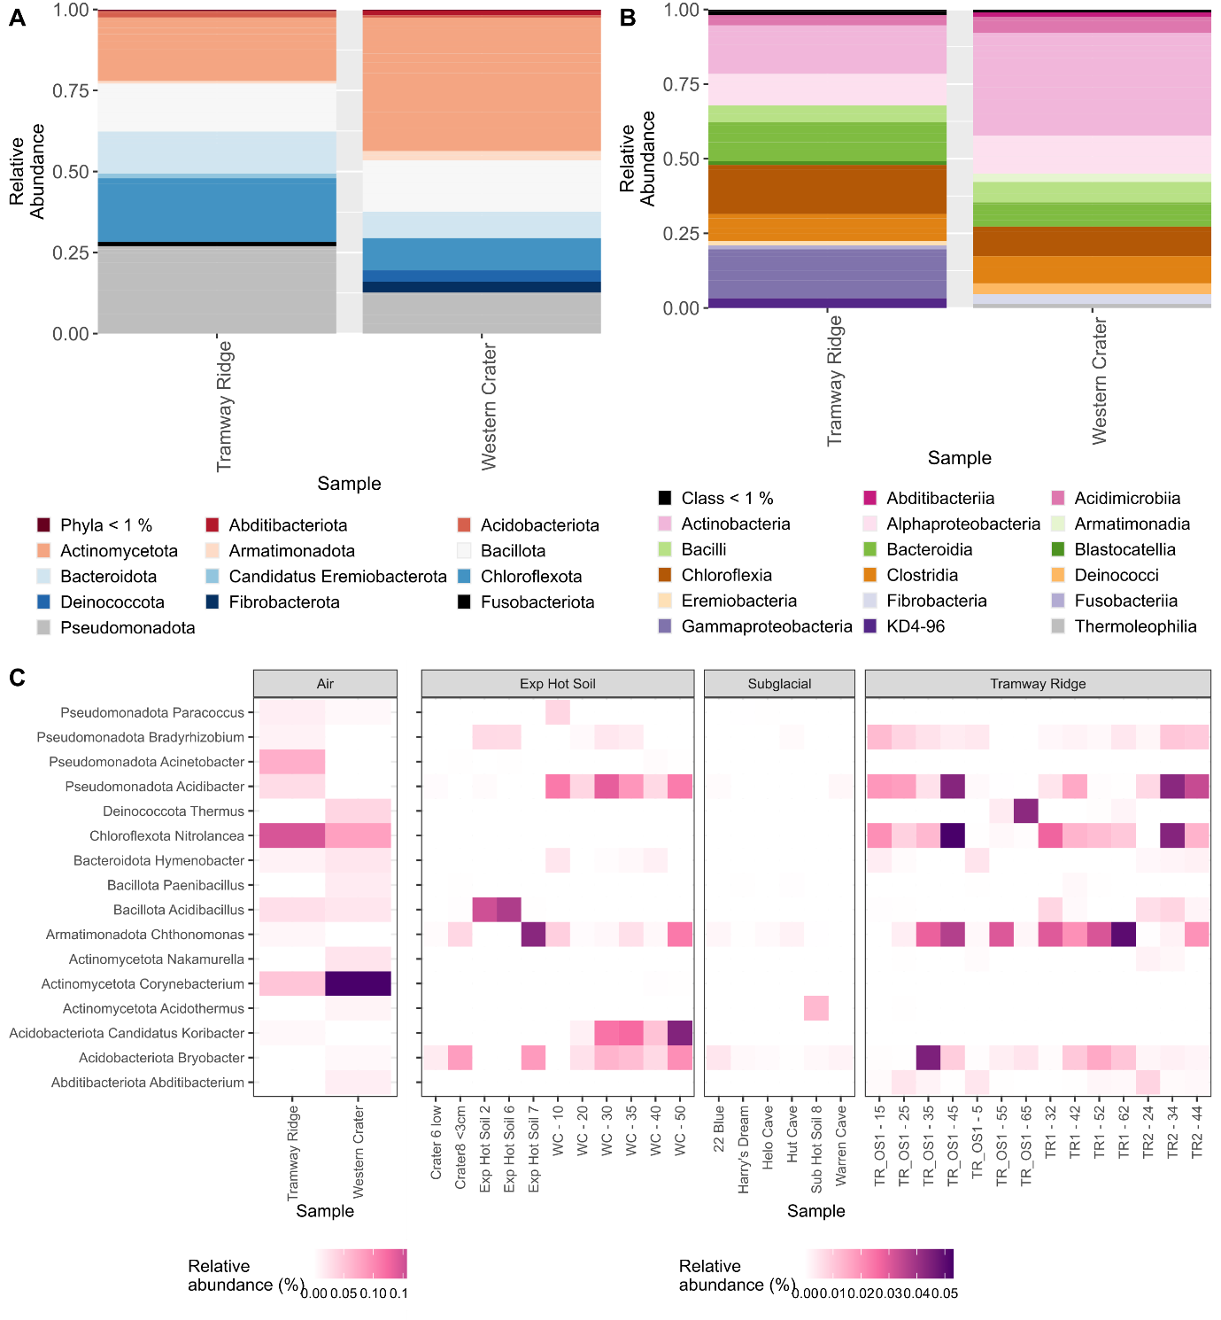
Figure S8 (A, B) Taxonomy of amplicon sequence variants (ASVs) from two air samples collected on Mt. Erebus at either (A) the phylum or (B) class level. (C) Heatmap showing the relative abundance of genera that matched between the air data and a previously published survey of microbial communities in heated soils around Mt. Erebus.

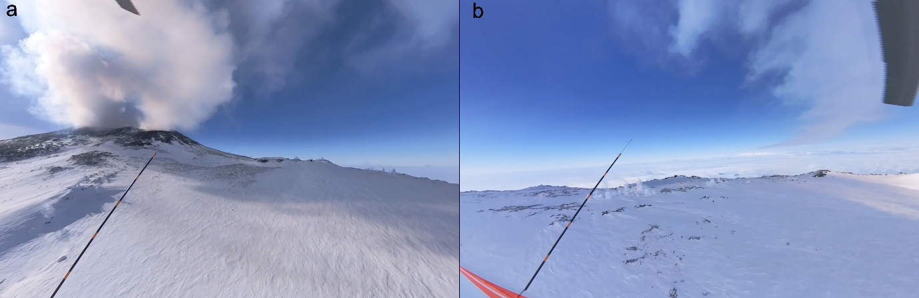
Figure S9 (A) Aerial view of the Mt. Erebus volcanic plume emanating from the Main Crater, looking east. (B) Aerial view of the Mt. Erebus volcanic plume trailing into the distance, looking west, taken at the same time as (A) using a 360-camera attached to the helicopter. Images courtesy of Anthony Powell.

