Target Fishing and Molecular Docking of Terpenes: A Systematic Evaluation of Method Concordance and Ligand Efficiency

Manasa Hegde¹; Armin Ahmadi¹; Daniel McShan²; Susan Trapp^{2,*}; Jerome Baudry^{1,*}

1: Department of Biological Sciences, The University of Alabama in Huntsville, Huntsville, Alabama, USA

2: Terpedia, LLC, Colorado, USA

*: Corresponding Authors: jerome.baudry@uah.edu; susan@terpedia.com

Supplementary Information 3

Effect of heavy atoms on docking scores

S1. Cannabinoid receptor 2 (CB2)

Figure S1 shows the relationship between the number of heavy atoms and docking scores for monoterpenes and sesquiterpenes, analyzed separately and together with their respective known ligands, docked against CB2. In Figure S1a, monoterpenes along with their known ligands (MK) showed a coefficient of determination of 0.946, which decreased to 0.112 when only monoterpenes were considered in Figure S1b. Similarly, sesquiterpenes combined with their known ligands (SK) showed a coefficient of determination of 0.926 in Figure S1c, decreasing to 0.245 when only sesquiterpenes were considered in Figure S1d.

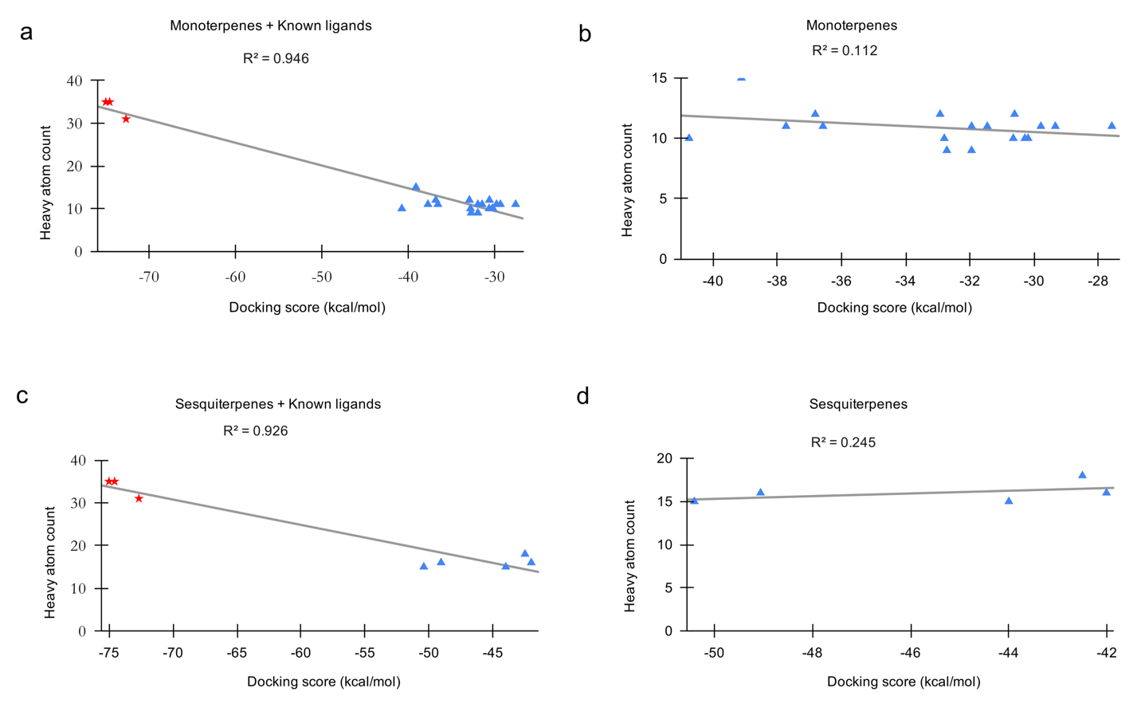

Fig. S1 Heavy atom count versus docking score for monoterpenes, sesquiterpenes, and their known ligands docked against CB2. Red represents known ligands, and blue represents terpenes.

S2. Androgen receptor
In the AR docking analysis, MK showed a coefficient of determination of 0.899 in Figure S2a, which decreased to 0.643 when only monoterpenes were considered in Figure S2b. Similarly, SK showed a coefficient of determination of 0.787 in Figure S2c, decreasing to 0.394 when only sesquiterpenes were considered in Figure S2d.

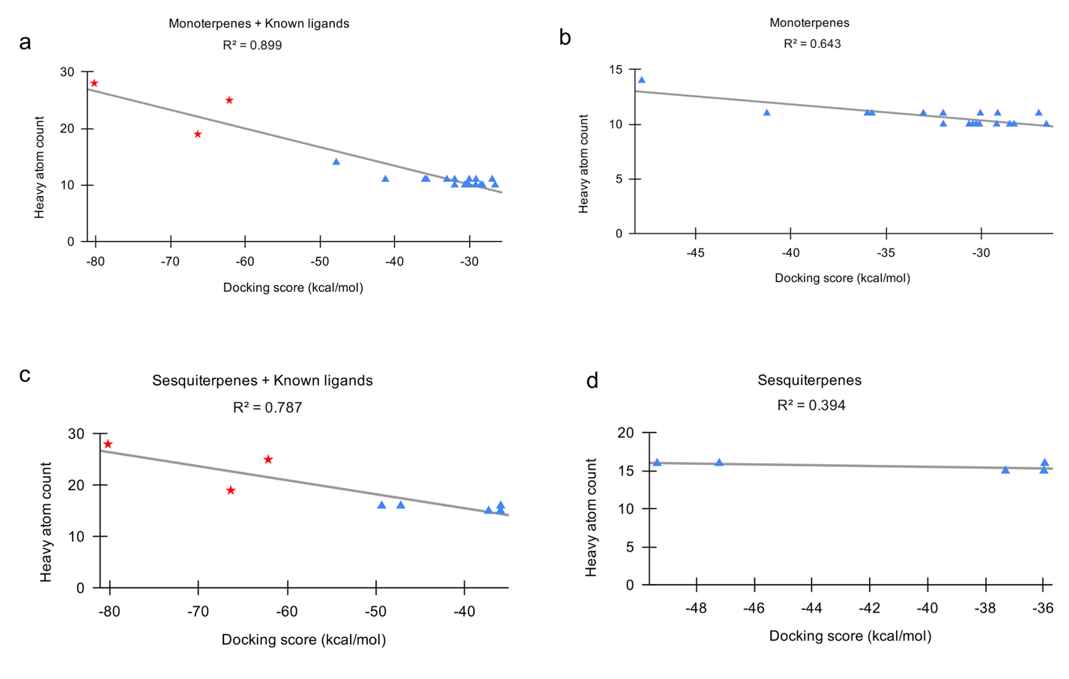

Fig. S2 Heavy atom count versus docking score for monoterpenes, sesquiterpenes, and their known ligands docked against AR. Red represents known ligands, and blue represents terpenes.

S3. 11β-Hydroxysteroid dehydrogenase 1

In 11β-HSD1 docking analysis, MK showed a coefficient of determination of 0.901 in Figure S3a, which decreased to 0.401 when only monoterpenes were considered in Figure S3b. Similarly, SK showed a coefficient of determination of 0.876 in Figure S3c, decreasing to 0.781 when only sesquiterpenes were considered in Figure S3d.

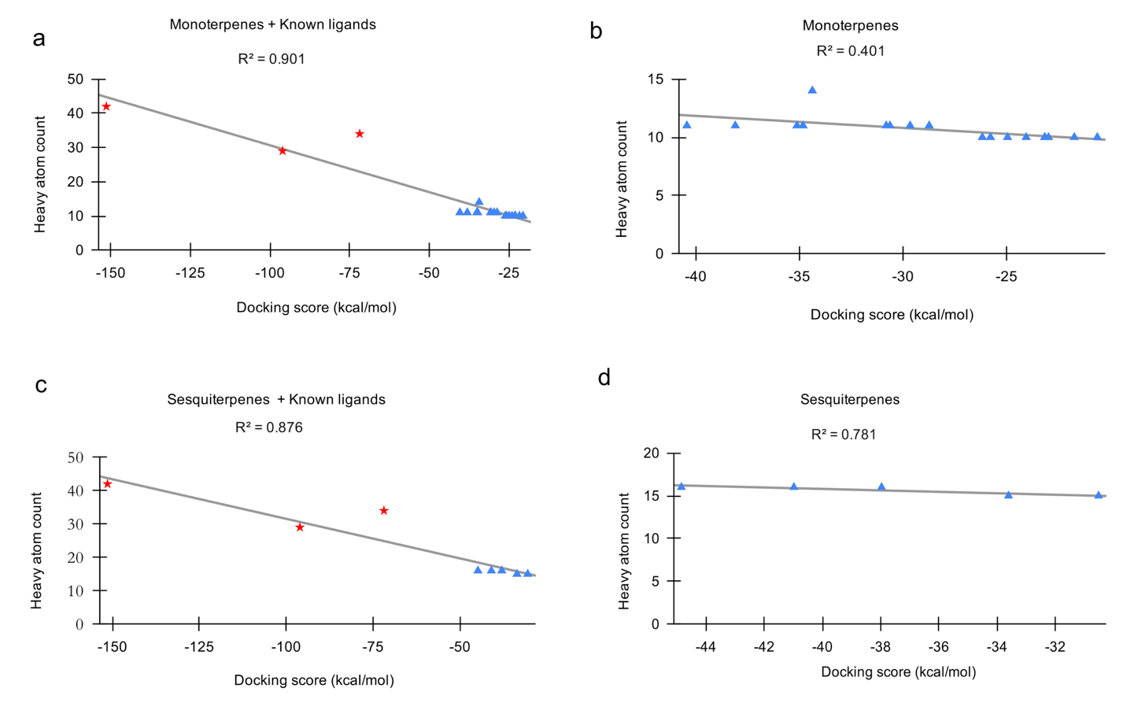

Fig. S3 Heavy atom count versus docking score for monoterpenes, sesquiterpenes, and their known ligands docked against 11β-HSD1. Red represents known ligands, and blue represents terpenes.

S4. Cytochrome P450 19A1

In CYP19A1 docking analysis, MK showed a coefficient of determination of 0.307 in Figure S4a, which increased to 0.604 when only monoterpenes were considered in Figure S4b. Similarly, SK showed a coefficient of determination of 0.112 in Figure S4c, increasing slightly to 0.154 when only sesquiterpenes were considered in Figure S4d. The heavy atom counts were higher for MK in Figure S4a and SK in Figure S4c.

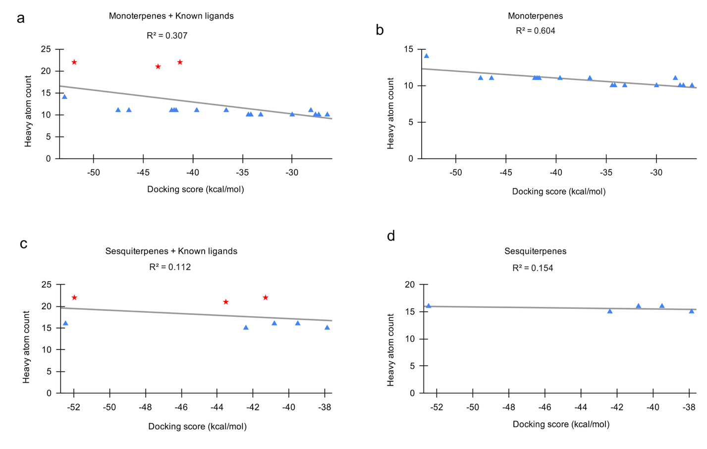
Fig. S4 Heavy atom count versus docking score for monoterpenes, sesquiterpenes, and their known ligands docked against CYP19A1. Red represents known ligands, and blue represents terpenes.

S5. Estrogen receptor β

In the ERβ docking analysis, MK showed a coefficient of determination of 0.925 in Figure S5a, which decreased substantially to 0.117 when only monoterpenes were considered in Figure S5b. Similarly, SK showed a coefficient of determination of 0.946 in Figure S5c, decreasing to 0.312 when only sesquiterpenes were considered in Figure S5d.

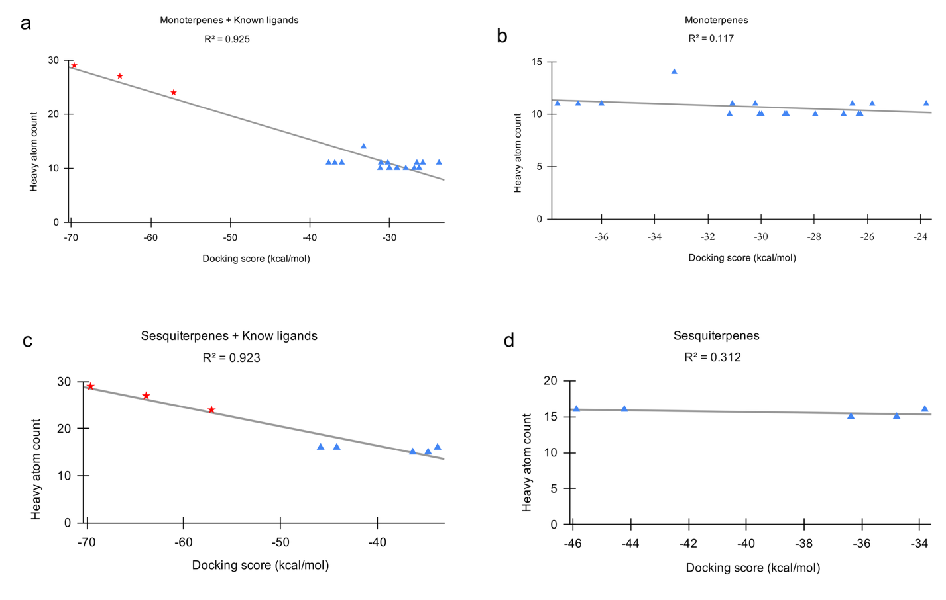

Fig. S5 Heavy atom count versus docking score for monoterpenes, sesquiterpenes, and their known ligands docked against ERβ. Red represents known ligands, and blue represents terpenes.

