Supplemental Material
White matter hyperintensities partly mediate genetically predicted blood pressure effects on vascular dementia
Table S1. Variants dropped by the a priori APOE window
GRCh37 chr19:44,909,039–45,912,650.
Phenotype | SNP dropped
WMH | rs769449
DBP | rs73036520
SBP | rs7255933
SBP | rs10420519
PP | rs7412
Table S2. 17q21.31 leave-out (European BP to WMH)
Region: hg19 chr17:43–46 Mb. This is a published WMH locus and contains the H1/H2 inversion. The H1 allele raises BP and lowers WMH, so the region can pull a polygenic BP to WMH estimate. The check asked whether that estimate moved by more than 10% after the region was dropped. It was not a discovery.
Exposure | Set | IVs | β (95% CI) | P | Change vs primary APOE-excl.
DBP | 17q excl. | 451 | 0.190 (0.133–0.247) | 6.59×10⁻¹¹ | +8.3% (below 10%)
SBP | 17q excl. | 449 | 0.096 (0.064–0.128) | 3.71×10⁻⁹ | +5.1% (below 10%)
Table S3. Japanese non-BP exposures to JPSC-AD WMH
Units: WMH residual SD per 1-SD exposure residual. Bonferroni 0.05/7=0.007.
Exposure | IVs | β | P | Passes 0.007?
eGFR | 52 | −0.031 | 0.73 | No
Serum creatinine | 51 | 0.027 | 0.77 | No
HbA1c | 24 | 0.132 | 0.061 | No
HDL cholesterol | 38 | 0.012 | 0.79 | No
LDL cholesterol | 23 | −0.141 | 0.012 | No (nominal only)
Triglycerides | 28 | 0.070 | 0.145 | No
C-reactive protein | 7 | −0.015 | 0.90 | No
Primary BP traits (Bonferroni 0.05/3=0.0167) are in main Table 1 and Figure 2B.
Table S4. Steiger directionality
Contrast | Result
DBP → WMH, all IVs | direction_ok, P=1.55×10⁻¹⁷
DBP → WMH, APOE-excl. | direction_ok, P=2.10×10⁻¹⁷
DBP → VaD, APOE-excl. | direction_ok, Fisher-z P=0.068 (borderline)
WMH → VaD, all IVs | direction_FAIL, P=9.10×10⁻⁴ (APOE)
WMH → VaD, APOE-excl. | direction_ok, frac=1.00, P=2.00×10⁻⁷³
WMH → VaD, R12 BP-indep. | direction_ok, P=4.03×10⁻⁴⁶
Table S5. Genome-wide association study datasets
Role | Phenotype | Source | Ancestry | n | Notes
Exposure | SBP, DBP, PP | Evangelou et al., Nat Genet 2018 | European | Discovery 757,601 | Per 10 mm Hg
Outcome (EUR) | WMH | GWAS Catalog GCST90472808 | European | 37,355 | CHARGE and UK Biobank
Outcome (EUR) | VaD (two-step, R12) | FinnGen R12 F5_VASCDEM | Finnish / European | 3,624 / 475,484 | ICD-based
Outcome (EUR, residual) | VaD | FinnGen R13 F5_VASCDEM | Finnish / European | 4,254 / 471,080 | Residual-path report
Exposure (JP) | SBP, DBP, PP residuals | BioBank Japan; Kanai et al., Nat Genet 2018 | Japanese | SBP 136,597; DBP 136,615; PP 136,249 | Residual SD. Never per mm Hg
Outcome (JP) | WMH residual | JPSC-AD; Furuta et al., npj Genom Med 2024 | Japanese | 9,479 | Residual SD. Not the 2026 NCGG+JPSC meta-analysis
LD (EUR) | — | 1000 Genomes Phase 3 EUR | European | — | Clump r²<0.001, 10 Mb
LD (JP) | — | 1000 Genomes Phase 3 JPT | Japanese | JPT 104 | Clump r²<0.001, 10 Mb
Analysis code and variant-level association results are available at https://github.com/sw4rsw4r/BP-WMH-VaD.
Table S6. All-instrument versus APOE-excluded European BP to WMH
Contrast | IVs | Estimate (95% CI) | P
DBP → WMH, all IVs | 455 | β=0.175 (0.115–0.236) | 1.37×10⁻⁸
DBP → WMH, APOE-excl. | 454 | β=0.176 (0.115–0.236) | 1.40×10⁻⁸
SBP → WMH, all IVs | 451 | β=0.091 (0.058–0.124) | 5.00×10⁻⁸
SBP → WMH, APOE-excl. | 449 | β=0.091 (0.058–0.124) | 5.63×10⁻⁸
Units are WMH SD per 10 mm Hg. Primary estimator: multiplicative random-effects IVW. b-step mean F=59.1, minimum F=32.7. The Sobel standard error sets Cov(a,b)=0. WMH to VaD with all 17 instruments is not the primary b step (OR 2.730, 0.938–7.945; Qp=3.73×10⁻⁵⁷).
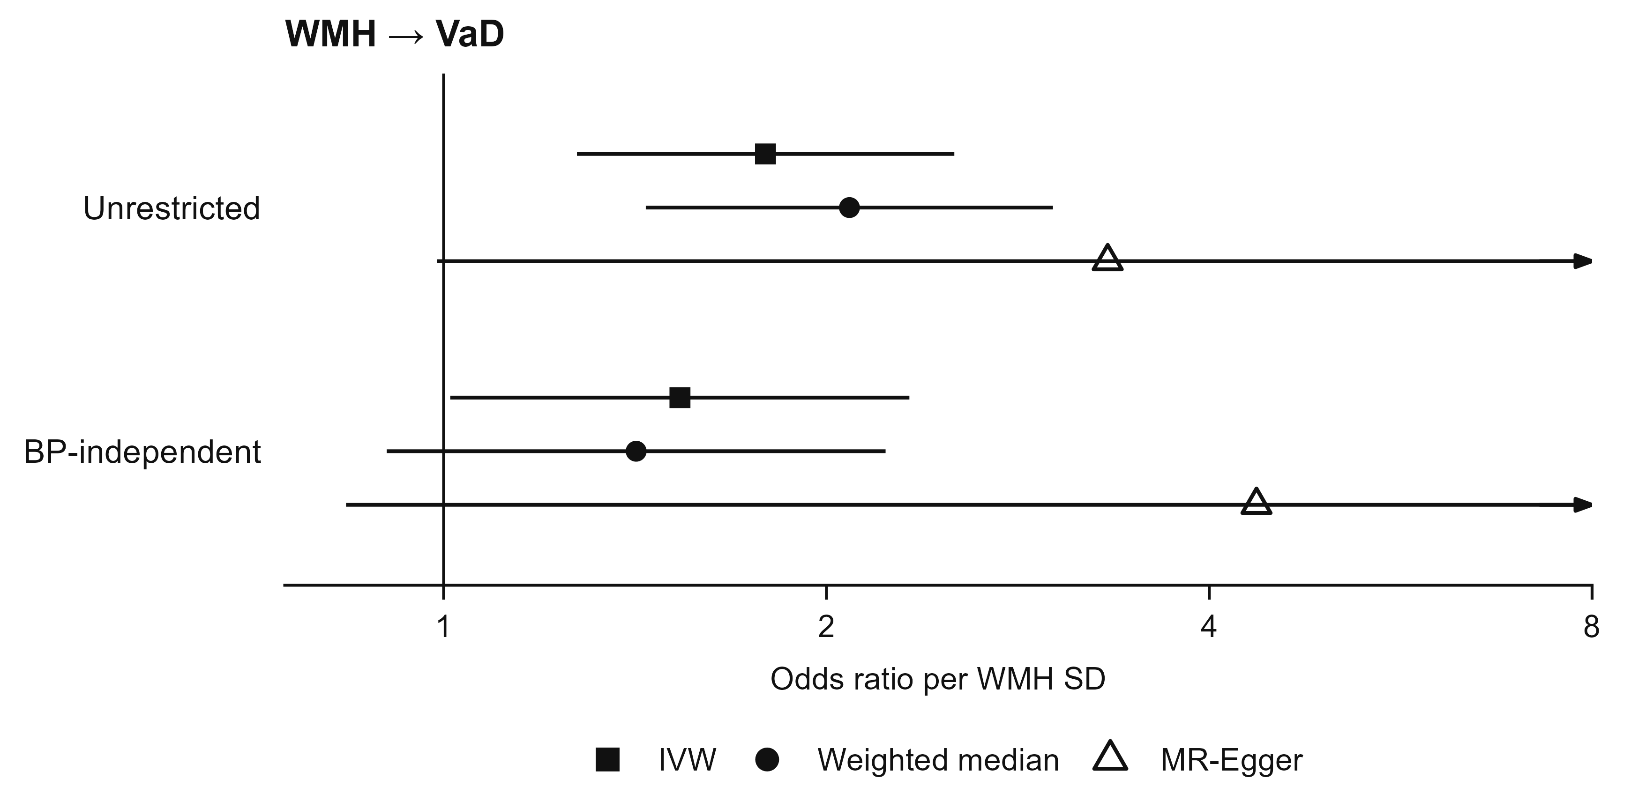
Figure S1. Residual WMH to VaD (FinnGen R13). APOE-excluded WMH instruments on VaD (odds ratio per WMH SD). Unrestricted set, 16 instruments. BP-independent set, 10 instruments after dropping SBP or DBP genome-wide instruments and 17q21.31. Filled square, inverse-variance weighted. Filled circle, weighted median. Open triangle, MR-Egger. Arrowheads mark truncated intervals.

