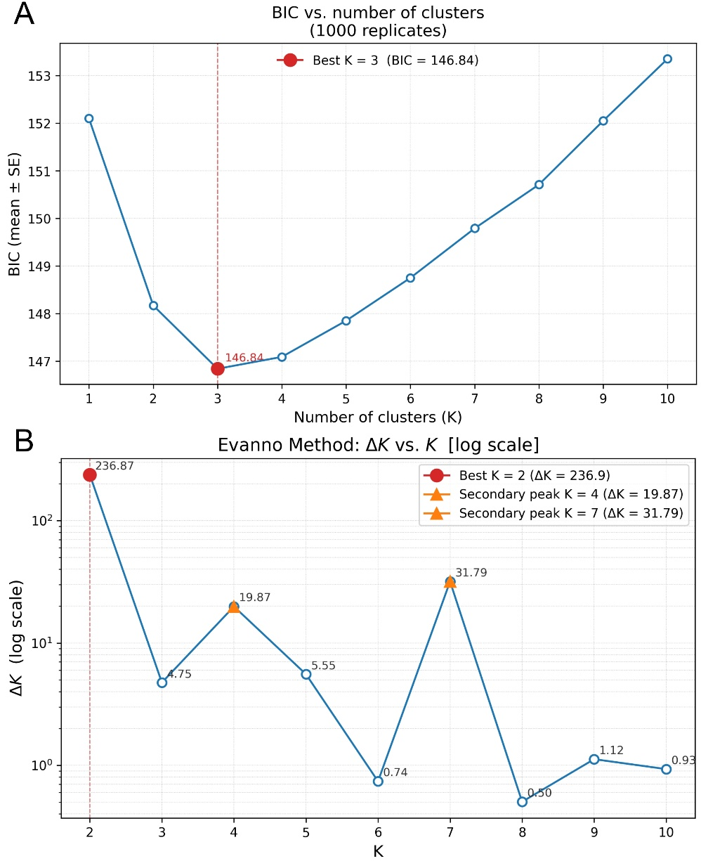
Figure S1. The selection of the number of clusters was based on 18 neutral SSR loci in 90 clone-corrected sweet cherry accessions. (A) The Bayesian Information Criterion (BIC) for K = 1–10 was obtained from find.clusters (mean ± SE over 1000 replicates); the minimum at K = 3 (BIC = 146.84) was retained for subsequent Discriminant Analysis of Principal Components (DAPC). (B) The Evanno ΔK for the STRUCTURE analyses (K = 1–11, with 20 replicates per K) is displayed on a logarithmic scale. The ΔK value peaked sharply at K = 2 (236.87). Secondary peaks at K = 7 (31.79) and K = 4 (19.87) are also indicated; however, both are approximately an order of magnitude lower and were not interpreted further. It should be noted that ΔK is defined solely for interior values of K and, as such, is shown for K = 2–10.

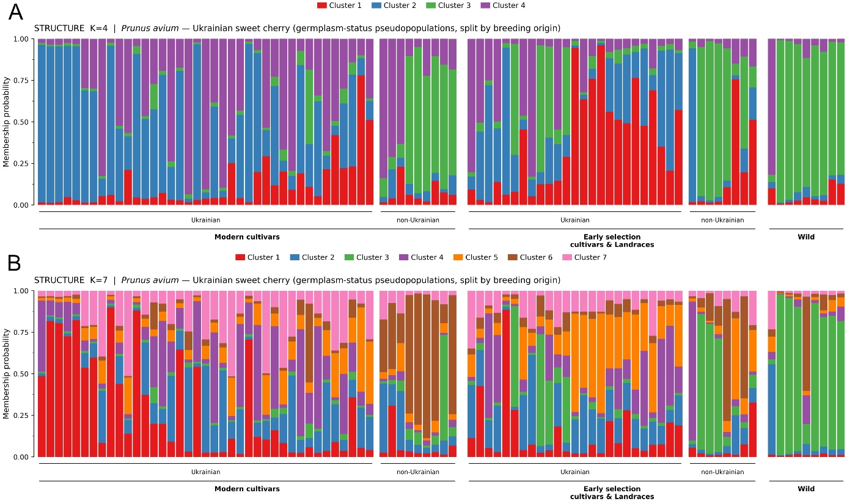
Figure S2. STRUCTURE membership coefficients at higher K for 90 clone-corrected sweet cherry accessions, based on 18 neutral SSR loci. (A) K = 4; (B) K = 7. Bars display CLUMPP-averaged ancestry proportions over 20 replicate runs; each vertical bar represents a single accession, segmented into its membership coefficients. Cluster numbering and colors are arbitrary and independent between panels and from Figure 2. Accessions are presented in the same sequence as in Figure 2, organized by germplasm status (Modern cultivars; Early selection cultivars & Landraces; Wild) and, within each status, by breeding origin (Ukrainian / non-Ukrainian), then sorted according to DAPC membership; these categories were not provided as prior information. At a membership threshold of Q ≥ 0.80, only 31 of 90 accessions were assignable at K = 4, and 14 of 90 at K = 7, compared to 82 of 90 at K = 2 (Figure 2B). The wild and introduced accessions remained the sole coherent group as K increased; the Ukrainian-bred material became progressively admixed, consistent with ongoing shared ancestry rather than further hierarchical subdivision.

