Supplementary Material S1: Online Content Corpus Source List and Verification Audit Trail
Collection date: 15 August 2026 | Verification method: direct comparison with original sources
The corpus comprised 31 publicly available items published between 2019 and 2026 and collected on 15 August 2026. Inclusion required each item to address GHRM practices, SDG 8/13 or Just Transition themes and to be traceable to a stable URL; salary-only posts, marketing material and duplicates were excluded. All items were verified against their original sources by the author on 20 August 2026, and dated screenshots were archived as an audit trail. Items are quoted verbatim; usernames are anonymised in line with Kozinets’ (2015) ethical guidance.
Corpus composition (31 items): employee review sites (AmbitionBox, Comparably, Indeed, Glassdoor) 12; layoff discussion board (TheLayoff.com) 4; social media (Reddit) 1; corporate channels (blog.se.com, YouTube, se.com) 9; press wires and media (PR Newswire, Businesswire, 3BL Media, UNLEASH, PublicNow) 5.
Theme 1: Green Ability Development (Training and Learning) — AMO: Ability (corpus items 1–6)
Item 1
"The company has a very good work culture and supportive management. Learning opportunities and career growth are really great here. Colleagues are cooperative…"
Source: AmbitionBox, President Systems employee review | https://www.ambitionbox.com/reviews/schneider-electric-president-systems-reviews
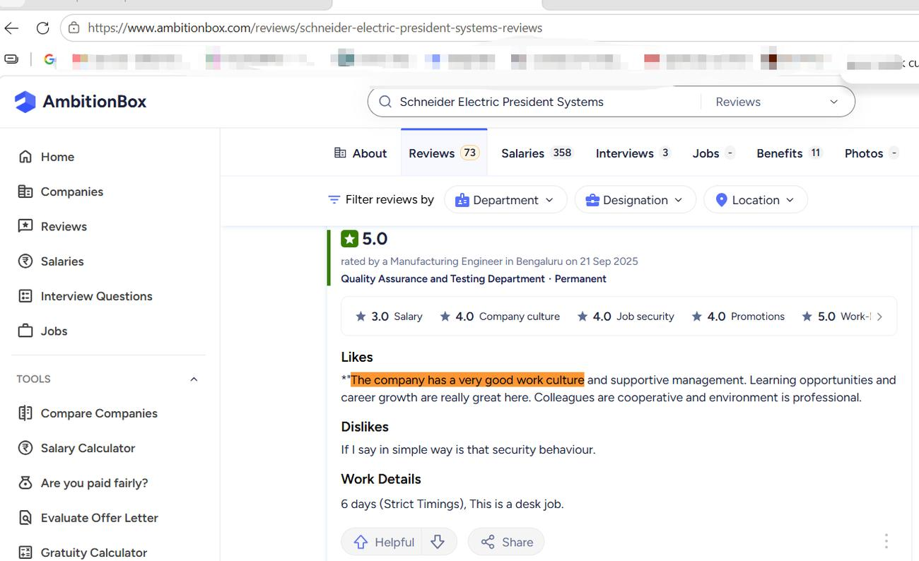
Item 2
"Good learning experience in core work | Dislikes: Poor work culture, lack of proper management and planning, high work pressure, and inadequate basic facilities"
Source: AmbitionBox, Learning review page | https://www.ambitionbox.com/reviews/schneider-electric-learning-reviews-20692
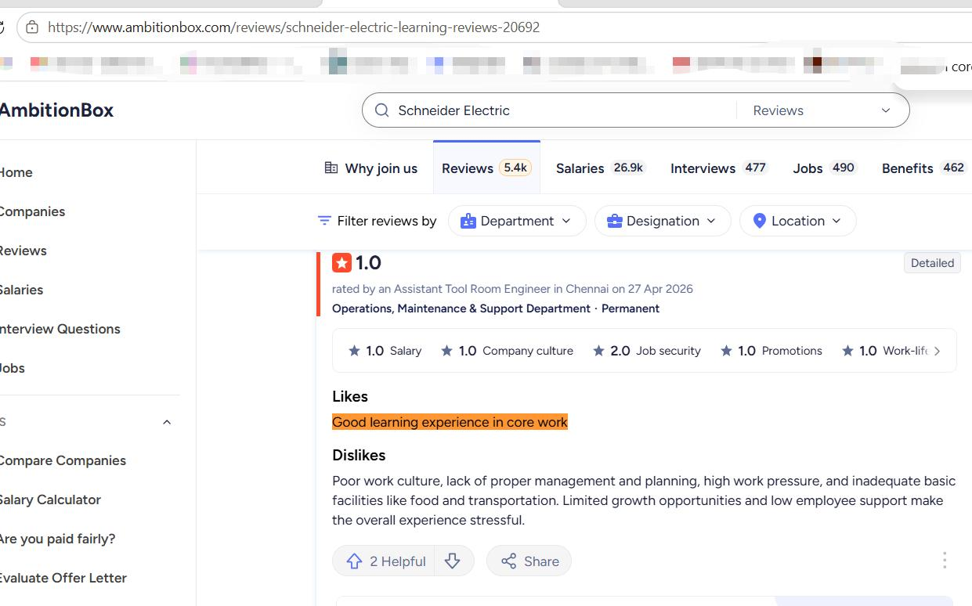
Item 3
"Learning & Development Support reported by 325 employees. Lot of opportunity…"
Source: AmbitionBox, aggregate rating (4.1/5, 5,400+ reviews) | https://www.ambitionbox.com/reviews/schneider-electric-reviews
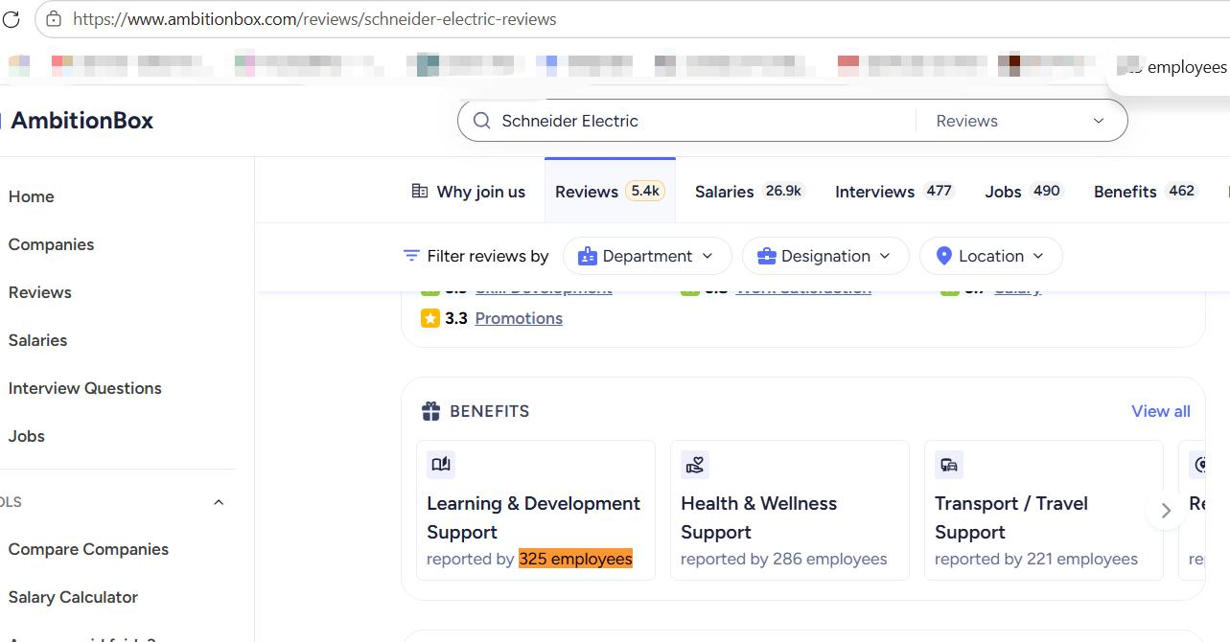
Item 4 (a)
"The variety! While I have worked at Schneider Electric, my role has evolved and changed substantially over that time. It has given me the opportunity to learn, develop and continue to challenge myself."
Source: Corporate blog employee interview — Jennifer Webster, Senior HRBP, Schneider Electric UK (attributed), 3 July 2019 | https://blog.se.com/sustainability/2019/07/03/schneider-electric-careers-help-stay-true-to-work-life-balance
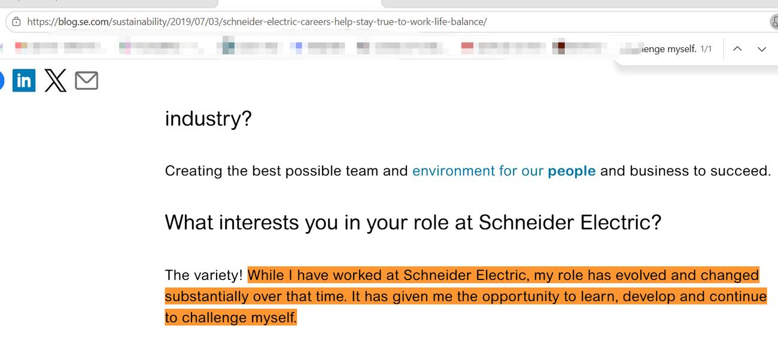
Item 4 (b)
"We are genuinely contributing to making the world a better, more sustainable place for the future – there is nothing more exciting or relevant than that! | Challenge: How to create a more inclusive culture for all our people so they feel their thoughts, views and interests are respected and valued."
Source: Corporate blog employee interview — Jennifer Webster, Senior HRBP, Schneider Electric UK, 2019 | https://blog.se.com/sustainability/2019/07/03/schneider-electric-careers-help-stay-true-to-work-life-balance
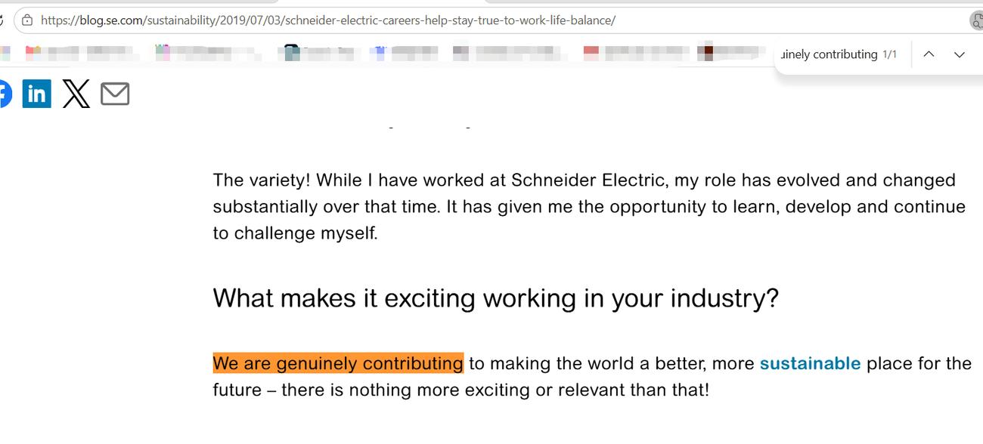
Item 5
"Learning everyday is one of the core values of Schneider. Innovation, I think, is at the bedrock for Schneider Electric…"
Source: Employee video testimonial (official YouTube channel, video transcript) | https://www.youtube.com/watch?v=8X6gVSqpvus
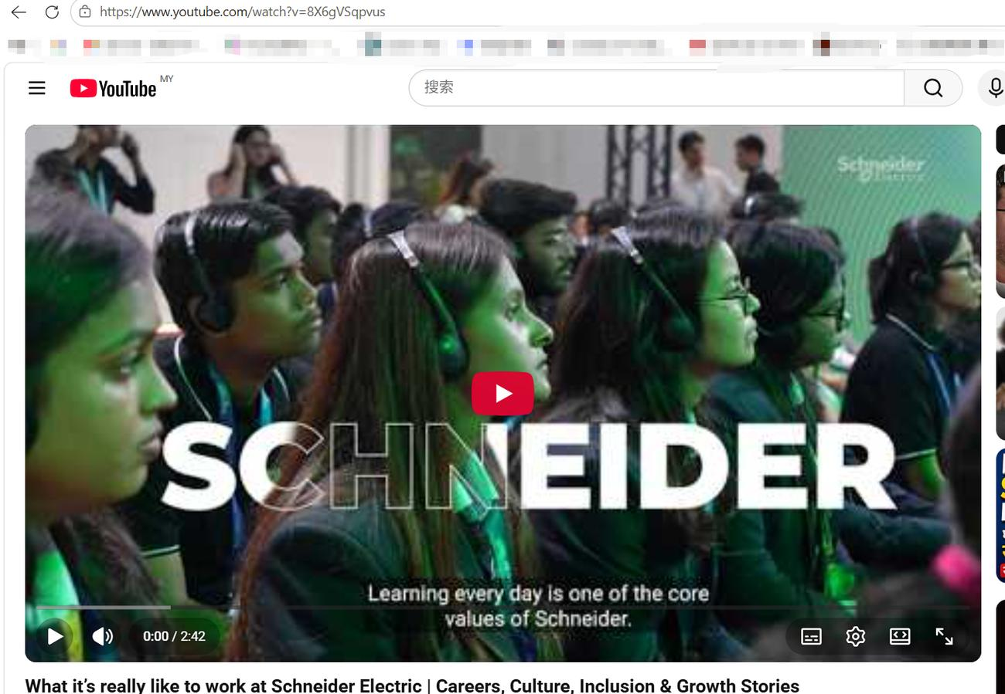
Item 6
"Best place to work. Focuses on sustainability. Employees are encouraged to think beyond boundaries. Offers best salary and perks…"
Source: Indeed, employee review (sustainability keyword filter) | https://www.indeed.com/cmp/Schneider-Electric/reviews?fcountry=ALL&ftext=Sustainability+
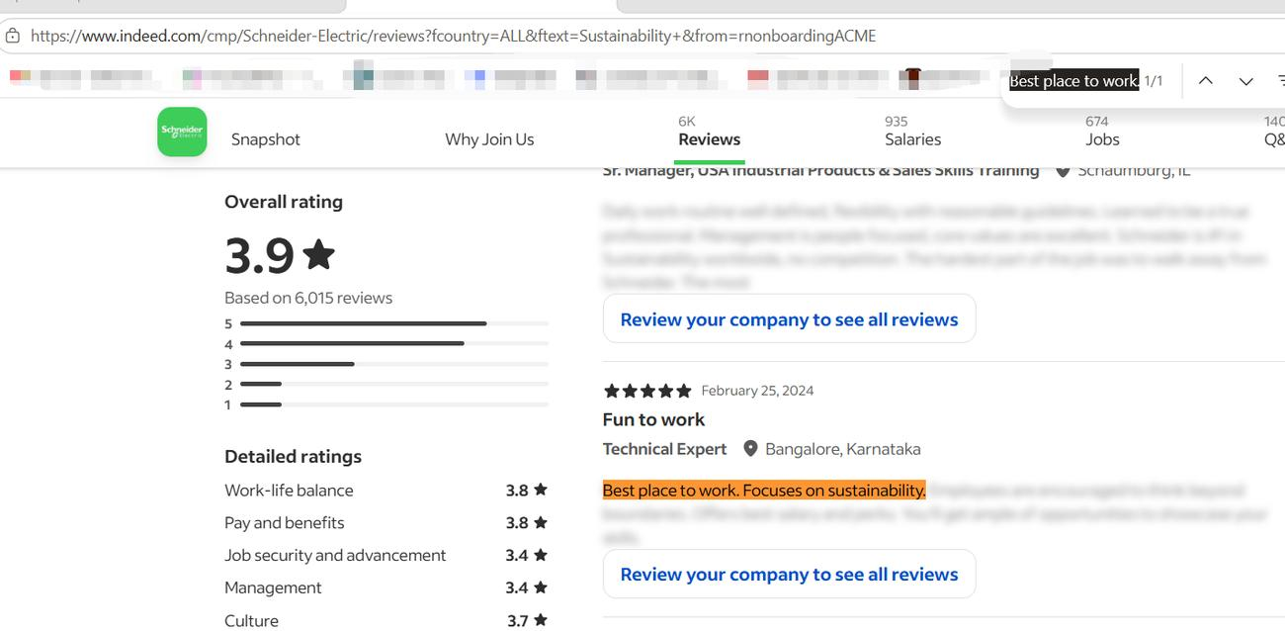
Theme 2: Green Motivation (SSI-Linked Compensation) — AMO: Motivation (corpus items 7–10)
Item 7 (a)
"You get your bonus (or variable) part for sure."
Source: Comparably, compensation review | https://www.comparably.com/companies/schneider-electric/reviews/compensation
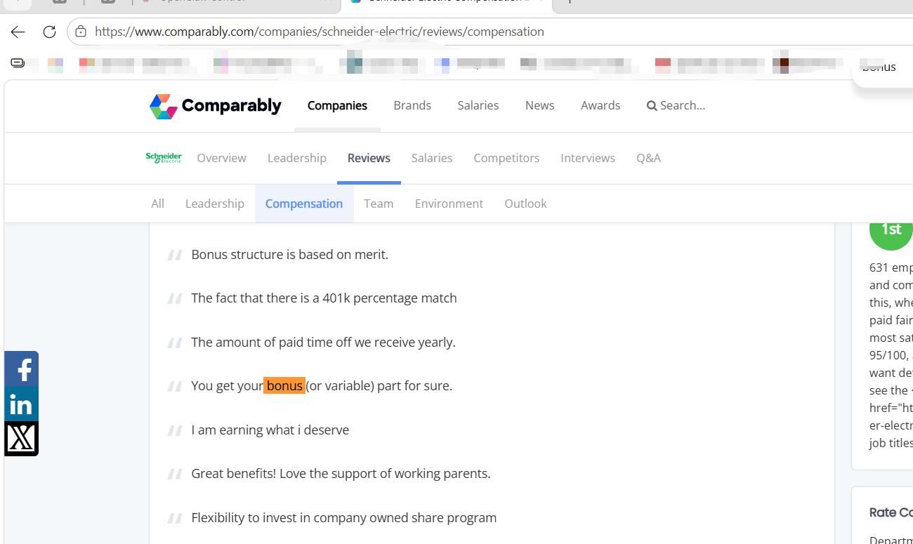
Item 7 (b)
"I am earning what i deserve"
Source: Comparably, compensation review | https://www.comparably.com/companies/schneider-electric/reviews/compensation
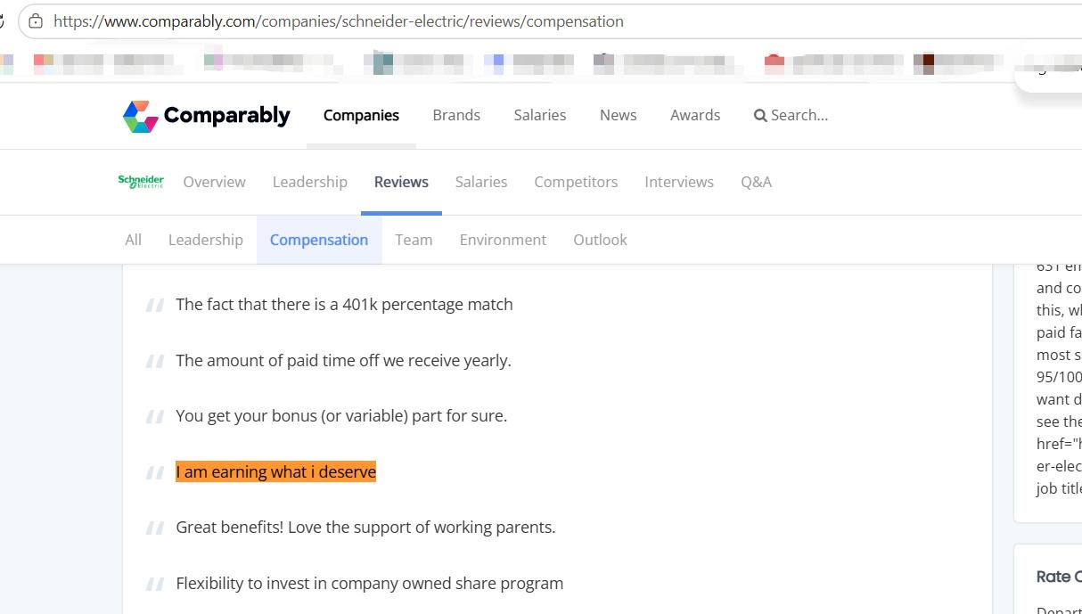
Item 7 (c)
"Great benefits! Love the support of working parents."
Source: Comparably, compensation review | https://www.comparably.com/companies/schneider-electric/reviews/compensation
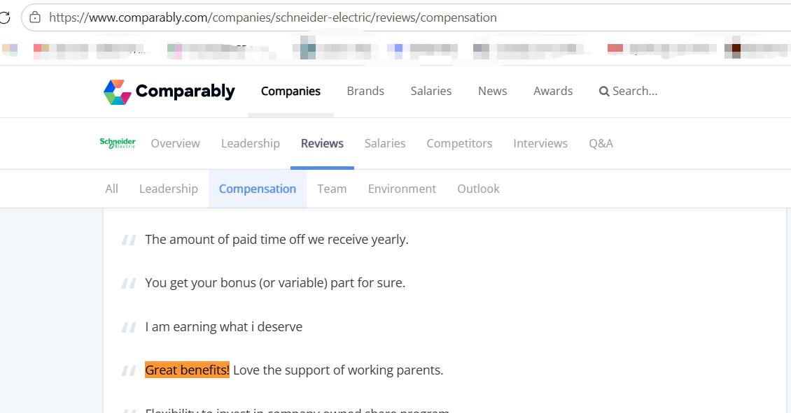
Item 8
"I have worked for Schneider for 4 years now as an Application Engineer. I can tell you they are at the top of the industry as far as compensation and benefits. I work full time from home and work life balance has been great (40 hours a week almost always). As for management, good luck finding a company that doesn’t have management issues."
Source: Reddit, r/PLC, 2023 | https://www.reddit.com/r/PLC/comments/13el90g/working_at_schneider/
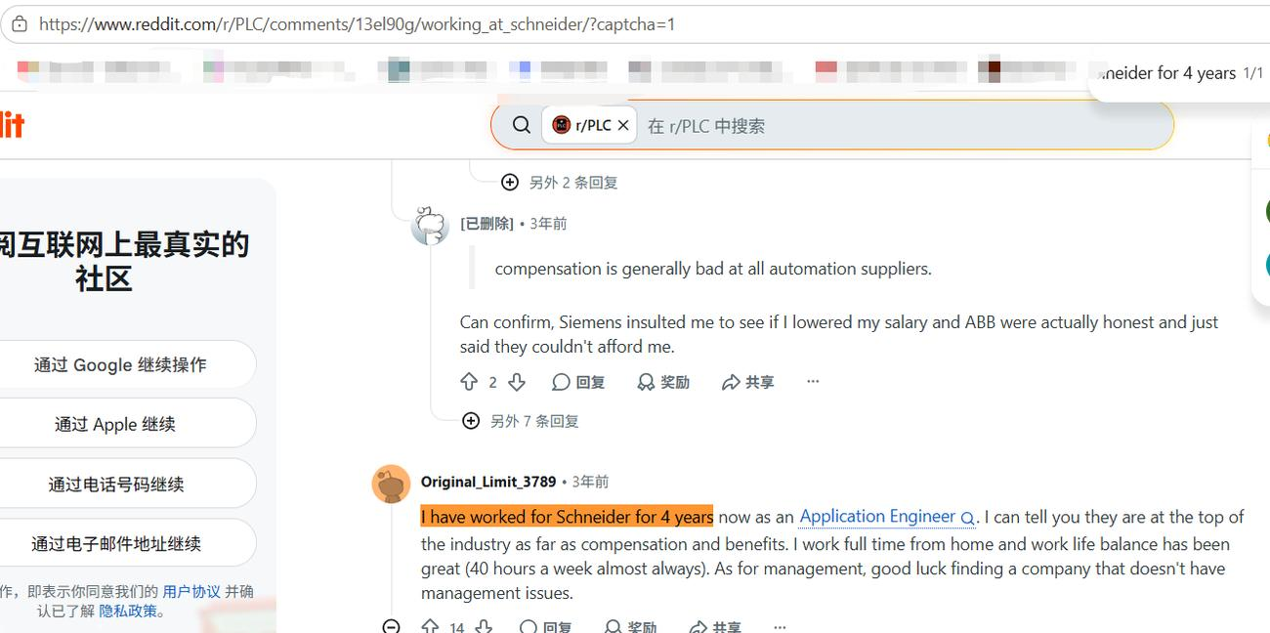
Item 9
"Official policy evidence: annual short-term incentives for the Group’s executives and about 76,000 eligible employees are linked to the Schneider Sustainability Impact (SSI) performance since 2011. From 2019, the weight of the SSI criteria has increased from 6% to 20% in the collective part of the annual incentive… In France, since 2012, the SSI has also been included in the profit-sharing incentive plan"
Source: se.com ESG FAQ (with Universal Registration Document 2024 page references) | https://www.se.com/ww/en/about-us/investor-relations/investment/esg
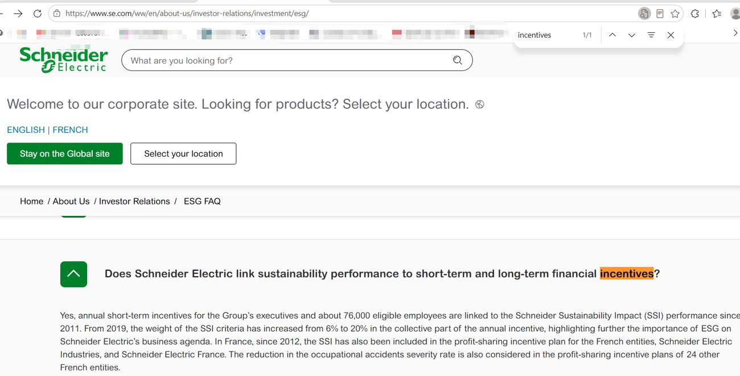
Item 10
"Each year, the SSI performance impacts short-term incentives for the Group’s executives and about 64,000 eligible employees, for 20% of the collective share."
Source: Official Sustainability Impact document (PublicNow archive) | https://docs.publicnow.com/897EAD78FCB404980D4E8E41DAE12FBFAD2CB92E
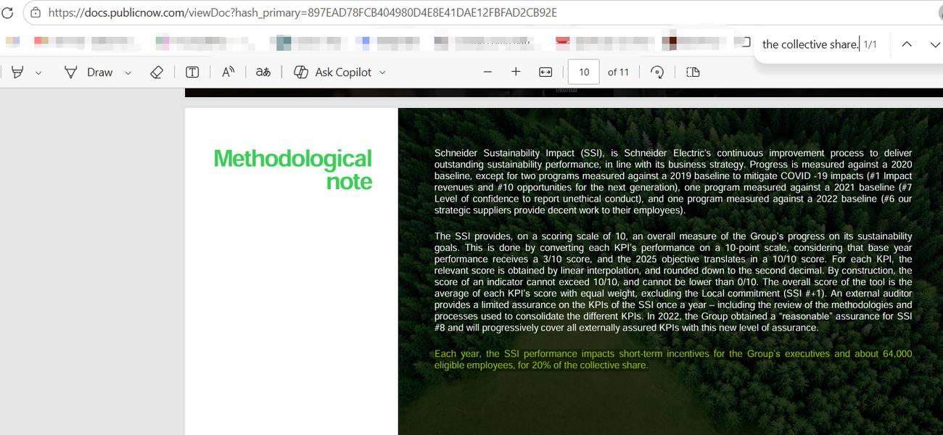
Theme 3: Green Opportunity Structures (50-40-30 Gender Commitment) — AMO: Opportunity (corpus items 11–16)
Item 11
"It is work life balance company, where great people make the great enviroment to work. User friendly and Equivalent gender diversity company…"
Source: Comparably, employee review #1555066 | https://www.comparably.com/companies/schneider-electric/reviews/1555066/it-is-work-life-balance-company-where-great-people-make-the-great-enviroment-to-work-user-friendly-and-equivalent-gender-diversity-company
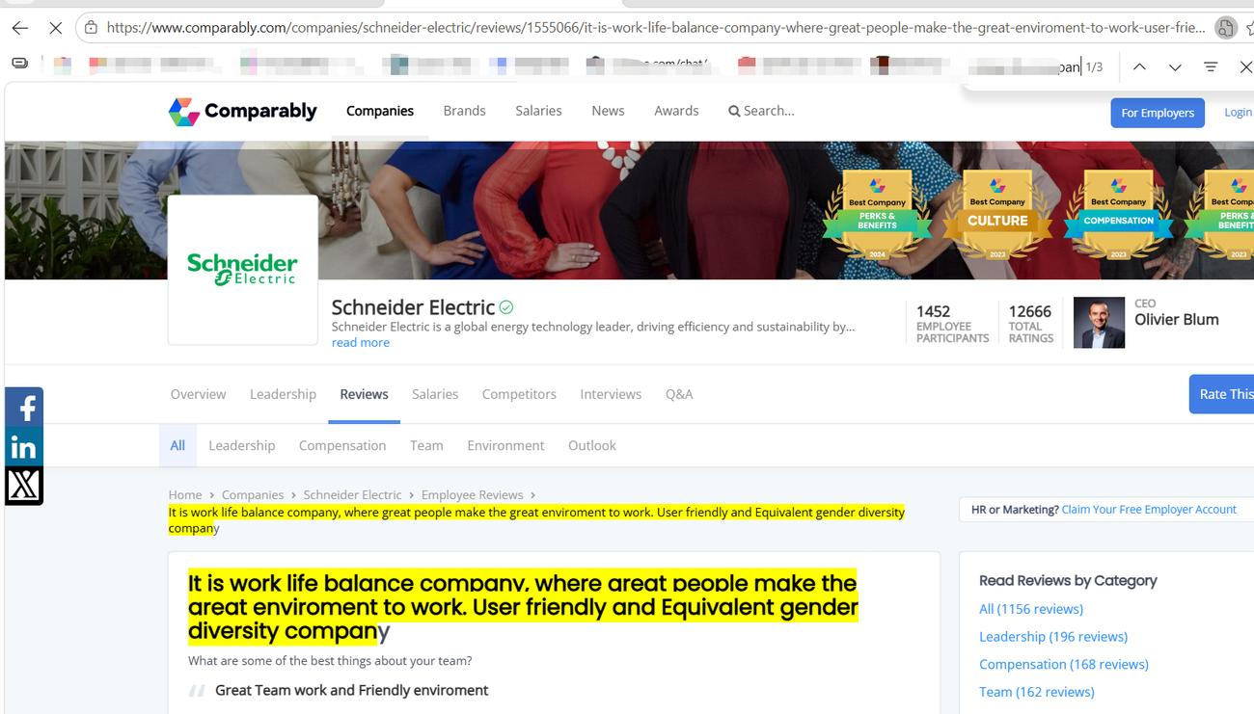
Item 12
"…we are as a company gender pay equitable for last 3 years in Schneider Electric India. What that means is for a particular job and a role, both a man and a woman gets the same salary and the same pay, which is something which we are very proud of as an organization."
Source: Employee video testimonial (official YouTube channel, video transcript) | https://www.youtube.com/watch?v=8X6gVSqpvus
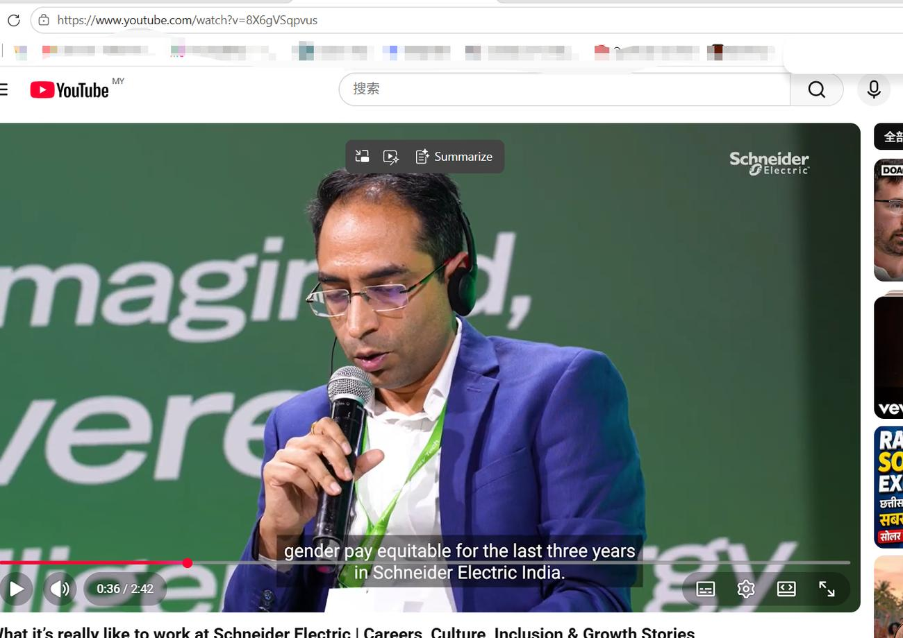
Item 13
"We have committed to 50% women in hiring, 40% women in front-line management, and 30% women in leadership teams. These commitments have led to measurable progress against WGEA’s indicators…"
Source: Schneider Electric Australia, press release, 5 March 2026 | https://www.se.com/au/en/about-us/newsroom/news/press-releases/schneider-electric’s-action-on-gender-pay-equity-67b65c1662604464c70276f4
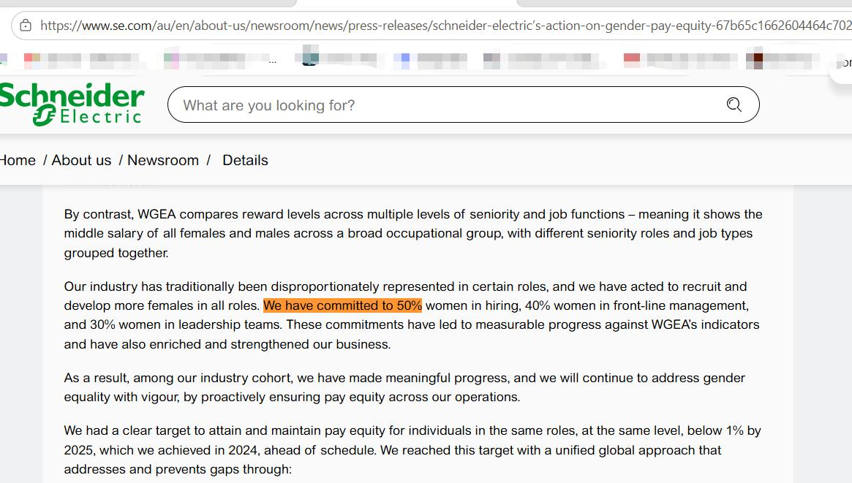
Item 14
"Although there’s still a long way to go, these efforts alone have gained a lot of internal and external recognition and I’m very proud of our journey,’ Le boasts. ‘DEIB is a marker and a differentiator for Schneider Electric."
Source: UNLEASH, interview with CHRO Charise Le | https://www.unleash.ai/diversity-equity-inclusion/news/schneider-electric-chro-we-believe-diversity-stimulates-innovation-and-wellbeing-generates-high-performance
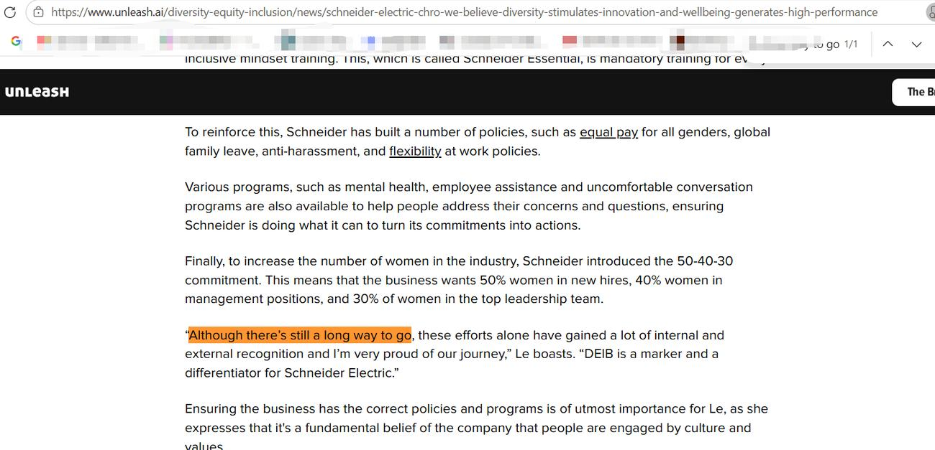
Item 15
"to achieve a 50:40:30 gender balance (i.e., women should represent 50% of all new hires, 40% of all frontline managers, and 30% of senior leaders)"
Source: 3BL Media (WEF Lighthouse), 16 March 2023 | https://www.3blmedia.com/news/schneider-electric-named-lighthouse-diversity-equity-inclusion-world-economic-forum
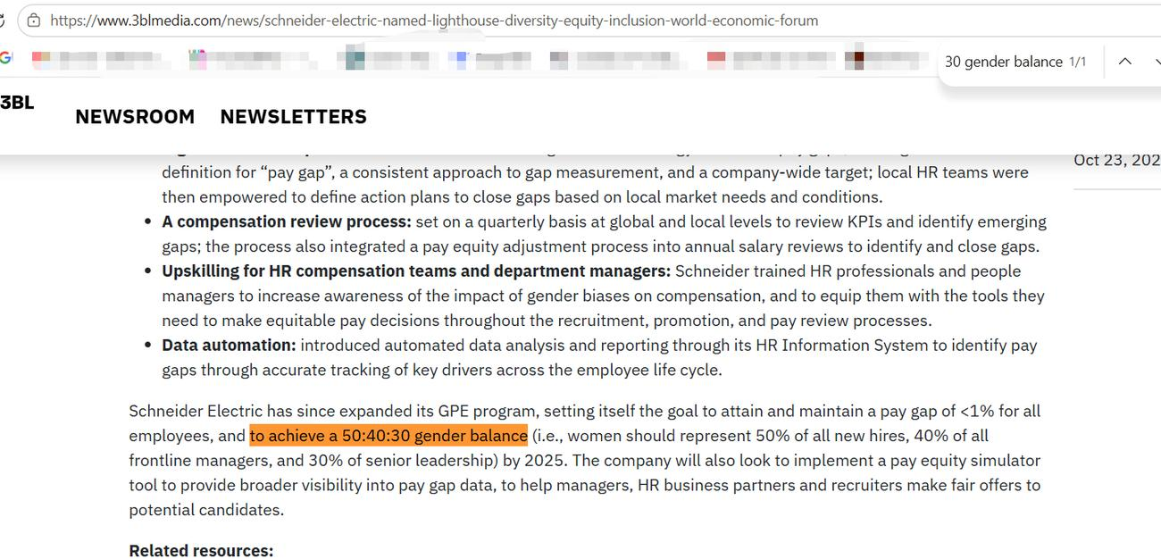
Item 16
"Schneider is also committed to attaining and maintaining a pay gap of <1 percent for all employees and achieving a 50:40:30 gender balance by 2025"
Source: Businesswire, 8 March 2023 | https://www.businesswire.com/news/home/20230308005218/en/Schneider-Electric-Recognized-for-Fifth-Consecutive-Year-for-Their-Commitment-to-Gender-Parity-in-the-Workplace
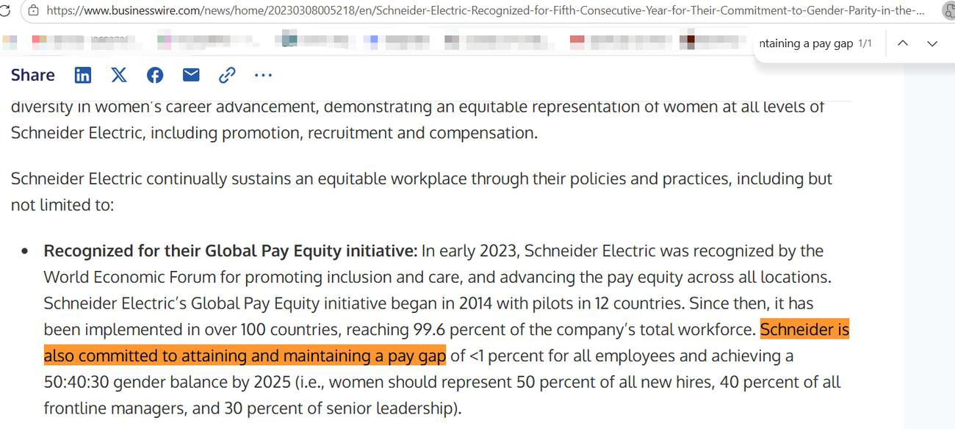
Theme 4: SDG 8–SDG 13 Tensions (Restructuring, Layoffs, Insecurity) — Countervailing Evidence (corpus items 17–21)
Item 17
"Layoffs every six months, creating ongoing uncertainty. Job security, flexibility, and employee goodwill no longer feel…"
Source: Glassdoor, “layoff” keyword-filtered review page (76 relevant reviews) | https://www.glassdoor.com/Reviews/Schneider-Electric-layoff-Reviews-EI_IE3956.0,18_KH19,25.htm
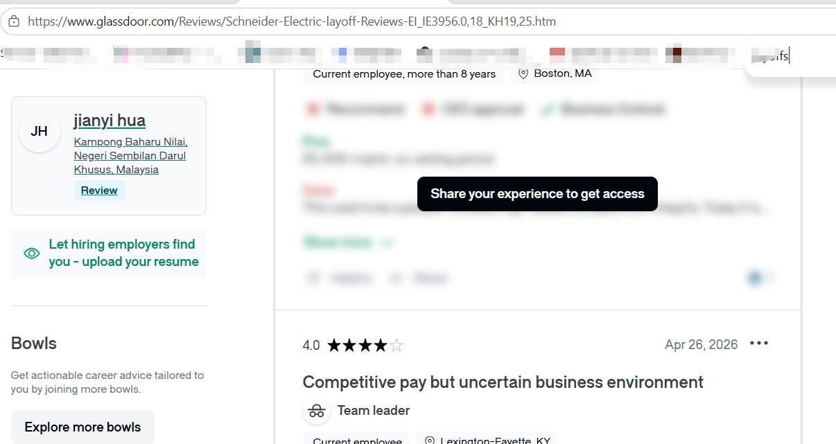
Item 18
"Tlaxcala 500 Layoffs — About 500 cut (19 June 2025, anonymous)"
Source: TheLayoff.com | https://www.thelayoff.com/schneider-electric
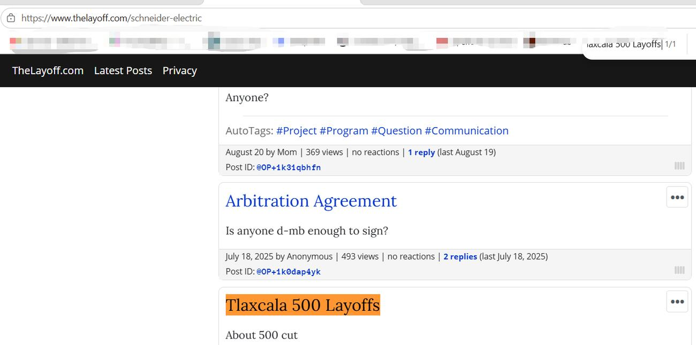
Item 19
"Jan 30th 2026 laidoff 600+ software engineers across USA. Heartbreaking! SE Andover never hired any engineer during covid. (1 February 2026)"
Source: TheLayoff.com, dedicated thread (600+ laid off after stopping PTO rollover) | https://www.thelayoff.com/t/1kgcpra2g
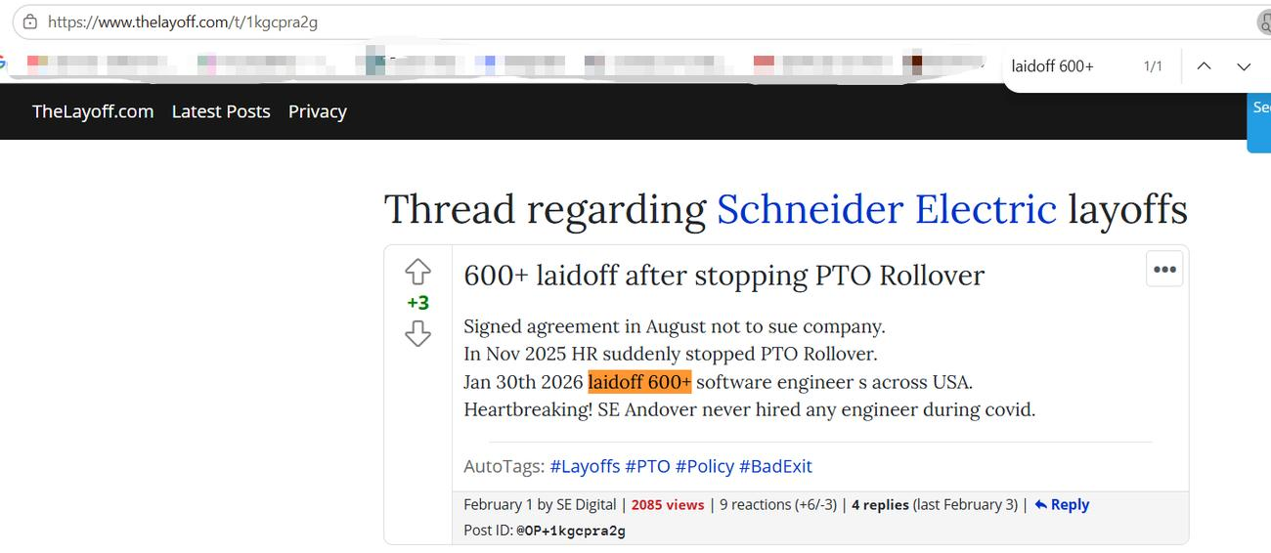
Item 20
"Seems that checking a box is more critical than keeping some skilled staff. The exit interviews are a joke. Must be checking a box again… (19 August 2024, anonymous)"
Source: TheLayoff.com | https://www.thelayoff.com/schneider-electric
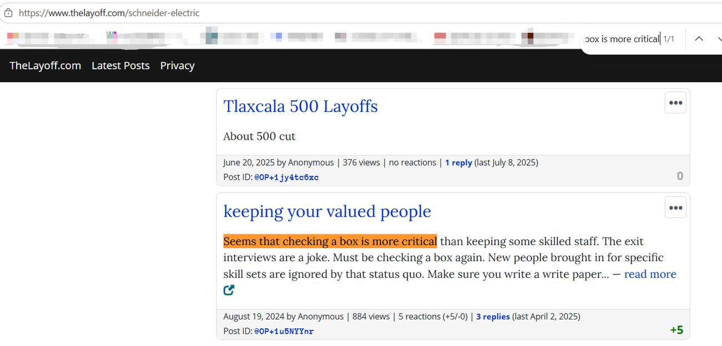
Item 21
"Is anyone d-mb enough to sign [the arbitration agreement]? (17 July 2025, anonymous)"
Source: TheLayoff.com | https://www.thelayoff.com/schneider-electric
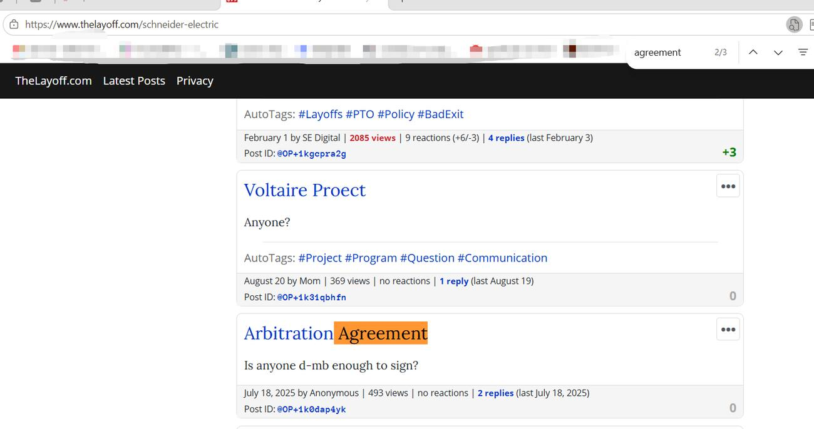
Supplementary: Workplace Climate and Employee Experience (Context and Saturation) (corpus items 22–27)
Item 22
"Schneider is awesome to work for. They have the best work life balance. My manager is great and very supportive. Co-workers are great."
Source: Indeed, engineer review | https://www.indeed.com/cmp/Schneider-Electric/reviews?fjobtitle=Engineer&ftopic=wlbalance
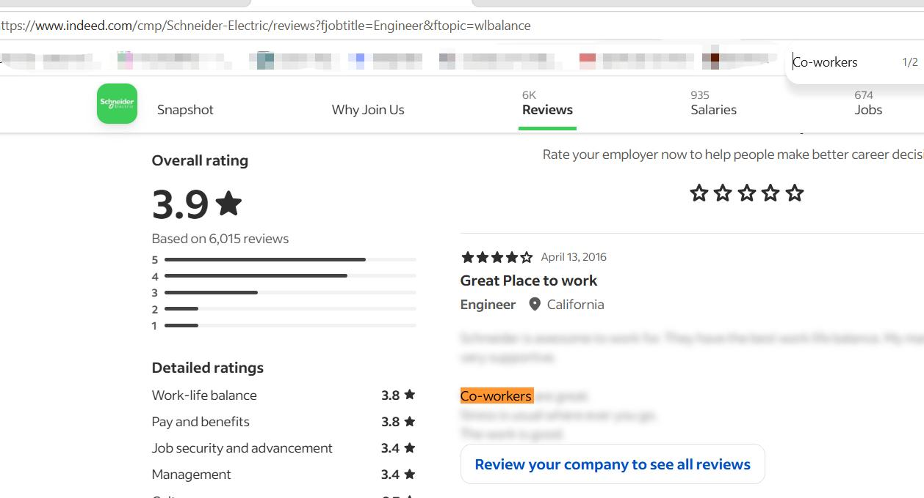
Item 23
"Good work life balance and…"
Source: Glassdoor, Sustainability Analyst job-title review page (4.1/5, 26 reviews) | https://www.glassdoor.com/Reviews/Schneider-Electric-Sustainability-Analyst-Reviews-EI_IE3956.0,18_KO19,41.htm
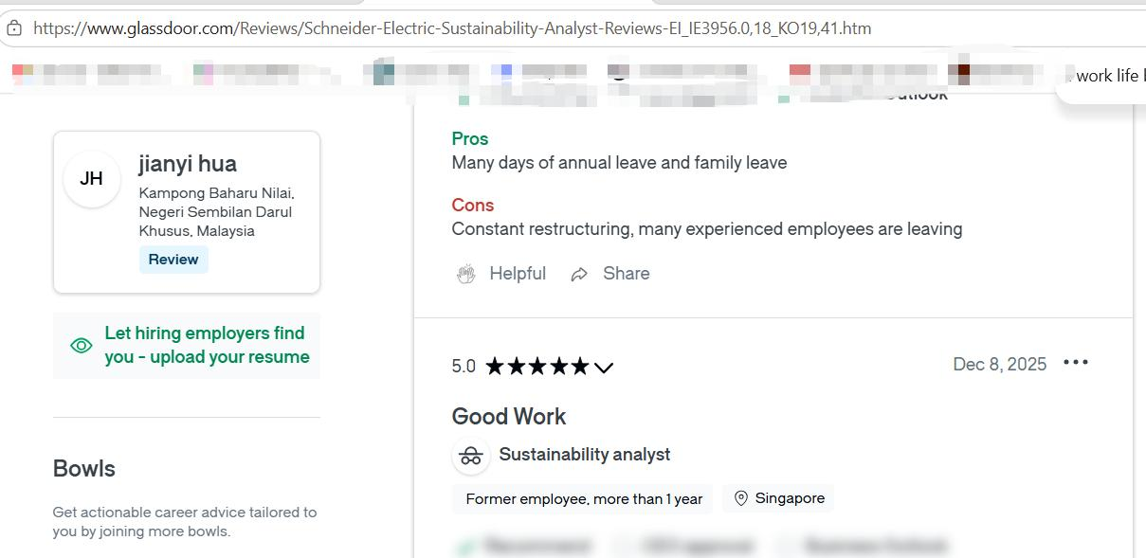
Item 24
"One of the cornerstones of our employee experience is our Flexibility@Work program… For our HR team, Glassdoor has been an invaluable tool… I personally take the time to read every review, and take action…"
Source: Corporate blog — Mai Lan Nguyen, HR Leader North America, 22 January 2025 | https://blog.se.com/life-at-schneider-electric/2025/01/22/culture-of-care-best-places-to-work
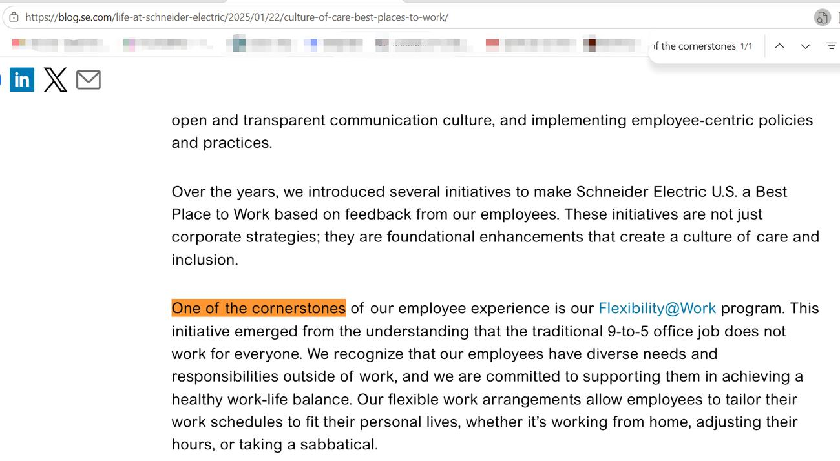
Item 25
"What makes this recognition so important is that this feedback comes directly from our employees… Since 2019, our internal employee engagement rating in North America has grown by 14 points."
Source: Amy deCastro, video transcript (YouTube) | https://www.youtube.com/watch?v=g0_aTF4Fkbk
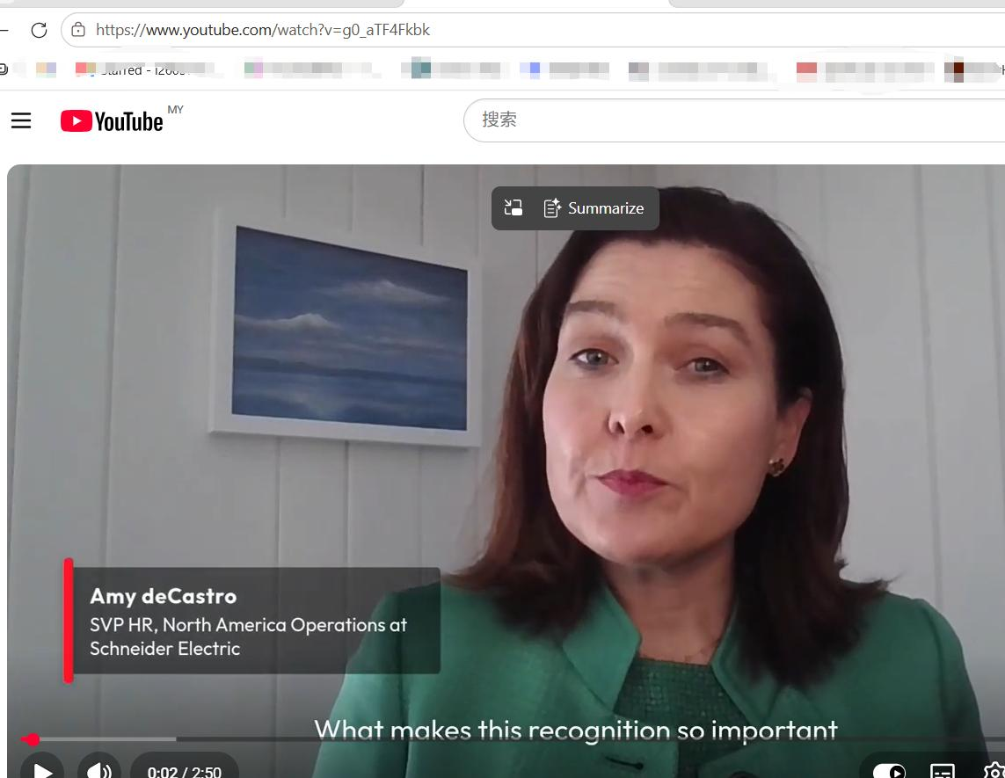
Item 26
"At the end of the quarter, the overall Schneider Electric Sustainability Impact (SSI) score came in at 7.29 out of ten… Recently recognized as the World’s Most Sustainable Company by TIME and Statista"
Source: PR Newswire, 30 October 2024 | https://www.prnewswire.com/news-releases/schneiders-sustainability-program-heads-full-speed-toward-its-end-year-targets-with-strong-local-impact-302291851.html
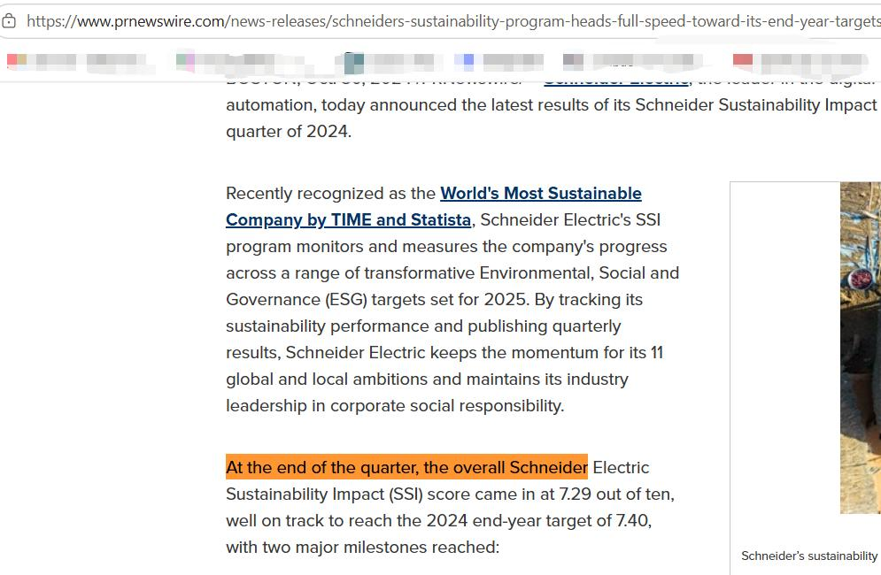
Item 27
"As of 2025, 98% of strategic suppliers conform to the Group’s Decent Work requirements… | SSI achieved an overall score of 8.86/10"
Source: se.com, official press release (SSI completion) | https://www.se.com/ww/en/about-us/newsroom/news/press-releases/Schneider-Electric-completes-its-Sustainability-Impact-SSI-20212025-program-setting-the-stage-for-the-next-chapter-699d9ef70c43e12f770ab803
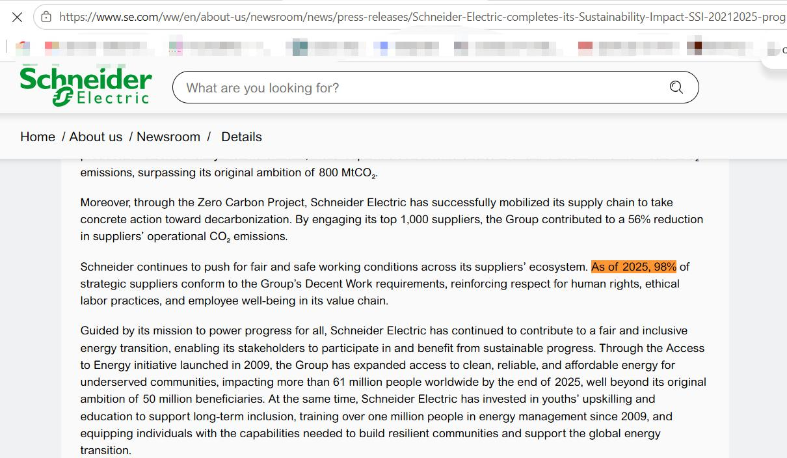
Verification and Triangulation Evidence (corpus items 28–31)
Item 28
Official quantitative data: se.com ESG FAQ discloses that, as of the end of 2024, women made up 42% of new hires, 30% of front-line management, and 31% of leadership teams. (The “50% target vs 42% result” claim in the manuscript has a verifiable source.)
Source: https://www.se.com/ww/en/about-us/investor-relations/investment/esg
Item 29
Gender pay tension: "While the company advocates for and touts fair pay – they still have a long way to go as we’re all still fighting to close the gender pay gap."
Source: Comparably, compensation review page | https://www.comparably.com/companies/schneider-electric/reviews/compensation
Item 30
Contract-worker disparity: "I feel undervalued as a contract staff because we are paid 10 times lesser than our colleague who are full staff. We are not entitles to alot of benefit the full staff has."
Source: Same page as above | https://www.comparably.com/companies/schneider-electric/reviews/compensation
Item 31
Restructuring criticism: "They buy companies and strip them down, closing factories, sending jobs out of the country… They constantly reorganize the company, moving people to new positions and new managers without your consent. They have you train lower paid people to do your job and then eliminate you."
Source: Indeed, Leesport PA, former employee, 28 January 2022 | https://www.indeed.com/cmp/Schneider-Electric/reviews?fjobtitle=Engineer&ftopic=wlbalance
Appendix A: Search Log
Data platforms: employee review sites (AmbitionBox, Comparably, Indeed, Glassdoor), the layoff discussion board TheLayoff.com, social media (Reddit), corporate channels (blog.se.com, YouTube, se.com), and press wires and media (PR Newswire, Businesswire, 3BL Media, UNLEASH, PublicNow).
Core search keywords: "Schneider Electric" + employee review / sustainability / SSI / bonus / diversity / gender / layoffs / training / work-life balance.
Time span of quotations: 2019–2026 (covering the 50-40-30 commitment and the SSI 2021–2025 cycle).
Inclusion criteria: (i) content addressing GHRM practices, SDG 8/13 or Just Transition themes; (ii) traceable to a source URL; (iii) non-duplicate.
Exclusion criteria: salary-only posts, rating-only posts without substantive content, marketing material, duplicate posts, and reposts whose source could not be verified.
Appendix B: Access Date Records
Citation format: (Platform, Year, Retrieved 15 August 2026, from URL).
Items 1–31: first accessed and verified on 15 August 2026; re-verified on 20 August 2026.

