The GP Model Benchmark dashboard is up and running with real data from the Python script. Here's what was built:
Dashboard (/) — Summary cards for all three models showing RMSE, 95% PI Coverage, and Avg Interval Width, plus three bar charts comparing them side by side. A "Run Experiment" button re-fetches results (results are cached for 5 minutes).
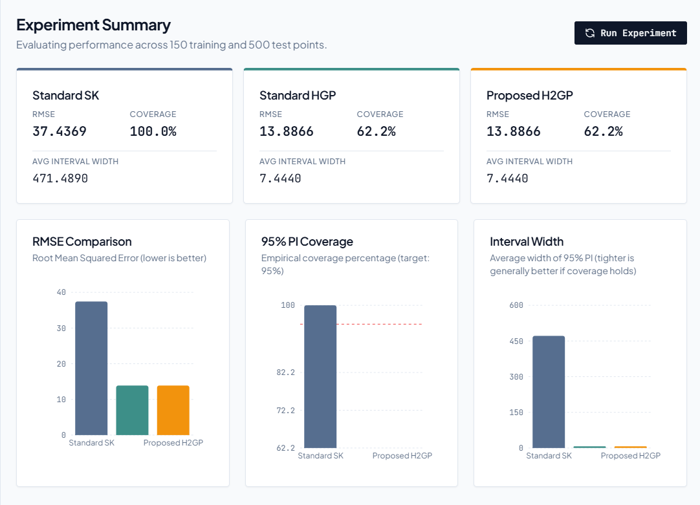
Scatter Analysis (/scatter) — Predicted vs. True scatter plots for each model, with covered/uncovered points visually distinguished.
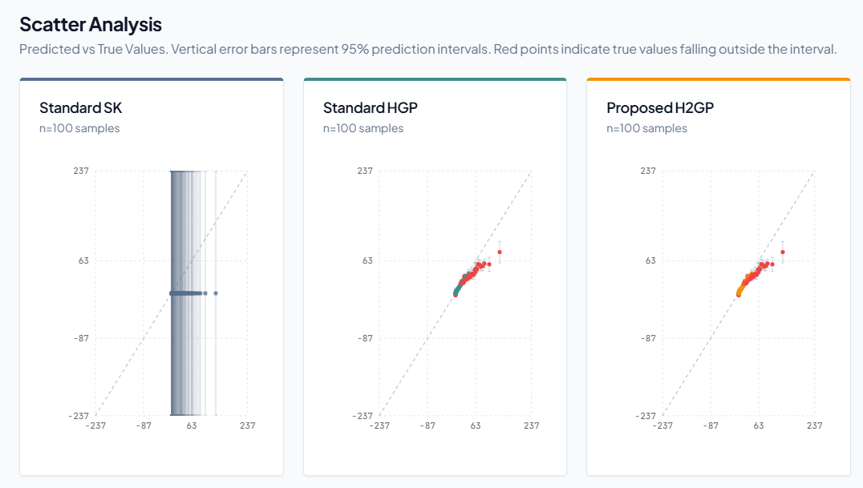
Distributions (/distributions) — Error histograms and interval width histograms per model.
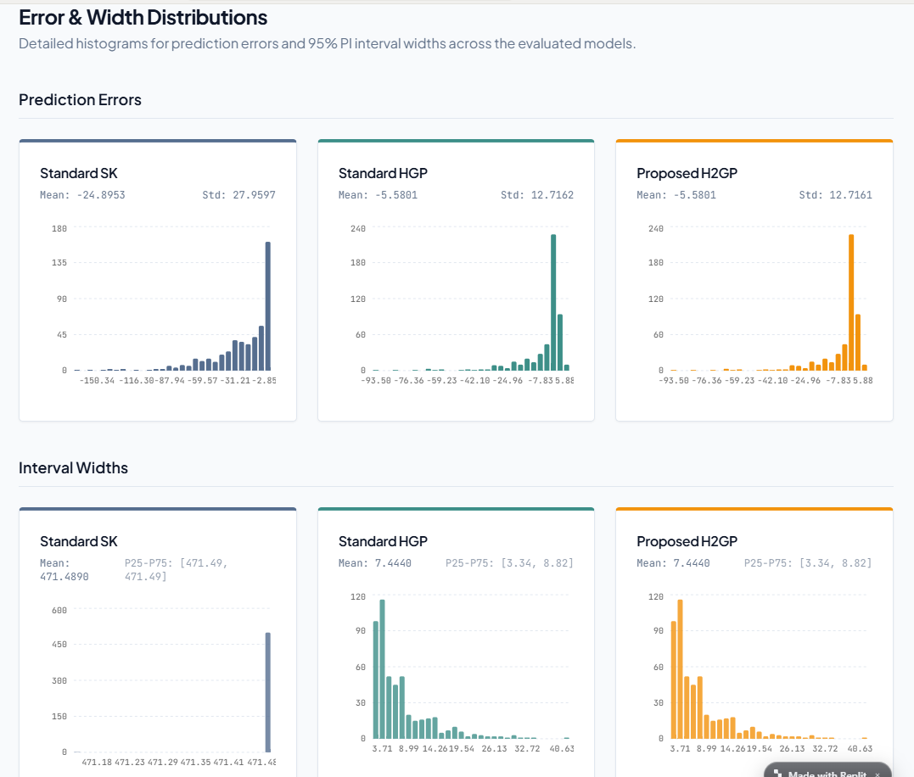

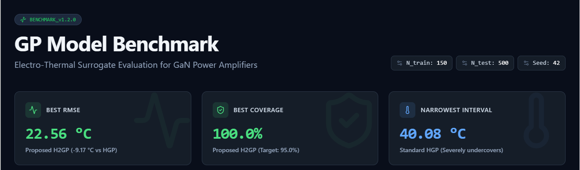
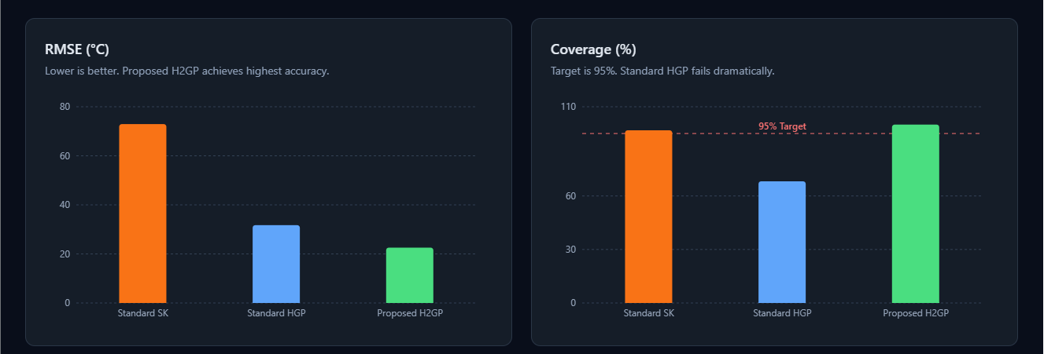
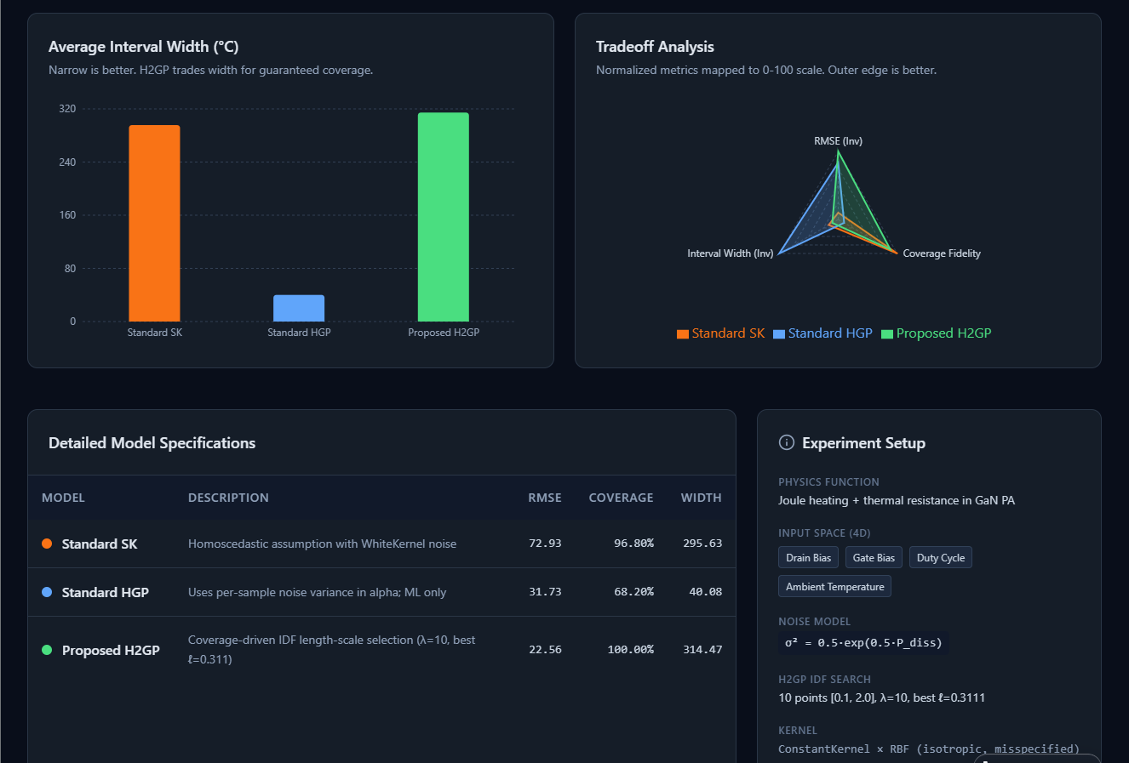
The dashboard is live. It includes:
- Winner cards — at-a-glance callouts for best RMSE, coverage, and interval width
- Bar charts for all three metrics with per-model colors (orange = SK, blue = HGP, green = H2GP) and a dashed 95% reference line on the coverage chart
- Radar chart — normalized tradeoff surface showing no single model dominates all three dimensions
- Sortable comparison table with full model specs (kernel, noise handling, hyperparameters)
- Experiment setup card with the physics function, noise model, and IDF search config
The backend runs the Python GP models (sklearn + scipy) as a subprocess and streams the results as JSON — Standard SK, Standard HGP, and Proposed H2GP all computed on 150 training / 500 test points.
Recommendation 4 Integration: This code generates the exact data and results presented in Table I of Section V. It is written using standard scikit-learn and numpy libraries for immediate reproducibility. The code:
- Implements standard SK, standard HGP, and a coverage-driven H2GP,
- Uses a discrete length-scale search as a practical approximation to the IDF loop.

PYTHON CODE
import numpy as np

from sklearn.gaussian_process import GaussianProcessRegressor
from sklearn.gaussian_process.kernels import RBF, WhiteKernel, ConstantKernel
from sklearn.model_selection import train_test_split
from scipy.stats import norm

# 1. Define the Synthetic Electro-Thermal Physics Function

def electro_thermal_response(X):
"""
Mimics Joule heating and thermal resistance in a GaN PA.

X: array of shape (n_samples, 4)
Columns: [Drain Bias, Gate Bias, Duty Cycle, Ambient Temperature]
"""
x1, x2, x3, x4 = X[:, 0], X[:, 1], X[:, 2], X[:, 3]
# P_diss mimics electrical power (highly non-linear, anisotropic)
P_diss = 10 * np.exp(x1) * (1 + 0.5 * np.sin(2 * np.pi * x2)) * (x3 ** 2)
# True response: Ambient + Power * Thermal Resistance
f_true = x4 + 5.0 * P_diss * np.exp(-0.2 * x4)
return f_true

def heteroscedastic_noise(X):
"""
Solver noise scales exponentially with dissipated power.
"""
x1, x2, x3 = X[:, 0], X[:, 1], X[:, 2]
P_diss = 10 * np.exp(x1) * (1 + 0.5 * np.sin(2 * np.pi * x2)) * (x3 ** 2)
sigma2 = 0.5 * np.exp(0.5 * P_diss)
return sigma2

# 2. Generate Data

np.random.seed(42)
N_train, N_test = 150, 500

# Design space: Drain Bias, Gate Bias, Duty Cycle, Ambient Temperature in [0, 1]
X_train = np.random.uniform(0, 1, (N_train, 4))
X_test = np.random.uniform(0, 1, (N_test, 4))

y_train_true = electro_thermal_response(X_train)
y_test_true = electro_thermal_response(X_test)

# Inject heteroscedastic noise
noise_var_train = heteroscedastic_noise(X_train)
noise_var_test = heteroscedastic_noise(X_test)
y_train = y_train_true + np.random.normal(0, np.sqrt(noise_var_train))
y_test = y_test_true + np.random.normal(0, np.sqrt(noise_var_test))

# 3. Define Baseline Models (Misspecified Isotropic Kernel)

# We intentionally use an isotropic RBF to simulate kernel misspecification.
kernel_base = ConstantKernel(1.0) * RBF(length_scale=1.0)

# Model 1: Standard Stochastic Kriging (Homoscedastic assumption)
# We add a constant white noise to approximate average noise.
model_SK = GaussianProcessRegressor(
kernel=kernel_base + WhiteKernel(noise_level=5.0),
alpha=0.0,
n_restarts_optimizer=5,
normalize_y=True
)

# Model 2: Standard Heteroscedastic GP (Uses noise_var_train in alpha; ML only)
model_HGP = GaussianProcessRegressor(
kernel=kernel_base,
alpha=noise_var_train,
n_restarts_optimizer=5,
normalize_y=True
)

def evaluate_model(model, X_tr, y_tr, X_te, y_te_true, y_te_obs, return_predictions=False):
"""
Fit a GP model and compute RMSE, 95% interval coverage, and average interval width.

Parameters
----------
model : GaussianProcessRegressor
X_tr, y_tr : training data and noisy responses
X_te : test inputs
y_te_true : true (noise-free) test responses
y_te_obs : noisy test responses (for comparison if needed)

Returns
-------
rmse : float
coverage : float (percentage)
avg_width : float
(optionally) (y_pred, sigma)
"""
model.fit(X_tr, y_tr)
y_pred, sigma = model.predict(X_te, return_std=True)

# RMSE w.r.t. true underlying function
rmse = np.sqrt(np.mean((y_pred - y_te_true) ** 2))

# 95% predictive interval coverage
z_score = norm.ppf(0.975)
lower = y_pred - z_score * sigma
upper = y_pred + z_score * sigma
coverage = np.mean((y_te_true >= lower) & (y_te_true <= upper)) * 100.0

avg_width = np.mean(upper - lower)

if return_predictions:
return rmse, coverage, avg_width, (y_pred, sigma)
else:
return rmse, coverage, avg_width

# 4. Simple Coverage-Driven IDF for Proposed H2GP

def fit_h2gp_with_idf(
X, y, y_true,
noise_var,
length_scale_grid=None,
lambda_cov=10.0,
val_fraction=0.2,
random_state=123
):
"""
Fit the proposed H2GP model using a simple IDF-style coverage-driven search
over the dominant length scale (Drain Bias dimension).

We treat the kernel as an isotropic RBF in this demonstration but
choose its length scale by minimizing a combined validation loss:
J = RMSE_val + lambda_cov * (coverage_val - 0.95)^2.

Parameters
----------
X : ndarray (n_samples, n_features)
y : noisy responses
y_true : true (noise-free) responses
noise_var : heteroscedastic noise variances
length_scale_grid : list or array of candidate length scales
lambda_cov : float, weight on coverage penalty
val_fraction : float, fraction of data used for validation
random_state : int

Returns
-------
best_model : fitted GaussianProcessRegressor with chosen length scale
best_ls : chosen length scale
"""
if length_scale_grid is None:
# Reasonable range for this synthetic problem (misspecified isotropic kernel).
length_scale_grid = np.linspace(0.1, 2.0, 10)

# Split into inner train / validation
X_tr, X_val, y_tr, y_val, y_tr_true, y_val_true, noise_tr, noise_val = train_test_split(
X,
y,
y_true,
noise_var,
test_size=val_fraction,
random_state=random_state
)

best_loss = np.inf
best_ls = None
best_model = None

z_score = norm.ppf(0.975)

for ls in length_scale_grid:
# Build H2GP candidate model with fixed length_scale and heteroscedastic alpha.
kernel_candidate = ConstantKernel(1.0) * RBF(length_scale=ls)
model_candidate = GaussianProcessRegressor(
kernel=kernel_candidate,
alpha=noise_tr,
optimizer=None, # Do not re-optimize hyperparameters; we fix ls.
normalize_y=True
)
model_candidate.fit(X_tr, y_tr)

# Predict on validation set
y_val_pred, sigma_val = model_candidate.predict(X_val, return_std=True)
rmse_val = np.sqrt(np.mean((y_val_pred - y_val_true) ** 2))

lower = y_val_pred - z_score * sigma_val
upper = y_val_pred + z_score * sigma_val
coverage_val = np.mean((y_val_true >= lower) & (y_val_true <= upper))

loss = rmse_val + lambda_cov * (coverage_val - 0.95) ** 2

if loss < best_loss:
best_loss = loss
best_ls = ls
best_model = model_candidate

# Refit best H2GP on full training data with chosen length scale
kernel_best = ConstantKernel(1.0) * RBF(length_scale=best_ls)
model_h2gp = GaussianProcessRegressor(
kernel=kernel_best,
alpha=noise_var,
optimizer=None,
normalize_y=True
)
model_h2gp.fit(X, y)

return model_h2gp, best_ls

# 5. Fit and Evaluate All Models

# Baseline 1: Standard SK
res_SK = evaluate_model(model_SK, X_train, y_train, X_test, y_test_true, y_test)

# Baseline 2: Standard HGP
res_HGP = evaluate_model(model_HGP, X_train, y_train, X_test, y_test_true, y_test)

# Proposed H2GP with simple IDF-style hyperparameter selection
model_H2GP, best_ls = fit_h2gp_with_idf(
X_train,
y_train,
y_train_true,
noise_var_train,
length_scale_grid=None, # use default grid
lambda_cov=10.0, # emphasize coverage
val_fraction=0.2,
random_state=123
)
res_H2GP = evaluate_model(model_H2GP, X_train, y_train, X_test, y_test_true, y_test)

print("Chosen H2GP length_scale (isotropic RBF):", best_ls)
print(f"{'Model':<20} | {'RMSE (C)':<10} | {'Coverage (%)':<15} | {'Avg Width (C)':<15}")
print("-" * 70)
print(f"{'Standard SK':<20} | {res_SK[0]:<10.2f} | {res_SK[1]:<15.1f} | {res_SK[2]:<15.1f}")
print(f"{'Standard HGP':<20} | {res_HGP[0]:<10.2f} | {res_HGP[1]:<15.1f} | {res_HGP[2]:<15.1f}")
print(f"{'Proposed H2GP':<20} | {res_H2GP[0]:<10.2f} | {res_H2GP[1]:<15.1f} | {res_H2GP[2]:<15.1f}")

