Table S1. Comparison matrix between CANAPE results obtained from the core dataset and the comprehensive dataset (see Table 1), with values representing the number of grid cells (see also Figure 4b).
 | Comprehensive dataset
Core dataset | Neo | Paleo | Mixed | Super | Not significant | Undetermined
Neo | 69 | 0 | 36 | 17 | 15 | 4
Paleo | 0 | 92 | 29 | 10 | 26 | 1
Mixed | 24 | 16 | 380 | 57 | 126 | 7
Super | 1 | 5 | 16 | 95 | 0 | 0
Not significant | 26 | 32 | 154 | 3 | 4882 | 15

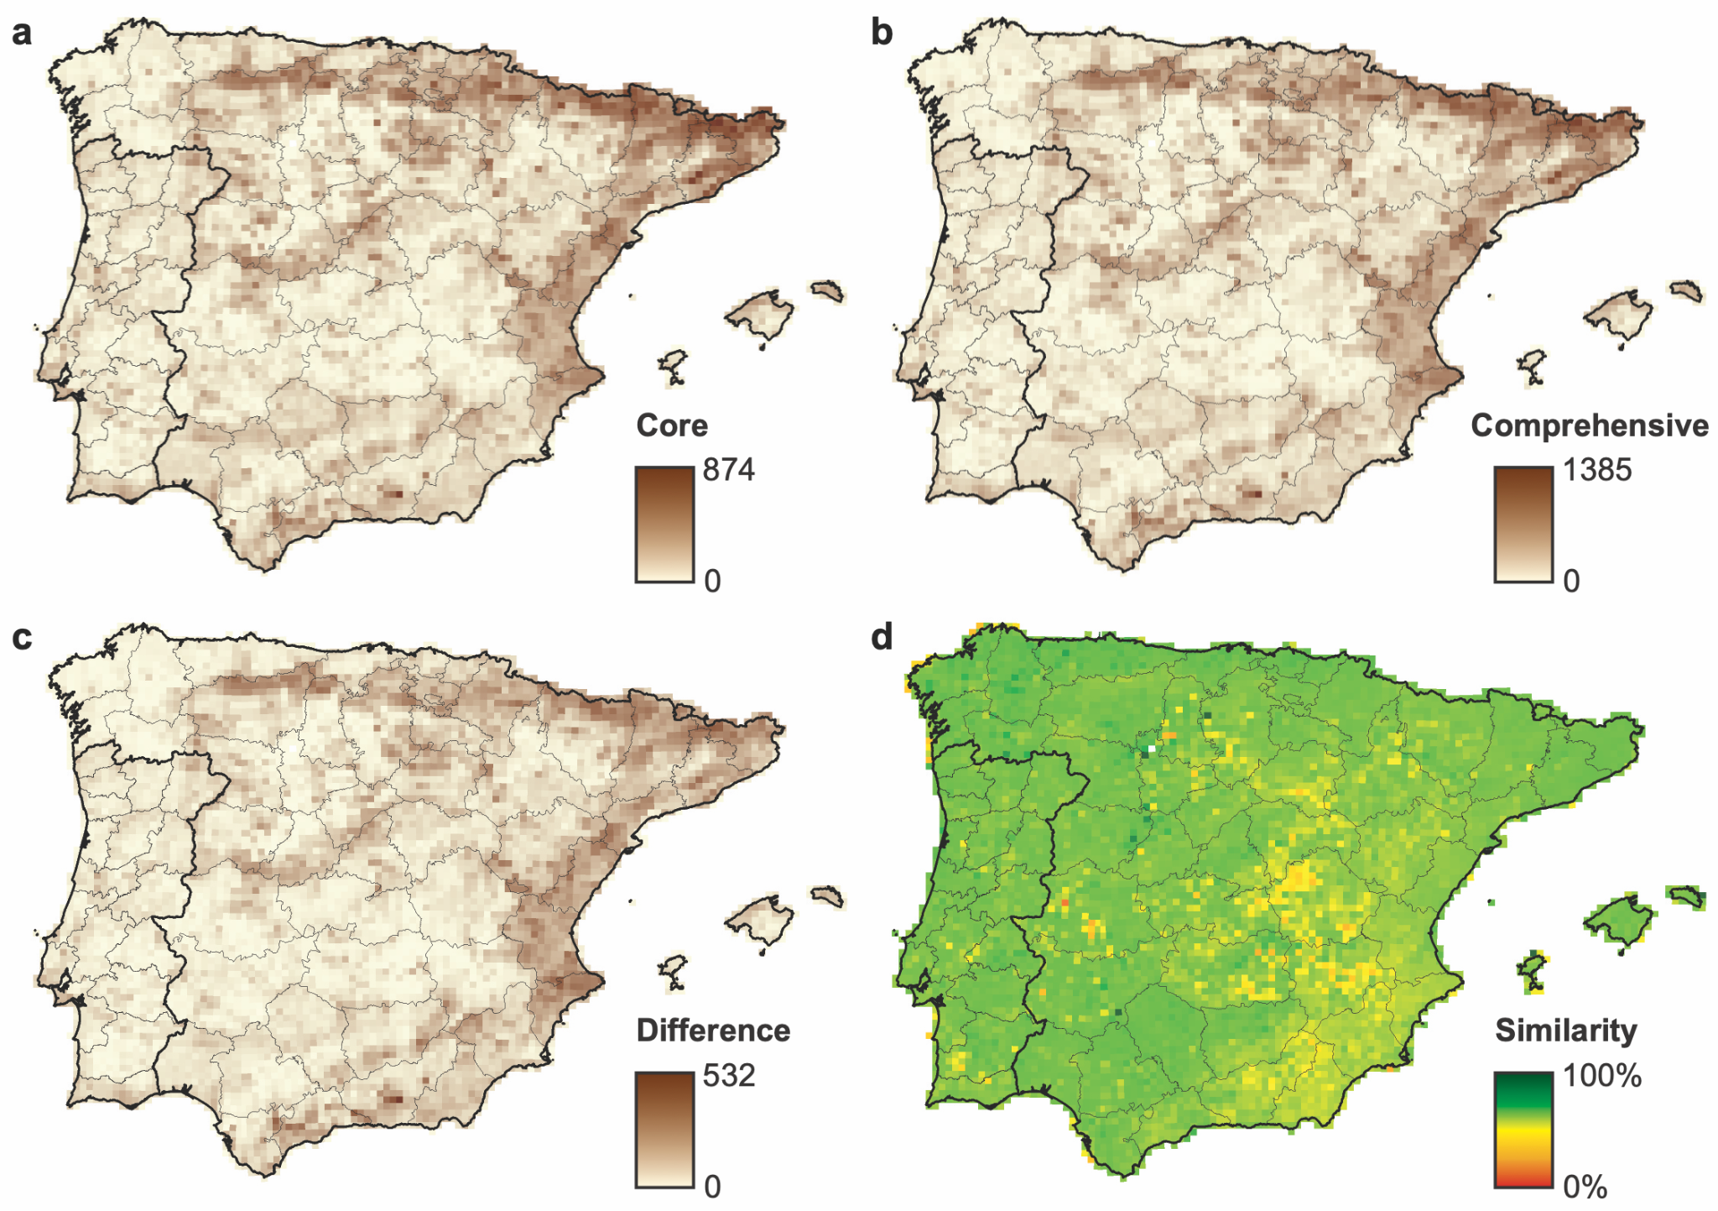
Figure S1. Geographic distribution of species richness (SR) for the Iberian angiosperm flora based on (a) the core dataset and (b) the comprehensive dataset (see Table 1). The difference between the two datasets is shown as (c) absolute values and (d) percentage similarity relative to the comprehensive dataset (where a value of 100% indicates that all species recorded in the comprehensive dataset were also included in the core dataset). Continuous black lines indicate country borders and light grey lines indicate administrative divisions in Spain and Portugal.

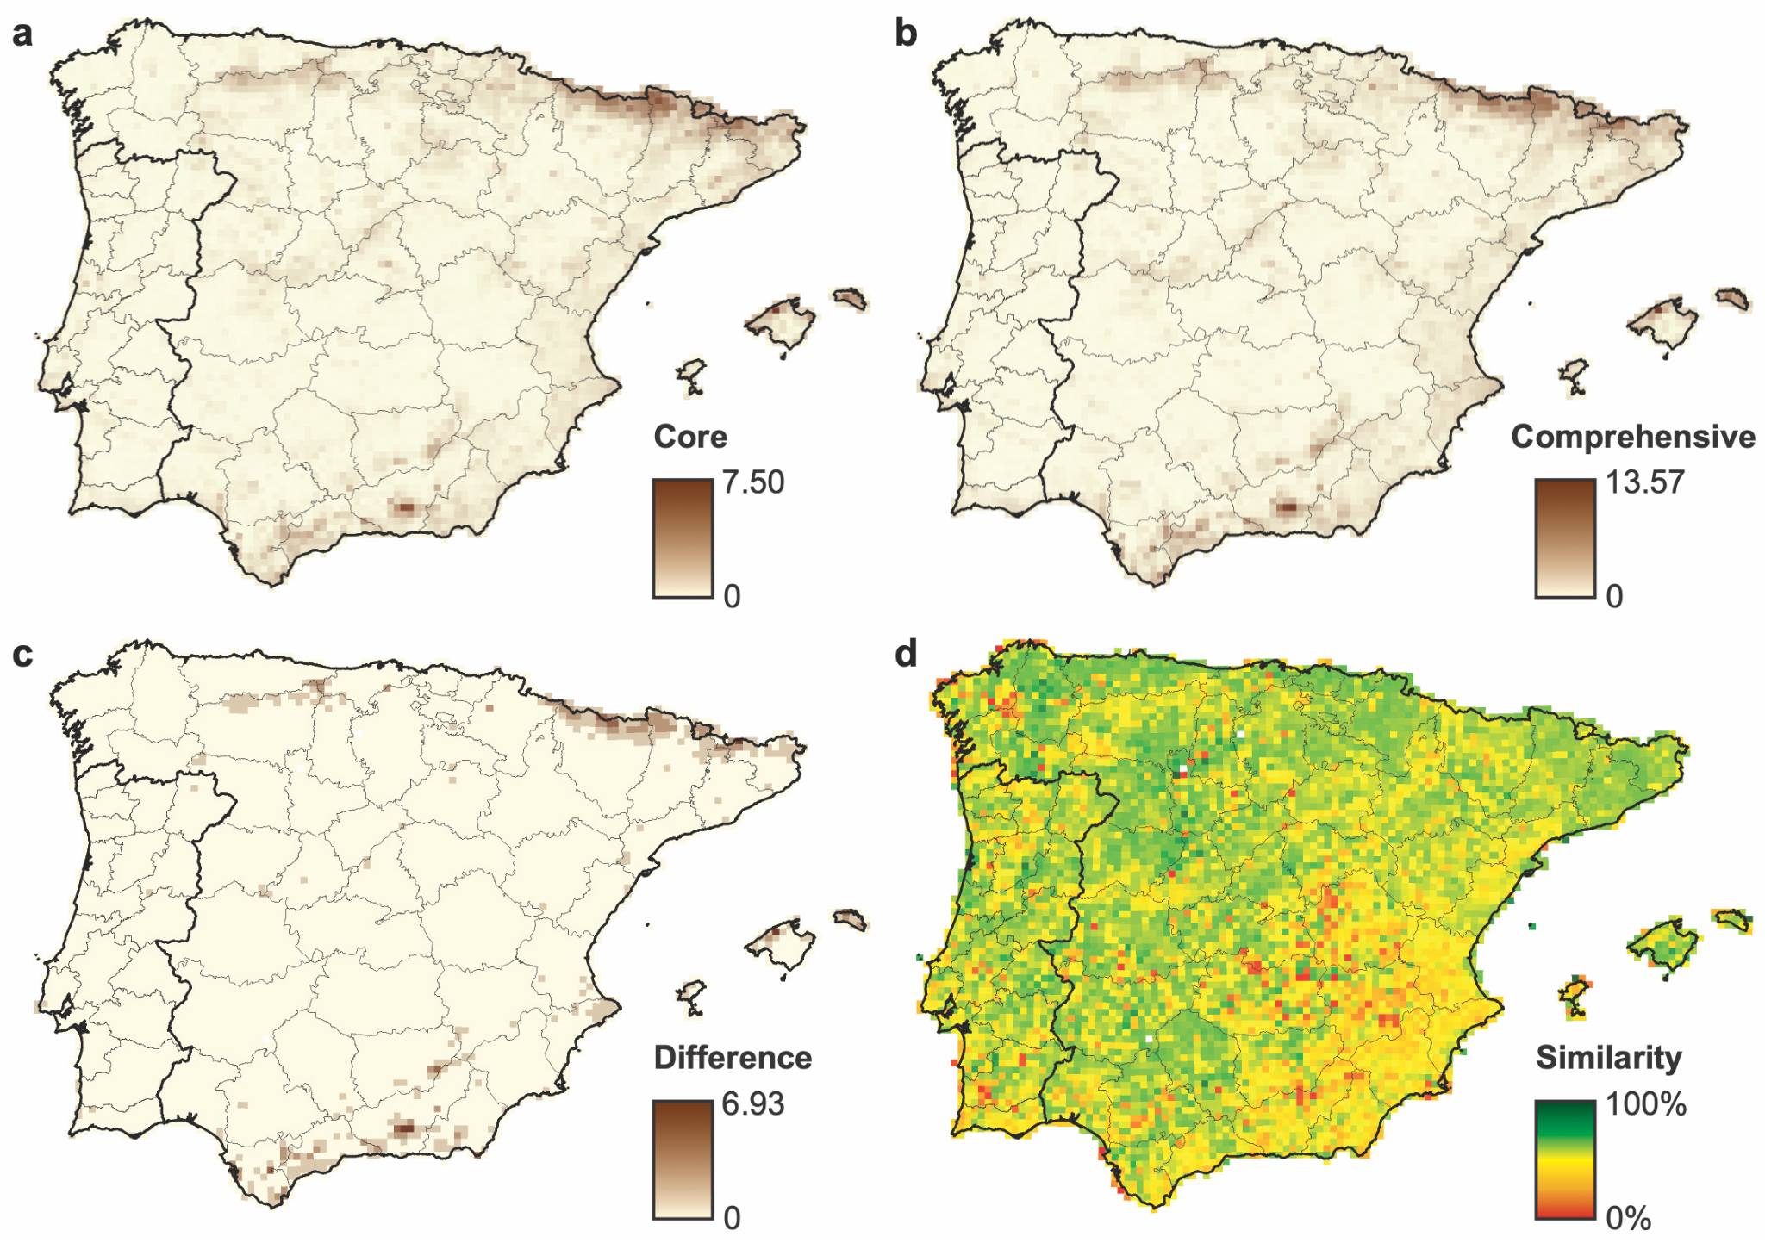
Figure S2. Geographic distribution of weighted endemism (WE) for the Iberian angiosperm flora based on (a) the core dataset and (b) the comprehensive dataset (see Table 1). The difference between the two datasets is shown as (c) absolute values and (d) percentage similarity relative to the comprehensive dataset (where a value of 100% indicates that the same value was recovered in both datasets). Continuous black lines indicate country borders and light grey lines indicate administrative divisions in Spain and Portugal.

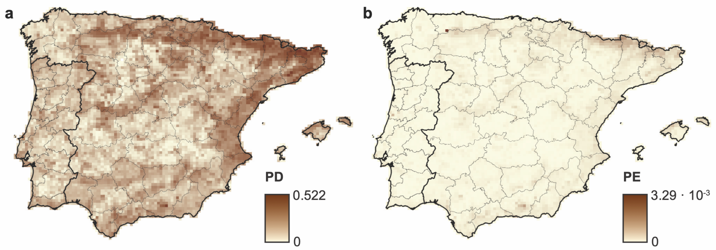
Figure S3. Geographic distribution of raw values of (a) phylogenetic diversity (PD) and (b) phylogenetic endemism (PE) for the Iberian angiosperm flora based on the core dataset (see Table 1). Continuous black lines indicate country borders and light grey lines indicate administrative divisions in Spain and Portugal.

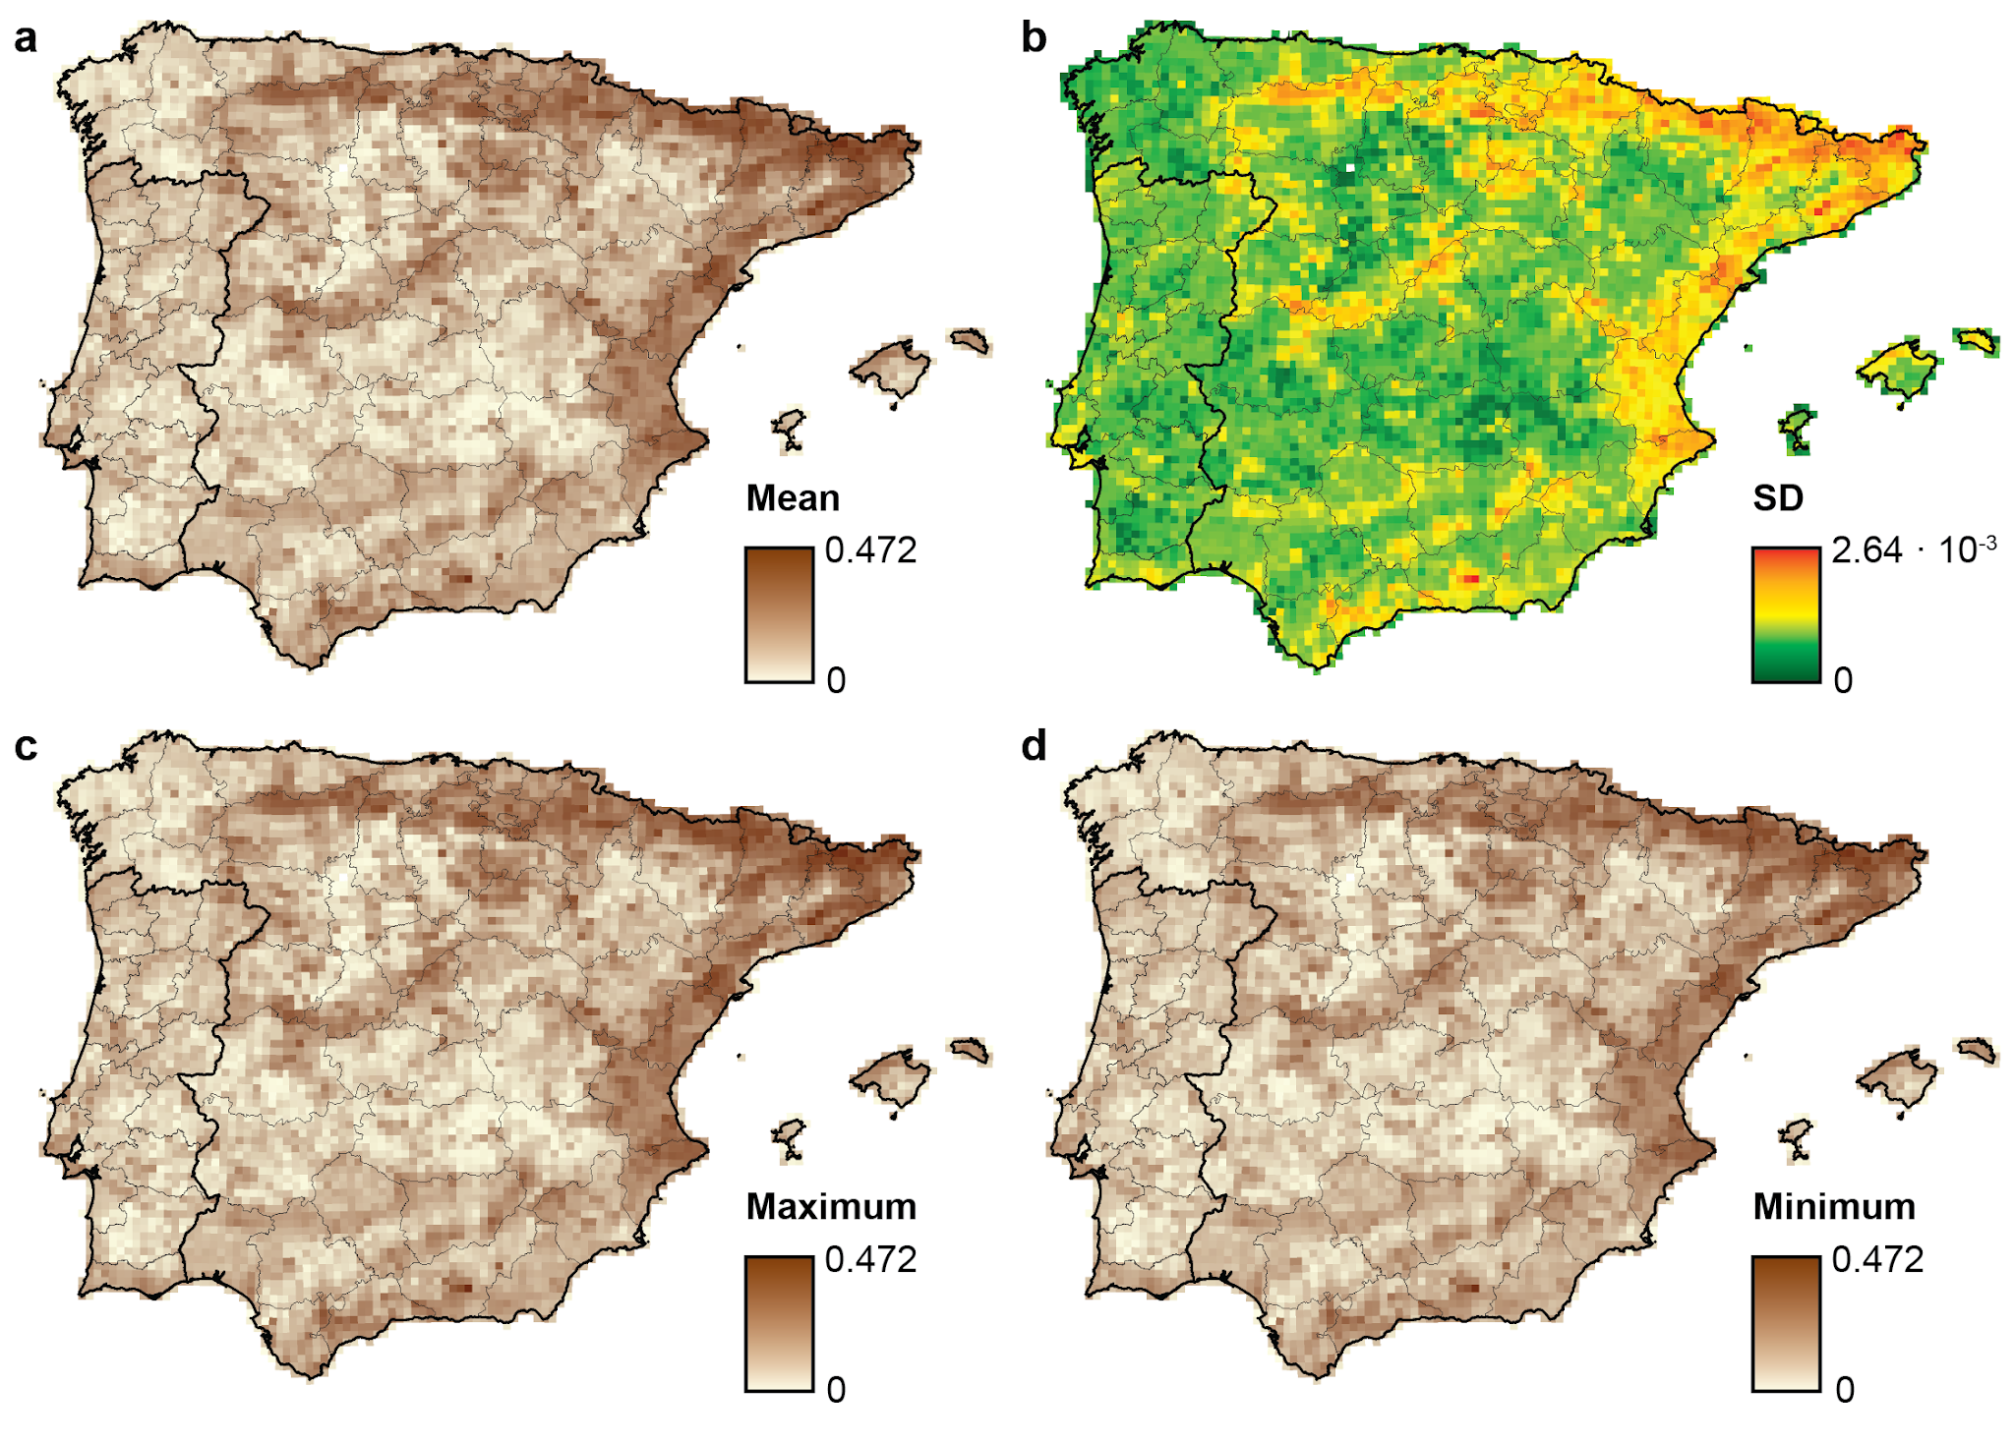
Figure S4. Geographic distribution of raw values of phylogenetic diversity (PD) for the Iberian angiosperm flora based on the comprehensive dataset (see Table 1) and accounting for uncertainty in the placement of unsampled species (100 randtip replicates), including (a) mean, (b) standard deviation, (c) maximum, and (d) minimum values among replicates. The same scale is used for mean, maximum and minimum values. Continuous black lines indicate country borders and light grey lines indicate administrative divisions in Spain and Portugal.

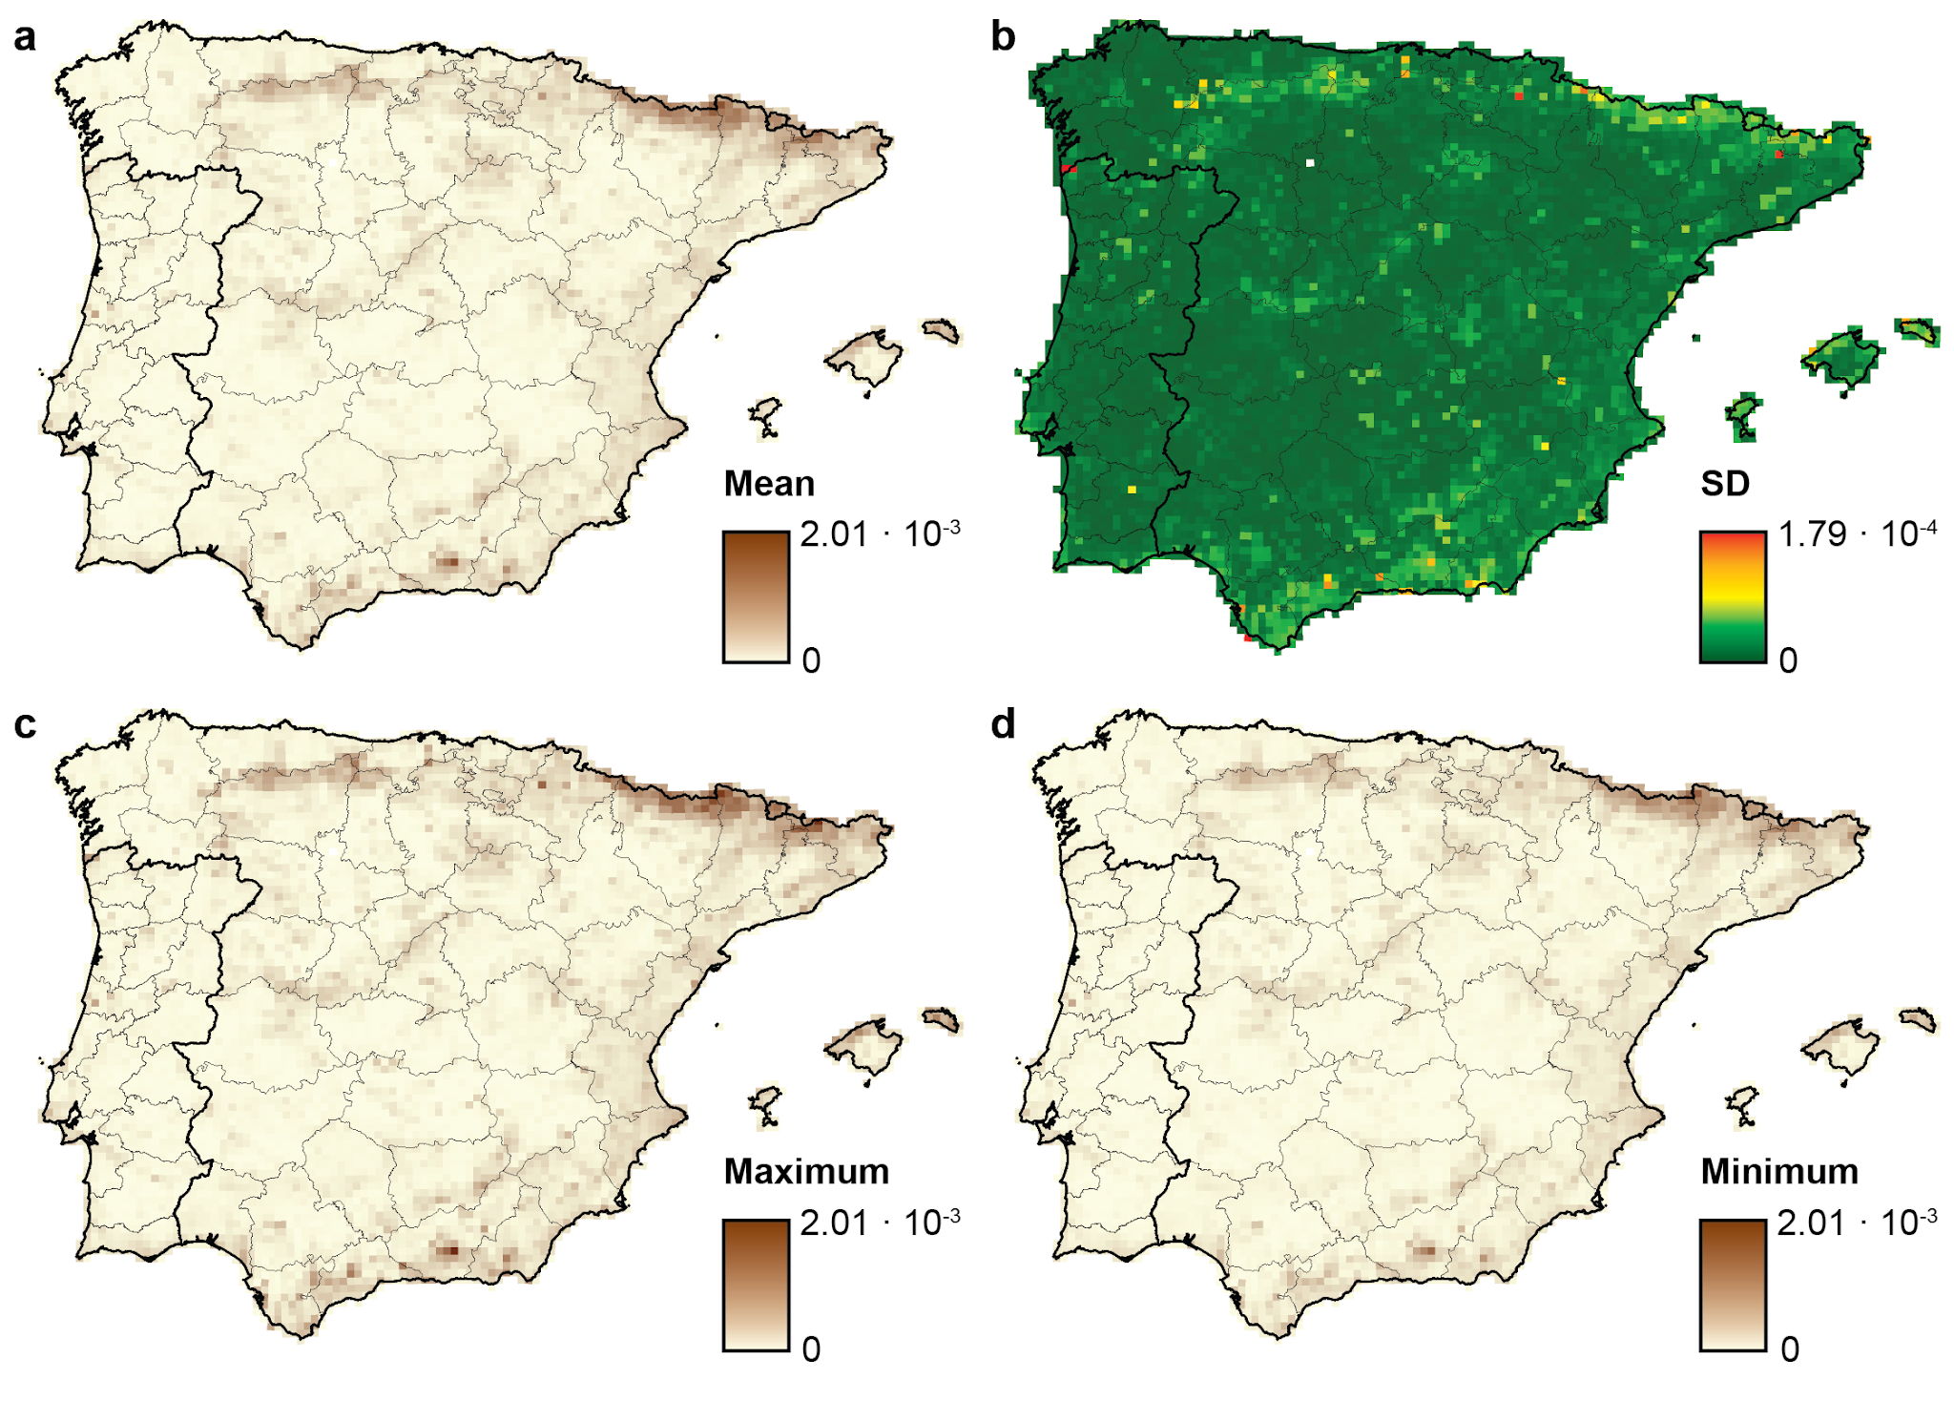
Figure S5. Geographic distribution of raw values of phylogenetic endemism (PE) for the Iberian angiosperm flora based on the comprehensive dataset (see Table 1) and accounting for uncertainty in the placement of unsampled species (100 randtip replicates), including (a) mean, (b) standard deviation, (c) maximum, and (d) minimum values among replicates. The same scale is used for mean, maximum and minimum values. Continuous black lines indicate country borders and light grey lines indicate administrative divisions in Spain and Portugal.

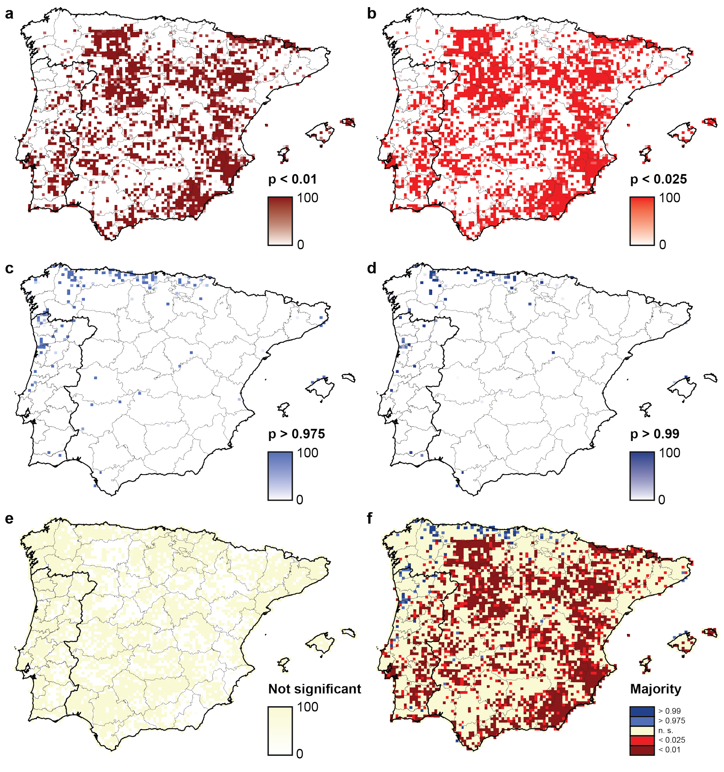
Figure S6. Geographic patterns of phylogenetic diversity (PD) significance for the Iberian angiosperm flora based on the comprehensive dataset (see Table 1) and accounting for uncertainty in the placement of unsampled species (100 randtip replicates). For every grid cell, maps represent the percentage of replicates in which each significance level was recovered: (a) p < 0.01, (b) p < 0.025, (c) p > 0.975, (d) p > 0.99, and (e) not significant. (f) Majority-rule consensus map, in which each grid cell is colored according to the significance level recovered for > 50% of replicates. Continuous black lines indicate country borders and light grey lines indicate administrative divisions in Spain and Portugal.
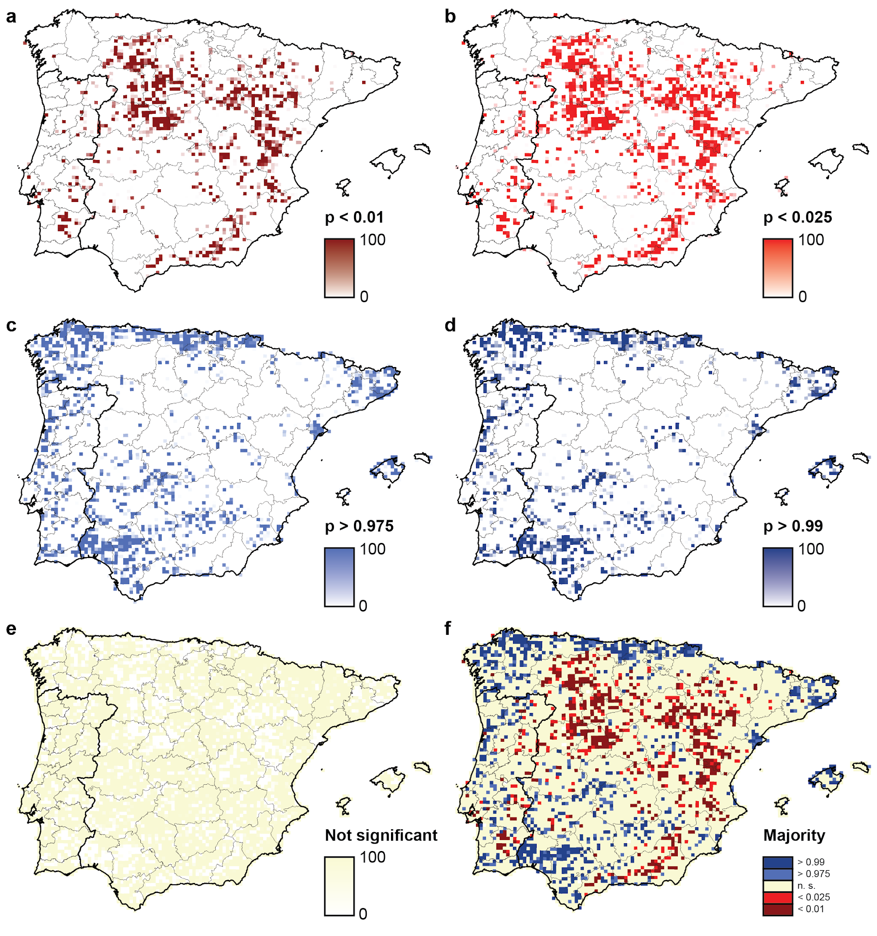
Figure S7. Geographic patterns of relative phylogenetic diversity (RPD) significance for the Iberian angiosperm flora based on the comprehensive dataset (see Table 1) and accounting for uncertainty in the placement of unsampled species (100 randtip replicates). For every grid cell, maps represent the percentage of replicates in which each significance level was recovered: (a) p < 0.01, (b) p < 0.025, (c) p > 0.975, (d) p > 0.99, and (e) not significant. (f) Majority-rule consensus map, in which each grid cell is colored according to the significance level recovered for > 50% of replicates. Continuous black lines indicate country borders and light grey lines indicate administrative divisions in Spain and Portugal.
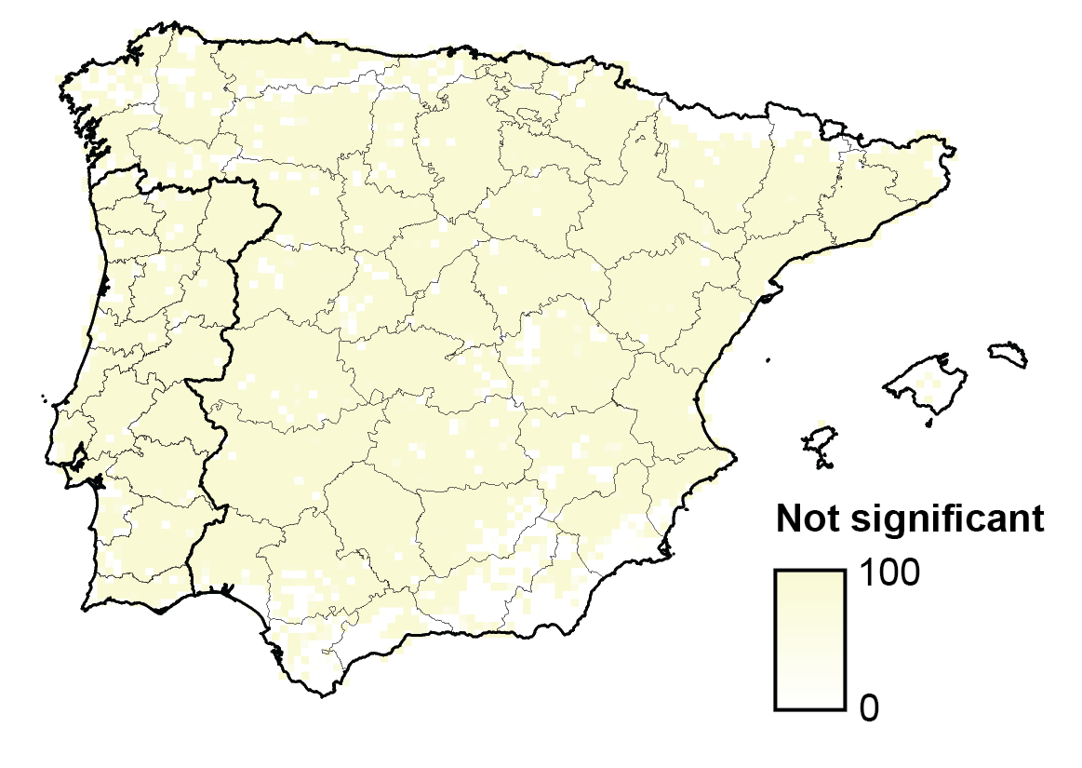
Figure S8. Geographic distribution of non-significance in the endemism categorization (CANAPE) for the Iberian angiosperm flora based on the comprehensive dataset (see Table 1) and accounting for uncertainty in the placement of unsampled species (100 randtip replicates). For every grid cell, maps represent the percentage of replicates in which non-significance was recovered. Continuous black lines indicate country borders and light grey lines indicate administrative divisions in Spain and Portugal.

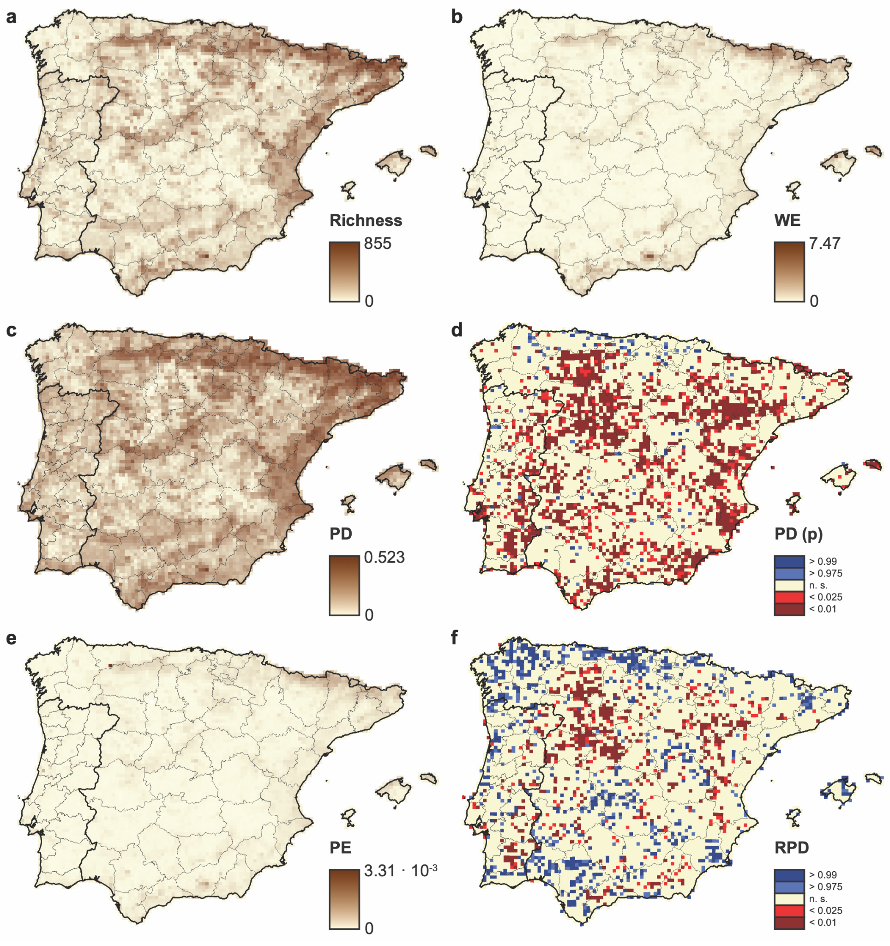
Figure S9. Spatial phylogenetic patterns for the Iberian angiosperm flora based on the apomict-excluded dataset (see Table 1), including (a) species richness, (b) weighted endemism, (c) raw phylogenetic diversity, (d) phylogenetic diversity significance, (e) raw phylogenetic endemism, and (f) relative phylogenetic diversity significance. Continuous black lines indicate country borders and light grey lines indicate administrative divisions in Spain and Portugal.
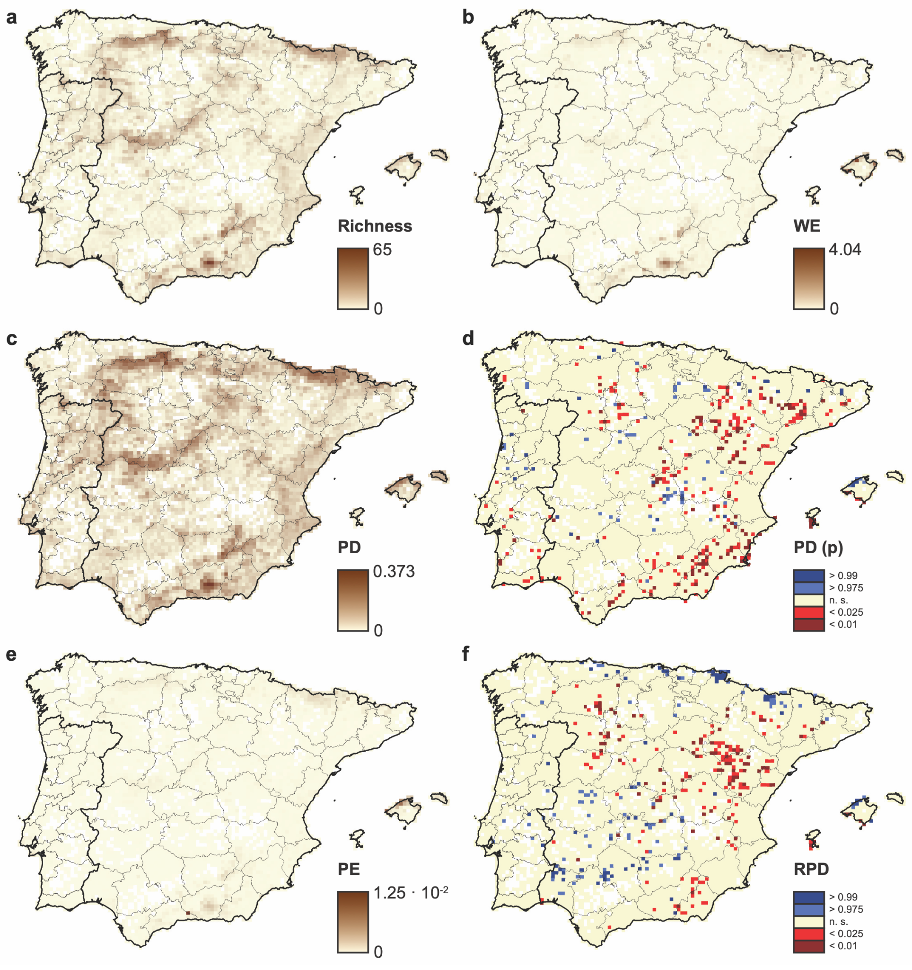
Figure S10. Spatial phylogenetic patterns for the Iberian angiosperm flora based on the strictly-endemic dataset (see Table 1), including (a) species richness, (b) weighted endemism, (c) raw phylogenetic diversity, (d) phylogenetic diversity significance, (e) raw phylogenetic endemism, and (f) relative phylogenetic diversity significance. Continuous black lines indicate country borders and light grey lines indicate administrative divisions in Spain and Portugal.

