Annexes

Annex 1: Conceptual Framework and Methodological Workflow
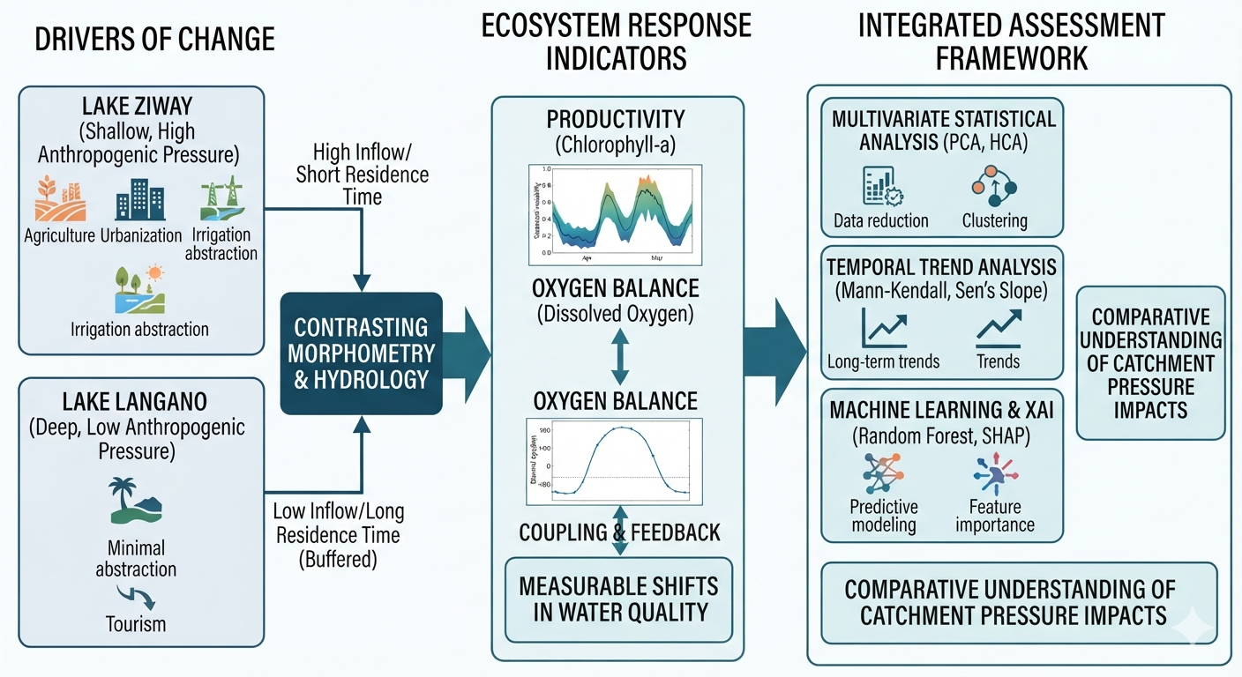
Figure 1. Conceptual Framework for Chlorophyll-a and Dissolved Oxygen
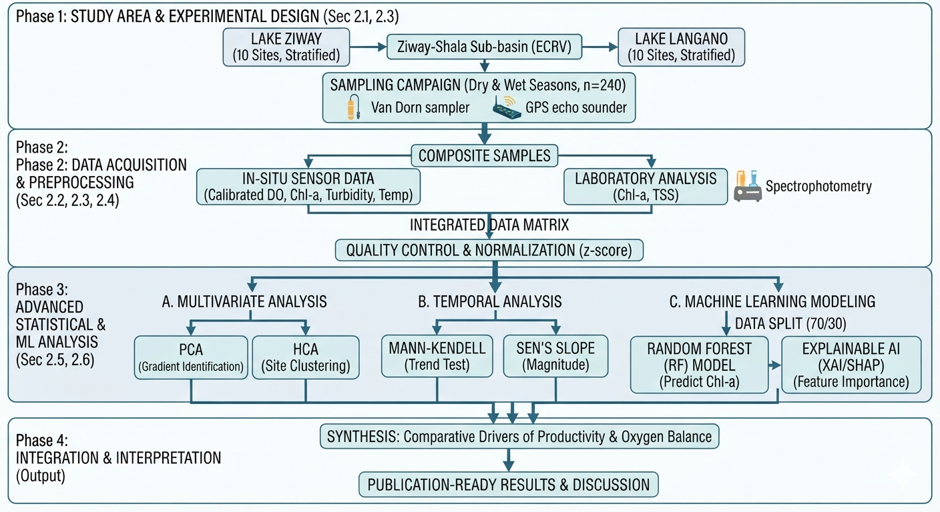
Figure 2. Methodological Workflow for Chlorophyll-a and Dissolved Oxygen

Annex 2: Lake Ziway
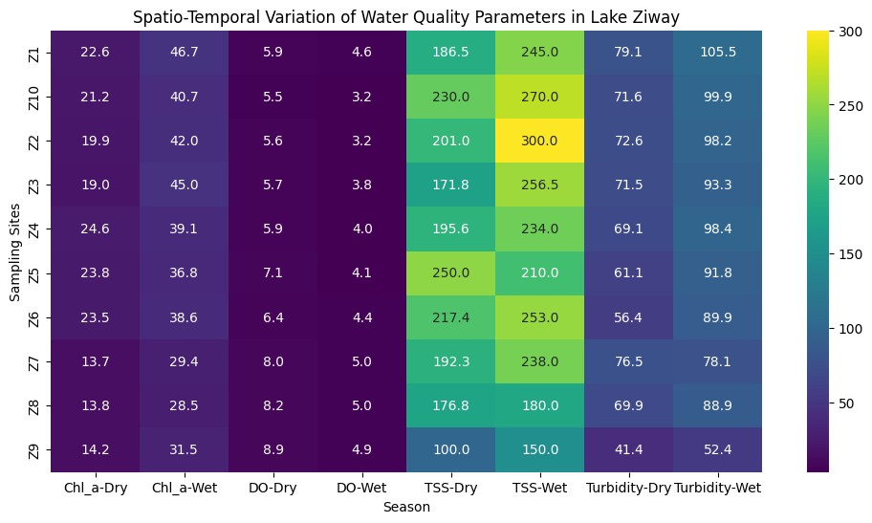
Figure 3. Spatio-temporal variations of selected water quality parameters for Lake Ziway
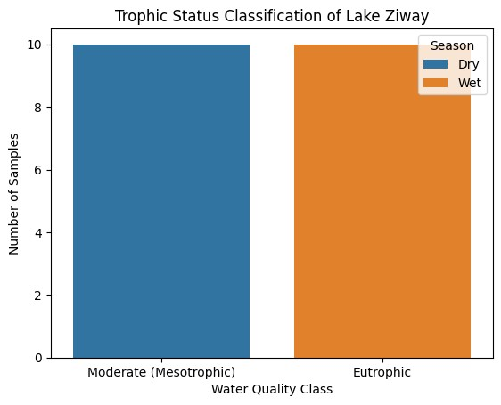
Figure 4. Tropic Status Classification of Lake Ziway
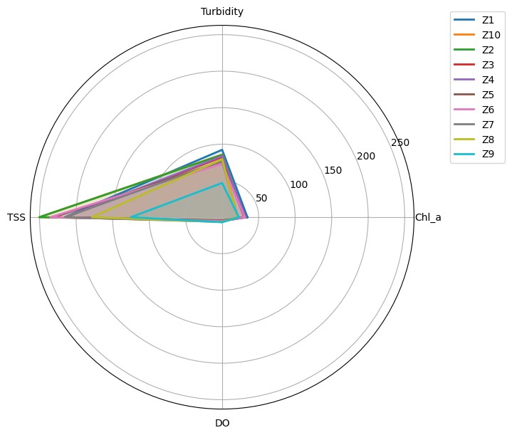
Figure 5. Spatial variations of selected water quality parameters for Lake Ziway

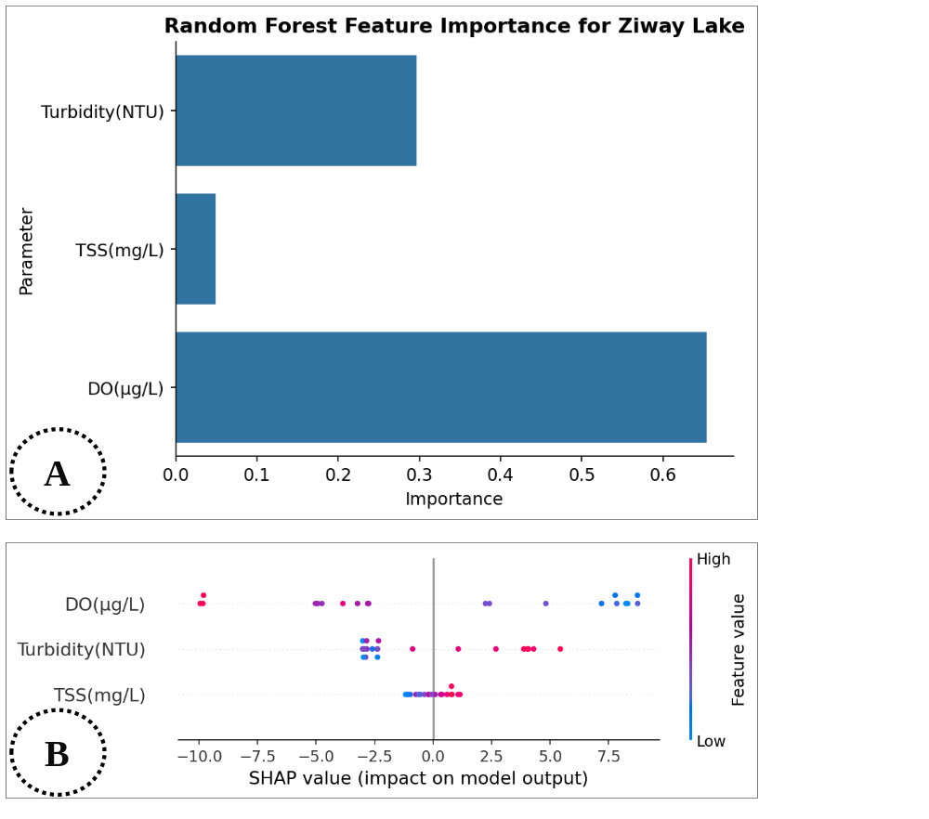
Figure 6. A) The Random Forest Modell’s feature importance and B) The Explainable AI for Lake Ziway

Annex 3: Lake langano
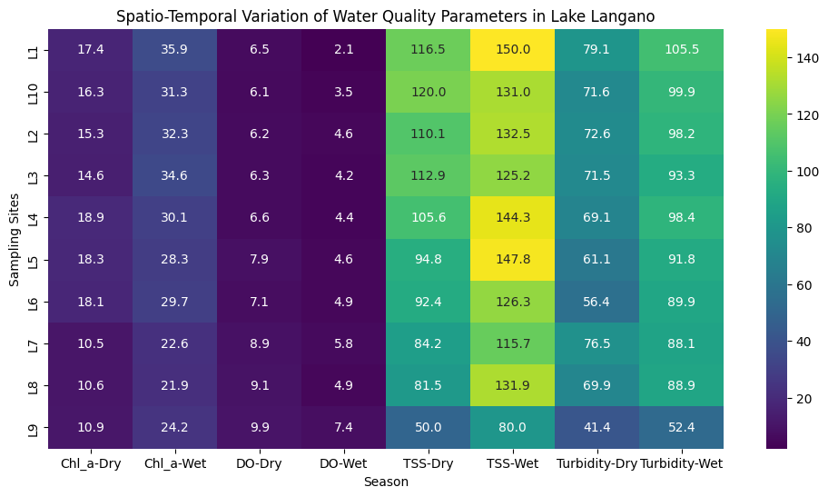

Figure 7. Spatio-temporal variations of selected water quality parameters for Lake Langano

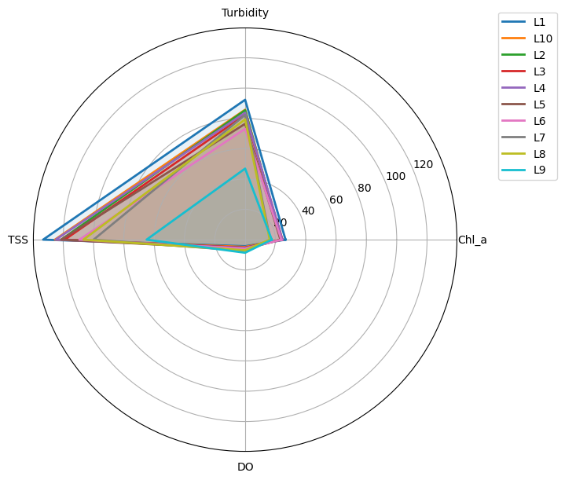
Figure 8. Spatial variations of selected water quality parameters for Lake Langano

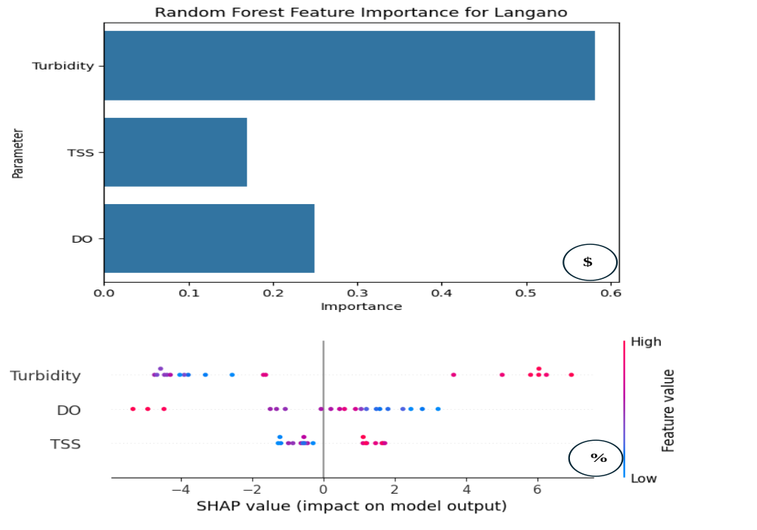
Figure 9. A) The Random Forest Modell’s feature importance and B) The Explainable AI for Lake Langano

Annex 4: Comparative Analysis
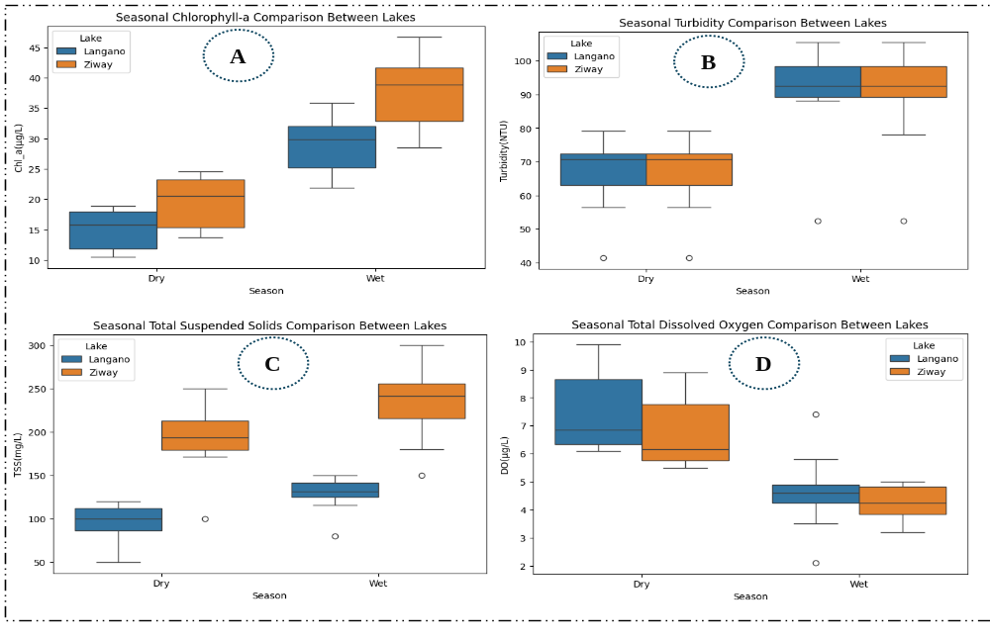
Figure 10. Temporal variations of: A) Chlorophyll-a, B) Turbidity, C) Total suspended Solids, and D) Dissolved Oxygen among Lakes
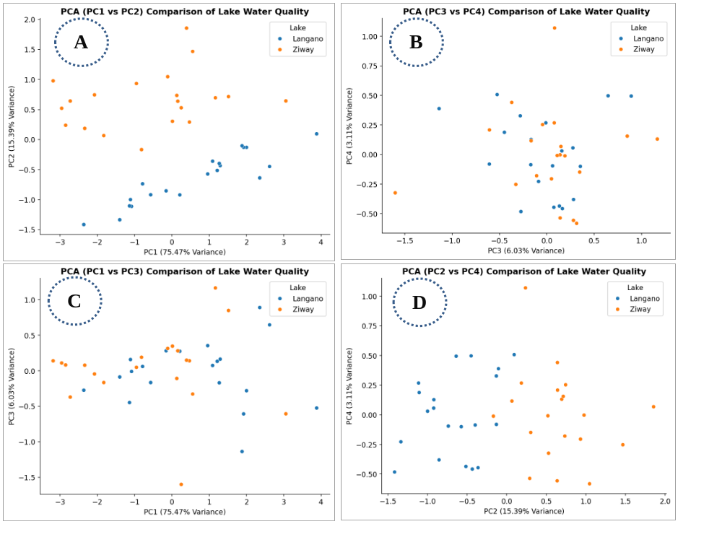
Figure 11. Principal Component Analysis of combination of selected water quality parameters among Lakes
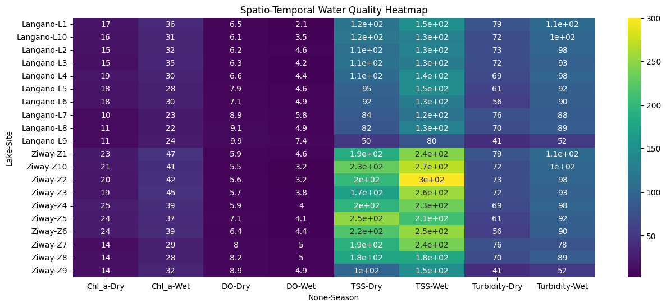
Figure 12. Spatio-temporal variations of selected water quality parameters among Lakes

Annex 5: Tables
Table 1. Physical and hydrological characteristics of the study lakes
Lake | Surface Area (km²) | Maximum Depth (m) | Elevation (m.a.s.l.) | Major Inflows | Outflow | Primary Uses | References
Lake Ziway | ~450 | ~9 | ~1636 | Meki River, Katar River | Bulbula River | Irrigation, fisheries, livestock, domestic use | Getnet et al. 2014 and Legesse and Ayenew, 2006
Lake Langano | 230–250 | 46–55 | ~1585 | Seasonal streams, rainfall | Horakela River | Tourism, recreation, limited irrigation | Seyoum et al., 2015, Kebbede and Hadley, 2016

Table 2. Analytical methods, instruments, and detection limits used for water quality analysis (APHA, 2017, EPA, 2009).
Parameter | Method (Standard) | Instrument / Technique | Unit | Detection Limit | Description
Chlorophyll-a | APHA 10200 H | Spectrophotometric method after extraction with 90% acetone | µg/L | 0.1 µg/L | Water samples filtered through GF/C filters followed by pigment extraction and spectrophotometric determination of chlorophyll-a concentration
Turbidity | APHA 2130 B | Nephelometric method using calibrated turbidity meter | NTU | 0.01 NTU | Turbidity measured using optical nephelometric sensor calibrated with Formazin standard solutions
Total Suspended Solids (TSS) | APHA 2540 D | Gravimetric filtration and drying method | mg/L | 1 mg/L | Water samples filtered through pre-weighed glass fiber filters and dried at 103–105 °C before weighing
Dissolved Oxygen (DO) | APHA 4500-O G | Optical dissolved oxygen probe (luminescence method) | mg/L | 0.01 mg/L | In-situ DO measure using calibrated optical sensor with two-point calibration (zero oxygen and air saturation)

Table 3. Sampling Sites in Lake Ziway
Site | Latitude | Longitude | Elevation | Factors affecting water quality
Z1 | 7.92419 | 38.7317 | 5204 | Agriculture, floriculture, and urban effluents
Z2 | 7.90478 | 38.7417 | 5204 | Floriculture impact on the river from Ziway Flower Shades
Z3 | 7.91912 | 38.7442 | 5204 | Urban, industry, agriculture, transport, far from shoreline
Z4 | 7.90032 | 38.743 | 5234 | Urban, industry, agriculture, transport, far from shoreline
Z5 | 7.93774 | 38.7268 | 5245 | Ziway town influence
Z6 | 7.93872 | 38.7335 | 5204 | Effluents from Ziway town
Z7 | 8.00893 | 38.761 | 5200 | Near natural forests near shoreline
Z8 | 8.07582 | 38.8941 | 5200 | Inflow impacts from Meki River
Z9 | 7.97016 | 38.8251 | 5200 | Sample from the center of the lake (relatively clear water)
Z10 | 8.03464 | 38.9266 | 5200 | Inflows from Katari River

Table 4. Sampling Sites in Lake Langano
Site | Latitude | Longitude |  | Elevation |  | Factors affecting water quality
L1 | 38.71064 | 7.668896 | 5387 |  | Sample from inflow from Harokela River
L2 | 38.72231 | 7.682703 | 5389 |  | Samples for nearby agricultural lands
L3 | 38.70983 | 7.657878 | 5368 |  | Agricultural inputs from nearby farms and through inflow
L4 | 38.70705 | 7.649325 | 5376 |  | Samples from urban/settlement impacts from Wabe Shebele
L5 | 38.7072 | 7.639989 | 5376 |  | Samples from urban/settlement impacts from African resort center
L6 | 38.69369 | 7.550385 | 5376 |  | Samples from urban/settlement impacts around IJA resort center
L7 | 38.74948 | 7.601612 | 5367 |  | Samples for clear water from the center of the lake
L8 | 38.7409 | 7.56782 | 5368 |  | Samples for clear water from the center of the lake
L9 | 38.78522 | 7.58171 | 5367 |  | Samples for clear water from the center of the lake
L10 | 38.75407 | 7.524852 | 5375 |  | Samples for inflows from small streams

Table 5. Seasonal Water Quality Parameters by Sampling Site in Lake Ziway (2024)
Site | Season | Chl-a (µg/L) | Turbidity (NTU) | TSS (mg/L) | DO (mg/L)
Z1 | Dry | 22.6 | 79.1 | 186.5 | 5.9
Z1 | Wet | 46.7 | 105.5 | 245.0 | 4.6
Z2 | Dry | 19.9 | 72.6 | 201.0 | 5.6
Z2 | Wet | 42.0 | 98.2 | 300.0 | 3.2
Z3 | Dry | 19.0 | 71.5 | 171.8 | 5.7
Z3 | Wet | 45.0 | 93.3 | 256.5 | 3.8
Z4 | Dry | 24.6 | 69.1 | 195.6 | 5.9
Z4 | Wet | 39.1 | 98.4 | 234.0 | 4.0
Z5 | Dry | 23.8 | 61.1 | 250.0 | 7.1
Z5 | Wet | 36.8 | 91.8 | 210.0 | 4.1
Z6 | Dry | 23.5 | 56.4 | 217.4 | 6.4
Z6 | Wet | 38.6 | 89.9 | 253.0 | 4.4
Z7 | Dry | 13.7 | 76.5 | 192.3 | 8.0
Z7 | Wet | 29.4 | 78.1 | 238.0 | 5.0
Z8 | Dry | 13.8 | 69.9 | 176.8 | 8.2
Z8 | Wet | 28.5 | 88.9 | 180.0 | 5.0
Z9 | Dry | 14.2 | 41.4 | 100.0 | 8.9
Z9 | Wet | 31.5 | 52.4 | 150.0 | 4.9
Z10 | Dry | 21.2 | 71.6 | 230.0 | 5.5
Z10 | Wet | 40.7 | 99.9 | 270.0 | 3.2
Seasonal Means | Dry Total | 196.3 | 669.2 | 1921.4 | 67.2
Seasonal Means | Dry Mean | 19.63 | 66.92 | 192.14 | 6.72
Seasonal Means | Wet Total | 378.3 | 896.4 | 2336.5 | 42.2
Seasonal Means | Wet Mean | 37.83 | 89.64 | 233.65 | 4.22

Table 6. Seasonal Water Quality Parameters by Sampling Site in Lake Langano (2024)
Site | Season | Chl-a (µg/L) | Turbidity (NTU) | TSS (mg/L) | DO (mg/L)
L1 | Dry | 17.4 | 79.1 | 116.5 | 6.5
L1 | Wet | 35.9 | 105.5 | 150.0 | 2.1
L2 | Dry | 15.3 | 72.6 | 110.1 | 6.2
L2 | Wet | 32.3 | 98.2 | 132.5 | 4.6
L3 | Dry | 14.6 | 71.5 | 112.9 | 6.3
L3 | Wet | 34.6 | 93.3 | 125.2 | 4.2
L4 | Dry | 18.9 | 69.1 | 105.6 | 6.6
L4 | Wet | 30.1 | 98.4 | 144.3 | 4.4
L5 | Dry | 18.3 | 61.1 | 94.8 | 7.9
L5 | Wet | 28.3 | 91.8 | 147.8 | 4.6
L6 | Dry | 18.1 | 56.4 | 92.4 | 7.1
L6 | Wet | 29.7 | 89.9 | 126.3 | 4.9
L7 | Dry | 10.5 | 76.5 | 84.2 | 8.9
L7 | Wet | 22.6 | 88.1 | 115.7 | 5.8
L8 | Dry | 10.6 | 69.9 | 81.5 | 9.1
L8 | Wet | 21.9 | 88.9 | 131.9 | 4.9
L9 | Dry | 10.9 | 41.4 | 50.0 | 9.9
L9 | Wet | 24.2 | 52.4 | 80.0 | 7.4
L10 | Dry | 16.3 | 71.6 | 120.0 | 6.1
L10 | Wet | 31.3 | 99.9 | 131.0 | 3.5
Seasonal  Mean | Dry Total | 150.9 | 669.2 | 9680 | 74.6
Seasonal  Mean | Dry Mean | 15.09 | 66.92 | 96.8 | 7.46
Seasonal  Mean | Wet Total | 290.9 | 906.4 | 1284.7 | 46.4
Seasonal  Mean | Wet Mean | 29.09 | 90.64 | 128.47 | 4.64

Table 7. Multivariate Principal Component Analysis (PCA) Loadings for Water Quality Parameters in Lake Ziway and Lake Langano
Parameter | Lake Ziway |  |  |  | Lake Langano
Parameter | PC1 | PC2 | PC3 | PC4 | PC1 | PC2 | PC3 | PC4
Chll-a (µg/L) | 0.516 | -0.396 | -0.244 | 0.719 | -0.477 | 0.790 | 0.216 | 0.319
Tur (NTU) | 0.498 | 0.077 | 0.864 | -0.022 | -0.497 | -0.440 | 0.733 | -0.149
TSS (mg/L) | 0.471 | 0.812 | -0.344 | -0.009 | -0.506 | -0.415 | -0.473 | 0.590
DO (mg/L) | -0.514 | 0.422 | 0.276 | 0.694 | 0.519 | -0.100 | 0.439 | 0.727

Table 8. Multivariate Principal Component Analysis (PCA) for standardized water quality parameters in Lake Ziway and Langano
Principal Component | Lake Ziway |  | Lake Langano
Principal Component | Eigenvalue | Variance Explained (%) | Eigenvalue | Variance Explained (%)
PC1 | 3.408 | 80.93 | 3.736 | 88.74
PC2 | 0.399 | 9.47 | 0.307 | 7.28
PC3 | 0.277 | 6.57 | 0.132 | 3.14
PC4 | 0.128 | 3.03 | 0.036 | 0.84

Table 9. Relative Importance of Water Quality Parameters in Lake Ziway and Lake Langano
Parameter | Importance (Lake Ziway) | Importance (Lake Langano)
Tur (NTU) | 0.256 | 0.552
TSS | 0.063 | 0.150
DO | 0.681 | 0.298

Table 10. Model Performance Evaluation Metrics for Water Quality Prediction in Lake Ziway and Langano
Metric | Value (Lake Ziway) | Value (Lake Langano)
Coefficient of Determination (R²) | 0.986 | 0.968
Root Mean Square Error (RMSE) | 1.230 | 1.435
Mean Absolute Error (MAE) | 0.886 | 1.209
Bias | -0.013 | -0.092

Table 11. Descriptive statistics of water-quality variables (n = 20)
Statistic | Chl-a | Turbidity | TSS | DO
Count | 20.000 | 20.000 | 20.000 | 20.000
Mean | 28.730 | 78.280 | 212.895 | 5.470
Std. deviation | 10.714 | 17.398 | 46.168 | 1.612
Minimum | 13.700 | 41.400 | 100.000 | 3.200
25th percentile | 20.875 | 69.700 | 184.875 | 4.325
Median (50%) | 26.550 | 77.300 | 213.700 | 5.250
75th percentile | 38.725 | 92.175 | 246.250 | 6.025
Maximum | 46.700 | 105.500 | 300.000 | 8.900
Table 12. Detected outlier based on Z-score criterion (|Z| > 2.5)
Site | Season | Chl-a | Turbidity | TSS | DO
Z9 | Dry | 14.2 | 41.4 | 100.0 |  | 8.9
Criterion: Observations with an absolute Z-score greater than 2.5 were flagged as potential outliers.

Table 13. Min–Max normalized water-quality variables
Observation | Chl-a_norm | Turbidity_norm | TSS_norm | DO_norm
1 | 0.2697 | 0.5881 | 0.4325 | 0.4737
2 | 0.1879 | 0.4867 | 0.5050 | 0.4211
3 | 0.1606 | 0.4696 | 0.3590 | 0.4386
4 | 0.3303 | 0.4321 | 0.4780 | 0.4737
5 | 0.3061 | 0.3073 | 0.7500 | 0.6842
6 | 0.2970 | 0.2340 | 0.5870 | 0.5614
7 | 0.0000 | 0.5476 | 0.4615 | 0.8421
8 | 0.0030 | 0.4446 | 0.3840 | 0.8772
9 | 0.0152 | 0.0000 | 0.0000 | 1.0000
10 | 0.2273 | 0.4711 | 0.6500 | 0.4035
11 | 1.0000 | 1.0000 | 0.7250 | 0.2456
12 | 0.8576 | 0.8861 | 1.0000 | 0.0000
13 | 0.9485 | 0.8097 | 0.7825 | 0.1053
14 | 0.7697 | 0.8892 | 0.6700 | 0.1404
15 | 0.7000 | 0.7863 | 0.5500 | 0.1579
16 | 0.7545 | 0.7566 | 0.7650 | 0.2105
17 | 0.4758 | 0.5725 | 0.6900 | 0.3158
18 | 0.4485 | 0.7410 | 0.4000 | 0.3158
19 | 0.5394 | 0.1716 | 0.2500 | 0.2982
20 | 0.8182 | 0.9126 | 0.8500 | 0.0000
Note: Min–Max normalization was used for visualization only. Standardized Z-scores were used for PCA.
Table 14. Z-score standardized water-quality variables
Observation | Chl-a_z | Turbidity_z | TSS_z | DO_z
1 | -0.5870 | 0.0484 | -0.5866 | 0.2737
2 | -0.8456 | -0.3350 | -0.2643 | 0.0827
3 | -0.9318 | -0.3998 | -0.9132 | 0.1464
4 | -0.3955 | -0.5414 | -0.3843 | 0.2737
5 | -0.4721 | -1.0131 | 0.8246 | 1.0373
6 | -0.5008 | -1.2903 | 0.1001 | 0.5919
7 | -1.4393 | -0.1050 | -0.4577 | 1.6101
8 | -1.4298 | -0.4942 | -0.8021 | 1.7374
9 | -1.3915 | -2.1748 | -2.5088 | 2.1829
10 | -0.7211 | -0.3939 | 0.3801 | 0.0191
11 | 1.7209 | 1.6052 | 0.7135 | -0.5537
12 | 1.2708 | 1.1747 | 1.9357 | -1.4446
13 | 1.5581 | 0.8857 | 0.9690 | -1.0628
14 | 0.9931 | 1.1865 | 0.4690 | -0.9355
15 | 0.7728 | 0.7973 | -0.0643 | -0.8719
16 | 0.9452 | 0.6852 | 0.8912 | -0.6809
17 | 0.0642 | -0.0106 | 0.5579 | -0.2991
18 | -0.0220 | 0.6263 | -0.7310 | -0.2991
19 | 0.2653 | -1.5262 | -1.3977 | -0.3627
20 | 1.1463 | 1.2749 | 1.2690 | -1.4446
Verification: Mean = approximately 0 for all variables; standard deviation = 1.025978 for all variables (using sample SD).
Table 15. Pearson correlation matrix
Variable | Chl-a | Turbidity | TSS | DO
Chl-a | 1.000 | 0.763 | 0.687 | -0.878
Turbidity | 0.763 | 1.000 | 0.705 | -0.754
TSS | 0.687 | 0.705 | 1.000 | -0.680
DO | -0.878 | -0.754 | -0.680 | 1.000
Interpretation: |r| > 0.8 = strong; |r| = 0.5–0.8 = moderate; |r| < 0.5 = weak.

Annex 6: Equations
$$Chl-a \left(\frac{μg}{L}\right)=\frac{\left(11.85\left(A_{664}-A_{750}\right)-1.54\left(A_{647}-A_{750}\right)-0.08\left(A_{630}-A_{750}\right)\right)×V_{e} }{V_{s}×l } (1)$$
Where:
- A₆₆₄, A₆₄₇, A₆₃₀ = absorbance at respective wavelengths (nm)
- A₇₅₀ ​ = turbidity correction
- V_{e} ​ = volume of extract (mL)
- V_{s} ​ = volume of sample (L)
- l = path length (cm)
$$NTU=k.I_{9^{0}} (2)$$
Where:
- I_{90°} = light scattered at 90°
- k = calibration constant
$TSS \left(\frac{mg}{L}\right)= \frac{\left(W_{f}-W_{i}\right)×1000 }{V } (3)$ W_{f} = final filter weight (mg)
- W_{i} = initial filter weight (mg)
- V = sample volume (mL)
$$TSS=a.Turbidity+b (4)$$
Where: a and b are site specific coefficients
$$DO \left(\frac{mg}{L}\right)=\frac{V_{t}×N×8000 }{V_{s} } (5)$$
Where:
- V_{t}= titrant volume (mL)
- N = normality of titrant
- V_{s}= sample volume (mL)
${DO}_{sat}=14.652-0.41022T + 0.007991T^{2} - 0.000077774T^{3} (6)$
Where:
- DO_{sat} is measured in mg/L and T is water temperature in ⁰C.
- 14.652 is a constant for theoretical baseline oxygen solubility.
- -0.41022 is a coefficient representing primary rate of decrease in DO solubility with increasing temperature.
- +0.007991 is a non-linear curvature coefficient in T-DO relationship.

$${PC}_{i}=a_{i1}X_{1}+a_{i2}X_{2}+…a_{in}X_{n} (7)$$Where
- PC_{i} represents the i^{th} principal component
- a denotes the component loadings, and
- X_{n} represents the standardized water quality variables.
$$s=\sum_{i=1}^{n-1}{\sum_{j=i+1}^{n}{sgn\left(x_{j}-x_{i}\right)}} (8)$$
$$sgn\left(x_{j}-x_{i}\right)= \left\{\begin{aligned} \\ +1, if{ x}_{j}-x_{i}>0 \\ 0, if{ x}_{j}-x_{i}=0 \\ -1, if{ x}_{j}-x_{i}<0\end{aligned}\right. (9)$$Then, the Sen’s slope estimator was applied to calculate the strength of temporal trends:
$$Q_{i}=\frac{x_{j}-x_{i}}{j-i} (10)$$ The variance of S accounts for tied ranks. The standardized test statistic is:
$$Z= \left\{\begin{aligned} \\ \frac{S-1}{\sqrt{var(S)}}, If S>0 \\ 0, If{ x}_{j} S=0 \\ \frac{S+1}{\sqrt{var(S)}}, If S<0\end{aligned}\right. (11)$$Where:
- n = number of observations in the time series
- x_{i} = value of the variable at time i
- x_{j} ​ = value of the variable at time j
- sgn(x_{j}−x_{i}) = sign function, returns +1, 0, or −1 depending on the difference
- S = Mann–Kendall statistic (sum of all pairwise signs)
- Var(S) = variance of S, adjusted for ties if present
- Z = standardized test statistic used to assess significance

