Supplementary Material

High-performance 3D semiconductor-based heterostructure photocatalyst in sustained control of harmful gas-phase pollutants under visible light irradiation

Dong-Eun Lee, Mi Hyang Bae, Wan-Kuen Jo*
School of Architecture, Civil, Environmental and Energy Engineering, Kyungpook National University, Daegu, 702-701, Korea

*Corresponding author: Tel., +82 53 950 6584; fax, +82 53 950 6579; E-mail address, wkjo@knu.ac.kr.

Photocatalyst characterization
The morphologies of the materials were characterized using a SU8230 field-emission scanning electron microscope (Hitachi, Japan). High-resolution field emission transmission electron microscopy images with selected area electron diffraction patterns were obtained using a FEI Titan G2 ChemiSTEM Cs Probe instrument (Hillsboro, OR, USA) equipped with an energy-dispersive X-ray spectrometer (EDS), operating at an acceleration voltage of 200 kV. X-ray diffraction patterns were examined for 2θ = 10–80° at a scanning rate of 3° min–¹ on a Rigaku D/max-2500 diffractometer (Tokyo, Japan) utilizing Cu K_{α} radiation and operated at 40 kV and 100 mA. UV-visible diffuse reflectance spectra (UV-Vis-DRS) were captured in a wavelength range of 200–800 nm using a CARY 5G Varian spectrophotometer (Cary, NC, USA), and BaSO₄ was utilized as a standard reference material. X-ray photoelectron spectra were recorded on a PHI Quantera SXM instrument (Chanhassen, MN, USA) utilizing an Al K_{α} X-ray source (hυ = 1486.6 eV) and operated at 15 kV and 20 mA, with the angle between the X-ray source and the detector equaling 45°. Fourier-transform infrared spectra were recorded in transmission mode from 4000 to 400 cm⁻¹ on a PerkinElmer Spectrum 100 FT-IR Spectrophotometer. Photoluminescence emission spectra were surveyed using an Action Research SpectraPro 2150i spectrophotometer (Princeton, NJ, USA) at an excitation wavelength of 320 nm.

Descriptive captions for figures
Figure S1. Test set-up for the photocatalytic building interior pollutant control under
simulated sunlight irradiation.
Figure S2. Converted Tauc plots according to the UV-visible diffuse reflectance spectra of
WOM, CNM, WOCNM-0.1, WOCNM-0.3, WOCNM-0.6, and WOCNM-1.6.
Figure S3. Photoluminescence emission spectra of (a) CNM and (b) WOM, WOCNM-0.1,
WOCNM-0.3, WOCNM-0.6, and WOCNM-1.6.
Figure S4. Photographs of raw MF, WOM, CNM, and WOCNM-0.6.
Figure S5. Valence-band X-ray photoelectron spectra of WO₃ and g-C₃N₄.
Figure S6. Fluorescence spectra of WOM, CNM, and WOCNM-0.6 used for the examination
of hydroxyl radical concentrations for simulated sunlight exposures of 20, 40, and
60 min.
Figure S7. Active species experiments (Isopropyl alcohol (IPA) for OH•, ammonium
oxalate (AO) for h⁺, and 1,4-benzoquinone (BQ) for O₂•–) for the photocatalytic
decomposition of RhB over WOCNM-0.6.

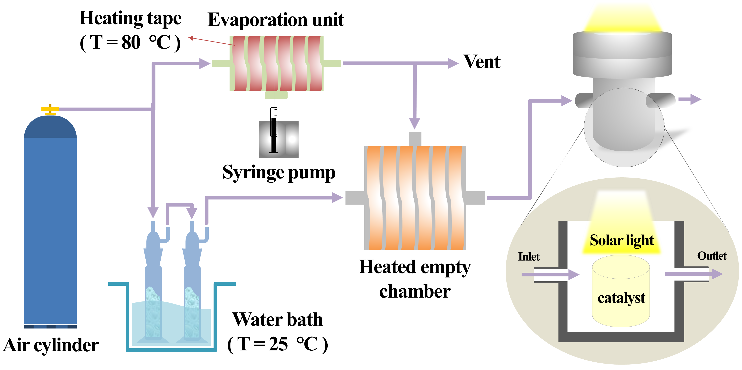
Figure S1. Test set-up for the photocatalytic building interior pollutant control under
simulated sunlight irradiation.

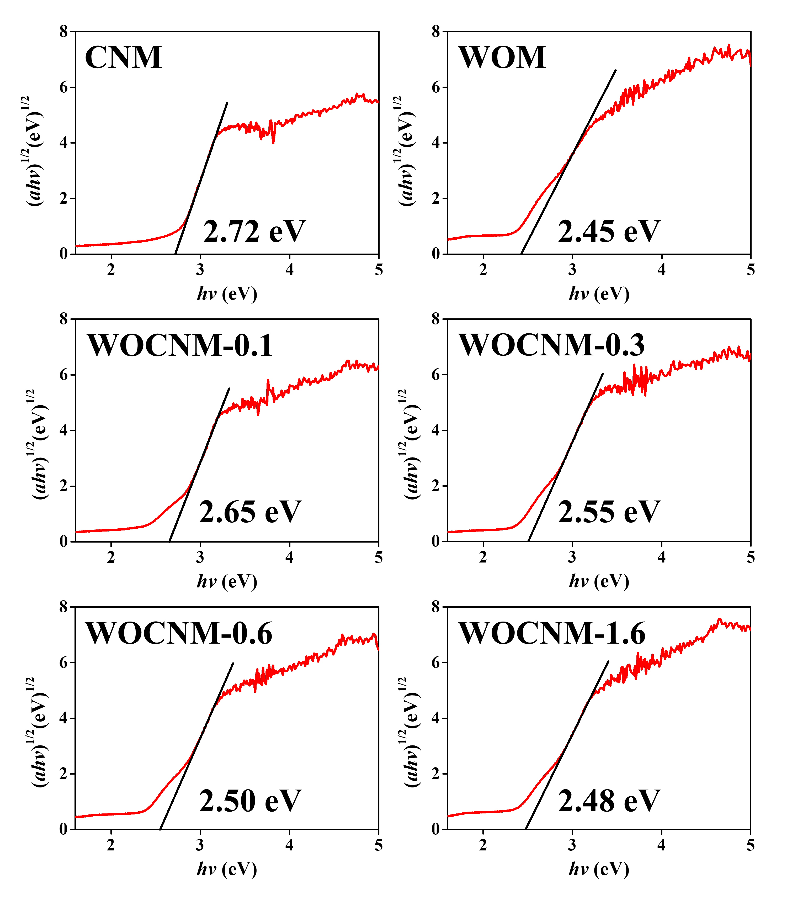
Figure S2. Converted Tauc plots according to the UV-visible diffuse reflectance spectra of
WOM, CNM, WOCNM-0.1, WOCNM-0.3, WOCNM-0.6, and WOCNM-1.6.

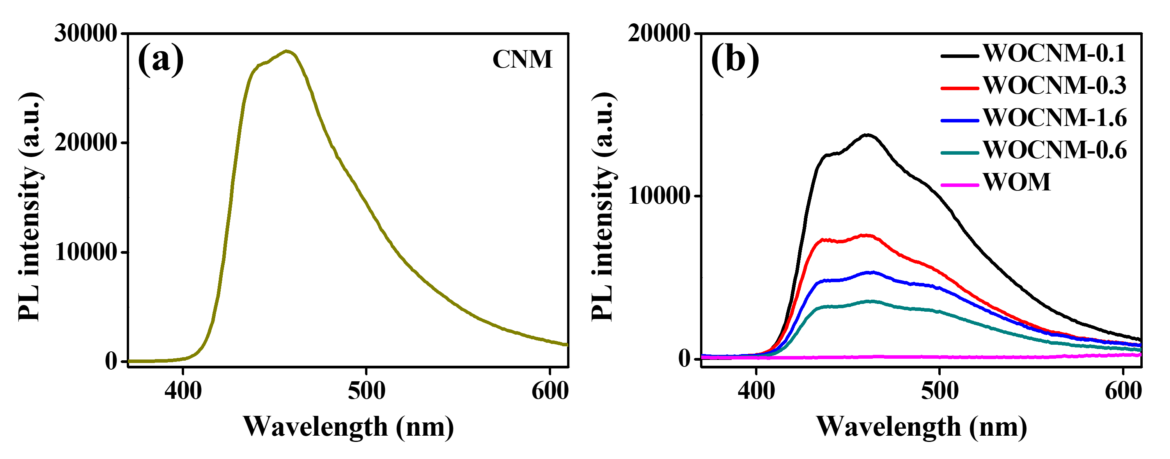
Figure S3. Photoluminescence emission spectra of (a) CNM and (b) WOM, WOCNM-0.1,
WOCNM-0.3, WOCNM-0.6, and WOCNM-1.6.
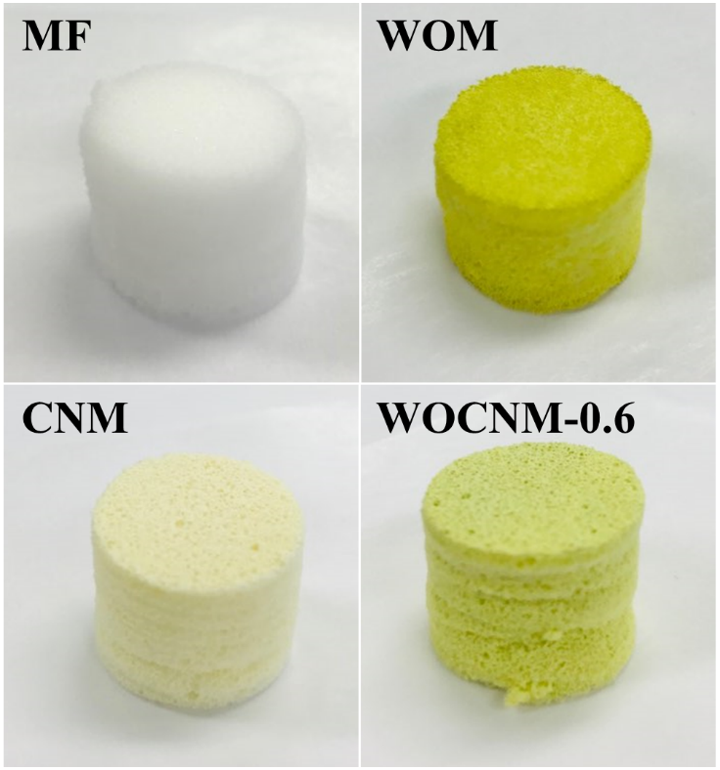
Figure S4. Photographs of raw MF, WOM, CNM, and WOCNM-0.6.

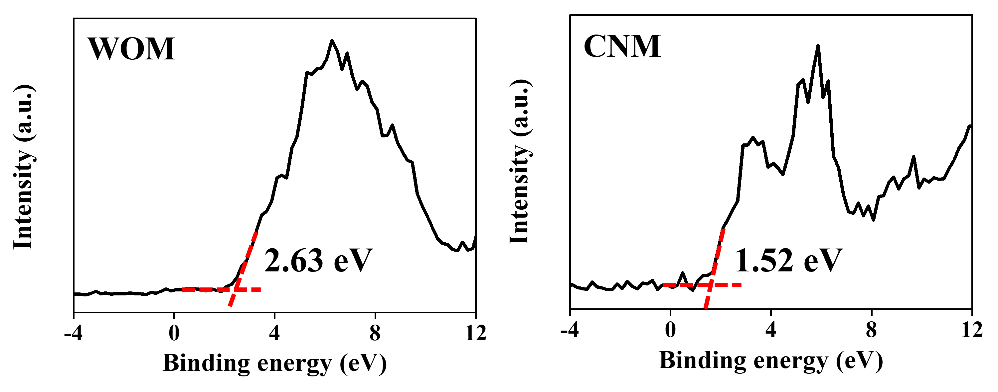
Figure S5. Valence-band X-ray photoelectron spectra of WO₃ and g-C₃N₄.

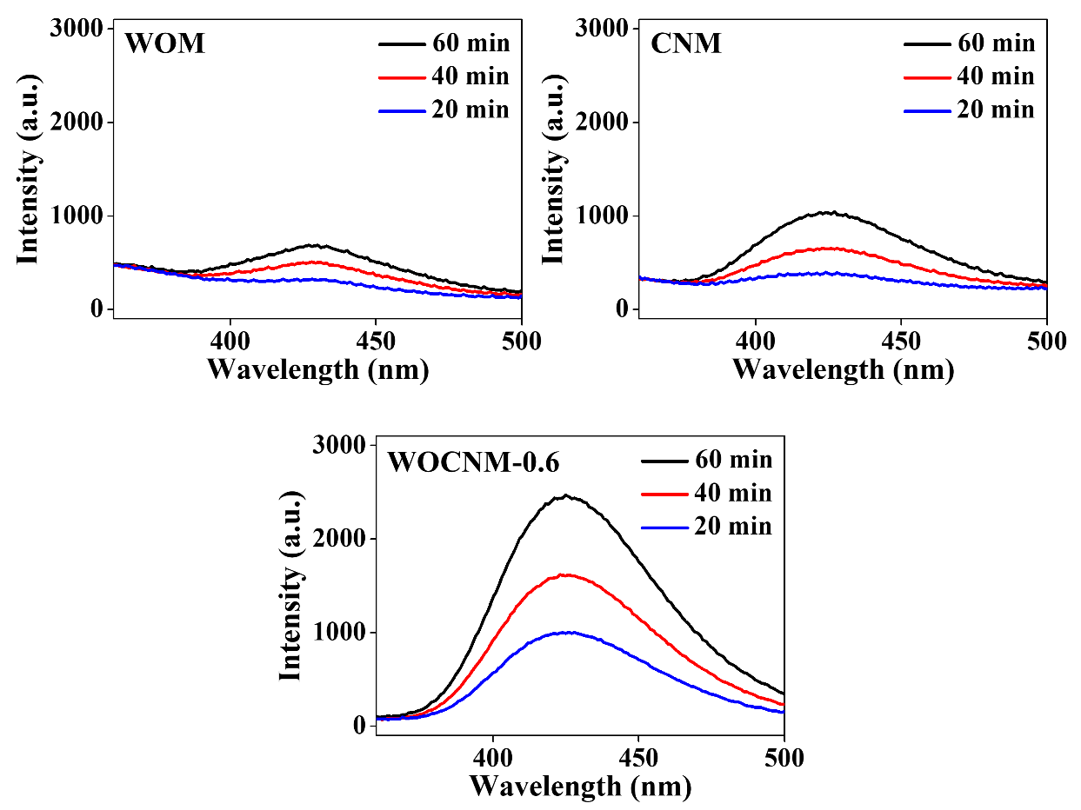
Figure S6. Fluorescence spectra of WOM, CNM, and WOCNM-0.6 used for the examination
of hydroxyl radical concentrations for simulated sunlight exposures of 20, 40, and
60 min.

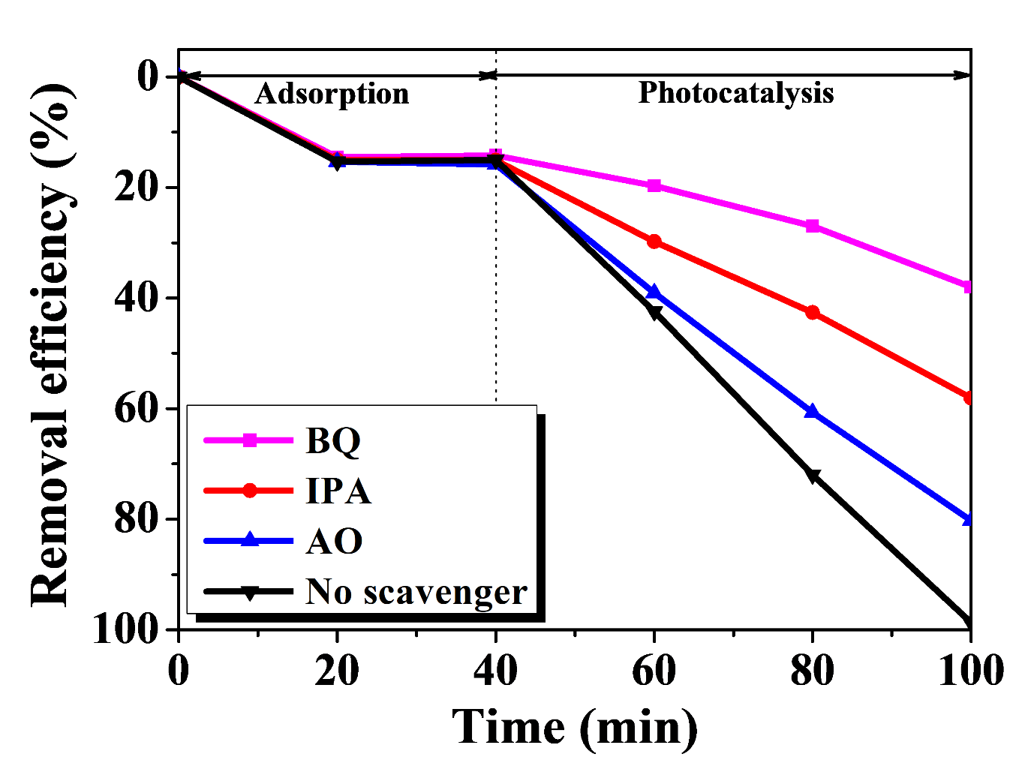
Figure S7. Active species experiments (Isopropyl alcohol (IPA) for OH•, ammonium
oxalate (AO) for h⁺, and 1,4-benzoquinone (BQ) for O₂•–) for the photocatalytic
decomposition of RhB over WOCNM-0.6.

