Supporting Information

Carryover of neotame, WS-23, and other additives from popular disposable e-cigarettes to aerosol

Remi A. Mellinghoff,^{1,2} Isabel X. Maday,^{1,2} Elena M. Bouldin,¹ Paul T. Anastas,^{1,3} Stephanie S. O’Malley,² Suchitra Krishnan-Sarin,² Julie B. Zimmerman,^{1,2} Hanno C. Erythropel^{1,2}*

1 Department of Chemical and Environmental Engineering, Yale University, New Haven,
Connecticut.
2 Yale Tobacco Center of Regulatory Science (TCORS), Dept. of Psychiatry, Yale School of Medicine, New Haven, Connecticut
3 School of Public Health, Yale School of Medicine, New Haven, Connecticut

*Corresponding Author: hanno.erythropel@yale.edu
10 Hillhouse Ave, New Haven CT, 06511
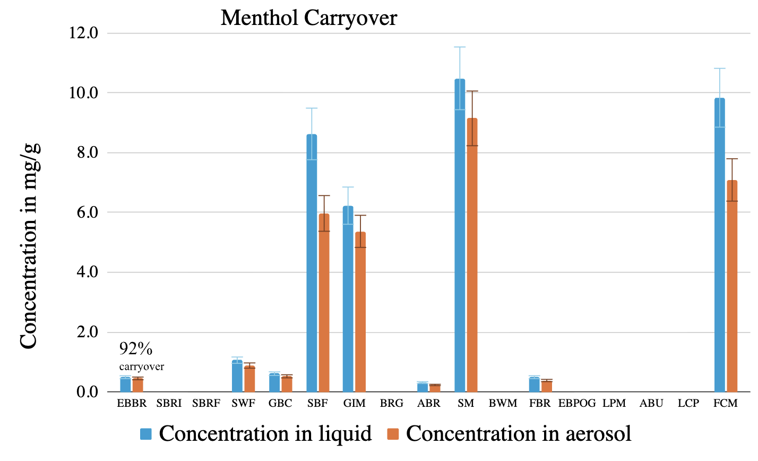
Figure S1: Concentrations of menthol in neat e-liquid (blue) and trapped aerosol (red), with carryover-% indicated for first data pair. Error bars represent standard deviation of the mean, all N = 3. Abbreviations, left to right: EBBR - Elf Bar Blue Razz; SBRI - SpreeBar Blue Razz Ice; SBRF - SpreeBar Rainbow Fruit; SWF - Sensa Watermelon Frost; GBC - Geek Bar Cherry; SBF - Sensa Blueberry Frost; GIM - Geek Bar Icy Mint; BRG - Breeze Grape; ABR - Air Bar Blue Razz Icy; SM - Sensa Mint; BWM - Breeze Watermelon Mint; FBR - Flum/Float Blue Razz Icy; EBPOG - Elf Bar Passion Orange Guava; LPM - Lost Mary Pineapple Mango; ABU - Air Bar Unicorn; LCP - Lost Mary Cherry Peach Lemonade; FCM - Flum/Float Cool Mint.

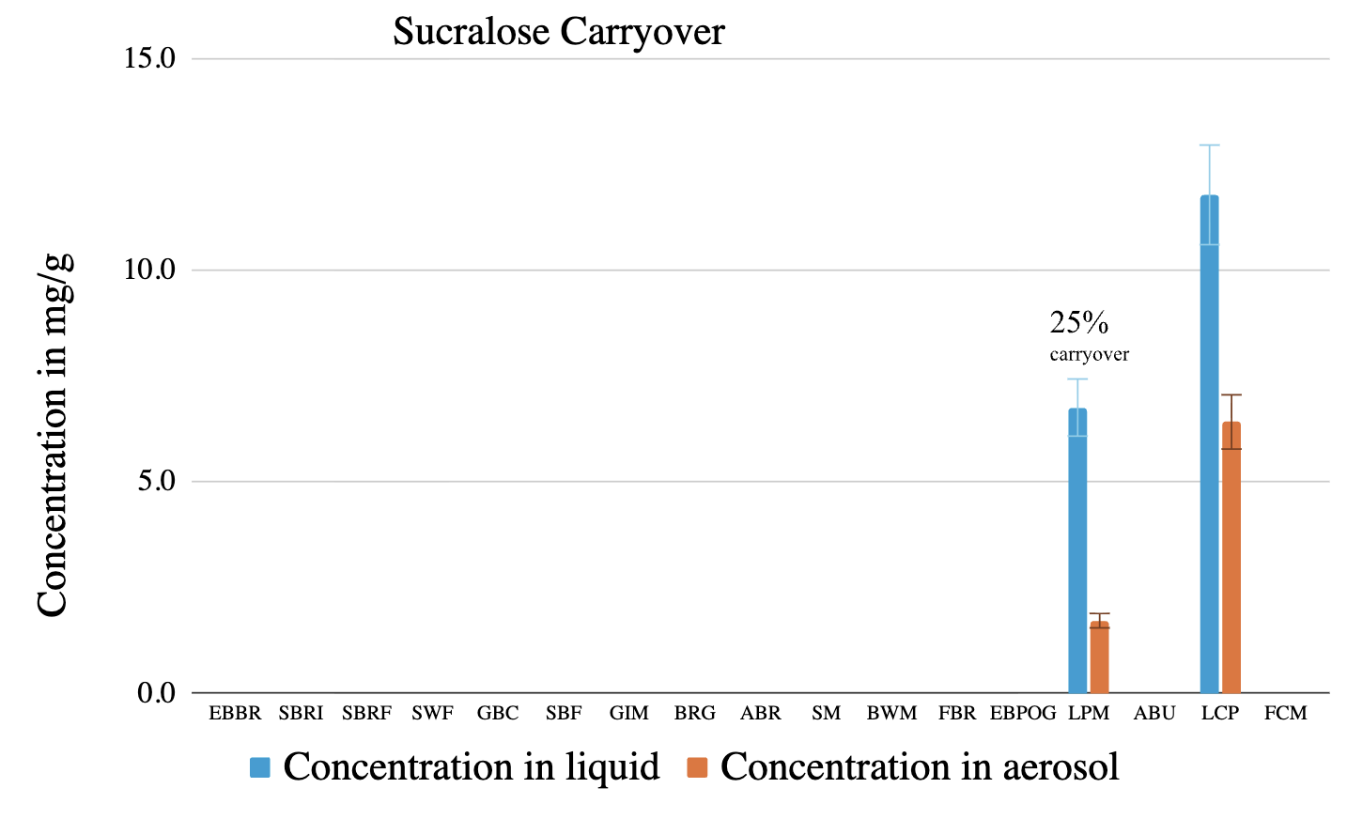
Figure S2: Concentrations of sucralose in neat e-liquid (blue) and trapped aerosol (red), with carryover-% indicated for first data pair. Error bars represent standard deviation of the mean, all N = 3. Abbreviations, left to right: EBBR - Elf Bar Blue Razz; SBRI - SpreeBar Blue Razz Ice; SBRF - SpreeBar Rainbow Fruit; SWF - Sensa Watermelon Frost; GBC - Geek Bar Cherry; SBF - Sensa Blueberry Frost; GIM - Geek Bar Icy Mint; BRG - Breeze Grape; ABR - Air Bar Blue Razz Icy; SM - Sensa Mint; BWM - Breeze Watermelon Mint; FBR - Flum/Float Blue Razz Icy; EBPOG - Elf Bar Passion Orange Guava; LPM - Lost Mary Pineapple Mango; ABU - Air Bar Unicorn; LCP - Lost Mary Cherry Peach Lemonade; FCM - Flum/Float Cool Mint.
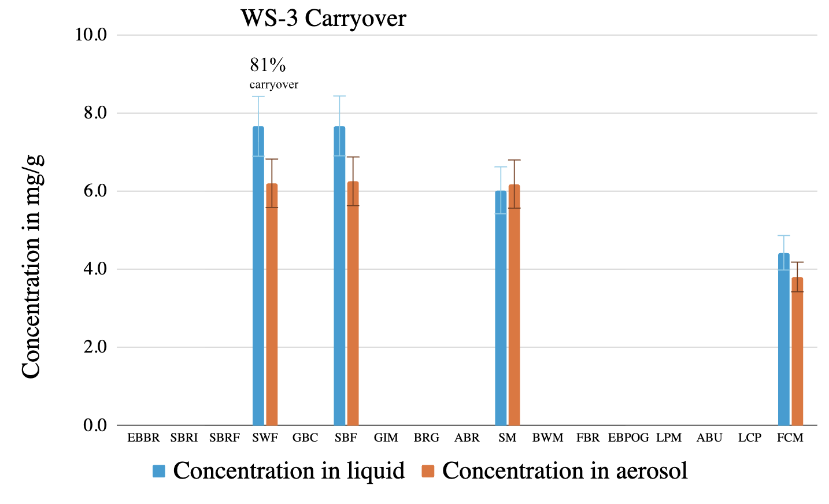
Figure S3: Concentrations of WS-3 in neat e-liquid (blue) and trapped aerosol (red), with carryover-% indicated for first data pair. Error bars represent standard deviation of the mean, all N = 3. Abbreviations, left to right: EBBR - Elf Bar Blue Razz; SBRI - SpreeBar Blue Razz Ice; SBRF - SpreeBar Rainbow Fruit; SWF - Sensa Watermelon Frost; GBC - Geek Bar Cherry; SBF - Sensa Blueberry Frost; GIM - Geek Bar Icy Mint; BRG - Breeze Grape; ABR - Air Bar Blue Razz Icy; SM - Sensa Mint; BWM - Breeze Watermelon Mint; FBR - Flum/Float Blue Razz Icy; EBPOG - Elf Bar Passion Orange Guava; LPM - Lost Mary Pineapple Mango; ABU - Air Bar Unicorn; LCP - Lost Mary Cherry Peach Lemonade; FCM - Flum/Float Cool Mint.

Table S1: Pearson linear regression and Spearman nonparametric correlation for compound carryover-% vs. measured compound concentration in e-liquid. Sample sizes for sucralose (n=2) and WS-3 (n=4) were too small.
 |  | Pearson |  | Spearman
Compound | N | R² | p | ρ | p
Neotame | 17 | 0.002 | ns (0.87) | -0.043 | ns (0.87)
WS-23 | 17 | 0.046 | ns (0.41) | -0.23 | ns (0.37)
Menthol | 9 | 0.068 | ns (0.50) | -0.059 | ns (0.89)
Nicotine | 11 | 0.65 | 0.003 | -0.66 | 0.032
Nicotine-9ª | 9 | 0.059 | ns (0.53) | -0.37 | ns (0.32)
a – excluding two samples with nicotine concentration > 50 mg/g (see Figure S4)

Table S2: Pearson linear regression and Spearman nonparametric correlation for compound carryover-% vs. measured propylene content in e-liquid. Sample sizes for sucralose (n=2) and WS-3 (n=4) were too small.
 |  | Pearson |  | Spearman
Compound | N | R² | p | ρ ^{(b)} | p
Neotame | 17 | 0.021 | ns (0.58) | 0.17 | ns (0.51)
WS-23 | 17 | 0.081 | ns (0.27) | -0.32 | ns (0.21)
Menthol | 9 | 0.018 | ns (0.73) | -0.27 | ns (0.47)
Nicotine | 11 | 0.048 | ns (0.52) | 0.14 | ns (0.67)

Table S3: One-way ANOVA and Bonferroni’s multiple comparisons test for compound carryover vs. nicotine (nic.)/no nicotine (no nic.)/6-methylnicotine (6MN) presence (3 treatments).
 | one-way ANOVA |  | Multiple comparison
Compound | F | p | Nic. vs.  no nic. | Nic.  vs. 6MN | No nic.  vs. 6MN
Neotame | 0.185 | ns (0.83) | ns (>0.99) | ns (>0.99) | ns (>0.99)
WS-23 | 0.223 | ns (0.80) | ns (>0.99) | ns (>0.99) | ns (>0.99)

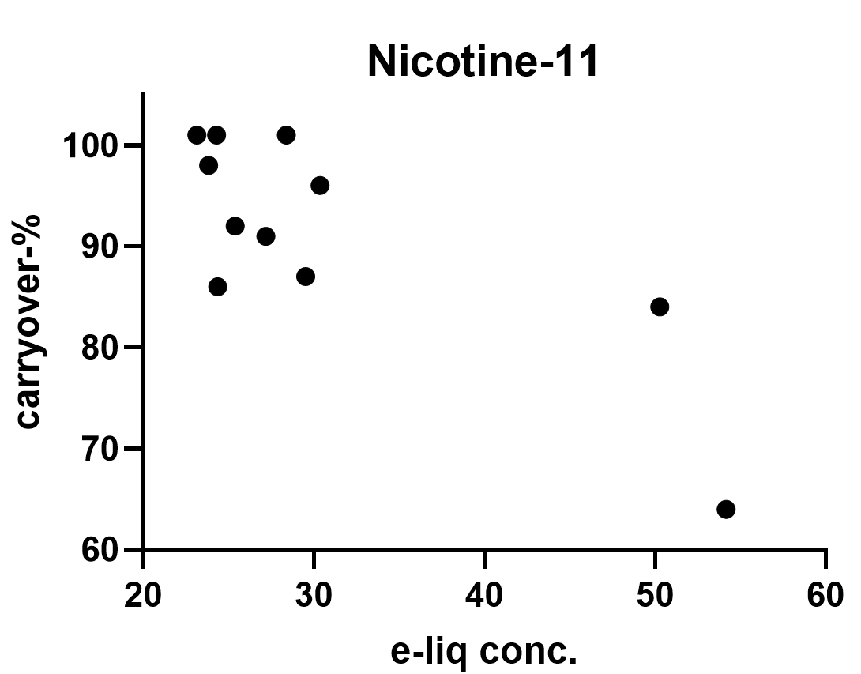
Figure S4: Measured e-liquid concentration vs. carryover-% of nicotine.

Table S4: Number of calibrators, limit of detection (LOD), limit of quantification (LOQ), and percent relative standard deviation (%RSD) for 7 quantified compounds. LOD and LOQ were calculated following regression analysis as: LOD=3.3×σ/S; LOQ=10×σ/S, where σ is standard error and S is slope. %RSD was calculated from 7 repeat injections of the same calibrator sample as
%RSD=stdev/mean×100.
Compound | N | LOD | LOQ (ug/mL) | %RSD
Neotame | 5 | 70 ng/mL | 200 ng/mL | 4.10%
Sucraloseª | 7 | <50 ng/mL | <50 ng/mL | 3.52%
Menthol | 6 | 20 ug/mL | 60 ug/mL | 1.25%
6-Methylnicotine | 4 | 25 ug/mL | 75 ug/mL | 1.15%
Nicotine | 4 | 40 ug/mL | 120 ug/mL | 0.87%
WS-23 | 6 | 20 ug/mL | 60 ug/mL | 1.22%
WS-3 | 6 | 20 ug/mL | 60 ug/mL | 1.37%
ª non-linear response observed, so LOD and LOQ based on calibration curve, where 50 ng/mL was the lowest injected concentration.

