ONLINE SUPPLEMENT TO

Characterization of pharmacological inhibition of the hERG potassium channel by nitazene opioids
By
Monisha R Chowdhury¹, Mattéo Baqué^{1,2}, Thomas Osborne⁴, Hongwei Cheng¹, Oliver Hanington¹, Yihong Zhang¹, Aziza El Harchi¹, Caroline Copeland³, Robin A Corey⁴, Stephen C Harmer¹, Jules C Hancox¹*
¹Bristol Medical School, Biomedical Sciences Building, University Walk, Bristol, BS8 1TD.
²Departement Genie Biologique, IUT, La Rochelle Université, Rue Albert Einstein, BP 33060 – 17031 La Rochelle.
³Centre for Pharmaceutical Medicine Research, Institute of Pharmaceutical Science, Kings College, London, SE1 9NH.

⁴School of Psychology and Neuroscience, Biomedical Sciences Building, University Walk, Bristol, BS8 1TD.

*Author for correspondence

Supplementary methods

S1. Cell culture and drug treatment
A HEK 293 cell line stably expressing HA-tagged (WT) hERG1a (HA-hERG1a) was constructed through subcloning the HA-hERG1a sequence (kindly provided by Professor Alvin Shrier (1)) into the pcDNA5-FRT vector (V601020, ThermoFisher Scientific) and recombining/stably integrating into the Flp-In™ T-REx™ HEK 293 cell line (R78007, ThermoFisher Scientific). Cells were maintained at 37 °C in a humidified atmosphere containing 5% CO₂ in culture medium supplemented with hygromycin (H011, TOKU-E; 100 µg/mL) and blasticidin (ant-bl-1, InvivoGen; 15 µg/mL). The hERG1a construct contained an extracellular HA epitope tag positioned between the S1 and S2 transmembrane domains, allowing the detection of hERG1a channels expressed at the cell surface.

For trafficking experiments, cells were seeded at a density of 3.75 × 10⁵ cells/mL into poly-L-lysine-coated 48-well Costar plates (Corning, 3338). Poly-L-lysine was obtained from Sigma-Aldrich (25988-63-0). Cells were cultured for 24 h following seeding before drug treatment. Cells were then exposed for 24 h to isotonitazene (1, 3 or 10 µM), protonitazene (0.3, 1 or 3 µM), doxycycline (10 µM) as a negative control, thioridazine (10 µM) as a positive control or the DMSO vehicle control. Drug solutions were prepared in medium and filtered, with a final DMSO concentration of 0.1%.

S2. Cell-surface (‘On-Cell’) and total cellular (‘In-Cell’) hERG1a expression assay
A previously validated LI-COR based on-cell/in-cell Western assay was employed (2;3). Following the 24 h drug-treatment period, the plate was placed on ice, and the medium was removed. Cells were incubated with a mouse monoclonal anti-HA antibody (Sigma-Aldrich, H9658; 1:1,000; 250 µL per well) for 1 h at 4 °C on a rocker.

Following primary-antibody incubation, cells were washed once with ice-cold DMEM and twice with ice-cold PBS+ (PBS containing 1 mM MgCl₂ and 0.1 mM CaCl₂). Cells were then fixed with 3.7% formaldehyde for 20 min at room temperature (10 min under static conditions followed by 10 min on a rocking platform). Following fixation, the wells were rinsed three times with PBS+ and once with ice-cold Hanks’ Balanced Salt Solution.

Wheat germ agglutinin conjugated to Alexa Fluor 680 (WGA-680; Life Technologies, W32465) was applied at 5 µg/mL for 10 min. The plates were then protected from light from this stage onwards. After two PBS+ washes, cells were incubated with anti-mouse DyLight 800-conjugated IgG secondary antibody (New England Biolabs, 5275S; 1:1,000; 250 µL per well) for 1 h at room temperature on a rocking platform. The wells were then washed three times with PBS+ and covered with fresh PBS+ before fluorescence imaging using a LI-COR® Odyssey CLx system.

Total cellular hERG1a expression was assessed in which the cells had been cultured and treated. Following the 24 h treatment period, the culture medium was removed and the cells were washed with PBS+. Cells were fixed with 3.7% formaldehyde for 20 min at room temperature (10 min under static conditions followed by 10 min on a rocking platform). After fixation, cells were washed three times with PBS+ and once with ice-cold HBSS.

Cells were then incubated with WGA-680 at 5 µg/mL for 10 min. The plate was protected from light from this stage onwards. Following two washes with PBS+, cells were permeabilised by three successive washes with 0.1% Triton X-100 in PBS+. Cells were then washed once with PBS+ and incubated with HEK 293 cell culture medium (without antibiotics) for 30 min on a rocking platform to reduce non-specific antibody binding. Total hERG1a was detected using mouse monoclonal anti-hERG antibody ((F-12): sc-377388; Santa Cruz) at 1:1,000 for 1 h at room temperature on a rocking platform.

Cells were then washed once with cell culture medium and twice with PBS+ before incubation with DyLight 800-conjugated anti-mouse IgG secondary antibody at 1:1,000 for 1 h at room temperature with gentle rocking. After three final washes with PBS+, fresh PBS+ was added to each well before imaging.

S3. Normalisation by sum analysis and statistical analysis
Fluorescence was quantified for the 700 WGA and 800 hERG1a channels. For each experiment, the fluorescence value from each well was first divided by the sum of all values measured in the corresponding channel. The sum-normalised 800 hERG1a value was then divided by the corresponding sum-normalised 700 WGA value to correct for differences in cell number.

Data from replicate wells were combined for each treatment condition, and individual points represent independent experiments. Results are presented as mean ± SEM. Statistical significance was assessed relative to the DMSO vehicle control using one-way analysis of variance (ANOVA) followed by Dunnett’s multiple-comparisons test. A value of P < 0.05 was considered statistically significant.

Supplementary Results

Figure S1 shows the results of the on-cell/in-cell Western assay. Figure S1A shows the plate layout, while Figure S1Bi and Ci show representative results for on-cell and in-cell experiments, respectively. Mean cell surface expression data are shown in Figure S1Bii. In contrast to thioridazine (positive control), neither isotonitazene nor protonitazene decreased surface expression of hERG relative to the DMSO control. In fact, there was a slight increase in surface hERG with 1 µM isotonitazene and with all 3 concentrations of protonitazene tested (without any concentration-dependence of effect). As shown in Figure S1Cii, no condition showed any significant difference from DMSO control for total cell hERG expression.

Considered collectively, the results of these experiments demonstrate that neither protonitazene nor isotonitazene affected total cell hERG expression and neither compound inhibited hERG cell surface expression. The small but statistically significant increase in surface hERG with chronic nitazene exposure is much smaller than acute I_{hERG} block observed for each compound; it would be insufficient to mitigate direct channel block in a scenario of sustained nitazene exposure. Thus, the principal effect of both nitazenes was acute hERG channel inhibition.

Figure S2 complements Figures 6 and 7 of the main manuscript, showing the 9 GNINA-generated docking poses for isotonitazene (Figure S2Ai) and protonitazene (Figure S2Aii) and Figure S2B showing Δ total decomposition by channel subunit chain. Figure S2C shows mean root-mean-square deviation (RMSD) of the protein Cα atoms, while Figure S2D shows mean RMSD of the bound ligand to Cα atoms.

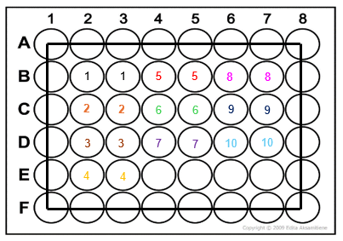
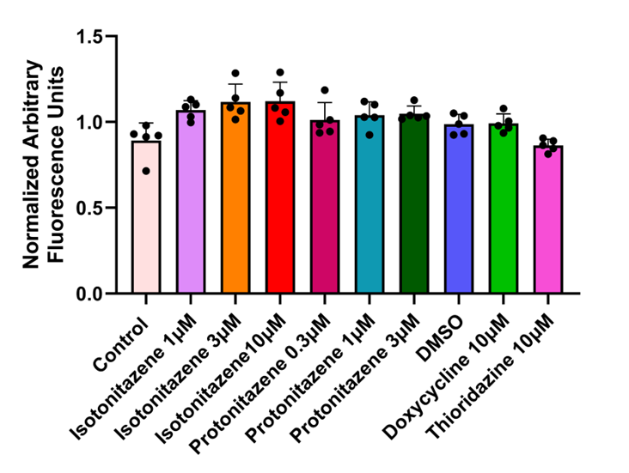
1) Control
2) DMSO
3) 10 µM Doxycycline
4) 10 µM Thioridazine
5) 1 µM Isotonitazene
6) 3 µM Isotonitazene
7) 10 µM Isotonitazene
8) 0.3 µM Protonitazene
9) 1 µM Protonitazene
10) 3 µM Protonitazene
On-cell
In-cell
Cell stain
Cell stain
Merged
Merged
Bi
Ci
Bii
Cii
A
Cell Surface
Total

Supplementary Figure 1. Effects of 24 h exposure to isotonitazene and protonitazene on cell-surface and total hERG1a expression.

(A) Schematic plate layout for the LI-COR®-based Cell Surface (‘On-Cell’) and Total cellular (‘In-Cell’) Western assays. HEK293 cells stably expressing HA-tagged hERG1a channels were cultured in 48-well plates and exposed for 24 h to isotonitazene (1, 3 or 10 µM), protonitazene (0.3, 1 or 3 µM), DMSO vehicle control, doxycycline (10 µM; negative control) or thioridazine (10 µM; positive control).

(Bi) Representative Cell Surface (‘On-Cell’) Western assay following the treatments shown in panel A. Cell-surface hERG1a was detected by the extracellular HA epitope in non-permeabilised cells and is shown in the 800 channels (green; upper panel). Cell number was measured using WGA-680 fluorescence in the 700 channels (red; middle panel), with merged images shown in the lower panel.

(Bii) Quantification of normalised cell-surface hERG1a expression.

(Ci) Representative Total cellular (‘In-Cell’) Western assay following the treatments shown in panel A. Total hERG1a expression was detected in permeabilised cells and is shown in the 800 channels (green; upper panel). Cell number was assessed using WGA-680 fluorescence in the 700 channels (red; middle panel), with merged images shown in the lower panel.

(Cii) Quantification of normalised total cellular hERG1a expression.

Individual points represent independent experiments and bars show mean ± SEM. Statistical significance for each treatment group relative to the DMSO vehicle control was assessed using one-way ANOVA followed by Dunnett’s multiple-comparisons test *P < 0.05, **P < 0.01.

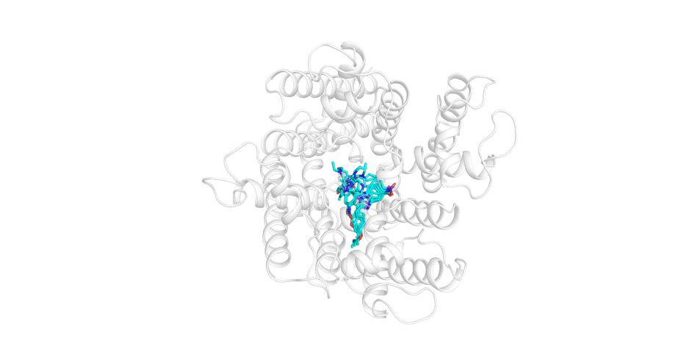
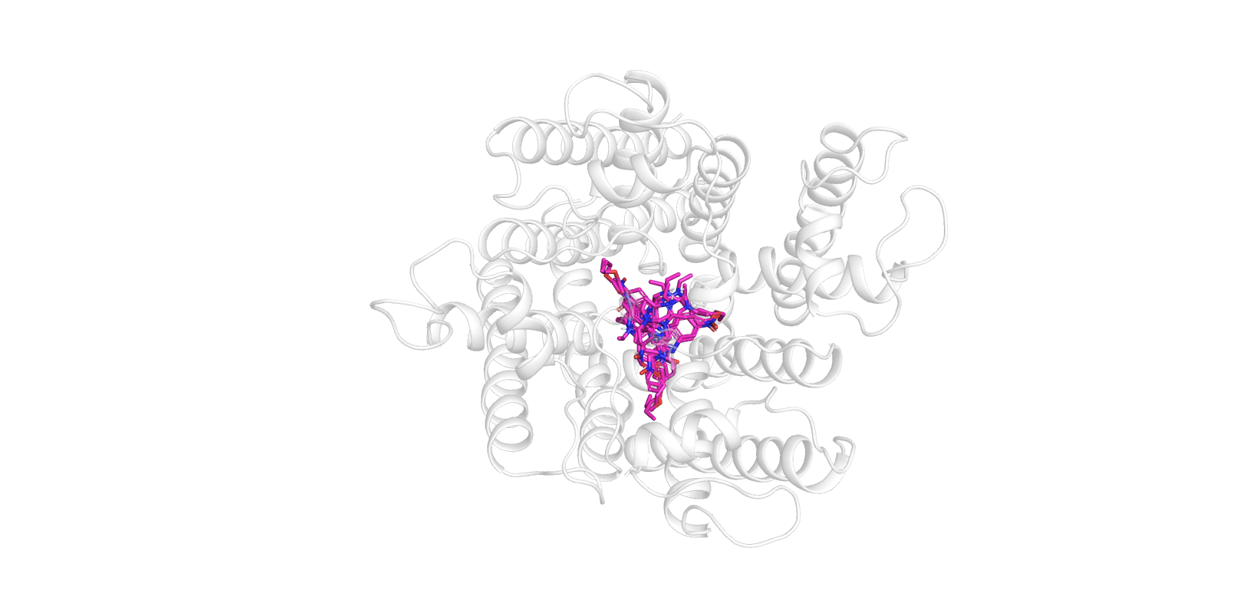
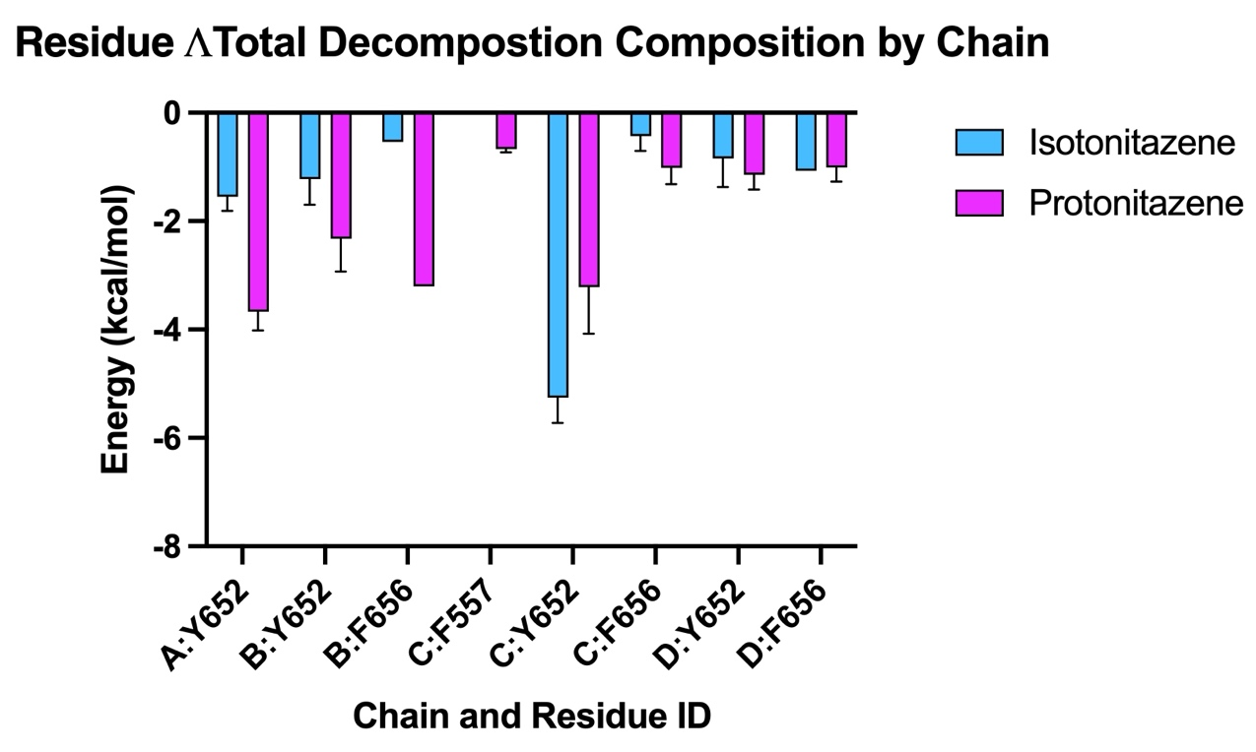
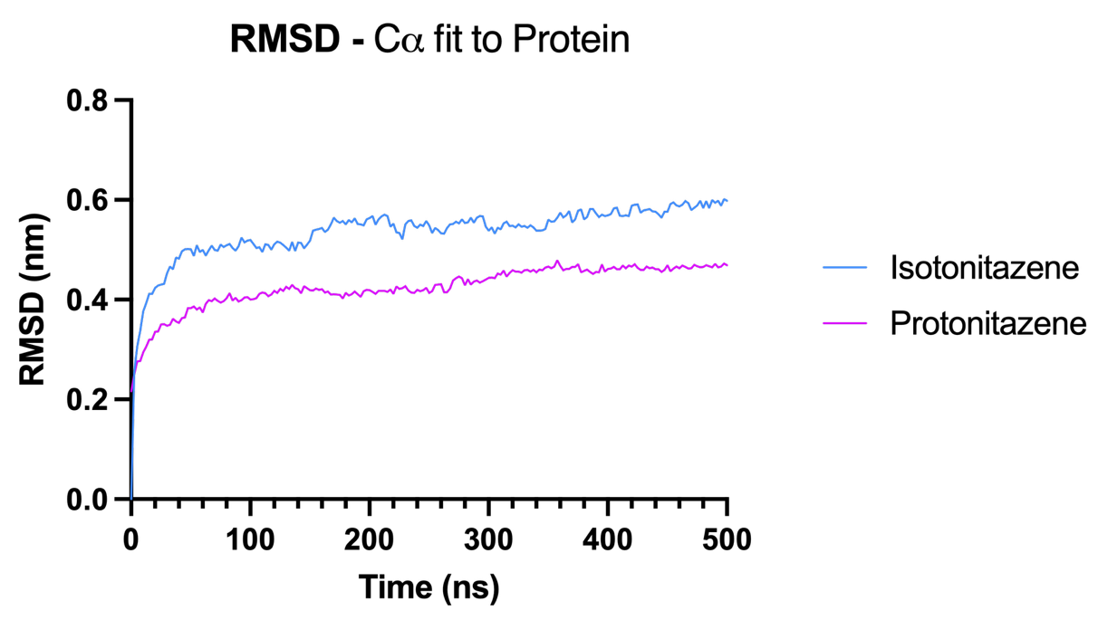
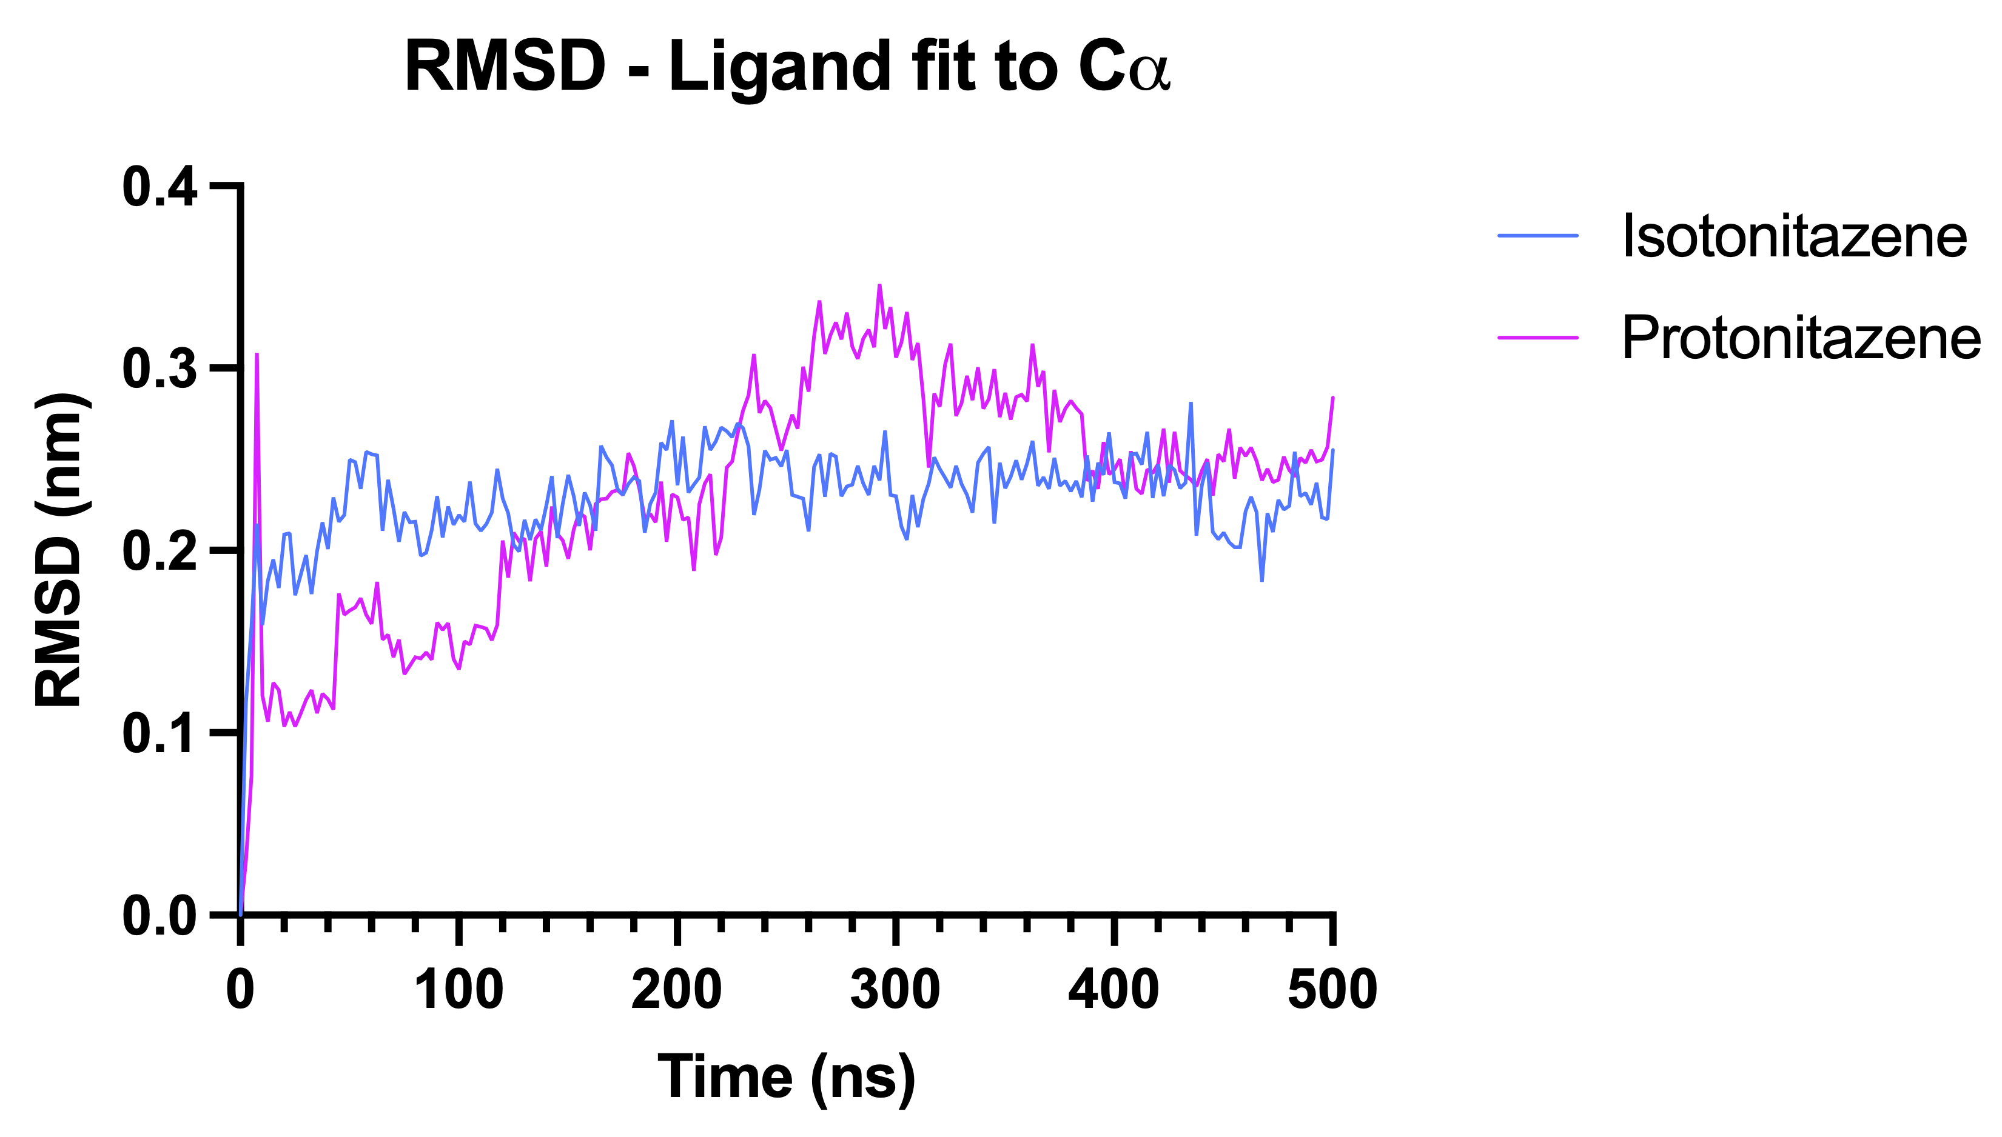
Ai
Aii
B
C
D

Supplementary Figure 2. Docking pose ensembles for isotonitazene and protonitazene within the hERG pore and mean per-residue enthalpy contribution (ΔTDC, kcal/mol).

(A) Superposition of the nine GNINA-generated docking poses for (Ai) isotonitazene, (Aii) protonitazene shown within the hERG channel pore. Both ligands occupy the central cavity, with the spread of poses illustrating the range of binding orientations sampled by docking prior to selection of a representative simulation pose.
(B) Mean per-residue enthalpy contribution (ΔTDC, kcal/mol). Data are grouped by chain and residue number, averaged across 5 independent replicate simulations. Data are shown as mean ± SEM
(C) Mean root-mean-square deviation (RMSD) of the protein Cα atoms. Data are plotted over 500 ns of MD simulation, averaged across 5 replicate simulations, for hERG in complex with isotonitazene and protonitazene.
(D) Mean RMSD of the bound ligand to Cα atoms. Data is plotted over 500ns of MD simulation and averaged across 5 replicate simulations.

References

(1) Apaja PM, Foo B, Okiyoneda T, Valinsky WC, Barriere H, Atanasiu R, et al (2013). Ubiquitination-dependent quality control of hERG K⁺ channel with acquired and inherited conformational defect at the plasma membrane. Mol Biol Cell;24(24):3787-804.
(2) Al Moubarak E, Zhang Y, Dempsey CE, Zhang H, Harmer SC, Hancox JC (2020). Serine mutation of a conserved threonine in the hERG K+ channel S6-pore region leads to loss-of-function through trafficking impairment. Biochem.Biophys Res.Commun. 526: 1085-1091.
(3) Zhang Y, Grimwood AL, Hancox JC, Harmer SC, Dempsey CE (2022). Evolutionary coupling analysis guides identification of mistrafficking-sensitive variants in cardiac K⁺ channels: Validation with hERG. Front Pharmacol;13:1010119.

