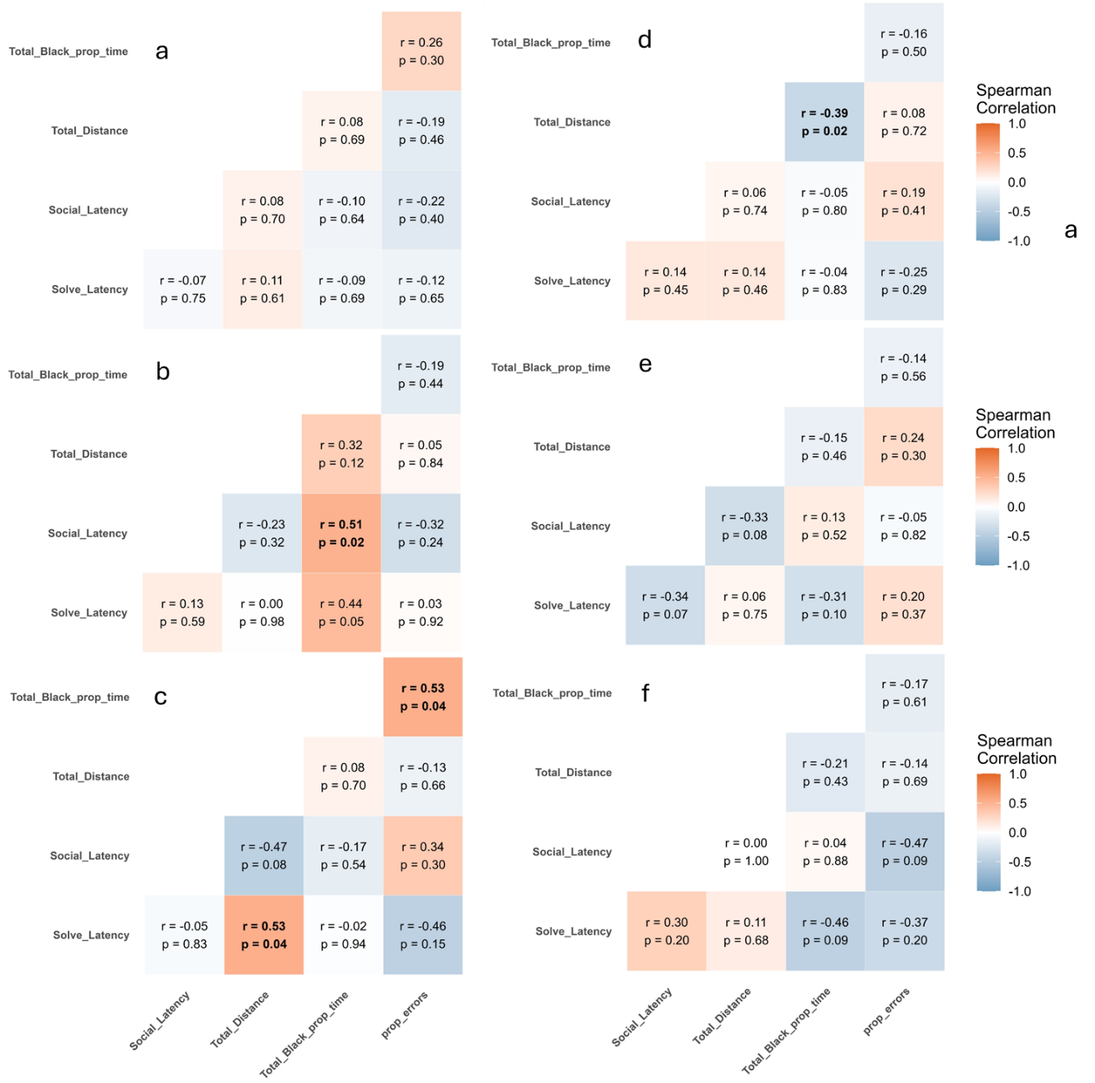
Figure S1.) Heatmaps of cognitive-behavioral correlations in sex-treatment groups a.) control males b.) low males c.) high males d.) control females e.) low females f.) high females. Spearman correlations are significant within each sex-treatment group, but correlations between sex-treatment groups are not significant (p> 0.05); Fisher’s z test with false discovery rate correction.

Trial Number | Participant n | Total n | proportion
1 | 96 | 123 | 0.7805
2 | 103 | 124 | 0.8306
3 | 86 | 125 | 0.6880
4 | 81 | 124 | 0.6532
5 | 63 | 122 | 0.5164
Table S1.) Total proportion of individuals that participated in the route learning task in each trial. To be considered a participant, individuals must enter both zone 1 and zone 2 in the route learning task in that trial. Trial 5 was not included in further analyses due to less than 65% of individuals participating.
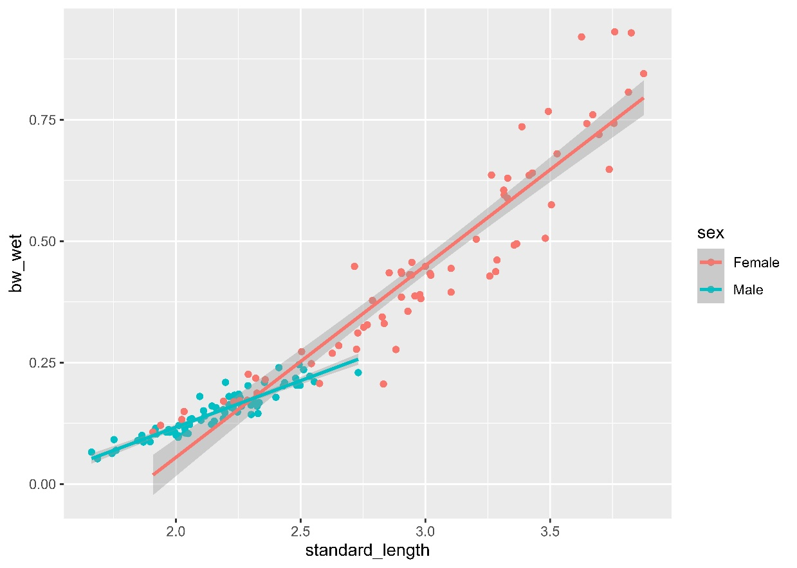
Figure S2.) The length-weight relationship of males and females. Males and females differ in earliest size at maturity, largest body weight, longest body, and the slope of the length-weight relationship.

