Supplementary materials for:

How tropical instability waves impact the equatorial Pacific interannual SST variability and heat budget in 2024

Qiaojun Chen¹, Rong-Hua Zhang^{1,2}*, Luying Yin³, Hai Zhi⁴, Yi Liu¹
¹ State Key Laboratory of Climate System Prediction and Risk Management/School of Marine Sciences, Nanjing University of Information Science and Technology, Nanjing, China
² Laoshan Laboratory, Qingdao, China
³ National Supercomputer Center in Tianjin, Tianjin, China
⁴ School of Atmospheric Sciences, Nanjing University of Information Science and Technology, Nanjing, China

*Corresponding Author
Email address:
rzhang@nuist.edu.cn

Contents
- Figure S1-S5
- Table S1
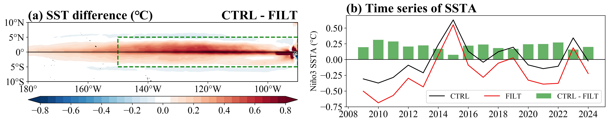
Fig. S1 Impact of TIWs on the climatological mean SST (2009–2024) in the equatorial Pacific. (a) Horizontal distribution of SST difference between the CTRL and FILT. (b) Time series of CTRL (black line), FILT (red line), and their difference (green bars) for SSTA averaged over the Niño3 region (5°S–5°N, 150°–90°W, green box in (a)).

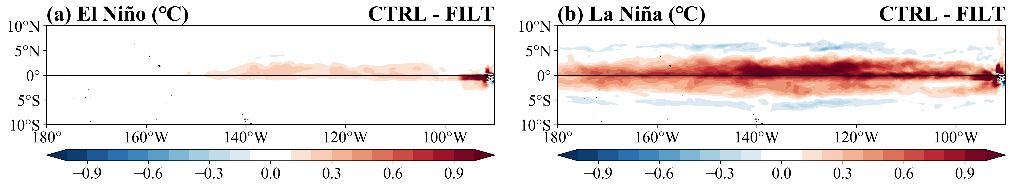
Fig. S2 Composite differences in interannual SSTA between the CTRL and FILT experiments for all (a) El Niño and (b) La Niña phases during 2009–2024. The definition of ENSO phase transitions follows Warner and Moum (2019).

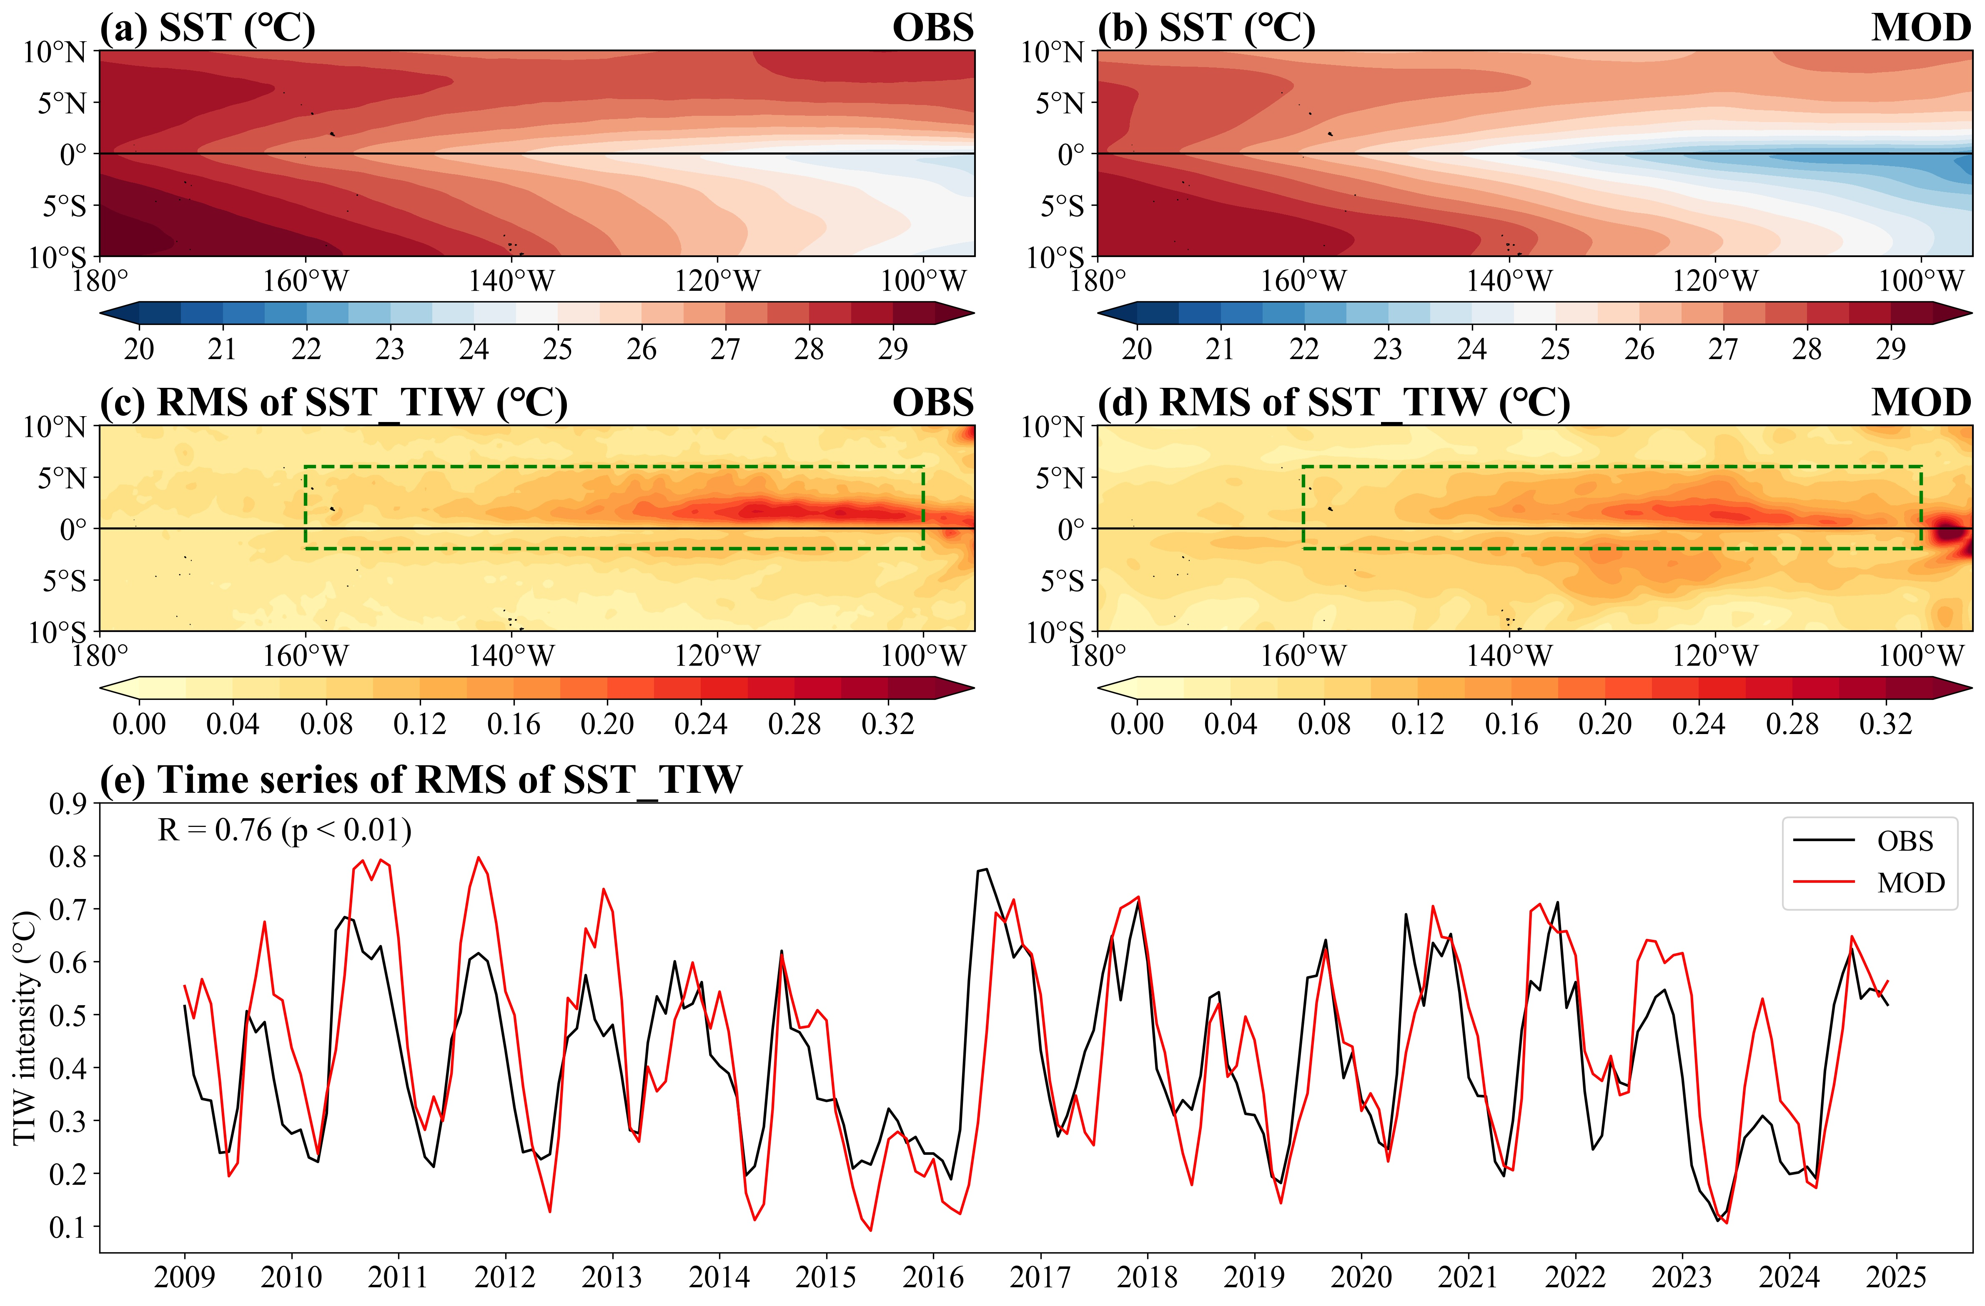
Fig. S3 Horizontal distributions of climatological mean SST from (a) observed OISST and (b) OGCM simulation during 2009–2024. (c, d) As in (a, b), but for the root mean square (RMS) of TIW-induced SST perturbations (SST_{TIW}, i.e., TIW intensity). (e) Interannual variability of observed (black) and simulated (red) TIW intensity averaged over the region (2°S–6°N, 160°–100°W, green box in (c–d)).

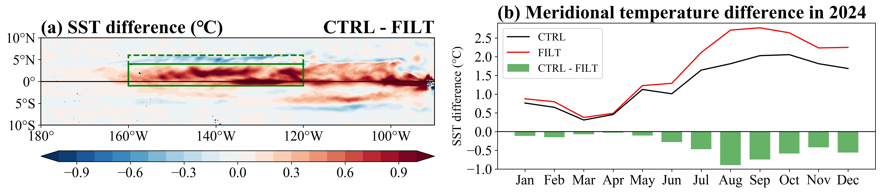
Fig. S4 Impact of TIWs on interannual SST variability in 2024. (a) Horizontal distribution of SST difference between the CTRL and FILT in boreal summer (July–August). (b) Time series of meridional SST gradient for CTRL (black line), FILT (red line), and their difference (green bars), calculated as the SST difference between the equatorial (1°S–4°N, 160°–120°W, solid-line green box) and off-equatorial (4°–6°N, 160°–120°W, dashed-line green box) regions.

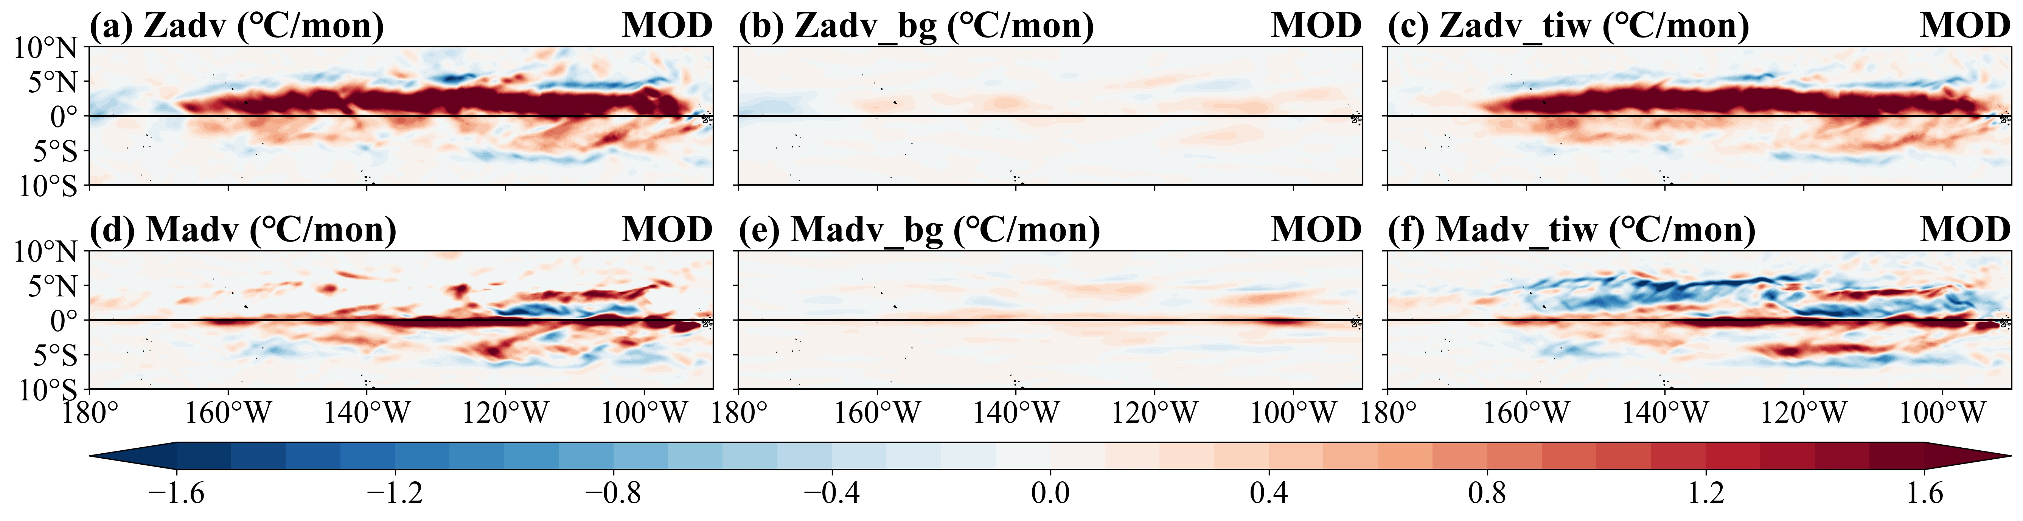
Fig. S5 Horizontal distributions of the anomalous SST budget terms calculated from daily outputs of the OGCM simulations in July–August of 2024. (a)–(c) Zonal (Zadv) and (d)–(f) meridional (Madv) components of the heat advection, decomposed into (left) total parts, (middle) background parts, and (right) TIW perturbation parts.

Table S1 Composite differences in SSTA (CTRL − FILT) averaged over the Niño3 region during El Niño and La Niña phases for the period 2009–2024.
ENSO phase | Niño3 SSTA (℃) |  |  | Contribution (%)
ENSO phase | CTRL | FILT | Difference | Contribution (%)
El Niño | 0.74 | 0.67 | 0.07 | 10.3%
La Niña | −0.61 | −0.97 | 0.36 | −37.5%

