SUPPLEMENTARY INFORMATION FOR
CVD Multilayer BN-encapsulated Graphene Solution-Gated Field-Effect Transistor for Wearable and Implantable Biosensors

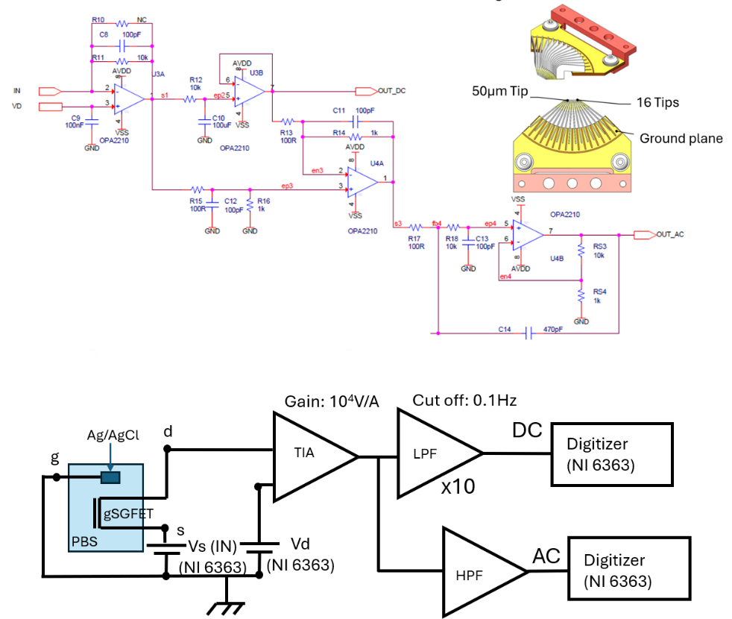
Figure S1: Electronic diagram of the current to voltage and amplifying chain for the transistor characterizations. Schematic of the measurement set up for the transistor characterizations.
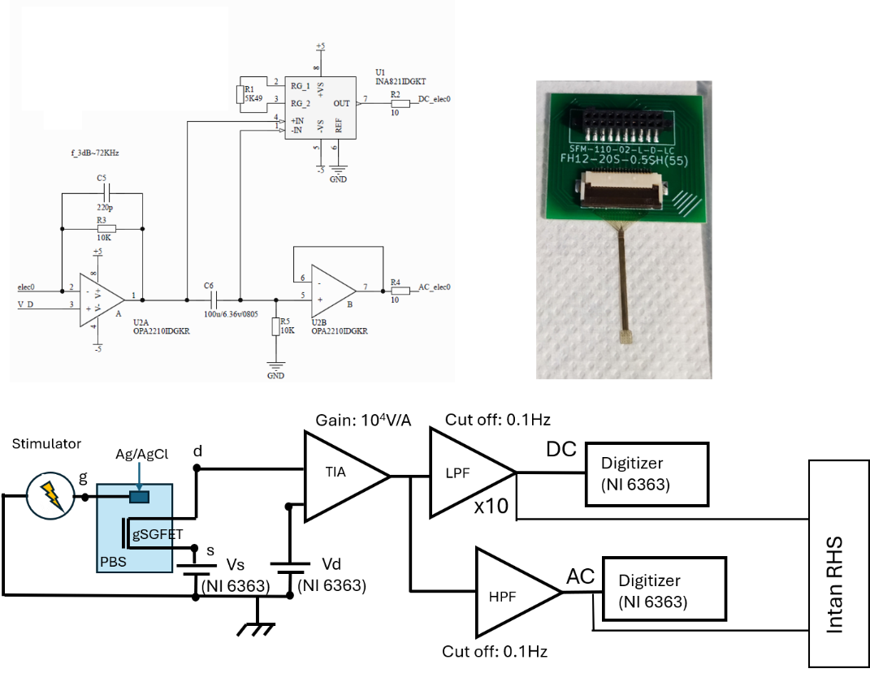
Figure S2: Electronic diagram of the current to voltage and amplifying chain for the recordings using the INTAN RHS system. Schematic of the measurement set up for the recordings using the INTAN RHS system.

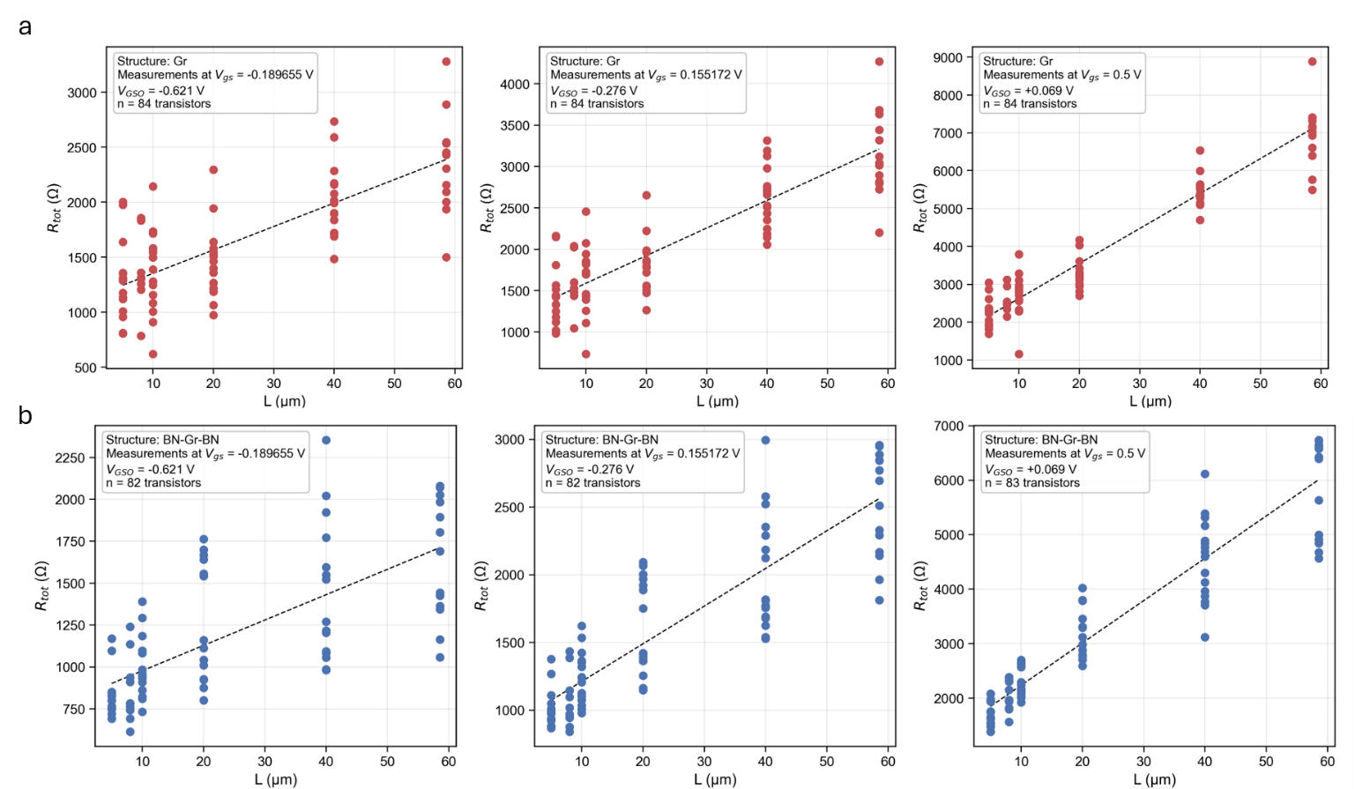
Figure S3: Data used for the fit of the R_{tot} in the TLM analysis. a) Data related to the bare gSGFET, b) Data related to the encapsulated gSGFET.
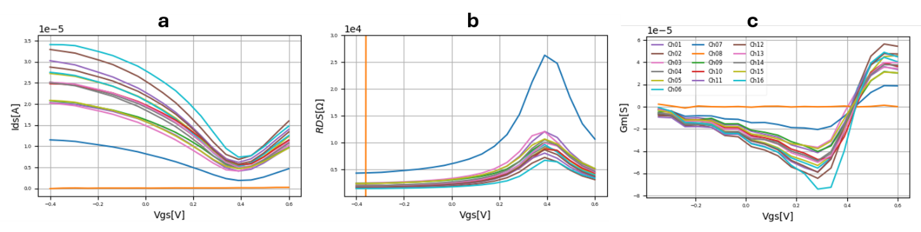
Figure S4: DC characterizations at V_{ds}=50mV of the BN-encapsulated gGSFET used to record the synthetic neuronal signal. a) I_{ds} vs V_{gs} transfer curve, b) R_{ds} vs V_{gs} ,c) G_{m} vs V_{gs}

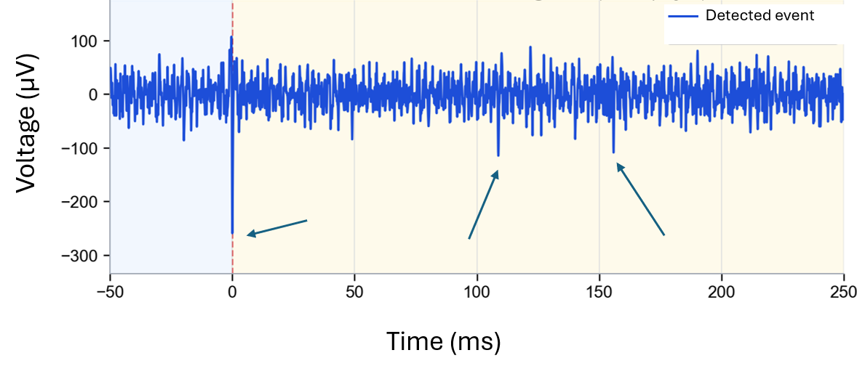
Figure S5: Single event detected on Channel B-023 (High pass filter above 300Hz). The 300µV and the 2 150µV spikes can be detected. The arrows represent the position of the spikes.

