Supplementary information
Endophyte-Mediated Elicitation Enhances Picrosides Production in Suspension Cultures of Picrorhiza kurroa Royle ex Benth.
Mahinder Partap^{1,4}, htps://orcid.org/0000-0002-4988-0171; email: mahinderpartap70@gmail.com
Ankita Thakur^{2,4}, https://orcid.org/0000-0001-7899-2503; email: ankitathakur2305@gmail.com
Amit Kumar^{1,4}, https://orcid.org/0009-0003-8967-3147; amitlakesar1997@gmail.com
Anish Tamang^{3,4}, https://orcid.org/0000-0002-9486-9393; email: anish78sang@gmail.com
Shiv Shanker Pandey^{2,4,}*, https://orcid.org/0000-0001-9730-2547; email: shiv.pandey@csir.res.in
Ashish R. Warghat^{1,4,}*, htps://orcid.org/0000-0001-5867-3329; email: ashish.warghat@csir.res.in; ashishwarghat@hotmail.com
¹Cell and Tissue Engineering Laboratory, Fermentation and Phytofarming Technology Division, CSIR-Institute of Himalayan Bioresource Technology (IHBT), Palampur- 176061 (H.P.), India
²Fermentation and Phytofarming Technology Division, CSIR-Institute of Himalayan Bioresource Technology (IHBT), Palampur- 176061 (H.P.), India
³Biotechnology Division, CSIR-Institute of Himalayan Bioresource Technology (IHBT), Palampur- 176061 (H.P.), India
⁴Academy of Scientific and Innovative Research (AcSIR), Ghaziabad- 201002, India
*Corresponding author:
E-mail: ashish.warghat@csir.res.in; ashishwarghat@hotmail.com
Tele-fax: +91-1894-230411, +91-1894-230433
*Co-corresponding author:
E-mail: shiv.pandey@csir.res.in
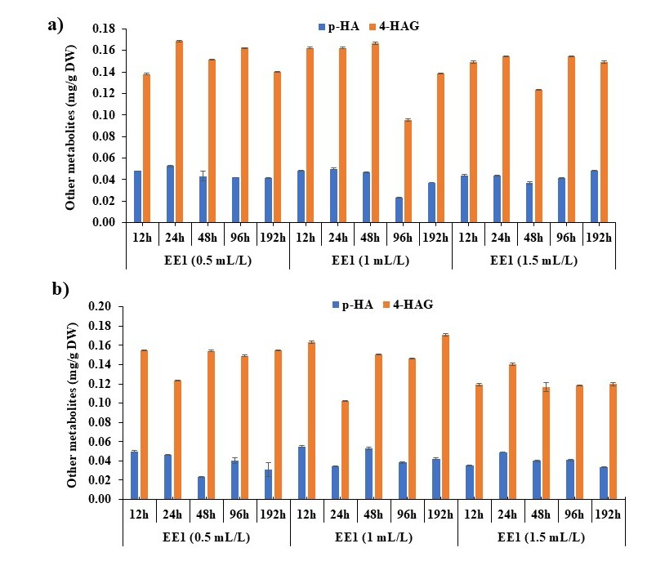
Fig. S1 Effect of different concentrations (0.5-1.5 mL/L) of endophytic extract of Trichoderma sp. (EE1) on p-HA and 4-HAG content in leaf cell suspension culture (LFSC) and rhizome cell suspension culture (RHSC) of P. kurroa. a) In LFSC b) In RHSC. EE1, Endophytic extract 1; p-HA, p-Hydroxyacetophenone; 4-HAG, 4-Hydroxyacetophenone β-D-glucoside

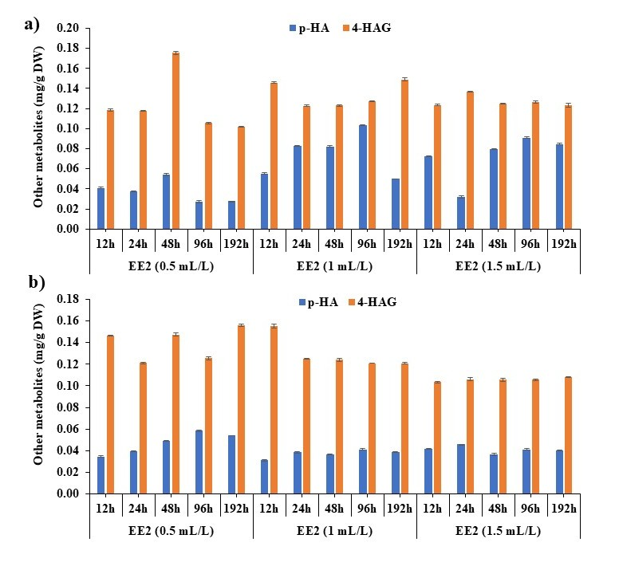
Fig. S2 Effect of different concentrations (0.5-1.5 mL/L) of endophytic extract of Fusarium acuminatum (EE2) on p-HA and 4-HAG content in leaf cell suspension culture (LFSC) and rhizome cell suspension culture (RHSC) of P. kurroa. a) In LFSC b) In RHSC. EE2, Endophytic extract 2; p-HA, p-Hydroxyacetophenone; 4-HAG, 4-Hydroxyacetophenone β-D-glucoside

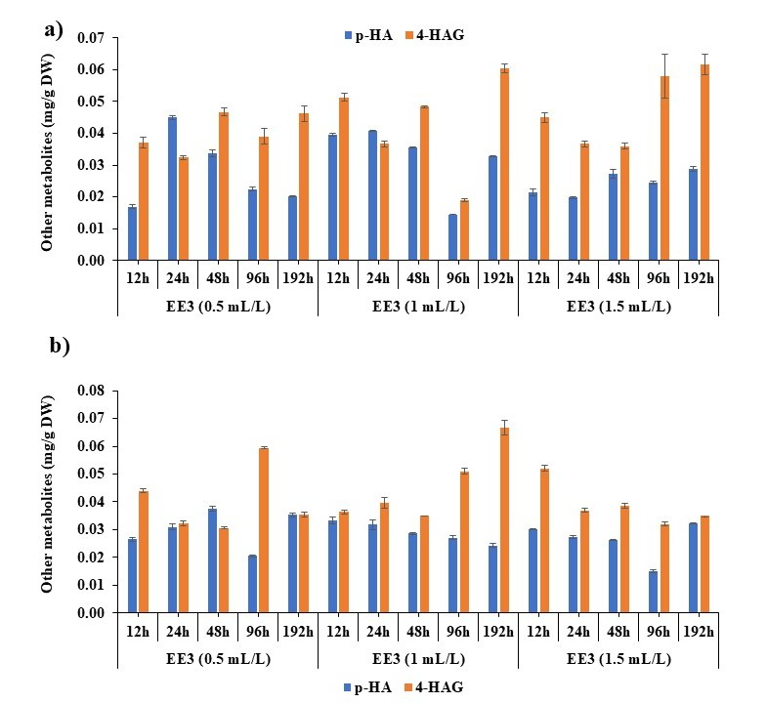
Fig. S3 Effect of different concentrations (0.5-1.5 mL/L) of endophytic extract of Fusarium sp. (EE3) on p-HA and 4-HAG content in leaf cell suspension culture (LFSC) and rhizome cell suspension culture (RHSC) of P. kurroa. a) In LFSC b) In RHSC. EE3, Endophytic extract 3; p-HA, p-Hydroxyacetophenone; 4-HAG, 4-Hydroxyacetophenone β-D-glucoside

